
Assignment 2: Operating Systems
CertHE Computing Skills for Workplace

Computer Architecture and Operating Systems. ACCA4022_LONDON
Dr Redhwan Al-Amri (Lecturer)
University of Wales Trinity Saint David (London Campus)
Student Name: Ena Joselin Galo Nunez
Student Number:2530035
Group: 01
Date: 12/08/2026 2:00 PM

Table of Contents
Introduction 1
1. Key functions of general Operating Systems 2
2. Use of Windows OS CLI commands. 6
3. Use of Linux OS CLI commands. 13
4. Use of Windows OS scripts. 18
5. Use of Linux OS scripts. 21
Conclusion 24
References 25
Appendices 26

Introduction

This report explains the main functions of operating systems and demonstrates how both Windows and Linux can be managed using graphical tools, command-line commands and simple scripts. Throughout this assignment, I explored different operating system features, including process management, memory management, file system management, and security and protection. I also carried out practical activities using Windows Command Prompt and the Linux terminal to learn how different commands are used to manage files, directories, users and system information. In addition, I created simple Batch and Bash scripts to perform basic tasks using variables, user input, arithmetic operations, loops and conditional statements. These practical activities helped me improve my understanding of operating systems and develop my command-line and scripting skills through hands-on practice.

Key functions of general Operating Systems

1.1 Process and process management
From my understanding, process management is an important function of an operating system because it helps control the programs that are running on the computer. Windows Task Manager allows me to see which applications and background processes are active and how much CPU and memory they are using. In my example, I could see programs such as Google Chrome, Microsoft Word and ChatGPT running at the same time. This helped me understand how Windows monitors different processes and manages the computer’s resources. [1]
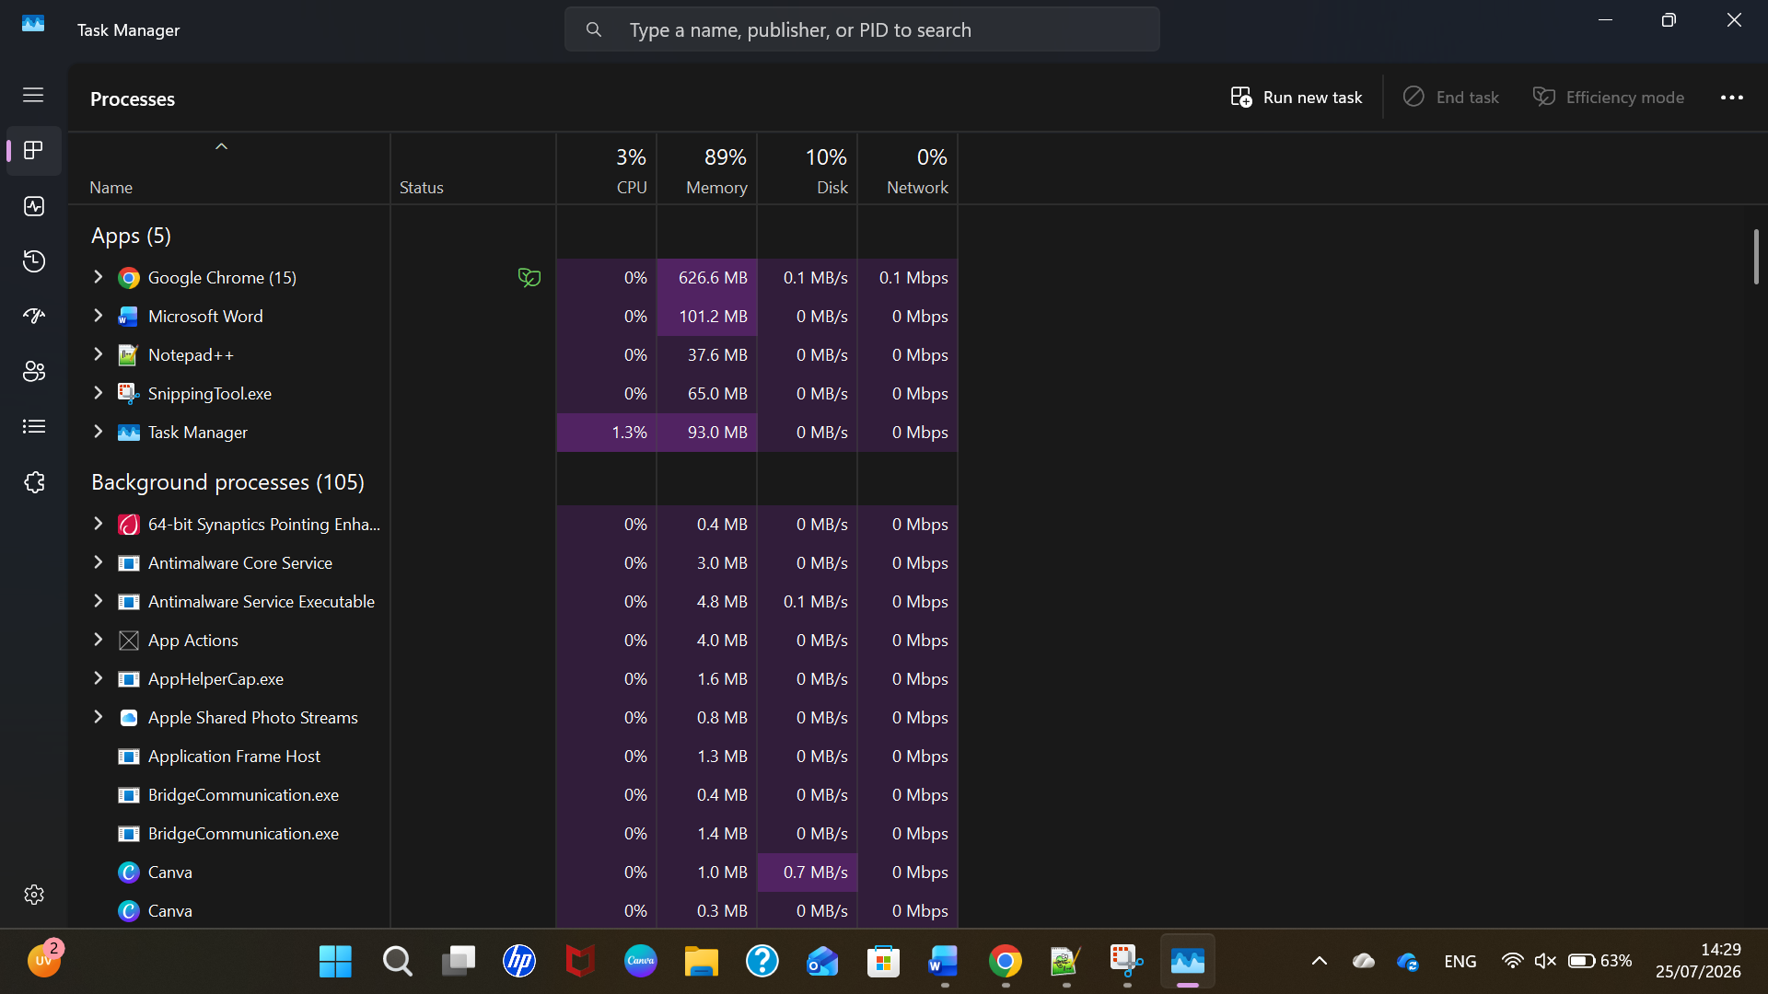
Figure 1: Windows Task Manager showing process and resource management.

1.2 Memory Management
From my understanding, memory management is the way the operating system controls and uses the computer's memory. It helps make sure that different programs have the memory they need to work correctly. Using Windows Task Manager, I was able to check the memory usage on my computer. My computer has 8 GB of RAM, and at the time of the screenshot, around 6.6 GB was being used. I also had around 1.1 GB available. This helped me see how Windows monitors the memory while different applications are running. [2]
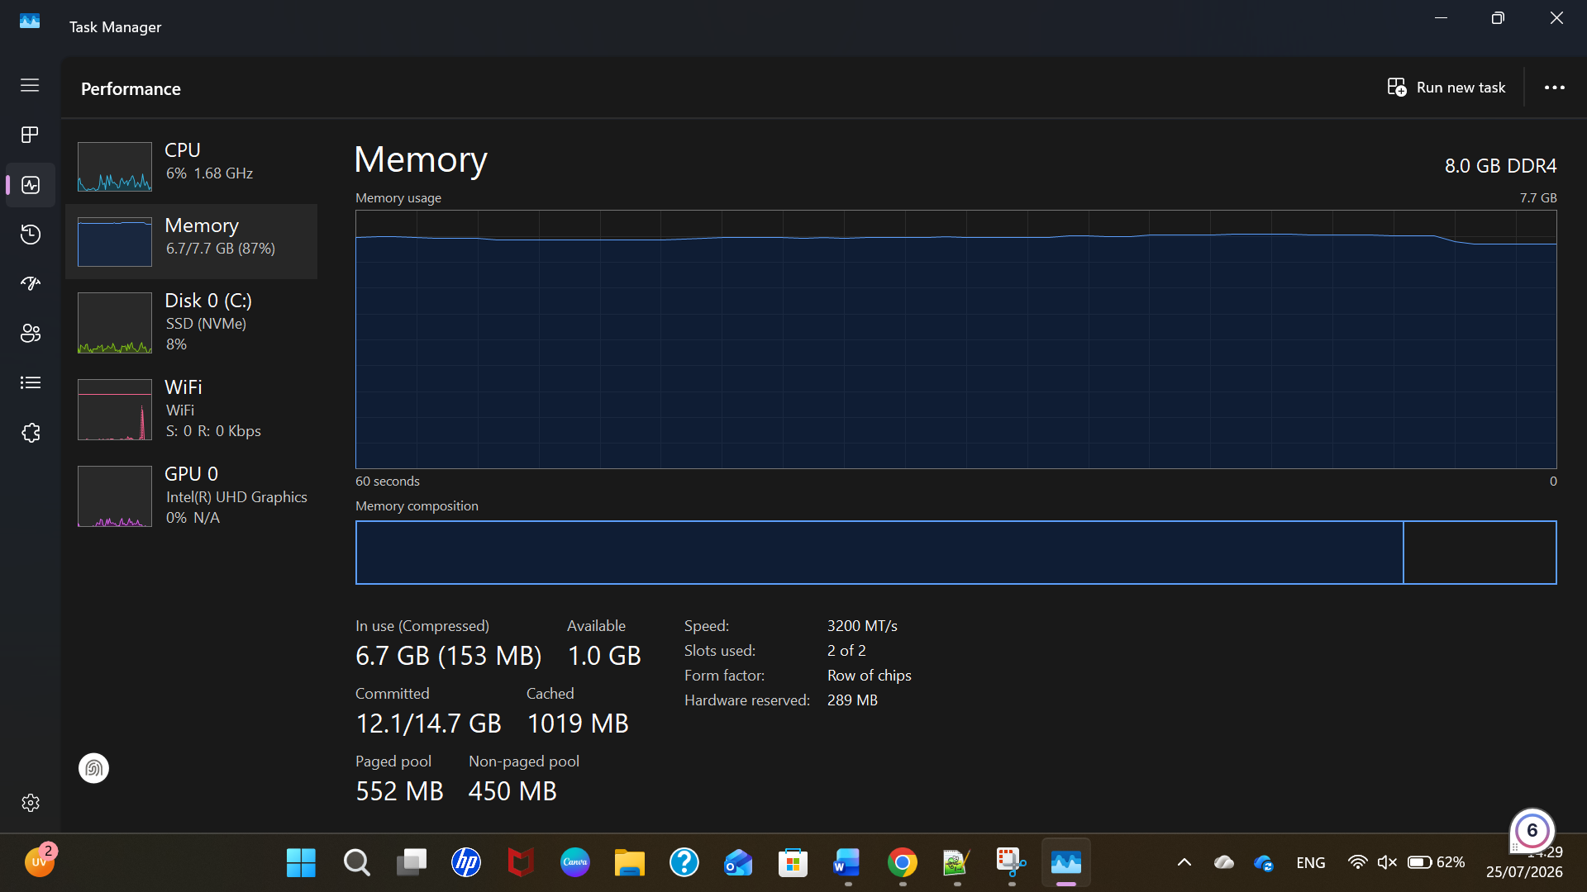

Figure 2: Windows Task Manager showing memory usage

1.3 File System Management
From my understanding, file management helps users organise and control the files and folders stored on a computer. Windows provides File Explorer, where I can access my documents, downloads, pictures and other folders. I can also create, copy, move, rename or delete files as needed. In my practical example, I used File Explorer to view and store folders on my computer. I could also see my Windows drive and how much storage space was available. This showed me how Windows makes it easier to organise and access information on the computer.

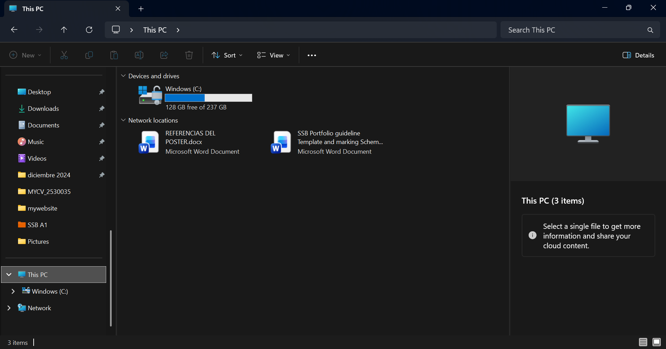
Figure 3: Windows File Explorer showing file and storage management.

1.4 Security and protection
From my understanding, security and protection are important functions of an operating system because they help keep the computer and personal information safe. Windows includes various security tools to protect the system from viruses, threats and unauthorized access. In my practical example, I opened Windows Security and could see several protection areas, including Virus & threat protection, Account protection and Firewall & network protection. Most of the areas showed that no action was needed. This helped me understand how Windows monitors my computer's security and provides options to keep the system protected. [3]
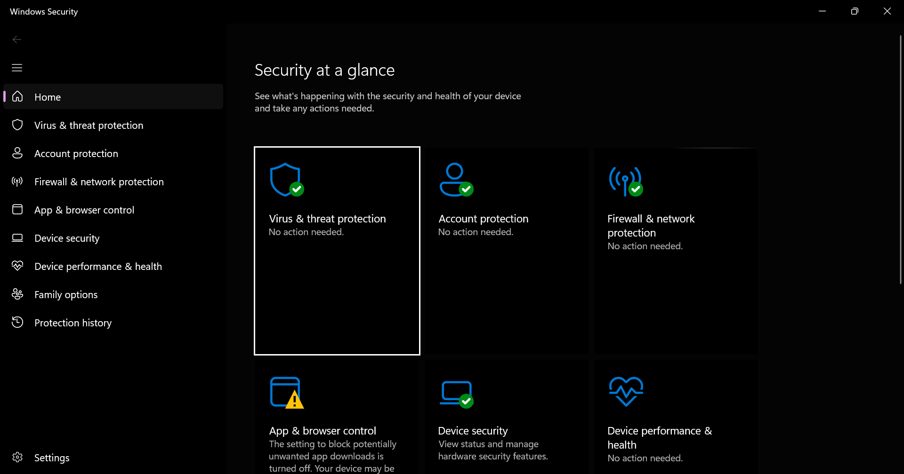

Figure 4: Windows Security showing different security and protection features

2. Use of Windows OS CLI commands.

2.1 tasklist
I used the tasklist command in Windows Command Prompt to check which processes were running on my computer. After entering the command, Windows displayed a list showing the process name, PID, session name and memory usage. I could see various Windows processes and services running in the background. The PID is useful because it gives each running process an identification number. I found this command useful because it provides a simple way to monitor processes directly from the command line without opening Task Manager. This practical activity helped me understand that Windows can be managed using both graphical tools and CLI commands. [4]
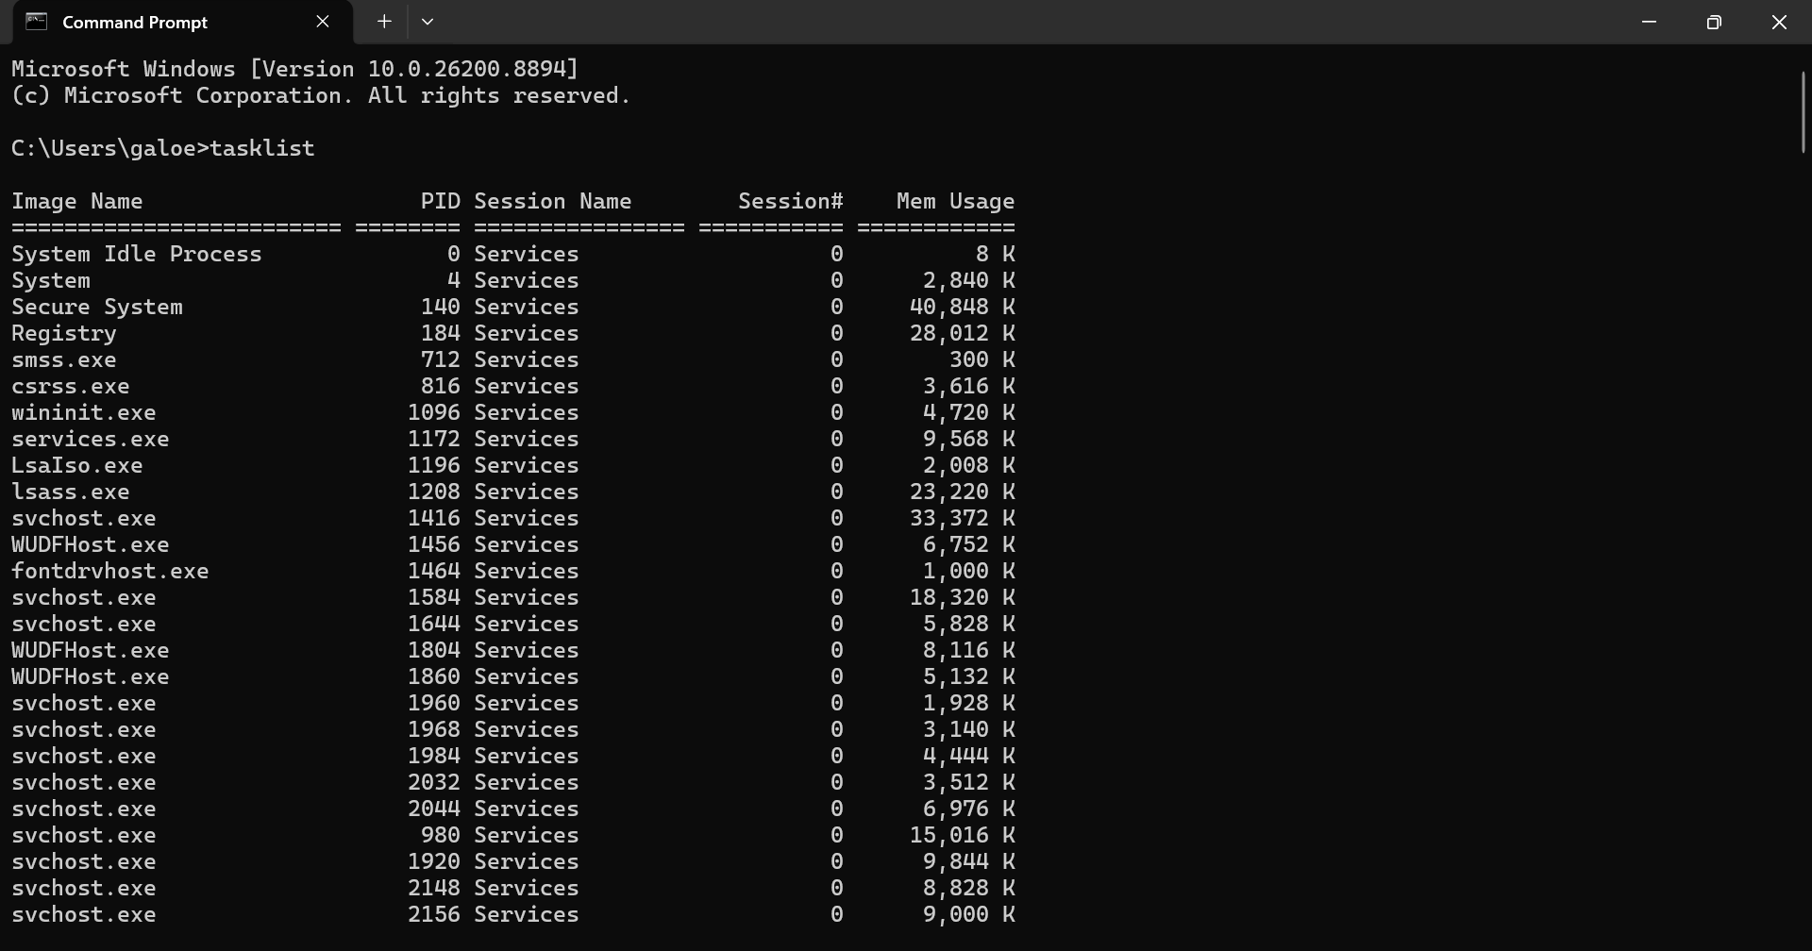
Figure 5: Using the tasklist command to display running processes in Windows.

2.2 taskkill
I used the taskkill command to stop a process running on my computer. First, I opened Notepad and ran tasklist | findstr "Notepad" to identify the application and its Process ID (PID). The result showed that Notepad had PID 1168. I then ran taskkill /PID 1168 to stop the process. The Command Prompt displayed a success message, and Notepad closed automatically. This activity helped me understand how Windows allows users to identify and stop running processes directly from the command line.
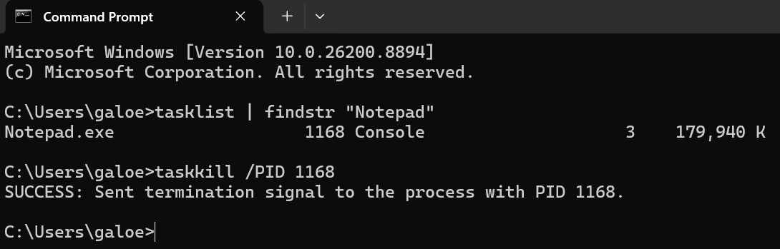Figure 6: Using the taskkill command to terminate the Notepad process.

2.3 dir
I used the DIR command in Windows Command Prompt to display the files and folders in my current directory. In my example, the command showed folders such as Documents, Downloads, Music, OneDrive, Pictures and Videos. It also displayed information about files, dates and available storage space. I found this command useful because it provides a quick way to see the contents of a location without opening File Explorer. This helped me understand how files and directories can be viewed and managed using the command line.

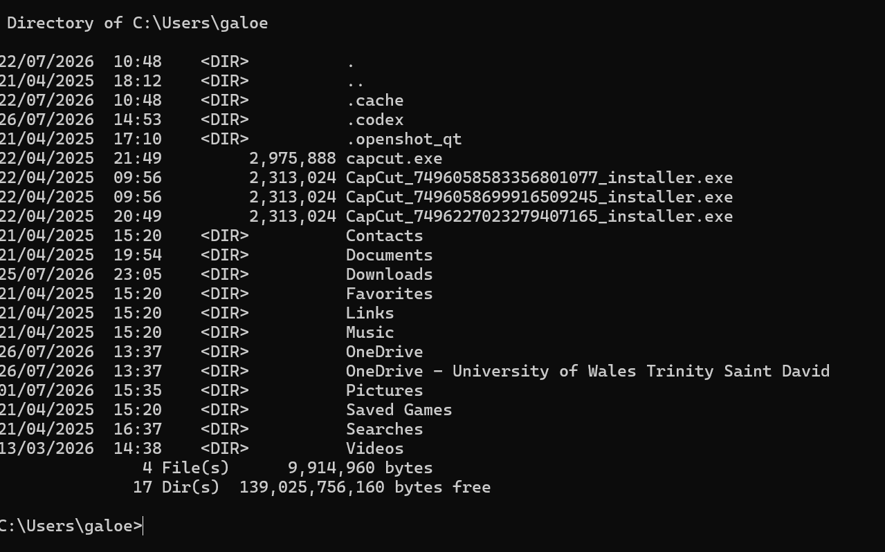
Figure 7: Using the DIR command to display files and directories in Windows.

2.4 mkdir
I used the mkdir command in Windows Command Prompt to create a new folder. I created a folder called OS_Assignment in my user directory. When I tried the command again, Windows displayed a message indicating that the folder already existed, confirming it had been created successfully. I also used the dir OS_Assignment command to check the folder. This activity helped me understand that folders can be created and checked directly from the command line without using File Explorer.
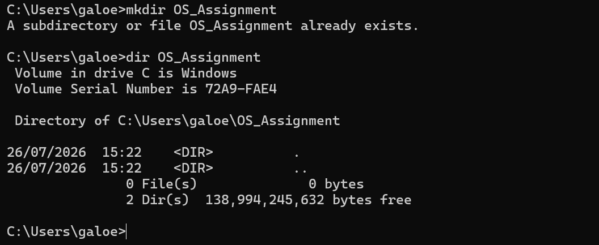
Figure 8: Using the mkdir command to create a new directory in Windows.

2.5 copy
I used the copy command in Windows Command Prompt to copy a file from one location to another. First, I created a simple text file called test.txt for this practical activity. I then used the command copy test.txt OS_Assignment to copy the file into the folder I had created earlier. The message “1 file(s) copied” confirmed that the command was successful. I found this command useful because it showed me how files can be copied and organised directly from the command line without using File Explorer.

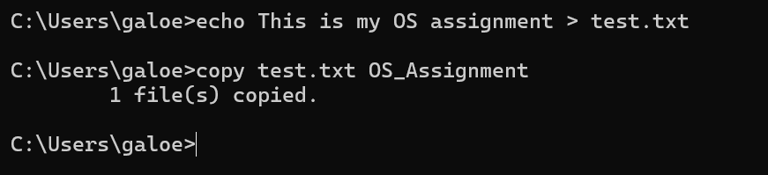
Figure 9: Using the copy command to copy a file into the OS_Assignment directory.

2.6 ipconfig
I used the ipconfig command in Windows Command Prompt to view the network configuration of my computer. The command displayed information about the different network adapters on the system. In my example, I could see that my Wi-Fi adapter was connected, and it showed information such as the IPv4 address, subnet mask and default gateway. Other network adapters were shown as disconnected. I found this command useful because it provides a quick way to check basic network information and can also help when identifying network connection problems.

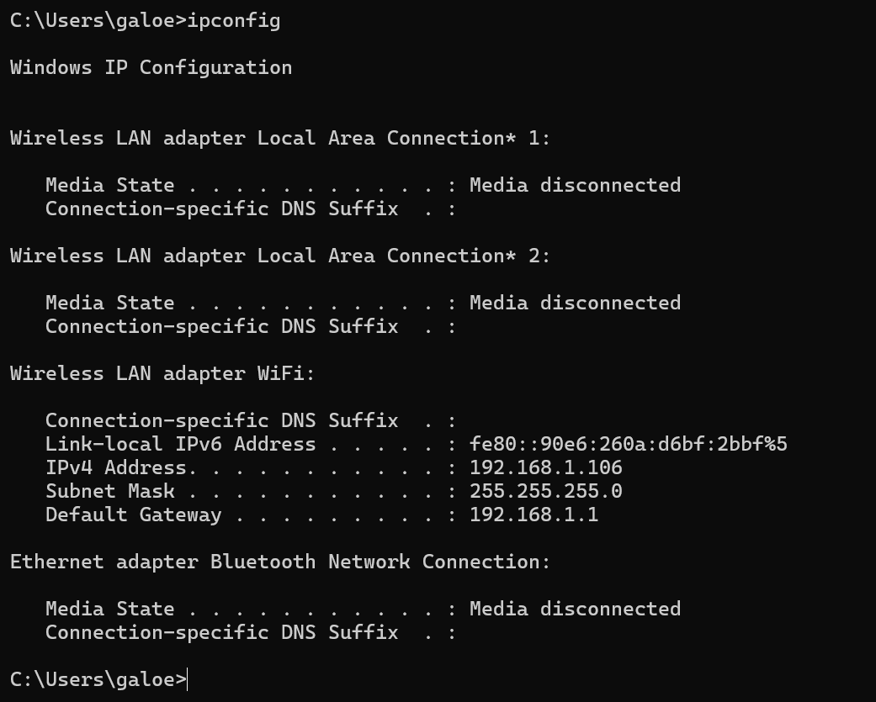
Figure 10: Using the ipconfig command to display the network configuration in Windows.

2.7 ping
I used the ping command to test the network connection between my computer and another server. In my practical example, I pinged google.com. The command sent four packets and received four replies, with 0% packet loss. It also showed the response time for each packet in milliseconds. This confirmed that my computer could communicate successfully with the Google server. I found this command useful because it can help check whether a network or Internet connection is working and can also help identify basic connectivity problems.
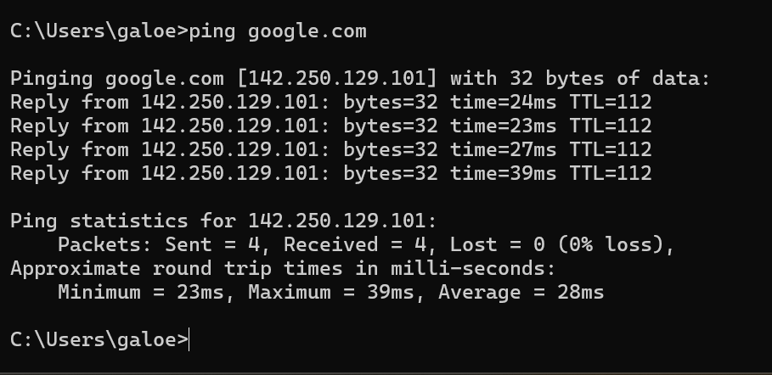

Figure 11: Using the ping command to test network connectivity with Google.

2.8 whoami
I used the whoami command in Windows Command Prompt to identify the user account that was currently logged into my computer. The command returned my computer's name followed by my username. This is a simple command, but I found it useful because it allows users to quickly check which account they are currently using. This can be especially helpful when a computer has different user accounts or when checking user permissions from the command line.

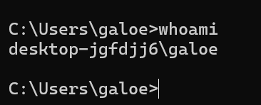
Figure 12: Using the whoami command to identify the current Windows user.

2.9 net user

I used the net user command in Windows Command Prompt to view the user accounts available on my computer. The command displayed a list of different accounts, including my own user account. At the end, Windows showed the message “The command completed successfully”, confirming that the command worked correctly. I found this command useful because it provides a simple way to view user accounts directly from the command line. It also helped me understand how Windows provides CLI tools for user management.

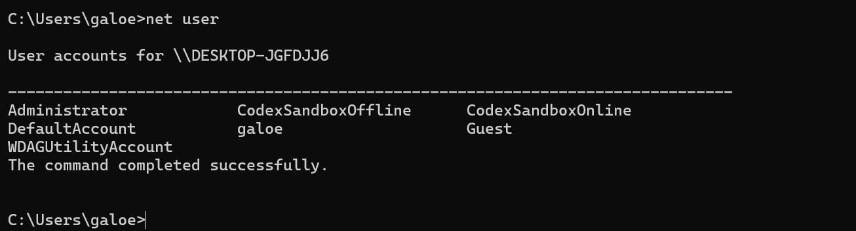
Figure 13: Using the net user command to display Windows user accounts.

2.10 schtasks

I used the schtasks command in Windows Command Prompt to view the tasks scheduled on my computer. The command displayed information such as the task name, the next run time and its status. In my example, I could see scheduled tasks for applications such as OneDrive and HP Support Assistant. Some of the tasks had the status “Ready”, meaning they were waiting to run at their scheduled time. This activity helped me understand how Windows can automatically run different tasks and how these tasks can be viewed directly from the command line. [5]

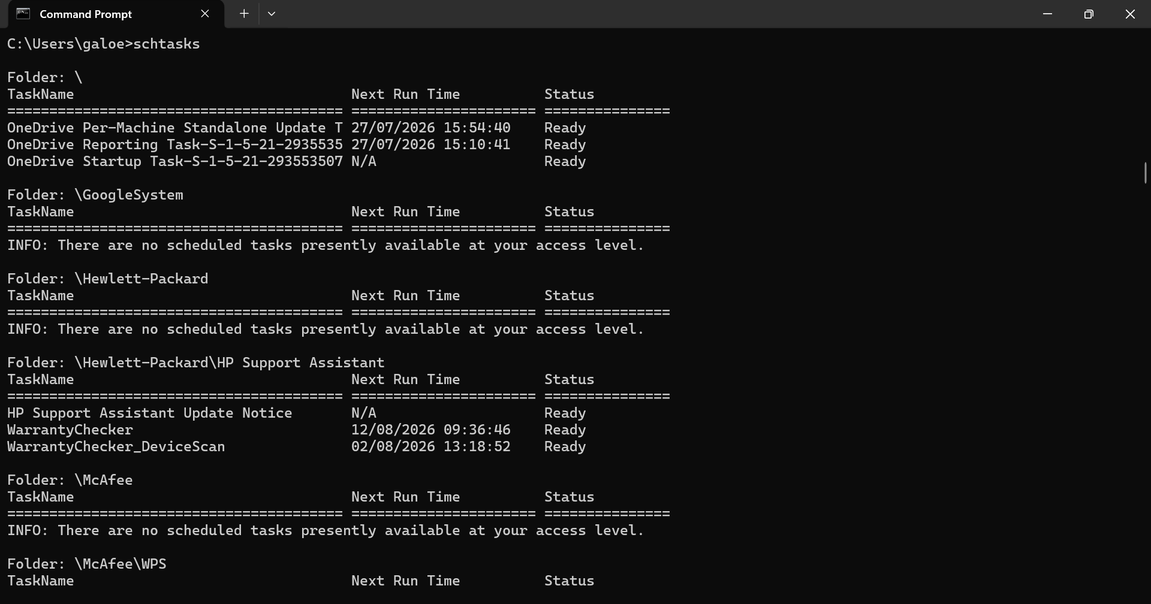
Figure 14: Using the schtasks command to display scheduled tasks in Windows.

3. Use of Linux OS CLI commands.

3.1 pwd
I used the pwd command in the Linux terminal to display my current working directory. The command showed that I was in my home directory, /home/galoe. I found this command useful because it helps users know their current location before creating, moving or managing files and folders. This practical activity helped me understand how Linux organises directories and how users can navigate the file system using the command line.
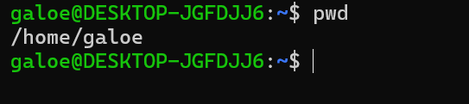
Figure 15: Using the pwd command to display the current working directory in Ubuntu.

3.2 ls
I used the ls command in the Linux terminal to display the files and folders in my current directory. At first, the directory was empty, so I created a folder called Linux_Assignment using the mkdir command. After running ls again, the new folder was displayed. This practical activity helped me understand that the ls command is used to view the contents of a directory and check whether files or folders exist.
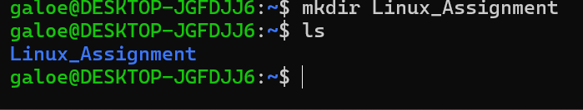
Figure 16: Using the ls command to display the contents of the current directory in Ubuntu.

3.3 mkdir
I used the mkdir command in the Linux terminal to create a new directory called Linux_Assignment. After creating the directory, I used the ls command to check that it had been created successfully. The new folder appeared in the directory, confirming that the command worked correctly. This practical activity helped me understand how to use the mkdir command to create new directories in Linux.
Figure 17: Using the mkdir command to create a new directory in Ubuntu.

3.4 cd
I used the cd command in the Linux terminal to change to the Linux_Assignment directory that I had created earlier. After changing directories, I used the pwd command to confirm my new location. The result showed /home/galoe/Linux_Assignment, confirming that I had successfully moved into the folder. This practical activity helped me understand how to use the cd command to navigate between directories in Linux.
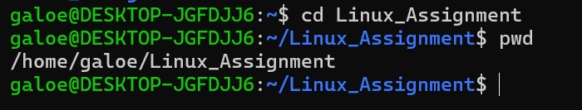
Figure 18: Using the cd command to change to the Linux_Assignment directory in Ubuntu.

3.5 touch
I used the touch command in the Linux terminal to create a new empty text file called notes.txt. After creating the file, I used the ls command to check that it had been created successfully. The file appeared in the directory, confirming that the command worked correctly. This practical activity helped me understand how to use the touch command to create new files in Linux.
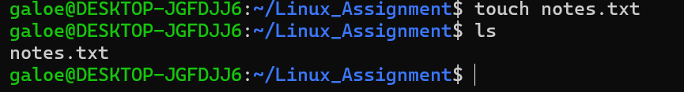
Figure 19: Using the touch command to create a new file in Ubuntu.

3.6 cp
I used the cp command in the Linux terminal to copy the file notes.txt. I named the new file notes_copy.txt. After running the ls command, both files were displayed in the directory, confirming that the copy was created successfully. This practical activity helped me understand how to use the cp command to duplicate files in Linux.

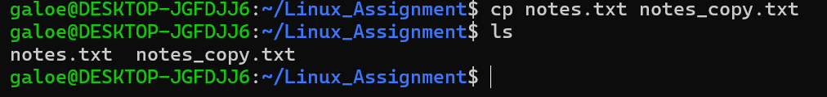
Figure 20: Using the cp command to copy a file in Ubuntu.

3.7 mv
I used the mv command in the Linux terminal to rename the file notes_copy.txt to notes_backup.txt. After running the ls command, the new filename appeared in the directory, confirming the command was successful. This practical activity helped me understand that the mv command can be used to rename or move files in Linux.
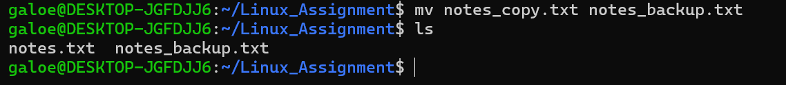
Figure 21: Using the mv command to rename a file in Ubuntu.

3.8 cat
I used the cat command in the Linux terminal to display the contents of a text file. Before using the command, I added the sentence "This is my Linux assignment." to the file notes.txt. After running cat notes.txt, the contents of notes.txt were displayed on the screen. This practical activity helped me understand how to use the cat command to read the contents of a file in Linux.

Figure 22: Using the cat command to display the contents of a text file in Ubuntu.

3.9 rm
I used the rm command in the Linux terminal to delete the file notes_backup.txt. After running the ls command, only notes.txt remained in the directory, confirming that the file had been removed successfully. This practical activity helped me understand how the rm command is used to delete files in Linux.

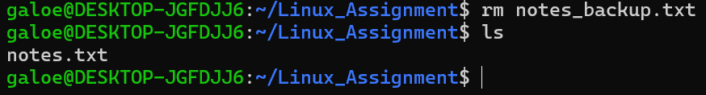
Figure 23: Using the rm command to delete a file in Ubuntu.

3.10 whoami
I used the whoami command in the Linux terminal to display the username of the current logged-in user. The command returned galoe, confirming the account that I was using in Ubuntu. I found this command useful because it allows users to quickly identify the active user account. This practical activity helped me understand how to display information about the current user in Linux through the command line. [6]

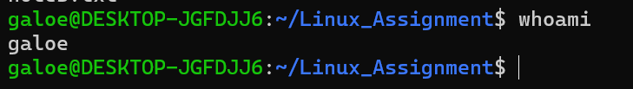
Figure 24: Using the whoami command to display the current user in Ubuntu.

4. Use of Windows OS scripts.

4.1 Simple Calculator Batch Script
I created a simple Batch script called Calculator.bat to perform basic mathematical calculations. The script asks the user to enter two numbers and choose an operation (+, -, * or /). It then uses variables to store the user input and if statements to perform the selected calculation. Finally, it displays the result on the screen. This practical activity helped me understand how Batch scripts can automate simple tasks using variables, user input and conditional statements. [7]

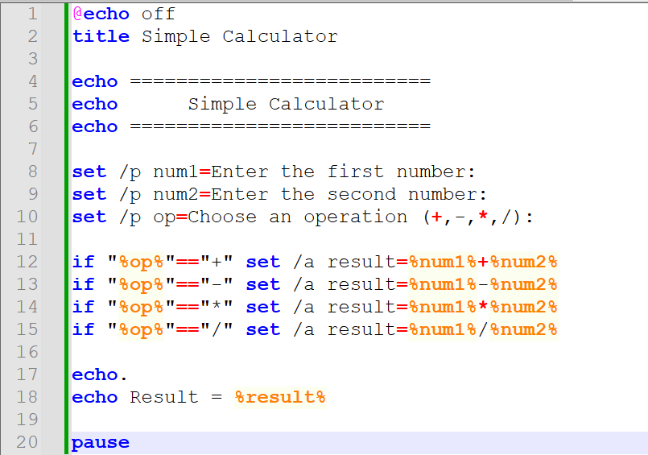
Figure 25: Batch script code for the Simple Calculator.

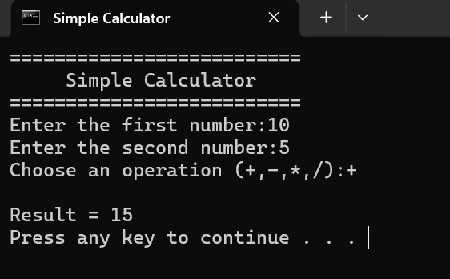
Figure 26: Running the Simple Calculator Batch script.

4.2 System Information Menu Batch Script
I created a Batch script called SystemMenu.bat to display a simple menu with different system information options. The script asks the user to choose an option using keyboard input. Depending on the selected option, it displays the current date, current time or the current Windows user. The script uses a variable, user input and conditional statements to control the menu and automate simple system tasks. This practical activity helped me understand how Batch scripts can interact with users and automate routine Windows command-line operations.

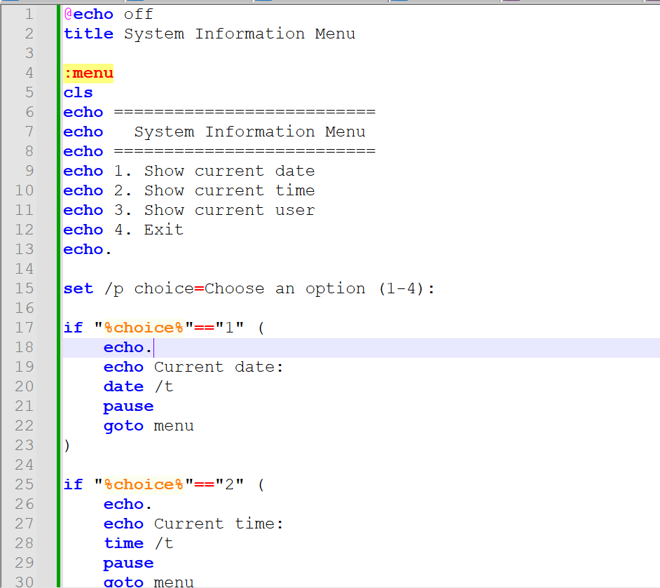
Figure 27: Batch script code for the System Information Menu.

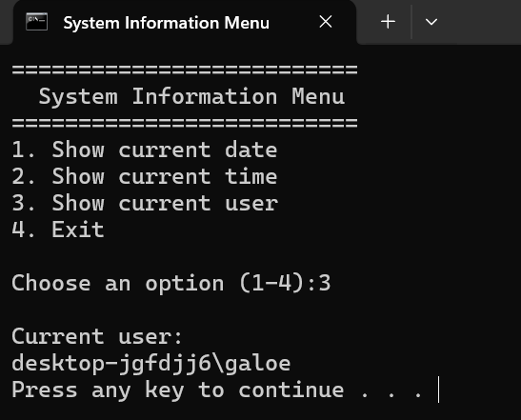
Figure 28: Running the System Information Menu Batch script.

5. Use of Linux OS scripts.

5.1 Simple Calculator Bash Script
I created a simple Bash script called calculator.sh to perform basic mathematical calculations in Linux. The script asks the user to enter two numbers and choose an operation (+, -, * or /). It uses variables to store the user input, arithmetic operations to calculate the result and a case statement to process the selected operation. Finally, it displays the result on the screen. This practical activity helped me understand how Bash scripts can automate simple tasks using variables, user input, arithmetic operations and conditional statements. [8]

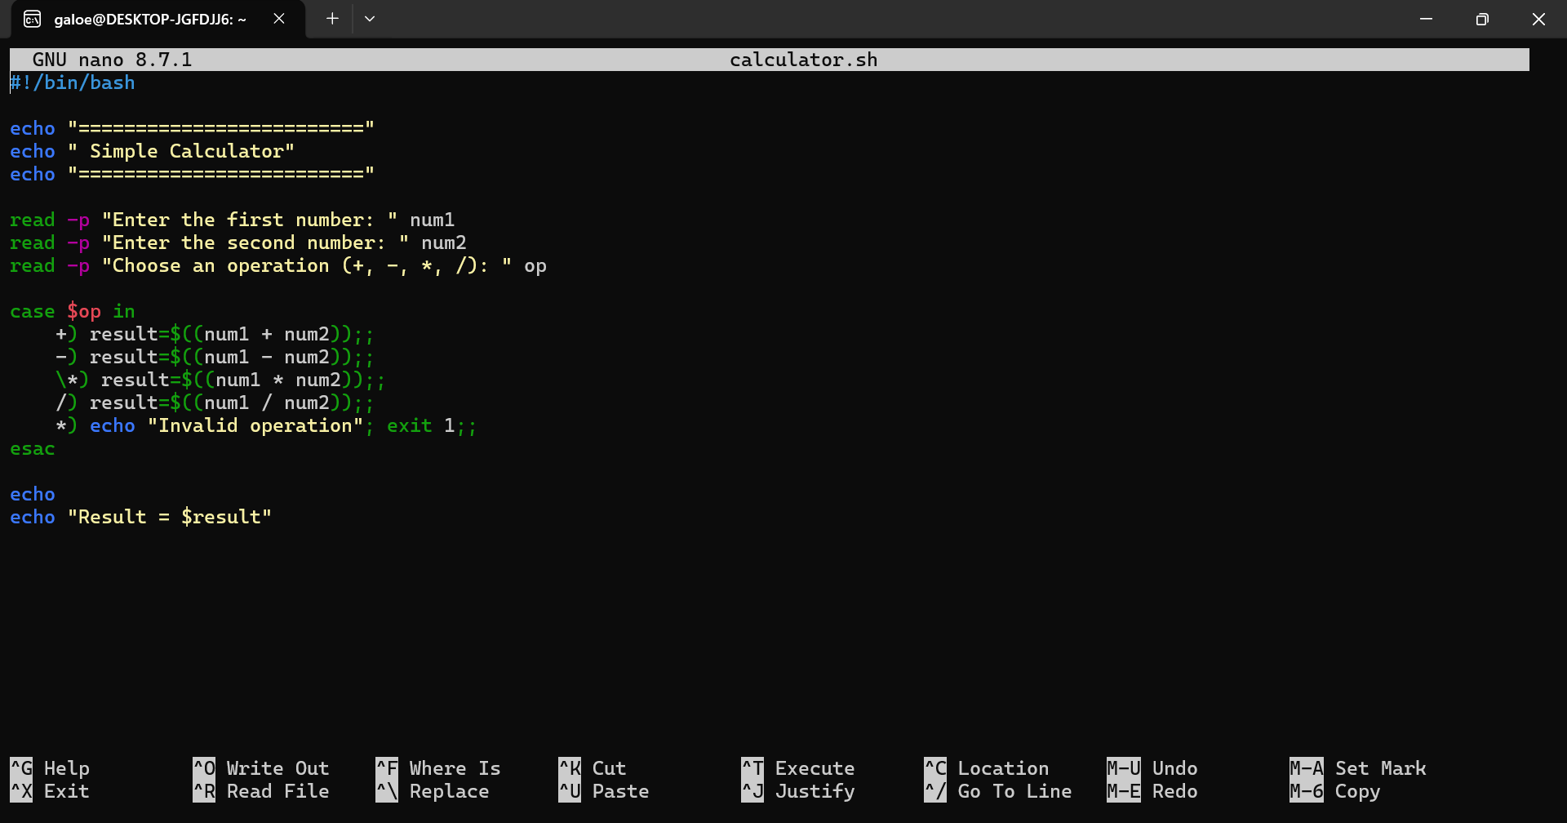
Figure 29: Bash script code for the Simple Calculator.
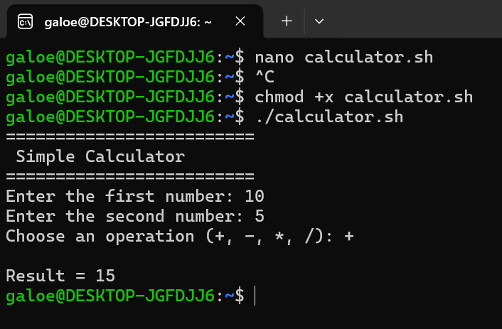
Figure 30: Running the Simple Calculator Bash script.

5.2 System Information Menu Bash Script
I created a Bash script called systemmenu.sh to display a simple menu with different system information options. The script asks the user to choose an option using keyboard input. It uses a while loop to keep the menu running until the user chooses to exit. A case statement processes each option and displays the current date, current time or the current user. This practical activity helped me understand how Bash scripts can automate routine tasks using variables, user input, loops and conditional statements.

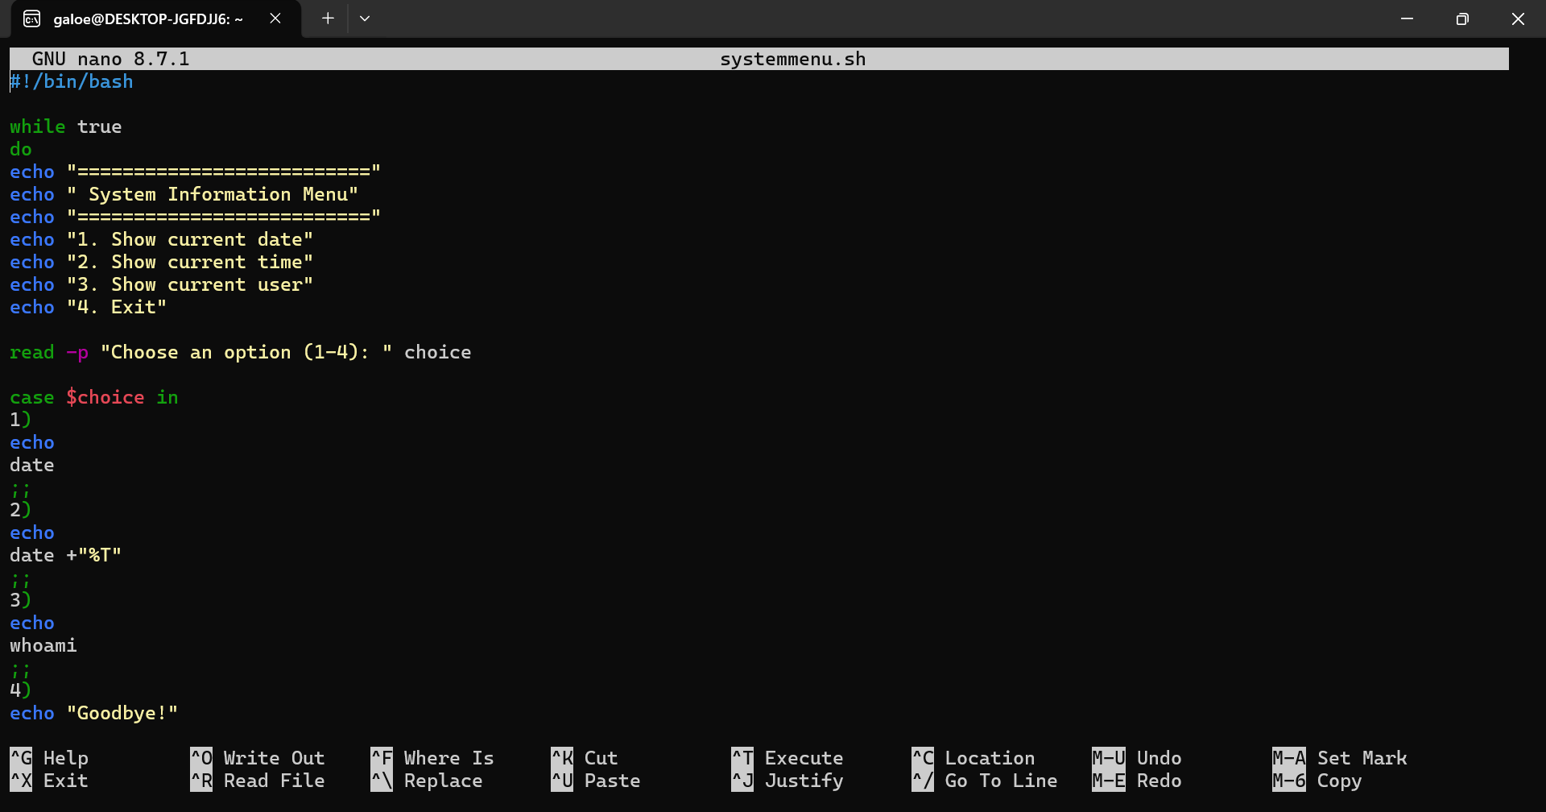
Figure 31: Bash script code for the System Information Menu.

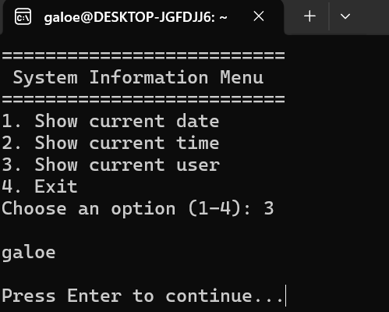
Figure 32: Running the System Information Menu Bash script.

Conclusion

In conclusion, this assignment helped me improve my understanding of how operating systems work and why they are important for managing computer resources. By completing the practical activities, I learned about the main functions of Windows and Linux, including process management, memory management, file system management, and security. I also gained experience using command-line commands in both operating systems and creating simple Batch and Bash scripts to automate basic tasks. These activities allowed me to apply both theoretical knowledge and practical skills. Overall, this assignment increased my confidence in using operating systems and showed me how command-line tools and scripting can be useful for everyday system administration tasks.

References
[1] R. Blum, Linux command line and shell scripting bible, John Wiley & Sons, 2008.
[2] P. K. Bhardwaj, How to Cheat at Windows System Administration using command line scripts, Elsevier, 2006.
[3] V. Dakic and J. Redzepagic,Linux Command Line and Shell Scripting Techniques: Master practical aspects of the Linux command line and then use it as a part of the shell scripting process, Packt Publishing Ltd, 2022.
[4] Æ Frisch, Windows 2000 Commands Pocket Reference, " O'Reilly Media, Inc.", 2001.
[5] C. Hosmer, J. Bartolomie and R. Pelli,Executing Windows Command Line Investigations: While Ensuring Evidentiary Integrity, Elsevier, 2016.
[6] T. Jaeger, Operating system security, Springer Nature, 2022.
[7] E. Abrossimov, M. Rozier and M. Shapiro, "Generic virtual memory management for operating system kernels", in Proceedings of the twelfth ACM symposium on Operating systems principles, pp. 123–136.
[8] B. Eager and A. Lister,Fundamentals of operating systems, Bloomsbury Publishing, 2016.

Appendices
Appendix A – Windows Batch Script Files
This appendix contains the Batch script files created for Task 4:
- Calculator.bat – Simple calculator using variables, user input and conditional statements.
- SystemMenu.bat – System information menu displaying the current date, time and user.
Appendix B – Linux Bash Script Files
This appendix contains the Bash script files created for Task 5:
- calculator.sh – Simple calculator using variables, user input, arithmetic operations and a case statement.
- systemmenu.sh – System information menu using a while loop and a case statement.
Appendix C – Practical Evidence
The practical activities completed in this assignment are supported by screenshots showing:
- Windows Task Manager.
- Windows Security.
- Windows File Explorer.
- Windows Command Prompt commands.
- Linux terminal commands.
- Windows Batch scripts.
- Linux Bash scripts.

