

Module Title: Managing Enterprise
Programme: Certificate of Higher Education in Employability Skills-LEVEL 4
Module code: BMSW4011
Module leader: Mel Squire
Student name: Paula Baruta(2326183)
Word count: 1500

Table of Contents
Task 1: Business Plan and Reflection 3
1. Business Plan 3
1.1 Introduction to the Business 3
1.2 Name of the Business with Type of Ownership 3
1.3 Mission Statement with Aim and Objectives 4
1.4 Location and Rationale 5
1.5 Human Resources 5
1.6 Marketing Activities 6
1.7 Market Research 7
1.8 Financial Resources 8
1.9 Threats to the Success 8
2. Reflection 9
2.1 Development of Business Skills and Knowledge 9
2.2 Evaluation of Entrepreneurial Strengths 9
2.3 Challenges Faced while Presenting the Business Plan 10
References 11

Task 1: Business Plan and Reflection

Business Plan

Introduction to the Business
A business plan presents a start-up of a business that offers a meal prep kit service. The business fulfils the needs of the individuals and also families who are considered health-conscious and desiring nutritious, delicious, and convenient options for their meal. However, they are not getting sufficient time due to their hectic schedules to prepare healthy meals for themselves. Therefore, the introduction of the service will be helpful to empower customers and provide them healthier choices without making sacrifices in their desired flavours. The business will also gain success in the growing healthy meal delivery industry and amongst the consumers.

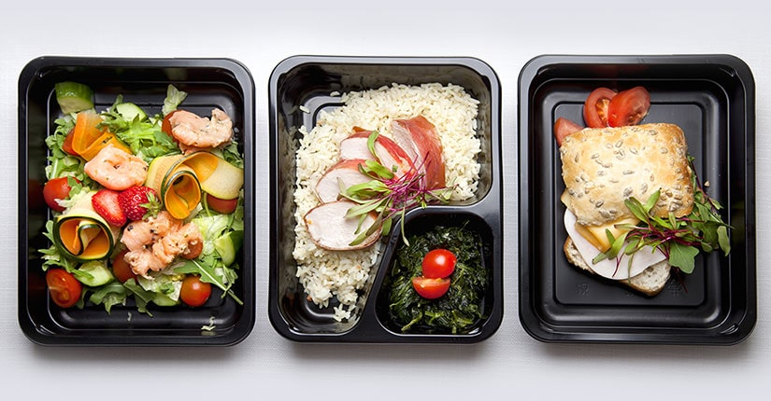
Source: (Peter and Dalla Vecchia, 2021)

Name of the Business with Type of Ownership
The suggested name for the start-up business for the provision of healthy meal prep kits will be “NutriQuick Kitchen”.
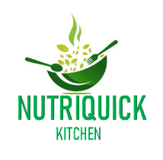
Source: (Self-Made)
The ownership will be sole trader. The pros seems in operating as sole trader to gain efficient set-up and management and quicker adaptation to the trends. The cons will be seen in facing challenges in assessing capital and burden of responsibilities in the peak times.

Mission Statement with Aim and Objectives
The mission statement of the business is
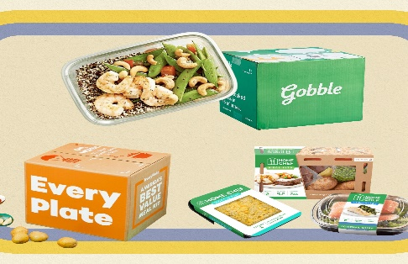
To become leader in offering healthy prep meal kits to the busy customers and make eating effortless and enjoyable.

The aim of the business is:
Source: (Eagle et al., 2020)
NutriQuick Kitchen empowers busy individuals and families to manage a healthier lifestyle with convenient and offering delicious meal prep kits without sacrificing their desired needs.
The business objectives are given as under:
- To ensure that the meals are prepared from 100% natural ingredients that offers customers greater nutrition options to support their health goals.
- To streamline the meal selection and efficiency in the delivery processes for gaining customer satisfaction.
- To educate people about healthy eating habits through promotion of the business that helps in increasing customer’s engagement.

Location and Rationale
In the start-up process, NutriQuick Kitchen will operate business as online and reach to the broad customer base using different online platforms.

Source: (Eagle et al., 2020)
The rational of selecting online business is reaching to the wider audience through social media apps. It will also be cost-effective business reducing the capital on rent and utilities.

Human Resources
NutriQuick Kitchen will need 5-10 people who can work for operations, marketing, and customer service management. The significant roles will be:
- Head Chef will prepare planning for meals and development of recipes.
- Nutritionist will ensure healthy standards in the meals.
- Marketing manager will work for promotion of the business.
- Customer service specialist will manage orders and feedbacks.
- Logistic In-charge will be responsible to deliver the orders to the customers.
The organisational chart is like:

Source: (Self-Made)

Marketing Activities
For the marketing activities, NutriQuick Kitchen needs implementation of several marketing and promotional measures for reaching the target audience. Social Media Campaigns are considered cornerstone for the strategy using the platform such as Facebook and Instagram to make increase in the business (Peter and Dalla Vecchia, 2021; Eagle et al., 2020). NutriQuick Kitchen will use social media marketing to manage targeted ads for highlighting the convenience and providing health benefits within the service. The marketing will help in reaching the customers who are actively seeking for the healthy food options with their eating solutions. Additionally, the implication of the digital marketing is helpful for the development of community engagement and building efficiency to the brand awareness.
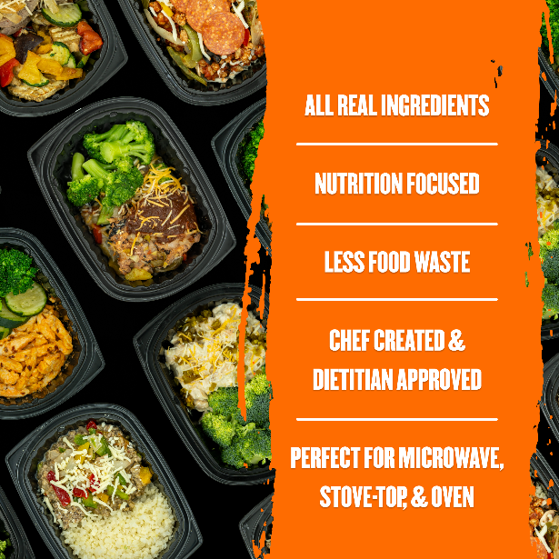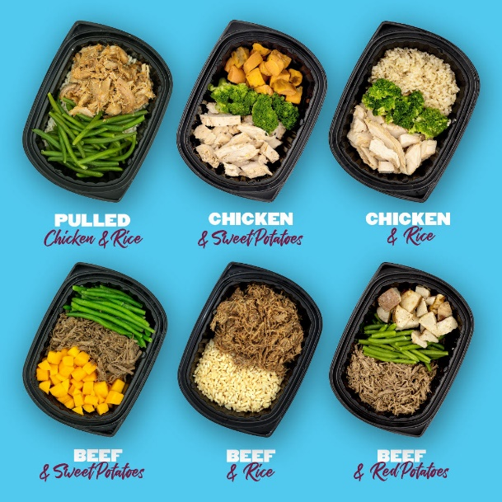
Source: (Peter and Dalla Vecchia, 2021)
Therefore, NutriQuick Kitchen will manage local events like healthy cooking workshops and related seminars to make direct connections with the health-conscious customers. The marketing managers will be responsible to promote services through distribution of flyers and brochures in different location and events that offers details on meal prep kits and also prices list that must be affordable in the beginning. Moreover, the business will leverage efficiency with influencer partnerships that defines collaboration with local health and wellness influencers for the promotion of the brand successfully. Park (2020) stated that the success is based on the collection of the authentic reviews and feedbacks from the values customers.

Market Research
The market research has been done by selecting social media platforms (Nabieva, 2021). The marketing manager posted some valuable content with polls for the customers who are willing and seeking for the nutritious prep meals at their doorsteps. The pages like Facebook and Instagram help marketing manager to learn about the dietary preferences of the people especially who are busy in their schedules. The findings from the market research shows that the product offerings and marketing strategies are allocated with each other for the success of the start-up business (Khan and Siddiqui, 2023). The business will focus on offering customizable meal kits according to the dietary needs of the customers like provision of vegetarian or gluten-free options that is conveyed through surveys on social media pages. Therefore, the data-driven approach is helpful to validate the business model and make demanding position of NutriQuick Kitchen in the health-conscious consumers’ market.

Financial Resources

Expected cash flow | Month 1-3 | Month 4-6 | Month 7-9 | Month 10-12
Cash In-flows | £5,000 | £7,000 | £8,000 | £10,000
Cash Outflows | £3,000 | £5,000 | £6,000 | £8,000
Net Cash flow | £2,000 | £2,000 | £2,000 | £2,000
Opening Cash Balances | £10,000 | £11,000 | £12,000 | £12,000
Closing Cash Balances | £15,000 | £15,000 | £16,000 | £16,000

Start-up costs | Cost (£)  Month 1-3 | Cost (£)  Month 4-6 | Cost (£)  Month 7-9 | Cost (£)  Month 10-12
Food ingredients and equipment | £ 10,000 | £10,000 | £12,000 | £15,000
Insurances and Charges | £ 5,000 | £5,000 | £5,000 | £5,000
License Fees | £ 2,000 | £2,000 | £2,000 | £2,000
Initial marketing costs before first sales begins | £ 2,000 | £2,000 | £2,500 | £3,000
Salaries and wages at the start-up phase | £ 10,000 | £10,000 | £12,000 | £15,000
Other expenses | £5,000 | £5,000 | £5,500 | £6,000
Overall start-up cost | £ 34,000 | £34,000 | £39,000 | £46,000

Threats to the Success
The biggest threat for NutriQuick Kitchen is intense competition in the market of healthy meal prep and delivery that has already been offered by some recognised brands. It will make difficulties to take a successful position in the existing market. For overcoming the challenge, the business needs focusing on the differentiation strategy with customisation and make enhancement in tastes and dietary to attract larger base of the target demographic (Hanaysha et al., 2021). There must be stronger customer engagement initiatives using social media and community events for building efficiency in the loyal customer base and encouragement to the word-of-mouth policies.

Reflection

Development of Business Skills and Knowledge
The learning and understanding of the start-up business of NutriQuick Kitchen has seen that I gained essential business skills and knowledge. I found that I learnt understanding of market research and related methodologies. It has allowed me to maintain effectiveness in the identification of the target demographics and analysis of the competitors. The knowledge gained is considered instrumental to shape the value proposition in the learning (Juska, 2021). I also learnt about tailoring the healthy meal prep kits for meeting the specific needs of busy individuals and also families who are not getting enough time to prepare their meals. Additionally, I have also developed understanding based on the financial projections that enhanced my analytical skills. It enables me to create realistic measures of cash flow forecasts and allocation of the budget to gain sustaining measures in the market. I also discovered the importance of clear communication to fulfil the mission and objectives of the business with implementation of efficiency business skills. I will apply SMART goals such as specific, measurable, achievable, relevant, and time-bound to achieve the goals in effective and efficient manners.

Evaluation of Entrepreneurial Strengths
Through presentation of the business plan based on the healthy meal prep kits to the customers, I have developed skills based on the entrepreneurial strengths. I have developed stronger commitment towards innovation and adaptability of the successful business measures in the existing markets. I also gained abilities to identify different market trends and consumer needs that are applied for staying competitive in the desired food industry. I found that the creativity allows has helped me in developing unique meal offerings for fulfilling the diverse dietary preferences of the customers. The greater organisational skills for the management of the logistics and operations efficiently (Hutt and Speh, 2021). However, I found that the strengths are complemented by working in a solid team and therefore, I committed to make a collaborative working environment for the encouragement of the input from all the concerned members.

Challenges Faced while Presenting the Business Plan
Despite of a lot of strengths that I gained by presenting a unique business plan, I also faced several challenges in taking the initiatives. Hunt et al. (2021) elaborated that the greater challenge is navigation of the competitive landscape based on the healthy meal prep services where the leading brands are already dominating the market share. To overcome the issue, I maintain my focus on efficiency towards customer engagement and satisfaction by the use of personalised services and community involvement measures. I also found that management of the operational abilities is a challenge for the provision of quality ingredients and insurance of the timely deliveries. Therefore, the stronger system for logistics and inventory management will be applied to make reduction in these types of emerging issues (Hofacker et al., 2020). I will also maintain financial stability in the initial months of operation that will be challenging for me to careful monitor the cash flow and expenses. It will ensure the sustainability until the achievement of the profitability.

References
Eagle, L., Czarnecka, B., Dahl, S. and Lloyd, J., 2020. Marketing communications. Routledge.
Hanaysha, J.R., Al Shaikh, M.E. and Alzoubi, H.M., 2021. Importance of marketing mix elements in determining consumer purchase decision in the retail market. International Journal of Service Science, Management, Engineering, and Technology (IJSSMET), 12(6), pp.56-72.
Hofacker, C., Golgeci, I., Pillai, K.G. and Gligor, D.M., 2020. Digital marketing and business-to-business relationships: a close look at the interface and a roadmap for the future. European Journal of Marketing, 54(6), pp.1161-1179.
Hunt, C.S., Mello, J.E. and Deitz, G.D., 2021. Marketing. McGraw-Hill.
Hutt, M.D. and Speh, T.W., 2021. Business marketing management: B2B. South-Western, Cengage Learning.
Juska, J.M., 2021. Integrated marketing communication: advertising and promotion in a digital world. Routledge.
Khan, F. and Siddiqui, K., 2023. The importance of digital marketing. An exploratory study to find the perception and effectiveness of digital marketing amongst the marketing professionals in Pakistan.
Nabieva, N.M., 2021. DIGITAL MARKETING: CURRENT TRENDS IN DEVELOPMENT. Theoretical & Applied Science, (2), pp.333-340.
Park, S., 2020. Marketing management (Vol. 3). Seohee Academy.
Peter, M.K. and Dalla Vecchia, M., 2021. The digital marketing toolkit: a literature review for the identification of digital marketing channels and platforms. New trends in business information systems and technology: Digital innovation and digital business transformation, pp.251-265.

