Effective Teamwork and Communication

Teamwork reflective report – BMSW4009
Sophie Jenkins - 2440056
2025

Contents

Introduction | 1
Key Components of Effective Teamwork | 1
My Natural Role within Teams | 1-2
Relationships and Communication | 2
Models and Theories that Helped me | 2-3
How I Applied My Learning | 3
Conclusion | 4
Reference Page | 5

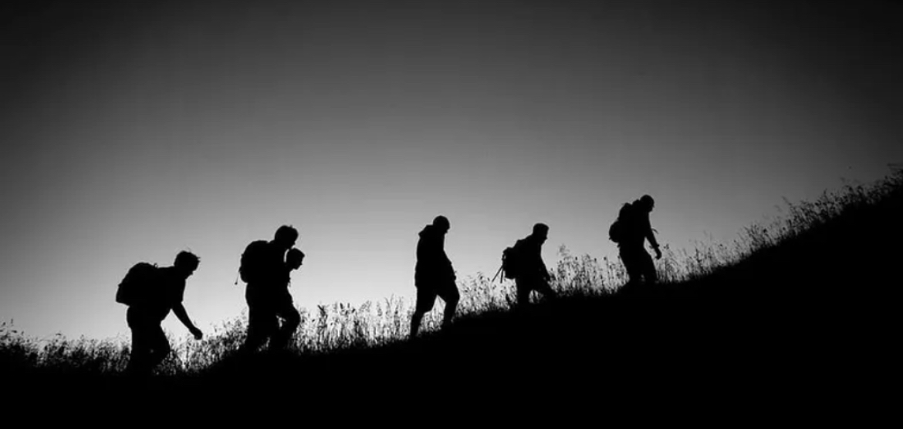
Teamwork Reflective Report

Introduction
Effective teamwork is essential in academic and professional environments, as it allows individuals to combine strengths, share responsibilities, and achieve goals. Research suggests that successful teams depend on clear communication, trust, defined roles, and effective conflict management (Marks, Mathieu & Zaccaro, 2001). Teamwork also relies on interpersonal relationships and coordinated effort, which influence group performance (Salas, Goodwin & Burke, 2009). I have worked within a
group to research together and complete tasks. This report reflects my natural behaviour within teams, supported by the Belbin Self-Perception Inventory (SPI) and the Thomas-Kilmann Conflict Mode questionnaire. I will also discuss relevant theories looked at in the module and evaluate how I put them into practice to improve. Finally, I will explore strategies to support my future development as an effective team member.

Key Components of Effective Teamwork
I have learned that several components are very much needed for successful teamwork. Firstly, clear shared goals to help ensure every member understands the task and expected outcomes. Secondly, defined roles support accountability and prevent duplication (Belbin, 1993). When roles are unclear, confusion can slow progress. Thirdly, open and respectful communication encourages members to share ideas, ask questions, and raise concerns without fear of judgment (Johnson, 2021). Finally, constructive conflict management is important. Conflict is natural, but when handled appropriately, it can increase creativity and improve decision-making (Thomas & Kilmann, 1974). I found that when these components were present in my group, it would increase the effectiveness of communication and our workflow improved, and we achieved better outcomes in less time.

My Natural Role within Teams
I recognise that I am naturally laid back a reflector, I prefer to be guided, supportive and good at listening. I will always give my opinion. In the early stages of discussions, I often waited to hear other people’s ideas before sharing my own. I am a little anxious about new environments. I then become more comfortable, I prefer to work quietly in the background, ensuring tasks are really looked at and are finished to the best standard possible.
My Belbin SPI results supported this reflection. I identified strongly with the Team worker role, which focuses on building relationships, mediating differences, and maintaining harmony within the group (Belbin, 2010). I also demonstrated characteristics of a complete finisher, taking responsibility for checking work, noticing details, and meeting deadlines. These strengths meant I contributed to a calm working environment, taking the initiative to organise meetups and team activities.
However, I scored lower in roles such as shaper. This reinforces my tendency to take a back seat, especially when the group is still negotiating roles. My Thomas Kilmann questionnaire highlighted accommodating and avoiding styles. Through this module, I have recognised that a degree of assertiveness can really improve teamwork.
Findings
Relationships and Communication
Throughout the module, I realised that when team members feel listened to and respected, this improves relationships and improves performance as they engage more actively. Communication also became easier when our roles were clear. As a laid-back team member, I appreciated it when others vocally took the lead and would outline tasks. This guidance helped me understand what was expected and allowed me to focus on completing my responsibilities to the best of my ability. (Mullins & Christy, 2016).
Models and Theories that Helped Me

Tuckman’s Team Development Theory
Tuckman (1965) suggested that teams progress through the Forming, Storming, Norming, and Performing stages. I observed these stages clearly within my group:
- Forming: We were polite and cautious, learning about each other’s strengths.
- Storming: Minor disagreements emerged about workload distribution.
- Norming: We agreed on communication channels and meeting times.
- Performing: We worked efficiently towards deadlines.
Understanding this theory helped me realise conflict isn't always bad, it can be resolved, it is normal and will happen. As a result, I was less likely to shy away from disagreements and became more engaged. I suggested we allocate tasks fairly and use each member’s strengths, helping move us towards the Norming stage.

Transactional Analysis – Parent-Adult-Child (PAC)
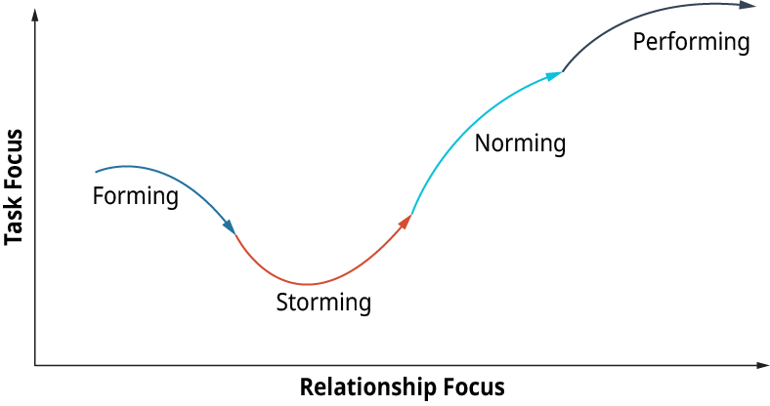

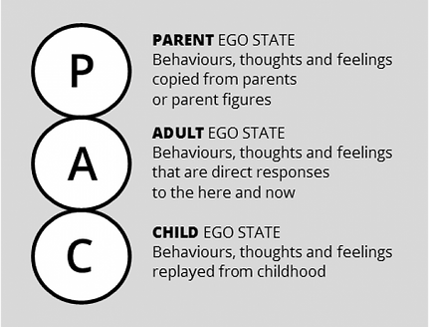
The PAC model explains how communication can shift between:
- Parent (controlling/nurturing),
- Adult (logical),
- Child (emotional/reactive).
In my group, I mostly communicated from the adult ego-state, concentrating on practical aspects and decisions. However, at times, I could see others slipping into Parent roles when directing tasks. Recognising this helped me stay calm and respond correctly. It also helped me identify when Child-like reactions (frustration or withdrawal) would emerge, particularly when deadlines were tight.
This model helped me manage my reactions and not take comments personally when in certain environments. (Berne,1964).
Thomas-Kilmann Conflict Mode Instrument

At first, I was heavily avoiding and accommodating. I then realised that I wouldn't get heard and that my opinions could and would be overlooked, and if deadlines weren't met or were I hadn't had any input. Later, while doing different research tasks, and working together, I attempted to shift toward a more vocal and collaborative style by openly suggesting different approaches while listening and respecting others’ views.
For example, during our presentation planning, members couldn't agree with slide distribution as some members were more present than others. Instead of sitting out on the discussion, I calmly suggested dividing sections based on our knowledge strengths and our comfort level, which we then all appreciated. This experience helped strengthen my confidence in positive engagement
How I have Applied my Learning
Looking at what we as a team and individually were taught, then putting this into practice allowed me to improve as a team member. I vocally contributed ideas earlier in discussions to not always sit on the fence and remain invisible. Also, I initiated short meet-ups in the library and online check-ins with the present team members and ones who could do so to maintain communication outside of class to help us all know what is expected and to prevent delays. Working within this group, a new team with different roles has made me see that I am not always that laid back, I am reliable, and I like to get things done that have been set, even when the whole team doesn't

Conclusion
This module has taught me new ways to look at things while working in a team or a group. We achieve more together, and we are shaped by our surroundings. Teamwork relies on trust, communication, managing any disagreements that have arisen, and finding a middle ground. I learned that I naturally adopt a supportive role and remain calm under pressure. (Heffernan,2019; Stadler, 2019).

Future Actions
I plan in the future to maintain a voice in group and team exercises or tasks, to use an approach that helps manage any disagreements, shift away from avoidance, and share my ideas with the group.

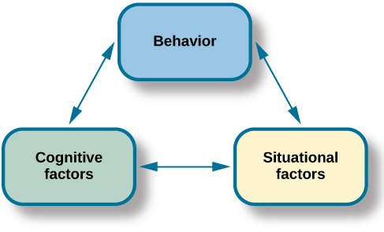

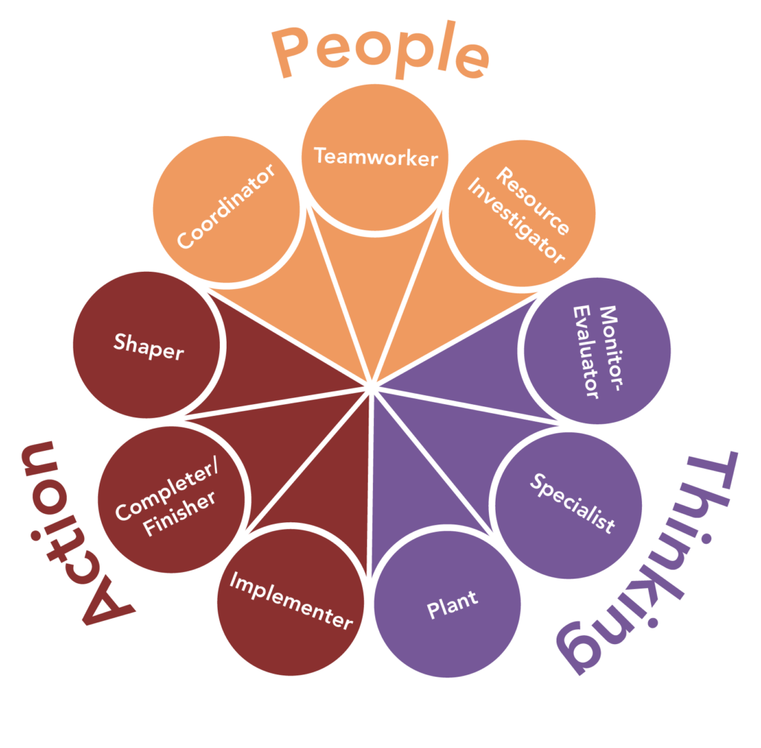

Reference List

Belbin, R. (1993) Team Roles at Work. Oxford: Butterworth-Heinemann.
Johnson, S. (2021) ‘The Science of Teamwork’.
Marks, M., Mathieu, J. & Zaccaro, S. (2001) ‘Team Effectiveness: A Review’.
Salas, E., Goodwin, G. & Burke, C. (2009) Team Effectiveness in Complex Environments.
Thomas, K. & Kilmann, R. (1974) Thomas-Kilmann Conflict Mode Instrument
Belbin,R.M. (2010) Team Roles at Work. 2nd edn. Oxford: Butterworth-Heinemann.
Mullins, L.J. and Christy, G. (2016). Management and organisational behavior. 11th edn. Harlow: Person
Berne,E.(1964) Games People Play: The Psychology of Human Relationships.New York: Grove Press.
Heffernan,M. (2019) Wilful Blindness. London: Simon & Schuster.
Stadler, S. (2019). Conflict, Culture and Communication. Milton; Routledge.

I acknowledge the use of my mobile Siri app to help with word grammar. I can confirm that I have not presented any AI generated text as my own work. I can confirm that I have copies of my drafts, notes, and other resources I used before and after the use of this.

Word count -1100

