
Building Survey
Digital Surveying and highway design
July 23, 2026
Isobel Baldwin-Pritchard (2502740)
UWTSD

Contents
Introduction / Brief 2
Part 1: Planning the Survey 3
Purpose of the Survey 3
Survey Area Definition 3
Site Assessment 3
Risk Assessment Summary 4
Part 2: Practical 5
Part 3: Measurement and Analysis 6
Manual Measurements 6
Software / Electronical measurement 7
Comparison 8

Introduction / Brief
You are to complete a structured digital building survey project in three parts. The focus is on real-world application of digital technologies, in particular 3D laser scanning. This will involve planning a professional survey, carrying it out on site, and interpreting processed point cloud data to extract accurate building measurements.

Part 1: Planning the Survey

Purpose of the Survey
We are conducting an internal measured survey of the first floor of the IQ Building at the University of Wales Trinity Saint David. The purpose of this survey is to verify and review the existing measurements of the first-floor area ensuring that an accurate and up-to-date record of the building is obtained. The survey will capture the internal arrangement of the floor, including room layouts, circulation areas, door and window openings, structural elements such as columns and walls, staircases and other permanent architectural features. The resulting information will be used to validate the existing floor plan and provide reliable dimensional data for future design, planning and facilities management purposes.

Survey Area Definition
The survey was undertaken within the open communal areas of the first floor of the University of Wales Trinity Saint David's IQ Building. All accessible spaces within the defined survey extent were measured and recorded to produce an accurate representation of the existing layout.
The survey included door and window openings, staircases, structural walls and pillars, furniture and the pedestrian bridge connecting the internal spaces.
The information collected during the survey has been incorporated into the floor plan drawings, providing a comprehensive and accurate record of the first-floor layout. The completed drawings are intended to support future design work, space planning and any subsequent refurbishment or maintenance projects requiring reliable existing building information.

Site Assessment
During the survey, the scanner was positioned centrally within each section of the first floor to maximise coverage and ensure sufficient overlap between individual scan locations. This approach enabled the capture of a comprehensive point while minimising the number of scan positions required and reducing the likelihood of data shadows caused by obstructions.
The survey was carried out under a combination of natural daylight and the building's LED lighting system, providing consistent illumination throughout the survey area. The lighting conditions were suitable for the successful capture of the internal environment and allowed all l features to be clearly recorded.
The first floor primarily consists of an open communal space with a limited amount of furniture, including tables and seating areas. Prior to each scan, the surrounding area was checked to ensure it was free from unnecessary obstructions and potential trip hazards. The scanner was set up on a stable, level surface, with the tripod legs fully extended and securely locked to prevent movement or the equipment from falling during data capture. The survey team also ensured that equipment did not obstruct pedestrian routes and remained vigilant for any members of staff or students entering the area while the survey was in progress. This helped maintain a safe working environment while ensuring the quality and accuracy of the survey data collected.

Risk Assessment Summary
Risk 1: Environmental Working Conditions (High Temperatures)
Risk: During the planned survey works, exceptionally high temperatures in excess of 30°C created an unsuitable working environment within the original survey area. Prolonged exposure to elevated temperatures could have resulted in heat stress, dehydration, fatigue and reduced concentration
Likelihood: This is a 50/50 chance of happening due to the climate change and location of place the survey is taking place
Mitigation: To minimise the risks associated with the extreme weather conditions, the survey location was relocated to a newer university building with improved environmental controls and cooler internal temperatures. This ensured the wellbeing of both the surveying team and university staff and students while allowing the survey to be completed safely.
Risk 2: Asbestos
Risk: Disturbance of asbestos-containing materials (ACMs) can present significant health risks during building surveys, particularly within older properties.
Likelihood: Low to zero as already stated that this building was built in 2018 and asbestos stopped in 1999
Mitigation: The survey was undertaken within a building completed in 2018. As the use of asbestos-containing materials was prohibited in the UK from 1999, there is no foreseeable risk of asbestos exposure within the survey area. No intrusive works were undertaken during the survey.
Risk 3: Live Services
Risk: Existing live electrical, mechanical and communication services may present hazards if their locations are unknown or if survey activities interfere with them.
Likelihood: It is very likely for live services to be present in building so using the right protocol will stop any harm
Mitigation: Existing as-built drawings and available building information were reviewed prior to the survey to identify the location of known services. The survey was carried out non-intrusively, ensuring that no live services were disturbed. Any visible service routes were noted during the survey to assist with future reference.
Risk 4: Working at Height
Risk: Surveying elevated features, such as high-level ceilings or structural elements, may expose surveyors to the risks associated with working at height.
Likelihood: working at high is a 50/50 chance depends what you are surveying and having the right PPE/ Equipment will stop anything going wrong
Mitigation: Wherever possible, all measurements were obtained from ground level using laser measuring equipment and remote surveying instruments. Where higher-level features required recording, appropriate surveying equipment and accessories were used to eliminate or minimise the need for working at height. No unnecessary access equipment was used.
Risk 5: Working Around Members of the Public and Building Occupants
Risk: Carrying out survey works in occupied buildings may create hazards for surveyors, staff, students and visitors through interaction with surveying equipment and movement around the site.
Likelihood: very likelihood to happen as it is a public university
Mitigation: The survey was scheduled to take place when the building was closed or experiencing minimal occupancy. This reduced the potential for disruption and significantly lowered the risk of accidental contact between members of the public and the surveying team or equipment.
Risk 6: Slips, Trips and Falls
Risk: Surveying activities may introduce trip hazards through the use of equipment, movement around the building and manual measuring methods.
Likelihood: unlikely as such minimal equipment is being used
Mitigation: The survey was primarily undertaken using laser scanning and electronic surveying equipment, reducing the need for manual tape measurements and limiting the amount of equipment placed across walkways. Surveyors maintained good housekeeping throughout the works, keeping equipment organised and ensuring access routes remained clear to minimise the risk of slips, trips and falls.

Part 2: Practical
On the Thursday 25th June we took part in a real on-site laser scan survey using a Leica RTC360 laser scanner and a manual measured survey using a Leica DISTO and a tape measure to carry out the works for the University Of Wales Trinity Saint David IQ First Floor. The exercise provided practical experience in collecting accurate existing building data using a combination of modern digital surveying techniques and traditional manual measurement methods this is a useful comparison to use to ensure accurate findings and determining definite dimensions
The primary objective of the survey was to capture the internal layout of the first floor and measure the dimensions of the existing floor plan. Throughout the survey measurements were taken by a tape measure and a Lecia Disto which provides a fast and highly accurate electronic distance measurements but also includes volume, area and distance for this particular detention survey I was focused on area and distance the Lecia Disto was particularly useful across larger spaces and areas that were more difficult to access this also assisted with much safer actions in obtaining dimensions
Throughout the survey, all observations and measurements were recorded thoroughly to ensure no areas were ignored. The first floor consisted mainly of an open communal space with corridor accessing learning rooms.
The data collected during the survey will be processed to produce an accurate set of measured floor plans and provide a reliable recording for the layout. This practical exercise demonstrated the importance of how accurate survey planning really is.

Part 3: Measurement and Analysis

Manual Measurements
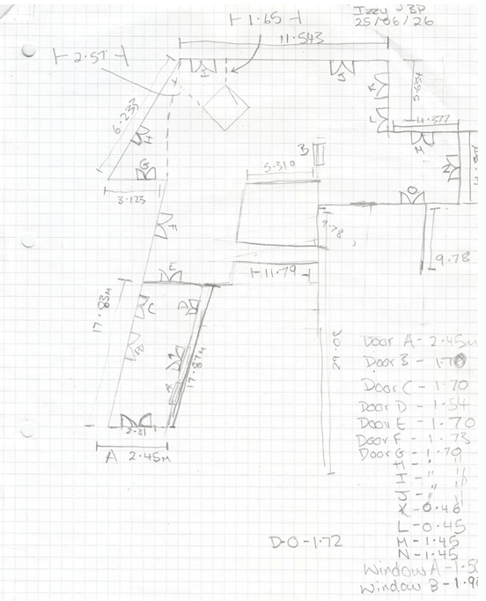
The manual measurements were completed using a combination of a tape measure which is used to find length, width and distance and a handheld Leica Disto laser scanner which is used quickly and accurately measure lengths, areas and volumes.

Software / Electronical measurement
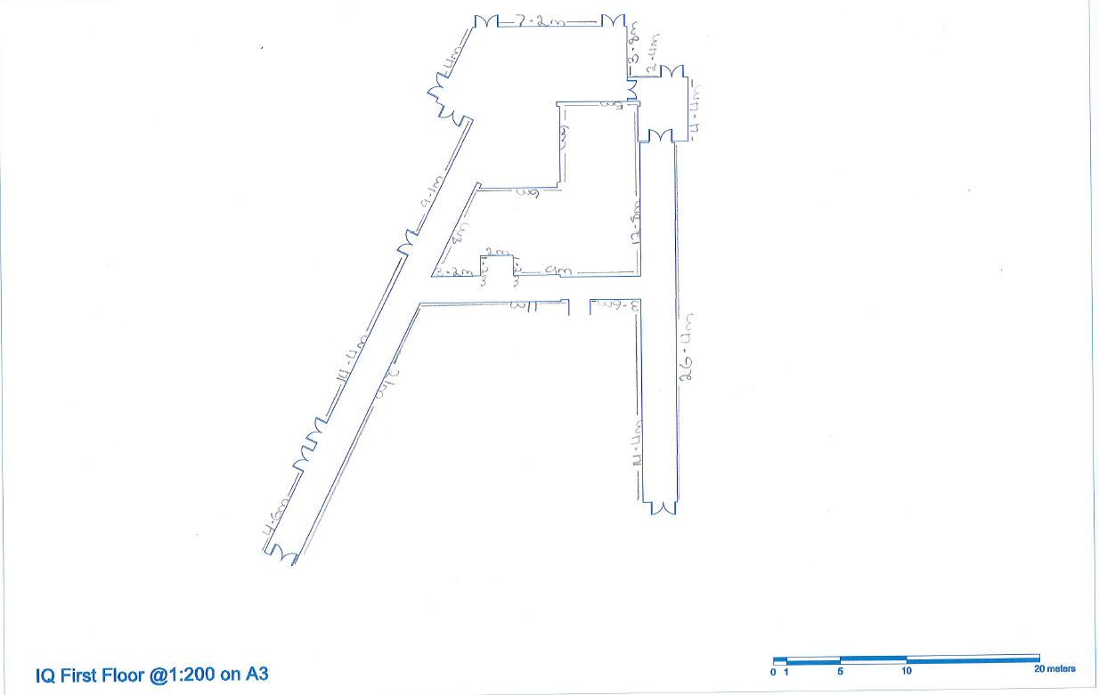
The software-based measurements were obtained using a Leica RTC360 laser scanner. The RTC360 captured a complete 360-degree scan of the first-floor area recording millions of data points to create an accurate digital representation of the building. These scans were processed into a three-dimensional point cloud providing a highly detailed electronic model of the surveyed space. Using specialist software measurements could then be extracted directly from the digital model allowing dimensions to be taken accurately without the need to revisit the site

Comparison
 | Software Measurement | Manual Measurement
Speed | Fast, once the data has been taken the floor plan gets automatically scaled and measuring is quicker due to the software doing it itself | Slower, requires drawings the floor and finding the correct scale and also measuring with pencil and ruler takes longer as you can to draw and write
Accuracy | High, correct scale and dimensions are calculated digitally. | Medium, depends on operator skill, tape measure accuracy and sketch quality. Errors can occur from missed measurements or transcription mistakes.
Completeness | High, as it includes overall building outline, wall geometry, scale bar and nearly all dimensions in a clean layout. | Medium, Contains room measurements, door widths and some wall lengths but not every wall or angle is fully defined. More analysis is required.
Consistency | All measurements follow the same coordinate system and scale | May have small inconsistence due to it being a freehand drawings and manual measuring
Presentation | Using software has a neat and tidy style to it make it look professional and presentable | Manual it can be helpful to make notes when measuring but will be needed to be redrawn if being used for meeting / clients
Risk for error | Low as once measurements have been put it the data is automatically saved | High due to human error, omitted measurements and incorrect drawing position
Cost | High, Equipment may cost £20,000–£50,000 but the survey / measuring takes about 30–60 minutes with the detailed measurements extracted later using software. | Low, equipment cost under £100 but the survey / measuring may take 4–6 hours on site with two surveyors.
Health & Safety | Low risk, Using software measuring such as a Lecia Disto and a Lecia RTC360 is it eliminates the need to climb ladders, stretch across hazards or rely on a partner. | High risk, because it heavily relies on human judgment and execution meaning putting yourself at risk by climbing hight, stretching across to the right point and putting someone else at risk if it is a 2-person job

