Amy Drewett – 2009939 – ECIE6002

Moving away from the traditional classroom: The silent digital revolution in education

Contents

Blog #1

Blog #2

Blog #3

Blog #4

Digital Dinosaur or Digital Diva?
Blog #1

#digitalera #timesarechanging #whatdoweneedineducation
How many of us shout for help from the younger generation when using technology? Leaving some of us feeling like dinosaurs, but what does the digital era mean? Should we all be learning more about it?

Digital competence is no longer a luxury; it is an essential skill that everyone should possess in today's digital age. The rapid advancement of technology has transformed the way we live, work, and communicate. From online banking to remote learning, digital skills have become indispensable for navigating our modern world.
(Alamy Limited 2023)

‘22% of Adults are without the essential digital skills needed for everyday life’ (Williams 2020)

Being digitally competent enhances communication and connectivity. With the rise of social media platforms and instant messaging apps, staying connected with friends and family has never been easier. Ask yourself, how many times do you check social media throughout the day? Can you honestly say not very much?
Author ‘Can you confirm the email address that you sent that document?’
Deputy Head ‘I sent it via post it should be there in the next few days’.
Author ‘Sorry, I didn’t even consider it could have gone by post’.
Digital literacy enables individuals to effectively navigate these platforms while ensuring their privacy and security online. Digital competence empowers individuals to be informed citizens in the digital era. With the abundance of information available on the internet, it is crucial to have the skills to critically evaluate sources for accuracy and reliability. Being digitally competent allows individuals to access diverse perspectives on global issues and engage in meaningful discussions (Cartelli 2012). It also allows individuals to catch up on everyday gossip and celebrity news. We must ask ourselves though, is everything too readily available and what are the negative effects of the dawn of the digital era?
The Digital Competence Framework Wales is a comprehensive tool developed by the Welsh government to equip individuals with the skills and knowledge to thrive in the digital age. What does this mean exactly? The framework recognises that digital, competence is not just about knowing how to use technology, but also about understanding its impact on society and being able to critically evaluate and navigate the digital world. How many times have you read a source and it turns out to be unreliable?
What led to the implementation of this framework?
Children and young people identified that the current curriculum was out of date for the digital era. With representatives from businesses enormously troubled that education environments were out of touch with the evolving digital workplace (Donaldson 2015a).

The framework is divided into three main areas: citizenship, creativity, and data and computational thinking.
- Citizenship focuses on developing responsible digital citizens who are aware of their rights and responsibilities online.
- Creativity encourages individuals to use digital tools for innovation, expression, and collaboration.
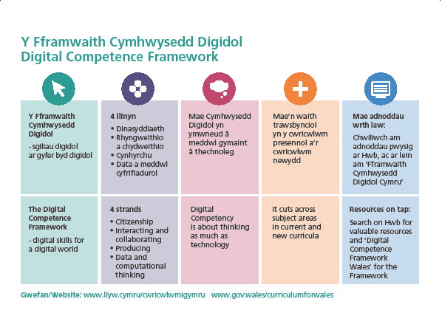
- Data and computational thinking emphasise problem-solving skills using data analysis and algorithmic thinking.
By implementing this framework in schools, colleges, and other educational institutions across Wales, the government aims to ensure that every individual has equal access to digital skills. This will not only enhance employability but also empower individuals to participate fully in an increasingly digitised society.
(Welsh Government 2018a)
Digital Competence Framework Wales recognises that learning does not stop at school or college. It encourages lifelong learning by providing resources for individuals of all ages to develop their digital skills at home or in the workplace (Welsh Government 2018b).
By incorporating the Digital Competence Framework into the curriculum, it prepares children and young people for future careers and the skills to live in everyday life. In almost every industry today, there is a growing reliance on technology. By giving children and young people the knowledge and tools with digital skills from an early age, they can use them for success in their future professional lives.
In today's digital world, it is essential for students to acquire digital competence skills that can be applied in real-life situations. These skills not only enhance their academic performance but also prepare them for the challenges they will face in the future.
There are several specific examples of practice that demonstrate the link between digital skills learned in school and their application in real-life scenarios. Schools can incorporate coding and programming into their curriculum. By learning these skills, students develop problem-solving abilities and logical thinking, which are crucial in various industries such as software development or data analysis. Coding also encourages creativity and innovation, enabling students to create websites or applications that address real-world issues (Dredge 2014). Does your child’s school have coding club? Many schools now incorporate this into extra-curricular clubs or lunch time sessions that provide a place for learners to go during break time.
‘Digital literacy, or digital competence, is as important in the twenty-first century as literacy and numeracy’ (Donaldson 2015b)

Schools have a duty of care to teach and educate children and young people in digital literacy and online safety. With the increasing reliance on technology, it is vital for children and young people to understand how to navigate the internet safely and responsibly. By educating them about online privacy, cyberbullying prevention, and critical evaluation of online information sources, schools equip children and young people with the tools to protect themselves and make informed decisions in our digital world. It is now part of government guidance for educational settings to equip children and young people with the necessary safety knowledge (Department of Education 2023).
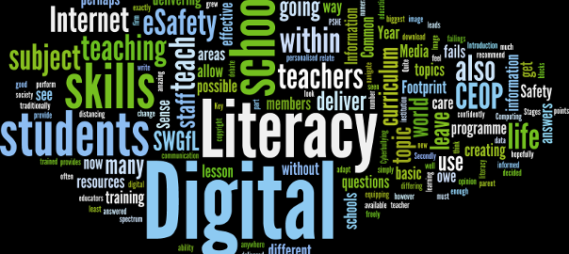
Schools can promote collaboration through virtual platforms. With remote work becoming more prevalent, it is crucial for children and young people to learn how to effectively communicate and collaborate with others digitally. By utilising tools like video calling or google software during group activities or extracurricular clubs, children and young people gain experience working with others they may not usually cross paths with. The impact of COVID meant that learners needed to be digitally competent and have access to the necessary tools to access their education. Unfortunately, many families and learners struggled with these aspects and the attainment gap between groups of learners specifically already disadvantaged learners grew. This is where digital competence being a cross curricular skill being embedded into all areas of learning and experience across the curriculum could help learners who have been disadvantaged previously.
(Witts 2015)

Reference list
Alamy Limited. 2023. Set of young children using phone illustration Stock Vector Image & Art - Alamy. Available at: https://www.alamy.com/set-of-young-children-using-phone-illustration-image362124015.html [Accessed: 6 November 2023].
Cartelli, A. 2012. Current Trends and Future Practices for Digital Literacy and Competence. Current trends and future practices for digital literacy and competence. doi:https://doi.org/10.4018/978-1-4666-0903-7.
Department of Education. 2023. Teaching online safety in schools. Available at: https://www.gov.uk/government/publications/teaching-online-safety-in-schools/teaching-online-safety-in-schools [Accessed: 30 December 2023].
Donaldson, G. 2015a. Successful Futures Independent Review of Curriculum and Assessment Arrangements in Wales. p. 15.
Donaldson, G. 2015b. Successful Futures Independent Review of Curriculum and Assessment Arrangements in Wales. p. 24.
Dredge, S. 2014. Coding at school: a parent’s guide to England’s new computing curriculum. Available at: https://www.theguardian.com/technology/2014/sep/04/coding-school-computing-children-programming [Accessed: 30 December 2023].
European Commission, Directorate-General for Education, Youth, Sport and Culture. 2019. Key competences for lifelong learning. Publications Office.
Welsh Government. 2018a. Digital Competence Framework Wall Chart and “Postcard.” Available at: https://educationwales.blog.gov.wales/2018/02/27/digital-competence-framework-wall-chart-and-postcard/ [Accessed: 30 December 2023].
Welsh Government. 2018b. Digital Competence Framework guidance.
Williams, L. 2020. Yes, There’s a Digital Skills Crisis in the UK, but We Can Solve it! Available at: https://www.ncfe.org.uk/all-articles/yes-there-s-a-digital-skills-crisis-in-the-uk-but-we-can-solve-it/#:~:text=The%20UK%20is%20in%20a [Accessed: 11 December 2023].
Witts, J. 2015. Writing an effective whole school Digital Literacy programme. Available at: https://www.jonwitts.co.uk/archives/682 [Accessed: 30 December 2023].

Balancing the scales: The positive and negative aspects of the digital world
Blog #2
#arewesafeonline #thegoodthebadthedigital
Being able to keep children and young people (CYP) safe is paramount when it comes to the digital world, but it is hard to keep track of what they are really up to. With CYP being more tech savvy than their adult counter parts how do we manage to balance the scales between the positive and negative aspects of the digital world.

NEGATIVES
- CYP have access to unsuitable content.
- Excessive use of devices leading to overstimulation and sleep disorders
- CYP at risk of cyberbullying
- Deception / identity theft
- CYP at risk of radicalisation / grooming
(Unicef 2017b)
POSITIVES
- Keeps CYP connected with friends and family
- An abundance of knowledge for CYP to learn from
- Educational content from around the world in all languages
- Allows CYP to problem solve
- Promotes creativity and curiosity
(Unicef 2017a)
(istock 2023)
How can we help?
The digital world has become an integral part of our lives, and its impact on children and young people cannot be ignored. While there are concerns about the negative effects of excessive screen time, it is important to acknowledge the positive effects that the digital world has on this demographic. As outlined in the bullet points above.

How easy is it to ask siri, alexa or google assistant the answer for a question? Technology has changed how we get answers and receive information. Connectivism is a learning theory that emerged in 2005, proposed by Downes & Siemen. It is based on the idea that knowledge is not solely stored within individuals but also distributed across networks and connections. In this digital age, where information is readily available and constantly changing, connectivism emphasises the importance of making connections and staying connected to keep up with the flow of knowledge (Kathleen Dunaway 2011).
(Clark 2020)

Connectivism, does not occur solely within an individual's mind but rather through interactions with others and technology. Connectivism has a huge prevalence with social media. The use of social media has evolved incredibly and has a powerful influence on children and young people. The theory suggests that learners should focus on building networks and developing skills to effectively navigate these networks. This includes knowing how to find relevant information, critically evaluate it, and apply it in various contexts.

Connectivism highlights the role of technology in facilitating learning. With the advent of the internet and social media platforms, learners have access to a vast amount of information from diverse sources. But when is being connected to social media to much?
‘Social media is designed to hook our brains, and teens are especially susceptible to its addictiveness’ (Miller 2022).

(Lin 2020)

Connectivism places emphasis on technology and overlooks other important aspects of learning such as critical thinking or reflection. It also questions its applicability in traditional educational settings where relationships are paramount in the building of connections in face-to-face situations. The power of manipulation for children and young people through algorithms and the pressure of keeping on trend can have a powerful impact. CYP are heavily influenced by producers using social media and targeting CYP as consumers.

‘The story of Prime Hydration illustrates the immense power that social media and influencers have on consumers, particularly the young. And those young consumers, influenced under the radar of their parents, will not let a label stop them’ (Lindén 2023).
(Crabbe 2022)
In today's digital age, it is crucial for policies and organisations in Wales to prioritise the safety of learners in the online world. With the increasing use of technology and internet access, CYP are exposed to various risks such as cyberbullying, inappropriate content, and online predators. Policies help ensure learner safety through the provision of statutory regulations. These regulations set guidelines for schools and educational institutions on how to protect learners from potential online threats. By implementing these regulations, schools can create a safe digital environment where learners can explore the internet without fear. The Department for Education states in statutory guidance that online safety should be included in all parts of the curriculum and should be included in the relevant policies and procedures (UK Council for Internet Safety 2022).
‘It is also an important part of the school’s pastoral care programme to ensure that learners are provided with the education and resilience needed to protect themselves and their peers from online dangers’. (School A 2023)
In my place of work, we have in place, E-Safety digital services IT support policy that is a comprehensive document that outlines the importance of moving forward with education in a digital world. The document also states,
Are you a spy? Do you check out what your child is up to online?
CYP can see this as an invasion of their privacy, however, online monitoring is an effective strategy to keep track of CYP safety. By monitoring online activities, schools and parents can identify any signs of cyberbullying or inappropriate behaviour early on and take appropriate action. This proactive approach helps create a safer digital space for CYP. Many parents may not be aware of the potential dangers their children face online or may lack knowledge about how to keep them safe. Schools and organisations can provide workshops or training sessions for parents to educate them about the safety measures they can implement at home.

Training professionals who work with learners is vital in ensuring their safety online. Teachers and other educational professionals need to be equipped with knowledge about internet safety so they can guide learners effectively. Policies should include regular training sessions for professionals to stay updated on current trends and risks associated with the digital world (Department for Education 2023). Writing this piece has got me questioning if my skills especially in connectivism are up to scratch not only as an educator but as a parent. It is a fine balancing act as we navigate the modern digital world around us. It is one we must embrace and move forward with or be stuck as a digital dinosaur.

Reference list
Clark, D. 2020. Plan B: Downes & Siemens – Connectivism… cMOOCs…. Available at: https://donaldclarkplanb.blogspot.com/2020/04/stephen-downes-and-george-siemens-have.html [Accessed: 31 December 2023].
Crabbe, E. 2022. Hundreds queue outside Aldi to get their hands on viral energy drink Prime. Available at: https://www.theargus.co.uk/news/23217762.prime-aldi-queues-crawley-supermarket-stocks-viral-drink/ [Accessed: 31 December 2023].
Department for Education. 2023. Keeping children safe in education 2023 Statutory guidance for schools and colleges. p. 8.
istock. 2023. 8,100+ Positive Negative Scale Stock Photos, Pictures & Royalty-Free Images - iStock. Available at: https://www.istockphoto.com/photos/positive-negative-scale [Accessed: 30 December 2023].
Kathleen Dunaway, M. 2011. Connectivism. Reference Services Review 39(4), pp. 675–685. doi:https://doi.org/10.1108/00907321111186686.
Lin, J. 2020. Social media has changed the lives of modern society. Available at: https://summitpsnews.org/2020/03/24/social-media-has-changed-the-lives-of-modern-society/ [Accessed: 31 December 2023].
Lindén, M. 2023. Hyped energy drink is a prime example of the power of social media. Available at: https://www.new-nutrition.com/nnbBlog/display/177# [Accessed: 31 December 2023].
Miller, S. 2022. The Addictiveness of social media: How Teens Get Hooked. Available at: https://www.jeffersonhealth.org/your-health/living-well/the-addictiveness-of-social-media-how-teens-get-hooked [Accessed: 31 December 2023].
School A. 2023. E-Safety, Digital Systems and IT Support.
UK Council for Internet Safety. 2022. Online safety in schools and colleges: Questions from the Governing Board. p. 2.
Unicef. 2017a. Children in a digital world. New York]: Unicef.
Unicef. 2017b. Children in a digital world. New York]: Unicef.
Western Governors University. 2021. Connectivism Learning Theory. Available at: https://www.wgu.edu/blog/connectivism-learning-theory2105.html.

Benefits and Barriers to Digital Learning
Blog #3
#dowereallylike #isitinclusive #breakingbarriers
Benefits and Barriers, what are the benefits to teaching and learning in the digital world? With the whole world forced into a scenario where they could previously never imagine during covid, did it enable education providers to try out a new digital way of teaching and learning. Or were the barriers that were already in place put into greater disparities between the people who can and the people who cannot?
Work Home
Name Amy Drewett Mum
Role Vocational Tutor Everything
Environment Behaviour, Emotional and Social Difficulties Chaotic
Age of Learners KS4 – Year 9, 10 & 11 7 & 11
Education
During Covid Digital Digital
Now Mostly face to face with some blended Face to Face
Digital learning, also known as online learning or e-learning, has become much more prevalent in educational settings, especially since the world had to endure the coronavirus pandemic. This use of learning uses technology to deliver educational content and promote interaction between learners and teachers. Learning online holds many benefits and can be good for both learners and staff. Digital learning offers flexibility and accessibility. Learners can access course materials at any time and from anywhere as long as they have an internet connection and the necessary devices to do so. This can allow individuals to learn at their own pace and fit their studies into their personal schedules (Stokes and Lewis 2021). Digital platforms often provide a wide range of multimedia resources, such as videos, interactive quizzes which cater to different learning styles. This enhances engagement and helps learners retain knowledge. Digital learning can encourage collaboration and communication among learners. Online discussion forums enable students to share ideas, ask questions, and give feedback on each other's work without the sense of being judged or made to feel stupid. This can lead to a sense of community within the virtual classroom environment. Teachers can track learner progress through online assessments and provide immediate feedback to learners.
The significance of health and wellbeing, particularly in relation to the welfare and care of children and young people, has been emphasised by the Welsh government in their New Curriculum. The integration of wellbeing into every aspect of the New Curriculum for Wales (2022) has been greatly influenced by the Future Generations Act (2015). This act highlights the need to enhance the wellbeing of individuals in each local authority by establishing objectives and devising a comprehensive plan to improve social, economic, cultural, and environmental wellbeing for all (Future Generations Commissioner for Wales 2015).
Barriers to learning are prevalent in all aspects of education. In today's digital age, access to technology and the internet has become increasingly important and expected, but there are still significant barriers to digital inclusion that prevent certain individuals and communities from fully participating in the digital world. These barriers can come in the form of:
- Economical
- Social
- Educational
- Or all of the above
But is it really this simple? Does digital learning suit everyone? In my experience things are not always what they seem especially when it comes to education. The school I work in is classed as an area of deprivation. The school has a large proportion of learners with free school meal entitlement. During covid we all had to adapt to a new way of learning. We went digital. But this was not the same experience for everyone. Digital learning has lots of different concepts and avenues. So, what are the barriers to learning in the digital world?
‘The UK’s food poverty rate is now among the highest in Europe, with 9.77 million adults experiencing food insecurity in September 2022 and 4 million children in food poverty in January 2022’ (Local Government Association 2023).

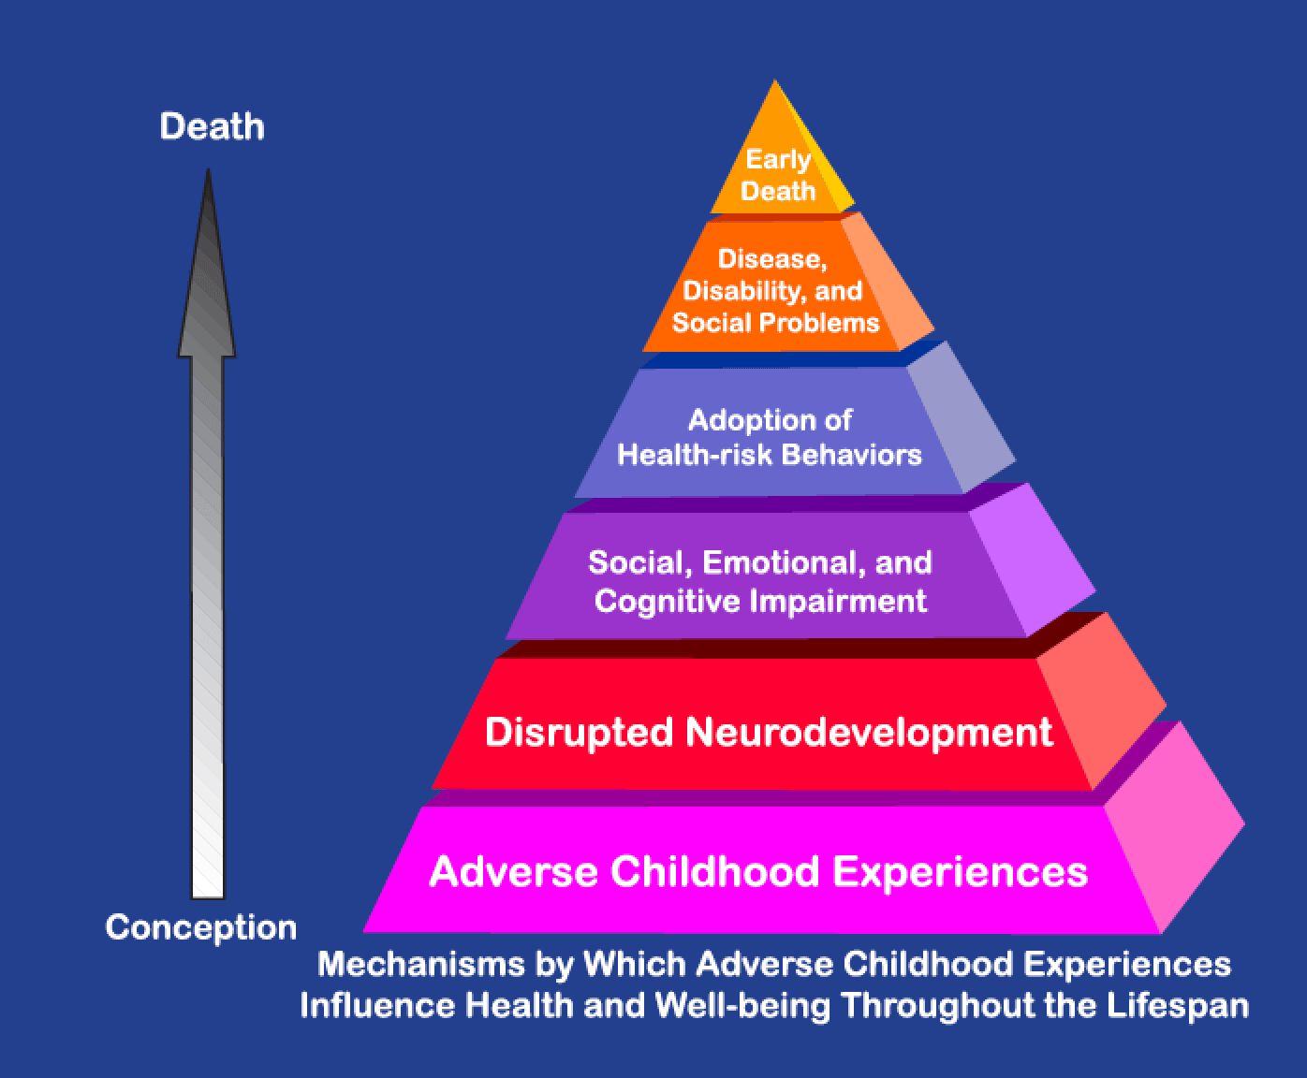
The cost-of-living crisis is currently putting huge financial pressures on families. Families who were already struggling or close to struggling are now finding the pressure to feed and clothe their children. Maslow's Hierarchy of Needs (1943) outlines it is essential for children and young people to have their fundamental requirements fulfilled, including food, shelter, water, and a sense of security and safety. Only when these basic needs are met can they be motivated to pursue higher-level needs and make progress (McLeod 2018). Failure to meet these basic needs creates barriers in various aspects of their lives such as digital learning.
(GETTINGWELL4 2015)
One of the main barriers is the lack of internet access or digital devices. Many low-income individuals cannot afford internet connections or even basic electronic devices such as computers or smartphones. During the pandemic I was expected to work online as well as my son who had live lessons. I used my phone to deliver online content to learners, answer emails and carry out necessities for my role and my son had to use the laptop. We are a family of two working parents, yet we did not have the means to purchase a new device. At times this was extremely difficult to manage and juggle. How would this have worked for the families who are disadvantaged? Internet access is now paramount in all aspects of living, governments need to look at the overall picture in helping all families be able to access the internet.
‘The proportion of pupils with little or no access to Information Technology (IT) in the most deprived schools (those in the top quintile for proportion of pupils eligible for FSM) was double that of the least deprived schools’ (Stokes and Lewis 2021)
A noticeable barrier to digital learning was the ability for parents to assist their children as they lacked the digital literacy skills to help. Parents may not have the confidence or necessary knowledge to navigate the digital world. On a personal reflection, I had to learn a lot of new digital skills, not only to help with my own children to learn digitally but also to deliver content online to the learners I work with. Since the coronavirus pandemic my digital literacy skills have improved vastly. Within my role I have noticed how many parents do not have access to the internet, class charts or emails. The school I work in could run a digital skills workshop for parents and young people to help them learn the skills they need to help navigate this world with their children.
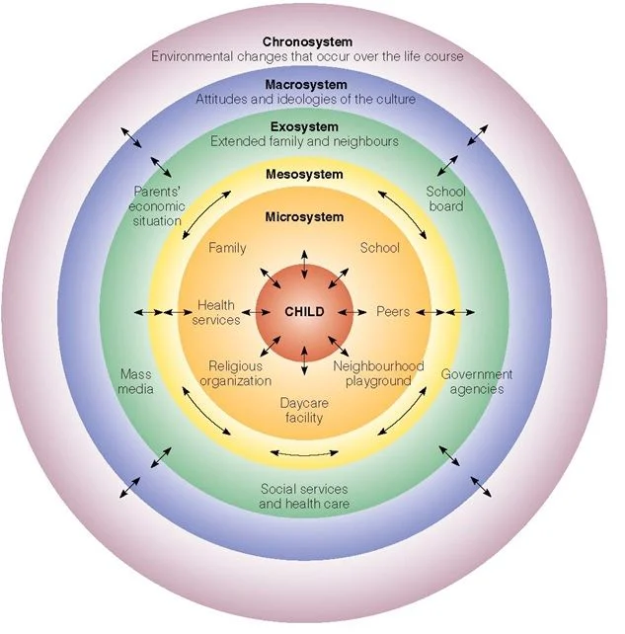
Since the pandemic the attainment gap between disadvantaged learners has grown. Within the environment I work in nearly all learners say they did not work during the pandemic. These learners come from disadvantaged backgrounds and live in an area of deprivation. Bronfenbrenner's Ecological Systems Theory (1977) highlights the essential elements for a child's success in a productive manner. The progression of human development occurs as each layer of the five systems is established. Any disparities within these entwined structures can have a detrimental impact on the entire system. The microsystem, which encompasses family, peers, educational environment, healthcare, and religious beliefs, holds the most significant influence on children. A balanced microsystem fosters positive outcomes for children (Härkönen 2007). For the success of digital learning children and young people need to have the support of the environment around them. Relationships between a learner and one emotionally available adult can be the instrumental factor that helps them succeed (Harmieson 2018, p.45). If we rely too heavily on digital learning, are we at risk of losing a key protective factor for inclusion for all?
(Guy-Evans 2023)

Reference list
Future Generations Commissioner for Wales. 2015. Well-being of Future Generations (Wales) Act 2015. Available at: https://www.futuregenerations.wales/about-us/future-generations-act/.
GETTINGWELL4. 2015. Grokking an Adverse Childhood Experiences (ACE) score.
Guy-Evans, O. 2023. Bronfenbrenner’s ecological systems theory. Available at: https://www.simplypsychology.org/Bronfenbrenner.html [Accessed: 5 January 2024].
Harmieson, J. 2018. Trauma informed schools and communities - delegate handbook. Trauma Informed Schools. p. 45.
Local Government Association. 2023. Debate on tackling poverty and the cost of food, House of Commons | Local Government Association. www.local.gov.uk. Available at: https://www.local.gov.uk/parliament/briefings-and-responses/debate-tackling-poverty-and-cost-food-house-commons#:~:text=The%20UK.
McLeod, S. 2018. Maslow’s Hierarchy of Needs. Simply Psychology. p. 1. Available at: https://canadacollege.edu/dreamers/docs/Maslows-Hierarchy-of-Needs.pdf [Accessed: 2 March 2023].
Singh, V. and Thurman, A. 2019. How Many Ways Can We Define Online Learning? a Systematic Literature Review of Definitions of Online Learning (1988-2018). American Journal of Distance Education 33(4), pp. 289–306. Doi: https://doi.org/10.1080/08923647.2019.1663082.
Stokes, J. and Lewis, J. 2021. Remote schooling through the coronavirus (COVID-19) pandemic, England - Office for National Statistics.

Inclusivity in Education: Google Classroom and ADHD
Blog #4
#digitaldiversity #adhddigitallearning #digitalinclusivity
Google Classroom is a cloud-based learning platform that was created by global digital corporation Google for the assistance of digital literacy and delivering education. The powerful tool has provided a virtual classroom where teachers can create, assign, and mark work with ease. The platform has allowed teachers to have a central hub where they can manage their classes and streamline the work they provide. It only takes a few clicks of the mouse for teachers to be able to assign work, interact with learners, post announcements, share resources, and set up live streamline classrooms. A key factor with Google classrooms is the way it collaborates with Google Docs, Sheets and Slides (Google for Education [no date] [a]).
In 2014 the platform was originally launched but it really came to the forefront in the UK during the coronavirus pandemic. The mad panic to make sure everyone could access learning online. Teachers learning new digital skills and being pushed out of their comfort zones. Parents trying their best to understand how online learning works. Were you one of them? Now that teachers have become accustomed to the prevalence of Google Classroom in their everyday lives it has become a useful tool to have at their disposition. The question we must ask ourselves is does it suit everyone?
‘150 million Google Education users worldwide’ (Google for Education [no date][b])
ADHD and Online Learning
Diversity and inclusion are at the heart of the Curriculum for Wales (2022). The four purposes encompass the shared vision and aspiration for every child and young person (Welsh Government 2017). Google Classroom has the adaptability for inclusivity for all learners. However not all learners enjoy or have the capabilities for the use of online learning. Attention Deficit Hyperactivity Disorder (ADHD) is a neurodevelopmental disorder that affects both children and adults. ADHD has symptoms such as inattention, hyperactivity, and impulsivity (Barkley 2016a, p.1). These symptoms can show in a range of ways.
Attention-Deficit | Hyperactivity-Impulsivity
Can not give close attention to detail | Fidgets and squirms
Makes mistakes | Has difficulty sitting in one place
Struggles to sustain tasks or activities | Runs or climbs in situations that do not require so
Has difficulty listening | Unable to remain quiet when required
Can not organise themselves or belongings | Constantly on the go
Has difficulty following instructions | Talks excessively
Fails to finish work | Interrupts / blurts out
Loses things | Difficulty waiting turns or for things to arrive
Gets distracted easily
Forgetful | (Barkley 2016b, p.2)
In the educational environment I work in, there are multiple boys who have been diagnosed with ADHD. The Year 9 Cohort, I work closely with, three of the male learners are prescribed medication for their ADHD. These learners have a different approach to learning compared to their peers in the classroom. While Google Classroom offers advantages, it also presents some challenges for these learners.
In today's digital age, where technology has become an integral part of our lives, the question is: do people with ADHD struggle with digital activities?
Benefits to Google Classroom | Disadvantage to Google Classroom
Can be done in own time | Impersonal
Tasks can be broken down | Lack of social interaction
Less distractions | Monotonous
Adaptable to individual learner | Over stimulation from screen time
 | Not all teachers will tailor to needs
 | Lack of structure

How do you put face to face, ADHD, classroom strategies in place for online learning?
The impact of online learning during the pandemic meant that learners with difficulties such as ADHD may not have been considered in the extent they should have been, leading to feelings of isolation and overwhelming. Barkley’s Behaviour Inhibition (1977) theory outlines the struggles learners have with functioning skills such as organisation and time management which can lead to difficulties with online learning (Becker and Barkley 2020, p.3). Online learning requires independence and the ability to self-regulate which can be challenging for learners with ADHD. However, for learners who struggle with overstimulation in the form of a traditional classroom, Google Classroom allows learners to work at their own pace in their own environment. I think the clear message to remember is the individuality of each and every learner and what works for one, may not work for another. This links closely to Dewey’s Education Theory (1938). Dewey believes that education should be learner centred and focus on the individual needs and interests of each learner. This approach supports the needs of learners with ADHD as it allows for personalised instruction that caters to their unique learning styles. This applies to the needs of learners while using Google Classroom or in the traditional classroom setting (Schiro 2013).
Does Google Classroom align itself with the Digital Competence Framework?
The Digital Competence Framework is divided into three main areas: citizenship, creativity, and data and computational thinking.
- Citizenship focuses on developing responsible digital citizens who are aware of their rights and responsibilities online.
- Creativity encourages individuals to use digital tools for innovation, expression, and collaboration.
- Data and computational thinking emphasise problem-solving skills using data analysis and algorithmic thinking (Welsh Government 2018b).
(Welsh Government 2018a)

Google Classroom allows learners to use a range of digital tools that are continuously evolving. The platform enables learners to express themselves by working collaboratively or independently. Google Classroom has the capability to allow learners to compile and review data and allow problem solving skills to be developed. Learners can do this at a pace that suits them enabling them to progress through the Digital Competence Framework strands of learning. Since the implementation of the Curriculum for Wales (2022) and Digital Competence becoming a cross curricular subject that needs to be interlinked into every subject it is paramount that the framework is used in conjunction with Google Classroom for optimal benefit (Welsh Government 2020).
Ultimately Google Classroom is still instructed by a teacher. The adaptability and inclusivity of the platform working for all learners as well as meeting the requirements of the DCF requires teachers to be mindful of their target audience. Adapting and creating work that is appropriate of those they are teaching. This doesn’t always happen, in both the virtual and real-life scenario of educating, learners with difficulties such as ADHD need understanding, patience, consideration and an approach that works for them.

Reference list
Barkley, R.A. 2016a. Managing ADHD in School: The Best Evidence-Based Methods for Teachers. Eu Claire, Wi: Pesi Publishing & Media. p. 1.
Barkley, R.A. 2016b. Managing ADHD in School: The Best Evidence-Based Methods for Teachers. Eu Claire, Wi: Pesi Publishing & Media. p. 2.
Becker, S.P. and Barkley, R.A. 2020. ADHD in adolescents: development, assessment, and treatment. New York: The Guilford Press. p. 3.
Google for Education. [no date][a]. Classroom. Available at: https://edu.google.com/intl/ALL_uk/workspace-for-education/classroom/ [Accessed: 5 January 2024].
Google for Education. [no date][b]. Classroom. Available at: https://edu.google.com/intl/ALL_uk/workspace-for-education/classroom/ [Accessed: 5 January 2024].
Lister, K. 2020. Making Online Classes Work for Students with ADHD. Times Higher Education. 17 November. Available at: https://www.timeshighereducation.com/campus/making-online-classes-work-students-adhd [Accessed: 6 January 2024].
Schiro, M. 2013. Curriculum Theory: Conflicting Visions and Enduring Concerns. 2nd ed. Thousand Oaks, Calif.: Sage Publications.
Welsh Government. 2018a. Digital Competence Framework Wall Chart and “Postcard.” Available at: https://educationwales.blog.gov.wales/2018/02/27/digital-competence-framework-wall-chart-and-postcard/ [Accessed: 30 December 2023].
Welsh Government. 2020. Introduction to Curriculum for Wales Guidance - Hwb. Available at: https://hwb.gov.wales/curriculum-for-wales/introduction-to-curriculum-for-wales-guidance/ [Accessed: 6 January 2024].
Welsh Government. 2017. Curriculum for Wales: Overview. Available at: https://www.gov.wales/curriculum-wales-overview#:~:text=The%20four%20purposes%20are%20the [Accessed: 5 January 2024].
Welsh Government. 2018b. Digital Competence Framework Guidance. Education Wales. p. 5.

