Sainsbury’s Report
Name of the author: Elena Pruteanu
Name of host organisation: Sainsbury
Date of report publication:18 November 2022
Word count:3000

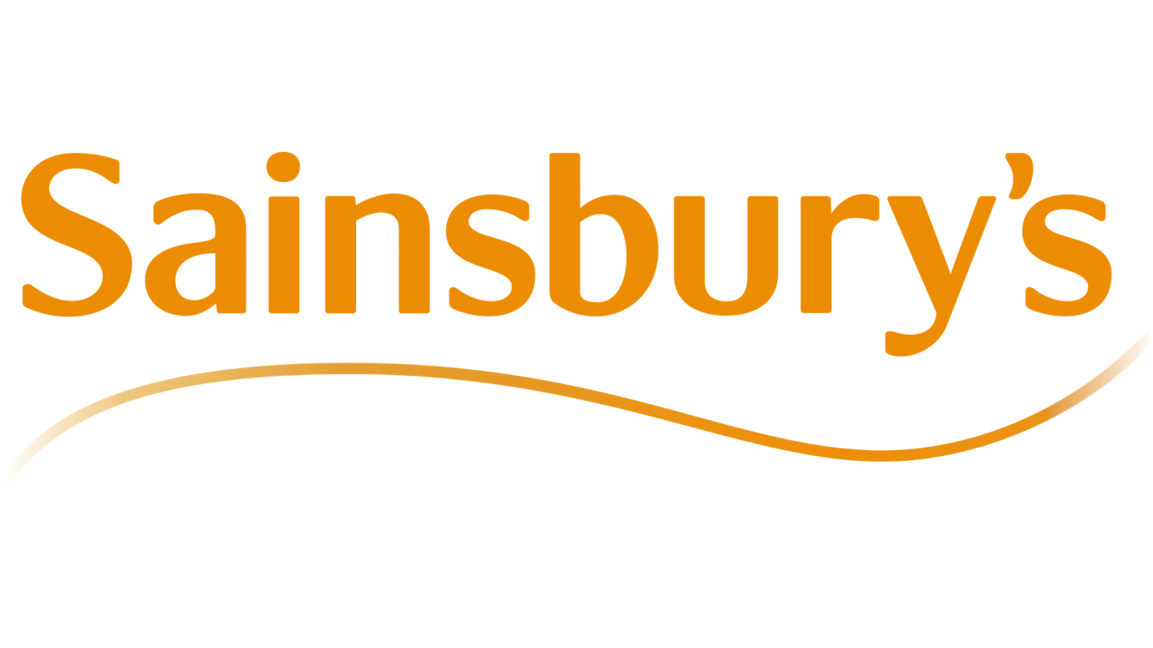

Executive Summary

When John James Sainsbury and his wife Mary Ann founded a store at 173 Drury Lane in London's Covent Garden in 1869, Sainsbury's was formed as a partnership. Fresh food was Sainsbury's initial focus, but it eventually added packaged goods like tea and sugar. His trade ethos was "Perfect quality, reasonable pricing," as written on a sign outside his first store.
A change in management style resulted from the 1992 retirement of long-time CEO John Davan Sainsbury, who was succeeded as chairman and chief executive by his cousin David Sainsbury (later Lord Sainsbury of Turville). However, neither strategy nor corporate beliefs about the company's position in the market were altered.
David Sainsbury and his successors, Dino Adriano, and Peter Davis, made mistakes like rejecting loyalty cards, being reluctant to enter the non-food retailing space, deciding between going for quality or value, "the sometimes-brutal treatment of suppliers" that caused them to prefer Tesco over Sainsbury's, and running an unsuccessful ad campaign with John Cleese as the face according to Wikipedia.

Contents
Table of Contents
Executive Summary 2
Contents 2
1.0 Introduction 3
2.0 Findings 3
2.1 Sainsbury's background 3
2.2 Data Collection and Evaluation 4
2.3 Segmentation, Strategies, Pricing and Differences 5
Process: 7
Physical Evidence: 7
2.4 Ethics and Sustainability 9
3.0 Conclusion 10
4.0 Appendix 11
5.0 Reference List 12

Introduction

To compose this research report about Sainsbury's effect on Sustainable Relationship Marketing policies and apply the impact on organisation performance. On the 2nd of November, the Marketing Executive Officer of “Marketing week “requested the development of this study so they could conduct an analysis within the Sainsburys organisation. I studied a range of materials in preparation for this research, conducting my academic work by checking dependable sources like the library and Google Scholar. I used the internet, scholarly journals, and reflective journals. To improve my professional performance and put ideas into effect, I enjoy conducting studies on the numerous topics supplied by these sources. Our vision is to be the most trusted retailer where people love to work and shop. That means harnessing the talent, creativity, and diversity of our colleagues to ensure that customers receive great service every time they shop with us, according to Sainsbury’s (2022).
It immediately gained recognition for providing premium goods at competitive pricing. By 1882, there were outposts in Stepney, Islington, and Kentish Town, three more market streets in the city. In that same year, bacon, the first item under the Sainsbury brand, was released.

2.0 Findings

2.1 Sainsbury's background
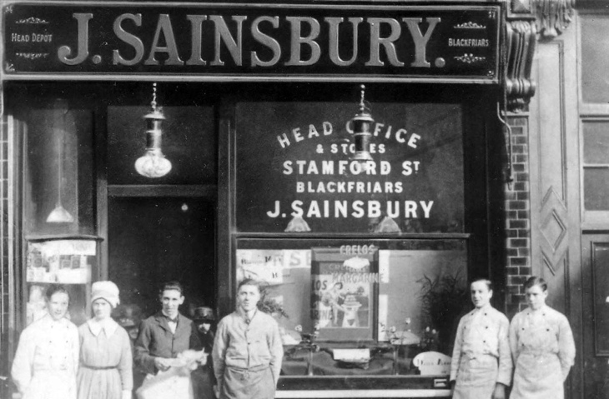
Sainsbury's was founded in 1869 by John James and Mary Ann Sainsbury, according to the Guardian (2007). They established their first modest dairy shop at 173 Drury Lane, which at the time was in one of London's poorest neighbourhoods.

It quickly became known for offering high-quality products at reasonable prices. Stepney, Islington, and Kentish Town, three other market streets in the city, all had outposts by 1882. The first product sold under the Sainsbury brand that year was bacon.

In 1973, the company went public in what was the largest stock market float at the time.

For a long time, Sainsbury's was the largest and most prosperous grocery chain in Britain. Tesco eventually surpassed it in 1995 because of lax management.

Sainsbury's has trailed behind in innovations like this because its former leader, David Sainsbury, famously rejected loyalty cards as "electronic green shield stamps."

The priceless client data that Tesco's Clubcard programme has amassed, however, has been a pillar of its future success.

J Sainsbury operates over 455 supermarkets and 301 convenience stores, making it the third-largest food retailer in Britain after Tesco and Asda, which is owned by Wal-Mart. It receives more than 16 million weekly visits in addition to its 153,000 employees.

Its comparative success is evidenced by its 16% market share of the total UK grocery business. Through an examination of its competitors, objectives, and market sector, this essay seeks to analyse Sainsbury's market. Aluko says that its logistical operations and issues will also be examined, and solutions to the problems will be suggested.

For a long time, retailers have used loyalty programmes to better understand their customers, offer more useful incentives, and boost sales. For the past 50 years, the purpose of CRM has been to deliver the right message to the right customer at the right time through the right channel.

2.2 Data Collection and Evaluation

Sainsbury's supermarket Ltd., the third largest and oldest retail business, was established in London, United Kingdom, in 1869. It presently controls 16.5% of the UK supermarket market. It received recognition for the 2011 SUPERMEAT and fish award. 700 distinct low-cost food and shopping options are available to Sainsbury's loyal customers. It has a special corporate obligation to work closely with everyone in the supply chain and to provide its customers with a healthy, balanced diet. International Journal of Business and Management; Vol. 7, No. 18; 2012 ISSN 1833-3850 E-ISSN 1833-8119 Published by Canadian Center of Science and Education
According to Chloe Rigby (2019), the Nectar customer loyalty programme, which Sainsbury's purchased in 2019, has also unveiled a new app and website that guarantees to give its users more pertinent and individualised offers. To forecast and supply the products that its consumers will wish to buy, Sainsbury's uses machine learning.
Sainsbury's uses machine learning and predictive analytics to spot new grocery trends as they appear. The business has worked with Accenture and Google Cloud to stay up to date with the newest gastronomic trends. They have jointly created machine learning solutions on the Google Cloud Platform that show what customers want and the patterns influencing their eating habits. "Both the food industry and consumer purchasing patterns are changing quickly.
Sainsbury's built predictive analytics algorithms to find patterns and adjust product inventory accordingly.
The Nectar app also allows users to create a loyalty account and use a mobile device-based digital card to accrue points for purchases of everything from groceries to entertainment and travel, according to Chloe Rigby (2019). They are guaranteed exclusive deals from Sainsbury's and roughly 400 other Nectar partners through the Nectar app on their phone, with individualised benefits like money off travel, shopping, days out, and movie tickets.
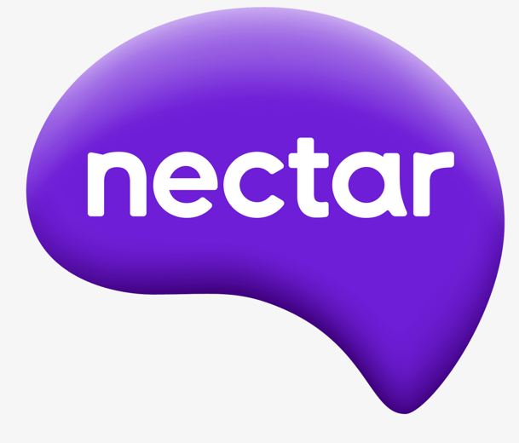
https://www.about.sainsburys.co.uk/brands-that-deliver/nectar

The primary objective of the campaign was to comprehend how mobile messaging may enhance the purchasing experience. To do this, it would offer consumers contextually relevant content to help them plan their purchases and remind them of the deals they had available, and then it would evaluate how people responded to find out how it affected spending, visits, and in-store time.

Additionally, Sainsbury's would get data on how customers move around a store, which could help with merchandising decisions.

The primary objective of the campaign was to comprehend how mobile messaging may enhance the purchasing experience. To do this, it would offer consumers contextually relevant content to help them plan their purchases and remind them of the deals they had available, and then it would evaluate how people responded to find out how it affected spending, visits, and in-store time.

Additionally, Sainsbury's would have data on how customers move around a store, which might help with merchandising decisions.

Using Tesco as an example, we can see that Tesco works daily to give its customers, communities, and the rest of the world a little bit better service. To do this, we need to be able to offer you products and services that meet these goals. An essential part of this is protecting the information you entrust to us. We want you to be confident in the security of your information with us and that you are aware of how we use it to give you a more useful and individualised shopping experience. If we compare this to Sainsbury, we can tell that Sainsbury’s method of data collection is more efficient as Sainsbury’s is able to use third-party data for collection about their company, whereas Tesco only uses their own and their Clubcard method.

2.3 Segmentation, Strategies, Pricing and Differences
Segmentation

A segmented market can boost profitability, concentrate on relationships, and cut costs for marketing and management. Controllable and aids in providing a marketing-focused emphasis.
According to Reichheld, some companies have higher levels of shareholder, employee, and customer loyalty than their competitors.
The challenge facing a market leader in creating a "super-loyalty brand." That is, to boost client loyalty above and beyond what the double jeopardy effect would predict, either through market segmentation or by providing services that are better than those of the competition.

Strategies

To improve food quality, increase choice and innovation, and consistently offer customers good value, we are fast streamlining operations and pushing up our cost-cutting activities. Argos, Habitat, Tu, Nectar, and Sainsbury's Bank are just a few of our portfolio companies that help our main food business while also making money for both customers and shareholders. We will continue to look for partnerships and contract out work as necessary so that our customers can benefit from the contributions of third parties.
Sainsbury's marketing plan and marketing plan combination(7PS)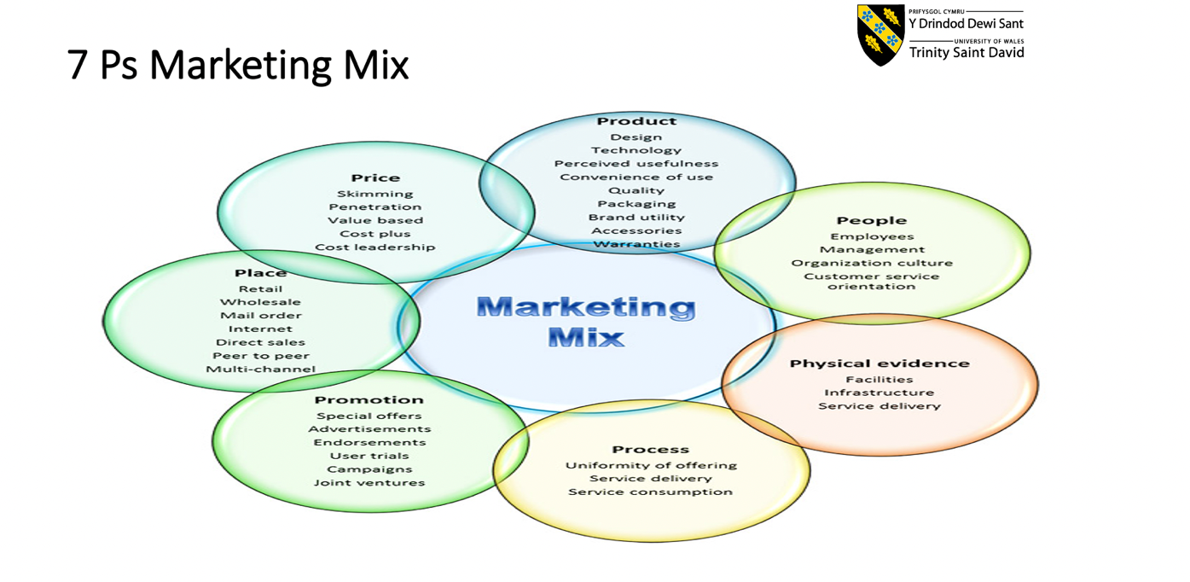
Sainsbury's Promotion & Advertising Strategy:
Promotion refers to all marketing tactics used to educate consumers about a company's products and urge potential buyers to buy them. Solomon and co. (2009). The campaign uses every marketing communication tool at the marketer's disposal.
Sainsbury's created the "Nectar reward card," allowing customers to earn points for every dollar spent in the store to increase sales and promote customer loyalty.
People:

Sainsbury works with a good mix of specialists and professionals who have the necessary training and an understanding of consumer behaviour. At Sainsbury's, the needs of the consumer come first, thus, new hires are trained on the job to satisfy both those needs and business goals. Since Sainsbury is aware that skilled employees have a completely different impact, it offers training for a wide variety of abilities. For its Store Managers and Team Leaders, it has established a Level 2 Craft skills Apprenticeship in addition to a new college completely devoted to leadership training.

Process:

Sainsbury has made online shopping incredibly convenient for its consumers with its "click & collect" service, which enables customers to obtain their products nearly instantly. It has also changed its price and the distribution of delivery times, which has boosted order volume and encouraged repeat business. Sainsbury is also creating new shop formats and selecting the sites for its new stores with care to satisfy the changing needs of its customers.

Physical Evidence:
Sainsbury effectively promotes its products by using verifiable evidence. It offers a variety of store layouts and styles to meet the needs of different customers. A fantastic shopping experience is guaranteed by the quality of the baskets and carts. Shopping is also made easy by the impressive shelf arrangement in the store. This therefore includes Sainsbury's marketing mix and strategy.
Place:
Place refers to commercial activities that bring the product in front of the target market. (2010) Kotler and co.
The location may also be referred to as a channel for distribution or an intermediary. It is a way for a producer or service provider to deliver goods and/or services to a client or consumer.

Product:
The combination of goods and services that a company offers to its target market is referred to as a product. Kotler et al., 2010
Many people simply define a product as the tangible item we buy or sell. The item can also be thought of as a service or an intangible.

Pricing
While perceptual discrimination tests are intended to compare product quality differences without brand information, the shopping basket approach is used to compare pricing. When there are discernible distinctions between products, product preference is established.

Retailers can choose between pricing techniques that encourage the heavy use of promotions and those that do not, so the performance impacts of different pricing methods in the current retail environment have direct implications for price variance, according to Volpe (2011).
Pricing strategies are of relevance from an economic standpoint because of their effects on retail price variance, according to Volpe (2011).
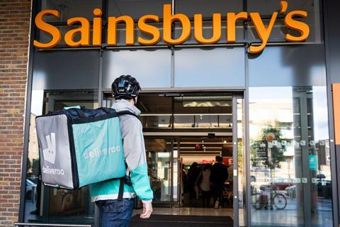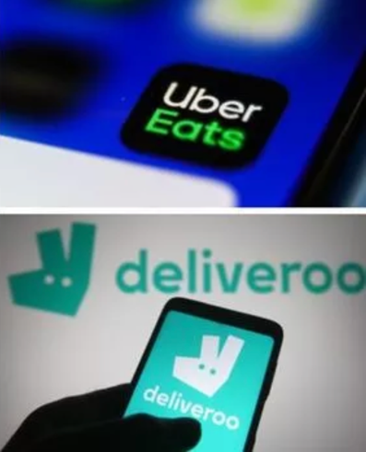https://www.express.co.uk/life-style/life/1422813/sainsburys-deliveroo-uber-eats-new-service-partnership-uk-stores/amp

Sainsbury's Deliveroo trial will include ten locations, the first of which, the North End Crescent Local store in Hammersmith, went online on Thursday. The same number and range of SKUs are offered.

"Working with Uber Eats will give customers another alternative to receiving Sainsbury's goods delivered to their door swiftly, conveniently, and safely," says Nigel Blunt, director of e-commerce at Sainsbury's. Chop Chop offers 60-minute rapid delivery of food to customers.
Ajay Lakhwani, vice president of new business at Deliveroo, stated that the company was eager to begin this new experiment with Sainsbury's.

Differences
By using differentiation as a business strategy, a company hopes to gain a reputation among consumers as a supplier of standout products that consumers are ready to pay more for since they cannot find comparable products or features elsewhere in the market.

Because they believe they will get more value from a differentiated product, customers are willing to pay more for it.

Sainsbury Supermarket
On September 29, 2010, Sainsbury's added to the size of its UK stores by expanding its Crayford, Southeast London, store, which has over 100,000 square feet (9,300 m2) of retail space and is the company's largest supermarket ever built in the country. Bybrook in Ashford, Kent, which reopened on November 16, 2011, contains more than 100,000 square feet (9,300 m2).

On November 24, 2010, the remodelled Sainsbury's in Lincoln, Lincolnshire, passed Crayford to rank second in size in the UK with 98,712 square feet. (9,171 m2).

Even though all establishments in the "supermarket" category run similarly and have comparable layouts, there could be variations in the services they provide to clients. A convenience kiosk, produce, meat, seafood, grocery, and frozen products sections will also be present in many of the stores, along with both staffed and self-service checkouts.
Nevertheless, based on the size of the shop, they might also offer a bakery, a pizza counter, a cafe or Fresh Kitchen, Tu clothing, and other products. Even a gas station, an internet picking department, and an Argos or Habitat can be found inside some stores. A few of the shops with concessions include a beauty hall, travel agencies, Jessops, Patisserie Valerie, Specsavers, Carte D'Or and Ben & Jerry's ice cream kiosks, Zizzi pizza counters, Sushi Gourmet counters, and The Fragrance Shop. Others include a dental clinic called the "Centre for Dentistry" and a school called "Explore Learning" that gives kids additional English and math instruction. Starbucks Coffee is a substitute for the in-store cafe at some stores.

Sainsbury's stores only allowed customers to buy three of each food item due to the UK lockdown that was declared in March 2020 due to the coronavirus pandemic and the ensuing panic buying. All customers had access to the necessities thanks to this action.

Sainsbury Fuel
At a few of its stores, Sainsbury's has a network of fuel forecourts that sell diesel, gasoline, and City Diesel. In the Croydon Sava Centre supermarket, the network opened its first forecourt in 1974. At the time, the forecourts were advertised and supplied as Jet stations. However, Sainsbury's began managing its own forecourts and fuel purchases in 1980. BP took over as the fuel provider in 2004 and, whenever possible, operated its forecourts inside of supermarkets. In 2009, this arrangement came to an end, and Sainsbury's was once again in charge of managing all forecourts and purchasing gasoline.

Sainsbury’s Café
There are a few retailers who operate the self-service cafes known as Sainsbury's Cafés, and most of them are open during the same hours as the supermarket.

Sainsbury’s Local
Sainsbury's expanded its portfolio of convenience stores by acquiring Bell's Stores, Jackson's Stores, JB Beaumont, and SL Shaw Ltd. in addition to developing its own sites. Sainsbury's first continued to use the recognisable Bells, Jacksons, and Beaumont trademarks. For instance, Sainsbury's at Bells was the moniker given to remodelled locations. These were essentially Sainsbury's Local stores that had been given a new fascia but retained some elements of the previous local chain. While offering Sainsbury's own brand goods, prices, and some points of sale, unrenovated stores did not accept Nectar cards. The previous brand and logo were kept. Additionally, Sainsbury's branding was added to the previous websites. But every single one of these acquired stores underwent a complete Sainsbury's Local fascia change beginning on May 4, 2007.

Sainsbury’s Online
Sainsbury's operates an online store called "Sainsbury's Online." Customers can take advantage of this service by dialling a number or placing an online grocery order (which includes a "phone order" fee). Additionally, Sainsbury's provides the transactional websites Sainsbury's Gift Cards and Sainsbury's Business Direct, which sell gift cards, gift certificates, and food tokens that may be redeemed at any Sainsbury shop and have credit or value. Both goods and services cannot be purchased with either product. Because there are so many products and retailers where it can be used, the Gift Card website promotes the card as the ideal gift. The cards are promoted on the MBL Solutions Ltd.-run Business Direct website as being ideal for encouraging and rewarding employees.

2.4 Ethics and Sustainability
Sainsbury's demands of its suppliers are high social and environmental standards, but we also recognise that many of them need help and support to implement more sustainable policies. Our goal is to build supply chains that are resilient to the social and environmental issues affecting the industry by collaborating with farmers, producers, and processors to promote and institutionalise excellence in sustainability. By 2020, our suppliers will be setting the standard for ethical behaviour in the social and environmental spheres.

The importance of ethical commerce is emphasised heavily in our sustainability strategy. The Sainsbury's Code of Conduct for Ethical Trade, which is based on the ETI Base Code for ethical sourcing, is something we demand from all our suppliers. There are 12 core principles in our Code, including paying fair salaries and ensuring safe and hygienic working conditions. Every supplier to Sainsbury's must comply with our Code of Conduct for Ethical Trade and provide evidence of ongoing improvements in worker wellbeing. Suppliers must have their own codes of conduct, resources, policies, and systems in place to manage ethical trade. The suppliers must also monitor their progress and be ready to inform Sainsbury's of any changes.

Sainsbury's Code of Conduct and ethical trading principles serve as the cornerstones of our ethical trade programme. All our suppliers have their risks assessed, and we require recurrent, unbiased, third-party ethical audits from high- and medium-risk locations. Any issues found by the audits must be resolved right away. As part of our efforts to improve worker welfare, we also work with significant suppliers to educate suppliers about ethical trade. Several key metrics for ethical commerce are used to assess the performance of our suppliers, and we take this evaluation into account when making purchasing decisions.

Sainsbury's is required to work with other companies, NGOs, and labour unions on ethical trade initiatives because it is a founding member of the Ethical Trading Initiative (ETI). Recently, our ethical trade team has expanded in the UK, and we are looking to hire more people in the countries where we source from.

We are persistent in our commitment to ethical and responsible sourcing, and we work with suppliers to make sure they maintain a high standard.

3.0 Conclusion
Throughout the multiple research that has been conducted for this report, multiple qualitative and quantitative data have been retrieved and analysed so it can be used to discuss what is needed for this report; relevant sources have been used to discuss the background of Sainsbury's, the data collection and evaluation of Sainsbury's, the segmentation, strategies, pricing, and differences and finally also used to find the ethics and sustainability of Sainsbury's, all of have been discussed in depth and effectively to complete and finalize this report.

4.0 Appendix
Annual retail sales of Sainsbury's in the United Kingdom (UK) from financial year 2008/09 to 2021/22
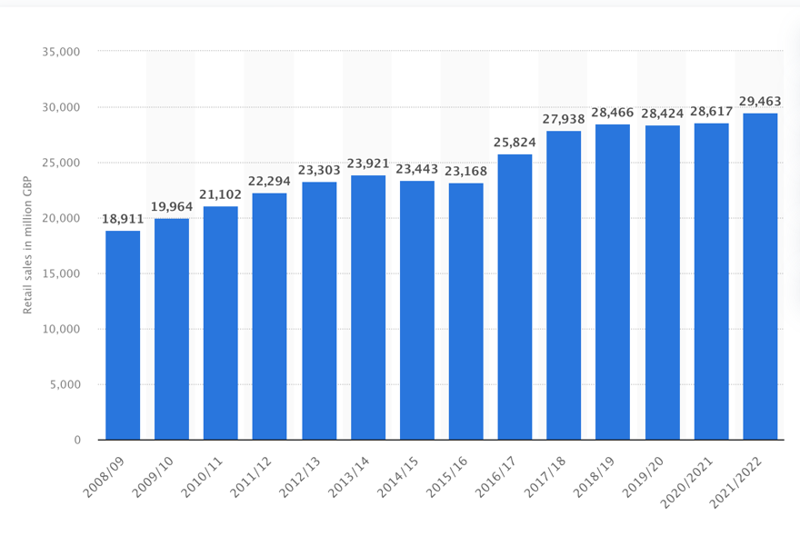

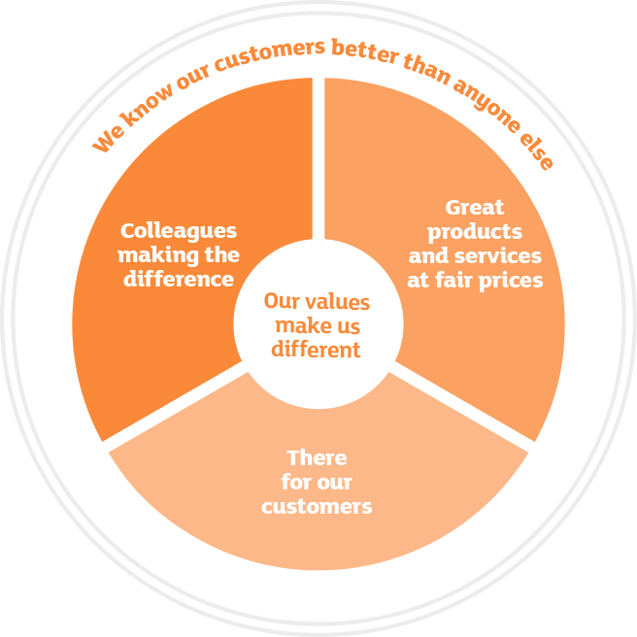

5.0 Reference List

Sainsbury's. (2022, October 29). In Wikipedia. https://en.wikipedia.org/wiki/Sainsbury%27s (retrieved November 2^{nd, 2022})

https://www.about.sainsburys.co.uk/about-us/our-business-strategy
(Retrieved November 2^{nd, 2022})

https://sainsburys.jobs/working-for-us/values-culture/ (retrieved November 5th, 2022)

https://doi.org/10.1108/09590550610714639 (retrieved November 5th, 2022)

International Journal of Retail & Distribution Management, vol. 33 no. 6 (retrieved November 5th, 2022)
Type: Research Article
DOI: https://doi.org/10.1108/09590550510600861
ISSN: 0959-0552

International Journal of Business and Management; Vol. 7, No. 18; 2012 ISSN 1833-3850 E-ISSN 1833-8119 Published by Canadian Center of Science and Education (retrieved November 5th, 2022)

VOLPE, R., 2011. Evaluating the Performance of U.S. Supermarkets: Pricing Strategies, Competition from Hypermarkets, and Private Labels. Journal of Agricultural and Resource Economics, 36(3), pp. 488-503. (Retrieved November 5th, 2022)

VOLPE, R., 2011. Evaluating the Performance of U.S. Supermarkets: Pricing Strategies, Competition from Hypermarkets, and Private Labels. Journal of Agricultural and Resource Economics, 36(3), pp. 488-503. (Retrieved November 5th, 2022)

Aluko, O., & Knight, H. (2017). From corner store to superstore: a historical analysis of Sainsbury’s co-evolution. Journal of Management History, 23(4), 423-435. (Retrieved November 5th, 2022)

Humble beginnings N/A (2007) https://www.theguardian.com/business/2007/feb/02/supermarkets2 (retrieved November 5th 2022)

Two ways Sainsbury’s is using data to give shoppers what they want, Chloe Rigby (2019) (retrieved November 6th 2022) https://internetretailing.net/strategy-and-innovation/two-ways-sainsburys-is-using-data-to-give-shoppers-what-they-want-20335/

Sainsbury’s partners with Uber Eats and Deliveroo, George Nott (2020) (accessed November 6th 2022) https://www.thegrocer.co.uk/online/sainsburys-partners-with-uber-eats-and-deliveroo/649869.article
A short history of design at Sainsbury’s, Ian Heath (2019) (retrieved November 6th, 2022) https://medium.com/sainsburys-customer-experience/a-short-history-of-design-at-sainsburys

(2010) Kotler and Armstrong, 7ps strategy (taken from school resources) (retrieved 8/11/2022)

https://www.express.co.uk/life-style/life/1422813/sainsburys-deliveroo-uber-eats-new-service-partnership-uk-stores/amp (retrieved 8 November 2022).

Sainsbury Corporate website press releaseArchived 23 July 2011 at the Wayback Machine(retrieved 9 November 2022).

Ryan, John (13 October 2016). "Store gallery: Nine Elms Sainsbury's looks to the future with Habitat and Argos". Retail Week. Archived from the original on 2 December 2016 (retrieved 10 November 2022).

"Sainsbury's and Asda limit sales of all food items". BBC News. 18 March 2020. Archivedfrom the original on 18 March 2020. (Retrieved 08 November 2022).

"Sainsburys Fuel". PetrolPrices.com. Archivedfrom the original on 13 February 2014. (Retrieved 08 November 2022).

"Forecourt fuel supplies threatened as ballot of BP Sainsbury's drivers opens". Archive.unitetheunion.org. Archived from the originalon 1 February 2014. (retrieved 08 November 2022).

"In Store Counters For Produce And Expert Advice". Sainsburys-live-well-for-less.co.uk. Archived from the original on 26 March 2014. (Retrieved 09 November 2022).

https://www.tesco.com/help/privacy-and-cookies/privacy-centre/privacy-policy-information/privacy-policy/ (accessed 15 November 2022)

https://www.marketingweek.com/sainsburys-marketing-ultra-personlised/ Marketing Week Reporters (2018) (accessed 15 November 2022)

https://www.statista.com/statistics/386342/sainsburys-retail-sales-united-kingdom-uk/ (accessed 17th November 2022)

https://www.about.sainsburys.co.uk/about-us/our-business-strategy (accessed 17th November 2022)

