Component 2- Research Report
Student Name: Misbah Khan
Student Number: 2221347
Lecturer Name:
Azida Zainol
LCHS4002_BIRM
Digital Skills and research Methods

Contents
1.Introduction…………………………………………………………………………………………………………………………….3
2. Research design……………………………………………………………………………………………………………………….3
2.1 Research question………………………………………………………………………………………………………………...4
2.2 Method…………………………………………………………………………………………………………………………….……4
2.3 Ethical considerations……………………………………………………………………………………………….………….4
3. Results……………………………………………………………………………………………………………………………….…….5-8
4. Discussion……………………………………………………………………………………………………………………………….8
5. Conclusion……………………………………………………………………………………………………………………………….9
6. Reference List………………………………………………………………………………………………………………………….10

1.Introduction
In this report I will detail the most important digital skills for UWSTD students. The report focuses on compiling the data from the survey/questionnaire sent to UWSTD students via Outlook. The research question is which digital skills do UWTSD student think are the most important? All data received as answers are carefully analysed and carefully disaggregated to display results. Digital literacy is the ability to use digital devices such as computers and smartphones to find, assess, use, share and create content.
It is crucial that digital skills are incorporated into educational policies. Having ICT skills can enhance an individual's chances of success in the job market and improve their ability to communicate with public administration. With the rise of digitization and globalization, it has become increasingly important to use the internet, applications, and other e-based devices for communication. Digital skills play a vital role in e-Government, enabling people to use e-Government services to interact with public administration (Sustainability 2022), In today's "Information Society," technology is transforming the way people live. Work is no longer limited to a specific location, personal communication is instantaneous, and information is readily available around the clock. Digital skills are necessary to navigate these changes as individuals progress through various stages of life. The European Union acknowledges the profound and irreversible impact of information and communication technologies on all areas of life, including professional, social, and personal domains. The Digital Agenda for Europe recognizes the importance of digital skills for innovation and growth in Europe and acknowledges that the skill requirements are constantly evolving due to the rapid pace of technological change. To remain competitive, workforces must continuously adapt to changing job requirements and organizational procedures associated with new technology-intensive practices. (European commission, 2014) (European Union 2012)
2. Research Design
Primary research involves collecting data first-hand by conducting research or commissioning the collection of data. This approach allows researchers to gather specific and relevant information for their research projects, rather than relying on pre-existing data samples that may not be applicable or useful for their research. Primary research methods include surveys, interviews, observations, and experiments, among others. By conducting primary research, researchers can gain a deeper understanding of their research topic and draw more accurate conclusions from their findings. (Driscoll, D.L.,2011) This is the research that was used to get the results for my questionnaire.
Secondary Research
Secondary research involves using existing sources of data and information that have been collected and archived by others. These sources can include government reports, industry studies, academic articles, books, and other publications found in libraries or online databases. Secondary research can provide valuable insights into a research topic, and it can be a cost-effective and time-efficient way to gather information. However, it is important for researchers to critically evaluate and validate the sources of information they use for their research, as the quality and reliability of secondary data can vary widely. (Stewart, D.W. and Kamins, M.A., 1993)

2.1 Research question
The question chosen: Which digital skills do UWSTD students find most important?
The aim of this question is to ensure the validity and reliability of the data collected, it was important to carefully design the questionnaire and select appropriate questions so we can better understand the digital skill which is most important to students at UWSTD Students.
Chosen method were open questions, rank order questions and Likert scale questions sent out via a questionnaire through Microsoft Outlook.
2.2 Methods- Quantitative Research
To collate the current data, there was usage of the quantitative research approach. Quantitative research is a research method that uses numerical data and statistical methods to analyse and draw conclusions from a sample or population. The objective of quantitative research is to test theories and hypotheses by measuring variables and analysing the relationships between them.
The use of tables, line graphs, bar graphs and pie charts have been used in this report as this is a common way to visually represent quantitative data and make it easier to understand and interpret. These visual aids can help to identify patterns, trends, and relationships in the data and can be used to support the conclusions drawn from the analysis.
Moreover, Creswell (1994) has given a very concise definition of quantitative research as a type of research that is `explaining phenomena by collecting numerical data that are analysed using mathematically based methods (statistics).'

2.3 Ethical Consideration’s
When conducting quantitative research, there are several ethical considerations that researchers must consider ensuring that the study is conducted ethically and that the rights and well-being of the study participants are protected. Some of the key ethical considerations that can arise in quantitative research include:
- Informed Consent: Researchers must obtain informed consent from all study participants before collecting data. Participants should be fully informed about the study's purpose, procedures, risks, and benefits, and they should be given the opportunity to ask questions and withdraw from the study at any time.

- Confidentiality and Anonymity: Researchers must ensure that all data collected during the study is kept confidential and that participants' identities are protected. This can be done by removing identifiable information from the data or assigning unique identifiers to participants.

- Fairness and Objectivity: Researchers should strive to conduct the study in a fair and objective manner, avoiding any biases or conflicts of interest that could influence results.

- Discrimination – Researchers must ensure that data collection procedures are standardized and do not discriminate against certain groups of people. For example, the use of language that is biased against certain ethnic or cultural groups should be avoided.

The following are things that could be put into place to address these issues.
- Store the collected data in a secure way e.g., on safe USBs and laptops
- Complete consent forms (with the right to withdraw their consent)
- Coding data such as names, locations, and so on.
- Ensuring that the collected data does not include sex, race, or religion.
- Ensure that the data is deleted after use.

(Polonski M.J, page 53- page76)

Results- 5 responses
Method used: Questionnaire
Question 1 - Do you consent to take part in this questionnaire voluntarily?
Yes or no answer
Pie chart below present the results provided.

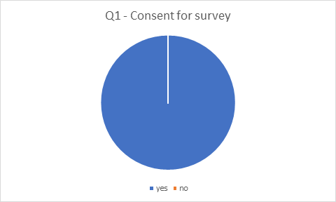
Question was sent above via outlook to 5 people. Received 5 responses.
Yes – 5
No – 0
For this question I have used a pie chart to show the results, it was important to ensure that all participants taking this questionnaire are giving their consent and are happy to take part.
Question 2 – Do you use MS Teams more than other digital skills?
Yes or no answer.
The following line chart presents the results for this question.
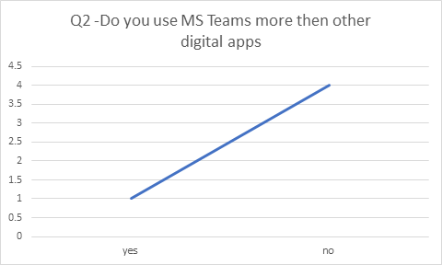
Questionnaire was sent out to UWTSD via outlook, 5 responses received.
Yes – 1
No – 4
The following line graph shows the results from the responses received; this graph clearly stated that UWTSD students do not feel they use MS Teams more than other digital apps.
Question 3 – How often do you use these apps to collaborate?
100 percent of results as follows:
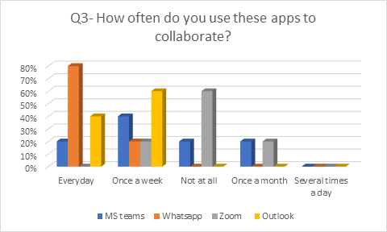
Questionnaire sent out to UWTSD via outlook, 5 responses recorded.
MS Teams – 20% everyday, 40% once a week, 20% not at all, 20% once a month
WhatsApp – 80% everyday, once a week 20%
Zoom – 20% once a week, 60% not at all, once a month 20%
Outlook – 40% everyday, 60% once a week

Question 4 – Rank these apps in order of how often you use them?
100 percent of results recorded.

Questionnaire sent out to UWTSD students via outlook. 5 responses recorded.
MS Teams – 60%
MS Word – 20%
MS PowerPoint – 20%
Excel – 20%

Question 5 – Which app do you consider the most important?
100 percent of the responses recorded show as following:

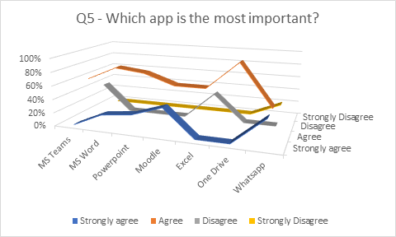
Questionnaire sent out to UWTSD students via outlook. 5 responses recorded.
MS Teams – 60% agree, 40% disagree.
MS Word – Agree 80%, Strongly agree 20%
MS PowerPoint – 75% agree, 25% strongly agree.
Moodle – 60% agree, 40% strongly agree.
Excel - 60% agree, 40% disagree.
One Drive – 100% agree.
WhatsApp – Agree 40%, 40% strongly agree, 20% strongly disagree.
Discussion
In today's digital age, having a strong set of digital skills is crucial for success in both academic and professional settings. As a result, many universities are placing a greater emphasis on teaching students the digital skills they need to thrive in the modern workplace.
At UWSTD, students have identified several digital skills as being particularly important. As shown above it is important that consent is taken from all participants that are taking part in the questionnaire to ensure that they are getting a choice to complete it.
MS Teams has become increasingly popular among students, particularly considering the COVID-19 pandemic and the shift towards remote learning. The platform offers a range of features, such as instant messaging, video conferencing, and file sharing, that make it a valuable tool for online collaboration however from this questionnaire I have established that UWTSD do not use teams more then other digital skills, from the 5 people that completed the questionnaire 4 people stated no and 1 person stated yes.
As shown in question 2, WhatsApp is a messaging app that is widely popular among students for its ease of use and ability to create group chats. It is often used for casual communication between friends but can also be used for group projects and assignment and during this questionnaire it has been established that all 5 students at UWTSD taking this questionnaire use this daily.
Zoom is a video conferencing platform that has become a popular tool for virtual classes and meetings. Students may use Zoom to attend virtual lectures, participate in group discussions, and collaborate on projects, results from the questionnaire show that students at UWTSD mostly do not use zoom at all.
Outlook is an email and calendar app that is often used by students to manage their academic schedules, communicate with professors, and organize their coursework, as for students at UWTSD according to the questionnaire outlook mostly once a week.
OneDrive is Microsoft's cloud storage service that allows you to store, sync, and share files across multiple devices. It enables you to access your files from any device with an internet connection and collaborate with others in real-time on Office documents. Additionally, OneDrive provides a simple way to organize and find important files, while also keeping them protected and backed up. According to students at UWTSD the most important digital app is One drive as shown in question 5, with Microsoft Word being a close second.
Conclusion
In today's digital age, students need to have a wide range of digital skills to succeed academically and professionally. The main key points identified are that students need to be proficient in using digital tools like Microsoft Teams, Zoom, and One Drive, Outlook to work collaboratively with their peers and teachers. With the vast amount of information available online, students need to be able to effectively search for and evaluate sources of information, as well as analyse and interpret data.
Digital literacy: Students need to be able to navigate digital platforms and tools with ease, including email, social media, and online learning management systems.
Cybersecurity: With cyber threats on the rise, students need to be knowledgeable about cybersecurity best practices, including password management, data protection, and safe online behaviour.
Creative thinking and problem-solving: Digital skills are not just about technical proficiency; students also need to be able to think creatively and solve problems using digital tools and platforms.
Overall, the digital skills most important for students will depend on their individual needs and goals. However, by developing a strong foundation in the above digital skills, students can position themselves for success in the digital age.

References
1. European Commission: Survey of Schools – ICT in Education: Benchmarking Access, Use and Attitudes to Technology in Europe’s Schools (2013), https://ec.europa.eu/ digital-agenda/sites/digital-agenda/files/KK-31-13-401-ENN.pdf (retrieved September 20, 2014)
2. European Commission, A.: Digital Agenda for Europe (2010), http://ec.europa. EU/information society/digital-agenda/index_en.htm (retrieved September 20, 2014)
3. CEDEFOP: Research Paper No 21, Skill mismatch: The role of the enterprise. Luxembourg. Publications Office of the European Union (2012)
Sustainability 2022, 14(20), 13117; https://doi.org/10.3390/su142013117
Driscoll, D.L., 2011. Introduction to primary research: Observations, surveys, and interviews. Writing spaces: Readings on writing, 2, pp.153-174.
Stewart, D.W. and Kamins, M.A., 1993. Secondary research: Information sources and methods (Vol. 4). Sage.
Creswell, J.W., Research Design: Qualitative & Quantitative Approaches, London: SAGE Publications, 1994. https://www.researchgate.net/profile/Vihan- What_are_the_characteristics_of_quantitative_research/ SuphatSukamolson.pdf
Polonsky, M.J 4999_Polonski_Chapter_5.pdf (sagepub.com)

