

ACCA4023: Introduction to Web and Database Concepts

Student ID: 2511138
Student Name :akram ahmadfakhredin

Contents
1. Introduction 3
2. Scenario Analysis 4
3. Entity Relationship Diagram (ERD) 6
4. Data Structure Development 6
4.1 Suppliers Table 7
4.2 Medicines Table 8
4.3 Customers Table 8
4.4 Sales Table 9
4.5 SalesDetails Table 10
4.6 Prescriptions Table 11
5. Normalisation to Third Normal Form (3NF) 12
5.1 First Normal Form (1NF) 12
5.2 Second Normal Form (2NF) 13
5.3 Third Normal Form (3NF) 13
6. Sample Data Population 13
7. Query Development 16
8. Validation and Testing 24
9. System Evaluation and Reflection 25
10. Conclusion 26
References 27

List of Images
Figure 1: ER diagram 7
Figure 2: Suppliers table creation code 8
Figure 3: Suppliers table 8
Figure 4: Medicines table creation code 9
Figure 5: Medicines table 9
Figure 6: Customers table creation code 10
Figure 7: Customers table 10
Figure 8: Sales table creation code 11
Figure 9: Sales table 11
Figure 10: SalesDetails table creation code 12
Figure 11: SalesDetails table 12
Figure 12: Prescriptions table creation code 13
Figure 13: Prescriptions table 13
Figure 14: Suppliers Table data insertion 15
Figure 15: Medicines Table data insertion 15
Figure 16: Customers Table data insertion 16
Figure 17: SalesDetails Table data insertion 16
Figure 18: Sales Table data insertion 16
Figure 19: Prescriptions Table data insertion 17
Figure 20: Query for Medicines Low in Stock 18
Figure 21: Results of Medicines Low in Stock query 18
Figure 22: Query for Medicines by Supplier 18
Figure 23: Results of Medicines by Supplier query 19
Figure 24: Query for Prescription History of Customer 19
Figure 25: Results of History of Customer query 20
Figure 26: Query for Total Sales per Day 20
Figure 27: Results of Total Sales per Day query 21
Figure 28: Query for Most Sold Medicines 21
Figure 29: Results of Most Sold Medicines query 21
Figure 30: Query for Customer Sales History 22
Figure 31: Results of Customer Sales History query 22
Figure 32: Query for Medicines Expiring Soon 23
Figure 33: Results of Medicines Expiring Soon query 23
Figure 34: Query for Sales with Medicine Details 24
Figure 35: Results of Medicine Details query 24

1. Introduction
The prospective chain of neighbourhood pharmacies is MediLink Pharmacy, and at present, it is manually balancing significant data of operation, such as inventory of medicines, prescriptions, supplier data and customer data. The problems associated with this manual system are mostly errors, duplication of data and problems with tracking of the stocks, prescriptions, and sales transactions. A Database system that handles these issues has been developed using Microsoft Access. The significant workflows that the system will automate are inventory management, prescription management, supplier management, and sales monitoring in an effort to have the pharmacy enhance the accuracy of the information, reporting, and the overall operations of the pharmacy.

2. Scenario Analysis
The MediLink Pharmacy database system is supposed to handle the data pertaining to medicines, suppliers, customers, prescription and sales transactions. The most important elements to develop the database were the key entities, their attributes, and relationship among them, based on the scenario [1].
Main Entities and Attributes
1. Medicines – contains the data about medications that are offered in the pharmacy.
Attributes include:
- MedicineID
- MedicineName
- Category
- Price
- StockQuantity
- ReorderLevel
- ExpiryDate
- SupplierID
2. Suppliers – the stores store the details of companies offering the pharmacy with medicines to pharmacies.
Attributes include:
- SupplierID
- SupplierName
- ContactPerson
- Phone
- Email
- City
3. Customers – customer details are found here.
Attributes include:
- CustomerID
- CustomerName
- Phone
- Email
- City
- DateRegistered
4. Sales – enter the records of each sales transaction.
Attributes include:
- SaleID
- CustomerID
- SaleDate
- TotalAmount
5. SalesDetails – records the medicines that are used on a sale.
Attributes include:
- SalesDetailID
- SaleID
- MedicineID
- Quantity
- UnitPrice
6. Prescriptions – stores information on prescriptions prescribed by physicians.
Attributes include:
- PrescriptionID
- CustomerID
- MedicineID
- DoctorName
- PrescriptionDate
- Quantity
Relationships Between Entities
- A single supplier can supply many medicines.
- There are numerous prescriptions per customer.
- A single customer can transact a lot of sales.
- A single sale may have numerous medicines, which are handled by the SalesDetails table.
- A single drug may be prescribed in several prescriptions and sales histories.

3. Entity Relationship Diagram (ERD)
An Entity Relationship Diagram (ERD) is a visual aid that was created to present the diagram of the MediLink Pharmacy database and demonstrate how various entities will be related in the database [2]. The key individuals that were determined in the scenario analysis are represented graphically in the diagram, as Suppliers, Medicines, Customers, Sales, SalesDetails and Prescriptions. All the entities are represented in the form of a table with their own attributes.
Each record of a table is uniquely identified by a primary key. Arbitrarily, the primary key of SupplierID, MedicineID, CustomerID, SaleID, SalesDetailID and PrescriptionID are the keys of the corresponding entities, respectively. Relationships among associated tables are made with the help of foreign keys. As an example, the SupplierID in the Medicines table is correlated with the medicines and their supplier, whereas the CustomerID in the Sales and Prescriptions tables is correlated with their customers and the transactions and prescriptions they make.
Throughout the ERD, most of the relationships are of the one-to-many (1:M) type [3]. To illustrate, a single supplier can supply numerous medicines, and an individual customer can place numerous sales and prescription orders. The SalesDetails table addresses the many-to-many relationship between Sales and Medicines, ensuring well-organised data and upholding the database's data integrity.
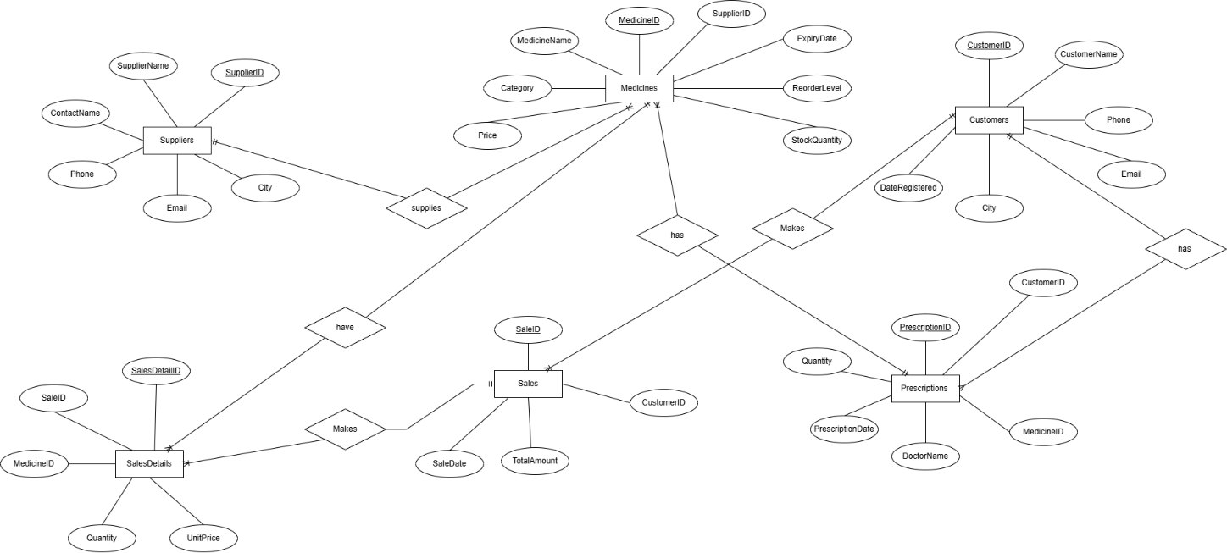
Figure 1: ER diagram
Source: (Author, 2026)

4. Data Structure Development
The MediLink Pharmacy database was deployed under Microsoft Access by the creation of tables against columns seen in the ERD. All the tables were appropriately designed to hold information with relevant data types. The primary keys were given to identify the unique records of each record, and foreign keys were employed to give relationships among similar tables. The Microsoft Access Relationships Tool was used to create these relationships, and the reference integrity was imposed to ensure data consistency and stop the invalid entries [4].

4.1 Suppliers Table
The suppliers table is where the data concerning companies that provide medicines to the pharmacy are stored. SupplierID is also the primary key used in identifying the suppliers, which are uniquely identified using SupplierID. The other attributes are supplier name, contact person, phone number, email and city. This table relates to the Medicines table with the help of the SupplierID field.

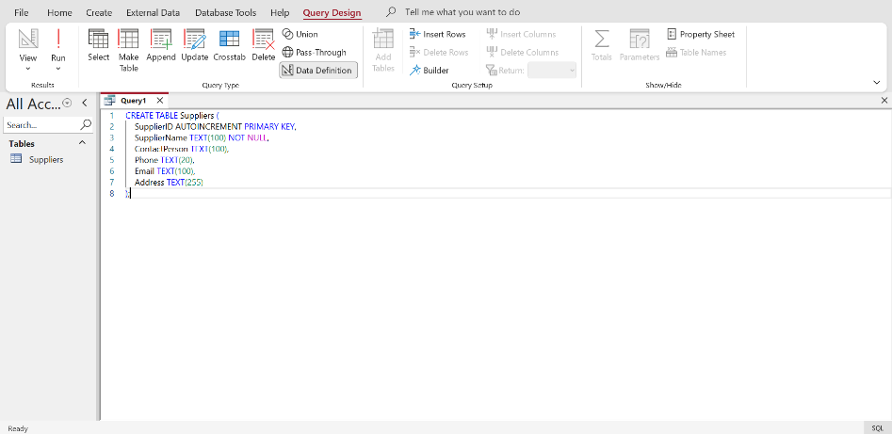
Figure 2: Suppliers table creation code
Source: (Author, 2026)
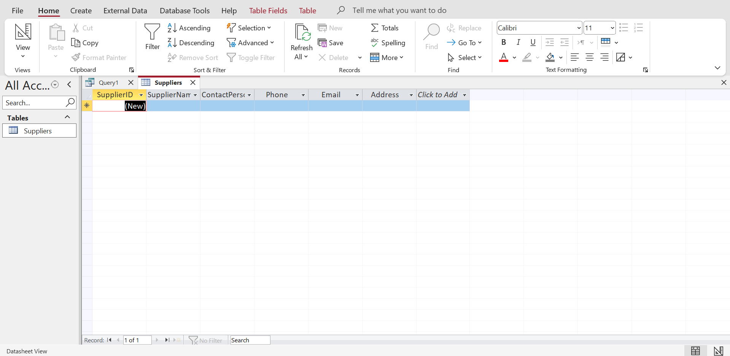
Figure 3: Suppliers table
Source: (Author, 2026)

4.2 Medicines Table
The medicines table will hold information regarding all the medicines in the pharmacy. Such traits as the medicine name, its category, price, stock quantity, reorder level, and expiry date are important. The primary key is medicineID, and SupplierID is a foreign key connecting each medicine to its supplier.
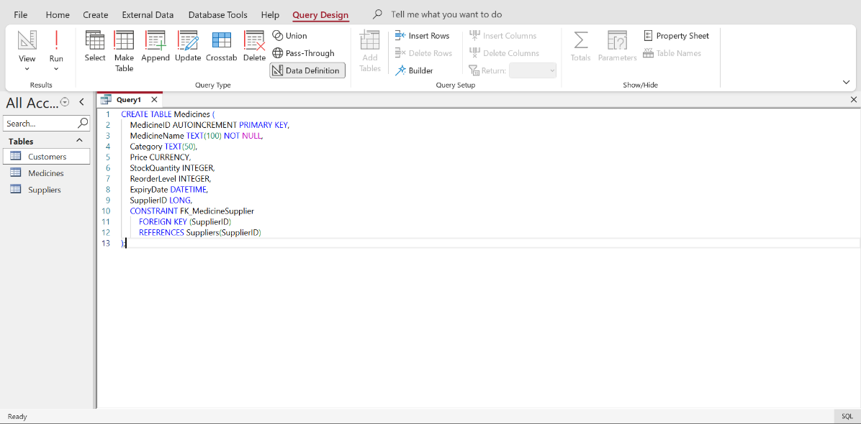
Figure 4: Medicines table creation code
Source: (Author, 2026)
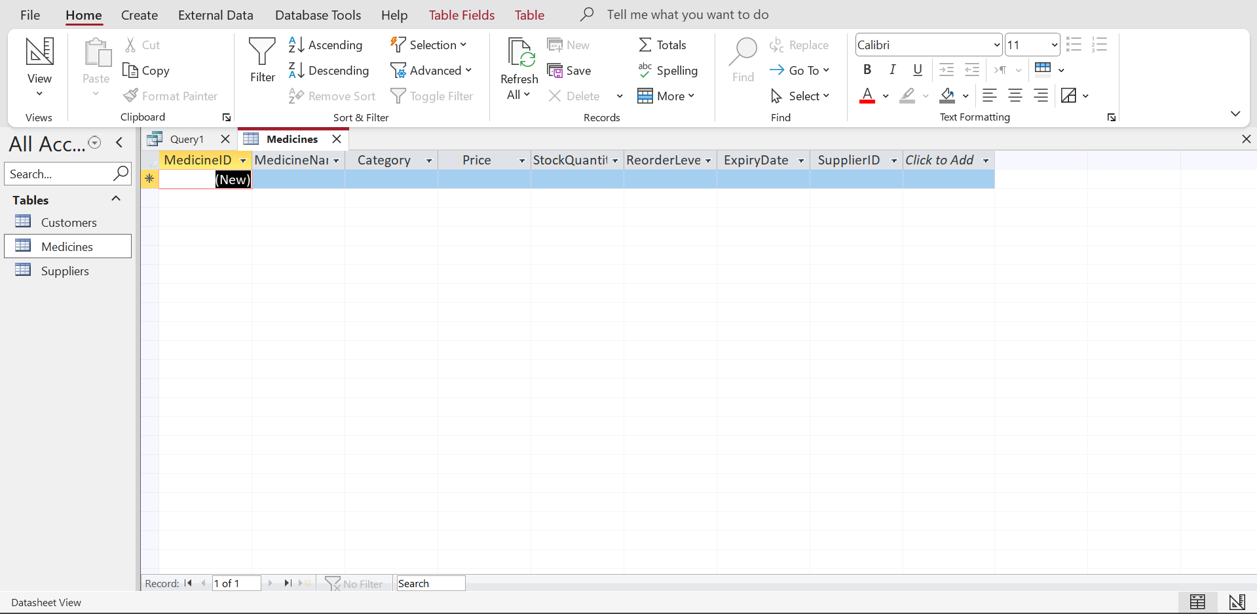
Figure 5: Medicines table
Source: (Author, 2026)

4.3 Customers Table
The Customers table contains the details of the consumer that include the name, phone number, email, the city of residence and the date of registration. CustomerID is the primary key of each customer and identifies a customer. This table is linked to the Sales table as well as the Prescriptions table.
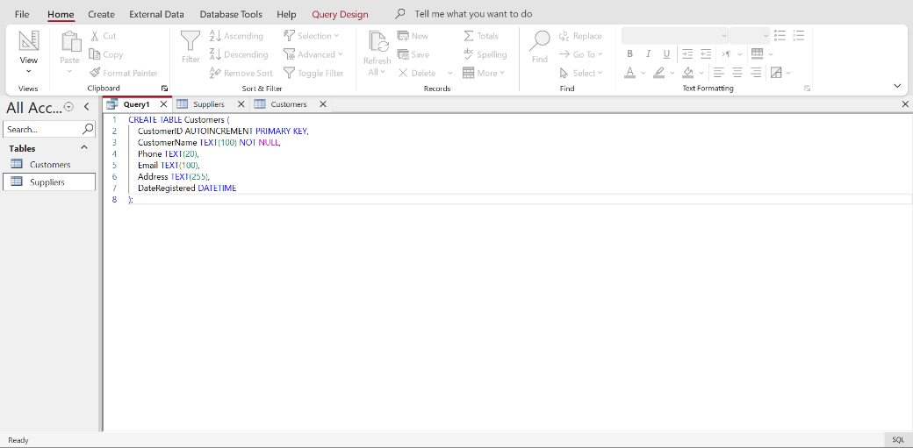
Figure 6: Customers table creation code
Source: (Author, 2026)
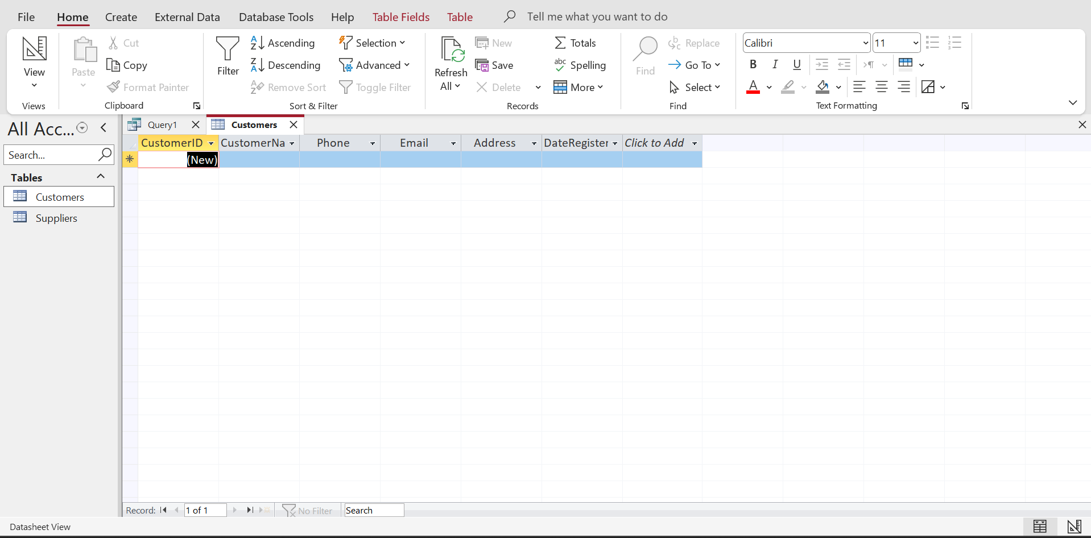
Figure 7: Customers table
Source: (Author, 2026)

4.4 Sales Table
The Sales table is used to document all sales made by the customers. The primary key of every transaction is SaleID. CustomerID is also a foreign key in the table, and it has the date of sale and the amount sold.
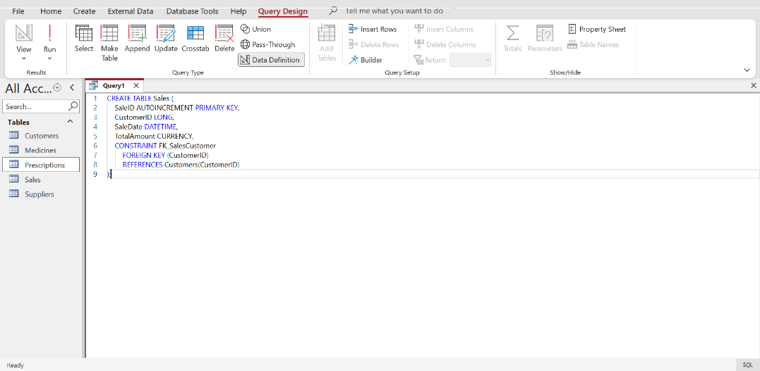
Figure 8: Sales table creation code
Source: (Author, 2026)
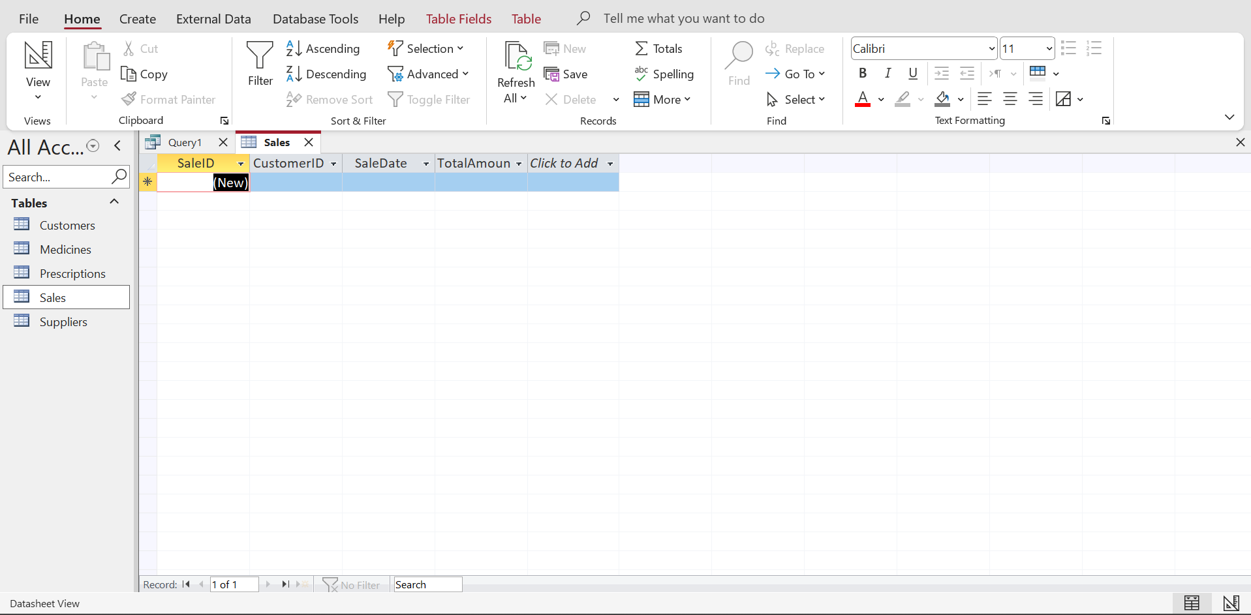
Figure 9: Sales table
Source: (Author, 2026)

4.5 SalesDetails Table
The SalesDetails table contains precise data of the medicines that have been part of each sale, the amount, and the price per unit. It has added SaleID and MedicineID as foreign keys to the Sales table and the Medicines table to resolve the many-to-many relationship that existed between the Sales table and the Medicines table.
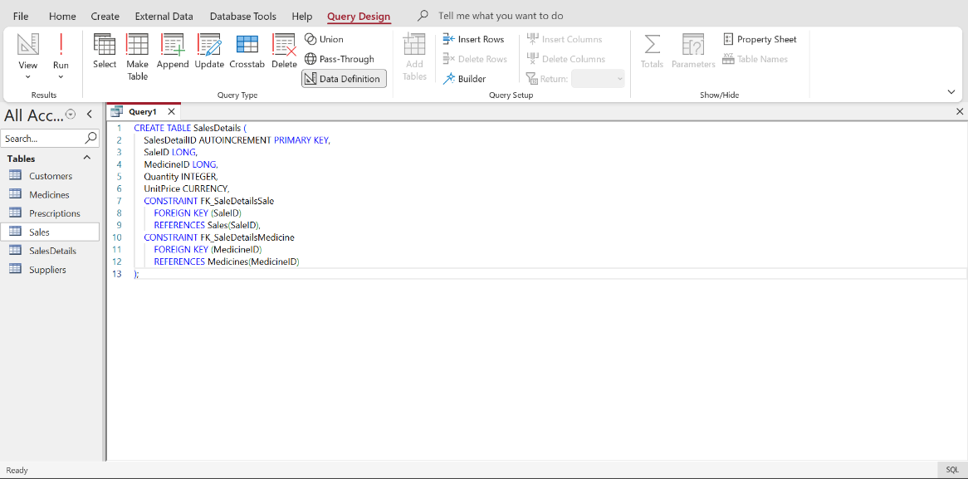
Figure 10: SalesDetails table creation code
Source: (Author, 2026)
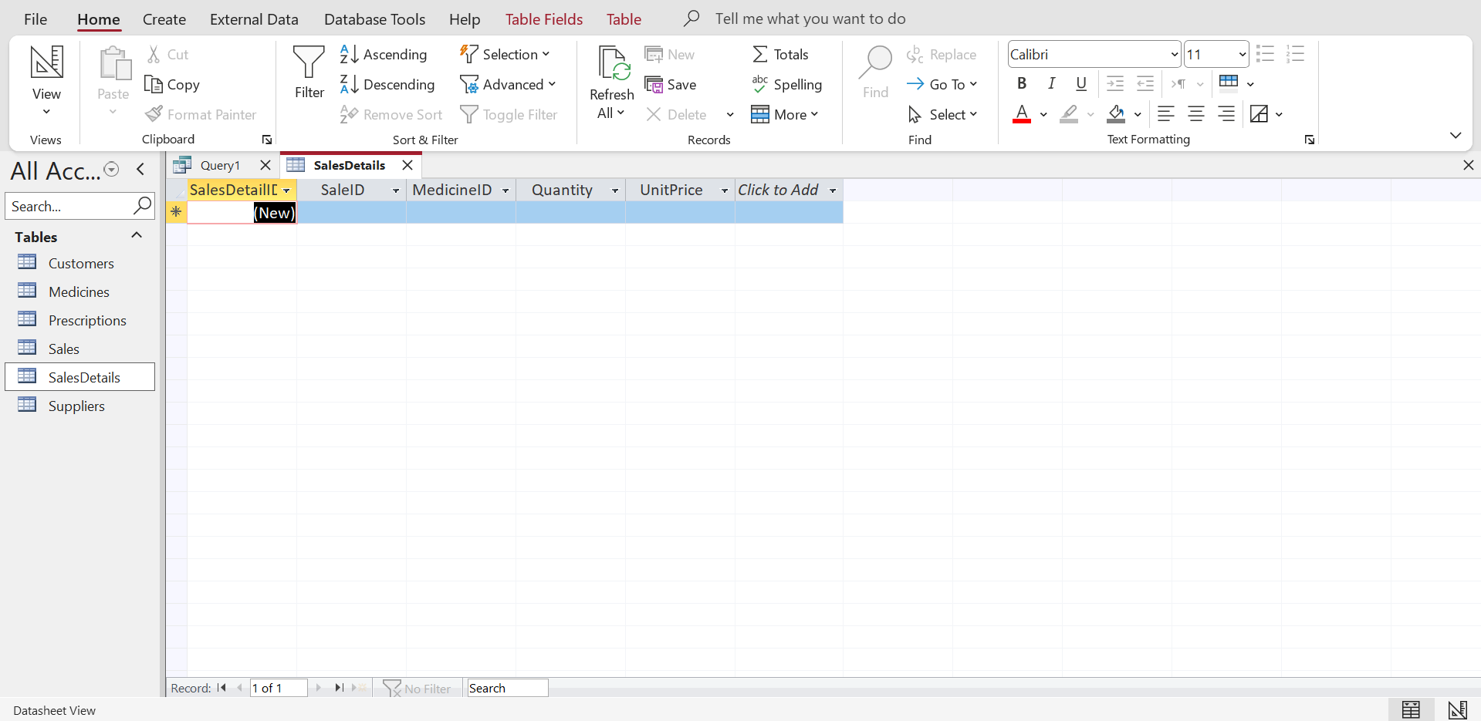
Figure 11: SalesDetails table
Source: (Author, 2026)

4.6 Prescriptions Table
The prescriptions table will hold details regarding the prescribed medicines by physicians to clients. PrescriptionID identifies each record where CustomerID and MedicineID are foreign keys, where the prescription is connected to the customers and medicine.
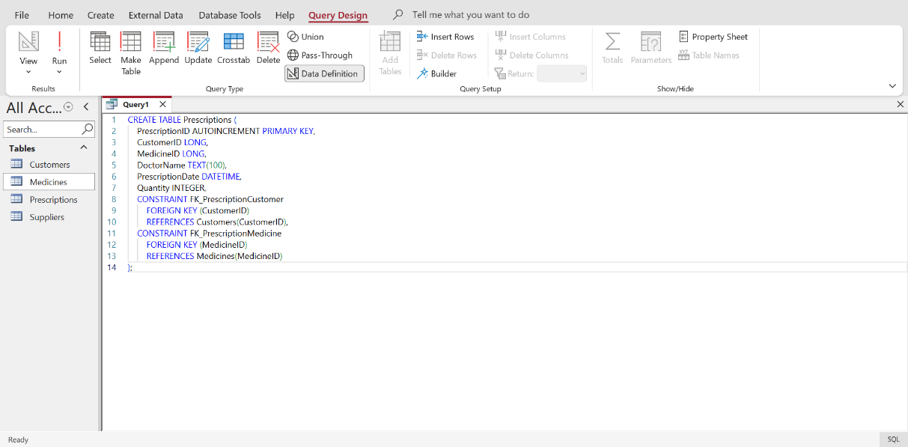
Figure 12: Prescriptions table creation code
Source: (Author, 2026)
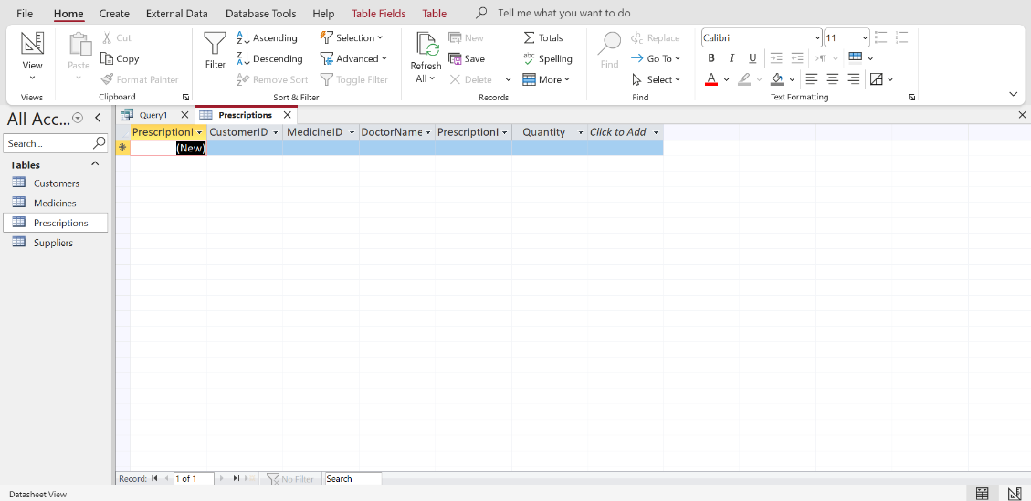
Figure 13: Prescriptions table
Source: (Author, 2026)

5. Normalisation to Third Normal Form (3NF)
To reduce redundancy and data consistency, the MediLink Pharmacy database design was normalised to the Third (3NF) normal form. The process made sure that any given table does not contain irrelevant data, and dependencies are appropriately designed.

5.1 First Normal Form (1NF)
A relation is in 1NF where all the attributes have simple values and no repeating groups [5].
The single values in the different fields are stored in each entity in the MediLink Pharmacy system. For example:
- Sales
SaleID → CustomerID, SaleDate, TotalAmount
A sale can consist of more than one medicine. To preserve the atomic values, medicines for sale are stored in a different table:
- SalesDetails
SalesDetailID → SaleID, MedicineID, Quantity, UnitPrice
This is done to ensure that only a single medicine is recorded in a single row, and this meets the 1NF requirement.

5.2 Second Normal Form (2NF)
A relation in 2NF is in 1NF, and all the non-key attributes are totally dependent on the primary key [2].
As an example, the dependencies of the system are:
- MedicineID → MedicineName, Category, Price, StockQuantity, ReorderLevel, ExpiryDate, SupplierID
- CustomerID → CustomerName, Phone, Email, City, DateRegistered
All properties are totally based on their primary key, which will guarantee adherence to 2NF.

5.3 Third Normal Form (3NF)
A relation is in 3NF when it is 2NF, and it contains no transitive dependencies [7].
Example dependency:
- SupplierID → SupplierName, ContactPerson, Phone, Email, City
Supplier information is not linked to MedicineID, but rather in the Suppliers table by SupplierID.
This normalised database minimises the redundancy, update anomalies and does not bring about poor database management.

6. Sample Data Population
Sample data were added to the MediLink Pharmacy database after the database structure was designed and all the tables were created to model real-life operations of the pharmacy. Proper populating of every table was carried out by ensuring that at least five records were added to the table to indicate the regular data the pharmacy handles in its day-to-day operations. This information assists in proving the manner of storing and handling various types of information concerning medicines, their suppliers, customers, prescriptions, and sales.
The data that had been inserted in the sample are:
- Supplier records This is the records of pharmaceutical firms supplying medicines to the pharmacy.
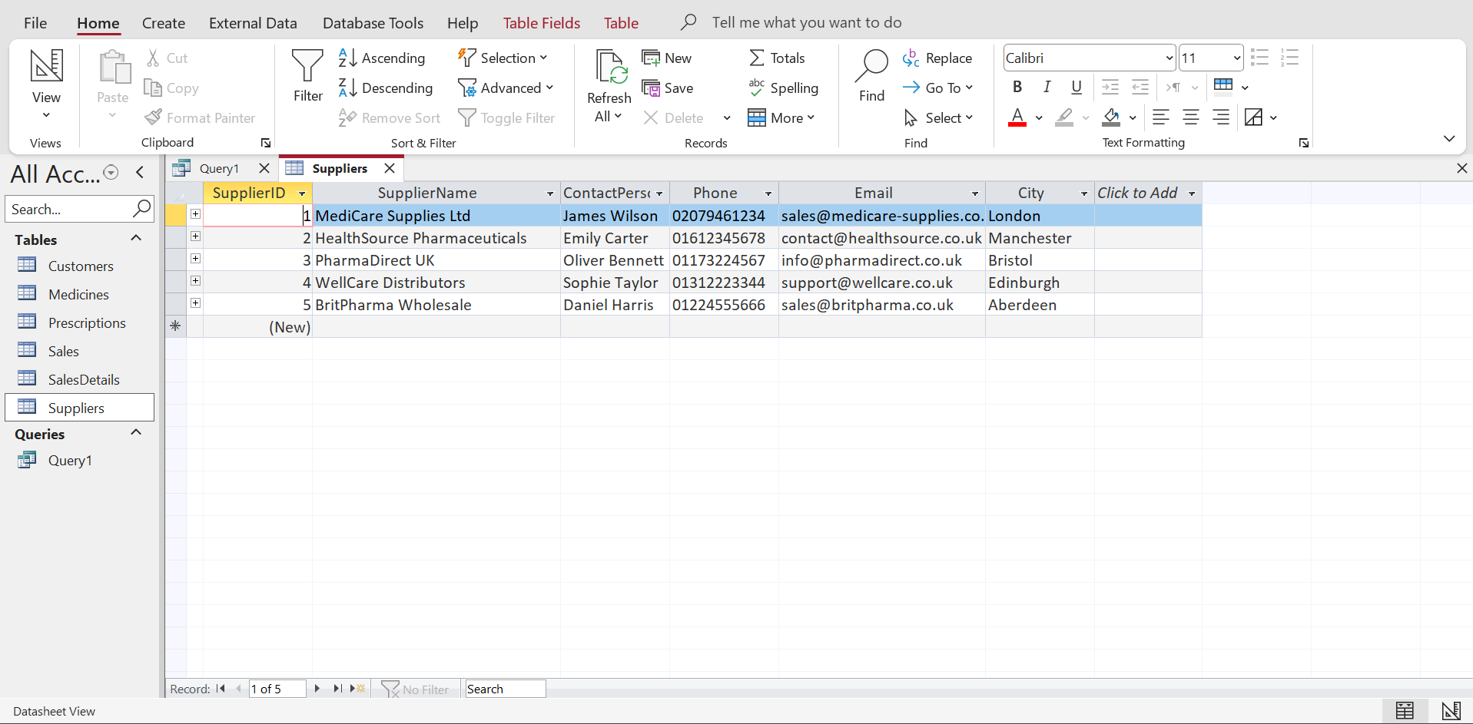
Figure 14: Suppliers Table data insertion
Source: (Author, 2026)
- Data in the medicine inventory, such as medicine names, category, prices, stock levels, re-order quantities and expiry time.
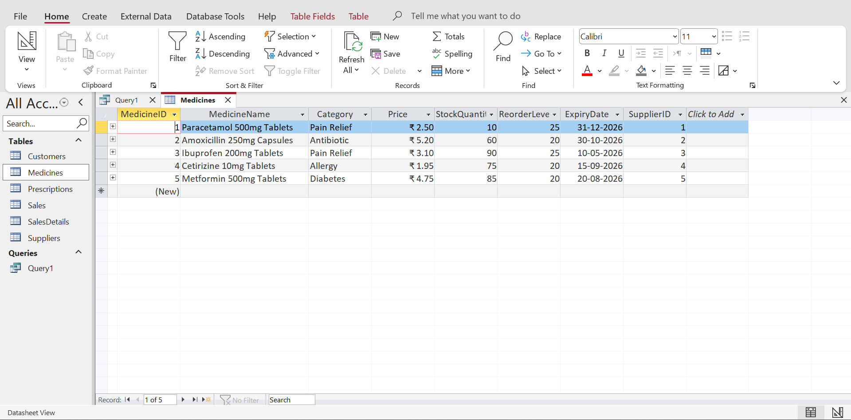
Figure 15: Medicines Table data insertion
Source: (Author, 2026)
- The customer details include customer names, contact details, and customer city details.
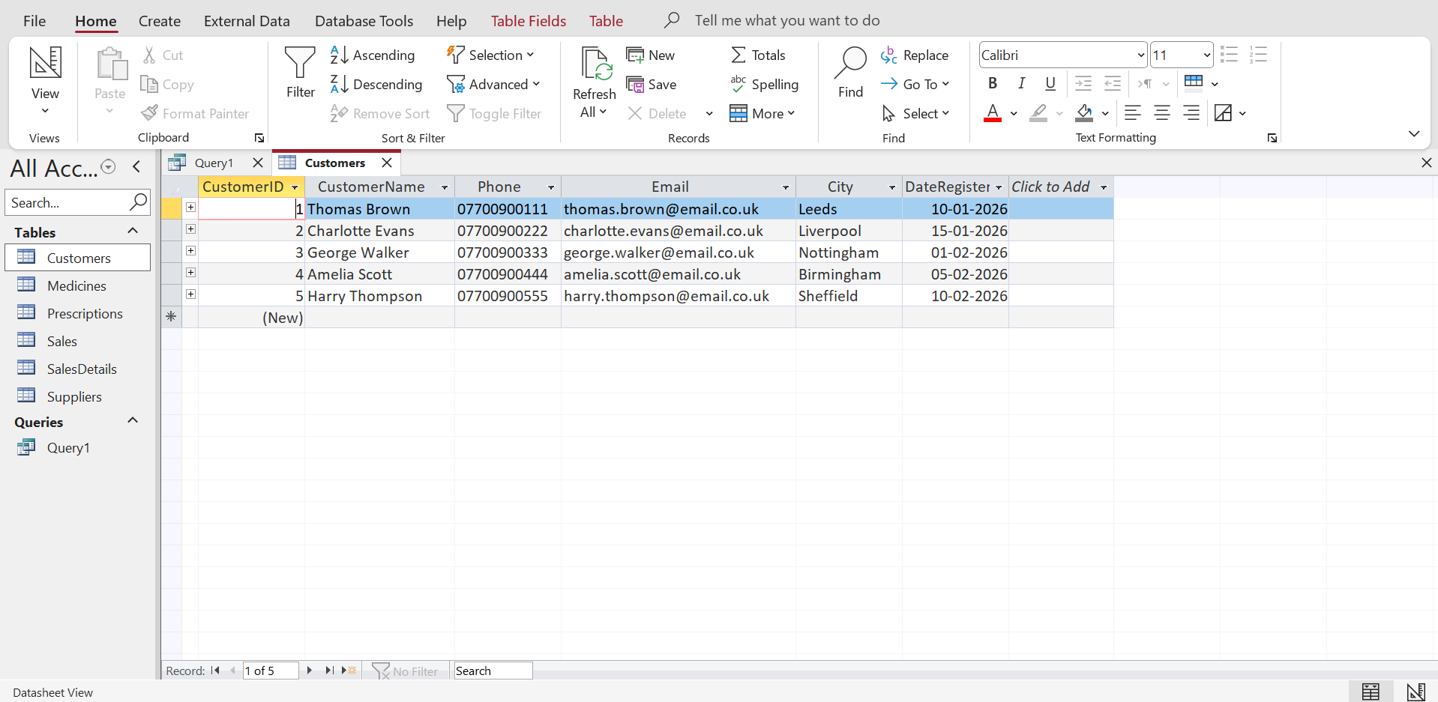
Figure 16: Customers Table data insertion
Source: (Author, 2026)
- Sales transactions, which would record the purchases made by customers, as well as the date and value of the sale.
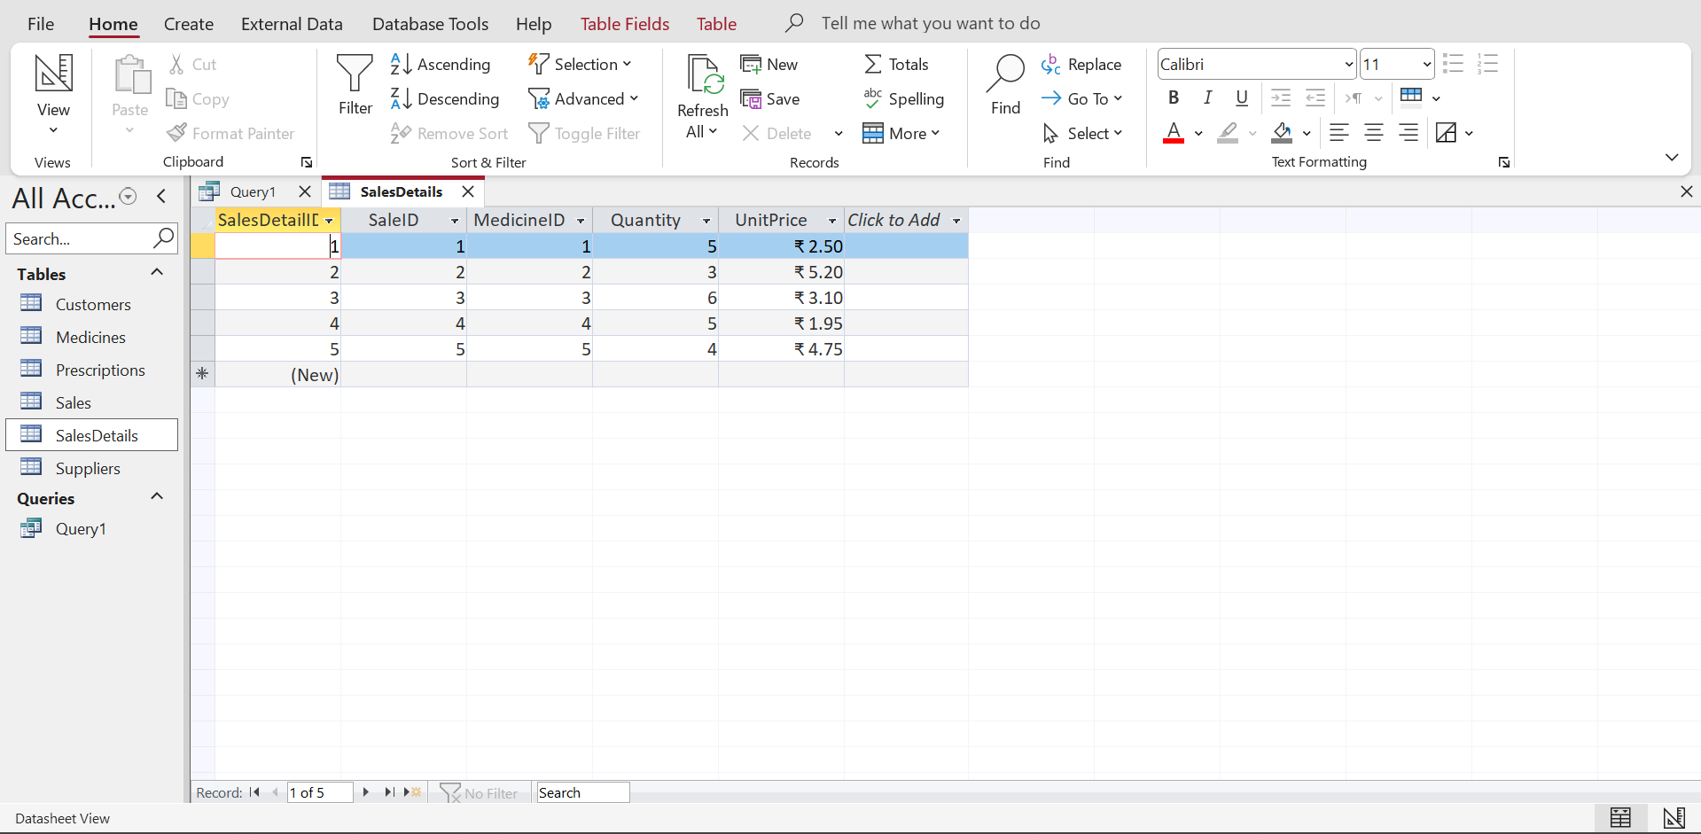
Figure 17: SalesDetails Table data insertion
Source: (Author, 2026)
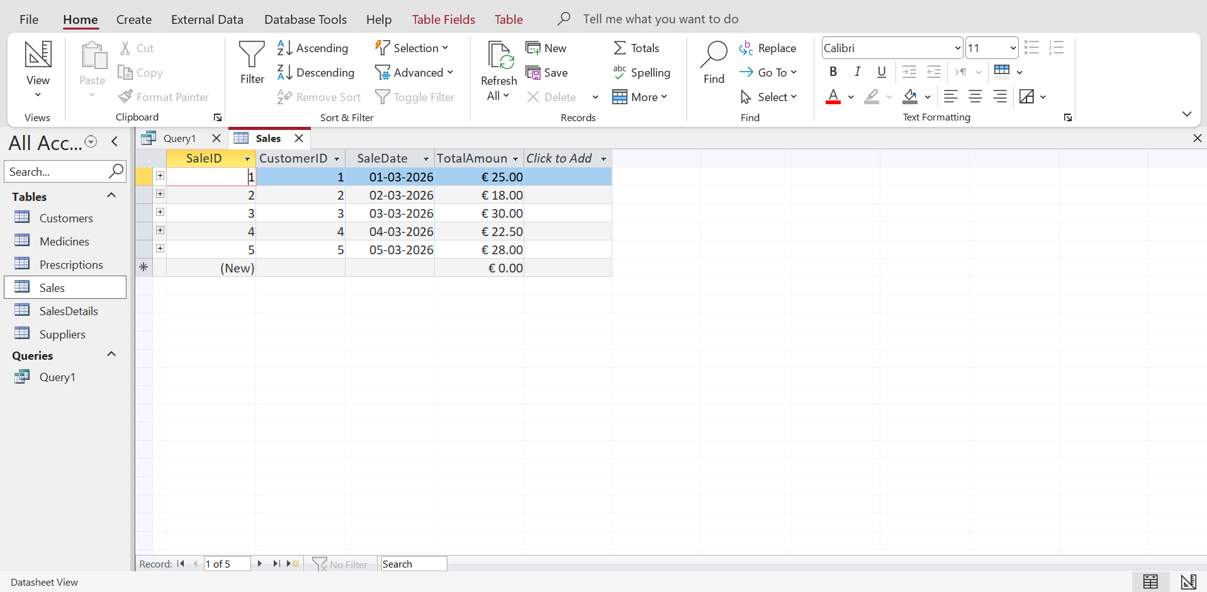
Figure 18: Sales Table data insertion
Source: (Author, 2026)
- Prescription records are given by the doctors to the medicines prescribed to the customers.
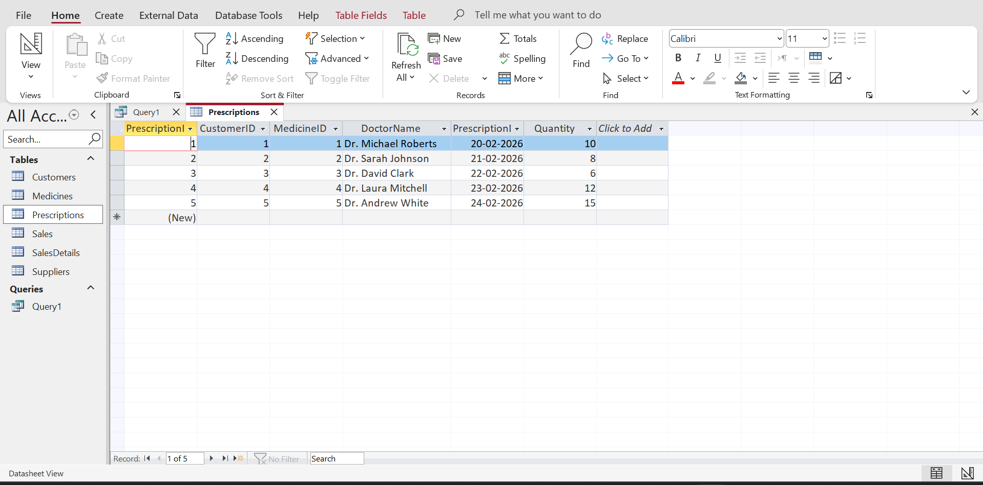
Figure 19: Prescriptions Table data insertion
Source: (Author, 2026)
The realistic signature of the sample population in the database gives a possibility to test the system. It allows queries to provide valuable results and illustrates how the database can be used to deal with pharmacy activities.

7. Query Development
Some queries were developed in Microsoft Access to prove that the MediLink Pharmacy database system can function. These queries enable users to access certain information stored in the database and facilitate the key processes of pharmacy management, namely the level of inventory, prescription tracking and sales analysis. The questions aid in the transformation of the stored data into information that can be used by the managers in making decisions.
The queries that were formulated included:
- Medicines Low in Stock
This query establishes medicines for which the stock level is below the reorder level. It prevents shortages of medicines and aids the workers in pharmacies to observe the quantity of stocks and avoid instances when the pharmacists run out of them.
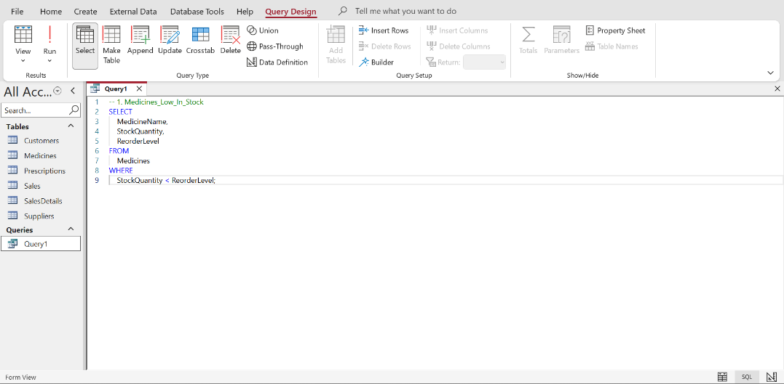
Figure 20: Query for Medicines Low in Stock
Source: (Author, 2026)
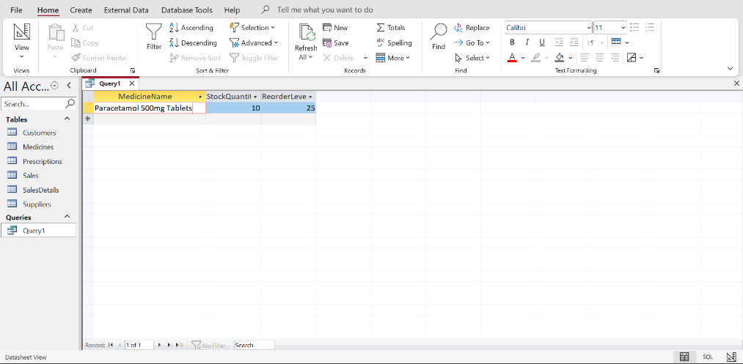
Figure 21: Results of Medicines Low in Stock query
Source: (Author, 2026)
- Medicines by Supplier
This query indicates drugs and their suppliers. It enables the pharmacy to conveniently find the supplier of every medicine and aids in the administration of suppliers.
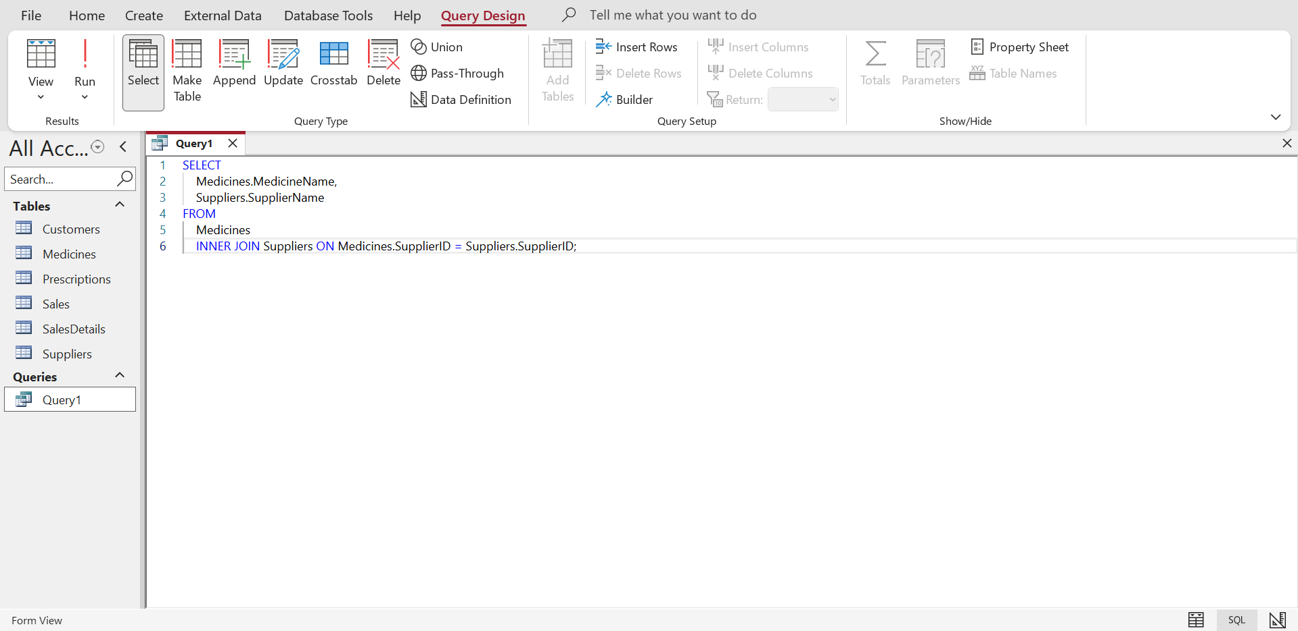
Figure 22: Query for Medicines by Supplier
Source: (Author, 2026)
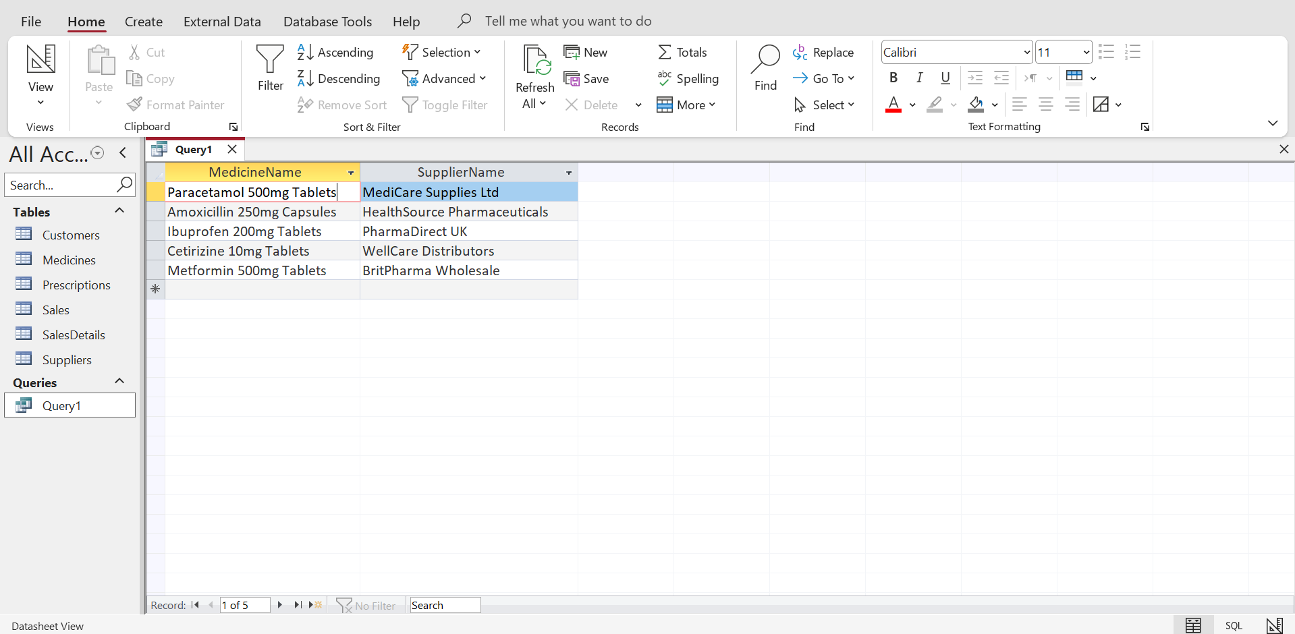
Figure 23: Results of Medicines by Supplier query
Source: (Author, 2026)
- Prescription History of Customer
This query obtains prescription history related to clients. It allows following the medicines prescribed by doctors and contains valuable data on the history of the prescription of a particular patient.
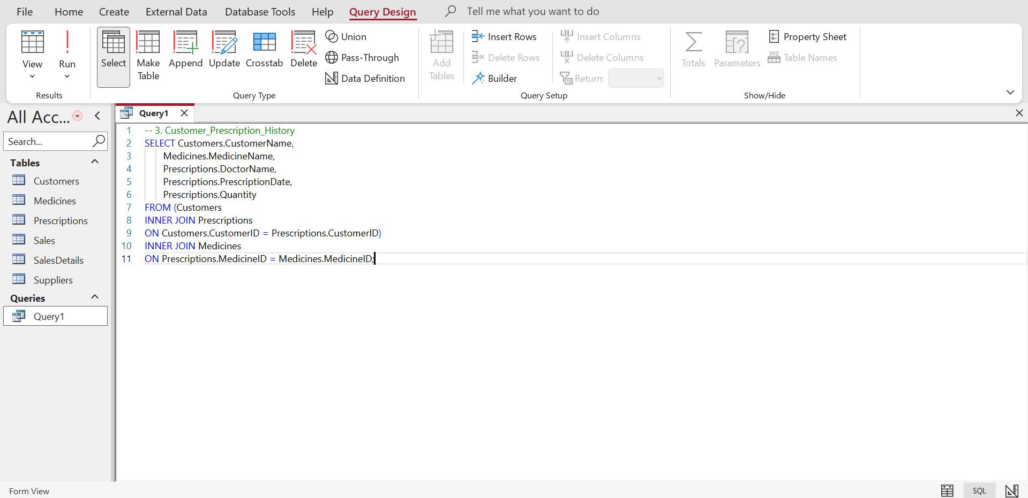
Figure 24: Query for Prescription History of Customer
Source: (Author, 2026)
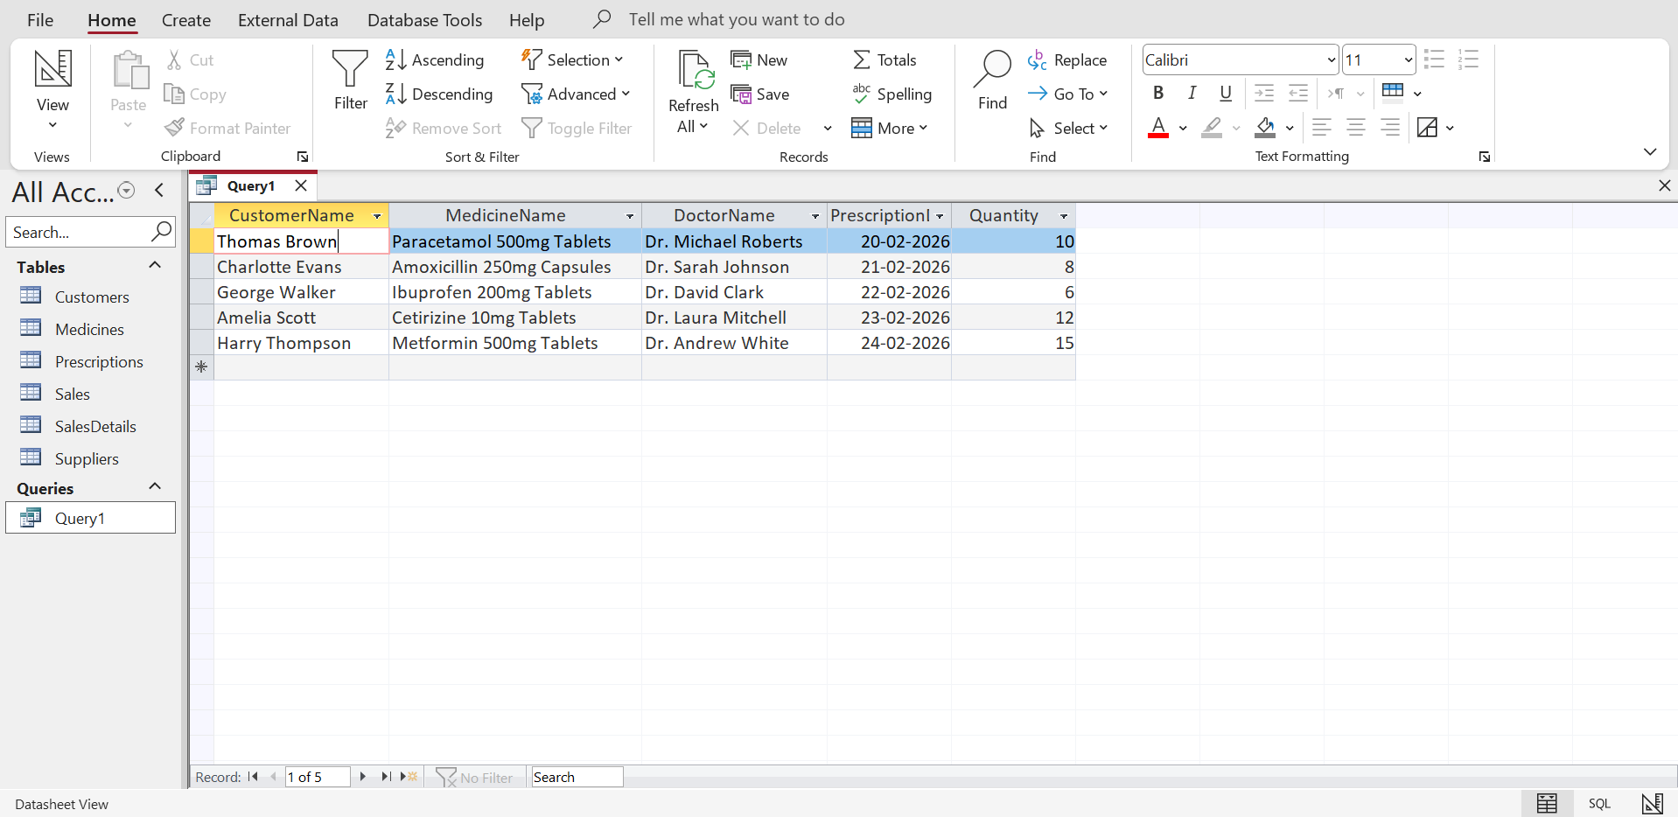
Figure 25: Results of History of Customer query
Source: (Author, 2026)
- Total Sales per Day
This query will provide the number of sales per day by adding the records of sales. It enables the pharmacy managers to study the day-to-day revenue as well as keep a track of the business functioning.
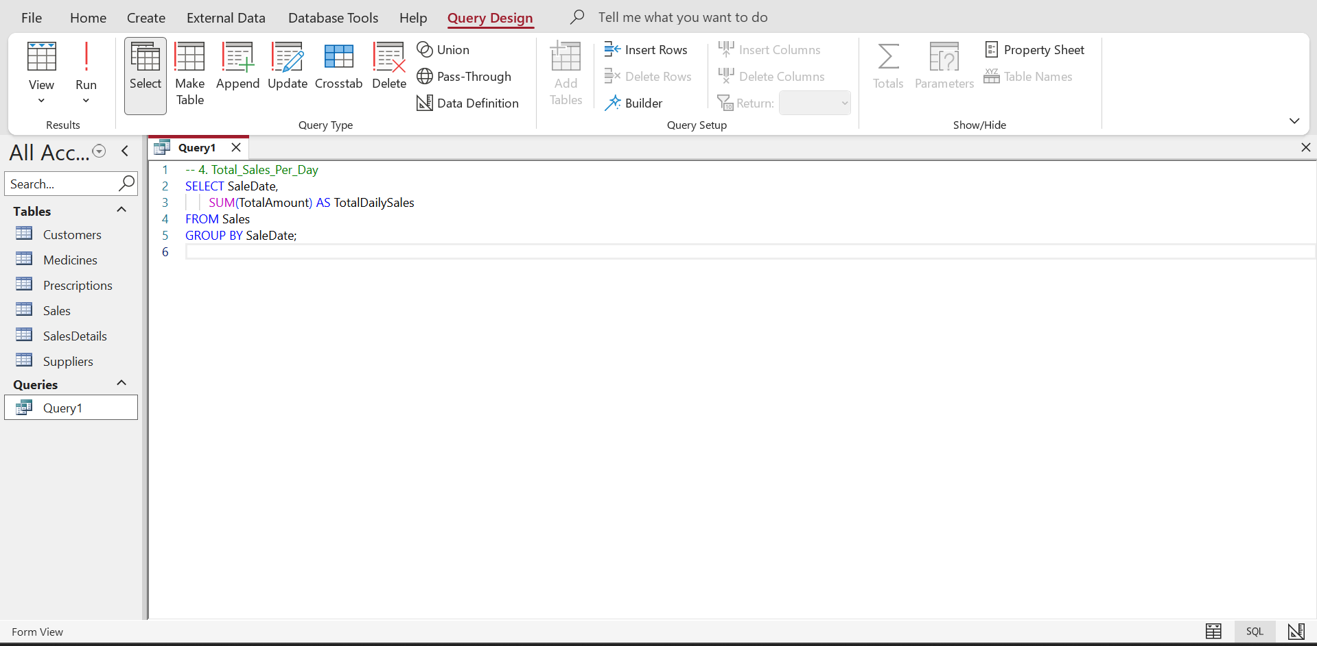
Figure 26: Query for Total Sales per Day
Source: (Author, 2026)
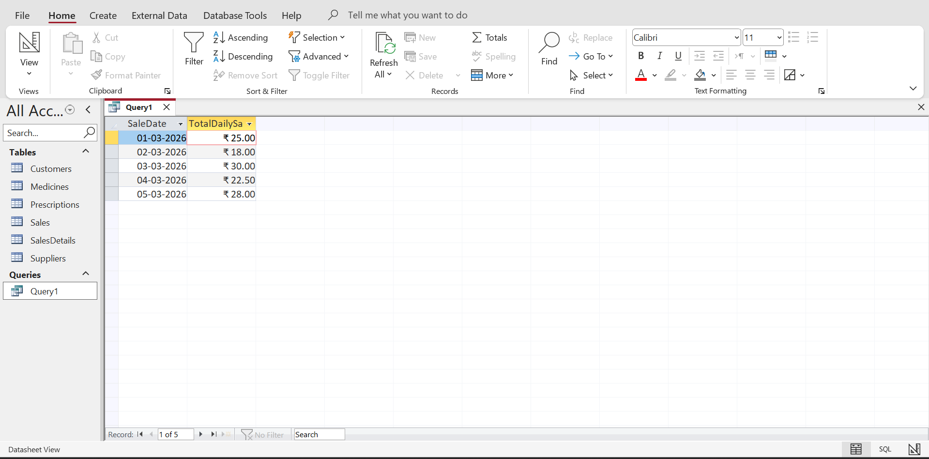
Figure 27: Results of Total Sales per Day query
Source: (Author, 2026)
- Most Sold Medicines
This query gives medicines that have the largest quantity of sales. It contributes to the understanding of the pharmacy of the most frequently purchased medicines, as well as helps in planning the stocks.
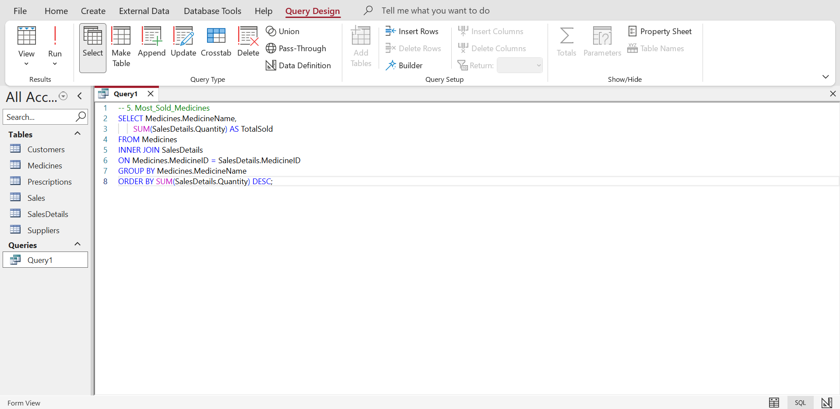
Figure 28: Query for Most Sold Medicines
Source: (Author, 2026)
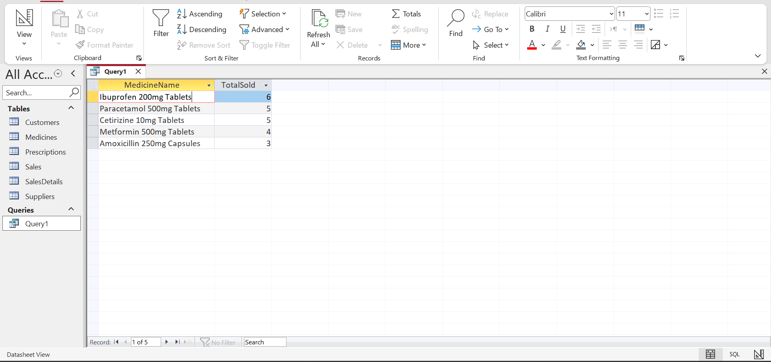
Figure 29: Results of Most Sold Medicines query
Source: (Author, 2026)
- Customer Sales History
This query shows all the transactions that customers make in terms of their sales. It enables the pharmacy to study the buying behaviour and the activity of the customers.
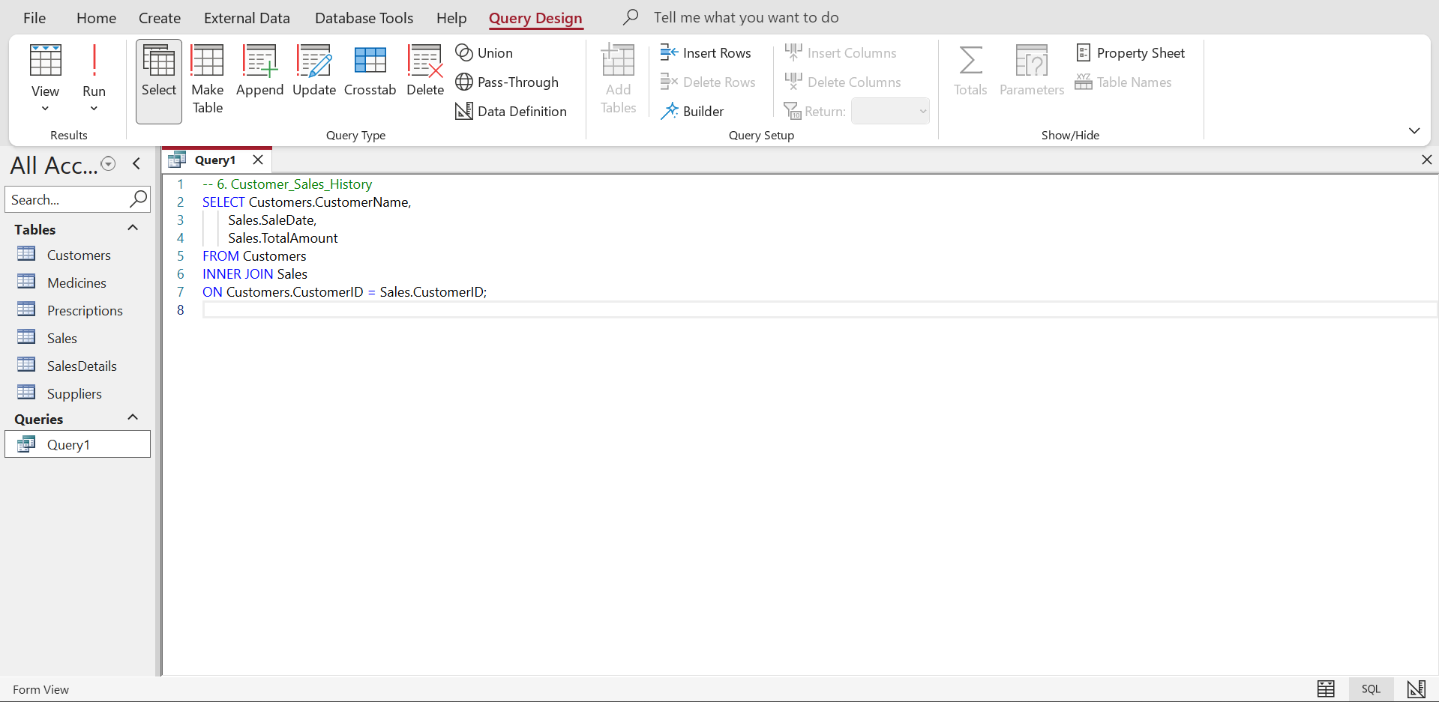
Figure 30: Query for Customer Sales History
Source: (Author, 2026)
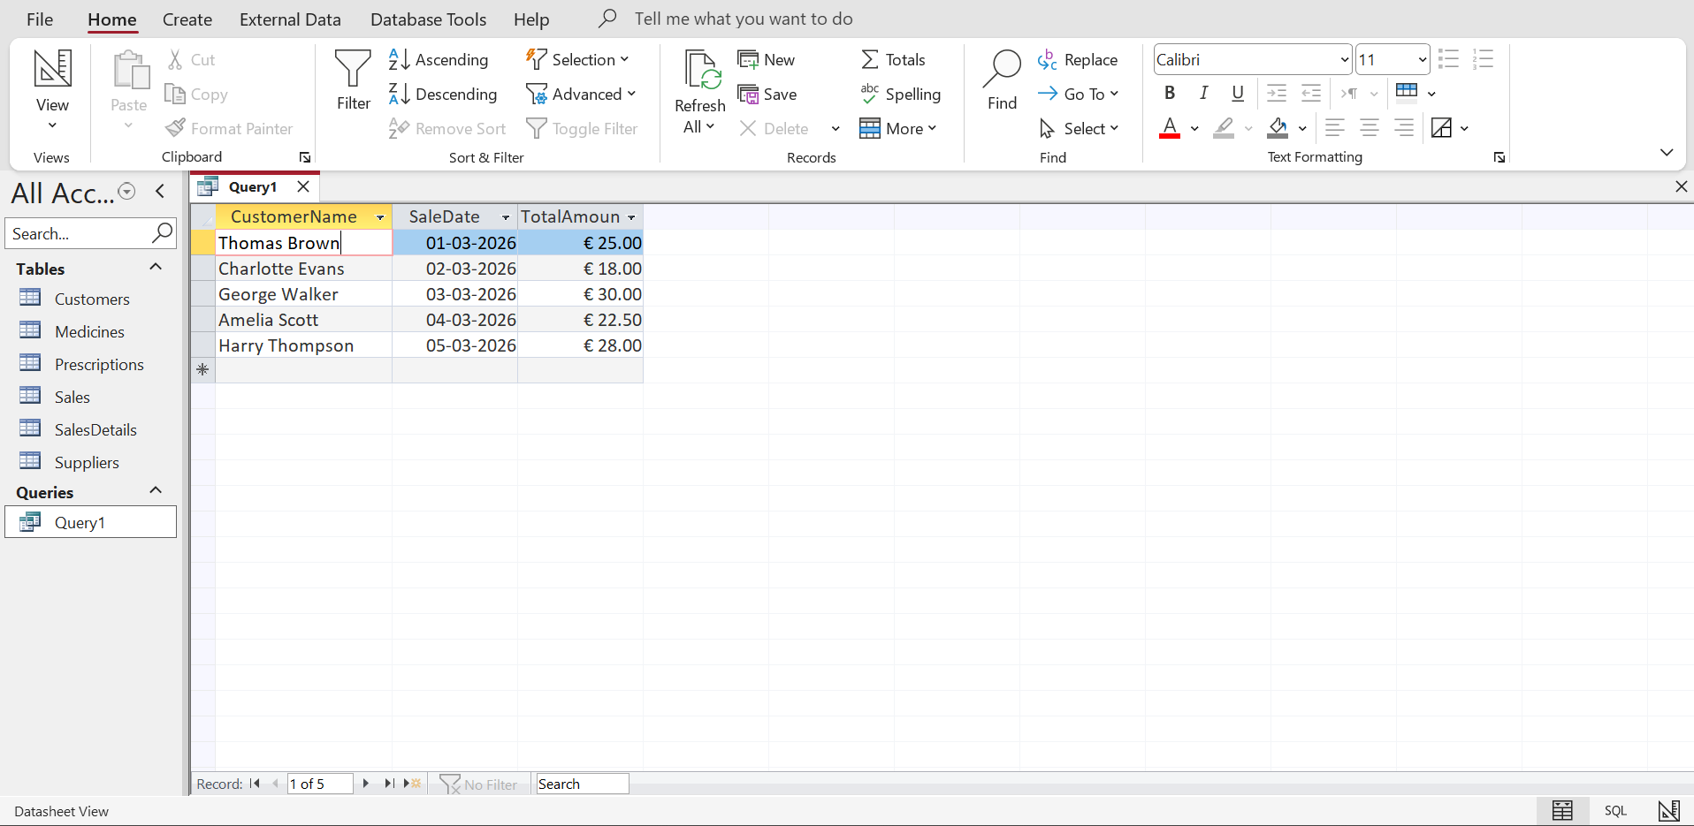
Figure 31: Results of Customer Sales History query
Source: (Author, 2026)
- Medicines Expiring Soon
This query shows medicines that are expired or approaching expiry date, and the pharmacy will be able to manage the stock and minimise waste that will be generated.
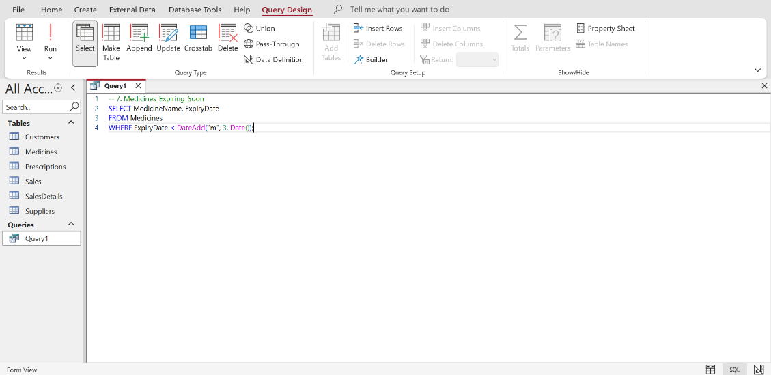
Figure 32: Query for Medicines Expiring Soon
Source: (Author, 2026)
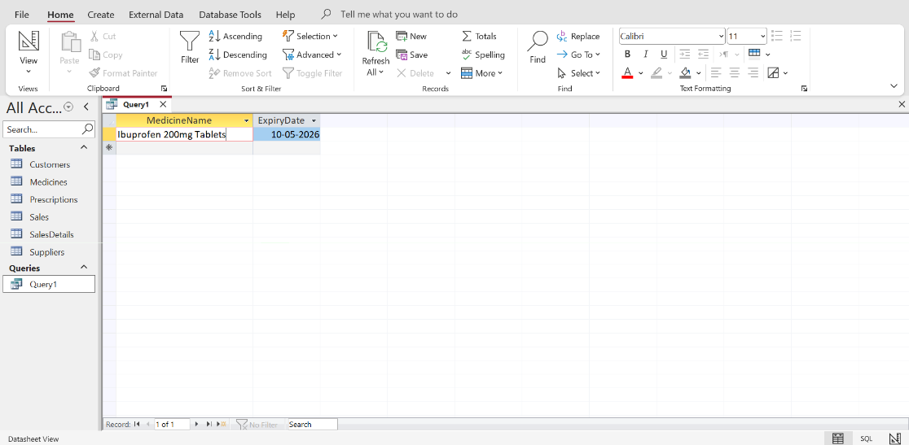
Figure 33: Results of Medicines Expiring Soon query
Source: (Author, 2026)
- Sales with Medicine Details
This query will allow a close perception of sales transactions, allowing us to see which medicines were put in each sale, how many were sold, and how much.
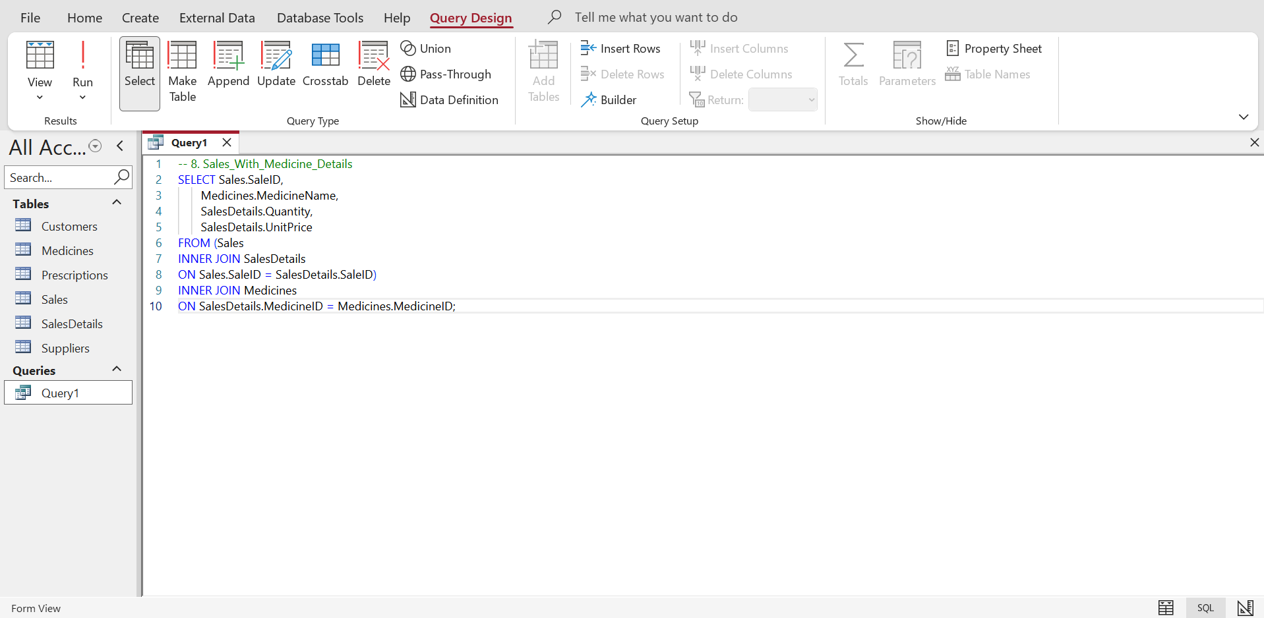
Figure 34: Query for Sales with Medicine Details
Source: (Author, 2026)
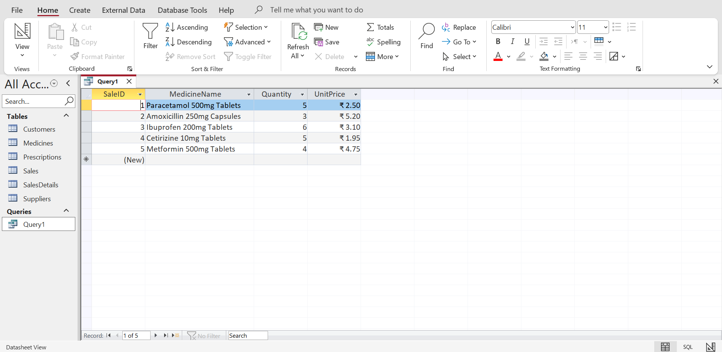
Figure 35: Results of Medicine Details query
Source: (Author, 2026)

8. Validation and Testing
The MediLink Pharmacy database system was put to the test to determine whether it is fit for the functional requirements that were identified during the scenario. This was done as testing through the database, whereby several operations were carried out using the database, which included adding new records, running queries and checking on the relationship between two or more tables. An example is understanding the storage of the data in the Customers table by insertion of a new record with the customer, which would ensure that the stored data is correct in the table. The other test was to run the low stock query with the view of making sure that medicines with stock levels lower than the reorder level were displayed properly. The perfectly calculated total sales were also tested using the daily sales query to ensure that the correct values in sales were calculated. These tests ensured that the queries had the right functionality, and the relationships ensured the data integrity, and the system has fulfilled the operational requirements of MediLink Pharmacy [8].

9. System Evaluation and Reflection
The design of the MediLink Pharmacy database system entailed several substantial decisions, which were aimed at offering efficiency and integrity of the data in the system. Among these design options is the fact that the SalesDetails table will hold the many-to-many relationship that exists between Sales and Medicines, in the sense that a given sales transaction can include several medicines. The database is also normalised to be at the Third Normal Form (3NF) to eliminate redundancy, besides achieving an effort to have the same data set in distinct tables [9].
It also experienced two issues during the development stages, and they included the maintenance of relationships between the tables, the type of data to be utilised in the fields and the writing of debugging queries to make sure that they produced the appropriate feedback.
The system can be refined to be more practical in the future and manage the inventory with the help of a convenient data entry form, automated management reports and stock notification.

10. Conclusion
Finally, the mediLink pharmacy database has been created and implemented using Microsoft Access. The system has been so beneficial in managing the medicines, suppliers, customers, prescriptions, and sales transactions. It enhances better control of stocks and reporting, and also allows useful queries, thereby making it convenient to support the decision-making of the management. To make sure that the data will be stored efficiently and reliably, the database design will be in agreement with the suggested best practices, including good relationships and normalisation of data management.

References
[1] P. Skavantzos & S. Link, “Entity/relationship graphs: Principled design, modeling, and data integrity management of graph databases,” Proceedings of the ACM on Management of Data, vol. 3, no. 1, pp.1-26, 2025. https://dl.acm.org/doi/pdf/10.1145/3709690
[2] D. Sineiro Barreiro, “Web application for generating Entity-Relationship diagrams with Natural Language Processing”, pp.1-92, 2024. https://ruc.udc.es/bitstreams/9502fd08-9bf5-44ba-8d30-85dca7832cf6/download
[3] N. Abdelaziz, M. Farghally, M. Mohammed & T. Soliman, “An interactive visual presentation of core database design concepts,” Proceedings of the 2024 on ACM Virtual Global Computing Education Conference V. vol. 1, pp. 5-11, December 2024. https://dl.acm.org/doi/pdf/10.1145/3649165.3690103
[4] R.J. Ramniklal, “Database security and integrity: Ensuring reliable and secure data management,” Mosaic of Ideas: Multidisciplinary Reflections, vol. 73, pp.1-411, 2024. https://www.researchgate.net/profile/Dr-Rawat-3/publication/382397856_MOSAIC_OF_IDEAS_Multidisciplinary_reflection/links/669b63ec4a172d2988b1e995/MOSAIC-OF-IDEAS-Multidisciplinary-reflection.pdf#page=81
[5] N.A.R. Amato, “Mastering database normalization: A comprehensive exploration of normal forms,” Researchgate, pp.1-14, 2023. https://www.researchgate.net/profile/Nicola-Antonio-Roberto-Amato/publication/374509386_Mastering_database_normalization_A_comprehensive_exploration_of_normal_forms/links/652106cffc5c2a0c3bbe361d/Mastering-database-normalization-A-comprehensive-exploration-of-normal-forms.pdf
[6] N.S. Snell & R.C. Lee, “A New Normalization Form for Limited Distinct Attributes,” arXiv preprint arXiv:2510.02865, pp.1-11, 2025. https://arxiv.org/pdf/2510.02865
[7] S. Abdy & S. Ramadhany, “Relational Database Design Principles: Normalization, Denormalization, and Query Optimization for Database Management Systems,” International Journal of Economics Management and Social Science, vol. 9, no. 1, pp.180-192, 2026. https://journal.salewangang.net/ijemss/article/download/43/40
[8] H. Omotunde & M. Ahmed, “A comprehensive review of security measures in database systems: Assessing authentication, access control, and beyond,” Mesopotamian Journal of CyberSecurity, vol. 2023, pp.115-133, 2023. https://journals.mesopotamian.press/index.php/CyberSecurity/article/download/109/113
[9] M. Hardini, V. Agarwal, D. Apriani, I.A. Widjaya, E. Setiawaty & N. Nurasiah, “Application of database normalization in increasing data storage efficiency,” International Transactions on Artificial Intelligence, vol. 3, no. 2, pp.201-211, 2025. https://journal.pandawan.id/italic/article/download/799/592

