UWTSD

Structure and Culture – Assessment 1

Module Code: LCBB4003
Module Title: Introducing the Modern Workplace
Year 1, Term 2

Module Lecturer Name: Rexon Nting
Student Name: Mecheres Sergiu Constantin
Student ID: 1814709

Submission date: 12.05.2020
Contents
1.0 Introduction 3
2.0 The relationship between organizational structure, culture, people and performance 4
3.0 The essential nature of managerial work 6
3.1 Role of leadership 6
3.2 Variables that determine effective management and leadership in ASDA 8
4.0 Understanding the behavioural approach to management 9
4.1 Factors affecting differences in individual behaviour in ASDA 10
5.0 Conclusion 11
6.0 References 12

Figure 1: Nature of Management 6
Figure 2: Mintzberg’s 10 roles of leadership 7
Figure 3: Factors affecting effective management 8
Figure 4: Behavioural approach to management 9
Figure 5: Factors that affect individual behaviour 10

1.0 Introduction
Depending on the organizational goal, the organizational structure determines the allocation of the roles and responsibilities, the monitoring process and the flow of communication between different levels (Aizhan et al., 2015). Organizational culture referred to the specific collection of values and norms that the peoples and the groups in an organization shares and control on the interaction process with others outside the organization (Rivera, 2016).
In this report, the relationship between organizational structure and organizational culture and the effect of the relationship on the worker of the organization and the organizational performance has been discussed. In this report, the essential nature of managerial work along with the role of leadership and the effective management and leadership variables has been also discussed. In the last part of this report, the behavioural approach to management through understanding the factors that affect differences in individual behaviour has been discussed. All the discussion in this report has been made based on the view of ASDA, which is one of the major retail business in the UK, to have a better understanding.

2.0 The relationship between organizational structure, culture, people and performance
Organizational structure and organizational culture are considered as the base of any organization. The organizational structure defines the rules and policies through which the development of organizational culture happens (Rivera, 2016). Organizational culture tends to define the organizational structure of an organization in some way but the structure tends to partially define the culture of an organization. If a company’s culture becomes disintegrated the structure of the organization will also follow it (Aizhan et al., 2015).
Organizational structure and organizational culture both are independent. An organizational structure refers to the attitude, policies, framework, strategies and moral values which tends to create the organizational culture (Woodside, 2010). As an example organization that follows a strict hierarchy and decision-making authority is fixed to the top management tends to have a lack of freedom and employee involvement and the culture seems less effective and rigid (Seong et al., 2019). When an organization structure is decentralized, the authority, responsibility and decision making power are shared with the employees working at all level and the culture become more innovative, interesting, accountable and independent (Sayapina, 2014)An organization distributes all the authority and responsibility depending on its employee’s behaviour. This kind of decisions of structure forms the organizational culture (Seong et al., 2019). Mostly the organizational structure makes a form of a pyramid in which the top management belongs to the top of the pyramid structure that comprises of president or CEO.
The organizational structure of ASDA Plc seems to be a formal hierarchical functional structure as ASDA has so many functional departments. The organizational culture of ASDA Plc is role culture as each of the employees and top executives of the organization have specific roles to perform. ASDA’s structure results in a lack of communication between different groups as each group tend to work separately. Sometimes the lower group of people feels dissatisfied as they do not get the opportunity to play an active role in taking the decision. To minimize these lacking ASDA start to ensure the communal culture in the organization.
The organizational structure along with organizational culture plays a very significant role to achieve the goal of an organization. ASDA’s organizational structure and its culture seem to have a great impact on its performance. The traditional hierarchical functional structure of ASDA along with the culture helps it to:
- Improve the chain of order and command
- Span of control
- Departmentalization and decentralization
- Work specialization
According to (Hashemi, 2019) organizational structures along with culture can improve the performance of employees when it assures proper communication and continuous innovation and invention (Sayapina, 2014). The manager at ASDA treat every employee equally and give all of them equal opportunity without discriminate anyone based on gender, age, race etc (Seong et al., 2019). the managers are very respectful to all the employees and don’t differentiate them based on their performance that makes every employee down to earth and motivated to perform better (Aizhan et al., 2015).

3.0 The essential nature of managerial work
According to F.W Taylor, management refers to the art of knowing what to do and when to do and how to do the work in the best and cheapest way possible. At every level in an organization, a manager has to get the required thing done through its subordinates (Sayapina, 2014).

Figure 1: Nature of Management
Source: (Rivera, 2016)
Management is a universal process. The cycle of management seems to continue its operation as long as the organization exists (Puranam and Maciejovsky, 2017). The main objectives of management are to make small and progressive changes that will come up with a greater value in the long run. Managerial work is an unseen and invisible force and it is called as a social process because it is done by people, through people and for the people (Martin, 2007). The result of the management can be noticed in an organization when the organization met its target according to its planning and also employees are happy and satisfied with it (Rivera, 2016). The main objective of managerial work is achieving the organizational goal. The objective requires group efforts to be achieved successfully. It ensures effectiveness with the highest efficiency by being creative (Aizhan et al., 2015).

3.1 Role of leadership
A leader is a person who motivates a group of people to act toward achieving a common goal of an organization. A leader convinces other people to follow his/her lead (Rivera, 2016).
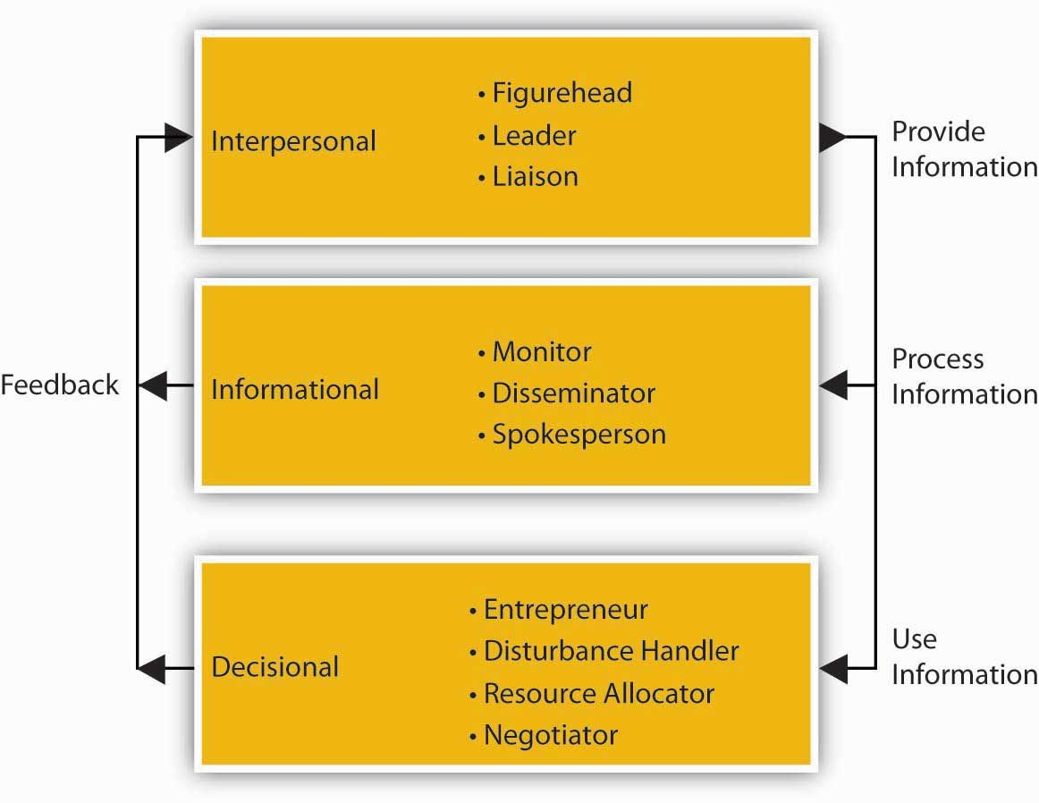
Figure 2: Mintzberg’s 10 roles of leadership
Source: (Puranam and Maciejovsky, 2017)
As a manager, a person has to play various roles within an organization. A manager has to constantly switch to different roles as per the requirement (Ceil, 2019). Henry Mintzberg who is a management expert recognized these changes of roles and categorised all the roles under three main categories (Gabriel, 2015). Under the Mintzberg’s interpersonal role, ASDA’s CEO plays the role of figurehead where he plays various legal, social, motivational responsibilities. He is known as the inspiration for the employees and has a higher degree of authority. The managers of ASDA play the role of leader. The managers are the head of the department of ASDA. ASDA’s manager as a leader train motivates, interact and encourage his team members and subordinates. The manager also plays the role of liaison where he has to maintain contracts with the internal and external people. He can create and maintain a network on behalf of ASDA.
Under informational role, ASDA’s manager who leads his team being in the frontline has the responsibility to monitor the performance, evaluate the training programs and maintain a regular report and personal contact with all the employees. He also ensures the wellbeing of his team. The manager also plays an informational role as being a spokesperson to all the external sources or contracts. He transfers the information and goals to all the outside sources and conduct meetings and conferences. The managers of ASDA also play the role of disseminator by communicating all the information within the organization and passing the decisions, reports and other necessary information to its subordinates (Aizhan et al., 2015).
Under the decisional role, all the managers of ASDA playing an entrepreneurial role through continuously identifying new ideas and innovations to start new projects and improving the existing projects as well (Gabriel, 2015). They are resolving the issues and conflicts arise within the organization and identify corrective actions or solution of the problem playing the role as a disturbance handler. ASDA’s managers have to identify, plan, arrange and allocate the resources at required levels or departments within the organization as a resource allocator. The managers of ASDA also participate in the debates and discussions to project the business correctly and try to negotiate within the department of ASDA as Negotiator (Ceil, 2019).

3.2 Variables that determine effective management and leadership in ASDA
Managerial effectiveness is measured by the degree at which a manager successfully achieves his/her set business objectives (Aizhan et al., 2015). Finding an objective measurement instrument is the most difficult part. It’s difficult because we can’t measure the quality of managerial effectiveness only depending on the hours spent on decision making and control process. Before measuring the managerial effectiveness, a manager must have to set standard and time lag for achieving the objectives (Hashemi, 2019).

Figure 3: Factors affecting effective management
Source: (Hashemi, 2019)
Being an effective manager who leads to effective management is about more than just driving the employees to work harder or more efficiently. Effectiveness is the ability to choose appropriate objective and an effective manager is the one who chooses the right thing to get done (Aizhan et al., 2015).
Goal setting is one of the major factors that affect effective management (Gabriel, 2015). ASDA’s managers set clear and independent goals which work as the main driver in not only motivating resources but also setting appropriate baseline targets for improvement. Once the goals have been set, ASDA’s managers maintain transparent communication. Each of the employees knows about their work and responsibility and how their works contribute to the ultimate organizational goal. After creating the sense of ownership ASDA’s managers tries to perform the actual task by providing them with facetime for effective engagement and open communication to create sustainability in the organization (Hashemi, 2019). Along with the team, ASDA’s manager tries to achieve the organizational goal and also recognize achievement among the team which create motivational notion toward exceeding targets. ASDA’s manager creates a fun and open environment to brainstorm new ideas (Ceil, 2019).

4.0 Understanding the behavioural approach to management
The main emphasis of the classical writer was based on the structure and the formal organization but during the great depression, social factors at work and the behaviour of employees within an organization started to grab the attention (Aizhan et al., 2015). The development of the ‘behavioural management’ came up with the famous experiment at the Hawthorn (Gabriel, 2015).
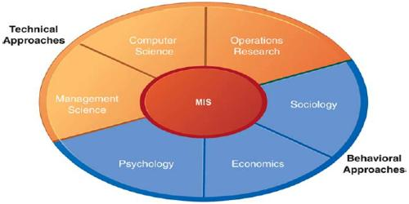
Figure 4: Behavioural approach to management
Source: (Gabriel, 2015)
The behavioural approach focuses more on sociology, economics and psychology. The behavioural approach to management tends to focus on human relations and employees wellbeing. Through the behavioural approach, managers help to create a condition which keeps workers satisfied and motivated (Gabriel, 2015).

4.1 Factors affecting differences in individual behaviour in ASDA
Every individual is unique and different from each other because the behaviour of human is considered as the most complex one (Biliavskа Y., 2017). Various challenges occur in an effective organization that could directly or indirectly affect the behaviour of the employees. There are varies factors that could affect the organizational behaviour of an individual such as personal factors, psychological factors, organizational system and resources and environmental factors (Ceil, 2019).
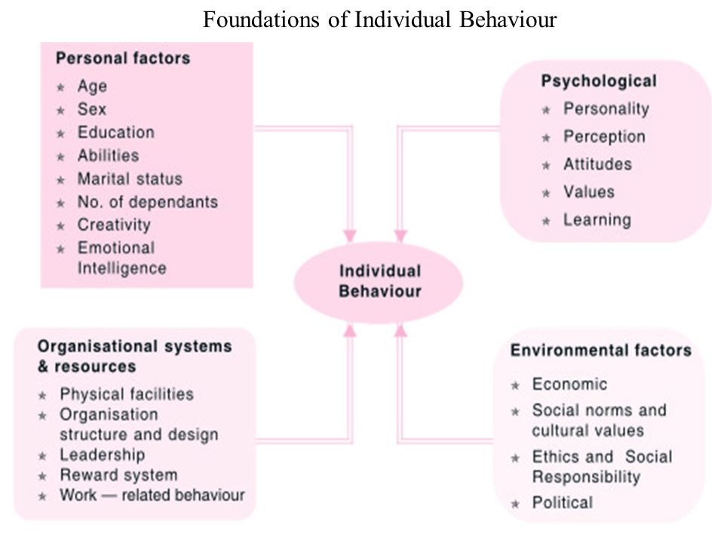
Figure 5: Factors that affect individual behaviour
Source: (Biliavskа Y., 2017)
ASDA’s individual employee’s behaviour depends mostly on the reward system of the organization, the structure and culture and the overall work environment of the organization. ASDA’s reward system involves both the monetary and non-monetary reward. People work as they want to be rewarded. ASDA’s structure defines the authority and responsibility of employees in the workplace which also shapes the nature of the relationship in the workplace. The employees of ASDA seem very friendly and cooperative as its organizational structure is very flexible. ASDA provide proper training to all its employees and thus increasing their ability to work properly. ASDA’s managers never judge their employee depending on their culture, race, age, gender. It motivates the employee to work more effectively.

5.0 Conclusion
The organizational structure is a framework for the organizational culture to be implemented on the other hand the culture defines how the company should be structured. Organizational structure and organizational culture are interrelated with each other (Aizhan et al., 2015). Right organizational structure creates the right organizational culture within the organization that ensures effective management and leadership (Ceil, 2019). The effective manager tends to motivate the employees by evaluating the behavioural approach and determine how to motivate individual employees based on their behaviour (Biliavskа Y., 2017).

6.0 References
Hashemi, M., 2019. The effect of infrastructure, corporate culture, organizational structure and information technology on Competitive Intelligence in Organizations. International Academic Journal of Organizational Behavior and Human Resource Management, 06(01), pp.32-39.
Aizhan, T., Tursun, G., Aliya, A., Moldir, Y. and Zhuldyz, D., 2015. Psychological Aspects of Physical Culture and Agonistics in Kazakh Culture. Procedia - Social and Behavioral Sciences, 205, pp.524-528.
Biliavskа Y., Y., 2017. The vital cycle of the organizational culture of the trading enterprises. The vital cycle of the organizational culture of the trading enterprises, 1(10), pp.3-11.
Ceil, C., 2019. Organizational Structure and Culture at a Beauty Salon. SSRN Electronic Journal,.
Gabriel, K., 2015. Organizational Development, Organizational Culture and Organizational Change. SSRN Electronic Journal,.
Martin, J., 2007. Organizational Culture. Thousand Oaks: Sage Publ.
Puranam, P. and Maciejovsky, B., 2017. Organizational Structure and Organizational Learning. SSRN Electronic Journal,
Rivera, J., 2016. Organizational Structure and Collaboration: Emergency Management Agencies and Their Choice to Work With Voluntary Organizations in Planning. Risk, Hazards & Crisis in Public Policy, 7(4), pp.160-175.
Sayapina, K., 2014. INNOVATION CLUSTERS FORMATION AS AN INSTRUMENT OF EFFECTIVE ECONOMIC MANAGEMENT. Effective crisis management, (6), p.88.
Seong, Y., Wehmeyer, M., Shogren, K., Palmer, S. and Little, T., 2019. Examining Underlying Relationships Between the ASDA-S and the AIR and the ASDA of Adolescents and Young Adults With and Without Disabilities. Advances in Neurodevelopmental Disorders, 3(2), pp.173-187.
Woodside, A., 2010. Organizational Culture, Business-To-Business Relationships, And Interfirm Networks. Bingley: Emerald.

