Title: “Define skill in the context of your own work of two Artists/Thinkers/Maker/ designers from the lecture strand.”

Student number: P145632
Course title – BA SURFACE PATTERN DESIGN
WORD COUNT: 2001
TUTOR: Julia Lockheart

Define skill in the context of your own work of two Artists/Thinkers/Maker/ designers from the lecture strand.
For most designers, past and present, skill is the act of articulating ideas using creativity, imagination and an artistic flair; creating an outcome through the art of making. In Richard Sennett’s book “The craftsman”, he states that “the Latin tag homo Faber means simply “man as maker”” and “homo Faber is the judge of material labour and practice”( Sennett, 2009:6) ( Sennett, Richard (2009) “the craftsman.” London: penguin books: accessed 7th December 2017). This theorises the fact that man, “being the maker”, uses his hands and his creativity as a tool into the practice of design, therefore defining the skill of a craftsman and the art of making.
In this analysis, I will be defining the skill of printmaking, through the workings of William Morris and Lucienne Day; both of whom were pioneers of two completely different movements: the Arts and crafts movement and the contemporary art movement, which came about in post-war Britain during the 1950’s. I chose these two Designers because they both had a notion for creating art for the people, to be used by the people and to be enjoyed by the people. When analysing their skills; I will be focusing closely on the type of printing my chosen artists specialise in and also the materials they use to give their designs beauty, tonal variation, texture and characterisation. I will also look at books and websites relating on the topics of study, so I get a clear understanding, when I come to defining the skill of a printmaker.
Printmaking; a technique of which ink or dye is applied to a woodcut, silk screen, mezzo print, etching, engraving and aquatint, is then pressed onto cloth or paper, revealing an image. Originating from the ancient Chinese, of whom invented sugar paper and silks, printmaking was a form of communication and storytelling, but also created for household decoration. From the 1300’s until the 1700’s, many printmakers worked on cloths, usually woven tapestries or a cloth known as vellum, of which depicted imagery inspired by the bible or drawings of folklore and everyday life. But the 18th century saw a massive change in the use of printmaking; due to the industrial revolution and the role of mass production, which led to a reinvention in the art practice of design. (Washington print makers gallery: (2003) history of printmaking. Accessed by: http://www.washingtonprintmakers.com/wp-content/uploads/2015/03/PrintmakingIntroduction.pdf (accessed on 2nd December 2017)).
William Morris, the leader of the arts and crafts movement and also an advocate against the industrial revolution and the urge for mass production, would have used a method of woodcut block printing to create his repeats. Inspired by the pre- Raphaelites and the romanticism movement, he was influenced by the beauty of nature and love, so decided to bring back the joy of craftsmanship and the pride in creating something beautiful. (William Morris gallery: (2012) William Morris: the designer. Accessed by: www.wmgallery.org.uk/.../Topic_4_Techniques_and_Materials_Block_printing (accessed on 2nd December 2017) In order to create a woodcut, Morris would draw his floral image onto paper using pencil or ink, which would then be transferred on to a woodblock and he would carefully carve the woodblock out like an etching, revealing the image on the block. Then he would basically press his block, covered in dye, on either fabric or paper and the image will be visibly print onto them. This defines the skill as a designer because Morris manually creates his printing techniques by hand, due to the fact that he was against the idea of using machinery and the industrial revolution. Morris’s quote:
“Apart from the desire to produce beautiful things, the Leading passion of my life has been and is hatred of modern civilization.” (Morris (1884:29))
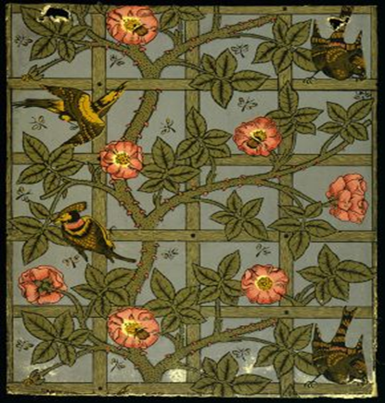
(Morris, William (1884) “art and socialism” (republished in 2003) London. (Accessed on the 7th December 2017). This clearly illustrates his skill of making things by hand because at the time, the industrial revolution was changing everything; bringing Britain and the rest of the world into a modern era. Morris feared that art and the joy of making would be forgotten, as mass production was generated, so he decided to bring the old way of creating back into society. Figure 1 ('Trellis' woodblock printed wallpaper, by William Morris, England, 1864. Museum no. E.452-1919, © Victoria & Albert Museum, London) is a woodblock print. As you can see there is a define quality in the use of layering and tones, which gives the piece a sense of realism, also defining the beauty of nature. This image clearly defines the skill of a printmaker because Morris beautifully created a work of art by hand, which is quite a challenging technique to perfect as there is a lot focus involved.
Therefore, the skills needed for woodblock printing printing are concentration and a creative flair for carving, as Morris’s techniques illiterate the beauty of craftsmanship.
Lucienne day, on the other hand, uses a more contemporary approach to creating her patterns, through the technique of screen-printing. Inspired by the Bauhaus artists such as Joan Miro and Kandinsky, and also the change in the society of post war Britain during the 1950’s, Lucienne wanted to create artwork which brought colour, geometry and rhythm to people’s homes; (now that the war was over, people’s lives began to carry on as normal.). (Harris, Jennifer (1993:2) “Lucienne day: A career of design” Whitworth art gallery. (Accessed on 3rd December 2017). In order to create these colourful, geometric patterns, Lucienne would get a silk screen; depending on the size of the fabric/paper she is working with, and carefully paint onto the screen using gouache, to give the image a pastel, matte finish. Then she would print her image onto either paper or cloth, using a wooden squeegee, which would push the gouache through the screen (depending on the pull) and the image will appear printed clearly on the materials. This defines the skill of a printmaker because although this is an easier technique to the one Morris used, the use of a screen gives off a clearer print if done correctly (sometimes the screen can move and the print will look uneven). It also defines skill of a printmaker because Lucienne hand paints onto the screen; this is a skill which confident designers use because paint is very messy and can smudge if not careful.
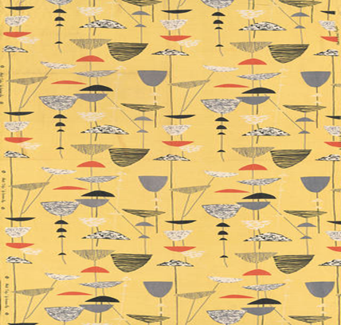
Figure 2 – (Calyx, furnishing fabric, Lucienne Day, 1951, England. Museum no. T.161-1995. © Robin and Lucienne Day Foundation/Victoria and Albert Museum, London) is a perfect example of a screen printed pattern in repeat. As you can see, the colours and the image is a lot more refined and soft, in contrast with Morris’s woodblock repeated patterns; depending on the strength of print, the image will come out much ore denser if you print harder than a more delicate, soft image if you print using a softer rhythm of printmaking. This defines the skill of a printmaker because unlike a woodblock print, which would be printed using a printing press; A screen-print is done manually by hand, which uses a lot of precision and concentration to gain a perfectly clear pattern.
Therefore, the skills needed for Screen-printing is the use of the hands and how hard you pull the squeegee in order to gain a clear image transfer, but also, similar to Morris, the use of concentration when painting gouache onto the screen, with delicate brushstrokes in order to gain a clean picture.
While the style of printmaking underpins the designer’s skill in creating their works of art, the use of materials is another aspect which underlines the skills of a printmaker. Within any form of printmaking, dyes are the most significant part of the process because they transfer the image onto the fabric/paper. As Morris is influenced by nature and beauty; whilst also inspired by the old style of craftsmanship, he creates all his materials by hand not machine. Following the old traditional ways of printing, Morris uses natural dyes (because acid/pigment based dyes were not invented during the late 19th century.) Morris extracts natural Dyes from vegetables and plants, which gives a variety of different tones, depending on the ripeness of the source. To create natural dyes, you would boil vegetable in hot water, and once the water has heated up the source, Morris would leave the vegetable in the water for a couple of hours, so that the warmth of the water would extract natural fibres. This illustrates the skill of a printmaker because making your own dyes from scratch is very time consuming and difficult if you don’t know where to start or where to look, but is effective in creating very natural looking designs. Morris used a variety of sources from nature in his work: indigo, woad, insect dyes kermes, cochineal, vegetable dye madder, weld, quercitron bark, roots of the walnut tree, tree sap and of course vegetables. (William Morris: (1889) the art of dyeing. Accessed by: https://www.marxists.org/archive/morris/works/1889/dyeing.htm (accessed on the 4th December 2017). William Morris also used Arsenic in his earlier work, which allowed him to gain stronger, denser colours; (but led to the death of hundreds due to fungi growth caused by the damp fibres in the rooms which counteracted with the wallpaper.) Once the dyes are ready, he would painstakingly paint each counterpart of a woodblock image, the colour he wants it to be, before he compresses it to paper/cloth.
This defines his skill as a printmaker because the way he inks up his woodblock by painting it, allows him to create much more designs quickly because you can reuse the same woodblock 2/3 times, rather than a printmaker who screen-prints because you can only create 1 design at a time as you would need to clean the screen to reduce dye marks or smudges.
Likewise, the skills illustrated here are the correct measurement of Materials and the Knowledge of natural fibres because the riper the source, the denser the colour.
Following the style of Morris, Lucienne Day, on the other hand uses more contemporary materials when creating her designs. Instead of Natural dyes extracted from plants and vegetables, Day uses direct dyes and pigment binders in her work; both of which prints beautifully on cellulose fibred fabrics (natural material) giving a denser image when contacted. In order to do this, Day must measure all the dyes with water and all the pigment binders carefully to insure that she has the right consistency, allowing her to gain a clear image. This defines skill as a printmaker because, especially in screen-printing, the correct measurement of the different dyes and binders will give you a definite depth of shade in colours, which allows you to build tones and layers. After this process, Day will spread her dye/binder onto her silkscreen image and with a hard grip, pull the squeegee along the screen in a repetitive manner until the materials have been exposed. Although day prints with dyes and binders, she sometimes paints gouache onto her screen, which gives her fall -on patterns when the dye is squeegeed over the top. This technique gives her work a very matte, chalky texture and bold colour because gouache is a very opaque binder material. This also defines the skill of a printmaker because playing with pigment binders, Dyes and gouache adds a variety of tones to fabrics and paper, but also allows you add texture, giving the print layers. (The Guardian (2010): “Lucienne day obituary”. accessed by - https://www.theguardian.com/artanddesign/2010/feb/03/lucienne-day-obituary (accessed on 4th December 2017).
Therefore, the skills needed for the mixing of pigments and dyes, is the knowledge of tonal variation in order to get dark and lighter shades, but also understanding what fabrics the dyes will work on, as most pigments only work on cellulose based fibres.
To conclude, the skills needed for a printmaker, analysed through both Lucienne Day and Morris, is Knowledge of the materials because certain dyes/pigments react differently on different materials, concentration, creativity and the use of hands in the practise of design.

Word count: 2001

Bibliography

Books:
Harris, Jennifer (1993:2) “Lucienne day: A career of design” Whitworth art gallery. (Accessed on 3rd December 2017)

Morris, William (1884) “art and socialism” (republished in 2003) London. (Accessed on the 7th December 2017).
Sennett, Richard (2009) “the craftsman.” London: penguin books: (accessed 7th December 2017)

Websites:

The Guardian (2010): “Lucienne day obituary”. accessed by - https://www.theguardian.com/artanddesign/2010/feb/03/lucienne-day-obituary (accessed on 4th December 2017).

Washington print makers gallery: (2003) history of printmaking. Accessed by: http://www.washingtonprintmakers.com/wp-content/uploads/2015/03/PrintmakingIntroduction.pdf (accessed on 2nd December 2017)).

William Morris gallery: (2012) William Morris: the designer. Accessed by: www.wmgallery.org.uk/.../Topic_4_Techniques_and_Materials_Block_printing (accessed on 2nd December 2017)

William Morris: (1889) the art of dyeing. Accessed by: https://www.marxists.org/archive/morris/works/1889/dyeing.htm (accessed on the 4th December 2017).

Figures:

Figure 1 – “trellis” accessed from: http://www.vam.ac.uk/content/articles/w/william-morris-and-wallpaper-design/ (accessed on 4th December 2017)

Figure 2 – “calyx” accessed from: https://www.vam.ac.uk/articles/lucienne-days-silk-mosaics (accessed on 4th December 2017)

