ACMA 5005 Six Sigma Green Belt
Custom Styli LEAD time reuction
Emyr Hunnam (2216571)



Table of Contents

Table of Contents 2
Introduction 4
Define 5
Problem Statement 5
Process Mapping 5
Project Scope 6
Measure 7
Analyse 8
Analysis Methods 8
Process flow map 8
Resource planning software - Syteline 8
Five whys 9
Route cause Identification 10
Improve 11
Improvement Solutions 11
Outsourcing 11
Utilizing standard components/ Off the shelf solution 11
Manual Machining Facility 11
Improvements FMEA 12
Future process flow 13
Improvement Validation 14
The examination of custom styli ordering following change implementation reveals a diverse range. Although many items arrived within 10 days, a few took up to 29 days. The average lead time was 10.7 days, with a median of 8 days, implying that half of the orders were finished within this timeframe. The standard deviation of about 8.5 days indicates that production is variable. Further inquiry indicated that building works made the manual machining plant inaccessible, resulting to longer lead times. Despite hurdles, the decision to make unique styli using a manual machining facility successfully reduced overall lead times. 14
Control 15
Conclusion 15
References 16
Appendices 17
Raw data for period October – December 2023 17
Raw data for period January – March 2024 18

Introduction
Renishaw plc, founded in 1973 in Gloucestershire, UK, has emerged as a global leader in engineering and scientific technologies. Initially focusing on touch-trigger probes, the company has since broadened its products to encompass a variety of precision measurement and healthcare solutions. Renishaw's revolutionary solutions are used in a variety of industries, including aerospace, automotive, healthcare, and electronics, enabling customers all over the world to achieve greater efficiency and quality. Renishaw's commitment to continual research and development keeps it at the forefront of technical developments, affecting the future of manufacturing and healthcare around the world. Renishaw's Miskin factory in South Wales accounts for a significant portion of its UK manufacturing. The 193-acre property currently houses 650 individuals working in a number of departments.
Renishaw's original innovation, the touch trigger probe, is still a key product, known for its quick and exact measurement capabilities in Coordinate Measuring Machines (CMMs). It has progressed beyond its original application and is now effortlessly integrated into machine tools and small Equator machines. At the heart of this probe is the stylus, a detachable component that allows it to adapt to a variety of measurement jobs. While Renishaw provides a wide choice of basic styli to meet most customer needs, however some applications require specialised solutions. These distinct requirements give rise to Renishaw's Custom Styli, which is designed to handle individual customer challenges with precision and efficiency.
In today's competitive manufacturing world, minimising lead times is critical for increasing operational efficiency and meeting customer needs on time. The goal of this project is to address Custom Styli lead time challenges by systematically applying the DMAIC (Define, Measure, Analyse, Improve, Control) methodology. By identifying and eliminating inefficiencies, the project aims to streamline operations and provide products in shorter timeframes, enhancing customer satisfaction and competitiveness.

Define

Problem Statement
The current lead time for Custom Styli is 16 weeks, limiting Renishaw's ability to meet customer requests and hindering market competitiveness. Long lead times not only reduce customer satisfaction, but they also raise the probability of losing potential business to competitors with faster turnaround times. According to Kenton 2024, customers are happier when deliveries are faster. Extended lead times are caused by inefficiencies in the production processes, such as manufacturing delays, subcontractor processes, and insufficient capacity utilisation. As a result, the quote conversion rate for Custom Styli is low (10-20%), resulting in wasted opportunities for revenue growth and client satisfaction. Addressing these difficulties is critical to strengthening Renishaw's market position, increasing customer retention, and driving overall business performance.

Process Mapping
Customers submit orders to the Custom Workshop through a variety of channels, offering particular specifications, quantities, and delivery timeframes. The order automatically updates the assembly cell planning detail, and the material controller then reviews the stock of the items on the BOM. If purchased parts are not stocked, an order will be placed for them; this typically takes 2-8 weeks, depending on the source. Manufactured parts not in stock will be requested internally. This will then be sent to a low volume machine shop, and depending on their workload, the part may be outsourced. This process can take between 6 and 10 weeks, depending on the low volume machine shop workload and the design of the part.

Finally, once all parts on the BOM are available, the part is assembled, which can take anywhere from one to three days depending on the number of parts in the assembly and the build methods. Once the assembly operations are completed, the part is packaged and transferred to the despatch department for shipment.

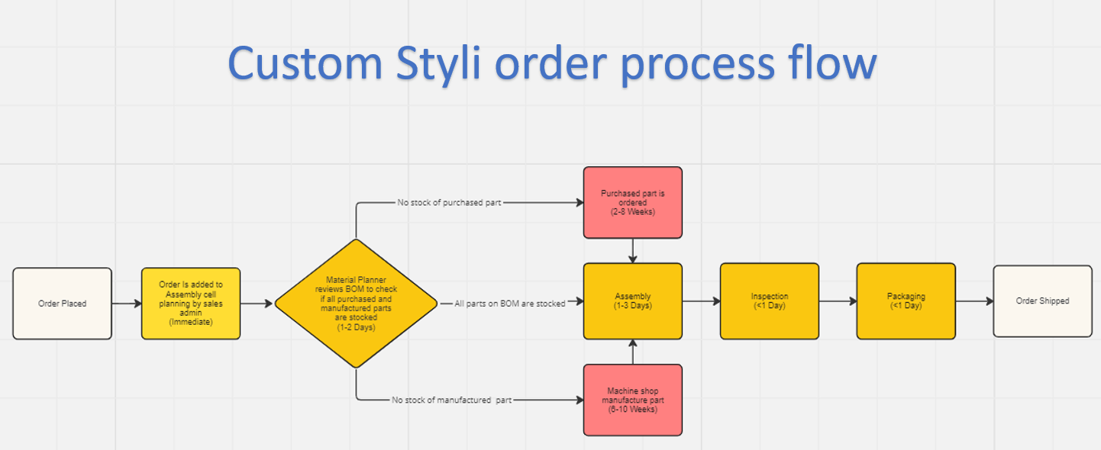

Figure 1 – Custom Styli Process Flow Map

Project Scope
The major goal of this project is to reduce lead time and boost quotation conversion rate, while maintaining or enhancing quality standards. The project aims to improve operational efficiency, better match consumer expectations, and strengthen market competitiveness. The project will strive to reduce lead times to a maximum of two weeks from the existing 13-week lead time. -The project will also aim to increase quotation conversion rates from 10-20% to 50% in order to fulfil the divisional target for all Styli product groups.
The project scope encompasses all processes and activities inside the organisation that contribute to lead time, from order placement to order fulfilment. This includes order processing, production scheduling, manufacturing operations, quality assurance, inventory management, and shipping procedures. The project scope will exclude processes that are not directly under the organization's control, such as external supplier lead times, transportation times, and customer-related delays. However, interactions with external stakeholders will be considered when looking for ways to improve the process.
Average lead time, quotation conversion rate, and any other relevant performance indicators determined during the project will be key metrics used to assess project success. Budgetary constraints, resource limitations, and any other constraints that may affect project execution shall be identified and managed throughout the project's life cycle. The project's stakeholders include management, process owners, assembly operator workers, customers, and suppliers. Effective communication and coordination among stakeholders will be critical to project success.

Measure
Lead times vary according to a variety of factors, including individual item specifications, stock availability, manufacturing methods, and assembly processes. The unique nature of the parts causes tremendous variety, both in the parts themselves and in the sophisticated methods required for their manufacturing. Designs vary from single, meticulously crafted components to assemblies made up of several machined parts, which complicates lead time consistency. Furthermore, whether these machined parts are manufactured in-house or outsourced adds to lead time uncertainty. Given the unique nature of these parts, stock availability is frequently a difficulty, with cases when the essential parts are not readily available in inventory.
The data collection will focus on custom styli lead times, which will run from October 2023 to March 2024. Lead times, being continuous variables recorded in units of time (e.g., hours or days), allow statistical analysis to yield useful insights. This includes computing essential metrics such as means, standard deviations, and ranges, which provide a thorough knowledge of lead time variability and trends throughout the chosen time period. Statistical analysis can identify trends and patterns in lead time data, allowing for more informed decision-making and targeted adjustments to increase overall efficiency and performance.
The data collecting procedure will use Renishaw's production software, which contains crucial information such as work numbers, start and finish dates. This software allows you to easily export data to Excel for additional analysis. Job start and completion dates will be collected continuously throughout the defined period, providing for a full capture of changes across lead times and production conditions. This technique provides a comprehensive perspective of lead time dynamics, allowing for the identification of trends, patterns, and possibilities for improvement within Renishaw's manufacturing processes.
Renishaw's internal production software is a reliable tool for tracking lead times when correctly designed, routinely updated, and efficiently used by employees. This system collects real-time data on a variety of production variables, such as task start and end timings, order processing time, and overall lead times for finished items. The organisation takes advantage of the software's features to automate data gathering, expedite reporting procedures, and get important insights into production efficiency and performance. However, the system's reliability is dependent on accurate data entry, continuous maintenance, and adherence to standard operating procedures. Regular audits and quality checks are critical for assuring the reliability and integrity of lead time data collected from internal production software.

Analyse

Analysis Methods

Process flow map
The custom styli process flow chart is particularly useful for finding bottlenecks because it highlights average process times. One important bottleneck occurs during part sourcing, when materials are either created in-house or obtained from outside vendors. This stage follows the material controller's assessment of the Bill of Materials (BOM), which usually occurs within 1-2 days following order placement. However, lead times vary greatly: bought parts can take between 2 and 8 weeks, whereas machined parts can take 6 to 10 weeks. Notably, if all essential parts are easily available, the full operation can be completed in just five days.

Resource planning software - Syteline
SyteLine is an enterprise resource planning (ERP) software product created by Infor. It is intended to assist manufacturing organisations with different areas of their operations, such as production planning, scheduling, inventory management, procurement, sales, and finance. SyteLine provides several features geared exclusively to the manufacturing business, including job costing, material requirements planning (MRP), shop floor control, and quality management.
Renishaw uses SyteLine to manage order progress and retrieve lead time statistics for customised styli. This data can be exported to Excel for examination, allowing for the generation of graphical representations like the one shown in Figure 2 below. The dataset covers the three-month period from October to December 2023.

Figure 2- Custom Styli Orders October-December 2023

Analysis of the figure demonstrates high variety in lead times, indicating a dynamic operating environment. Despite changes, the average lead time for this period is 16.3 days, with a maximum of 32 days and a relatively short minimum of 3 days. It is possible that longer lead times are due to the need for assembly components before manufacturing can begin, but lower lead times can be obtained when the necessary stock is available. This insight emphasises the value of effective inventory management and supply chain optimisation in reducing lead time variability and improving overall operational performance.

Five whys
The five Whys is a systematic problem-solving technique that originated in the Toyota production system (Card, 2017). It identifies core causes by continually asking "why," creating a thorough understanding of problems and encouraging continuous development. While it works well for simple problems, its usefulness may be limited in more complicated scenarios. Nonetheless, when used properly, it remains an effective instrument for promoting organisational improvement. As a result, a five whys analysis will be undertaken to identify the key bottlenecks in the process, notably lead times for both external items and internal machining.

- Why are internal low volume products (LVP) lead times long?
- Because the capacity is insufficient to keep up with the demand.
- Why the capacity is insufficient to keep up with the demand?
- Because the shop has limited recourses such as equipment and manpower.
- Why does the shop have limited resources?
- Because the LVP has budget constraints and space limitations.
- Why does LVP have budgetary and space constraints?
- Because they are competing with other departments in a larger organisation and there is currently no large-scale demand for the shop to reduce their lead-times.
- Why is there no demand to reduce lead time in the shop?
- Because the majority or components that the shop manufacture go into a standard product range therefore stock control is in place and the customer isn’t waiting on machining lead times.

- Why are external lead times long?
- Because many of the vendors are overseas rather than in the UK.
- Why are the vendors overseas rather than in the UK?
- Because the overseas vendors provide higher quality product at a lower cost.
- Why do overseas vendors provide higher quality product at a lower cost?
- Because they may have a lower labour cost overseas.
- Why do overseas vendors have lower labour costs?
- Because of various factors such as government policies, economic development, and currency exchange rates.
- Why do these factors contribute to a lower labour cost for vendors overseas?
- Because they contribute to the supply and demand dynamics of the labour market

Route cause Identification
Unfortunately, the bespoke nature of the parts complicates issues, making it impractical to keep an inventory of required components. In-house production and purchasing are highlighted as the longest stages of the process, with large opportunity for improvement. While lowering lead times for purchased parts is beyond the project's scope due to vendor negotiations and quality assurance concerns, the bottleneck that need immediate attention is the in-house manufacturing process, notably the low-volume machine shop.
The five whys argue that the only way to shorten internal machining lead times is to increase the budget to allow for more equipment and staff, which there is currently insufficient demand for.

Improve

Improvement Solutions

Outsourcing
Outsourcing machined components is an appealing concept since it accelerates production timelines and allows businesses to focus on their core capabilities while potentially lowering costs. Nonetheless, this technique gives up some control over the manufacturing process, adding reliance on external suppliers, which could lead to interruptions. Furthermore, there is a risk of intellectual property loss, particularly when sharing sensitive information with third-party providers. Furthermore, managing communication barriers and cultural differences with offshore providers may necessitate extra effort. As a result, while the promise of shorter lead times is appealing, it is critical to balance these benefits against potential downsides in order to make informed judgements.

Utilizing standard components/ Off the shelf solution
Renishaw could investigate employing standard components or off-the-shelf products as an option. These easily available parts have several advantages, including faster lead times, reduced costs, and streamlined logistics. Styli components are mass-produced and easily accessible from manufacturers, making them suitable for integration into designs without requiring special machining. While not all orders will completely fit custom specifications, many can be completed by mixing pieces from other high-volume Styli. Overall, using standard components provides a realistic and efficient approach for meeting urgent machining requirements while reducing lead times and prices.

Manual Machining Facility
Another possible method is to use an internal manual machining facility as a substitute for the low-volume machine shop, which has an average lead time of 8 weeks. The principal activities of this workshop are modifications and repairs, as well as apprentice training efforts. It appears to be a potential alternative to the current low-volume machine shop infrastructure, as it is fully equipped with the necessary tooling and technology for the manufacturing of customised styli.

This argument is based on the inherent benefit of manual machining, which eliminates the need for CAD modelling or programming. As a result, when compared to the CNC methodology, the workshop can produce small batches of styli more quickly. Furthermore, the accessibility of equipment within the workshop allows for the immediate initiation of machining operations upon receipt of an order, adding to increased operational agility and responsiveness.

Improvements FMEA
An FMEA was conducted to establish the most appropriate solution for implementation. Each option, whether outsourcing or utilising the manual machining facility on-site, was evaluated for failure modes, with severity, occurrence, and detection scores provided to each. According to Li and Zeng (2014), while FMEA is frequently used as a technique for building a new product or process, it may also be used to assess risk and make decisions. These results were then utilised to determine the Risk Priority Number (RPN) for each failure mode. The solution with the lowest total RPN value was picked for progression. Standard component utilisation was removed from the FMEA due to its complexity within the product's scope. Analysis found that outsourcing machined components resulted in the greatest total RPN. As a result, the manual machining facility has been chosen as the progression solution.

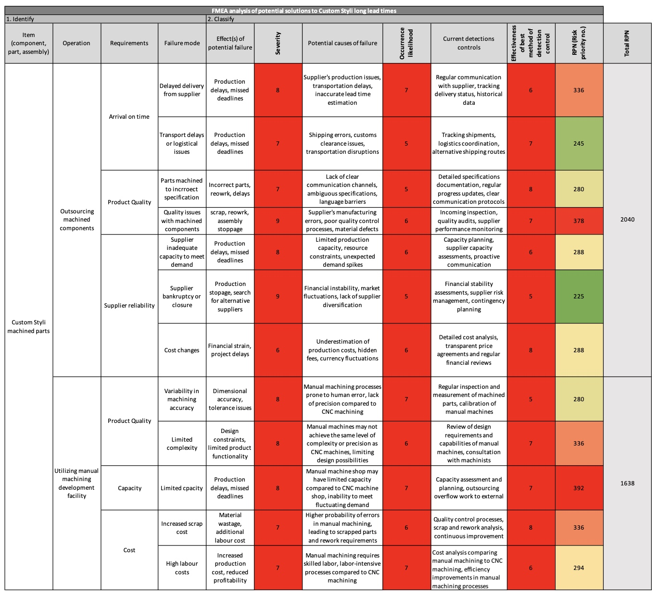

Figure 3 - FMEA

Future process flow
The Custom Styli via manual machining facility order process begins with customers placing thorough orders via several channels, including requirements, quantities, and delivery timeframes. Sales reps contact divisional teams, who subsequently schedule order meetings, provide production and assembly drawings, and record part quantities and delivery dates. Prior to the meeting, the manufacturing team verifies material and tooling availability, while the assembly teams evaluate stocked part amounts and identify potential assembly concerns. During the meeting, teams discuss concerns and set a due date. The manufacturing team then builds and inspects the parts according to the drawing specifications. Parts are then kitted into job packs that contain all of the components required for assembly in the assembly cell. After assembly, the pieces are packaged and transferred to the dispatch department for shipping.

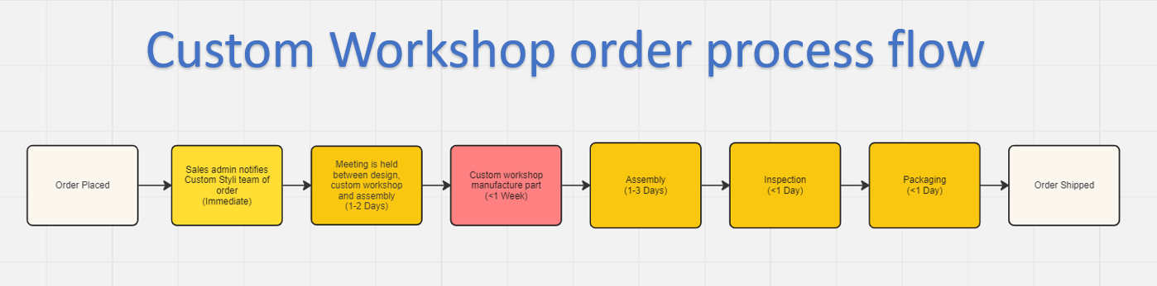

Figure 4 – Custom Workshop Styli order process flow chart

Improvement Validation

Figure 5 - Custom Styli Orders January – March 2024

The examination of custom styli ordering following change implementation reveals a diverse range. Although many items arrived within 10 days, a few took up to 29 days. The average lead time was 10.7 days, with a median of 8 days, implying that half of the orders were finished within this timeframe. The standard deviation of about 8.5 days indicates that production is variable. Further inquiry indicated that building works made the manual machining plant inaccessible, resulting to longer lead times. Despite hurdles, the decision to make unique styli using a manual machining facility successfully reduced overall lead times.

Control
To ensure efficient process control, the new procedures must be smoothly integrated with current corporate protocols such as job sheets, work instructions, and quality schedules. This integration assures consistency and dependability in operations while reducing the need for further training and streamlining procedures. Furthermore, the ongoing use of Syteline software is critical for tracking job data, encouraging transparency, and maintaining responsibility throughout the production process. Renishaw can use this software to keep track of critical metrics and performance indicators, allowing for more informed decision-making and proactive problem solving.

In addition to software integration, frequent meetings will be held to monitor and discuss performance measures, allowing for the early detection of any deviations from agreed targets. These meetings will include representatives from assembly, manufacturing, and sales, and will serve as forums for data analysis, challenge discussion, and corrective action implementation as needed, ensuring project alignment and fostering a culture of continuous improvement within the organisation. This organised approach not only helps to sustain the changes made, but it also fosters a collaborative environment in which employees are encouraged to contribute to ongoing process optimisation efforts. Renishaw will be able to efficiently respond to changing market needs and preserve its position as a leader in precision engineering if it embraces this continuous improvement culture.

Conclusion
The report outlines Renishaw's efforts to reduce lead times for custom Styli through a DMAIC project. Key findings include the identification of extended lead times as a significant challenge, stemming from inefficiencies in internal manufacturing processes and reliance on external vendors. The analysis identified difficulties in the production workflow, such as differences in lead times caused by special demands and stock availability. Between October and November 2023, Custom Styli had an average lead time of more than 16 days. Outsourcing, standard component utilisation, and utilising the in-house manual machining capability were all considered as improvement alternatives. The manual machining facility emerged as the chosen alternative, providing faster production and improved operational agility, reducing Custom Styli's average lead times to 8 days. The facility also shown that with shorter lead times, the quotation conversion rate increased from 10-20% to more than 40%. The initiative also intends to sustain these benefits by integrating the new process with current procedures and conducting continuing monitoring.

Moving forward, recommendations include ongoing monitoring and improvement, increased investment in technology and workforce development, and improved engagement with suppliers. Renishaw's goal in implementing these tactics is to improve operational efficiency and strengthen its position as a leader in precision engineering.

References

Card, A.J. (2017). The Problem with ‘5 Whys’. BMJ Quality & Safety, [online] 26(8), pp.671–677. Available at: https://qualitysafety.bmj.com/content/26/8/671.

Kenton, W. (2024). Lead Time: Definition, How it Works, and Example. [online] Investopedia. Available at: https://www.investopedia.com/terms/l/leadtime.asp#:~:text=Once%20a%20customer%20places%20an.

Li, S. and Zeng, W. (2014). Risk analysis for the supplier selection problem using failure modes and effects analysis (FMEA). Journal of Intelligent Manufacturing, 27(6), pp.1309–1321. doi:https://doi.org/10.1007/s10845-014-0953-0.

Appendices

Raw data for period October – December 2023
Job Number | Start Date | End Date | No of working days | Target
JOB18625 | 02/10/2023 | 12/11/2023 | 30 | 10
JOB20561 | 03/10/2023 | 13/11/2023 | 30 | 10
JOB24681 | 04/10/2023 | 16/11/2023 | 32 | 10
JOB27386 | 04/10/2023 | 18/10/2023 | 11 | 10
JOB28746 | 05/10/2023 | 18/11/2023 | 32 | 10
JOB28756 | 05/10/2023 | 25/10/2023 | 15 | 10
JOB29147 | 09/10/2023 | 19/10/2023 | 9 | 10
JOB29157 | 12/10/2023 | 25/11/2023 | 32 | 10
JOB29475 | 13/10/2023 | 30/10/2023 | 12 | 10
JOB29573 | 17/10/2023 | 30/10/2023 | 10 | 10
JOB31579 | 17/10/2023 | 30/10/2023 | 10 | 10
JOB31598 | 17/10/2023 | 14/11/2023 | 21 | 10
JOB31597 | 17/10/2023 | 14/11/2023 | 21 | 10
JOB35792 | 19/10/2023 | 14/11/2023 | 19 | 10
JOB36591 | 23/10/2023 | 13/11/2023 | 16 | 10
JOB37652 | 23/10/2023 | 13/11/2023 | 16 | 10
JOB38475 | 23/10/2023 | 16/11/2023 | 19 | 10
JOB38479 | 25/10/2023 | 15/11/2023 | 16 | 10
JOB38471 | 25/10/2023 | 16/11/2023 | 17 | 10
JOB39684 | 25/10/2023 | 23/11/2023 | 22 | 10
JOB40257 | 09/11/2023 | 20/11/2023 | 8 | 10
JOB42036 | 13/11/2023 | 30/11/2023 | 14 | 10
JOB42059 | 13/11/2023 | 12/12/2023 | 22 | 10
JOB42657 | 13/11/2023 | 19/12/2023 | 27 | 10
JOB42871 | 14/11/2023 | 19/12/2023 | 26 | 10
JOB43679 | 15/11/2023 | 21/12/2023 | 27 | 10
JOB47913 | 20/11/2023 | 04/12/2023 | 11 | 10
JOB50297 | 20/11/2023 | 05/12/2023 | 12 | 10
JOB50347 | 30/11/2023 | 05/12/2023 | 4 | 10
JOB50392 | 30/11/2023 | 05/12/2023 | 4 | 10
JOB50417 | 30/11/2023 | 06/12/2023 | 5 | 10
JOB50763 | 30/11/2023 | 12/12/2023 | 9 | 10
JOB53690 | 01/12/2023 | 20/12/2023 | 14 | 10
JOB53691 | 05/12/2023 | 21/12/2023 | 13 | 10
JOB53169 | 05/12/2023 | 18/12/2023 | 10 | 10
JOB57312 | 05/12/2023 | 18/12/2023 | 10 | 10
JOB57391 | 06/12/2023 | 20/12/2023 | 11 | 10
JOB57392 | 12/12/2023 | 21/12/2023 | 8 | 10
JOB58731 | 13/12/2023 | 18/12/2023 | 4 | 10
JOB58792 | 14/12/2023 | 18/01/2024 | 26 | 10
JOB59683 | 18/12/2023 | 20/12/2023 | 3 | 10
JOB60834 | 18/12/2023 | 21/01/2024 | 25 | 10

Raw data for period January – March 2024
Job Number | Start Date | End Date | Leadtime (Days) | Target
JOB61359 | 15/01/2024 | 23/01/2024 | 7 | 10
JOB62394 | 18/01/2024 | 25/01/2024 | 6 | 10
JOB62947 | 20/01/2024 | 02/02/2024 | 10 | 10
JOB63874 | 22/01/2024 | 23/01/2024 | 2 | 10
JOB64273 | 23/01/2024 | 29/01/2024 | 5 | 10
JOB64728 | 24/01/2024 | 30/01/2024 | 5 | 10
JOB64829 | 30/01/2024 | 31/01/2024 | 2 | 10
JOB65982 | 31/01/2024 | 01/02/2024 | 2 | 10
JOB68359 | 01/02/2024 | 07/02/2024 | 5 | 10
JOB69583 | 05/02/2024 | 06/02/2024 | 2 | 10
JOB69781 | 05/02/2024 | 19/02/2024 | 11 | 10
JOB71834 | 05/02/2024 | 19/02/2024 | 11 | 10
JOB73248 | 06/02/2024 | 06/02/2024 | 1 | 10
JOB73249 | 06/02/2024 | 06/02/2024 | 1 | 10
JOB73918 | 06/02/2024 | 20/02/2024 | 11 | 10
JOB75129 | 07/02/2024 | 07/02/2024 | 1 | 10
JOB76284 | 14/02/2024 | 14/02/2024 | 1 | 10
JOB81947 | 14/02/2024 | 14/02/2024 | 1 | 10
JOB82416 | 14/02/2024 | 22/02/2024 | 7 | 10
JOB83691 | 15/02/2024 | 26/02/2024 | 8 | 10
JOB83912 | 15/02/2024 | 28/02/2024 | 10 | 10
JOB83926 | 19/02/2024 | 04/03/2024 | 11 | 10
JOB84567 | 20/02/2024 | 20/03/2024 | 22 | 10
JOB84629 | 20/02/2024 | 29/03/2024 | 29 | 10
JOB84712 | 22/02/2024 | 03/03/2024 | 7 | 10
JOB86420 | 27/02/2024 | 21/03/2024 | 18 | 10
JOB86712 | 28/02/2024 | 18/03/2024 | 14 | 10
JOB88475 | 28/02/2024 | 29/03/2024 | 23 | 10
JOB89572 | 28/02/2024 | 21/03/2024 | 17 | 10
JOB91684 | 28/02/2024 | 21/03/2024 | 17 | 10
JOB92073 | 28/02/2024 | 18/03/2024 | 14 | 10
JOB92681 | 29/02/2024 | 29/02/2024 | 1 | 10
JOB92816 | 04/03/2024 | 14/03/2024 | 9 | 10
JOB94521 | 05/03/2024 | 05/03/2024 | 1 | 10
JOB94871 | 07/03/2024 | 20/03/2024 | 10 | 10
JOB97581 | 11/03/2024 | 21/03/2024 | 9 | 10
JOB98263 | 11/03/2024 | 20/03/2024 | 8 | 10
JOB98456 | 11/03/2024 | 20/03/2024 | 8 | 10
JOB98712 | 11/03/2024 | 20/03/2024 | 8 | 10
JOB99263 | 19/03/2024 | 25/03/2024 | 5 | 10
JOB99834 | 25/03/2024 | 26/03/2024 | 2 | 10
JOB99923 | 27/03/2024 | 28/03/2024 | 2 | 10

