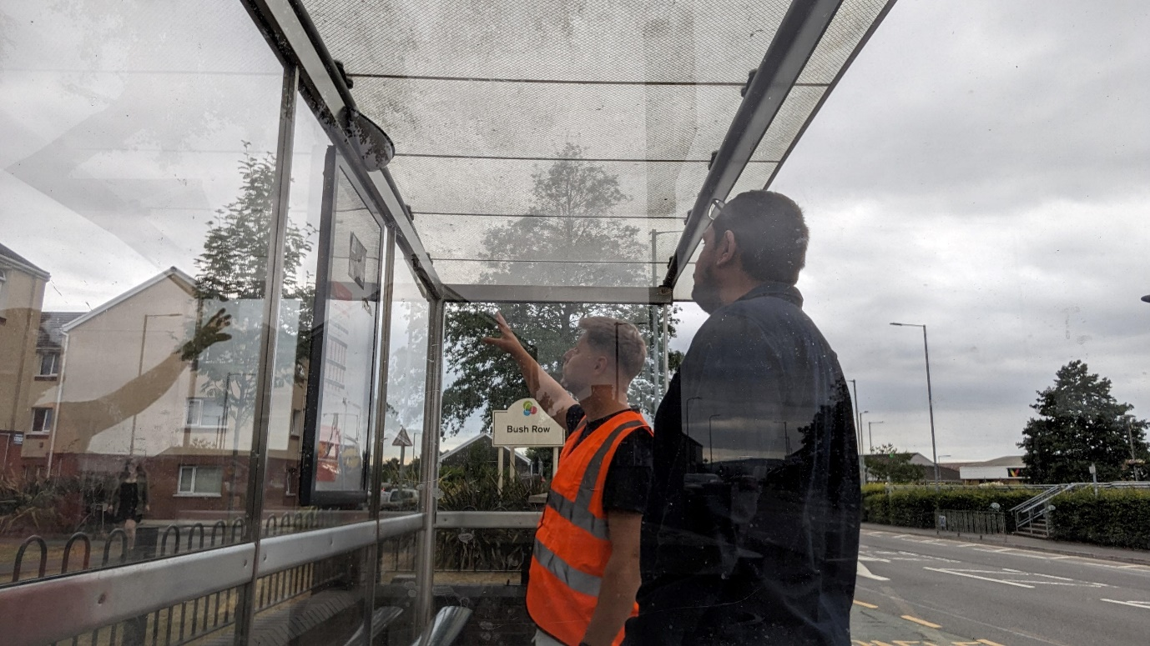

The Book Lockers project, aimed at introducing convenient book-sharing facilities in bus stations, has required careful planning and proactive risk management to ensure its success. In this blog, we will explore two vital aspects of our project: the Work Breakdown Structure (WBS) and Risk Analysis. These frameworks have enabled us to effectively break down complex tasks and anticipate potential challenges, paving the way for a seamless implementation.
The Work Breakdown Structure is a hierarchical representation of project tasks (Raftery, 2003), enabling us to organize and define the scope of work required for the Book Lockers project. By breaking down the project into manageable components, we gained clarity on the specific activities needed to achieve our objectives.
Risk analysis allows us to identify and mitigate potential obstacles that may arise during the project. By proactively assessing risks and formulating contingency plans, we ensure smooth progress and minimize disruptions. Conducting evaluations at various stages of the project provides valuable insights into its effectiveness and enables us to make informed decisions for improvement.

Reference
Raftery, J., 2003. Risk analysis in project management. Routledge

