Project Managment

  - Name: Sarann Strange

Student Number: 1701763

University of wales Trinity saint David

Stream: B.Sc. Software Engineering

Module Tutor: Sue Maw

Table of Contents
1 Table of Contents 1
2 Table of figures 3
3 Introduction 4
4 Risk management 5
4.1 Probability impact table 5
4.1.1 Probability impact matrix 6
4.2 Risk exposure & reduction leverage 7
4.3 Risk exposure 8
4.4 Risk reduction leverage 9
5 Sustainability issues 10
5.1 First Sustainability issues 10
5.2 Second Sustainability issues 10
5.3 Third Sustainability issues 11
6 Project issues 12
6.1 Ethical Issues 12
6.2 Legal Issues 12
6.2.1 The data protection act 2018 12
6.2.2 General Data Protection Regulation 13
7 British Computer Society Code of Conduct 14
7.1 Public Interest 14
7.2 Professional Competence 14
7.3 Duty Relevant Authority 15
7.4 Duty to the Profession 15
8 Brexit 16
8.1 Legal outcomes 16
8.2 Ethical outcomes 16
9 Quality Assurance 17
9.1 Functionality 17
9.2 Reliability 17
9.3 Usability 18
9.4 Efficiency 19
9.5 Maintainability 20
9.6 Portability 21
10 Conclusion 22
11 References 23

Table of figures
Figure 1 Lookup table for risk, probability and severity 5
Figure 2 Probability table 5
Figure 3 Probability impact matrix 6
Figure 4 total number of days and the calculation to discover the minimum & maximum of days for each level of severity 7
Figure 5 Risk exposure table 8
Figure 6 Risk reduction leverage table 9

Introduction
The report contains an evaluation of the risks that may delay the project and the severity of the impact that it would have on the project that is displayed within a probability matrix.
The creation of a risk exposure that displays fixes the cost and if they are valid implementations.
The discussion of first second third sustainability issues due to the project’s existence. The ethical legal issues of the project. Code of conduct of the British computer’s society and its relationship to the project. Brexit and its potential effects on the project. The quality assurance of the project.

Risk management

Probability impact table
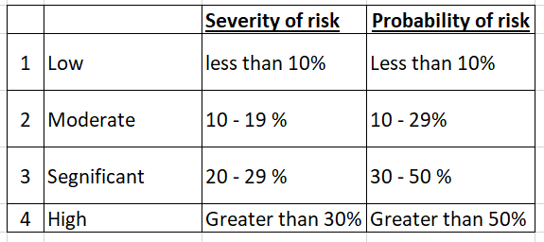

Figure 1 Lookup table for risk, probability and severity

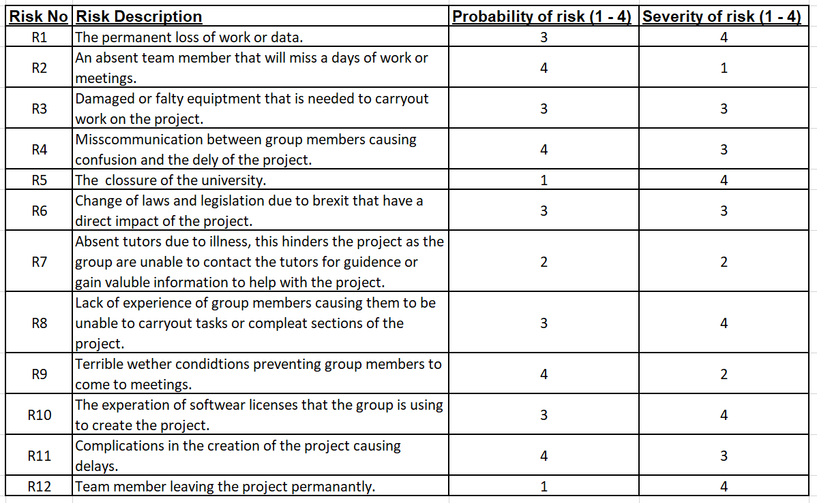
Figure 2 Probability table

Probability impact matrix
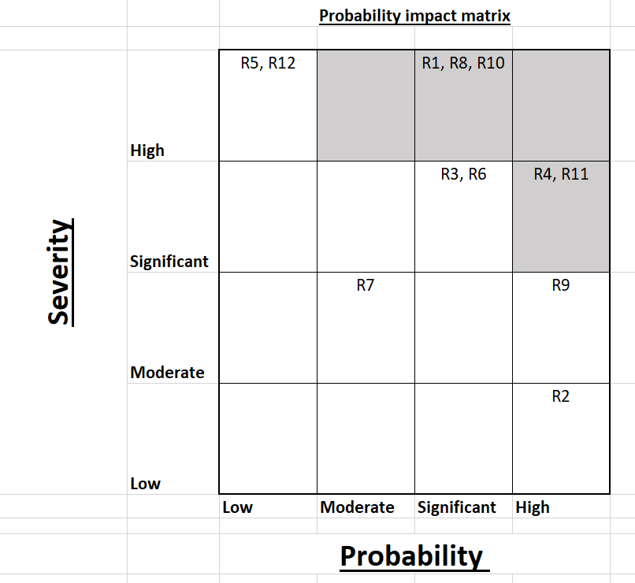
The grid within figure 3 represent the severity and probability of risks occurring. The tolerance line is represented by the grey sections within the matrix, as seen in figure 3, R1, R8, R10, R4 and R11 fall into this category, the severity or the probability of these risks must be reduced to decrease the likelihood of them occurring to prevent the failure of the project.
Figure 3 Probability impact matrix

Risk exposure & reduction leverage
The project has a total of 86 days (Wed 24/10/18 – Tue 15/01/19). The total number of days was calculated to provide the minimum and maximum of days for each level of severity.

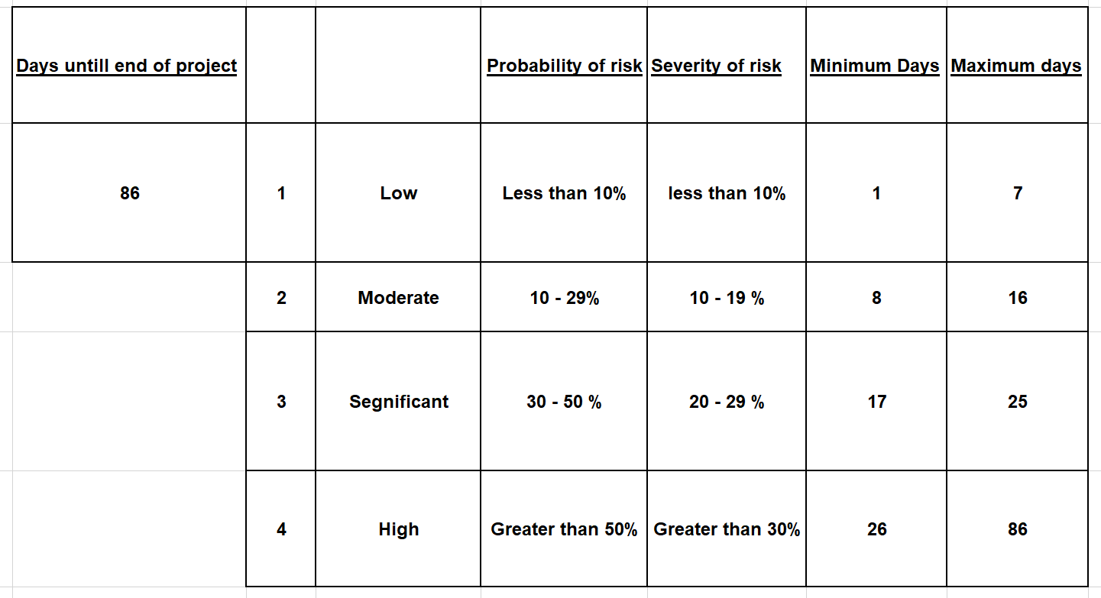
Figure 4 total number of days and the calculation to discover the minimum & maximum of days for each level of severity

For context a single day was given a monetary value of £5, within the following tables the severity of risks and the risk reduction is displayed using a monetary value.

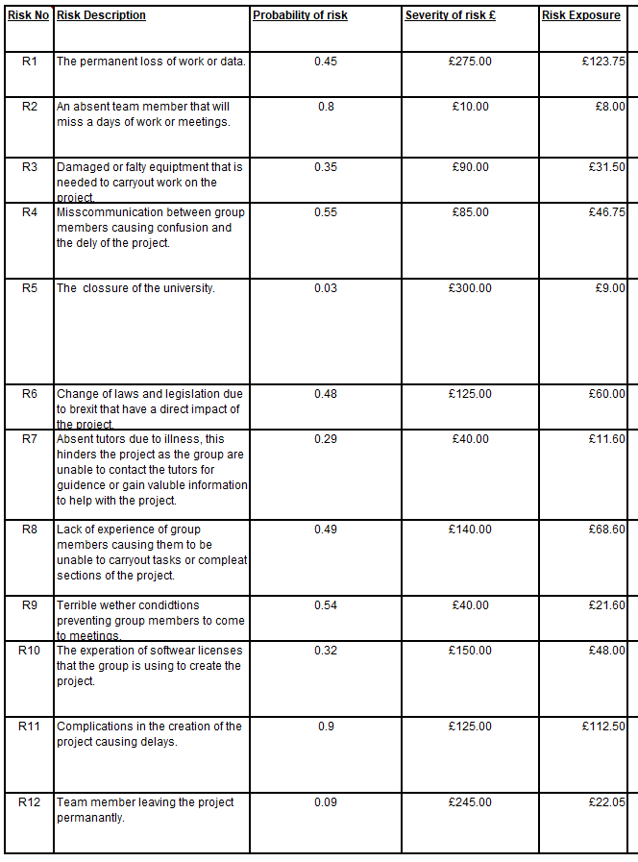
Risk exposure
Figure 5 Risk exposure table

Risk reduction leverage
Figure 6 Risk reduction leverage table
The table below displays reduction methods that the group can make to reduce the overall impact of the risks discussed and the outcome value of the reduction method. The formulas used was as follows:
(Risk Exposure before – Risk Exposure after) / cost of reduction = Risk reduction leverage [1].
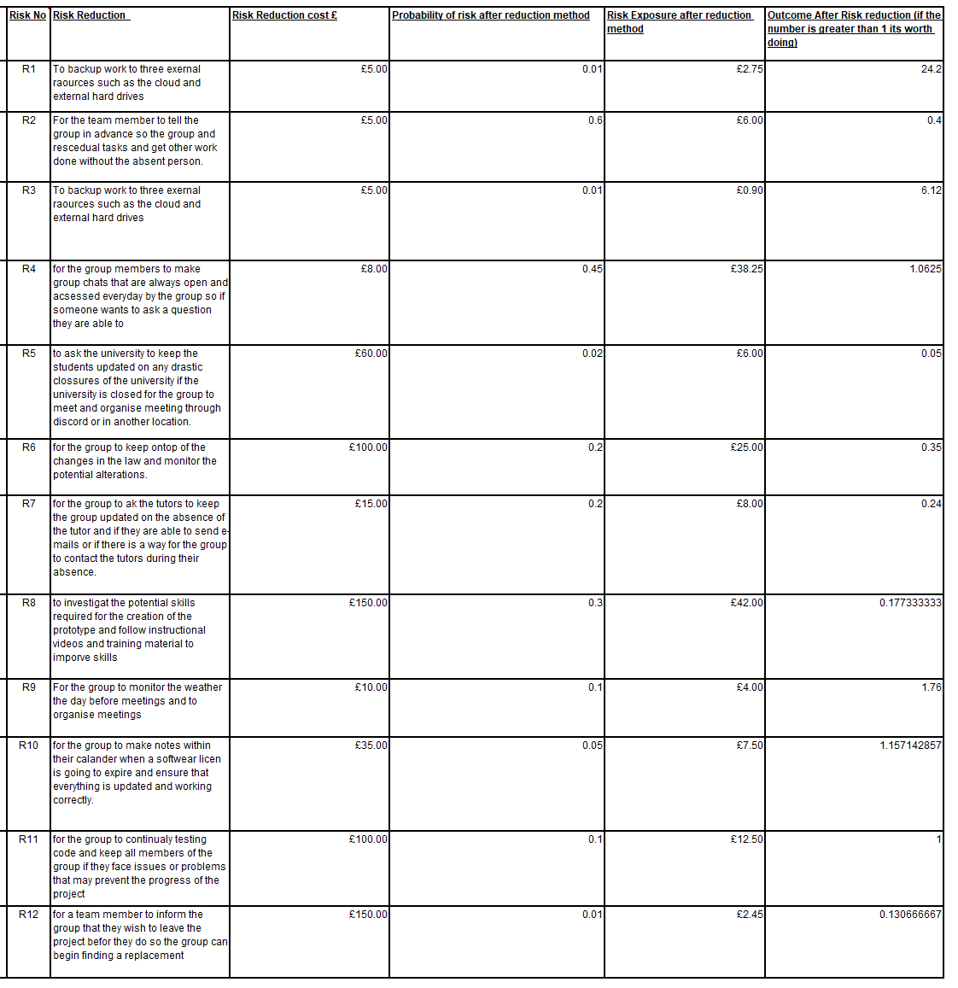
If the risk reduction leverage is greater than or equal to 1 then the risk reduction measure is worth carrying out.

Sustainability issues
Due to the creation of an application and the devices it will be used on, it has a direct and indirect impact on the sustainability of the environment during different stages of its initial creation to its established use and continued use throughout its life span.

First Sustainability issues
The first sustainability issues are a direct result of the requirements and developmental stages of SHARD’s product that involve the use of fossil fuels that emit GHG (greenhouse gasses).
- The initial creation of the computer systems, mobile phones and laptops to design, code and create the application
- The use of the devices that require electricity to run and other items such as headsets and programs for communication between group members.
- The vehicles that each member uses to travel to meetings that require fossil fuels
- The use of other companies’ services
  - Who run their own vehicles
  - Use electricity to power their devices and buildings
  - The servers used to store SHARD’s data that require electricity and a form of cooling

The e-waste generated due to upgrades and the replacement of information technology devices such as mobile phones, laptops or computer parts that are required for the group to continue collaborating and working on the project e-waste is damaging to the environment if it is not recycled as more devices will be created to replace the ones being thrown continually increasing the number of devices being thrown [2][3].

Second Sustainability issues
The second sustainability issues are the results of the disaster and how SHARD combats and reduces them.
- Signs, landmarks or buildings may be damaged by a disaster, due to locations being logged and tracked on a live map SHARD reduces confusion of rescue workers treading the same path twice or becoming lost.
- If a rescue worker is injured or trapped they can be found quickly.
- The current location of a victims and their status e.g. dead, severely wounded, injured or trapped is displayed by the application. Rescue-workers can prioritise victims and respond to the individuals who require aid first. A queue biased system allows rescue workers to save more lives that may otherwise have perished.
- Requests for specifically skilled rescue workers can be made, allowing for individuals to respond faster to the needs of victims as they know the location they are needed.
- Constant communication is possible which allows for requests for help or sharing of information such as the length of time they will be until they are available.

Third Sustainability issues
The third sustainability issues involve the long-term impacts of SHARD on society. If the project is accepted on a large-scale it could be implemented within the emergency services and used worldwide [4].
The device would attach to the uniform of the emergency service worker and provide updates on the location of their colleges and provide instant messaging.
- Doctors and nurses working in large buildings could view an indoor map of the hospital displaying all floors and the location of their colleges, if they needed to find them if they did not respond to messages or calls [5].
- SHARD could be used in conjunction with old technology or replace it, allowing an easier form of instant communication between doctors or nurses [6][7][8][9].
- Police officers could use SHARD to view the area that they are in and see the other officers’ locations along with ranks and training if they needed a higher-ranking officer they could easily request their assistance.
- SHARD would allow the different emergency services to view each other on the map to build an idea on who has been notified and are currently at the scene.
Another possibility is that the application will be made available to members of the public. Allowing them to input the emergency, its location and the emergency services they require, rather than phoning and relaying the information to an operator [4][10].

The negative effects of the application becoming popular would be many phone operators would not be required to man the phone line for calls to the emergency services as members of the public can input requests directly.
Emergency service workers would have the responsibility of managing the application and contacting other emergency services themselves through the application.
The location of emergency service workers would always be on display and recorded some individuals would find this a breach of privacy and refuse to work under constant monitorization.

Project issues

Ethical Issues
Due to the sensitive information of rescue workers and victims being stored on servers and the way it is accessed many ethical issues must be considered [11].
It may be argued that it is not morally acceptable for deceased victims to be tagged on a map alongside personal information and for rescue workers to continue their search for survivors without removing those bodies from the area first.
If the business becomes a publicly owned company the risk of the application being used by news organisations to broadcast the locations and number of victims within a disaster, if this scenario does occur the identity of individuals could be compromised as locals recognise the maps and the area that their friends or relatives would be. If that data is broadcast across the news would it invoke widespread panic and hysteria as locals’ question if their loved ones are involved in the disaster and are deceased [12][13][14].
If one of the devices is stolen or falls into the wrong hands the location of victims within a disaster area will be displayed on the device to potential threats and thieves[15].
If the disaster is due to terrorists, they could place false notes on the map and lure the emergency workers to that area and attack them. The system runs the risk of being hacked and private information of the rescue workers can be stolen and used in a manner that is unwanted.

Legal Issues

The data protection act 2018
The data protection act governs how businesses, companies and the UK government uses and stores private data within the UK [16].
This law affects SHARD as the application will be storing and using confidential information of rescue workers and victims, the law states that the company must regulate the use of data for its specified purpose and only when necessary and in a way that is fair and transparent, there for SHARD cannot use the data that it has gathered for any other purpose than intended and only for the length of time that the data is needed.
This law impacts the project as confidential data of rescue workers such as their name, skills, job roles and position and location in real time are displayed on a live map, the law governs the handling of that data that it must be up to date and states that it must be secure and protected from individuals who have no right to alter, share, use or access it. SHARD must place safety precautions in place and hire trusted professionals who only have access to the confidential information [17].

General Data Protection Regulation
The GDPR was implemented by the EU parliament, this law has a direct impact on the project and the group as it effects organisations within the EU and ones that are providing services and goods to individuals and organisations that reside within the EU.
The GDPR aims to protect private information that an organisation has from breaches through minimising unnecessary data gathering and providing individuals and businesses control over their own personal data through consenting to data and information being gathered and used for various reasons [18].
This directly affects SHARD as private data of the rescue workers will be acquired and maps of areas will be used and stored by the organisation. SHARD must ensure they do not display or store unnecessary information of shops, victims or individuals that live within an area without their explicit consent.
If a breach occurs and SHARD is hacked, they must inform individuals and users within 72 hours of the breach’s discovery. Individuals using SHARD must have access to their own data if they want their data to be removed SHARD must comply[19].
GDPR states that privacy measures to protect the private data of users of the application must be considered and implemented from the beginning it cannot be an addition to the system. It requires only necessary data to be stored and only relevant individuals to have access to said data, if SHARD does not comply with the GDPR the company can face a fine of 2% to 4% of the company’s global turnover[20].

British Computer Society Code of Conduct
The British computer society is one of the professional governing bodies that advise the government and businesses that are part of the group on topics on the professional code of conduct to acceptable and unacceptable behaviour[21].
When working on a project or within a company, issues may arise that could potentially impact the human-rights of individuals using the product or working on the project, or individuals impacted by the introduction of the product into their culture or area.

Public Interest
The application can track rescue workers and log the location of victims within a disaster zone and display an accurate and current location on an online map. The application can potentially impact members of the public, if the map location of the rescue workers is easily accessible to individuals who are not members of the rescue team they could potentially target victims and steal from them or try to harm the rescue workers themselves, furthering the chaos of the disaster. SHARD while working on the project developed strategies and safeguards to protect the public’s health and privacy by implementing passwords on all devices.
Within the BCS code of conduct it protects the health, security, wellbeing and security of members of the public as stated within the BCS Code of Conduct
“Have due regard for public health, privacy, security and wellbeing of others and the environment” [22]

Professional Competence
Throughout the project the team members had to adopt and continually learn new skills. The skills consist of coding practices, coding using C++, coding for android and NODE MCU to create the prototype of the product. The group monitored and adapted to updates of used platforms such as android, google and Windows.
The group developed a comprehensive understanding of the laws that govern their own country when handling data and the subsequent country’s they wish to publish the application to.
If the group did not keep up-to date with the changes made to platforms, then the development and implementation could be out-of-date causing functionality issues further into the project.
The skills and knowledge of team members would quickly become outdated and obsolete if they did not develop and maintain their knowledge of current technologies. A lacking knowledge and comprehensive understanding of laws and legislation may result in the group being summoned to court and liable to charges and fines if the unwittingly broke laws.
“Develop your professional knowledge, skills and competence on a continuing basis, maintaining awareness of technological developments, procedures, and standards that are relevant to your field.” [22]

Duty Relevant Authority
SHARD has a duty of care for the public and users of its application there for they should not mislead or misrepresent their application or its capabilities knowingly or take advantage of individuals who are not IT literate or have a limited understanding of the product that SHARD is creating.
If SHARD behaves in this fashion they would receive bad publicity from the press and public, the target market they wish to use their application and the trust of potential business partners and companies that wish to collaborate or invest in SHARD. They could also face legal repositions and possible fines affecting their revenue and profits.
“NOT misrepresent or withhold information on the performance of products, systems or services (unless lawfully bound by a duty of confidentiality not to disclose such information), or take advantage of the lack of relevant knowledge or inexperience of others.” [22]

Duty to the Profession
Members of SHARD consistently supported each other during the development of the project through effective communication via group interactions and meetings, encouragement of ideas, positive and constructive criticism of work and recommendations on relevant material and learning rescores to improve themselves and the project.
If the group did not follow this code of conduct they would not function sufficiently or share ideas or contribute to the success of the project, they themselves would not improve their own skills or understanding or the groups.
If negative feedback is given without an indication on how to improve then the recipient will respond negatively and their productivity and interest in the project may decline, the working environment may become hostile and the ethos of the team could collapse.
“Encourage and support fellow members in their professional development.” [22]

Brexit
The UK has been a part of the European union from 1973 and had to follow the laws created and implemented by the EU. Due to the Brexit referendum the UK officially declared that it will leave the EU this poses possible alterations to current laws that businesses must follow [23].

Legal outcomes
The UK after Brexit is required to be deemed by the EU as a ‘safe third country’ this allows the UK to continue to trade personal data from the EU to the UK [24].
If the UK do not achieve adequacy agreement, transferring data becomes more difficult were EU businesses wishing to export data will have to develop and maintain their own export mechanisms such as consent from the individuals who own the data agreeing for it to be sent to the UK this must follow the laws of the EU. UK businesses who have locations within the EU can still transfer data between sites residing within the EU.

Ethical outcomes
Brexit has the potential of impacting start-up businesses due to uncertainty over the result of Brexit, larger organisations are afraid to invest in smaller businesses within the UK as they are uncertain if they will have the freedom to import and export products, data or easily interact with individuals living within the EU. Businesses feel that they must protect themselves from future failure due to the UK leavening the EU which in turn potentially impacts smaller businesses who would have thrived and grown because of the investments from businesses within the EU [25][26].
The freedom to travel between the EU and the UK is questioned as individuals living within the UK who work for companies within the EU are concerned over the freedom to travel between countries if they require a work visa to enter countries within the EU. Uncertainties over EU businesses investing in individuals due to the uncertainty over the requirement of work visas [27].

Quality Assurance

Functionality
When discussing the functionality of the system, the accuracy, interoperability, compliance and security of the system must be maintained and followed. When maintaining the suitability and accuracy the application it must allow each individual rescue worker to inputting 150 notifications into the system, display the notifications and location of rescue workers and victims to a total of 100 devices at one time within a 10km radius on an accurate map of the area.
The system will be security protected using passwords or a fingerprint scanner that is inbuilt into the device that prompts the user before they gain access to the device.
The website will be hosted as a HTTPS website, the additional security as opposed to regular HTTP allows for the server to query device location.

Reliability
The reliability involves the maturity, fault tolerance and the recoverability of the system.
The maturity of the system involves the growth and the length of time the system runs and is in use, to achieve this a user side reporting system will be implemented were the users of the application can report bugs and issues. Patches will be released every three months. An annual meeting will be conducted to discuss the application the future of the application and further improvements that will be made through the upcoming year.
The fault tolerance involves stress testing the system to ensure that it functions as expected [28].
One method to test the system involves three separate groups of 5 individuals with a device each inputting various notifications. If any one of the devices fails, the other devices should continue functioning and updating the notifications.
The downtime of the system should only be 3 hours a fortnight, and it should take no more than 3 minutes for the system to be rebooted from a hard crash. The system will be backed up on 3 separate devices and in three separate locations and the use of DRaaS as a cloud based recovery platform for the system will be implemented [29].

Usability
The usability consists of the understandability, learnability, operability and the attractiveness of the system. Due to the environment that the application will be used individuals must find it intuitive and user friendly. The application when it is first released must be available in five different languages, after 3 years this will increase to 10.
For the system to be understood it must allow a variety of individuals from different backgrounds, cultures and country’s to successfully perceive and interpreted the system [30][31]. To achieve this the system will be tested with a focus group of 300 people who will provide feedback on the system and the level at which they understood it [30], the system must have a pass rate of 85% on how easy it is to understand. This involves what the individuals are looking at if they can identify the map, buttons, icons if they can input messages, close menu screens and follow the pointers on the map to find other individuals using the application[31].
The learnability is how quickly users can learn how to use the system. For the application to be learnable, it requires an intuitive user interface that aids in the training of the application [32]. The system will require 2 – 3 hours of training to fully understand the system and its capabilities. To find the success rate of the training of the system, a follow up test will be carried out. The success criteria of the test will be 89% of individuals who did the training.
The operability involves the level at which an individual can operate the application. For each interaction and functionality of the application to be only 2 - 3 levels away from the main menu screen. For recognisable icons, buttons and easily readable text [32] that 95% of users are capable of understanding, for the system to be correctly calibrated to instantly respond to a user’s touch and interaction to the application.
The attractiveness of the system involves how the icons, buttons and text look to an end user, this is important as they must be sharp and clear images that a user can identify that aren’t easily confused with another icons or images, the system will have a colour palate that that can be customisable allowing for an application that is both functional and visually appealing.

Efficiency
Due to the nature of the application, the importance of it functioning and being in use at all times. The system must run and respond to inputs and alterations of the locations of users quickly, there for the time behaviours of the system such as its response time of the map and how quickly it updates and loads markers will be every 20 second.
The application must be capable of running on a low specification device such as a phone with a CPU with 2 cores running at 2.0Ghz, 1 GB of RAM and the minimum internet seep of 5 megabits per second.

Maintainability
The maintainability involves analysability, testability, stability and the changeability of the application. The analysability of the system is the ease at which the application of the setup of the application can be analysed to identify issues or faults, to aid in analysability the business will use the same syntax throughout the programming process and continually include comments.
The application should ideally be forward compatible for browsers and devices.
The changeability of the application involves the ease at which the system can be exported from one database management system to another, the same coding language will be used throughout the creation of the application, if sections of code requires alterations it can be done by different individuals working for the business.
For the system to be stable it must be robust and suffer a minimum number of crashes if the system does experience a malfunction that users of the system can contact the business immediately for it to be resolved. The system must have no more 4 crashes in a week.
The system will run tests weekly inputting fictional locations and data that will check and validate how its working it must have a pass rate of 90% [28], the application will gain data from the rescue workers on the field and log failures and errors. This should allow for those errors to be reproducible and testable to develop solutions to fix them.

Portability
The application will be adaptable and replaceable between different web browsers and systems. As discussed within 9.4 efficiency the application will have the capability to run on a low-end device if a system breaks or is unusable another device can easily log into the webserver and retrieve the exact data that the original had.
The application runs from a webserver there for it does not need to be installed directly onto a device.
Co-existence the system does not have an expectation to co-exist with other software.

Conclusion
The report successfully discussed the potential issues that the group may experience due to risks, their severity and exposure. The effects of the project on the sustainability of the world. The level of importance that the group had to follow the data protection act 2018, GDPR and the British computer society code of conduct. The potential impact of Brexit and the changes that may have to be made to the project. The different quality assurance tests and levels and checks to ensure the success of the project.

References
[1] Syque, “Risk Reduction Leverage,” 2019. [Online]. Available: http://www.syque.com/improvement/Risk Reduction Leverage.htm. [Accessed: 27-Jan-2019].
[2] A. Turner and M. Filella, “Bromine in plastic consumer products – Evidence for the widespread recycling of electronic waste,” Sci. Total Environ., vol. 601–602, pp. 374–379, Dec. 2017.
[3] P. Dato, “Economic analysis of e-waste market,” Int. Environ. Agreements Polit. Law Econ., vol. 17, no. 6, pp. 815–837, Dec. 2017.
[4] C. Owen, “How can governments enable and support community-led disaster recovery,” Aust. Inst. Disaster Resil., vol. 33.
[5] T. Kitanouma, E. Nii, N. Adachi, and Y. Takizawa, “SmartFinder: Cloud-based self organizing localization for mobile smart devices in large-scale indoor facility,” in 2017 Global Internet of Things Summit (GIoTS), 2017, pp. 1–6.
[6] tigerconnect, “HIPAA Compliant Texting App | FAQs | TigerConnect,” 2019. [Online]. Available: https://www.tigerconnect.com/about/faqs/hipaa-compliant-texting-app/. [Accessed: 26-Jan-2019].
[7] K. P. Steinberg, “Pagers Versus Smartphones - ProQuest,” AHC Media LLC, vol. 9, no. 8, 2014.
[8] Priyanka Dayal McCluskey, “Hospitals turning a ‘pager’ on data hardware,” 2016. [Online]. Available: https://www.bostonglobe.com/business/2016/02/01/beep-this-accessory-busy-doctors-finally-gets-upgrade/gRcjTy7w3RuTJiqaeKTsEN/story.html. [Accessed: 26-Jan-2019].
[9] Marissa Laliberte, “Why Hospitals and Doctors Still Use Pagers | Reader’s Digest,” Readers digest, 2018. [Online]. Available: https://www.rd.com/health/healthcare/hospital-pagers/. [Accessed: 26-Jan-2019].
[10] L. A. (Lopac) Hendrickson, S. Croymans, and S. Cronin, “Extension Builds on Tradition of Meeting Community Needs by Using Technology in Disaster Recovery,” J. Fam. Consum. Sci., vol. 109, no. 3, pp. 45–49, Aug. 2017.
[11] B. Barocas and S. Barocas, “Computing Ethics: Big Data’s End Run Around Procedural Privacy Protections,” Assoc. Comput. Mach. Commun. ACM, vol. 57, no. 11, Nov. 2014.
[12] “Freedom of Information Act 2000.”
[13] P. Prindle and S. Prindle, “Information Ethics and Academic Libraries: Data Privacy in the Era of Big Data,” J. Infor. Ethics, vol. 26, no. 2, pp. 22–33, Oct. 2017.
[14] G. Alter and R. Gonzalez, “Responsible practices for data sharing.,” Am. Psychol., vol. 73, no. 2, pp. 146–156, Feb. 2018.
[15] IEEE, “IEEE - IEEE Code of Ethics,” 2019. [Online]. Available: https://www.ieee.org/about/corporate/governance/p7-8.html. [Accessed: 27-Jan-2019].
[16] M. Hawke, “Data Protection Policy,” 2018.
[17] GOV.UK, “Data protection - GOV.UK,” 2018. [Online]. Available: https://www.gov.uk/data-protection. [Accessed: 24-Dec-2018].
[18] M. Goddard, “The EU General Data Protection Regulation (GDPR): European Regulation that has a Global Impact,” Int. J. Mark. Res., vol. 59, no. 6, pp. 703–705, Nov. 2017.
[19] H. de S. Daniel Alvarez, “GDPR Is Here: Are You Ready?: EBSCOhost,” 2018. [Online]. Available: https://web-b-ebscohost-com.ezproxy.uwtsd.ac.uk/ehost/pdfviewer/pdfviewer?vid=1&sid=dcca34d4-39b4-4577-acef-78e149b33e67%40pdc-v-sessmgr05. [Accessed: 27-Jan-2019].
[20] EU, “General Data Protection Regulation Policy (GDPR),” 2018.
[21] U. of C. T. Computer Science Department, “BCS Codes of Conduct and Practice.” [Online]. Available: https://www.cs.uct.ac.za/mit_notes/ethics/htmls/ch04s04.html. [Accessed: 27-Jan-2019].
[22] BCS The Chartered Institute for IT, “Code of conduct | Membership | BCS - The Chartered Institute for IT,” 2018. [Online]. Available: https://www.bcs.org/category/6030. [Accessed: 27-Nov-2018].
[23] “Digital Brexit Planning for a successful digital future outside of the EU.”
[24] Norton Rose Fulbright, “Impact of Brexit on technology and innovation,” 2018. [Online]. Available: http://www.nortonrosefulbright.com/knowledge/publications/136983/impact-of-brexit-on-technology-and-innovation. [Accessed: 27-Jan-2019].
[25] Anonymous, “Brexit - ProQuest,” J. Int. Taxation; Bost., vol. 27, no. 12, pp. 26–36, 2016.
[26] J. Bouoiyour and R. Selmi, “Are UK industries resilient in dealing with uncertainty,” Eur. J. Comp. Econ., pp. 277–293, 2018.
[27] P. Mindus, European citizenship after Brexit : freedom of movement and rights of residence. Sweded, 2017.
[28] C. Preimesberger, “Key Considerations for Financing Enterprise Disaster Recovery.,” eWeek, p. 1, 2018.
[29] E. Andrade, B. Nogueira, R. Matos, G. Callou, and P. Maciel, “Availability modeling and analysis of a disaster-recovery-as-a-service solution,” Computing, vol. 99, no. 10, pp. 929–954, Oct. 2017.
[30] J. Rubin and D. Chisnell, Handbook of usability testing : how to plan, design, and conduct effective tests. Wiley Pub, 2008.
[31] C. PRIBEANU, “A Revised Set of Usability Heuristics for the Evaluation of Interactive Systems,” Inform. Econ., vol. 21, no. 3/2017, pp. 31–38, Sep. 2017.
[32] T. H. Baek and C. Y. Yoo, “Branded App Usability: Conceptualization, Measurement, and Prediction of Consumer Loyalty,” J. Advert., vol. 47, no. 1, pp. 70–82, Jan. 2018.

