Internet Technology and Security

Synthesize a Solution to a Potential REAL-LIFE scenario

Christopher James Hopkins (1911310)

1911310@student.uwtsd.ac.uk
Table of Contents
- Introduction 2
- Computer Security 2
2.1 BYOD 2
2.2 BYOD Advantages 2
2.3 BYOD Disadvantages 3
2.4 A Summary of BYOD Environments 4
2.5 Threats and Vulnerabilities 5
2.6 MDM (mobile device management) & MAM (mobile application management) Software 7
3. Network Security 8
3.1 Packet Filtering Firewalls 9
4. Information Security 9
4.1 Data Encryption 9
4.2 Cyber Security Policy 10
4.3 Mitigating strategy after employment or when a device is lost or stolen 12
4.4 Data Retained by CoffeeCapulus 12
5. Conclusion 12
References 13

- Introduction

For the “Synthesize a solution to a potential real life scenario” coursework, students were tasked with assuming the role of an IT security consultant who has been hired by CoffeCapulus, a coffee company who sell a sought after blend of Jamaican coffee. It was stated that along with the companies “massive online presence” they use “cloud services to deliver IT services to its staff and clients” and almost all of the company’s network is wireless based. Throughout this report the author will break down different aspects of the security needed to run a safe network and the problems the company could face along the way.

- Computer Security

  - BYOD
BYOD or Bring your own device is the ever-growing practice of employees or members of the public bringing their own devices into workplaces, establishments, or public spaces. These devices can include smartphones, tablets, and laptops.
As technology has developed and more and more people own and use smartphones and laptops during their everyday lives, companies have been adopting BYOD device schemes as they can benefit both employee and business alike. BYOD policies can divide opinions on the practice in modern culture as there is a plethora of pros and cons that accompany these policies. Implementing them incorrectly can pose serious security risks to an organisation but on the other hand can increase employee productivity and reduce company costs. [1]

  - BYOD Advantages
There are several advantages of companies adopting a BYOD policy in the workplace. The author will list and discuss the most prevalent below in no particular order.
- Flexibility, productivity and comfort for the employee
When given the option to use their own devices for work purposes, employees will feel more comfortable using systems and software that they are used to and are already self-trained to use. For example, a study by Intel in 2010 found that “61% of Gen Y and 50% of 30+ workers believe that the technology tools they use in their personal/social life are more efficient and productive that those used in the work life”. [2] Both employees and employers can also benefit from increased productivity when staff are able to use operating system they are familiar with. For instance, a large proportion of smartphone and laptop owners will use either windows or apple products. Both these operating systems are very different and could create an ongoing learning curve for users.
Another aspect to consider is what the current pandemic has shown us. In this newly developing time of working from home and “hot-desking”, employees are able to use their personal devices for work-based activities. Even in their free time, they could be considered “always on”. Answering work emails during commuting or developing ideas or a brands social media platform over the weekend when they otherwise would leave their devices at work and not engage out of hours. A study conducted by TalkTalk in 2020 found that “58% percent of workers in the UK have been more productive as a result of working from home.” [3] Although this study focuses on mainly “working from home” the same principles and outcomes apply to BYOD where staff can use their own devices.
- Cost reductions for the organisation
A BYOD policy could also create significant cost saving. The trade-off of staff being allowed to use their treasured personal devices will benefit the finances of the employers. There would no longer be need for staff to be provided with devices and the upkeep that would follow. Companies could save a lot of money not having to spend drastic amounts on modern technology as the staff have more than lightly already purchased products. Although it is perhaps notable that creating a framework for a safe BYOD policy and implementation could be costly, the “CoffeCapulus” brand has been noted to have intellectual properties worth billions so the security needed to protect the organisation is very important. [4]

  - BOYD Disadvantages
Some disadvantages of a BYOD policy have been made apparent at this point, but the author will discuss them in more detail below.
- Distractions in the workplace
With the prevalence of social media usage in modern culture there is a concern that staff may take advantage of the BYOD environment and spend a lot of time on personal social media accounts such as Facebook or Instagram and even apps like YouTube. Aside from the matter of security risks and unsafe websites, staff may use company time to surf the web and perform other tasks that should be addressed in personal time. This issue will have to be addressed within the policy and safeguards put in place to deter any unwanted behaviour from staff who mean to take advantage of the BYOD environment.
- Data leaks within the organisation
As staff would be permitted to use their own devices, there is a concern over data leaks of sensitive information. Company information could be at risk due to malicious apps or human error and a lack of consideration. On the other side of this employee personal information could be leaked and could pose a threat to the individual. [1] Defensive measures would have to be put in place to minimise these serious risks. These could include firewalls, VPN and IT framework put in place to make sure the user and the organisations information is guarded.
The Ponemon Institute carried out a study of 798 U.S. IT and data security practitioners. They found, amount other things, that “59% of employees circumvent or disable required security settings on their mobile devices”. [5] Training could be considered to warn unaware users of the dangers that could occur due to an unsafe BYOD environment, this would put some responsibility on the user themselves to protect sensitive data and consider their actions.
- Malware, spyware and malicious websites
Malware, spyware and malicious websites are also a cause for concern when people are in a BYOD environment. When devices are used to file share, visit unsafe websites or download unsafe software there is heightened risk of the device and even organisation falling victim to a malware attack. The attack could take control of systems and cause a lot of damage. Data breaches, as a result of malware attacks, caused the loss of billions of dollars across the world in 2011. [6] This number has only increased in recent years and especially in 2020 due to technology being depended on more as people work from home. When a BYOD policy is put in place, the possibility of attacks must be addressed and safeguards must be put in place.
- Devices could “fall into the wrong hands”
Another point to consider is that when staff are using their personal devices for work, at any level, there may be sensitive information stored on that device. If a device were stolen, lost or intercepted there could be damage done to the company. Files could be stored offline on the device itself so safeguards would have to be introduced to make sure that if a device does “fall into the wrong hands” there are locks and ways to immediately trace the location of the device.

  - A Summary of BYOD Environments
Now that the author has outlined some of the advantages and disadvantages of BYOD, he will try to summarize the findings from the research.
It seems to be clear, in the authors opinion, that the pros outweigh the cons of BYOD environments. Although there will certainly be setup and ongoing costs to running a safe network that utilizes BYOD, there will be reduced costs which would have gone towards purchasing hardware and software that users will already own. Staff will hopefully be a lot more productive and proactive with their work due to comfort in using their own devices. The hopeful result of staff having their work devices on them at all times is that they can be more flexible with work, perhaps promoting their work and participating in conversations about work more during the evenings and weekends. Another big factor that we have not covered so far is the improvement of the company’s reputation. Seeming willing to evolve and be part of the digital and “social media world” is definitely in the company’s interest. With the prevalence of and developing mindsets around BYOD, CoffeCapulus would not want to seem “old fashioned” and fall behind the competition. A survey held by Tech Pro Research showed that 59% of organizations already allowed employees to use their won devices. [7] The disadvantages mentioned, such as security risks, can be battled with security restrictions that will not have a negative effect on the employee or company.
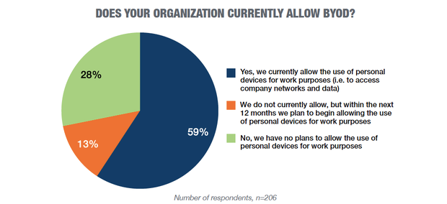
[7]

  - Threats and Vulnerabilities
Cyberthreats to any company, large or small is a serious issue. Due to the various real-world threats there has to be safeguards in place to protect CoffeeCapulus. Below the author will cover some of the most common forms of attack that could affect an organisation like CoffeeCapulus.
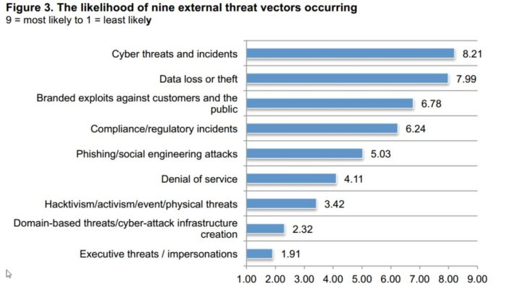 [8]
- Malware
Malware is malicious software that was created with the intent of stealing data, damaging systems, or causing other kinds of harm to people or companies. There are several kinds of malware that cybercriminals use.
  - Ransomware
Ransomware is essentially a software that, when released into a system, will eventually lock the users out of being able to gain access to their files. Ransomware is often disguised as an email containing a link, when this link is activated it can infect the device and then even the network of the organization. The data then stored in these locations is held at ransom by cyber criminals. They will offer to restore the data for a price but then the options offered are to accept data loss which can cost large sums of money or deal with criminals who often wont actually restore the data that has been effectively stolen. The FBI estimates that there are around 4000 of these attacks every day and up to 60% of small business have been somehow affected by ransomware. [9] The issue with ransomware is that it is usually a form of “social hacking” or “social engineering”, tricking employees into clicking on links that seems safe and sent from a colleague. Employee training is key in this scenario as a first line of defence against ransomware as it will be unaware employees that will usually release these attacks upon the network. Failing that, an enterprise class firewall may keep these attacks from harming network systems.
  - Trojans

Trojans are usually disguised as software to attack systems and gain access to files on a device. Once installed the Trojan will usually make changes to your security systems and can cause chaos within an organization. The way to combat these is foremost employee education and then perhaps blocks on installing any software not first permitted by the IT technicians.

  - MiTM Attacks (Man in the middle)
Man in the middle attacks can compromise Wi-Fi or Bluetooth connections between two users. When two users communicate over a network there can sometimes be a third party that remains “unseen” by the users. This party can then eavesdrop and intercept messages, even altering them. [10] These attacks can be hard to notice but the risk of them happening can be mitigated by having multifactor authentication within the network or encryption protocols such as SSH or TLS.
  - Phishing attacks
Phishing is a blanket term usually referring to social engineering attacks that trick users into performing actions that cybercriminals want performed. In a report published by IBM in 2011 it was found that mobile users are three times more lightly to be affected by these types of attacks which could be an issue when implementing a BYOD environment. Employee awareness and education of these attacks is imperative to help combat them.

  - MDM (mobile device management) & MAM (mobile application management) Software
A product that could be considered for implementation within the organization is Microsoft Intune. Intune is a cloud based service that would manage the security of devices within the CoffeeCapulus system.
CoffeeCapulus would be able to configure device security measures along side the implemented security policy. It can be used with the Office 365 package which includes word processors, excel, teams and other basic tools within the company. All the devices security can be modified to each member of staff within the organization, allowing them to use personal devices safely. [11]
See below for architecture options for Intune integration. [12]
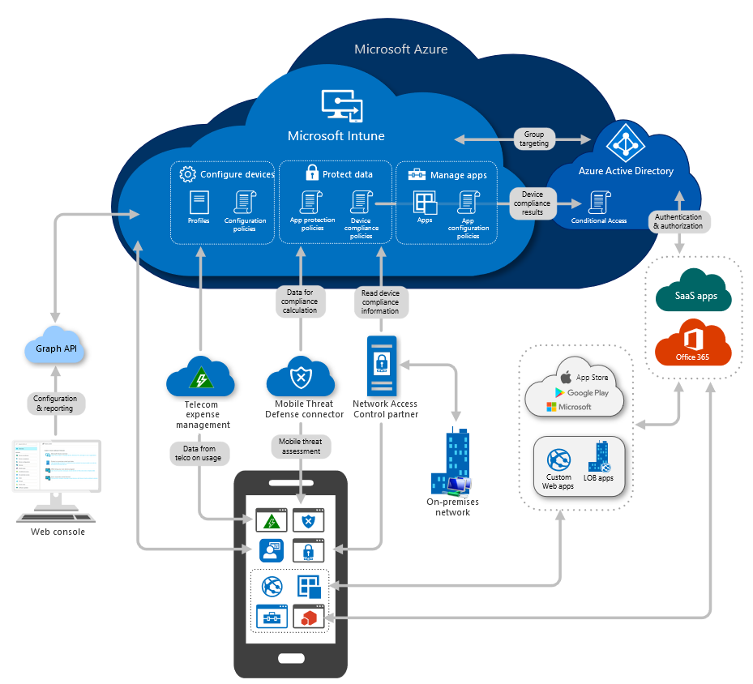
Intune would provide protection against attacks and data leaks while enabling a BYOD environment to be implemented. Devices can be enrolled onto the network with Intune that are even third party and other OS such as Android, iOS and Macs.

- Network Security
The network security of CoffeeCapulus will require a network to be build. The author will use Cisco Packet Tracer to build a virtual network of how this could work. (See below)
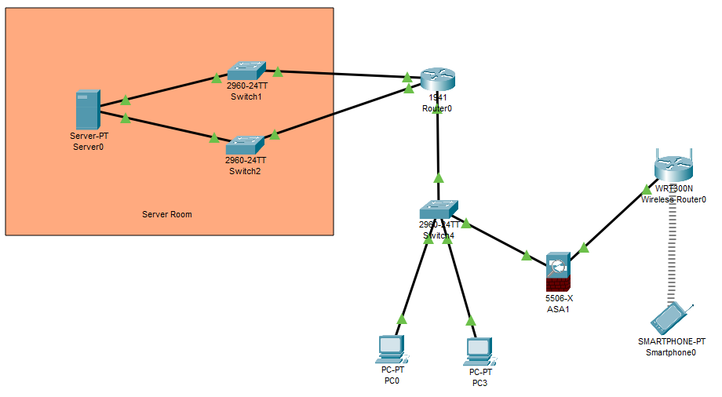
This is the basic network; the creator has enabled passwords within the switches, a server room to protect data in the case of a malfunction and a firewall between the wireless router and the switches.
Passwords were set using the CLI. So, when a user attempts to connect to configure, they are prompted for the password.
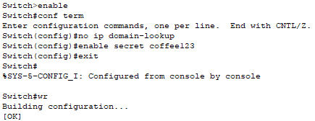
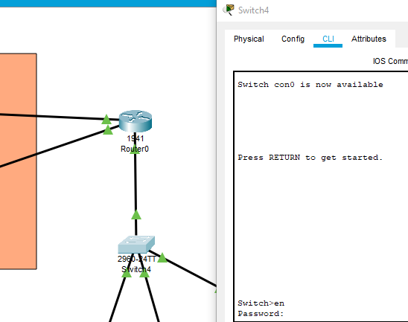

  - Packet Filtering Firewalls
Packet filtering firewalls are a basic type of firewall that monitors network traffic based on the packet’s information. They run on the network layer and can deny access based on the packet’s header information. They have their share of advantages and disadvantages. For example, they are fast and low cost, but they do not actually check the data itself. This means that sometimes malware can be hidden within the data and can get through. They also do not monitor the packet when it has passed through. They are very cost efficient but do not offer the best security within the network. [13]

- Information Security

  - Data Encryption
An aspect of security to consider is data encryption. To protect sensitive data and information, an encryption method could be implemented. Encryption is the process of scrambling information using algorithms and then when the receive has it after it has been sent while scrambled, it is decoded with a key.
Microsoft Intune, which CoffeCapulus can use to create the BYOD environment, can be used in sync with BitLocker. BitLocker is an encryption tool that can protect sensitive data by encrypting even full drives. Microsoft Intune then provides a “built-in encryption report that presents details about the encryption status of all devices, across all managed devices.” [14] With this software CoffeeCapulus will be able to manage all device encryption and status from the same place and even set permissions and scope of the devices on the network.

  - Cyber Security Policy
Cyber-attacks can be costly and even devastating to a company. It is imperative that CoffeeCapulus has a clear policy for all staff to adhere to so that the sensitive data and intellectual property of the company is protected. The author has created a policy with different aspects of the company in mind.
Please see below:


CoffeeCapulus Cyber Security Policy
v.1.0

Brief
The CoffeeCapulus cyber security policy has been created to protect the security and integrity of employees and the organization from technological threats.
CoffeeCapulus’ BYOD (Bring Your Own Device) environment grants employees the privilege of using their own devices in the workplace for greater convenience and flexibility.
This policy aims to protect all parties from falling victim to malware, hackers, human error, system failures and other threats posed by an online workplace system.
Scope
This policy covers any persons using the network. This includes, but is not limited to, all employees, volunteers, contractors, interns, contractors, managers, and casual staff.
Confidential Data Definitions
Confidential Data – CoffeeCapulus defines confidential data as, but not limited to:
- Employee passwords, usernames, emails, and asset tag information
- Customer & supplier information and data
- Contract and legal documents
- Patents, paperwork, office documents, sales records
- Financial data and information
- Intellectual property
All employees, volunteers, contractors, interns, contractors, managers, and casual staff agree to protect “confidential data” within and outside the workplace.
Acceptable Use
- Limited personal use such as reading, playing games, messaging
- Employees are barred from entering illicit or unsafe websites
- No apps are to be downloaded or installed by members of staff, all must be installed by a qualified IT technician
- Staff may use their devices to access company resources, including emails, calendars, and contacts, provided that have clearance for said resources
- Devices may not be used at any point to download illicit materials, send confidential data to third parties, harass or bully others or harm company image in any way
Employees are however encouraged to use their devices and social media in positive ways to expand an understanding of the company’s brand and the employees own skill and professionalism.
Requirements
All employees are required to always follow the listed requirements and always contact IT if unsure.
- All devices accessing the network must be password protected using both lower, uppercase and numbers with a minimum of 8 characters
- All devices must be registered/enrolled with the company cyber security software (Microsoft Intune)
- Employees must only use “accepted apps” – contact IT for a list of cleared apps for each individual employee
- IT must be notified before updates are applied to OS or accepted apps
- All device hardware must be “locked”, and password protected at all times
- All devices must always use the secure work environment network while in the workplace
- All staff are required to attend cyber security training and sign the declaration after the training has been received
- Staff must be vigilant about the legitimacy of emails and files
- Never open suspicious emails or click on email links – consult with IT if unsure
- Only send confidential data over secured workplace networks
- Always obtain permission from IT/management when unsure while using software or sending files
- Employees must inform IT if a device is lost or stolen
- Employees are required to report to IT before leaving employment so their devices and permissions can be addressed through a device debrief
- Alert IT immediately if any requirement is breached by yourself or another member of staff
Risks
Employees assume full accountability for any exposure to viruses, malware, or other threats.
CoffeeCapulus reserves the right to disciplinary action against the employee if any of the listed requirements are breached. This includes suspension or even employment termination.
This document has been created to protect all employees as well as the employer. Staff will always be notified of any changes to the cyber security policy.

  - Mitigating strategy after employment or when a device is lost or stolen
The company policy states that when an employee’s employment has come to an end, they must report to IT for device debriefing. Microsoft Intune will then be used by IT to un-enrol the device on the network and stop the staff members permissions. This will disable previous permissions that the employee had to company resources. Also, the same will happen if the device is stolen or lost. Using Intune, IT can either track the device or block access so that data remains protected.

  - Data Retained by CoffeeCapulus
CoffeeCapulus will reserve the right to retain certain data contained on the employee’s device. The MDM software, Microsoft Intune, needs to collect certain data on behalf of CoffeeCapulus. This includes things like User information, phone number, hardware information, audit log information, support and access information and device data. However, Intune does not collect web browsing history, photos, or other personal data the employee has so that their privacy is also protected. It is up to the user to be professional with their device.

- Conclusion
CoffeeCapulus’ network should be managed by Microsoft Intune; this would allow IT to manage all the devices registered for the BYOD environment. They would be able to keep the users and company as safe as possible while giving everyone the required permissions to access resources. The BYOD environment positives outweigh the negatives in the case of CoffeeCapulus and would help the companies image moving into the future. Although safeguards will have to be put in place as listed within the policy, if followed and monitored CoffeeCapulus will be safe and secure.

References

[1] | S. S. E. R. V. S. Chalee Vorakulpipat, “A Policy-Based Framework for Preserving Confidentiality in BYOD Environments: A Review of Information Security Perspectives,” Security and Communication Networks, vol. 2017, 2017.
[2] | Intel, “Consumerization: What is in store for IT?,” July 2010. [Online]. Available: http://i.dell.com/sites/content/business/solutions/whitepapers/it/Documents/intel-imr-consumerization-wp_it.pdf. [Accessed November 2020].
[3] | TalkTalk, “Homeworking boosts Britain’s productivity: ‘Five days work Now done in four’,” 17 September 2020. [Online]. Available: https://www.talktalkgroup.com/article/talktalkgroup/2020/lockdown-lessons. [Accessed November 2020].
[4] | M. Dhingra, “Legal Issues in Secure Implementation of Bring Your Own Device (BYOD),” ScienceDirect, vol. 78, pp. 179-184, 2016.
[5] | P. Crosman, “Mobile Data Leaks May Kill BYOD at Banks,” American Banker, vol. 178, pp. 7-7, 2013.
[6] | D. Dang-Pham, “Comparing intention to avoid malware across contexts in a BYOD-enabled Australian university: A Protection Motivation Theory approach,” Computers & Security, vol. 48, pp. 281-297, 2015.
[7] | T. Maddox, “BYOD, IoT and wearables thriving in the enterprise,” TechRepublic, [Online]. Available: https://www.techrepublic.com/article/byod-iot-and-wearables-thriving-in-the-enterprise/. [Accessed Novemeber 2020].
[8] | P. Institute, “Security Beyond the Traditional Perimeter”.
[9] | UniTrends, “How Ransomware Works,” UniTrends, [Online]. Available: http://www.unitrends.com/solutions/ransomware-education. [Accessed 2020].
[10] | D. Javeed, “Man in the Middle Attacks: Analysis, Motivation and Prevention,” International Journal of Computer Networks and Communications Security, vol. 8, no. 7, pp. 52-58, 2020.
[11] | Microsoft, “Microsoft Intune is an MDM and MAM provider for your devices,” 23 06 2020. [Online]. Available: https://docs.microsoft.com/en-us/mem/intune/fundamentals/what-is-intune. [Accessed December 2020].
[12] | Microsoft, “High-level architecture for Microsoft Intune,” 03 November 2019. [Online]. Available: https://docs.microsoft.com/en-us/mem/intune/fundamentals/high-level-architecture. [Accessed December 2020].
[13] | D. Rountree, “Packet Filtering Firewall,” ScienceDirect, 2011. [Online]. Available: https://www.sciencedirect.com/topics/computer-science/packet-filtering-firewall. [Accessed December 2020].
[14] | Microsoft, “Manage BitLocker policy for Windows 10 in Intune,” 22 10 2020. [Online]. Available: https://docs.microsoft.com/en-us/mem/intune/protect/encrypt-devices#create-an-endpoint-security-policy-for-bitlocker. [Accessed December 2020].

marking criteria and Student FEEDBACK

This section details the assessment criteria. The extent to which these are demonstrated by you determines your mark. The marks available for each criterion are shown. Lecturers will use the space provided to comment on the achievement of the task(s), including those areas in which you have performed well and areas that would benefit from development/improvement.

Common Assessment Criteria Applied (Assignment 1) | Marks available | Marks  awarded
1. Engagement with Literature Skills
Extent of research and/or own reading, selection of credible sources, application of appropriate referencing conventions.
You have discussed key concepts and appropriate summaries of articles. However, the research literature can be benefitted from more peer reviewed articles/journal papers. (Grade mark: 70.00%) | 15 | 10.5
2. Knowledge and Understanding Skills
Extent of knowledge and understanding of concepts and underlying principles associated with the discipline.
Your work demonstrated understanding of concepts and underlying principles. You have not used the IEEE report format. (Grade mark: 70.00%) | 15 | 10.5
3. Cognitive and Intellectual Skills
Analysis, evaluation and synthesis; logic, argument and judgement; analytical reflection; organisation of ideas and evidence
Your introduction could benefit by stating what the rest of the report will include. Your report discussions were very good incorporating the application of the case study within the research aspect. You have also explained your design diagram. Your conclusion should also summarised the key aspect of your report. (Grade mark: 75.00%) | 40 | 30
4. Practical Application Skills
Deployment of methods, materials, tools and techniques; application of concepts; formulation of innovative and creative solutions to solve problems.
Your packet tracer is blank there is no design into it. However, a copy was inserted in your report explaining the security measures that was applied. (Grade mark: 60.00%) | 20 | 12
5. Transferable Skills for Life and Professional Practice
Attributes in professional practice: individual and collaborative working; deployment of appropriate media; presentation and organisation.
Your report flow and written well. However it could do with some formatting and alignment. (Grade mark: 70.00%) | 10 | 7

Assignment Mark (Assessment marks are subject to ratification at the Exam Board. These comments and marks are to give feedback on module work and are for guidance only until they are confirmed. ) | Late Submission Penalties (tick if appropriate) |  | 70%
 | Up to four weeks late |  | 70%
 | First Attempt? |  | 70%

