To test the existence of the Stroop effect

Abstract

The psychological assessment tool known as the Stroop test was initially published in 1935 by American psychologist John Ridley Stroop in a paper titled "Studies of Interference in Serial Verbal Reactions" (Brunetti et al., 2021). This study is a partial replication of the Stroop effect study (1935). The goal was to see if the Stroop effect existed and if people choose to focus on one component of a stimulus while disregarding others. The hypothesis predicts that in the incongruent condition, colour naming times will be much longer. A convenience sample of 23 students (21 females and 2 men) ranging in age from 18 to 47 years was used. A related design was utilised. All individuals took part under both congruent and incongruent circumstances. While being timed, all participants were asked to identify the ink colour. A related t-test was performed, and the results revealed a statistically significant difference between the two conditions. The findings supported the existence of the Stroop effect. This study is significant in understanding the brain's ability to prioritise automatic activities when there is conflicting data.

Introduction

In psychology, attention is the focus of awareness on a phenomenon at the expense of other stimuli (Styles & Styles, 2006). The term "automaticity theory" derives from the word "automatic," which refers to a person's ability to recognise and process information with minimal effort. Automaticity theory, according to Samuels (2007), has been used in reading fluency to determine a student's ability to look at words and read them without thinking (Feruzi, 2021). Automatic and controlled thinking are the two types of cognitive processing (Marcel, 1983; Brown et al., 2002). It is not necessary to have controlled attention whilst reading words as it is an automatic process. Recognising colours, however, will require greater attention as it is not an automatic process (Ning, 2021).
Linnman et al. (2006) conducted a stroop effect test on the internet with 40 participants (20 male and 20 females). Linnmans et al. (2006) study results incentivised that the Stroop effect existed and supported Stroop1935 original paper. Also, identifying that the Stroop test could be conducted both online and in person, however in person showed better results. Lee et al. (2000) also conducted a stroop effect test to identify whether the Stroop effect existed and whether results were similar when conducted in both English and Chinese. Lee et al. (2000) found that there was no significance difference between doing the Stroop in English and Chinese. Also, they confirmed an existence of the Stroop effect through their study. This further supports Stroop’s (1935) original Stroop test.
Furthermore, a supporting study by Johnson et al. (2019), the neural underpinnings of the Stroop effect were examined using functional magnetic resonance imaging (fMRI). The researchers aimed to inspect the neural correlates associated with the interference effect observed in the Stroop Test. Participants participated a modified version of the Stroop test while undergoing fMRI scanning. The study found robust activation in the anterior cingulate cortex (ACC), a region known to be involved in cognitive control and conflict monitoring. Additionally, increased activation was observed in the dorsolateral prefrontal cortex (DLPFC), a region associated with working memory and executive functions. These findings provided evidence supporting the engagement of brain regions involved in attentional control and conflict resolution during the Stroop task. The study's use of neuroimaging techniques allowed for a deeper understanding of the neural mechanisms underlying the Stroop effect and further validating the Stroop effects significance in the field of cognitive psychology. Thompson, et al., (2020) carried out a systematic review to check the applicability of the Stroop Test within a clinical population. The results identified that the Stroop Test demonstrated clinical utility in various psychiatric disorders and cognitive impairments. It effectively captured attentional deficits and impulsivity in individuals with ADHD, differentiated between anxiety disorder patients and healthy controls, and detected executive function impairments in traumatic brain injury patients. The findings emphasise the Stroop Test's value as a diagnostic and assessment tool in clinical settings. Further supporting Stroop’s (1935) original paper.
In summary, the Stroop test offers a reliable and valid method for assessing attentional control, cognitive flexibility, and executive functions. It provides valuable insights into cognitive processing and has practical applications in both clinical and research contexts.
Commonly used, The Stroop Colour and Word Test (SCWT) is a neuropsychological test that assess the ability to inhibit cognitive interference, which occurs when the processing of one stimulus attribute interferes with the simultaneous processing of another.

Hypothesis
Colour naming times will be significantly longer in the incongruent condition. The independent variable was the congruency of the words and their colours. The dependant variable was the time taken to name the colours.

Methodology

Design
The design was related and had one independent variable and one dependent variable. The independent variable was the congruency of the words and their colours. The dependent variable was the total time taken to name every colour. The experiment consisted of two conditions: congruent and incongruent. This was a one tailed experiment where participants were involved in both conditions.

Participants
A convenience sample of Twenty-three participants completed both conditions of this study: 2 were male and 21 females. Ages ranged from 18 to 39 years (M = 24.26, SD = 3.52 years). Participants were all undergraduate students from UWTSD who took part in the Stroop test. All participants were naive to the purpose of the experiment.

Materials
- Timer on Mobile phone
- Notebook
- Pencil
- Piece of paper with coloured words on each side

Two stimuli were used in the experiment. A colour stimulus and a word stimulus. The purpose of having two stimuli were to test whether there would be a significant difference in the time with one set of words matching the name of the colour and the other not.
The two lists consisted of fifteen words each.
The words consisted of the colours: Pink, Blue, Black, Green, Brown, Red, Orange, Purple, Grey and Yellow. (See appendix 1)

Procedure
(See appendix 2)

Results

The following results present the findings for the Stroop test effect.

Table 1
Mean scores for congruent and incongruent statistics.
T-test

The mean time spent by participants partaking in the Stroop test
Paired Samples Statistics

Mean
N
Std. Deviation
Std. Error Mean

Pair 1
congruent
6.64
23
1.25
.26150
incongruent
13.47
23
3.18
.66385
(SD=1.25)
(SD=3.18)

The table above shows the mean scores of the participants congruent and incongruent scores. Demonstrating that the congruent word list took less time to read than the incongruent list.

To examine if the mean scores for both conditions are significantly different to the probability of .05, the non-parametric T-test statistical test was carried out.

A related t-test t indicated that the difference in time taken to state the colour between the congruent and incongruent condition was statistically significant (t(22) = 21.79, p <.001, cohen’s d = 2.09), with a mean effect size (Cohen, 1988)

The results indicate that the hypothesis that participants take longer in the incongruent test than the congruent test was supported and provides support for the Stroop effect.

Discussion and conclusion

The aim of this study was to examine cognitive processing and attention control in individuals by measuring their response times and accuracy in completing the Stroop test. The hypothesis was supported as the results showed that participants took longer to read incongruent words than those of congruent words. Also showing support for the findings of the initial 1935 Stroop effect and providing support for the automaticity theory mentioned within the literature. There are significantly less males than females which does not show a true representation of the male perspective. Another limitation to this study is that it has a small sample size which does not provide enough representation for the wider population.
The study conducted by Linnman et al. (2006) examined the Stroop effect and supported the original findings by Stroop (1935). The results identified that the Stroop effect existed and could be conducted both online and in person, although in-person testing yielded better results than online. Similarly, Lee et al. (2000) conducted a Stroop test in English and Chinese, which found no significant difference between both languages and also confirmed the existence of the Stroop effect. These studies provide additional support for the validity of Stroop's original research. Also, Johnson et al. (2019) study found that revealed activation in brain regions associated with cognitive control, conflict monitoring, working memory, and executive functions. This neuroimaging study provided valuable insights into the underlying neural mechanisms of the Stroop effect, further strengthening its significance in the field of cognitive psychology and further supporting the original Stroop effect and this was further supported by Thompson et al. (2020) study. Also, along with the literature the results from the study performed for the purpose of this report further supported the Stroop effect showing that participants took longer on congruent words than incongruent words.
To conclude, the Stroop Test has proven to be a valuable tool in understanding attentional processes, cognitive control, and cognitive impairments. It has been further supported by a number of studies, including the original research by Stroop (1935). The test's applicability in both research and clinical settings underscores its significance in assessing attentional control, cognitive flexibility, and executive functions. Future research should look further into the emotional Stroop test.

References

Brown, R. J., & Oakley, D. A. (2004). An integrative cognitive theory of hypnosis and high hypnotizability. In The highly hypnotizable person (pp. 160-194). Routledge.
Brunetti, R., Indraccolo, A., Del Gatto, C., Farina, B., Imperatori, C., Fontana, E., Penso, J., Ardito, R. B., & Adenzato, M. (2021). eStroop: Implementation, Standardization, and Systematic Comparison of a New Voice-Key Version of the Traditional Stroop Task. Frontiers in psychology, 12, 663786. https://doi.org/10.3389/fpsyg.2021.663786
Feruzi, S. M. (2021). Development of Reading Fluency from the Perspective of Automaticity Theory. International Journal of English Language Studies, 3(9). https://doi.org/10.32996/ijels.2021.3.9.3
Johnson, A. R., Smith, B. T., & Davis, C. L. (2019). The neural correlates of the Stroop effect: A functional magnetic resonance imaging study. Cognitive Neuroscience, 21(3), 457-468. doi:10.1080/13506285.2018.1492003
Lee, T. M., & Chan, C. C. (2000). Stroop interference in Chinese and English. Journal of Clinical and Experimental Neuropsychology, 22(4), 465-471
Linnman, C., Carlbring, P., Åhman, Å., Andersson, H., & Andersson, G. (2006). The Stroop effect on the internet. Computers in human behavior, 22(3), 448-455.
Ning, R. (2021). How language proficiency influences stroop effect and reverse-stroop effect: A functional magnetic resonance imaging study. Journal of Neurolinguistics, 60. https://doi.org/10.1016/j.jneuroling.2021.101027
Scarpina, F., & Tagini, S. (2017). The Stroop Color and Word Test. Frontiers in psychology, 8, 557. https://doi.org/10.3389/fpsyg.2017.00557
Styles, E., & Styles, E. (2006). The Psychology of Attention (2nd ed.). Psychology Press. https://doi.org/10.4324/9780203968215
Thompson, L. M., Roberts, A. R., & Williams, H. J. (2020). The Stroop Test and its Application in Clinical Populations: A Systematic Review. Journal of Clinical Psychology, 76(, 1379-1398. doi:10.1002/jclp.22945

Appendences

Appendices must be individually labelled (appendix 1: word list, 2: informed consent sheet etc)

Things to copy and paste (under lecture 7)
- Stroop task (both conditions)
- Standardised instructions
- Information sheet and consent form (informed consent form)
- Debrief form
- Stroop ethics form
- Raw dater (scores) (Table)
- SPSS

1. Stroop task
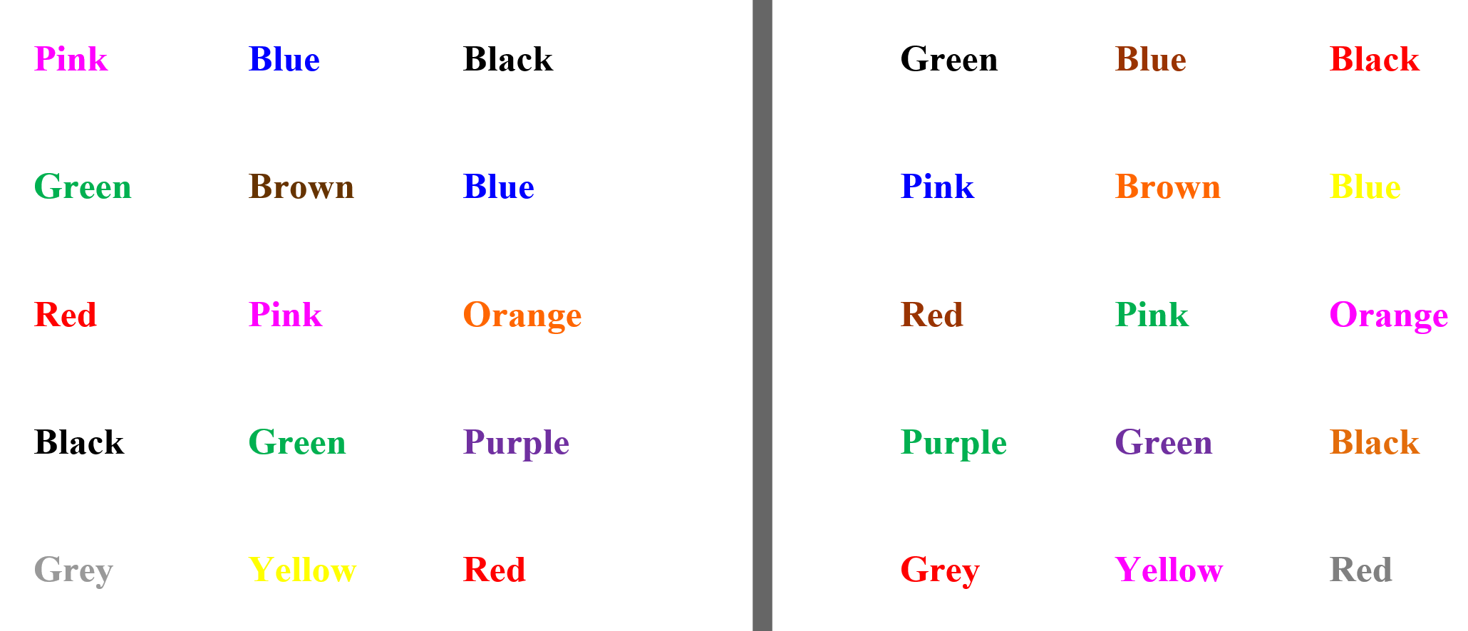

2. Standardised instructions

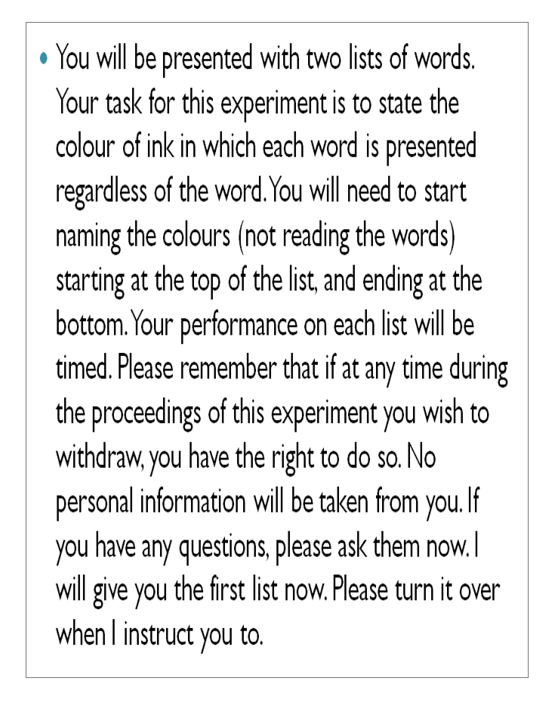

3. Information sheet and consent form
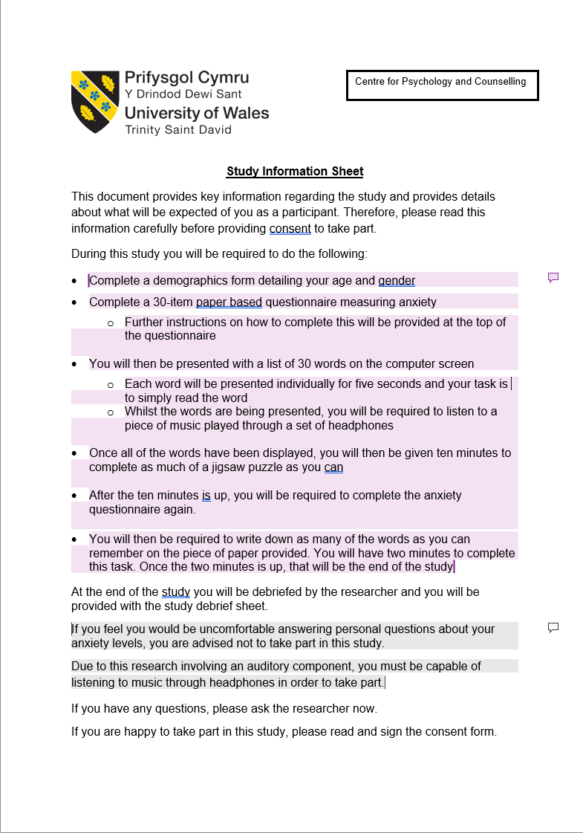

4. Debrief form
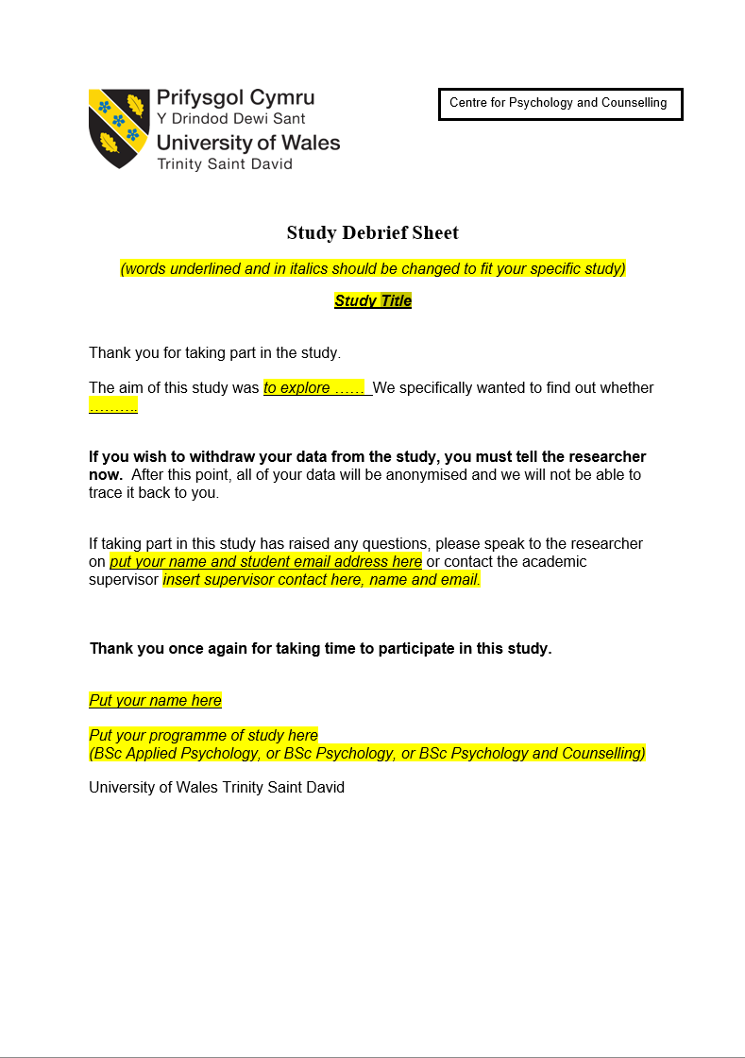

5. Stroop ethics form

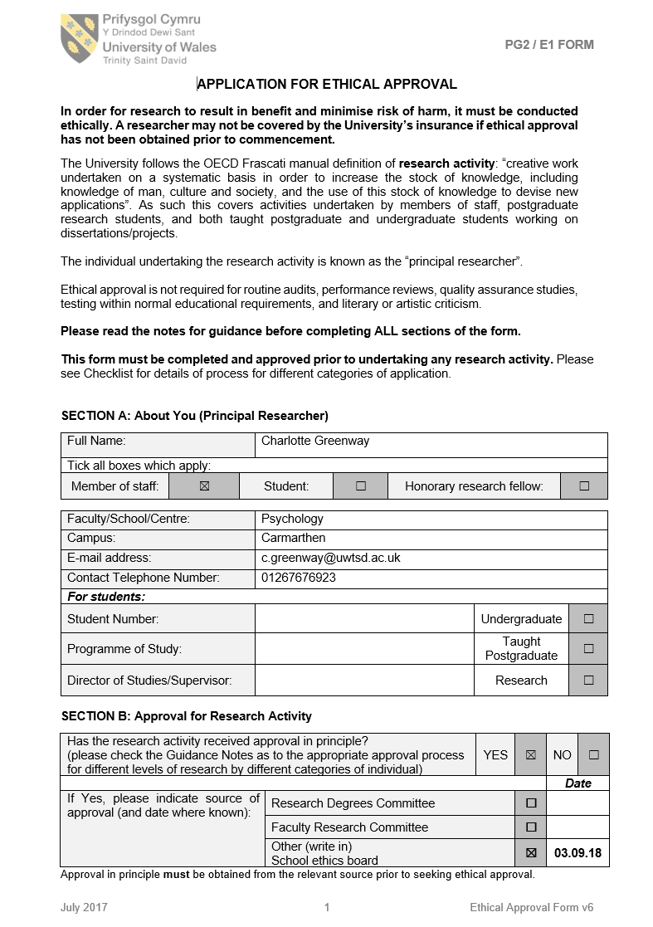

6. Raw data

Congruent Condition Incongruent addition
Condition 1 6.61 Condition 2 10.84
Condition 1 8.75 Condition 2 16.55
Condition 1 5.57 Condition 2 12.43
Condition 1 6.31 Condition 2 18.45
Condition 1 4.10 Condition 2 10.50
Condition 1 6.10 Condition 2 12.75
Condition 1 8.50 Condition 2 21.65
Condition 1 6.20 Condition 2 16.12
Condition 1 4.05 Condition 2 16.24
Condition 1 4.98 Condition 2 17.37
Condition 1 6.31 Condition 2 13.94
Condition 1 6.59 Condition 2 16.40
Condition 1 7.33 Condition 2 13.71
Condition 1 6.55 Condition 2 11.36
Condition 1 5.92 Condition 2 10.33
Condition 1 6.94 Condition 2 11.11
Condition 1 7.66 Condition 2 12.13
Condition 1 8.44 Condition 2 14.31
Condition 1 6.15 Condition 2 9.89
Condition 1 7.56 Condition 2 10.33
Condition 1 7.44 Condition 2 12.39
Condition 1 6.62 Condition 2 9.59
Condition 1 7.99 Condition 2 11.37

7. SPSS

