
BA Business Management

Title: Challenges and Opportunities in the UK Mobile Network Industry: An Analysis of Profit Maximization and Sustainability
Lecturer name: Khai Le

Student Name: Viorica Birloiu
Student ID: 2227895
Module Title: Management Economics
Module Code: LCBB5008

Assignment Type:
Individual Report (Assessment Component 1)

Table of Content
Introduction: 3
Section 1: Overview of the U.K. Mobile Network Industry 3
Industry Structure: 3
Current Challenges: 3
Opportunities: 4
Section 2: Profit Maximization Theory in the U.K. Mobile Network Industry 4
Explanation of Profit Maximization Theory: 5
Application in the UK Market: 5
Problems of Profit Maximization: 5
Section 3: Application of Economic Theories 6
Demand and Supply Analysis: 6
Market Structures: 7
Policies and Bylaws of the Government: 7
Section 4: Business Objectives and Stakeholder Considerations 7
Business Objectives: 7
Stakeholder Issues: 8
Section 5: Recommendations for Sustainable Growth 8
Sustainability in the U.K. Mobile Industry: 8
Strategies for Sustainable Growth: 9
Conclusion: 10
Reference list: 10

Introduction:

Technology Transformation in the U.K. Mobile Network Industry in recent years, the U.K. Mobile Network Industry has evolved significantly as new technological breakthroughs, mergers and consumer preferences redefine the landscape of this market. This report sets out to address just this issue, focusing on both the challenges and opportunities faced by the industry with a strong emphasis on how mobile network operators (MNOs) may maximise profitability while at the same time enabling sustainable growth. This analysis informs how such companies successfully operate in an increasingly competitive and regulated market landscape.
With their huge customer base and large networks, Vodafone, O2, Three and E.E., amongst others, cash in on the consumers. They are oligopolists operating in a market where competition is fierce, but regulations and the scale of infrastructure costs (such as 5G networks) create unusual headaches. Consolidations like the Vodafone-Three merger also help mould industry dynamics around market share concentration, pricing strategies, and competitive behaviours.
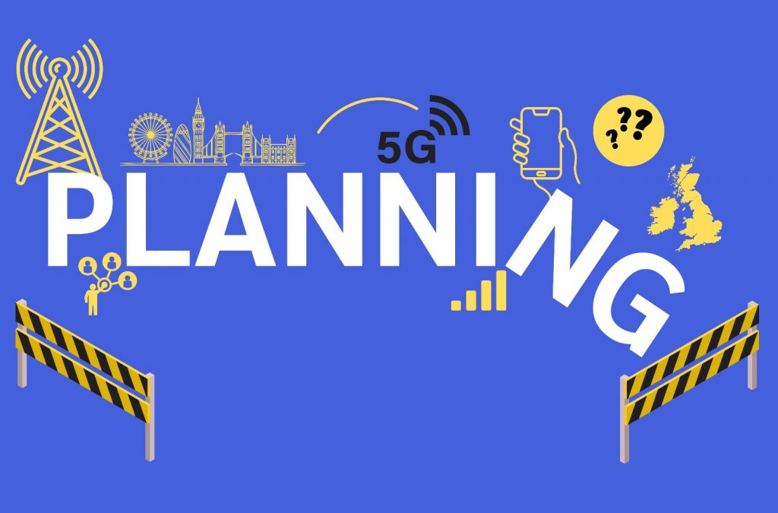
Figure 1: UK mobile industry calls for planning reform (Mann, 2024)
Several sections follow this report. First, it considers the current issues and potential in the industry. Then, it looks at profit maximisation theory, particularly in the market of mobile networks, economic theories and analysis, such as supply-demand market structure.

Section 1: Overview of the U.K. Mobile Network Industry

Industry Structure:

The mobile network industry in the U.K. is an oligopoly, such as a market or industry that a few large firms dominate. Of the significant players in the industry (Three, Vodafone, E.E. and O2), they collectively enjoy a strong market share in all mobile contracts. Due to it being an oligopolistic market, competition does exist, but not in its perfectly competitive form. Instead, all of these companies control prices, market behaviour and innovation (Tilson, 2021). These costs are among the reasons new entrants need help breaking into this market due to large capital expenditures on infrastructure and technology. The current debate over Vodafone's reported attempted takeover of Three only further highlights this trend in consolidation within the market, with ever fewer leading operators holding sway.

Current Challenges:

The U.K. mobile network industry is being tested for profitability and sustainability. The most important of these is that the market becomes saturated. The U.K. is already a well-penetrated mobile phone market, and everyone has at least one—in many cases, two—so the customer numbers are there but not growing. Accordingly, the market trend has changed from acquisition to retention and increasing ARPU via value-added services (Tilson, 2021).
Oligopolies are also often fiercely competitive. This competition can be achieved through aggressive pricing, promotion, or bundling services, such as data packages or additional entertainment options. This competition can cause downward pressure on margins and limit firms' ability to increase profitability.
Infrastructure costs are another hurdle, especially with 5G network rollouts (Shayea et al., 2020). Upgrading network infrastructure involves a huge investment in building new and adapting existing infrastructure to support faster speeds and more reliable connections. While the benefits of 5G include faster speeds and more intelligent networks, the costs are widely prohibitive upfront and a significant financial burden in the near term.

Opportunities:

However, several upcoming opportunities can drive growth for the U.K. mobile industry. Rapidly evolving tech, like the impending introduction of 5G, further enhances what customers and businesses can achieve (Shayea et al., 2020). The transition to Internet of Things (IoT) services is also a significant opening, given that mobile networks are expected to provide the underpinning data connections for everything from smart homes to driverless cars. The rise of data services is one of the biggest revenue drivers due to streaming, connected devices, and cloud computing, which are all increasing in demand.
Vodafone's proposed merger with Three would be a major consolidation that could change the shape of the marketplace (Attaran, 2021). If it goes through, the merger would provide the combined company with economies of scale, lower operational costs, and a stronger market position that might allow it to better compete with the likes of E.E. and O2. It would also help spur 5G rollout, which could set the U.K. as the global mobile technology lead again.

Section 2: Profit Maximization Theory in the U.K. Mobile Network Industry

Explanation of Profit Maximization Theory:

Profit maximisation is a fundamental term of economic theory, which states that the main goal of a business firm is to gain the maximum profit from its operations. Firms maximise the difference between their total revenue and cost: an assumption that is part of NEIO (Banda, Mzyece and Mekuria, 2022). In other words, profit maximisation is when a firm achieves equilibrium between marginal cost (MC) and marginal revenue (M.R.), i.e. further production, except that point decreases profitability.
For the mobile network industry, cost-effective production (profit maximisation) is very specific because it depends on how important that industry is now and how capital-intensive it already is. Companies need investments in infrastructure and technology (to provide 5G and network upgrades to the public). Hence, profit maximisation is a requirement not only for operational sustainability but also to fulfil the financial requirements for future growth and technological up-gradation (Cicek et al., 2020). The mobile network providers continually strive to achieve this goal by optimising their pricing models, managing costs as effectively as possible and responding to the market dynamics.

Application in the UK Market:

Network operators like Vodafone, Three, E.E. and O2 use several techniques to increase their revenue within the mobile market in the U.K. The strategy mentioned above is pricing model optimisation. Bundled services combining data with voice and text have long been a staple of the British mobile operators (Coe and Yang, 2021). This plan forces customers to pay more for bundled packages and not only their specific services, which increases total revenue.
Decreased operational costs are another way to increase profits. As part of this, the U.K. mobile network providers invest heavily in shared infrastructure, especially for rolling out newer technologies like 5G. We're looking at you on spectrum auction pricing to keep costs as low as possible by sharing capex among multiple operators. Furthermore, automation and digital transformation have allowed providers to simplify processes that increase profitability by lowering labour costs (Coe and Yang, 2021).

Problems of Profit Maximization:

Although mobile network operators in the U.K. pursue profit maximisation as a basic goal, they face several challenges in fulfilling this goal. Regulatory pressure is a major pain point. The U.K. imposes strict regulations to protect consumers and ensure fair competition. For example, restrictions to transparent contracts and price caps constrain firms' pricing activities, which directly influence their revenue potential (Mohajan and Mohajan, 2022).
Operational costs represent the other issue. One potential challenge is that it takes billions of dollars to build the infrastructure needed for 5G deployment, and infrastructure investment may only become profitable for a few years. In addition, the costs of network maintenance, spectrum acquisition, and customer service further exacerbate the financial imbalance. After all, the U.K. is a cutthroat mobile market (Mohajan and Mohajan, 2022). Large competitors vying for cut shares on the market mean that companies must resort to competitive pricing to survive, dramatically narrowing profit margins.

Section 3: Application of Economic Theories

Demand and Supply Analysis:

The U.K. mobile network industry has a few demand and supply dynamics determinants, such as consumer tastes, price sensitivity, and innovation. Mobile services have been showing consistent growth due to the widespread use of smartphones, greater adoption of data-heavy apps, and mobile internet as a new, turbocharged means of communication and entertainment (Fukase and Martin, 2020). With 5G networks beginning to come out, the need for faster speeds and a better connection has consumers looking for higher data limits more than ever before.
But demand is inelastic, so you will likely buy at least some refined oil. The shift can be attributed to the fact that most consumers consider mobile services as non-discretionary, which means they are less price elastic, especially for basic services like voice and data plans. However, price elasticity may exist for premium services like unlimited data or high-speed 5G plans, and customers are more likely to leave their provider or downgrade features if they are priced higher.
Since data consumption increases have placed additional pressure on demand, network providers continue to reinforce their infrastructure (Fukase and Martin, 2020). On the supply side, the deployment of 5G networks with greater capacity and faster speeds provides a big boost. However, the expense of infrastructure upgrades is one of the main reasons supply can't get ahead, with providers needing to balance their investment in new technology with maintaining profitability.
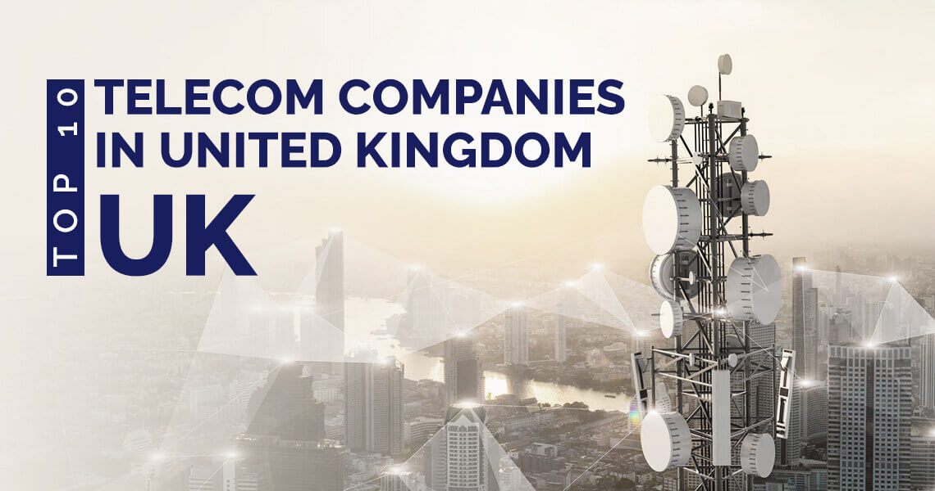
Figure 2: Top 10 Telecommunication Companies in United Kingdom (UK) (Wavetel-Buisness, n.d.)

Market Structures:

The U.K. mobile network landscape is oligopolistic, with only a small handful of firms Vodafone, Three, O2, and E.E., providing service to millions of customers nationwide. Oligopoly—In an oligopoly, firms are marked by high market power, but the degree of interdependence among suppliers is high, too. Pricing and strategic decisions are hugely impacted by other players in the game (de Janvry and Sadoulet, 2020). The possible merging of Vodafone and Three is key as it would further reduce competition. The merger could drive increased economies of scale, enabling the company to offer better prices or double down on infrastructure investment.

Policies and Bylaws of the Government:

Shot 12/2/19 Government intervention and Ofcom control of the industry significantly influence the future direction of the U.K. mobile network (Schlesinger, 2022). As the regulator, Ofcom promotes competition, protects consumers, and ensures that high-quality services are available to businesses. One of the most important responsibilities in this respect is to regulate spectrum, for which the primary regulatory tool has been spectrum auctions, to secure fair and transparent access by all operators to mobile services.
Ofcom also enforces consumer protection rules, including those relating to transparent pricing and charges for roaming services intended to prevent harmful conduct by companies and so that consumers have the information they need before it is too late (Schlesinger, 2022). The industry cannot be balanced without measures that enforce competition in the market and prevent abuses by larger companies. The objectives of the regulatory framework are for innovation to flourish and dodder consumers to benefit from risks because of market dominance by only key players.

Section 4: Business Objectives and Stakeholder Considerations

Business Objectives:

The mobile network providers need to turn a profit, but maximising these profits cannot be their only consideration if they hope to win the coming battle for prominence. One of those objectives is to make the customer experience better. Customer satisfaction is one of the important variables as the mobile industry becomes more competitive in retaining and growing its customer base (Eeckhout, 2022). It includes investing in customer service, enabling functional connectivity, and bundling value-added services such as mobile apps and cloud storage with entertainment bundles. Improving reliability in service delivery at the lowest possible downtime is an essential part of this objective.
The other objective is to increase market share. In the U.K., where mobile network industry competition is very high, providers should seek to secure market share proactively by adopting an effective price strategy, perspective-targeted marketing, and service differentiation. The expansion could also mean mergers and acquisitions, such as the mooted Vodafone/Three merger, to create a bigger competitive threat to market-leading players E.E. and, in particular, O2.
Driving innovation is also important for sustaining growth (Begovic, n.d.). Primary areas of development for decades were mobile networks on 5G, IoT, and all the leveraging that radar could provide in conjunction with prescriptive learning.

Stakeholder Issues:

All stakeholders have to be taken care of by mobile network service providers. Shareholders' focus on profitability and financial returns leads companies to manage costs and generate revenues (Polydoropoulou, Pagoni and Tsirimpa, 2018). Customers expect high-quality services at the right price and demand bulletproof networks, enhanced features and seamless support. Ofcom is a regulatory body concerned with competition, consumer protection, and universal service. These regulations would force companies to continue adhering to the rules while needing them to be profitable. They expect job stability, decent remuneration and a chance to grow, all of which must be pursued while ensuring cost-effectiveness.
It's a tricky balance, but the key is for companies to plan for profit while still considering everything they need to do concerning long-term sustainability (Polydoropoulou, Pagoni and Tsirimpa, 2018). As a whole, this aids mobile network providers in serving all needs of their stakeholders and facilitating growth while remaining compliant and improving the public perception surrounding the industry.

Section 5: Recommendations for Sustainable Growth

Sustainability in the U.K. Mobile Industry:

For U.K. mobile network operators, sustainability can be broken down into three main pillars: economic, social and environmental. In this area, the financial sustainability of companies is associated with the capacity to keep or part with profits in another extremely competitive and capital-intensive industry. It means upgrading to new technologies, like 5G, and finding ways to create added revenue in short, it means surviving financially (Skeete et al., 2020). At the same time, social sustainability involves meeting the needs of different stakeholders, such as customers, employees and regulators. It is about serving the community by offering the best services at affordable prices, boosting digital inclusion and upping customer satisfaction. Environmental sustainability: This term generally refers to lessening the environmental impact of the industry. More mobile networks, more toll on carbon and energy usage, on waste. Indeed, this is why growth for U.K. mobile providers will not be sustainable if it comes at the expense of these three sets of responsibilities (Skeete et al., 2020).

Strategies for Sustainable Growth:

Investment in 5G Infrastructure: Encouraging innovation and investment in 5G infrastructure is also a vital strategy to boost the U.K. mobile network industry. The network efficiency will increase considerably with 5G technology, resulting in faster data download speeds and minimal latency. As a result, new revenue streams have been allowed to emerge based on these implementations, mostly in spaces like IoT, smart cities and autonomous vehicles (Forge and Vu, 2020). In addition, businesses can better respond to increasingly high consumer expectations and remain competitive by providing network services that operate more efficiently. They also equip mobile operators to take advantage of future opportunities, such as integrated mobile capabilities and user experiences.
Merger and Acquisition (M&A) Strategies: M&A strategies like the suggested Vodafone-Three merger represent another critical part of sustainable growth. Merger: Mergers are a way for companies to strengthen their position in the market by combining resources, infrastructure, and customer bases (Wickens et al., 2023). This enables them to better compete with their competitors, at home and abroad. A blend of such economies will generally follow facilitation with M&As, thenceforth, adding to the mix and improving profitability by reducing costs. As far as the U.K. mobile telco is concerned, mergers and acquisitions can fill in any gaps in service coverage and introduce 5G services more quickly, which can only be good for consumers while helping solidify the companies involved over a longer period financially.
Customer-Centric Innovation: The only way to compete in an ever-competitive world is customer-centric innovation. Mobile network operators need to develop new services that match their customers' constantly changing trends in various domains more flexible and cost-effective data plans, better customer service, and innovative OTT digital solutions (Young Won Park and Hong, 2024). Focusing on the customer leads to improved customer loyalty, retention, and acquisition. This tactic should increase profitability and keep businesses from becoming obsolete in a fast-evolving technological world.
Environmental Sustainability: The lower the carbon footprint of network operations, the better for saving our planet. Mobile operators can use cleaner technologies renewable energy for data centres and network towers and to drive other energy-saving behaviours across their operations (Gordon, 2020). Companies focusing on these strategies for improving energy efficiency and reducing emissions can help reach global sustainability goals AND lower operating costs. Low-carbon credentials are also increasingly seen as a helpful tool to distinguish oneself in the market, with investors and consumers keen to invest in responsible firms.

Conclusion:

In summary, long-term success for the U.K. mobile network industry can only be achieved through a balanced and mutually reinforcing blend of financial, social and environmental ambitions. These companies are investing hundreds of billions in 5G infrastructure, making strategic M&A, creating innovation for customers, and being the best corporate citizen regarding the environment. Mobile network operators are facing the dual challenge of transitioning to newer technologies and complying with regulatory requirements, all while taking steps to reduce their environmental impact as new socially responsible consumer targets enter the fold. By doing so, companies can learn to navigate the digital ecosystem where profit maximisation and sustainability co-exist.

Reference list:

Alsmadi, A.A., Shuhaiber, A., Alhawamdeh, L.N., Alghazzawi, R. and Al-Okaily, M. (2022). Twenty Years of Mobile Banking Services Development and Sustainability: A Bibliometric Analysis Overview (2000–2020). Sustainability, 14(17), p.10630.
Attaran, M. (2021). The impact of 5G on the evolution of intelligent automation and industry digitization. Journal of Ambient Intelligence and Humanized Computing, [online] 14(5).
Banda, L., Mzyece, M. and Mekuria, F. (2022). 5G Business Models for Mobile Network Operators—A Survey. IEEE Access, 10, pp.94851–94886.
Begovic, B. (n.d.). Book review The Profit Paradox: How Thriving Firms.
Cicek, C.T., Gultekin, H., Tavli, B. and Yanikomeroglu, H. (2020). Backhaul-Aware Optimization of UAV Base Station Location and Bandwidth Allocation for Profit Maximization. IEEE Access, 8, pp.154573–154588.
Coe, N.M. and Yang, C. (2021). Mobile Gaming Production Networks, Platform Business Groups, and the Market Power of China’s Tencent. Annals of the American Association of Geographers, 112(2), pp.1–24.
de Janvry, A. and Sadoulet, E. (2020). Using agriculture for development: Supply- and demand-side approaches. World Development, 133, p.105003.
Eeckhout, J. (2022). The Profit Paradox : How Thriving Firms Threaten the Future of Work. www.torrossa.com, [online] pp.1–352. Available at: https://www.torrossa.com/gs/resourceProxy?an=5564957&publisher=FZO137. [Accessed 8 October 2024]
Forge, S. and Vu, K. (2020). Forming a 5G strategy for developing countries: A note for policy makers. Telecommunications Policy, 44(7), p.101975.
Fukase, E. and Martin, W. (2020). Economic growth, convergence, and World Food Demand and Supply. World Development, 132(132), p.104954.
Gordon, D. (2020). Sustainability in the Operating Room. Anesthesiology Clinics, [online] 38(3), pp.679–692.
Lipscombe, P., 2024. Data Center Dynamics. [Online]
Available at: https://www.datacenterdynamics.com/en/news/vodafone-ceo-push-through-merger-with-three-or-risk-falling-further-behind-with-5g/
[Accessed 8 October 2024].
Mann, C. (2024). UK mobile industry calls for planning reform. [online] Advanced-television.com. Available at: https://advanced-television.com/2024/06/17/243607/ [Accessed 10 Oct. 2024].
Mohajan, D. and Mohajan, H. (2022). Profit Maximization Strategy in an Industry: A Sustainable Procedure. [online] mpra.ub.uni-muenchen.de. Available at: https://mpra.ub.uni-muenchen.de/id/eprint/114675. [Accessed 8 October 2024].
Polydoropoulou, A., Pagoni, I. and Tsirimpa, A. (2018). Ready for Mobility as a Service? Insights from stakeholders and end-users. Travel Behaviour and Society, 21.
Schlesinger, P. (2022). The neo‐regulation of internet platforms in the United Kingdom. Policy & Internet.
Shayea, I., Ergen, M., Hadri Azmi, M., Aldirmaz Colak, S., Nordin, R. and Daradkeh, Y.I. (2020). Key Challenges, Drivers and Solutions for Mobility Management in 5G Networks: A Survey. IEEE Access, 8, pp.172534–172552.
Skeete, J.-P., Wells, P., Dong, X., Heidrich, O. and Harper, G. (2020). Beyond the EVent horizon: Battery waste, recycling, and Sustainability in the United Kingdom Electric Vehicle Transition. Energy Research & Social Science, [online] 69(1), p.101581.
Tilson, D.A. (2021). The Interrelationships between Technical Standards and Industry Structures: Actor-Network Based Case Studies of the Mobile Wireless and Television Industries in the US and the UK. [online] Ohiolink.edu. Available at: https://rave.ohiolink.edu/etdc/view?acc_num=case1207164101 [Accessed 10 Oct. 2024].
Wavetel-Buisness. (n.d.). Top 10 Telecommunication Companies in the United Kingdom (UK). [online] Available at: https://wavetelbusiness.co.uk/latest-news/top-10-teleccommunication-companies-in-united-kingdom-uk/. [Accessed 10 Oct. 2024].
Wickens, M., Klein, T., Padilla, J. and Reynolds, P. (2023). Do Four-to-Three Mobile Mergers Harm Consumers? A Review of Post-Merger Effects and Concentration Studies. Social Science Research Network. [online] doi:https://doi.org/10.2139/ssrn.4647944.
Young Won Park and Hong, P. (2024). Navigating the New Frontier: Digital Marketing Strategy in the Cosmetics Industry. pp.75–91. doi:https://doi.org/10.1007/978-981-97-3674-4_4.

