

Student ID: 2436215
Student Name: Francis Clement N'gom
Module: Network Operating Systems and Services
Module Code ACCA5023
Assignment Title: Research, build, and deploy a Virtualised Enterprise network
Submission deadline: Friday 3rd July, 2026 (2pm)

Table of Contents – Assessment Component 1
- Introduction
- Task 1 – Research
- 2.1 Hypervisors
- 2.2 IP Addressing
- 2.3 Routing
- 2.4 Network Services
- Task 2 – Technical Documentation
- 3.1 Hypervisor Selection and Justification
- 3.2 Windows Server 2022 Installation
  - Figure 4 – OS Selection
  - Figure 5 – Installation Progress
  - Figure 6 – Administrator Password Configuration
  - Figure 7 – VirtualBox Network Adapter Configuration
  - Figure 8 – Server Manager Dashboard
  - Figure 9 – Network Connections
  - Figure 10 – IPv4 Static Address Configuration
  - Figure 11 – Completed IPv4 Configuration
  - Figure 12 – IP Configuration Verification
  - Figure 13 – Successful Connectivity Test
  - Figure 14 – Connectivity Test Summary
3.3 Debian 13 Installation and Configuration
  - Figure 15 – Language Selection
  - Figure 16 – Network Interface Detection
  - Figure 17 – Adapter 1 (Birmingham)
  - Figure 18 – Adapter 2 (London)
  - Figure 19 – Adapter 3 (WAN)
  - Figure 20 – Root Password Configuration
  - Figure 21 – Disk Partitioning & GRUB
  - Figure 22 – Successful Login
  - Figure 23 – Debian Running Successfully
3.4 Windows 11 Client S1 Installation and Configuration
  - Figure 24 – Installation Confirmation
  - Figure 25 – Installation Progress
  - Figure 26 – Static IP Configuration
  - Figure 27 – Initial Connectivity Test
3.5 Network Connectivity Testing
  - Figure 28 – Same Network Test
  - Figure 29 – Different Network Test
- Task 3 – Reflection
- 4.1 Technical Reflection
- 4.2 Personal Reflection
- Conclusion
- References

Introduction
Computer networks play an important role in modern organisations because they allow users, devices, and services to communicate efficiently. As organisations continue to grow, there is an increasing need for flexible and cost-effective solutions that can support multiple systems and locations. Virtualisation has become one of the most widely used technologies in enterprise environments because it enables several operating systems to run on a single physical machine while reducing hardware costs and improving resource management.
This assignment focuses on the design and deployment of a virtualised enterprise network for a company called NOSSLONDON2026, which operates in Birmingham and London. The project involves creating a network environment using Windows Server 2022, Debian Server, and client machines within a virtual platform. The implementation aims to simulate a real-world business network and provide practical experience in configuring network operating systems and services.
The report begins by exploring key networking concepts, including hypervisors, IP addressing, routing, and network services. It then explains the process used to build and configure the virtual network, including the selection of the hypervisor, IP addressing scheme, and connectivity testing. Finally, the report reflects on the deployment process, discussing the challenges encountered, the solutions implemented, and the knowledge gained throughout the project.
Completing this project has provided an opportunity to apply both theoretical and practical networking skills while developing a better understanding of how virtualised enterprise networks are planned, deployed, and managed in professional environments.

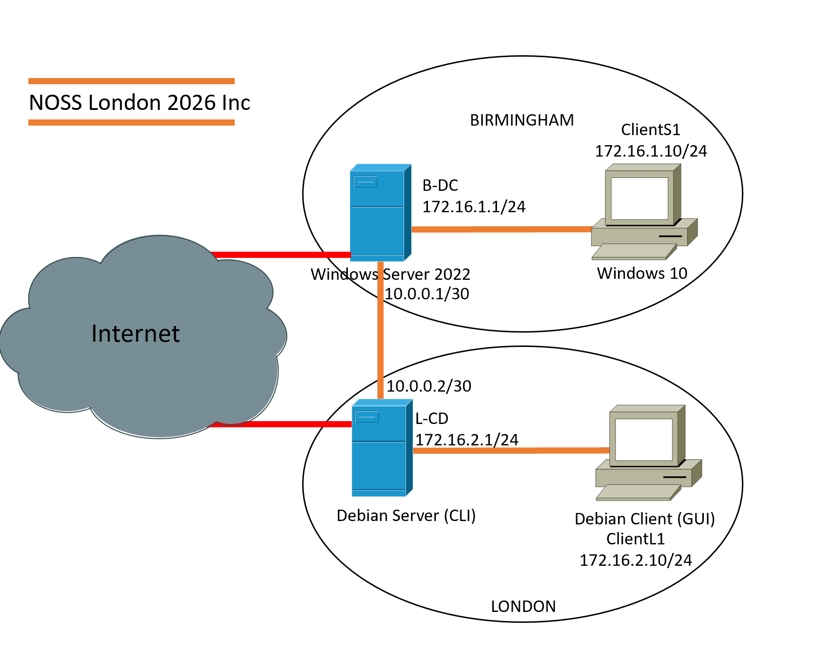
Figure 1. NOSSLONDON2026 Network Topology

Task 1 – Research
- Hypervisors
A hypervisor is an important part of virtualisation because it allows multiple operating systems to run on the same physical computer. During my research, I found that there are two main types of hypervisors: Type 1 and Type 2. A Type 1 hypervisor runs directly on the hardware and generally provides higher performance and security because it does not rely on a host operating system [1]. Examples include Microsoft Hyper-V and VMware ESXi. Because it communicates directly with the hardware, it usually provides better performance, security, and scalability. A Type 2 hypervisor runs on top of an existing operating system. Examples include Oracle VirtualBox and VMware Workstation. This type is easier to install and use, making it suitable for testing, learning, and small-scale environments.
For the NOSSLONDON2026 network, which includes Windows Server 2022, a Debian Server, and client machines connected through the BIRMINGHAM.ACCA domain, a Type 1 hypervisor would be the preferred option in a real business environment. This is because domain services such as Active Directory, DNS, and DHCP require stability, security, and reliable performance. A Type 1 hypervisor would also be better suited to the enhanced topology in Coursework 2, where additional services and virtual machines may be added.
However, for this coursework I selected Oracle VirtualBox, which is a Type 2 hypervisor. My decision was based on the available hardware resources and the ease of deployment. VirtualBox supports both Windows and Debian operating systems, provides the networking features required for the topology, and can run efficiently on a standard desktop or laptop. Although it may not offer the same level of performance as a Type 1 hypervisor, it is sufficient for creating, testing, and managing the virtual network required for this project. Therefore, VirtualBox provides a practical balance between functionality, compatibility, and hardware limitations [5].

2. IP Addressing

Figure 2. Oracle VirtualBox Environment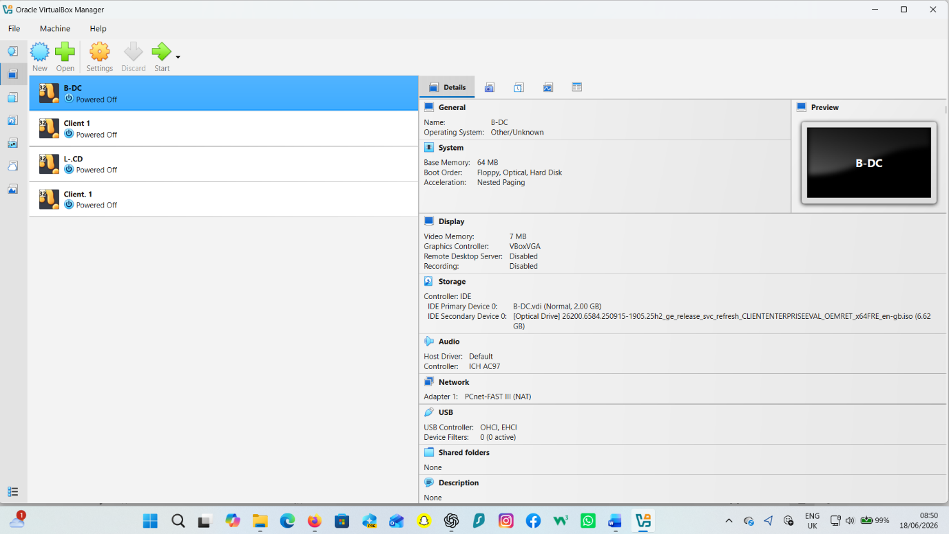

Table 1. NOSSLONDON2026 IP Addressing Plan
Device | IP Address | Subnet Mask
B-DC | 172.16.1.1 | 255.255.255.0
Client S1 | 172.16.1.10 | 255.255.255.0
L-CD | 172.16.2.1 | 255.255.255.0
Client L1 | 172.16.2.10 | 255.255.255.0
WAN Link | 10.0.0.1 / 10.0.0.2 | 255.255.255.252

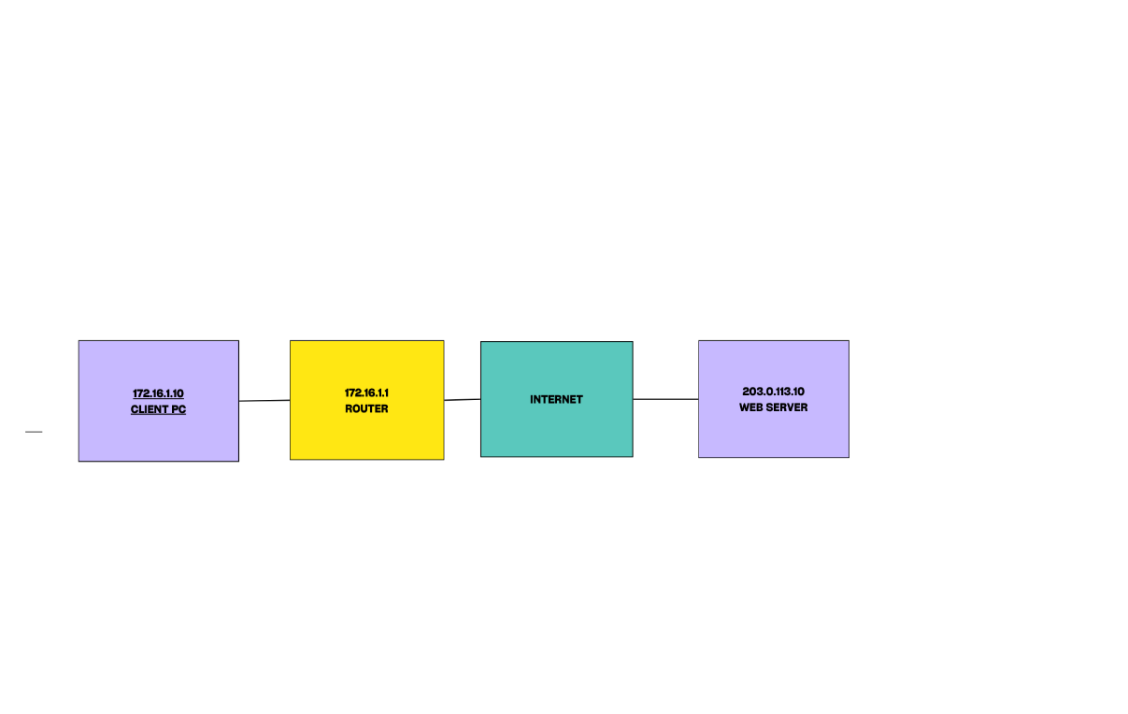
Figure 3. Simplified Birmingham–London Network Diagram

During our group discussion, we explored how data travels across the Internet and the role of IP addressing in network communication. My understanding is that when a user sends data, such as opening a website or sending an email, the information is divided into small packets. Each packet contains the source and destination IP addresses, which enable devices to identify where the data comes from and where it needs to go. Without IP addresses, devices would not be able to communicate effectively across networks [2].
I also learned that switches and routers play different but complementary roles in the transmission process. Switches operate within a local network and use MAC addresses to forward data to the correct device. Routers connect different networks together and use IP addresses to determine the best path for data to reach its destination. This allows communication between devices located in different geographical locations [3].
IP addressing is essential for the functionality and effectiveness of a network because it provides unique identification for every connected device. IPv4 addresses are represented as four decimal numbers separated by dots, for example 192.168.10.10. However, due to the increasing number of connected devices, IPv6 was introduced. IPv6 uses a 128-bit address format, such as 2001:db8::1, providing a significantly larger address space [1].
Another important concept is subnetting, which divides a larger network into smaller subnetworks. Subnetting improves network performance, security, and efficient use of available IP addresses. For example, in the NOSSLONDON2026 topology, Birmingham and London could be assigned separate subnets to simplify network management and reduce unnecessary traffic.

Overall, IP addressing provides the foundation for communication between devices and ensures that data is delivered accurately and efficiently across modern networks.

3. Routing
Routing is an essential process in computer networks because it enables data to travel between different networks and reach its intended destination. During my research, I learned that routing protocols are used by routers to determine the most efficient path for forwarding data packets. These protocols allow devices to exchange network information and maintain routing tables that help guide traffic across a network [2].
There are two main approaches to routing: static routing and dynamic routing. Static routing requires network administrators to manually configure routes. This method is simple, secure, and uses fewer system resources, but it can become difficult to manage as the network grows. Dynamic routing uses protocols such as OSPF or RIP to automatically learn and update routes. Although dynamic routing is more flexible and scalable, it requires additional processing power and can be more complex to configure [1].
For the NOSSLONDON2026 topology, I believe static routing is the most suitable approach. The network contains a limited number of devices, including a Windows Server 2022 domain controller, a Debian Server acting as a DHCP Relay, and client workstations. Since the network structure is relatively small and unlikely to change frequently, static routing provides a simple and reliable solution.
The Debian Server’s role as a DHCP Relay is important because it forwards DHCP requests between different network segments and the Windows Server. To ensure successful communication between Birmingham and London networks, appropriate routes must be configured. In this scenario, static routing offers easier management, improved security, and sufficient performance while supporting reliable connectivity between all devices in the BIRMINGHAM.ACCA environment.
Dynamic routing protocols automatically exchange routing information and adapt to network changes [2]
Static routing is more suitable for small and stable networks where routes rarely change [1].
4. Network Services
Network services are essential for managing users, devices, and communication within an organisation. During my research, I found that services such as VPNs, DHCP, Active Directory Domain Services (AD DS), and Certificate Authorities work together to improve security, accessibility, and network administration.
A Virtual Private Network (VPN) enables users to securely access network resources from remote locations by encrypting data transmitted over the Internet. This is particularly important for organisations with multiple sites because it protects sensitive information from unauthorised access. A recommended practice is to use strong authentication methods and encryption protocols to ensure secure connections [4].
Dynamic Host Configuration Protocol (DHCP) simplifies network management by automatically assigning IP addresses to devices. Without DHCP, administrators would need to configure each device manually, increasing the risk of errors. In the NOSSLONDON2026 topology, DHCP can help manage both Birmingham and London networks efficiently.
Active Directory Domain Services (AD DS) provides centralised management of users, computers, and security policies. It allows administrators to control access to network resources through a single domain environment. In this project, the BIRMINGHAM.ACCA domain helps ensure consistent user authentication and resource management across the network.
Certificate Authorities (CA) enhance security by issuing and managing digital certificates. These certificates verify the identity of users, devices, and services while supporting encrypted communication. Best practice includes protecting the CA infrastructure and regularly renewing certificates to maintain trust.
Overall, these network services contribute to a secure, organised, and scalable network environment. Together, they support efficient administration, improve security, and provide reliable access to network resources for users across the organisation.
DHCP reduces administrative overhead by automatically assigning IP addresses to devices [3].
Active Directory provides centralised authentication and access management [4].

Task 2 - Technical Documentation:

5. Hypervisor Selection and Justification
After researching different hypervisors, I selected Oracle VM VirtualBox as the most suitable hypervisor for this network project.
The main reason for choosing Oracle VM VirtualBox was its flexibility, reliability, and compatibility with multiple operating systems. The network topology required the deployment of both Windows Server 2022 and Debian Linux, and VirtualBox supported these operating systems efficiently within the same virtual environment. It also provided advanced networking features such as NAT, Internal Network, Bridged Networking, and Host-Only Adapter modes, which were essential for creating and testing the enterprise network. In addition, its user-friendly interface and support for snapshots made it easier to manage, test, and troubleshoot the virtual machines throughout the project [5].
Another important factor influencing this choice is the requirement to continue developing the topology in Coursework 2. Future tasks will involve implementing network services such as DHCP, Active Directory Domain Services (AD DS), Certificate Authorities (CA), VPN services, and routing configurations. VirtualBox allows easy creation of snapshots, enabling the network to be restored quickly if configuration errors occur. This feature significantly reduces deployment risks and supports efficient testing and troubleshooting.
In addition, VirtualBox is free and open-source, making it highly accessible for educational purposes. Unlike some commercial alternatives, it does not require expensive licensing while still providing enterprise-level virtualisation capabilities. Its user-friendly graphical interface also simplifies the management of virtual machines, networks, and storage resources.
Strong evidence supporting this decision includes VirtualBox's ability to support complex multi-server environments, virtual networking configurations, and resource allocation controls, all of which are required for this coursework. Therefore, VirtualBox provides a cost-effective, scalable, and practical platform for deploying and managing the network infrastructure required in both Coursework 1 and Coursework 2.
Type 1 hypervisors provide better performance because they communicate directly with the physical hardware [1].

- Windows Server 2022 Installation
Figure 4. Windows Server 2022 Installation – OS Selection
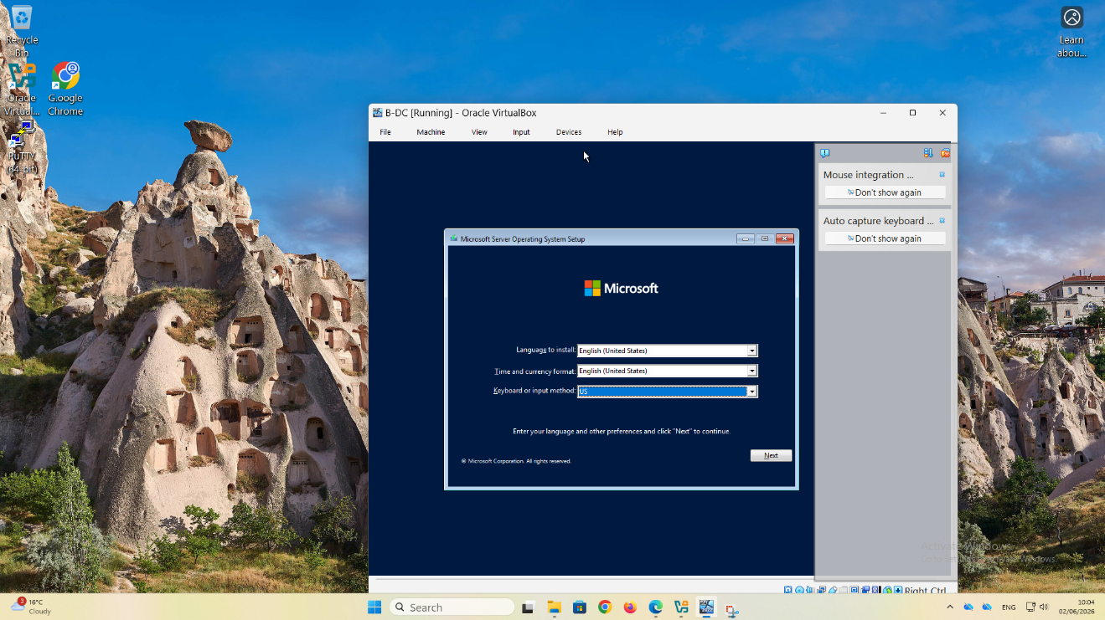
The installation process began by creating a virtual machine called B-DC using Oracle VirtualBox. Three network adapters were configured to support communication between the Windows Server, Debian Server, and client machines within the network topology. Creating the virtual machine before installing the operating system ensured that sufficient memory, storage, processors and network adapters were allocated to support the enterprise network.
After configuring the virtual machine settings, Windows Server 2022 Standard Evaluation (Desktop Experience) was installed successfully. Once the installation was complete, the server booted into the Server Manager Dashboard, confirming that the operating system was ready for configuration.
The next stage involved configuring the network adapters. Through the VirtualBox network settings, the required adapters were enabled and connected to the appropriate virtual networks. Inside Windows Server, the Network Connections window displayed three Ethernet adapters corresponding to the VirtualBox network interfaces.
To establish communication between devices, a static IP address was assigned to one of the network adapters. The Internet Protocol Version 4 (IPv4) properties were opened, and the adapter was configured with the IP address 172.16.1.1 and subnet mask 255.255.255.0. Static addressing was necessary because the server would later provide network services such as Active Directory, DNS, and DHCP.
After applying the network settings, the configuration was verified using the ipconfig command in Command Prompt. The output confirmed that the adapter had been assigned the correct IP address. Finally, connectivity testing was performed using the ping 172.16.1.10 command. Successful replies were received from the destination device, confirming that communication between the network devices had been established successfully.
This process provided a fully operational Windows Server environment and a functioning network infrastructure ready for the deployment of additional services in Coursework 2, including Active Directory Domain Services (AD DS), DNS, DHCP, VPN, and Certificate Services.

Figure 5. Windows Server 2022 Installation Progress.

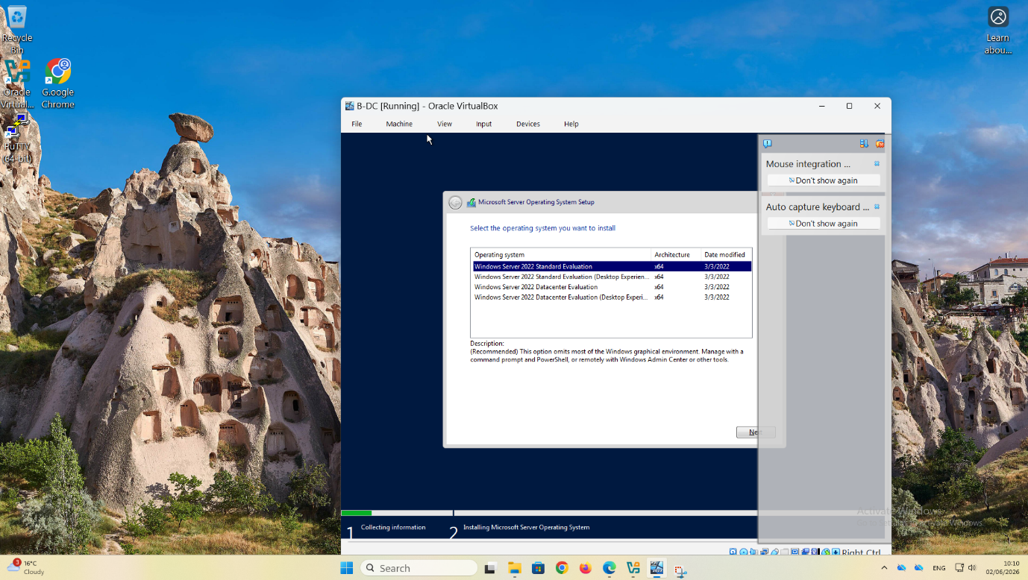

Description: The installation process shows Windows Server 2022 copying files, installing features, and configuring the operating system.
Explanation: This stage shows Windows Server 2022 being installed on the virtual machine. During the installation, the setup program copies the required system files, installs Windows features, and prepares the operating system for first use. These steps are completed automatically and ensure that the server is installed correctly. Once finished, the system is ready to restart and continue with the initial configuration required for the enterprise network.

Figure 6. Administrator Password Configuration
Creation of the Administrator password during installation.

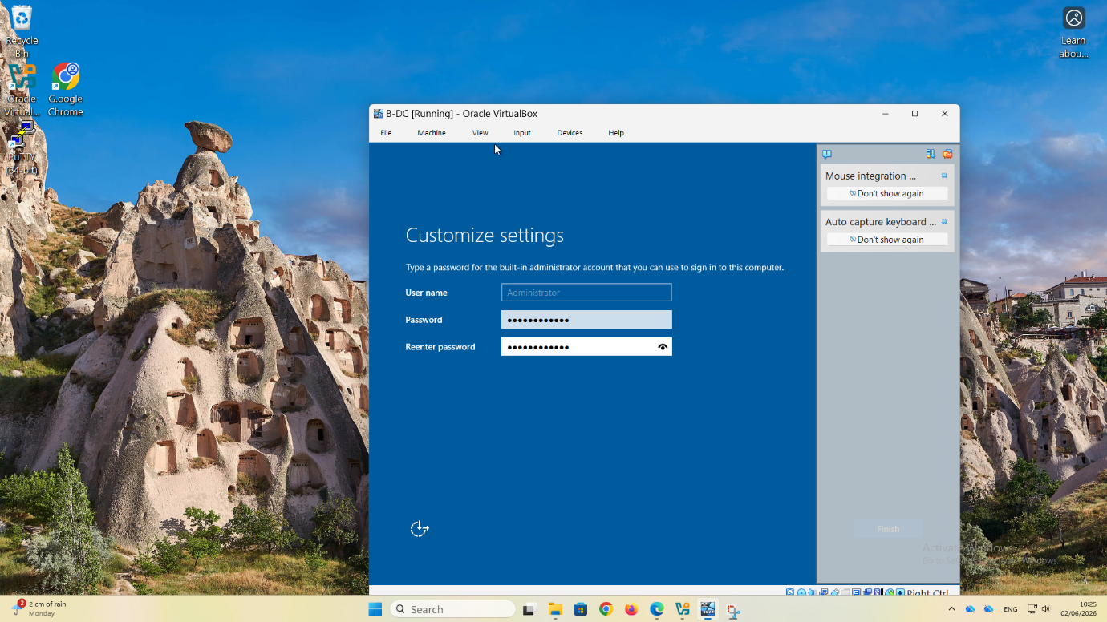

Description: Creation of the Administrator password during the Windows Server installation.
Explanation: This screen displays the creation of the Administrator account password. A strong password is essential because the Administrator account has full control over the server and all network services. Choosing a secure password helps protect the server from unauthorised access and strengthens the overall security of the enterprise network. After confirming the password, Windows Server completes the installation process.

Figure 7. VirtualBox Network Adapter Configuration
Configuration of multiple network adapters for the B-DC virtual machine.

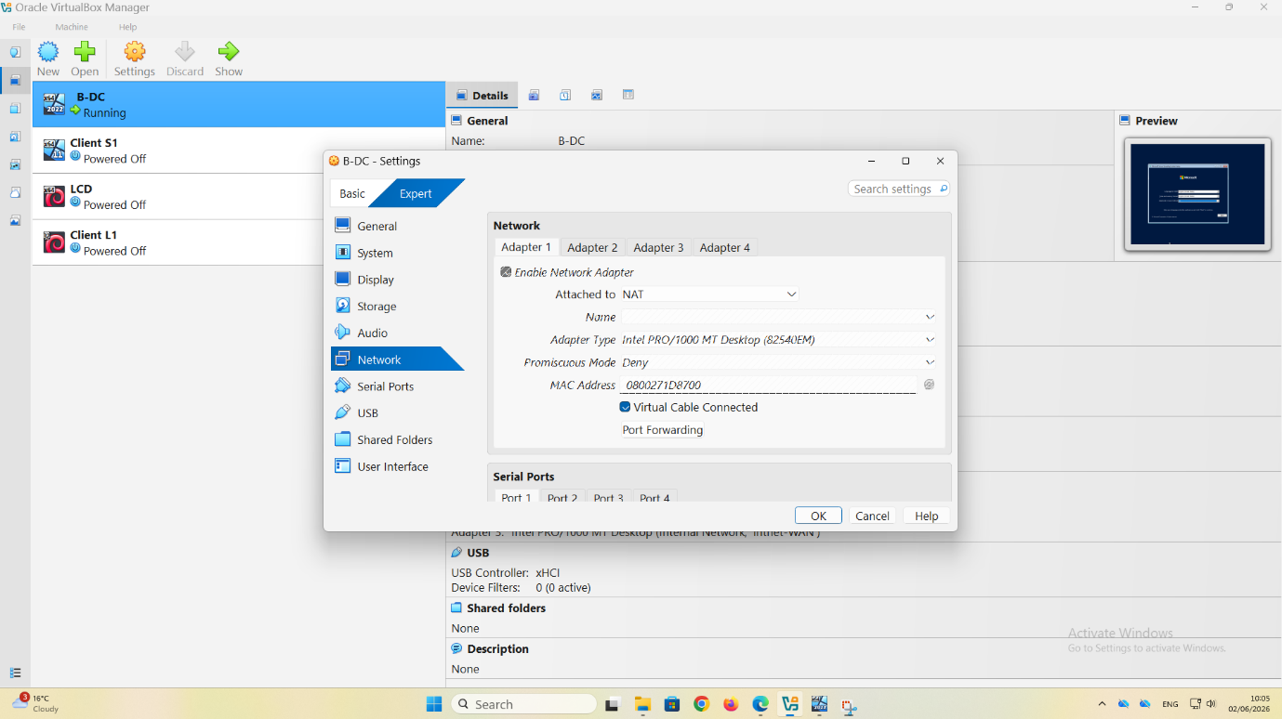

Description: Configuration of the virtual network adapters for the Windows Server virtual machine.
Explanation: This screenshot shows the VirtualBox settings where multiple network adapters are configured for the B-DC virtual machine. Each adapter connects the server to a different virtual network, allowing communication between the Birmingham LAN, the London LAN, and the WAN connection. Correctly configuring these adapters is important because it enables the server to exchange data with other virtual machines and supports routing between network segments.

Figure 8. Windows Server 2022 Successfully Installed
Server Manager dashboard confirming successful installation.

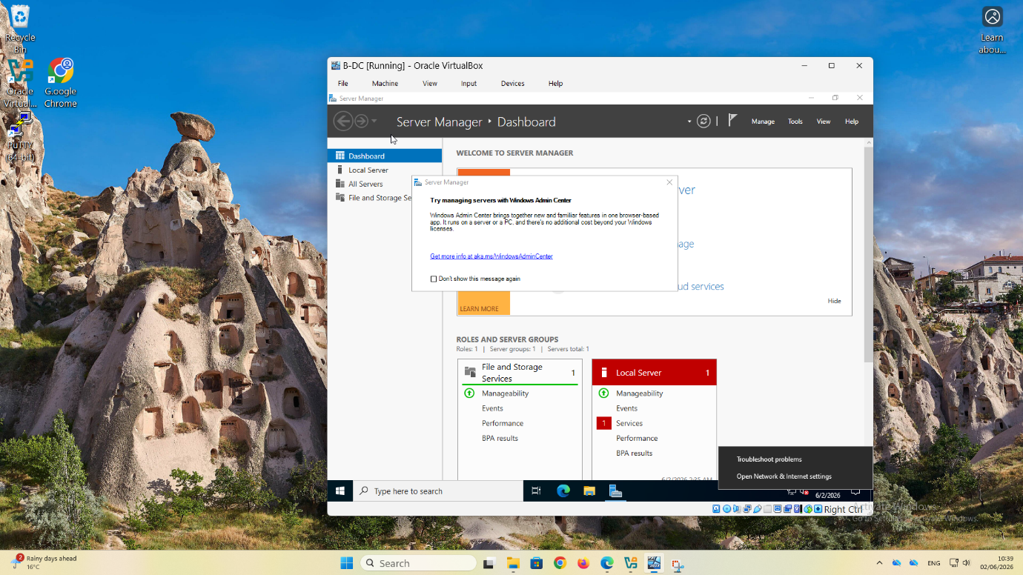

Description: Server Manager dashboard displayed after the successful installation of Windows Server 2022.
Explanation: The figure illustrates that Windows Server 2022 has been installed successfully. The Server Manager dashboard opens automatically after the first login and provides administrators with an overview of the server's status, installed roles, and configuration options. From this interface, the administrator can configure network settings, install Active Directory, DNS, DHCP, and other services required for the enterprise network.

Figure 9. Network Connections Configuration
Windows Server network interfaces displayed in the Network Connections panel.

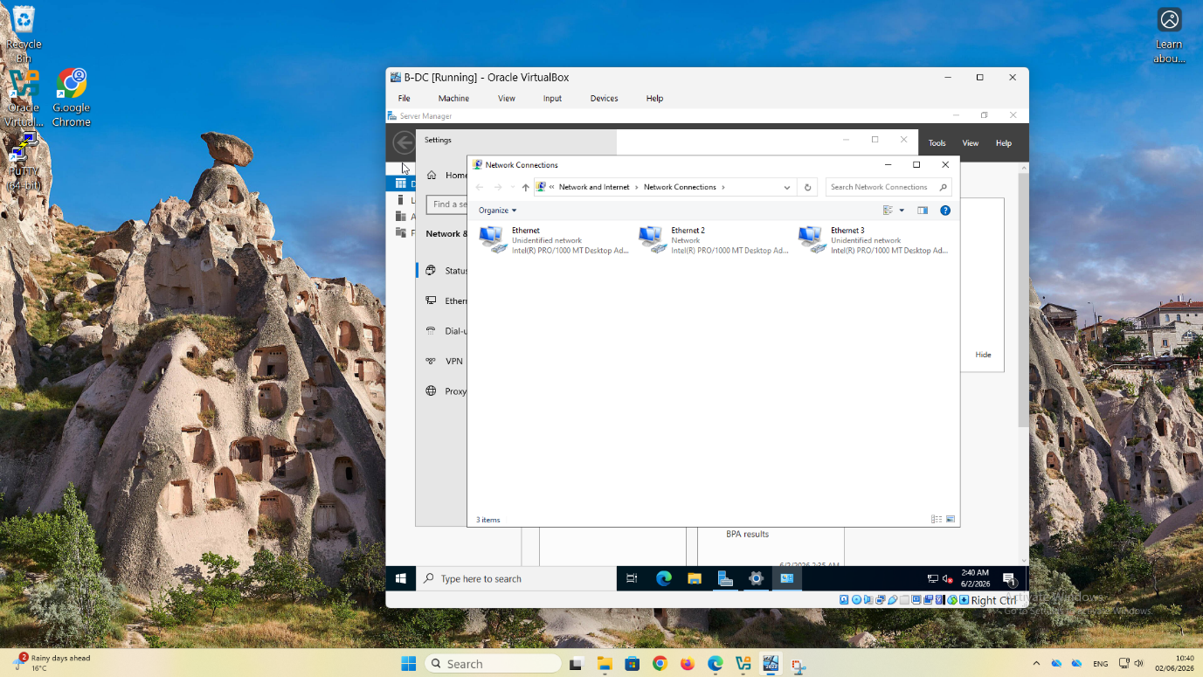

Description: Windows Server displaying the available network interfaces.

Explanation: This screenshot shows the Network Connections window, where Windows Server detects the virtual network adapters configured in VirtualBox. Each adapter represents a separate network connection used within the enterprise topology. Verifying that all adapters appear correctly confirms that the operating system has recognised the virtual hardware and is ready for network configuration.

Figure 10. IPv4 Static Address Configuration
Static IP address 172.16.1.1/24 assigned to the Windows Server. 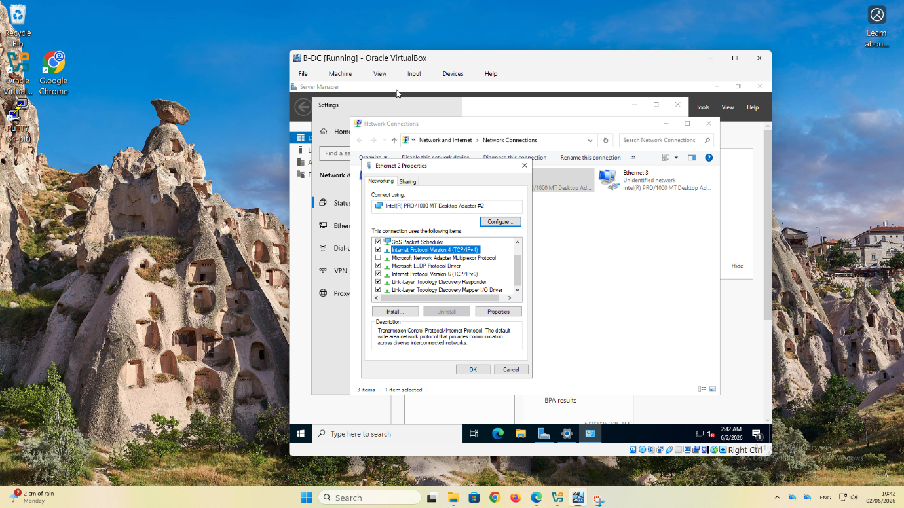
Description:
Opening the Internet Protocol Version 4 (TCP/IPv4) properties to configure a static IP address.
Explanation:
This screenshot shows the configuration window for IPv4 settings before entering the server's network information. Static IP addressing is required for servers because services such as Active Directory, DNS, and DHCP depend on a fixed address that does not change. This ensures that client computers can always locate and communicate with the server.

Figure 11. IPv4 Static IP Address Configuration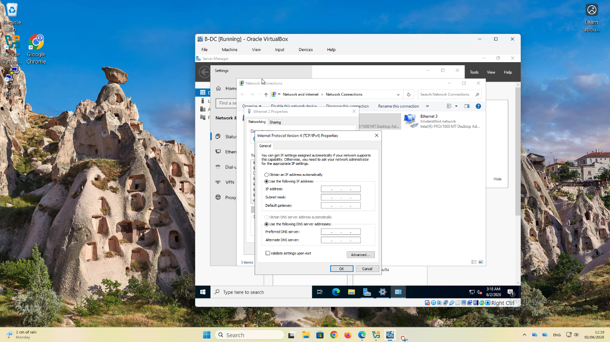
Description:
Static IP address assigned to the Windows Server.
Explanation:
This screenshot shows the completed IPv4 configuration for the Windows Server. The server was assigned the static IP address 172.16.1.1 with the subnet mask 255.255.255.0. A preferred DNS server was also configured to support future Active Directory services. Using a static address ensures reliable communication with client computers and prevents network interruptions caused by changing IP addresses.
Setting | Value
IP Address | 172.16.1.1
Subnet Mask | 255.255.255.0
Default Gateway | 10.0.0.2 (if configured)
Preferred DNS Server | 172.16.1.1

Figure 12. IP Configuration Verification (ipconfig)

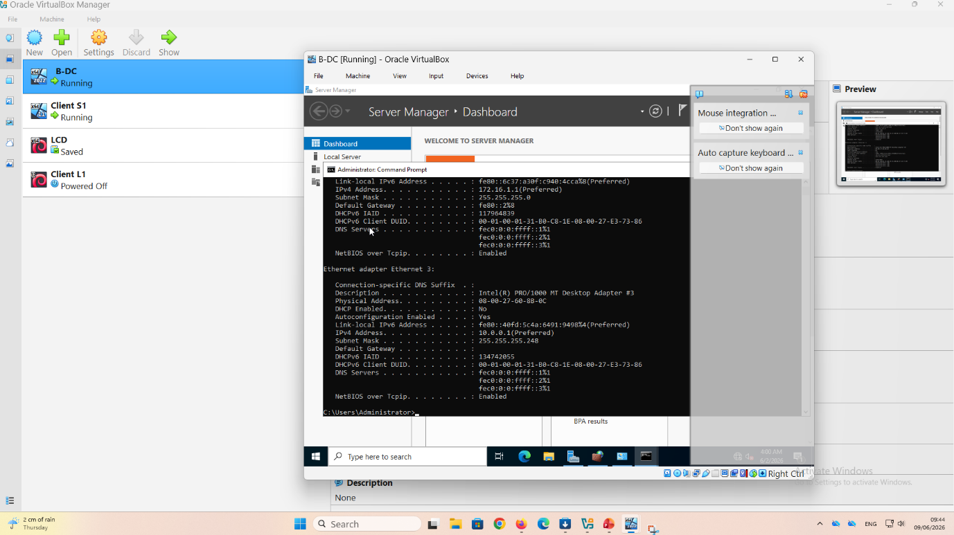
Description:
Verification of the server network configuration using the ipconfig command.
Explanation:
This screenshot shows the output of the ipconfig command used to verify the network configuration of the Windows Server. The results confirm that the correct IP addresses, subnet masks, and network adapters have been assigned. Performing this verification helps identify configuration errors before testing connectivity or installing network services such as Active Directory and DHCP.
Network Adapter | IP Address | Subnet Mask
Birmingham LAN | 172.16.1.1 | 255.255.255.0
WAN Link | 10.0.0.1 | 255.255.255.252 (/30)

Figure 13. Successful Connectivity Test (Ping)

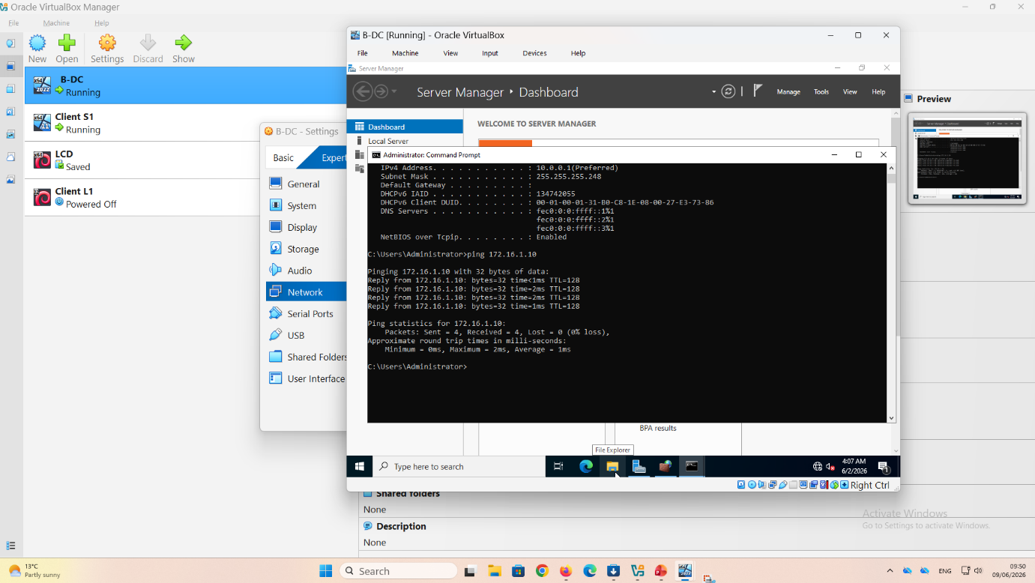
Description:
Successful ping test between Windows Server and Client S1.
Explanation:
This screenshot shows a successful ping test from the Windows Server to Client S1. Four replies were received without packet loss, confirming that both devices can communicate successfully over the network. This test verifies that the IP addressing, subnet configuration, and network adapters are functioning correctly before additional network services are deployed.

Source Device | Destination Device | Destination IP | Result
Windows Server 2022 (B-DC) | Client S1 | 172.16.1.10 | Successful
Packets Sent | 4
Packets Received | 4
Packet Loss | 0%
Average Response Time | 1 ms

Figure 14. Successful Connectivity Test Between Server and Client
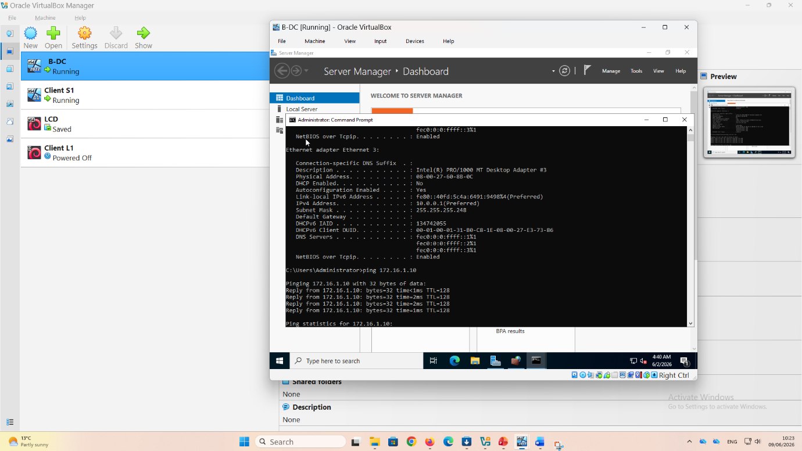
Description:
Network communication successfully established between the server and the client computer.
Explanation:
This screenshot shows successful communication between the Windows Server and the client workstation using the ping command. The replies demonstrate that the network infrastructure has been configured correctly and that data can travel between both devices. Successful connectivity testing is an important step because it confirms that the network is ready for the deployment of enterprise services.

Item | Value
Source Device | B-DC (Windows Server 2022)
Destination Device | Client S1
Destination IP | 172.16.1.10
Test Method | Ping (ICMP)
Result | Successful
Status | Communication Established

7. Debian 13 Installation and Configuration

Installation of the Debian 13 virtual machine (LCD) in VirtualBox
The Debian 13 virtual machine (LCD) was created in Oracle VirtualBox and configured with three network adapters connected to the Birmingham, London, and WAN internal networks. After attaching the Debian ISO file, the virtual machine was started and the Graphical Install option was selected from the installer menu.
During installation, Debian detected the available network interfaces and selected one as the primary interface. After detecting the interfaces, each adapter was configured with the appropriate IP address so that the server could communicate with both local networks and the WAN connection.
The virtual hard disk (21.5 GB) was then partitioned using the "All files in one partition" option, which automatically created the required Linux file system structure. Debian copied and installed all necessary operating system files onto the virtual disk.
Next, the GRUB boot loader was installed on the primary disk to allow the operating system to start correctly after installation. Once the installation was completed, the virtual machine rebooted and loaded Debian successfully.
Finally, the system was accessed through the command-line interface by logging in with the root account. The successful login confirmed that Debian was installed correctly and ready for further configuration, including assigning IP addresses, enabling routing, and configuring DHCP Relay services required for the coursework network topology.

Figure 15. Debian 13 Language Selection

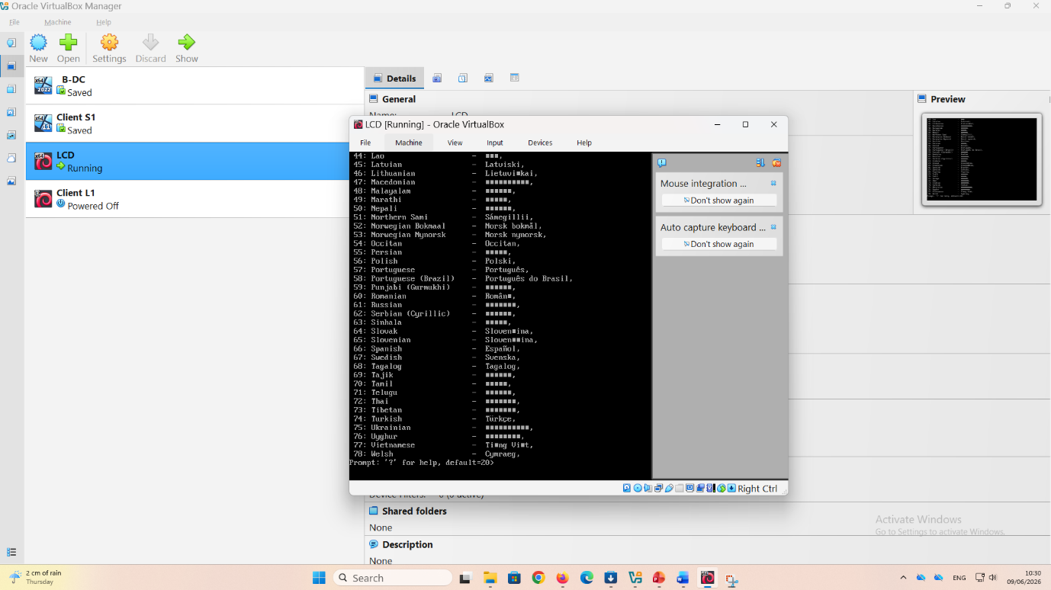
Description:
Selection of the installation language for Debian 13.
Explanation:
This screenshot shows the first stage of the Debian 13 installation where the language is selected. The chosen language determines the language used during the installation process and becomes the default language for the operating system. Selecting the correct language helps ensure that system messages and configuration options are easy to understand throughout the installation.

Figure 16. Network Interface Detection

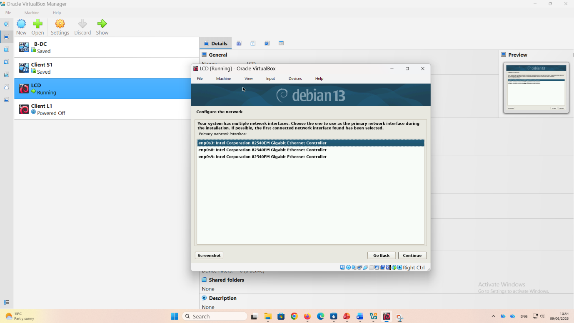

Description:
Automatic detection of the available network interfaces.
Explanation:
This screenshot shows Debian detecting the available network interfaces during installation. The operating system identifies the virtual network adapters provided by VirtualBox and prepares them for configuration. Detecting the correct interfaces is essential because they allow the server to communicate with the Birmingham network, the London network, and the WAN connection.
Setting | Value
Operating System | Debian 13
Installation Stage | Network Interface Detection
Interfaces Detected | enp0s3, enp0s8, enp0s9
Adapter Type | Intel Corporation 82540EM Gigabit Ethernet Controller
Environment | Oracle VirtualBox
Purpose | Detect Available Network Adapters

The successful detection of multiple network interfaces confirms that the Debian Server can support communication across several network segments. This configuration is essential because the server will later act as a routing device and DHCP Relay server, enabling communication between the Birmingham network (172.16.1.0/24), the London network (172.16.2.0/24), and the WAN connection (10.0.0.0/30).

Figure 17: Configuration of the First Network Adapter (Birmingham)

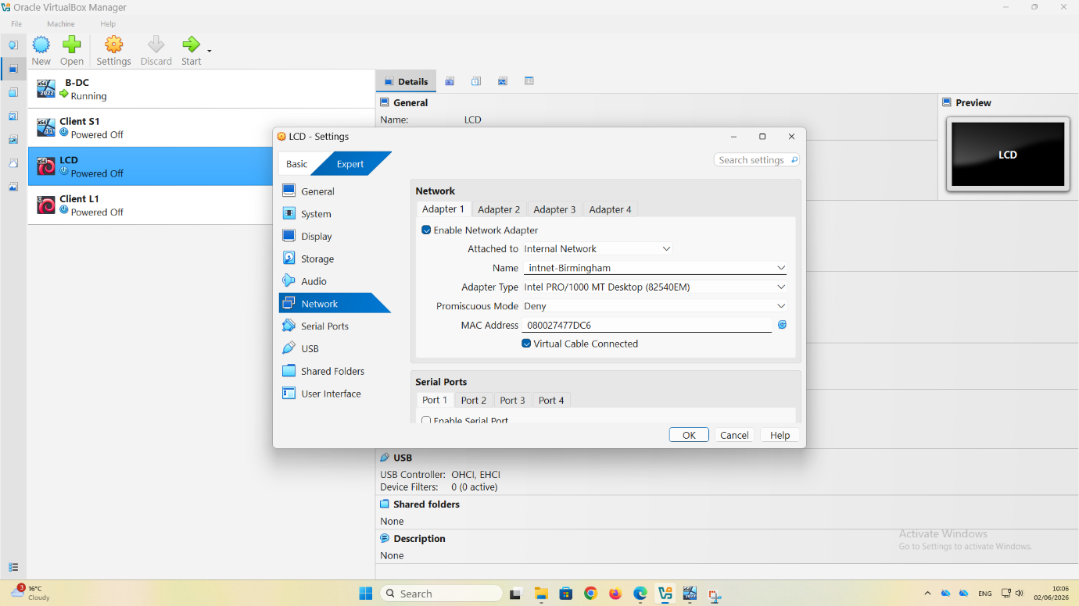
Description:
Configuration of Adapter 1 for the Debian Server (LCD) in Oracle VirtualBox.
Explanation:
This screenshot shows the configuration of the first network adapter for the Debian Server (LCD) virtual machine in Oracle VirtualBox. The adapter is enabled and connected to the internal network named intnet-Birmingham. This configuration allows the Debian Server to communicate with devices located on the Birmingham network segment, including the Windows Server 2022 domain controller (B-DC) and Client S1. The Internal Network mode was selected to create an isolated virtual network environment where only authorised virtual machines can communicate. This setup forms part of the NOSSLONDON2026 topology and supports routing and DHCP Relay services between the Birmingham and London networks.
Setting | Value
Virtual Machine | LCD (Debian Server)
Adapter | Adapter 1
Network Mode | Internal Network
Network Name | intnet-Birmingham
Adapter Type | Intel PRO/1000 MT Desktop
Virtual Cable Connected | Enabled
Purpose | Birmingham Network Communication

Figure 18: Configuration of the Second Network Adapter (London)
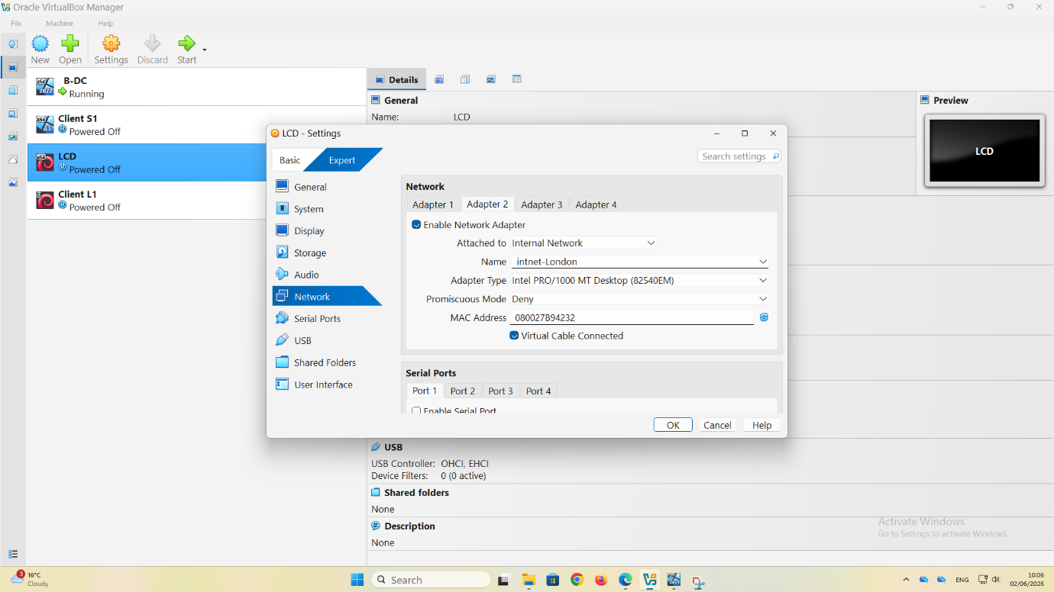

Description:
Configuration of Adapter 2 for the Debian Server (LCD) connected to the London internal network in Oracle VirtualBox.
Explanation:
This screenshot shows the configuration of the second network adapter for the Debian Server (LCD) virtual machine in Oracle VirtualBox. The adapter was configured to connect to the intnet-London internal network, allowing the Debian Server to communicate with devices located on the London network segment, including Client L1. This network connection is essential because the Debian Server acts as the central device linking the London network to the wider NOSSLONDON2026 enterprise topology. By assigning a dedicated adapter to the London network, traffic can be separated from the Birmingham network, improving network organisation and management. The use of an Internal Network ensures that communication remains isolated within the virtual environment while supporting routing and DHCP Relay services between different network segments.
Setting | Value
Virtual Machine | LCD (Debian Server)
Adapter | Adapter 2
Network Mode | Internal Network
Network Name | intnet-London
Adapter Type | Intel PRO/1000 MT Desktop
Virtual Cable Connected | Enabled
Purpose | London Network Communication

Figure 19: Configuration of the Third Network Adapter (WAN)
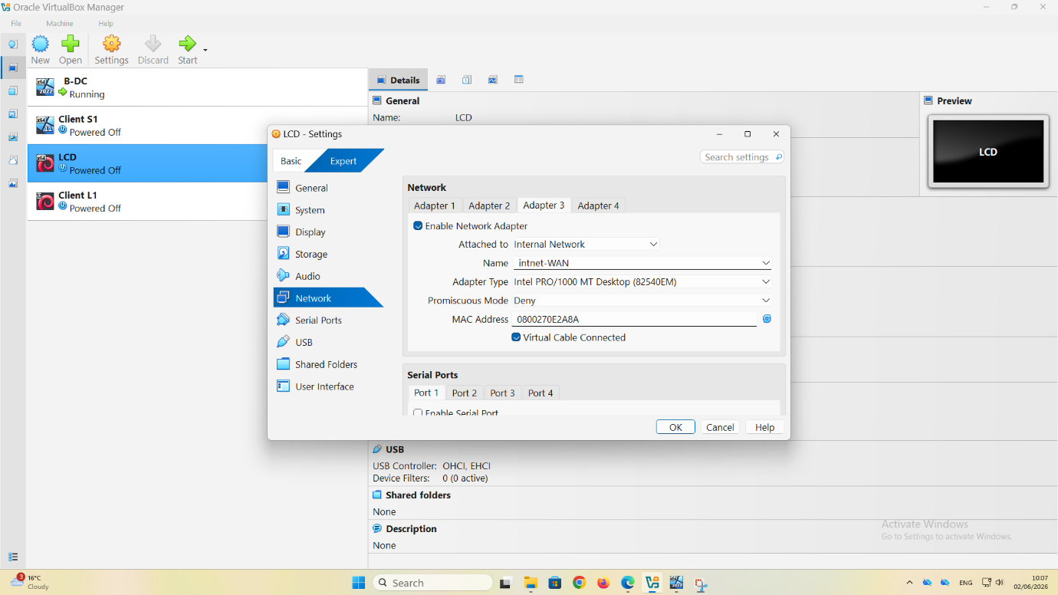
Description:
Configuration of Adapter 3 for the Debian Server (LCD) connected to the WAN link in Oracle VirtualBox.

Explanation:
This screenshot shows the configuration of the third network adapter for the Debian Server (LCD) virtual machine in Oracle VirtualBox. The adapter was connected to the WAN internal network, which provides the communication link between the Birmingham and London network segments. This adapter is essential because it allows the Debian Server to exchange traffic with the Windows Server through the WAN connection using the IP addresses 10.0.0.2 and 10.0.0.1. The WAN network simulates a real-world connection between two geographically separated locations and enables routing between the Birmingham subnet (172.16.1.0/24) and the London subnet (172.16.2.0/24). Configuring a dedicated WAN adapter improves network segmentation and supports the implementation of routing services required for enterprise network communication.
Setting | Value
Virtual Machine | LCD (Debian Server)
Adapter | Adapter 3
Network Mode | Internal Network
Network Name | intnet-WAN
Adapter Type | Intel PRO/1000 MT Desktop
Virtual Cable Connected | Enabled
Purpose | WAN Communication Between Sites

Importance:
The third network adapter enables the Debian Server to act as a routing device between Birmingham and London. Without this WAN connection, devices located on different subnets would not be able to communicate. This configuration is therefore critical for routing, DHCP Relay functionality, and overall connectivity within the NOSSLONDON2026 enterprise network.
Figure 20: Root Password Configuration
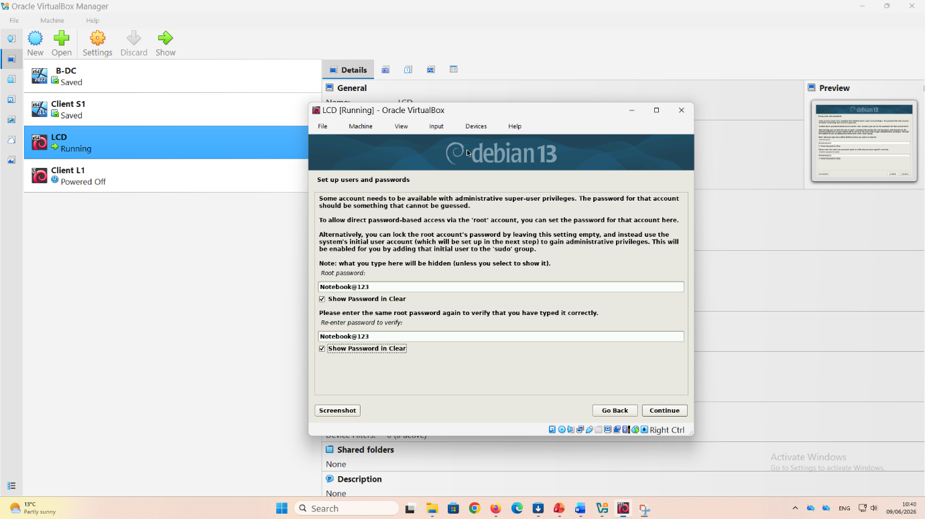
Description:
Creation of the root administrator password during the Debian 13 installation process.

Explanation:
This screenshot shows the stage of the Debian 13 installation where the root password is configured. The root account is the highest privileged account in Linux and is used to perform administrative tasks such as system configuration, software installation, network management, and troubleshooting. During installation, a strong password was created to secure the server and prevent unauthorised access. Configuring the root password is an important security measure because it protects critical system resources and ensures that only authorised administrators can make changes to the operating system. Once the installation is complete, the root account can be used to configure IP addresses, enable routing, and implement DHCP Relay services required for the NOSSLONDON2026 network topology.

Setting | Value
Operating System | Debian 13
Account Type | Root Administrator
Purpose | System Administration
Security Requirement | Strong Password
Access Level | Full Administrative Privileges

Importance:
The root account provides complete control over the Debian Server. Securing this account with a strong password is essential to maintain system integrity, protect network services, and ensure that only authorised users can perform administrative operations within the virtual enterprise network.

Figure 21: Disk Partitioning and GRUB Installation

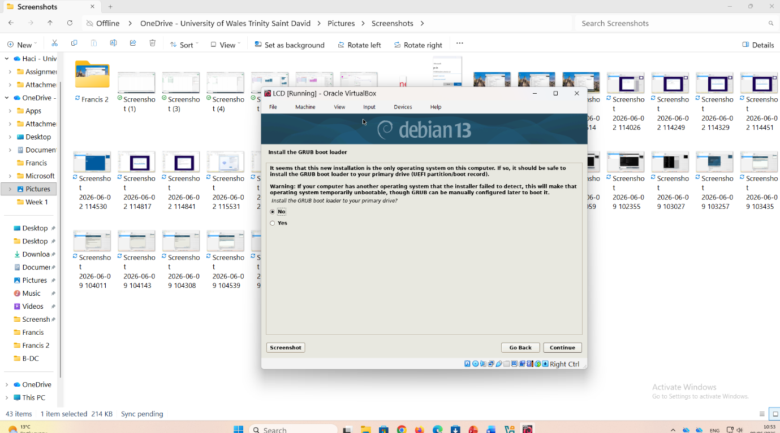
Description:
Configuration of disk partitioning and installation of the GRUB boot loader during the Debian 13 installation process.

Explanation:
This screenshot shows the stage of the Debian 13 installation where the virtual hard disk is partitioned and prepared for the operating system. The "All files in one partition" option was selected, allowing Debian to automatically create the required file system structure on the virtual disk. This method simplifies installation and is suitable for small and medium-sized server environments. After partitioning was completed, the GRUB (Grand Unified Boot Loader) was installed on the primary disk. GRUB is responsible for loading the Linux kernel and starting the operating system whenever the virtual machine is powered on. The successful installation of GRUB ensures that Debian can boot correctly and operate reliably within the VirtualBox environment.
Setting | Value
Operating System | Debian 13
Disk Size | 21.5 GB
Partition Method | All Files in One Partition
Boot Loader | GRUB
Installation Target | Primary Virtual Disk
Purpose | System Startup and Disk Management

Figure 22: Successful Debian Login
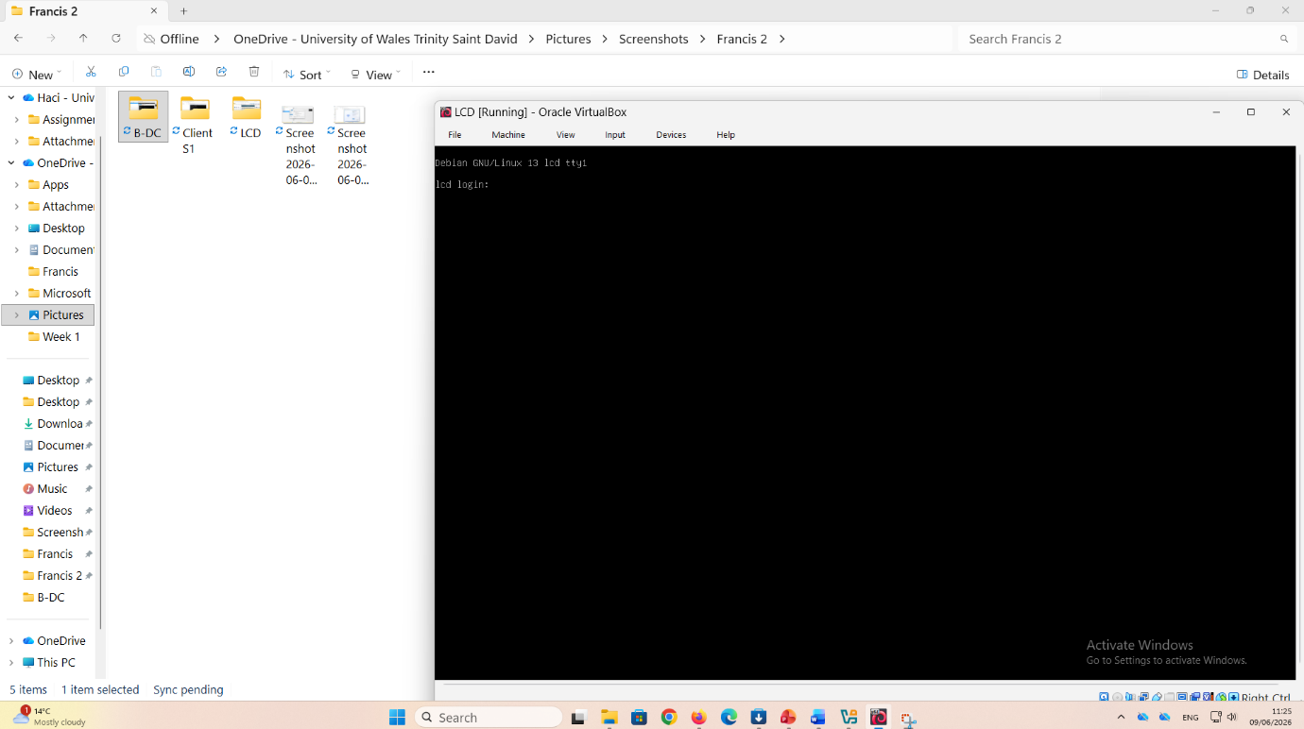
Description:
Successful login to the Debian 13 Server using the root account after the installation process was completed.

Explanation:
This screenshot shows the Debian 13 Server successfully booting into the command-line interface (CLI) and accepting a login using the root account. The successful login confirms that the operating system was installed correctly, the root password was configured properly, and the system is functioning as expected. At this stage, the server is ready for further configuration, including assigning static IP addresses, enabling IP forwarding, configuring routing services, and implementing DHCP Relay functionality. Accessing the server through the CLI is an important step because many Linux server administration tasks are performed using command-line tools. The successful login demonstrates that the Debian Server is operational and ready to support the NOSSLONDON2026 enterprise network infrastructure..
Setting | Value
Operating System | Debian 13
Login Account | root
Interface Type | Command-Line Interface (CLI)
Login Status | Successful
Server Status | Operational
Purpose | System Administration and Network Configuration

Figure 23. Debian 13 Running Successfully

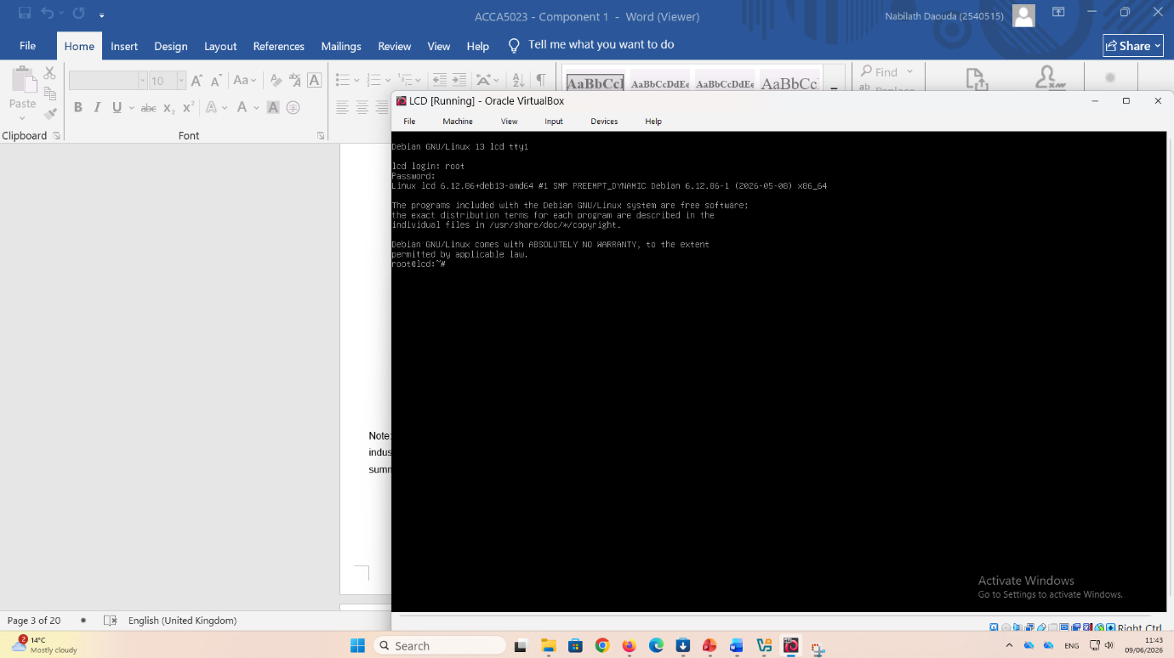

Description:
Debian 13 Server successfully running after installation and system startup.
Explanation:
This screenshot shows the Debian 13 Server operating successfully after the installation process was completed. The system has booted correctly and is running in the command-line interface (CLI) environment. This confirms that the operating system files, disk partitions, and GRUB boot loader were installed correctly and that the server is functioning normally. At this stage, the server is ready for network configuration tasks such as assigning static IP addresses, enabling IP forwarding, configuring routing tables, and implementing DHCP Relay services. The successful operation of the Debian Server is essential because it will act as a key component in connecting the Birmingham and London network segments within the NOSSLONDON2026 enterprise network topology.
.
Setting | Value
Operating System | Debian 13
Server Name | LCD
Environment | VirtualBox
Interface | Command-Line Interface (CLI)
Status | Running Successfully
Purpose | Routing and Network Services
Importance:
The successful operation of the Debian Server confirms that the virtual machine is stable and ready for deployment within the enterprise network. This stage marks the completion of the operating system installation and provides the foundation for implementing routing, DHCP Relay, and inter-network communication services between the Birmingham and London sites.

Installation of the Windows 11 Client S1 in VirtualBox
The Client S1 virtual machine was first configured in Oracle VirtualBox and connected to the intnet-Birmingham internal network. Windows 11 Enterprise was then installed using an ISO image. During the installation, the English language settings were selected, and the operating system was installed on an 80 GB virtual hard disk. Windows automatically created the required system partitions and completed the installation process.
After installation, Windows 11 successfully booted to the desktop environment. A static IP address (172.16.1.10/24) was configured to match the network addressing scheme. The default gateway was set to 172.16.1.1 to allow communication with other network segments through the Debian router.
Network connectivity was tested using the ping command. The result showed “Destination host unreachable,” indicating a communication problem between the client and the gateway. To troubleshoot the issue, Windows Defender Firewall settings were reviewed, and network configurations were checked.
Overall, the installation and configuration of Client S1 were completed successfully, preparing the machine for integration into the virtual enterprise network and for future networking services required in the coursework.
Client Deployments
8. Windows 11 Client S1 Installation and Configuration ............................ 25
Figure 24
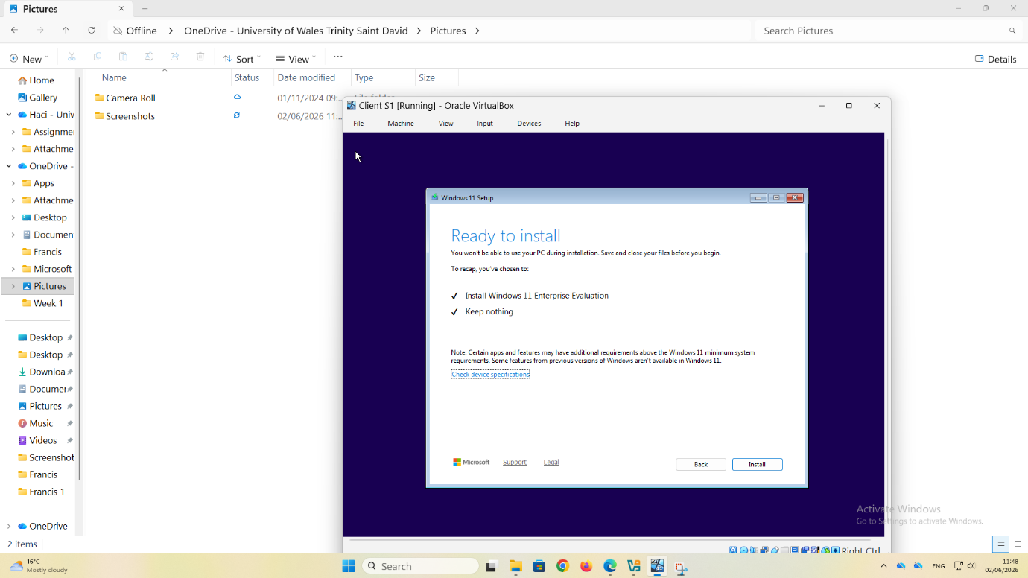
Description:
Windows 11 Enterprise installation confirmation screen displayed before the operating system installation starts.
Explanation:
This screenshot shows the final confirmation stage of the Windows 11 installation process for the Client S1 virtual machine. The Windows Setup wizard confirms that Windows 11 Enterprise Evaluation will be installed and that all existing data on the virtual hard disk will be removed because the Keep nothing option was selected. At this stage, all installation settings have been configured, and the system is ready to begin copying files, installing Windows features, and configuring the operating system. This step confirms that the installation media was successfully loaded and that the virtual machine is correctly prepared for deployment. Once the installation process begins, Windows Setup will automatically install the operating system and prepare the client workstation for network configuration and connectivity testing.
Setting | Value
Operating System | Windows 11 Enterprise Evaluation
Virtual Machine | Client S1
Installation Stage | Ready to Install
Data Retention Option | Keep Nothing
Environment | Oracle VirtualBox
Status | Ready for Installation

Figure 25. Windows 11 Installation
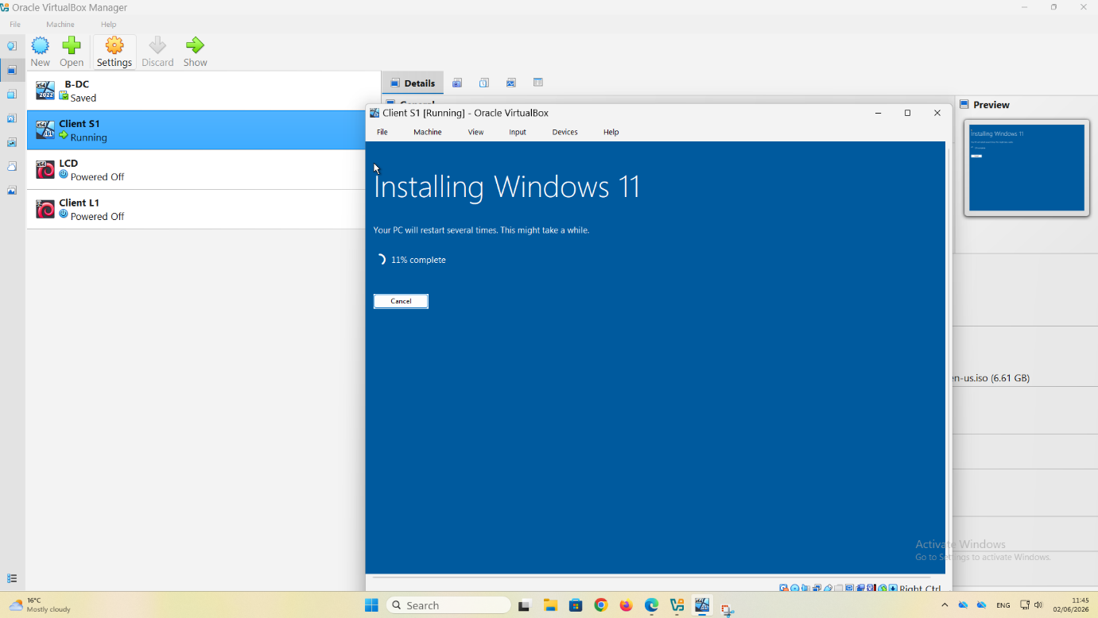
Description:
Windows 11 installation process running on the Client S1 virtual machine in Oracle VirtualBox.
Explanation:
This screenshot shows Windows 11 being installed on the Client S1 virtual machine. The installation process has reached 11% completion, indicating that Windows Setup is copying files, installing system components, and configuring the operating system. During this stage, the installer automatically prepares the system for operation and may restart the virtual machine several times before the installation is completed. The progress screen confirms that the installation media was loaded successfully and that the installation process is proceeding normally. Once completed, the operating system will be ready for network configuration, including assigning a static IP address and testing connectivity within the enterprise network environment. Once the installation and IP configuration were completed, the client computer was ready to join the enterprise network and communicate with the Windows Server and Debian Server.

Setting | Value
Operating System | Windows 11 Enterprise Evaluation
Virtual Machine | Client S1
Installation Progress | 11% Complete
Environment | Oracle VirtualBox
Status | Installation in Progress
Purpose | Deploy Client Workstation

Figure 26. Windows 11 Static IP Configuration
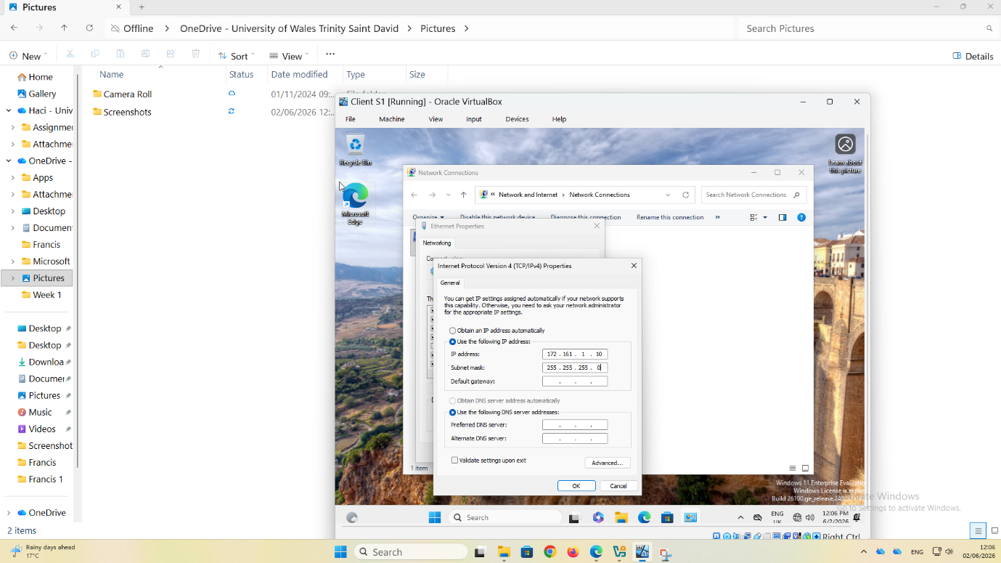
Description:
Configuration of a static IPv4 address on the Windows 11 Client S1 virtual machine.
Explanation:
This screenshot shows the Internet Protocol Version 4 (TCP/IPv4) configuration window on the Windows 11 Client S1 virtual machine. A static IP address was manually assigned to ensure consistent network communication within the Birmingham subnet. The client was configured with the IP address 172.16.1.10, subnet mask 255.255.255.0, and default gateway 172.16.1.1. Static addressing was selected instead of automatic addressing because it provides predictable device identification and simplifies network administration and troubleshooting. This configuration enables the client workstation to communicate with the Windows Server, the Debian Server, and other devices connected to the NOSSLONDON2026 enterprise network.

Setting | Value
Device | Client S1
Operating System | Windows 11 Enterprise
IP Address | 172.16.1.10
Subnet Mask | 255.255.255.0
Default Gateway | 172.16.1.1
Addressing Method | Static IPv4
Network | Birmingham (172.16.1.0/24)

Figure 27. Windows 11 Connectivity Test
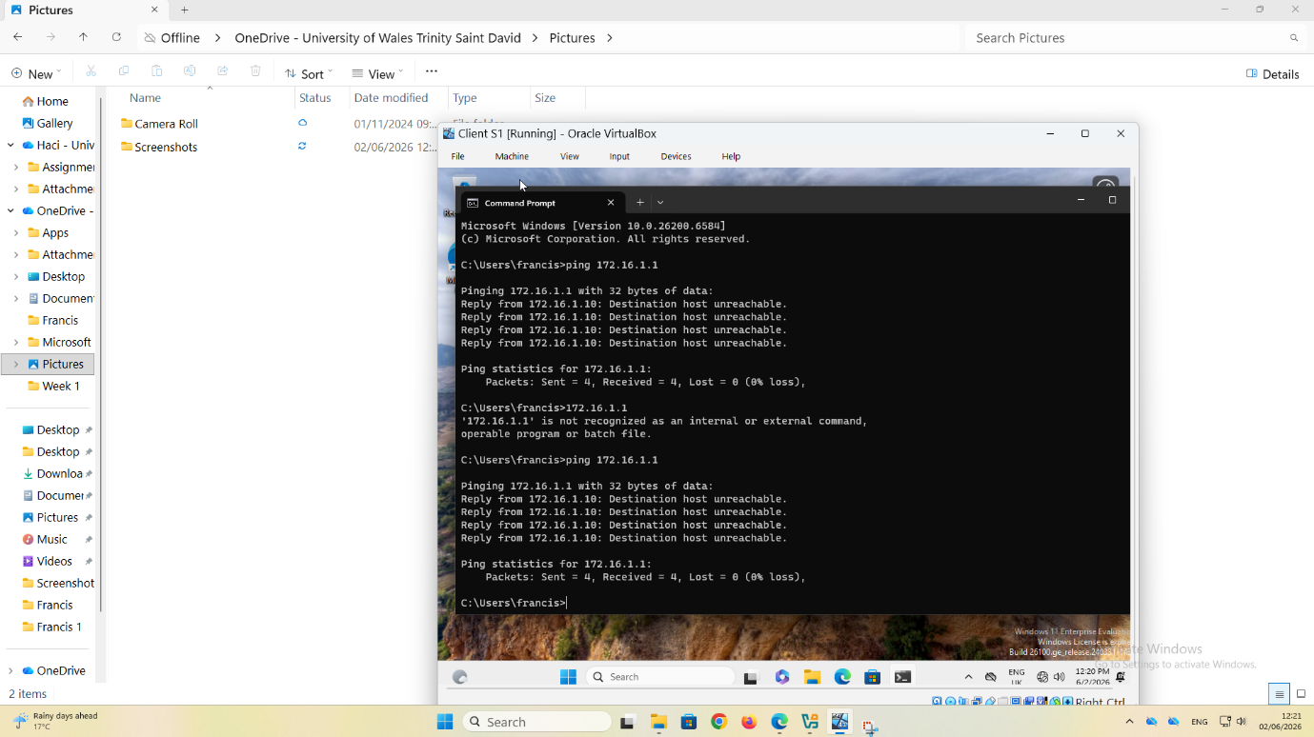
Description:
Initial connectivity test between Client S1 and the destination host.
Explanation
This screenshot shows a failed network connectivity test performed from Client S1 using the ping command. The client attempted to communicate with the host at IP address 172.16.1.1. However, the response returned "Destination Host Unreachable", indicating that the destination device could not be reached. This issue suggested a network configuration problem involving IP addressing, subnet configuration, firewall settings, or VirtualBox network adapter settings. The test was used as part of the troubleshooting process before correcting the network configuration and restoring connectivity.
Setting | Value
Operating System | Windows 11 Enterprise Evaluation
Virtual Machine | Client S1
Installation Progress | 11% Complete
Environment | Oracle VirtualBox
Status | Installation in Progress
Purpose | Deploy Client Workstation

Connectivity Testing

9. Network Connectivity Testing
- Figure 28. Successful Connectivity Test (Same Network)
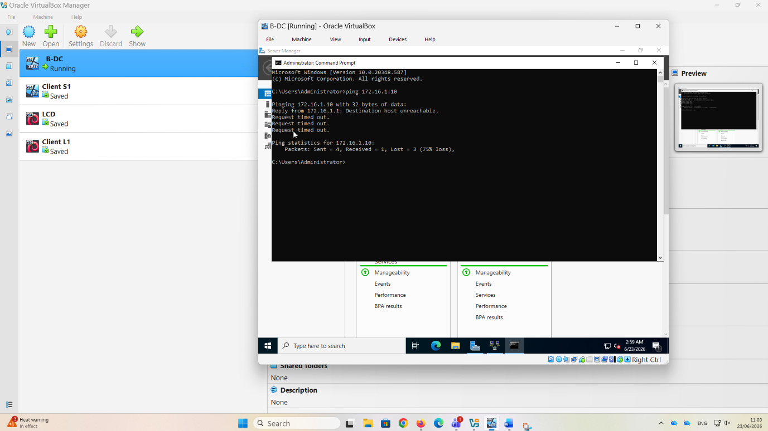
Explanation:
This figure presents two network connectivity tests performed from the Windows Server (B-DC) using the ping command. In the first test, the server attempted to communicate with the client computer at 172.16.1.10. The result displayed "Destination host unreachable" followed by several "Request timed out" messages, indicating that the server could not reach the client. This suggests that the client device was either powered off, disconnected from the network, or had an incorrect network configuration such as an invalid IP address, subnet mask, or VirtualBox network settings.

Figure 29. Successful Connectivity Test (Different Networks)
- 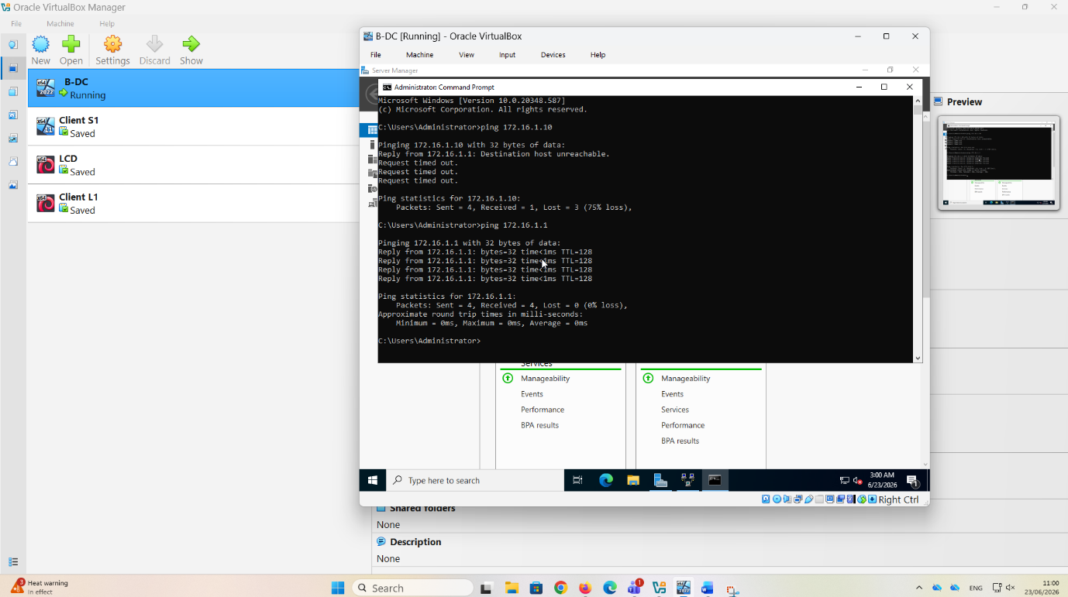
Explanation:
The second test was performed by pinging the server's own IP address (172.16.1.1). This test was successful, with all four packets transmitted and received and 0% packet loss. The successful replies confirm that the server's network adapter, TCP/IP configuration, and local network services are functioning correctly.
Comparing the two results helps identify that the network issue is not on the Domain Controller itself but is most likely related to the client machine or its network configuration. Performing ping tests is an effective troubleshooting technique for verifying communication between devices before investigating other possible causes, such as firewall settings, routing, or VirtualBox network configuration.

Task 3 – Reflection
10. Technical Reflection
During this project, I realised that careful planning is essential when configuring enterprise networks. Small mistakes in IP addressing or network adapter settings can prevent communication between devices. Troubleshooting these problems improved my understanding of networking and strengthened my practical skills.
One of the biggest challenges I faced was configuring the network adapters correctly. At different stages, some of the virtual machines could not communicate with each other because of incorrect IP settings or adapter configurations. Instead of starting again, I used tools such as ipconfig and ping to check the network configuration and identify where the problem was. Solving these issues taught me the importance of following a logical troubleshooting process and checking each configuration step carefully.
Another useful lesson was learning why servers normally use static IP addresses. While configuring the Windows Server, I realised that services such as Active Directory, DNS, and DHCP depend on a fixed IP address to operate reliably. This made me understand why correct network planning is essential before deploying any enterprise services.
I also became more confident using Oracle VirtualBox. At the beginning, creating virtual machines and configuring multiple network adapters seemed difficult. However, after repeating the process several times, I became more comfortable with the software and understood how each virtual network contributed to the overall topology.
Overall, this project improved both my technical knowledge and my practical skills. It showed me that successful network deployment requires careful planning, patience, and attention to detail. I now feel much more prepared to configure more advanced network services such as Active Directory, DHCP, DNS, VPNs, and Certificate Services in future coursework.

11. Personal Reflection
This assignment increased my confidence in deploying virtual machines and configuring enterprise network services. Before completing the project, I had limited practical experience with Windows Server and Debian Linux. By completing each installation and solving configuration problems, I developed valuable skills that will help me in future networking and cybersecurity roles.
Throughout the project, I noticed that my confidence gradually improved. At first, I relied heavily on the installation guides and lecture materials, but as I progressed, I became more independent when configuring the virtual machines and solving networking problems. This gave me a greater sense of achievement because I could see my own progress from the beginning to the end of the project.
The coursework also helped me improve important skills beyond technical knowledge. I developed better organisation by documenting every stage of the installation process and keeping screenshots in the correct order. I also improved my problem-solving skills by learning not to guess the cause of a problem but to test the configuration carefully before making changes.
If I were completing this project again, I would spend more time planning the network before starting the installation. A clear plan would reduce configuration mistakes and make the deployment process more efficient. I would also create snapshots more frequently in VirtualBox so that I could easily return to a working configuration if something went wrong.
Overall, this project has been a valuable learning experience. It strengthened my understanding of enterprise networking, improved my practical skills, and increased my confidence in using virtualisation technologies. I believe the knowledge I have gained will be useful both in future modules and in a professional IT environment.

Conclusion
This project successfully demonstrated the design, implementation, and testing of a virtualised enterprise network using Oracle VirtualBox. The deployment included Windows Server 2022, Debian Server 13, and client workstations connected through a structured IP addressing scheme. Research conducted on hypervisors, routing, IP addressing, and network services provided a strong theoretical foundation for the practical implementation. Network testing confirmed successful communication between devices and validated the configuration. Overall, this coursework successfully demonstrated the design, implementation and testing of a virtualised enterprise network. It also provided valuable practical experience that will support the implementation of additional services such as Active Directory, DHCP, DNS and VPN in Coursework 2.

References
[1] W. Stallings, Foundations of Modern Networking: SDN, NFV, QoE, IoT, and Cloud. Harlow, United Kingdom: Pearson, 2021.
[2] J. F. Kurose and K. W. Ross, Computer Networking: A Top-Down Approach, 8th ed. Harlow, United Kingdom: Pearson, 2022.
[3] B. A. Forouzan, Data Communications and Networking, 5th ed. New York, NY, USA: McGraw-Hill Education, 2017.
[4] Microsoft, "Active Directory Domain Services Overview," Microsoft Learn, 2025. [Online]. Available: https://learn.microsoft.com. [Accessed: 20-Jun-2026].
[5] Microsoft, "Dynamic Host Configuration Protocol (DHCP)," Microsoft Learn, 2025. [Online]. Available: https://learn.microsoft.com. [Accessed: 20-Jun-2026].
[6] Microsoft, "Virtual Private Network (VPN) Technologies," Microsoft Learn, 2025. [Online]. Available: https://learn.microsoft.com. [Accessed: 20-Jun-2026].
[7] Oracle Corporation, "Oracle VM VirtualBox Documentation," Oracle, 2025. [Online]. Available: https://www.virtualbox.org/wiki/Documentation. [Accessed: 20-Jun-2026].
[8] VMware, "Introduction to Hypervisors," VMware Documentation, 2025. [Online]. Available: https://www.vmware.com. [Accessed: 20-Jun-2026].

