BA Leadership and Management Skills for the Workplace
Assignment Title: Coaching & Mentoring Skills for the Workplace
Name: Firon Miah
ID: 1605305

Table of Contents
Introduction 3
A critical evaluation of the purpose of coaching and mentoring at Sainsbury 4
Defining coaching and mentoring 4
Individual and organizational benefits of coaching and mentoring 7
Purposes and objectives of coaching and mentoring at Sainsbury 9
Cost and benefit analyses of coaching and mentoring 10
Alternative strategies for developing and supporting employees 10
GROW model 11
Egan’s Skilled Helper Model 12
A critical analysis of the skills, attitudes, behaviors, values, and beliefs of an effective coach at Sainsbury 14
Organizational, operational, and individual barriers in coaching and mentoring at Sainsbury and the ways to overcome it 18
Individual barriers to coaching and mentoring and ways to overcome 19
Application of Appropriate Framework for Coaching and Mentoring at Sainsbury 20
Conclusion 24
References 25

Introduction
Coaching and mentoring are two widely used skill development and improvement tools applied by the manager in the modern workplace. Coaching and mentoring become a prerequisite in the world of increasing competition and globalization. It becomes very useful for personal development as well as professional development. Coaching and mentoring helps to build a concrete and positive change in skills and human behavior to boost performance in the workplace. It helps to improve competencies that are crucial for exploring objectives. Thus modern business organizations apply different innovative coaching and mentoring techniques in the workplace for the simultaneous benefit of the organizations and their individuals (Bureau, 2018). Considering the rising significance of coaching and mentoring in business management, this report is going to explore the skills, principles, and practice of effective management, coaching, and mentoring with the benefits that they bring to the business. For this, the report will evaluate the purpose of coaching and mentoring in Sainsbury and analyze the skills, beliefs, values, attitudes, and behavior of the effective coach and mentor as well. Later part of the report will apply different strategies and techniques to effectively coach and mentor at Sainsbury.

A critical evaluation of the purpose of coaching and mentoring at Sainsbury
- Company overview
Sainsbury is the second-largest supermarket chain in the UK that was founded in 1869. Currently, it holds a 15.3% market share with 1400+ locations and £309 million net income (2018). Sainsbury under the management of Martin Scicluna and Mike Coupe is growing very fast ensuring superior quality. It is a family of 186,900 (2018) who works together to explore the corporate objectives of Sainsbury (Sainsbury's 2019).

Defining coaching and mentoring
- Coaching
Coaching is defined as a systematic process of developing and improving workplace skills and competencies to explore organizational objectives. The process often focuses on improving some specific skills areas that required for acquiring short term objectives (Holliday, 2015).
- Mentoring
Mentoring refers to a systematic process and semi-structured guidance whereby an experienced leader or person shares his knowledge, skills, techniques, and experience to assist the subordinates in the progress of their workplace excellence. He/She often identifies the potential nurturing areas of the subordinates and develops shared long term goals by the subordinates to explore (Holliday, 2015). It is mainly long term oriented in nature.
- The role of coaching and mentoring
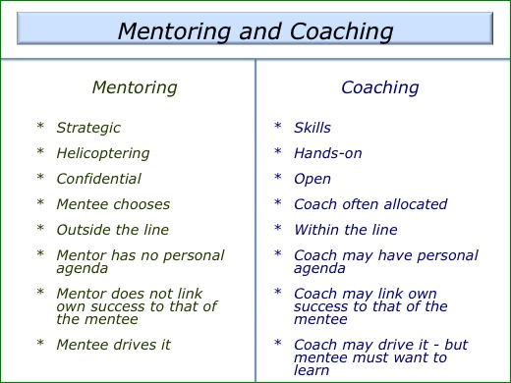
Figure: the role of coaching and mentoring
Differences and overlaps of coaching, mentoring, and training
Coaching, mentoring, counseling, and training are four major approaches used by leaders and managers for the development and improvement of skills and competencies of the subordinates to explore the objectives.
Overlaps between coaching, mentoring, and training
There are some common features of these development and improvement approaches that overlap each other. These are described below:
- Arises from the knowledge gap
All of these four approaches have arisen from the knowledge gap. More Skilled and experienced person shares his skills and knowledge to reduce the gaps between them.
- Inherent objectives
The core objectives of these four approaches are the development and improvement of existing knowledge and skill base to explore the goals.
- Communication
Each approach requires an effective communication channel to share skills and knowledge. Thus direct communication channel among the parties is common for both the techniques.
- Development process
All of these strategies consider some key stages to implement including identification of goals, current realities, available alternative options, and behavioral aspects to implement the development strategy.

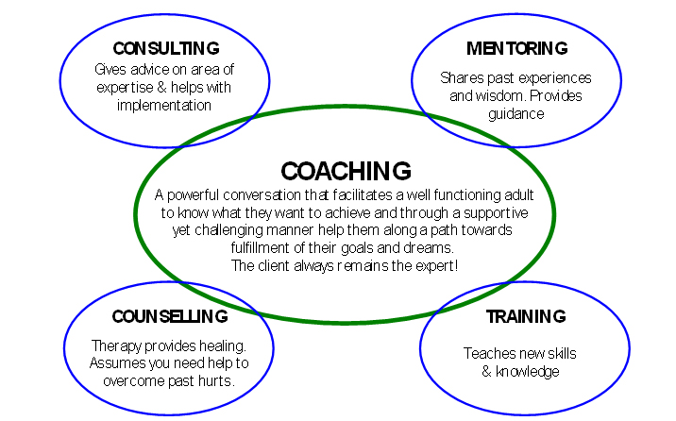
Figure: overlaps between coaching, mentoring, counseling, and training
- Differences between coaching, mentoring, counseling, and training
Point of differences | Coaching | Mentoring | Training
Objectives | Coaching aims at transforming behavior or performance | Mentoring focuses on integrated personal development along with the career and behavioral development | Training focuses on advanced skills and competencies or some other personal development factors (Holliday, 2015).
Time horizon | It is short term in nature | It is long term in nature | It is often variable and depends on the objectives of training.
Facilitator skill requirement | It requires an expert on the coaching field on the subject matter (Holliday, 2015). | It requires comparatively higher expertise and experience in the field. | Along with expert knowledge, it requires practical application experience.
Nature | It is formal, task-oriented, and performance-driven | It is informal, relationship-oriented, and development-driven. | It is formal, structured, and can be both the task and relationship-oriented with measurable outcomes.

Individual and organizational benefits of coaching and mentoring
Coaching and mentoring provides numerous benefits to organizations and individuals simultaneously. Sainsbury's can make organizational objectives easier to explore using different coaching and mentoring techniques. On the other hand, employ can explore their career objectives by the development process followed by coaching and mentoring.
Individuals’ benefits of coaching and mentoring are as follows:
- Personal development at a cost of the organization
Each individual has some specific career goals. But it can be difficult and costly to attain. Coaching and mentoring facilities provided by an organization can make this task easier to explore. Coaching and mentoring can easily increase self-confidence and improve work performance, relationships, and communication (Bureau, 2018). Thus coaching and mentoring provides an invaluable space for personal development.
- Explore job and life satisfaction
Improvement of skills and competences always brings self-satisfaction. As a result, it improves intrinsic motivation and satisfaction of personal life (Olta, 2019).
- Makes self-reliant
Self-confidence is very crucial for the effective completion of tasks. Coaching and mentoring increases self-confidence thus makes individuals self-reliant as well.
- Increases credibility and responsibilities
Coaching and mentoring encourage individual accountability. As a result, individuals get more committed to their tasks and become more credible and responsible for their performance (Olta, 2019).
Coaching and mentoring also improves team working skills, relationships, personal qualities, and productivity by reducing personal weaknesses.

Organizational benefits of coaching and mentoring
As we have described earlier that coaching and mentoring provide a dual benefit system simultaneously, it is also very crucial for Sainsbury and can provide a host of benefits. Some of the major benefits of coaching and mentoring to Sainsbury are as follows:
- Increases employee retention and motivation
Hiring new employees is always a very costly and time-consuming process. Besides, it requires additional training and development cost to make newly employed employees competent for the workplace. So, a higher retention rate is very crucial for any organization. Effective coaching and mentoring system at Sainsbury can encourage the loyalty of the employees to the organization. Through coaching and mentoring a sense of credibility and connection arises among the employees. Coaching and mentoring helps the employees to feel comfortable and positive with the management and encourages Open communication. A positive work experience emerges among the employees. As a result, the corporate citizenship behavior of the employee becomes very high. Thus they are not willing to leave the organization. As a result, Sainsbury does not need to spend on hiring new employees.
- Increases team efficiency and productivity
Coaching and mentoring are often used to identify the strengths and weaknesses of employees. As a result, Sainsbury can easily capitalize their resources to reduce weaknesses and explore opportunities. Besides, coaching and mentoring also work for developing an effective team and organization as a whole. Thus, Sainsbury can get synergy benefits from coaching and mentoring. So, coaching and mentoring can be a very effective weapon for Sainsbury to increase productivity and efficiency (Kelly, 2019).
- Develops a positive workplace culture
Coaching and mentoring is all about sharing skills and experience. Besides, it also increases the intrinsic satisfaction of the employees. As a result, coaching and mentoring induces a positive and sharing workplace environment.
- Builds high potential employees within the organization
Coaching and mentoring are part of the organizational succession plan. It provides a big ground to develop future leaders within the organization. It provides an exact direction for corporate success. Sainsbury can identify high potential employees and can coach them to improve leadership and management skills Who can lead the entire organization in the future.
In the end, we can say that coaching and mentoring increases employee engagement and communication, develop high potential employees, build strong management relationships, encourages employees to take responsibilities, and demonstrate organizational commitment to career development.

Purposes and objectives of coaching and mentoring at Sainsbury
Sainsbury is the second-largest retailer chain in the UK. It is mostly known for its superior customer service and quality products. Currently, more than 186,000 employees are working at Sainsbury. They have come from different cultures, countries, religions, genders, and races. Besides, the qualification level and confidence are also different. Thus shaping all the performance indicators of the employees within a framework is very crucial for superior sustainable performance. Self-beliefs, confidence, and self-awareness of the employees play a vital role in the improvement of workplace relationships and performance. Coaching and mentoring are the two most useful tools that are used in developing and improving the competencies of the employees. The core purposes of coaching and mentoring at Sainsbury are as follows:
- Building self-belief, loyalty, engagement, commitment, and confidence
The level of Self-belief and confidence in the workplace determines the possibilities of both success and failure. Employees with higher self-confidence can accumulate the factors that are required for success and extract efforts accordingly. Considering this, Coaching and mentoring at Sainsbury aims at developing the potential level of self-beliefs, loyalty, engagement, commitment, and confidence among the employees.
- Unlocking employees’ potential
Coach and mentor help the employees to learn and identify the potential skill level of the employees. They try to unlock the potential of the employees for optimum performance. Coaching and mentoring enables the employees to forget their past mistakes and keep them moving forward (Bureau, 2018). Coaching and mentoring at Sainsbury often release a rich reserve of talent, motivates, and builds a strong sense of purpose among the employees.
Thus the purposes of coaching at Sainsbury are to inspire, improve, develop, motivate, boost the performance of the employees with their potential.

Cost and benefit analyses of coaching and mentoring
- Potential benefits of coaching and mentoring
We have already identified the potential benefits of coaching and mentoring from the Perspective of the individuals and organizations. Most of the benefits will come from the improvement of soft skills and improve workplace culture. Though we can measure the benefits of coaching and mentoring in terms of rising in revenue and profitability by remaining all other things constant, we can’t measure the qualitative changes. So, it provides a big room for management discretion and prudence of Sainsbury.
- Potential cost analysis of coaching and mentoring
Sainsbury can apply different coaching and mentoring techniques to explore their goals. But in the area of competition, globalization, and regulation proper analyses of each approach can maximize the value and outcome (Olta, 2019). Thus An effective cost-benefit analysis for different approaches of coaching and mentoring can give the best-intended outcomes to Sainsbury. But coaching and mentoring are run through the area of skills and experience. As a result, proper cost estimation will depend on the prudence and efficiency of the management. Thus the potential cost items for coaching and mentoring are as follows:
- Fees and commission to the coaches and mentors
- Training costs of internal coaches and the continuing fixed costs of the mentors
- Potential resources and equipment costs that are required to train the employees
- Opportunity costs of spending time and resources
Besides, coaching and mentoring can also incorporate some other miscellaneous costs as well. Thus costs can vary depending on the culture and nature of coaching and mentoring.

Alternative strategies for developing and supporting employees
Developing and supporting employees is a continuous process. It includes providing opportunities for learning, a delegation of challenging assignments, promoting work engagement and collaboration, and arranging cross-training programs, counseling, coaching, and mentoring. Sainsbury can also apply different strategies for developing and supporting their employees to make them competent and motivated in the workplace. In this regard, there are different alternative models of coaching and mentoring. Mostly used models for coaching and mentoring are as follows:
- Traditional coaching models (GROW model, CIGAR model, ACHIEE model, COACH model, STEPPPA model, etc.)
- Egan’s skilled helper model
- Johari window
- Gibbs reflective cycle
- Kolb’s model, etc.
Application of different coaching and mentoring models at Sainsbury to develop and support employee is as follows:

GROW model
The GROW model is a very popular and widely used coaching model. It is very simple to understand but very effective in the workplace. The model was developed by Sir John Whitmore, Alan Fine, and Graham Alexander. But it was popularised by Max Landsberg in his book ‘The Tao of Coaching'. From then it becomes a standard coaching model, particularly in the corporate world. The application of the model will start with a detailed planning journey considering the objectives of Sainsbury. A detailed view of the growth model is as follows:
G = Goal
R = Current Reality
O = Options
W = Will/ Way forward
- Goal
The corporate objective of Sainsbury is to provide great food at a fair price. It aims at the highest level of customer service with quality products. Their vision is to be the most trusted retailer, where people love to work and shop. Considering their aims, objectives, mission, and vision they should develop a SMART corporate goal. Here SMART stands for specific, measurable, attainable, realistic, and time-bound.
Currently, Sainsbury has a 15.3% market share of the supermarket sector with £518 million operating income and £309 million net income. They are in second position in the supermarket sector in the U.K. in terms of size. So, their SMART goal can be-
- Be in the top positions in terms of market share in the upcoming 2 years in the U.K.
- Raise operating income by 10% within the next 12 months
- Raise net income by 10% within the next 12 months
Though these objectives refer to the organisational views, there is a hidden objective of coaching and mentoring. Because coaching and mentoring focus on the personal development and personal development results superior organisational objectives. Improving interpersonal skills, emotional intelligence, and cultural knowledge can be the coaching and mentoring objectives for these organisational goals. They can choose any of these alternatives as their SMART goal. All of these goals are SMART because they are specific, measurable, attainable, realistic, and time-bound. It is also inspirational, challenging, and fits in the bigger picture. It will also contribute to its mission and vision.
- Current reality
After selecting a SMART goal Sainsbury should focus on the current realities of their business. They should consider their strengths, weaknesses, opportunities, and potential threats. Besides, they should have a clear understanding of their industry and external environmental factors. They should consider their past to shape the present and explore the future. Their current strengths are the right expansion moves, strong HR base, sophisticated business philosophy, and innovative promotions strategy. But their weaknesses are the higher brand switching, low margin, and the growing costs. On the other hand, they have opportunities for global expansion, raising non-food items, grow general merchandise, and consolidate local giants. Most of their threats have come from higher market competition and changing perceptions of the customers (Kelly, 2019).
They should incorporate all of these current realities in their coaching and mentoring strategy to explore their objectives more efficiently.
- Exploring the options
Considering different goals Sainsbury needs to select the best options that will ensure sustainable success and growth. Here we have selected three different goals in the first section of the model. Thus increasing net income or operating by 10% may not be the best decision for Sainsbury because focusing only on the income may be a result of sacrificing quality. Even there is a possibility of losing customer confidence as well. Thus focusing on the increase of market share can be the best decision for them. It will incorporate the personal development of the employees through coaching and mentoring to make them efficient in the marketplace.
- Will/Ways forward
After developing the best alternative, Sainsbury needs to focus on the personal development of the employees because employees are treated as the core executors of the organisational objectives. Thus the significance of coaching and mentoring comes from these objectives. Thus they need to focus on the timeframe, motivation, empathy, and execution strategy to explore the goals. The strategy should be flexible enough for unexpected future events and review the process continually. For this, Sainsbury can use a work breakdown structure and an integrated feedback and controlling loop for success. It may enable the employees to explore their progress in this area.

Egan’s Skilled Helper Model
The skilled helper model of Gerard Egan is a 3-stage framework that is used by counselors to counsel or coach the individuals in a structured way. Each stage of the model focuses on some specific skills that are required for moving forward. The model also emphasizes the empowerment of the employees. Three stages of the model are:
- Exploration (current scenario/what is going on?)
- Challenges (preferred scenario/what do I want instead?)
- Action (How might I get to what I want?)

- Stage 1: Exploration (the current scenario)
To explore the benefits of the model by Sainsbury, they should provide a platform to the coach or mentor to tell their story and to be fully heard and acknowledged. It will enable the employees to see the wider picture of situations in other's perspectives. This stage has three interrelated parts including expansive part, challenging part, and moving forward part. In the expensive part, the employees should encourage the coach or mentor. In the challenging part, they should reduce the difficulties. It is also known as a blind spot. in the final part, they should prioritize the areas that are required to focus on. Exploration stages require good listening skills, concentration, reflection skills, and summarizing skills. Thus active listening skills of the employees can give a better understanding of the current skill level and scenario. Competent employees at Sainsbury can the most competitive advantages for them.

- Stage 2: Challenges (The expected scenario)
In this stage of the model, the mentor needs to identify a range of future objectives that the employees should focus on. In this regard, the coach or mentor of Sainsbury should focus on three distinctive sections including the possibilities, changes in agenda, and the commitment. Duties and responsibilities of the coach and mentor in these sections are as follows:
- In the possibilities section, the mentor and coach of Sainsbury use creative thinking and brainstorming sessions that enhance their imagination and judgments for a better future.
- In the second section, a range of alternative agenda is evaluated to match the organizational goals to the employees' goals. Thus the goal should be specific, measurable, attainable, realistic, and time-bound.
The commitment of the employees is wry crucial for attaining organizational goals. The Mentor should enable the employees to embrace and take responsibility for the goals.

- Stage 3: Action/Strategies (ways to moving forward)
After developing the objectives and goals of coaching and mentoring, the mentor develops the appropriate action plan for the employees. For this, mentors and coaches of Sainsbury make a basket of alternative strategies. Mentors and coaches use their skills, experience, creative thinking, brainstorming, and imagination to identify the possible strategies that best suit the employees (Olta, 2019). But all the strategies are not equally effective for the employees. Mentor identifies the most effective and appropriate approach that is most likely to succeed and that the employees have enthusiasm for.
This model can be very useful in building strong workplace relationships and mentoring the people at Sainsbury. The effectiveness of the model largely depends on the emotional intelligence, genuineness, respect, and communication skills of the leaders and managers at Sainsbury who are going to counsel the employees (Kelly, 2019).
- Drawbacks of Eagan’s Skilled Helper Model
The application of the model at Sainsbury can be very challenging. Employees’ engagement plays a very crucial role here. Their skills and competencies are required for the effectiveness of the mentors and coaches. Besides, the evaluation of the current organizational scenario and development of SMART goals require more subjective judgments. Even different situational factors can also negatively affect the framework at any stage.

A critical analysis of the skills, attitudes, behaviors, values, and beliefs of an effective coach at Sainsbury
According to a good and effective coach or mentor should have some crucial competencies like self-confidence, passion to his/her profession, ability to overcome negative feedback, control emotions, exceptional intelligence, creative thinking, and the ability to work under tremendous pressure. He added that an effective coach or mentor should have positive attitudes, cultural awareness, and potential coaching skills and experience (Olta, 2019). Thus he also claimed that the success of a coach also depends on numerous situational factors like organizational barriers, perceptions of the organization, individual, and situational demands.
Major coaching skills are:
- Effective planning skill
- Ability to build trust and confidence
- Effective question skills
- Giving continual feedback
- Effective communication of the purposes
- Self-awareness/ sensitivity
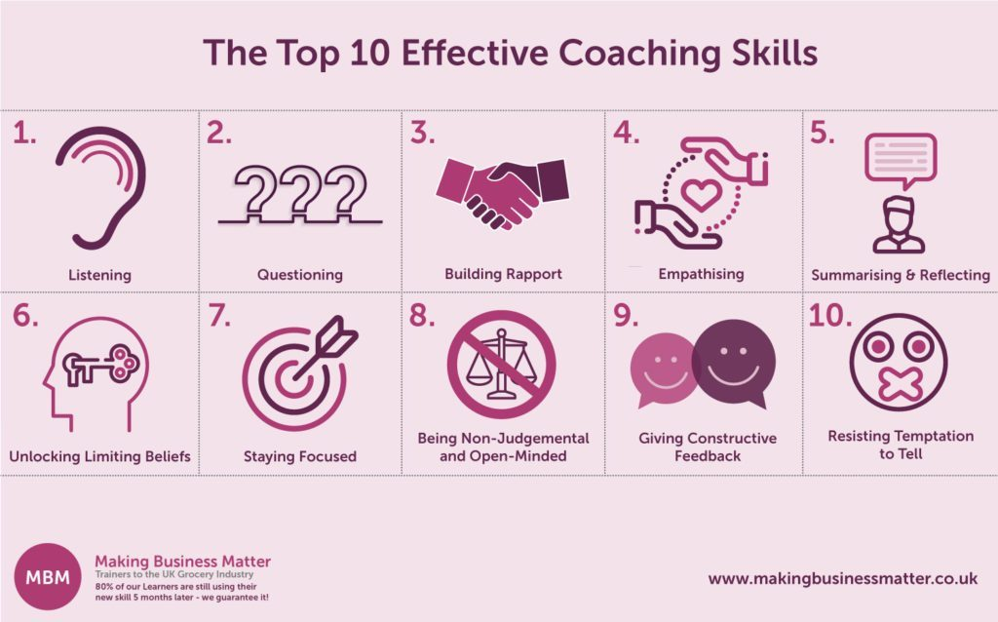
Figure: Top 10 effective coaching skills

To analyze the behaviors, beliefs, values, attitudes, and skills of an effective mentor I have selected Antony Cromb who is the head of business integration at Sainsbury's. He leads several teams and plays varieties of roles at Sainsbury's successfully. He is working at Sainsbury for 10years and he was in the position of head of the strategy from 2017-18.

Antony Cromb

- A critical analysis of his skills, behaviors, attitudes, beliefs, and values of Antony Cromb are as follows:
He has a strong ability to build relationships and trust. He likes to communicate high expectations and has faith in the abilities of his subordinates. He does not like to compare personally and avoids jumping in. He often likes to relate things with realistic expectations.
He has a strong ability to frame the coaching process. He believes in the willingness of his people, focuses on a two-way commutation process, and sees coaching as something other than training (Sainsbury's 2019).
He can set SMART goals and targets. He encourages participation while setting organizational and individual goals. He believes that it encourages intrinsic motivation and engagement of the employees.
He has special skills to identify and analyze the potential areas of coaching. He has coaching experience as well as like to get feedback from the employees. He describes feedback differently. He believes that negative feedback is the start of working and positive feedback can be the point of stopping. He considers individual needs while coaching and likes to provide homework in the coaching session. He often asks the individual to summarize the issues, problems, and challenges. It helps him to clarify the situation and tasks.
He also can conduct effective coaching conversations. He avoids coaching during the poor moods of the people and avoids over-planning, negatives, and over-rehearsing during coaching sessions. But he encourages asking questions, acknowledges the achievements, and to think back to the experience for future success.
Finally, he can deal with resistance and defensiveness. He never assumes that the individuals’ reluctant and nervousness are the sign of resistance and defensiveness. He explains it as cultural and behavioral differences. He also likes to lead by example.
- Beliefs and attitudes of Antony Cromb
He always likes to be positive even in challenging situations. He enjoys taking challenges and pressures. He has a positive physical self-content. He likes to take the good things and behavior of his people. He has self-confidence and enjoys learning from mistakes. Integrity, Sincerity, and determination are the most prominent characteristic of his behavior (Sainsbury's 2019).

Organizational, operational, and individual barriers in coaching and mentoring at Sainsbury and the ways to overcome it
Maheshwari, (2019) described some key organizational barriers to coaching and mentoring. According to him, organizational barriers to coaching and mentoring are time and resources, lack of experience, resistance, low level of skills, complicated risk-reward strategy, organizational culture, lack of prioritizing, and over-complicated organizational techniques. Thus I have found the following barriers at Sainsbury to coaching and mentoring:
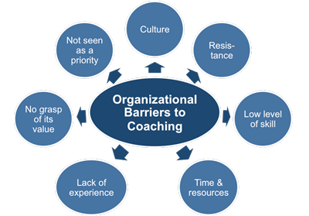
Figure: Organisational barriers to coaching and mentoring
Source: (Olta, 2019)
- Complicated risk-reward philosophy
There is a difference in perception among the employees in Sainsbury. Besides, organizational needs are different from personal needs. Sainsbury also tries to allocate limited resources efficiently (Bureau, 2018). But the task is quite complex to rise required coaching and mentoring programs. As a result, the complex risk-reward system at Sainsbury works as a barrier to coaching and mentoring. To overcome this barrier, Sainsbury should design an integrated risk-rewards strategy that best suited to the individual and organizational objectives.
- Cultural differences
A human resource base of 187,000 is a complex challenge to manage. They are from different cultures and backgrounds. Their needs and perceptions are also different. As a result, developing a common coaching and mentoring strategy for this diversified human resource creates barriers to Sainsbury. To overcome this challenge, Sainsbury can classify their employees according to different cultural backgrounds and should promote positive workplace culture. Besides, they should take cultural diversity as their strengths and use it for innovation.
- Time and resource insufficiency
Coaching and mentoring requires skilled and experienced employees. But they are not sufficient enough to meet all the coaching and mentoring requirements at Sainsbury. Besides, it requires much time to coach employees. The opportunity cost of coaching can be higher than the benefits. As a result, Sainsbury has to think and rethink about different coaching and mentoring strategies. They can apply proper time and resources management tools and techniques to reduce mistakes and misuse of time (Kelly, 2019).
- Lack of understanding the value of coaching and mentoring
Due to the complexity of the cost-benefits of coaching and mentoring, several managers argue against coaching and mentoring. They also have weaknesses in the traditional training and development process. Sainsbury can promote the benefits of coaching and mentoring to the managers who are not aware of the benefits of coaching and mentoring. It can reduce traditional biases as well.
Besides, wrong priorities and coach centered rather than coachee centered behavior also create barriers to coaching and mentoring at Sainsbury.

Individual barriers to coaching and mentoring and ways to overcome
Individuals at Sainsbury also have some barriers to coaching and mentoring. Most of the barriers come from the differences in their competency level, background, and cultural differences. Their beliefs, values, and attitudes are also different from each other. Designing a coaching and mentoring program separately for each level of employees is costly as well as time-consuming (Holliday, 2015). So, the differences in individual perceptions, behaviors, backgrounds, competencies, values, attitudes, and cultures at Sainsbury also create barriers to coaching and mentoring. The best ways to overcome these challenges are the emotional intelligence and execution excellence of the coach and mentor. Constructive coaching and mentoring structure and approaches with the proper selection of coaching strategies can reduce individual barriers to coaching and mentoring at Sainsbury (Kelly, 2019).
Besides, there are different types of individuals who have different levels of motivation. Sometimes they are directed or less-directed and sometimes they are self-directed as well. Regarding this, coach and mentor at Sainsbury can use the following tool to overcome the barriers to coaching and mentoring.

Application of Appropriate Framework for Coaching and Mentoring at Sainsbury
- Identifying the coaching opportunities
Organizational and personal development is a continuous process. Sainsbury is currently holding the second position in the retailer in the UK. Still, they have potential opportunities for development. They can further develop and improve the efficiency of their employee base. They have coaching opportunities in the area of increasing commitment, loyalty, confidence, skills base improvement, and performance improvement. They should design their coaching objective considering these opportunities.
- Determining the objectives of coaching
There are different types of coaching like modeling, instructive, inspirational, enhancing, and problem-solving. Each type of coaching has different objectives. A coaching plan should be incorporated with a clear understanding of the objectives (Bureau, 2018).
Situational review/current reality
Traditionally Sainsbury likes to take challenges and encourages innovation. Coaching can be a very effective tool for that. But they should evaluate their current position critically. Internal and external analysis can be the best approaches to evaluate the current reality of Sainsbury (Kelly, 2019).
- Timing and steps
In this section, if the coaching plan Sainsbury should focus on the estimated period requires exploring the coaching objectives. They can use a work breakdown structure for the efficient allocation of time for every single step. They should encourage virtuous learning and focus on building relationships as well.
- Applying coaching tactics
To develop coaching tactics proper understanding of the team members is very crucial. To understand team members there are different mind-tools is available. Below tool is used to understand employees:
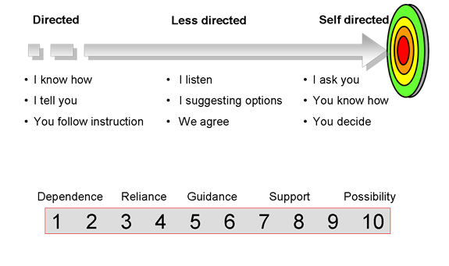
In general, self-regulated people have a strong sense of positivity and highly connected with the task.
- Developing quality questionnaire
After understanding the people, the coach needs to develop a quality questionnaire for higher engagement during the coaching session (Olta, 2019). The questionnaire should be simple, should have a purpose, can have an open or hidden agenda, and should influence the learning.
Then the coach should focus on effective conversation with the employees. A useful conversation should incorporate the following stages:
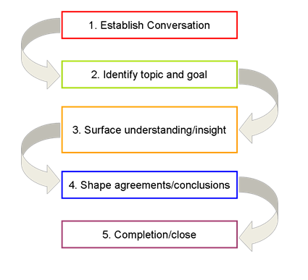
- Monitoring the progress
To monitor the performance of the employees we need to develop a benchmark performance standard. For this Sainsbury can develop two identical groups. Performance of the control group can be compared to the absolute group to understand the progress. There should have a continuous feedback loop to improve the below standard performance.

- Review the outcomes
After getting the outcomes from the coachee, the coach should evaluate it. It the performance matches with the expectation they can retain it. The coach should also encourage the coachee for further learning and can set further challenges (Olta, 2019).

Conclusion
Coaching and mentoring has become very effective tools for developing and improving employees where coaching incorporates the short term goal and mentoring incorporates the long term goals (Holliday, 2015). These development approaches show their excellence during the challenging events. As a result, coaching and mentoring is different from traditional training. Sainsbury has started using numerous coaching and mentoring tools. They have brought tremendous success in the recent year. Thus this report has explored the benefits of coaching and mentoring from both the perspective of the organization and individual. The analysis of an effective coach at Sainsbury has explored some crucial skills like building trust, effective planning skills, giving continual feedback, effective communication of the purposes, and self-awareness/ sensitivity. Later the application of different models and frameworks at Sainsbury shows the effectiveness of coaching and mentoring in the current competitive business world. Further, they can focus on the continuous improvement processes to make them further efficient in using coaching and mentoring tools.

References
Bureau, D. and Lawhead, J. (2018). Assessing Student Leadership Development From Mentoring, Coaching, and Advising. New Directions for Student Leadership, 2018(158), pp.73-85.
Garvey, R; Stokes, P, and Meggison, D (2011) Coaching and Mentoring: Theory and Practice, Sage London
Guilds, C. (2019). Sainsbury's Accredited Training Programme case study | City & Guilds. [online] Cityandguilds.com. Available at: https://www.cityandguilds.com/news/february-2015/sainsburys-retail-case-study#.XT7ViOgzbIU [Accessed 29 Jul. 2019].
HAMPTON, G. (2016). PRACTICAL GUIDE TO MENTORING, COACHING, AND PEER -NETWORKING. [Place of publication not identified]: ROUTLEDGE.
Hargreaves, E. (2010). Knowledge Construction and Personal Relationship: Insights About a UK University Mentoring and Coaching Service. Mentoring & Tutoring: Partnership in Learning, 18(2), pp.107-120.
Hargrove, R. (2008). Masterful coaching. San Francisco: Jossey-Bass.
Hawkins, P. and Smith, N. (2013). Coaching, Mentoring And Organizational Consultancy. Maidenhead: McGraw-Hill Education.
Holliday, M. (2015). Coaching, mentoring & managing. Petaling Jaya, Malaysia: Advantage Quest, Publications.
Kelly, R. (2019). Sainsbury's celebrates Black History Month. [online] About.sainsburys.co.uk. Available at: https://www.about.sainsburys.co.uk/making-a-difference/our-values/our-stories/2017/sainsburys-celebrates-black-history-month [Accessed 29 Jul. 2019].
Maheshwari, R. (2019). Soft Skills - Coaching & Mentoring. [online] YouTube. Available at: https://www.youtube.com/watch?v=ngTPeNdIWAE [Accessed 29 Jul. 2019].
Megginson, D. (2002). Mentoring. Bradford: Emerald Group Publishing.
Olta, C. (2019). Colleague engagement. [online] About.sainsburys.co.uk. Available at: https://www.about.sainsburys.co.uk/making-a-difference/our-colleagues/colleague-engagement [Accessed 29 Jul. 2019].
Pask, R. and Joy, B. (2007). Mentoring & Coaching. Maidenhead: McGraw-Hill International (UK) Ltd.
Sainsbury's (2019). Sainsbury's. [online] Sainsburys.co.uk. Available at: https://www.sainsburys.co.uk/ [Accessed 29 Jul. 2019].
Services, I. (2019). Effective Coaching Skills. [online] YouTube. Available at: https://www.youtube.com/watch?v=KFGXBDfOUQI [Accessed 29 Jul. 2019].

