Entrepreneurship

Table of Contents
Introduction 2
Business Description (Green Home Construction) 4
Industry Analysis 5
Competitive Analysis 7
Operations and Management Team Plan 8
Marketing Plan 10
Financial Plan 11
Market Research 12
Conclusion 13
Reference List 14

Introduction
Entrepreneurship is connected or associated with starting a new venture or enterprise. This report discusses the business plan for the construction company Green Home Construction. The company will deal in building residential and institutional buildings. It will first start with building housing complexes or buildings for its customers in London and nearby cities. The company also deals in renovation. The report discusses the industry and competitive analysis for the construction industry. Further, it examines the Operations and Management Plan of Green Home Construction. The management team will comprise finance, marketing, legal, and human resource departments.

Business Description (Green Home Construction)
Green Home Construction will be incorporated as a small-scale company in the construction industry (Massa et al., 2017). The company will deal in building residential complexes and institutional buildings. The company will be headquartered in London, the United Kingdom performing its business operations with the employment of 200 employees at most.
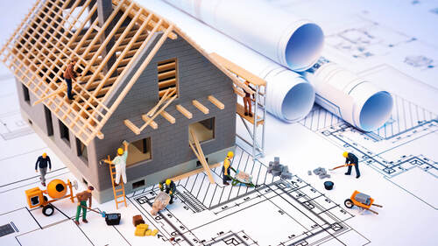
Source: (Massa et al., 2017)
Mission: The Company wants to provide accommodations to its customers that best suit their personalities and characteristics and provide the feeling of home on the first visit
Vision: Green Home Construction's main vision is to provide its customers with the same experience that will exceed their expectations.
Products and Service: The main aim of the company is to design, build, manage, and construct the entire process of building new homes in London and nearby cities (Henriques et al., 2022). On the contrary, institutional construction is linked with projects that assist in the formulation of educational buildings, healthcare buildings, institutional buildings, research buildings, and so on.
Green Home Construction is a company that would be built on the heritage and feeling of loving homes. The architectural designs and internal infrastructure will be in first consideration with the customer’s requirements. If the plans strategized by the company are effectually achieved, Green Home Corporation will expand its operations across the United Kingdom and nearby countries.
Legal Structure of the Company (Green Home Construction)-
The legal structure of the organization is stated as the company framework in which Green Home Construction will perform its operations (Mohseni et al., 2022). It could also be regarded as the organizational structure, business structure, or legal structure that is dependent on the size and nature of the company. The legal structure of Green Home Construction is in the process of operating as a Partnership firm. Operating a business with huge responsibilities in the residential sector requires careful thought and consideration. With a partnership firm, the owners of the company will form a partnership deed deciding all the terms and conditions of the company beforehand (Xu et al., 2023). It will assist in reducing any further disputes in the management of the company. Green Home Construction will be headquartered in London, the United Kingdom.

Industry Analysis
The Construction industry in the United Kingdom could total $467.8 billion in the year 2022 and has been expected to rise in the market share by around 2 percent by the year 2027. However, it includes construction in all aspects of the economy from transport, energy, housing, health, and education infrastructure projects (Massa et al., 2017). Also, the enhanced demand for obtaining new housing and the recovery from the COVID-19 challenge has supported the growth of residential construction. With the attainment and building of a new residential complex, renovation, and refurbishment has depicted quick growth. However, it is forecasted that people need to bear high rates of interest in the upcoming period. Thus, residential construction may demonstrate a fallback in the year 2023 (Akundi et al., 2022). But, in the upcoming years, it is expected that the government could invest in housing projects that will reflect growth momentum from the year 2025. Also, the investments could be recognized in energy-efficient residential buildings and structures. The institutional construction could be seen with a positive outlook that will help to depict a rise in the gross value of projects for the construction of education and healthcare buildings (Xu et al., 2023).

Porter Five Forces Model
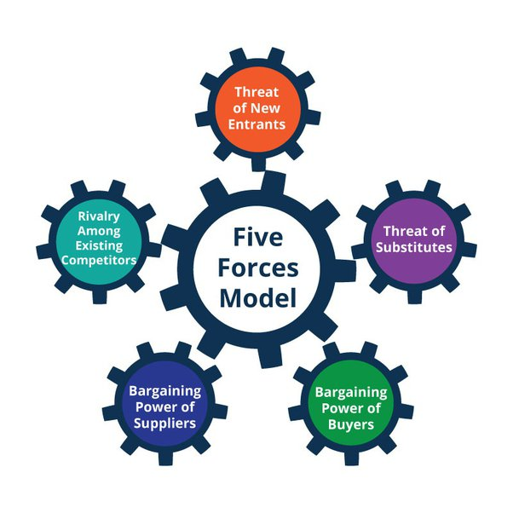
Source: (Mohseni et al., 2022)
- Threat of New Entrant: In the construction industry, new entrants arrive in the market and are willing to acquire the market share. This industry accelerates tough competition while it brings down profitability (Sutrisna et al., 2022). New entrants need to register and obtain government contracts. Green Home Construction identify that new entrant brings barrier and opportunities while entering the market.
- The Power of Supplier: The Construction industry is supplier-dominated and dealt with construction materials. Moreover, the construction material cost is often high due to currency devaluation and inflation (Xu et al., 2023). Suppliers have power is a critical force in the competitive construction industry. Green Home Construction supplier has spread their power drastically in the construction sector.
- The Power of Buyer: In this industry, the government mainly acts as a client or a market. It influences the demand of the construction industry through changes in fiscal and monetary policies (Mohseni et al., 2022). Moreover, clients in the construction industry influence the procurement and directly impact on contractor.
- The Threat of Substitutes: In the construction industry, it is not possible to substitute products or services (Akundi et al., 2022). There is limited or no direct substitute for the construction industry products. Nowadays, the robotic system is used by the construction industry to reduce the cost.
- Rivalry between Existing Competitors: Analyzing the fierce competition, though, is necessary for the company that help them understand the practices and policies of the competing companies (Massa et al., 2017). Some of the strong competitors in the house building industry are Persimmon Plc, Taylor Wimpey Plc, Barratt Development Plc, etc.
Name of Competitor | Differentiation
Persimmon Plc | It is one of the largest firms in the housing industry. The Company sold close to 10,000 homes i.e. show a huge progress, and immense success in the marketplace (Xu et al., 2023). The Company employed extensive product differentiation to crowd out competition.
Taylor Wimpey Plc | The Company differentiation in the long term focuses on value and achieves both financial and quality goals (Sutrisna et al., 2022). The Company is a customer-focused residential.
Barratt Development Plc | Barratt improves the user experience with a fully responsive design and increases the conversion rate (Akundi et al., 2022). The Company diversifies its products or services from competitors.

Competitive Analysis
The United Kingdom has a fierce competitive edge in the construction sector (Sutrisna et al., 2022). The country has world-class designers, architects, engineers, and developers who are associated with British companies contributing to the development and growth of the construction industry in a sustainable manner (Akundi et al., 2022). Also, the changes happening in the international economy affect the opportunities and threats for UK companies. So, the government is taking necessary steps to assist the economy to develop with the contribution of British businesses to grow, aspire, and drive competition in the global market. This also comprises funding for infrastructure projects and providing loan schemes (Xu et al., 2023). Green Home Construction will be a small enterprise so it needs time to reach the level of competition involved in dominating the market. The company plans to attain that level with effective performance and a good management structure that will ensure the company achieves good returns, builds loyal customers, and enhances its brand image (Sutrisna et al., 2022). The vision of the company is to develop residential buildings that will just feel like home and suit best the personality and characteristics of our customers.

Operations and Management Team Plan
Operations
In the construction industry, Green Home Construction mainly focuses on distinct types of operations like constructing, altering, repairing, extending, and demolishing (Massa et al., 2017). Apart from this, the Company focuses on cleaning buildings internally and externally in the course of their construction while repairing to improve the customer experience. It is essential for completing the other construction work within the estimated timeframe.
Management Team of Green Home Construction-
Human Resource Department: This department of the company is responsible for managing all the personnel in the entity. The human resource department ensures and handles matters associated with the hiring and selection of employees and manpower-oriented matters (Pandey et al., 2022). Green Home Construction will recruit a well-qualified and experienced human resource manager to perform the duties and responsibilities of the position. It is accountable for ensuring a healthy work environment in the organization and retention of the best candidates in the company. The department is also responsible for ensuring that day-to-day operations performed by employees are effectively performed (Sutrisna et al., 2022).
Finance Department: The finance department of Green Home Construction is accountable for managing the cash inflows of the company and investment decisions (Syapsan, 2019). All the money-associated matters are discussed in this department. The human resource department of the company has to connect with the finance department to manage the payroll system of the employees. The finance department of Green Home Construction develops the financial plans ensuring the optimum utilization of resources and allocation of funds within the numerous departments (Mohseni et al., 2022).
Marketing Department: One of the vital departments in the Green Home Construction company will be the marketing department (Lim, 2023). This department is held responsible for maintaining the brand image of the company and promoting its existence to a wide range of audiences. The marketing team is also responsible for performing market research helpful in identifying the target market. To expand its operations and attain growth, Green Home Corporation has to ensure that it develops an effective marketing strategy (Pandey et al., 2022).
Legal Department: This department in the organization is held to manage legal affairs and regulations (Goyal and Kumar, 2021). Establishing a company requires performing a lot of legal formalities, so it is required to maintain a legal department in the company. It will also help to safeguard the interests of the company from any fraudulent activity. The legal department will help ensure the company is protected from contingent risks and maintain good relations with the public and local authorities (Lim, 2023).

Marketing Plan
Product: Being a construction company, Green Home Construction helps build houses and institutional complexes along with providing renovation and development facilities. The services offered by the company include the efforts of the best employees (Sutrisna et al., 2022). The home construction products purchased and involved by the company will be of high quality that ensures the long-lasting and strong existence of the building. The purpose of building houses is mainly to provide a space to customers where they can feel relaxed and at home at the very first sight (Mohseni et al., 2022). The product of the company includes houses and infrastructure facilities and services include consultancy and design for the houses. Also, the accommodation built will ensure proper location, utilities, and availability of necessary places nearby such as schools, hospitals, and supermarkets.
Price: The price refers to the exchange value that will be received from the customers in exchange for the products provided. The price set will be by the contractor and client considering the raw materials used, labor efforts, location, internal infrastructure, and other factors. Also, it will be based on the size of the location, and the competitive environment in the marketplace (Lim, 2023).
Place: Place refers to the physical existence of the company. It includes the distribution aspects also comprising of company location and logistics, and others (Syapsan, 2019). The company is pondering establishing its headquarters in London, the United Kingdom. In residential construction, the company will either provide a location and could also develop houses on the locations provided by its customers. With an expansion in the market, Green Home Construction will connect with estate agents to look out for more suitable locations (Lim, 2023).
Promotion: The dimension of Marketing is the method through which the company will inform about its existence to the consumers (Goyal and Kumar, 2021). To grow and expand, the entity must increase its target market with the assistance of promotion and increase brand awareness. Green Home Construction will promote the company through Social Media platforms and traditional advertising methods such as newspapers and television (Syapsan, 2019).

Financial Plan
Financial Planning for Green Home Construction is effectively ensured with strategic financial management. This will help ensure all the departments at the company will stay on track concerning the availability of financial resources (Goyal and Kumar, 2021). With effective financial management, the finance in charge of the company will be provided with data that will help in forecasting long-term plans for the entity. Also, it will aid in ensuring the investment decisions, liquidity, profitability, cash inflows of the company, and more (Syapsan, 2019). As a small company, the company will seek advice from an expert financial planner ensuring effective resource and finance movement in the company within various departments.
 | Month 1 | Month 2 | Month 3 | Month 4 | Month 5 | Month 6
Revenue | 10,000 | 15,000 | 20,000 | 22,000 | 24,000 | 26,000
Fixed Costs | 4,000 | 4,000 | 4,000 | 4,000 | 4,000 | 4,000
Variable Costs | 3,200 | 4,500 | 6,000 | 8,500 | 7,560 | 12,400
Profit | 2,800 | 6,500 | 10,000 | 9,500 | 12,440 | 9,600

Financial planners who will welcome customers will also help to guide the customers regarding the investment decision for their new houses maintaining trust and healthy relationships with customers. The company must identify its permanent source of cash inflows and expenses classifying them into fixed and variable (Goyal and Kumar, 2021). Green Home Construction also needs to ensure that the financial plan of the company aligns with the overall goals and objectives of the company. It has to ensure proper fund allocation for marketing and human resource departments. The finance department of Green Home Construction will ensure the ethical and legal movement of the company's investment and cash flows (Lim, 2023). Financial Statements of the company will depict Balance Sheet, Cash flow statements, and Income statement.
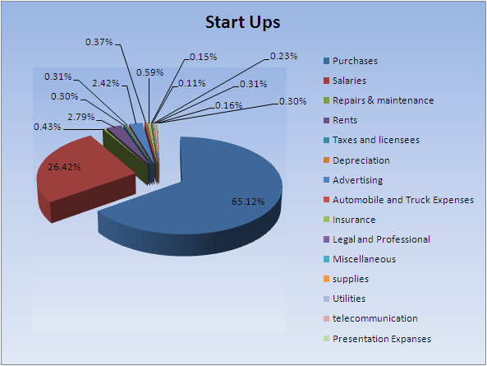
Source: (Goyal and Kumar, 2021)

Market Research
The key construction industries in the United Kingdom are associated with residential construction, commercial construction, institutional construction, and so on. The residential construction includes the building and development of single-housing families and multi-housing families. It was observed that this industry reflected high growth in recent years due to the availability of loans with low interest rates (Henriques et al., 2022). Searches for living building materials have increased by 1,100% over the last decade. Nowadays, the construction trend includes BIM, construction robotics, and advanced materials to improve quality as well as the experience of customers.

Conclusion
Green Home Construction will perform its operations in London, the United Kingdom. The report discusses the business plan that states the incorporation of the construction company. The competition is highly fierce in the United Kingdom. Green Home Construction needs to analyze its competitor’s strategies and patterns to maintain its position in the marketplace. The company might be operating as a partnership firm. Further, the report continues with the marketing plan that examines the 4Ps of Green Home Construction. The company will determine its product prices based on the resources utilized and the competitive company's price range. It will promote its brand with social media and traditional marketing methods. Lastly, the report discusses the financial plan for the company.

Reference List
Akundi, A., Euresti, D., Luna, S., Ankobiah, W., Lopes, A. and Edinbarough, I., 2022. State of Industry 5.0—Analysis and identification of current research trends. Applied System Innovation, 5(1), p.27.
Goyal, K. and Kumar, S., 2021. Financial literacy: A systematic review and bibliometric analysis. International Journal of Consumer Studies, 45(1), pp.80-105.
Henriques, P.L., Matos, P.V. and Jerónimo, H.M., 2022. Eager to Develop Sustainable Business Ideas? Assessment through a New Business Plan (BP4S Model). Sustainability, 14(2), p.1030.
Lim, W.M., 2023. Transformative marketing in the new normal: A novel practice-scholarly integrative review of business-to-business marketing mix challenges, opportunities, and solutions. Journal of Business Research, 160, p.113638.
Massa, L., Tucci, C.L. and Afuah, A., 2017. A critical assessment of business model research. Academy of Management annals, 11(1), pp.73-104.
Mohseni, S., Brent, A.C., Kelly, S. and Browne, W.N., 2022. Demand response-integrated investment and operational planning of renewable and sustainable energy systems considering forecast uncertainties: A systematic review. Renewable and Sustainable Energy Reviews, 158, p.112095.
Pandey, A.K., Singh, R.K., Jayesh, G.S., Khare, N. and Gupta, S.K., 2022. Examining the Role of Enterprise Resource Planning (ERP) in Improving Business Operations in Companies. ECS Transactions, 107(1), p.2681.
Sutrisna, M., Ramnauth, V. and Zaman, A., 2022. Towards adopting off-site construction in housing sectors as a potential source of competitive advantage for builders. Architectural engineering and design management, 18(3), pp.165-183.
Syapsan, S., 2019. The effect of service quality, innovation towards competitive advantages and sustainable economic growth: Marketing mix strategy as mediating variable. Benchmarking: An International Journal, 26(4), pp.1336-1356.
Xu, Y., Tao, X., Das, M., Kwok, H.H., Liu, H., Wang, G. and Cheng, J.C., 2023. Suitability analysis of consensus protocols for blockchain-based applications in the construction industry. Automation in Construction, 145, p.104638.

