MODULE CODE/ COD Y MODIWL: BMSK4002

Report Title: Effective Communication in Willow Bank Residential Care Home

Student Name:Tahmina Sharmin
ID: 1816429
Module Name: EFFECTIVE TEAM WORKING & COMMUNICATION
Lecturer’s Name: Benedict Mabu
Date: 26/08/2019

Table of Contents

Introduction………………………………………………………………………………………….…… 03
Types of Communication……………………………………………………………………………. 03
Models of Communication…………………………………………………………………………. 07
Methods of Successful Communication………………………………………………………… 09
Conclusion…………………………………………………………………………………………………… 10
References…………………………………………………………………………………………………… 11
Appendix………………………………………………………………………………………………………..12

Introduction:
Communication is a means of conveying one’s emotions and thoughts to others. It is the art of letting others know about the matters going on in one’s mind and create a bond through delivering the message (Roy, 2010). The act of communication may be done either verbally or non-verbally. It can be indicative or expressive, written or spoken depending on the person’s choice. Communication is the pathway that clears the bridge between individuals by expressing their words. Therefore, making a clear communication and knowing the proper means of communication is of utmost importance. An understanding of proper means of communication makes life easier both in personal and professional lives. Thus this course conducted on communication helped me in understanding how to picturize my thoughts into words and convey it to others. This also helped me in my workplace, Willow Bank Residential Care Home, a care home for people with dementia. In dementia people tends to forget things, thus they need to be handled with care and a proper communication is the best way to help them recall things and maintain a normal life. Thus learning about the different ways of communication from this course and using them in my real life helped me really do better in real life.
Types of Communication:
The messages one wants to convey can be delivered in many ways. Communication is of various types based on the way the message can be best delivered by the person delivering and understood by the recipient. Thus a proper choice of the mode of communication is very important in real life and specially in the workplace. There are three main types of communication. They are:
- Verbal Communication
- Non-verbal Communication
- Written Communication

Verbal Communication:
Verbal communication is the communication between individuals by delivering speech. Here the thoughts, ideas, perceptions and knowledge of the sender is delivered by speaking (Collins, Anne, Diamond and Burke, 2011). It is the most common way of communication. Our class lecture gave us a clear elaboration of verbal language where it said that verbal communication is simply the things we say. Some great personalities like, Nelson Mandela, Martin Luther king and John F Kennedy were great at verbal communication and made it their strength throughout their lives in order to achieve their goals. It is very important in workplace. In Willow Bank Residential Care home, I need to use verbal communication. My class lectures helped to make my verbal communication better in my workplace. For example, Whenever, I talk to a new client I greet them with a very polite tone. I talk in a very friendly and welcoming manner in order to make them feel comfortable in the care home. Not only that, I also follow the things learnt in the class while talking to my seniors in the workplace. I have to report the daily works to my seniors every day and they had chosen me for this for my confident way of verbal communication with everyone. I try to convey all my messages in clear and simple way that is understandable by all. Not only that, the knowledge of proper communication helps me to distribute duties to my juniors in the workplace. Mostly, I always keep in mind the tone I need to use while communicating. And a good communication skill made a very good leader in my workplace and I can smartly explain their duties and assign them with their daily rosters.

Non-verbal Communication:
Non-verbal communication is the way of delivering one’s message, thoughts and ideas without actually saying anything. It is a way of communication through signs and signals. It can be through facial expressions, eye movement, body posture and so on (Ekman, P., 2003). . This is one of the most important and used means of communication. In non-verbal communication people conveys their emotions without making a noise. When a baby is born they first learns to make nonverbal communications and then gradually learns verbal communication as they grow. Non- verbal communication was beautifully explained in our class and this helped me to a great extent in my workplace from the very beginning starting from my interview. In class I was taught the importance of my body posture and that it would speak for me. And to my utmost wonder this proved to be right. As I learned dressing beautifully and formally, and a having confident smile with a smart look would convey the message that I am not scared and ready for the interview, I did so on that very day. I sat with a formal posture and without saying a I was praised for my gesture. Before starting to question me, my interviewers were already impressed and then I understood how important non- verbal communication is.
Not only this, this is the language understood by all, even by animals. Animals can read expressing even though they cannot understand our language. I have a pet dog named Snowy. Whenever I wave at him he understands that I am calling him, if I narrow my eyes he understands that I am angry. Such non-verbal communications were also taught in class with picture visualisations. It helped us to understand different expressions and emotions without any spoken or written words. But there are also some drawbacks of non-verbal communication. Many times we tend to trust expression way too much. In class we were taught that a person speaking lying will not look eye to eye, will sweat or tremble. But in many cases it does not occur. Thus a clear understanding of non-verbal communication and evaluating it before accepting it completely is extremely important.

Visual Communication:
Visual communication is the communication conducted by showing various gestures. It is a way of expressing thought through visual representation and understanding through the signals received. For example, the traffic signal is the best representation of visual communication. In workplace a thumbs up to the patients makes them feel positive and a hug makes them feel like home. These gestures, without even saying a work does my work in the workplace and helps me acquire a better place there.

Written Communication:
Written Communication is the means of delivering message in a written format. Here the sender writes the message, their thoughts in various ways to express themselves and the receiver reads it to derive its meaning. Written communication is very important in workplaces thus our class lectured emphasized deeply in written communication and taught us the best way to communicate in written form. Examples of written communications includes our class lectures where our professor beautifully conveys his knowledge to us in class. Not only this, in workplace, it is the route that helps us get the job. That is, a professional and impressive CV along with a good cover letter helps us get a call for the job. Further, in my workplace, the Willow residential care home, I need to communication by writing every day. I need to send e-mails to the suppliers about new products, post advertisements on social media, write formal letters, applications and mostly maintain a register to keep a record of all the daily activities. All this means of communication was taught in our class.
The various types of written communication are used every day and each have their own type of representation and unique type of use. The materials provided in class help me learn how to do it correctly and what materials to include in my written communication. Written communication can be formal or informal write for external or internal recipients. Thus the choice of type of writing is made based of it. I often use letters and applications for formal communication in the Care home, make reports of the monthly activities of the care home and make memos for the daily works. To make my communication I use simple languages, paragraphs, proper grammar and punctuations as taught in my class. I also avoid tautologies and clichés in my writing to make my communication clearer and easier to understand.

Formal and Informal Communication:
Formal communication is the via of communicating in an official way. It can be through written communication like letters, emails, reports or verbal communication in the form of meeting. It is most used in workplace while setting policies or among strangers.
Whereas, informal communication is a casual form of communication. Advantages of informal communication is that it enables people to communicate freely without any boundaries. It is an open door communication.

Models of communication:
Conveying a message follows some a general cycle that is a sender send the message and a receiver receives the message and sends a feedback. Models of communication have been made to make understanding communication easier. There are three main models of communication. They are:

- The Shannon-Weaver Mathematical Model 1949:

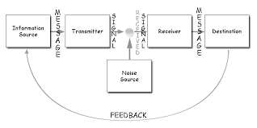
This model is considered to be the mother of all communication models. Here, an encoder (sender) sends the message through a channel (the medium used for sending message) to the decoder (machine)to the destination (the receiver) (Littlejohn, S.W. and Foss, 2008). The channel is sometimes interrupted by a noise (sounds from environment) that interrupts the message to be send to the receiver. But it is more useful in person to person communication rather than among groups. For example, in my workplace, the Willow Residential Care Home I need to communicate with many clients every day, using this model I always care for the external noise and take feedback from the clients to be sure that they understood all the messages I conveyed.
- Berlo’s Model of Communication
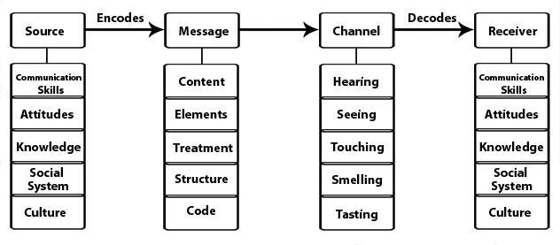
This model has 4 main components. It has a sender, channel, message and a receiver. The sender sends a message through the channel and it is received by the receiver (Schulz, Peter and Paul, 2013). It mainly focuses om the fact that the message is encoded by a source before it is send by the sender and decoded by a channel before received by the receiver. The drawback of this models that it has no scope for feedback.
- Schramm’s Model of Communication
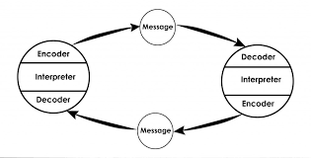
According to this model the communication is a two-point pathway. It is made up of a receiver and a sender and an interpreter (Schulz, Peter and Paul, 2013). It picturizes the communication in a more practical way. But the drawback of this system is that it does not focus on external noise that would interrupt the interpretation. While I send emails I use this model the message is encoded by the computer before sending and the decoder from the other side decodes the message before the receiver receives it.
The lectures discussed in class helped me understand the models of communication well and use it efficiently in my workplace for the best employee outcome.

Method of Successful Communication:
We all know that communication is a means of conveying message but in order to convey the message correctly and to make the receiver receive it correctly knowing the ways of making a communication successful is a must. A good communication can make oneself a good employee and help to obtain a good position in a workplace. Making a communication successful requires only 5 basic steps as taught in our classroom. First, it is important to tell everything about a brand to the employees as they can communicate about it to others (Nageshwar and Rajendra, 2014). A clear discussion about all the features to the clients is also very important. Secondly, we need to use the right tone with the right person. Thirdly the message should be conveyed in the simplest and in the easiest to understand format. Next, and the last two most important parts of a successful communication is to take feedback from the opposite person and be a good listener while the other is conveying their message. All this knowledge obtained in class help me in the Willow residential care home. Thus once the discussion is over it is important to take feedback. Like, in the care home, as soon as I have completed speaking to a new client about our residential home I ask them about their opinion and try to understand from their expression the nonverbal feedbacks they have on their face (Ekman, P., 2003). Not only that, I consistently talk to the residents of the care home in a very gentle manner to give them a homely feeling and take their feedbacks which helps me understand if everyone is getting the best service or not. These communication skills helped me make the care home a better place for its residents.

Conclusion:
Lastly, it can be concluded by saying that, communication is one of the most important tools in our everyday life. No matter whether the communication is made verbally, non-verbally or in a written format only a proper understanding of communication can lead to a successful communication. The knowledge I received from class not only helped me understand communication but also helped me to become one of the best employees in my workplace.

References:
- Lauren G. Collins, Anne Schrimmer, James Diamond, Janice Burke
- Evaluating verbal and non-verbal communication skills, in an ethnogeriatric OSCE
- Patient Education and Counseling, Volume 83, Issue 2, 2011, pp. 158-162
- Ekman, P. (2003). Emotions revealed: Recognizing faces and feelings to improve communication and emotional life. New York: Times Books
- Argyle, Michael; Veronica Salter; Hilary Nicholson; Marylin Williams & Philip Burgess (1970). "The communication of inferior and superior attitudes by verbal and non-verbal signals". British Journal of Social & Clinical Psychology. 9 (3): 222–231.
- Littlejohn, S.W. and Foss, K.A. (2008). Theories of human communication, 9th edition. Belmont, CA: Thomson Wadsworth.
- Schulz, Peter. Cobley, Paul. (2013). Theories and Models of Communication. Berlin: De Gruyter Mouton. 2013.
- Nageshwar Rao, Rajendra P. Das (2014), Communication skills, Himalaya Publishing House, 9789350516669, p. 48
- Roy M. Berko, et al., Communicating. 11th ed. (Boston, MA: Pearson Education, Inc., 2010) 9–12

Appendix
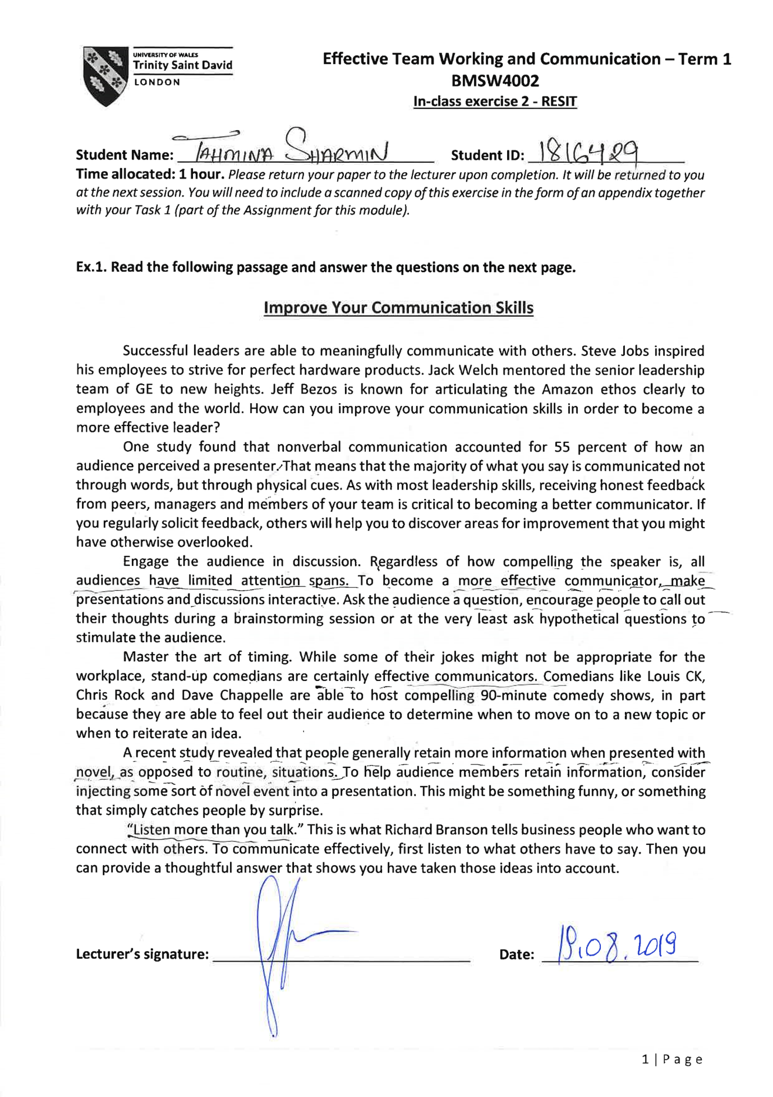
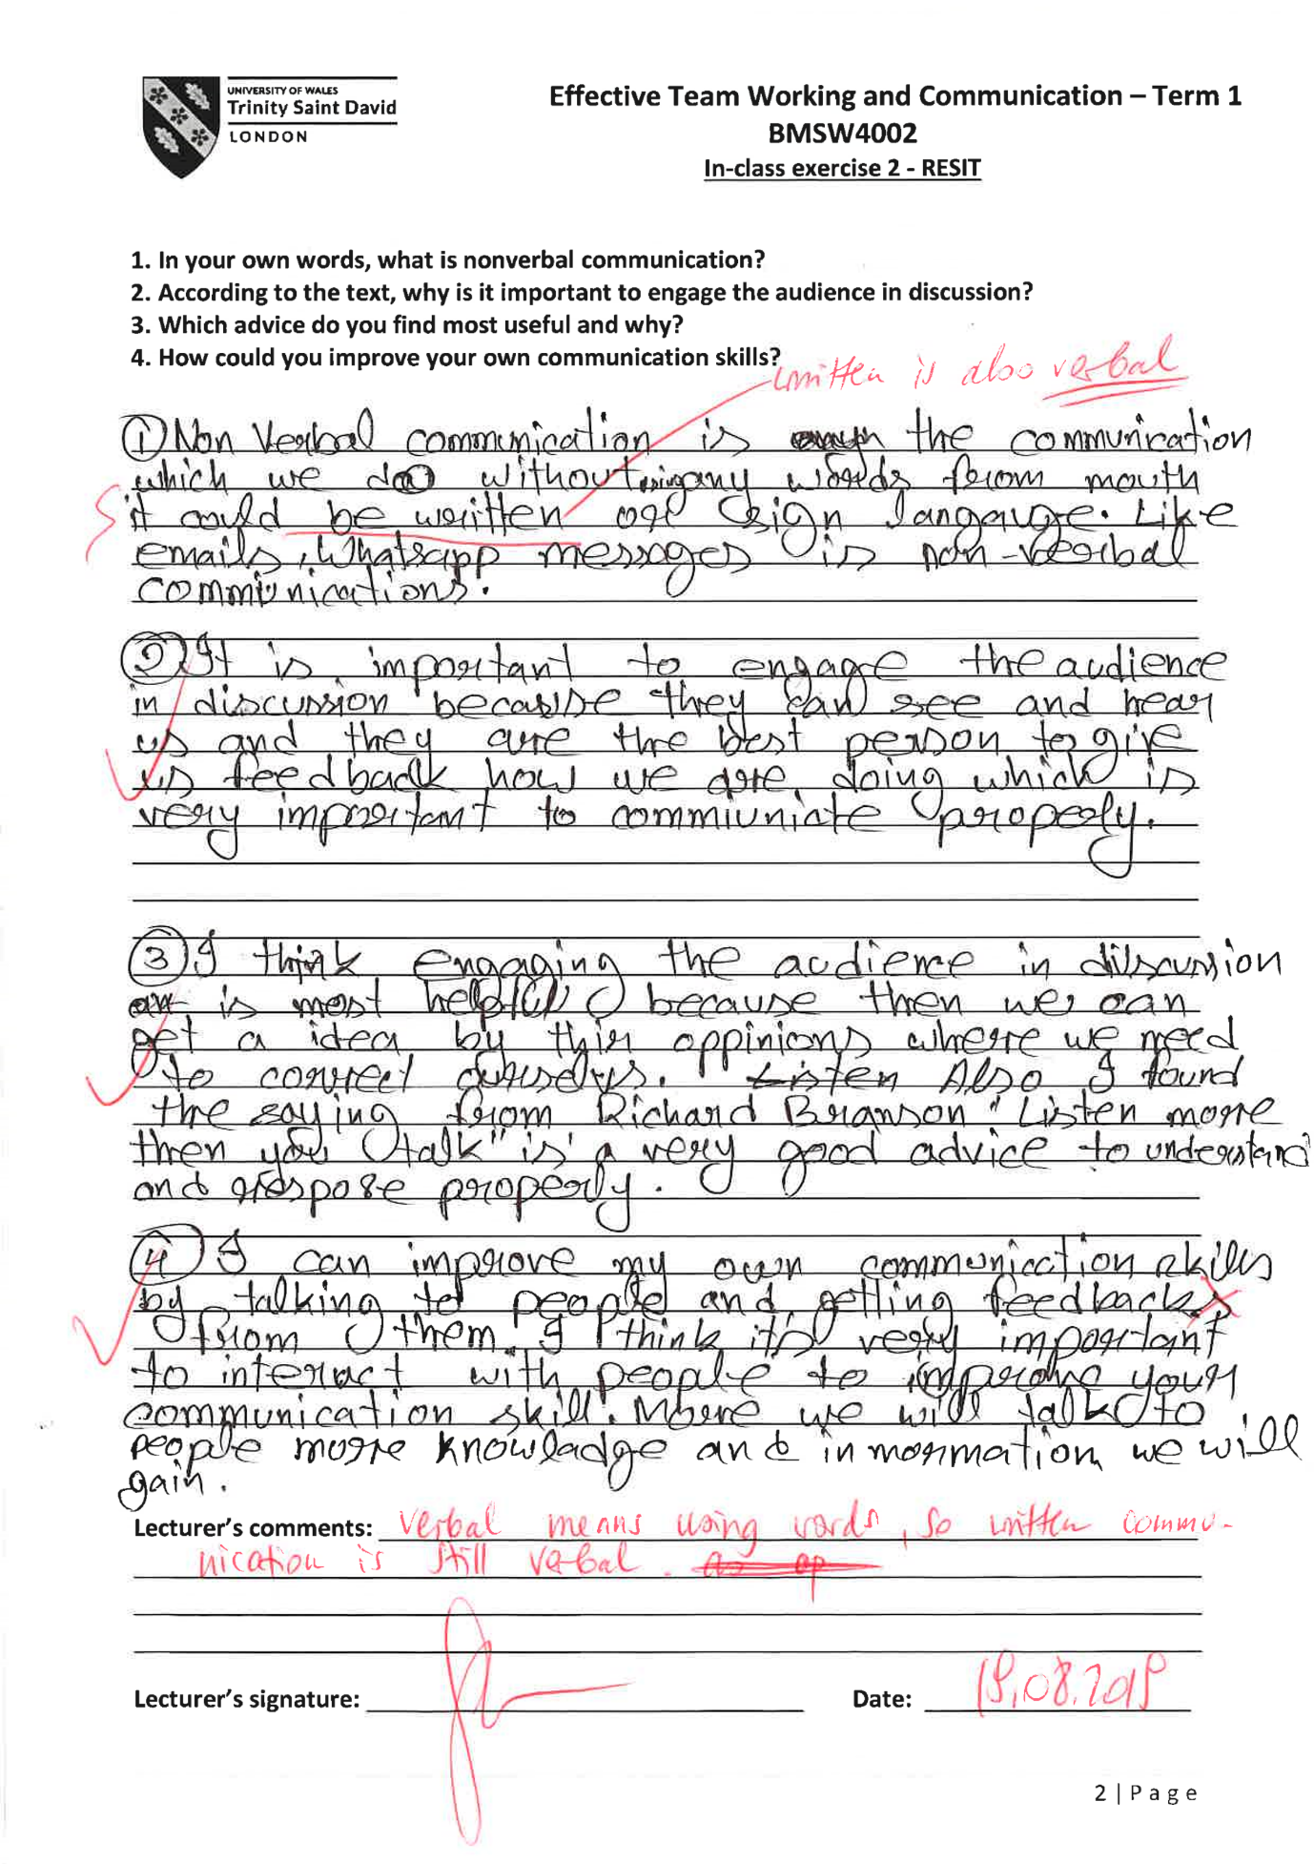

df

