

Assessment Component 2: Marketing Portfolio

Programme : Master of Business Administration
Student Name: MD SOHIDUL ISLAM
Student ID:2504070
Module Name: Marketing Management
Module Code: LCMB7024
Lecturer’s Name: Dr Tushara Balendran
Word Count: 2500
Group :3 , Term 1
Date of Submission: 17th December 2025

Table of Contents
1. Introduction 3
2. Element 1 – STDP Analysis 4
2.1 Company Background & New Brand Concept 4
2.2 Segmentation Analysis 5
2.3 Targeting Strategy 5
2.4 Differentiation Strategy 6
2.5 Positioning Strategy 6
3. Element 2 – Marketing Mix (4ps) 7
3.1 Product Strategy 7
3.2 Price Strategy 8
3.3 Place Strategy 9
3.4 Promotion Strategy 9
4. Element 3 – Marketing Strategy Pitch 11
5. Element 4 – Reflection 12
5.1 Description 12
5.2 Feelings 13
5.3 Evaluation 13
5.4 Analysis 13
5.5 Conclusion 14
5.6 Action Plan 14
6. Conclusion 16
7. References 17

1. Introduction
The Body Shop is an international brand of ethical beauty retailer that specialises in natural ingredients and high sustainability principles. This portfolio presents its new brand line, the Harmony Steam Diffuser, which is spreading the company into the smart home-wellness area. Smart diffusers are the logical next step in the history of aromatherapy at The Body Shop since consumers are increasingly interested in mood-neutralising self-care products (Homburg and Wielgos, 2022). These products are technologically enabled and enhanced. This portfolio works on a complete marketing plan of the new brand, which encompasses the STDP analysis, the 4Ps marketing mix, as well as a convincing sales pitch. It ends by giving a reflective analysis of the learning that was undertaken during the brand development process.

2. Element 1 – STDP Analysis
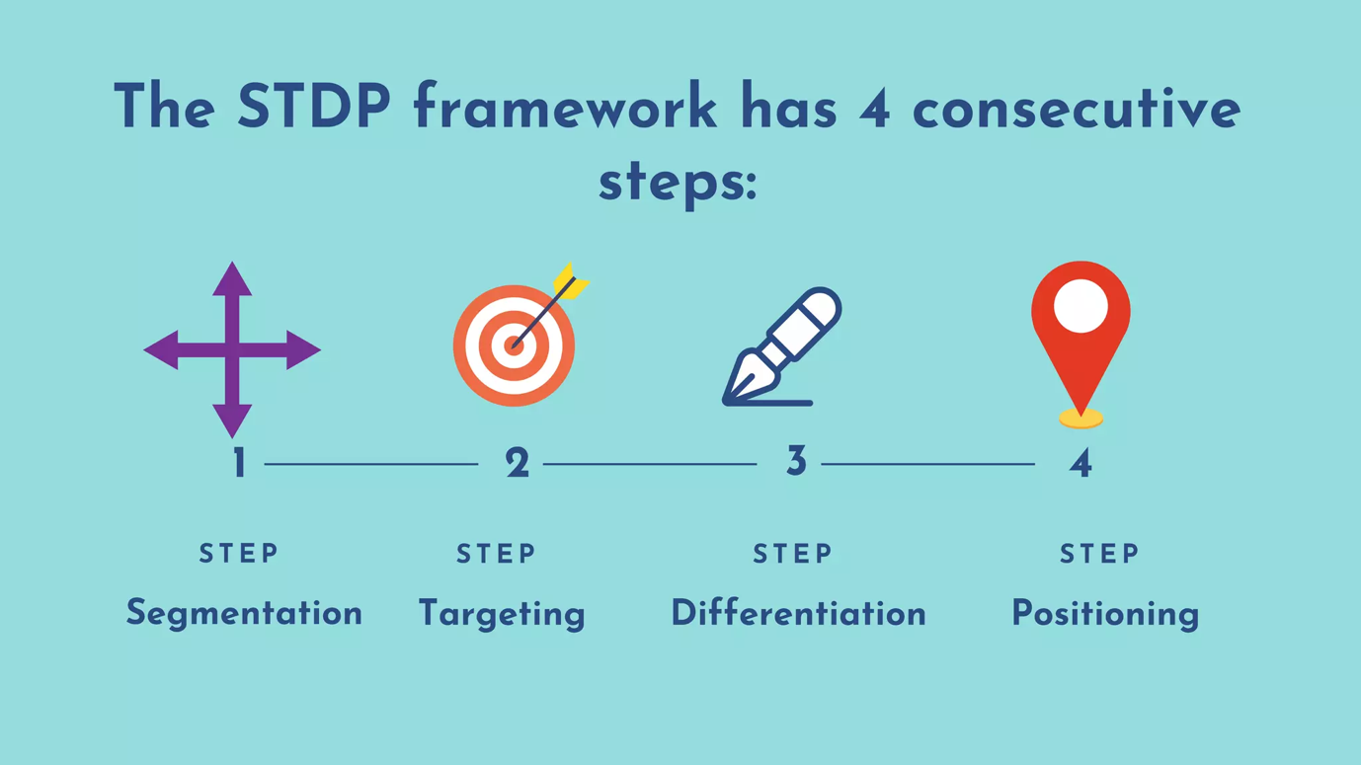
Figure 1: STDP Analysis
Source: (Blichfeldt and Faullant, 2021)

2.1 Company Background & New Brand Concept
The Body Shop is an internationally renowned ethical beauty retailer that is associated with natural ingredients, fair-trade sourcing, and high brand activism. It has not yet ventured into smart wellness products, though it has a range of products, including skincare, bath products, and essential oils. This new product is the proposed Harmony Steam Diffuser, which presents the upscale, ultrasonic aroma diffuser with the recommended application of soft heat and programmable olfactory modes (Blichfeldt and Faullant, 2021). This product is a wellness-technology innovation on the brand’s current aroma oils category, which turns passive use of fragrances into active, mood-sensitive use. This change will enable The Body Shop to be involved in the rapidly expanding smart self-care market. This positioning paid off as it helped in making the brand relevant in the long term.
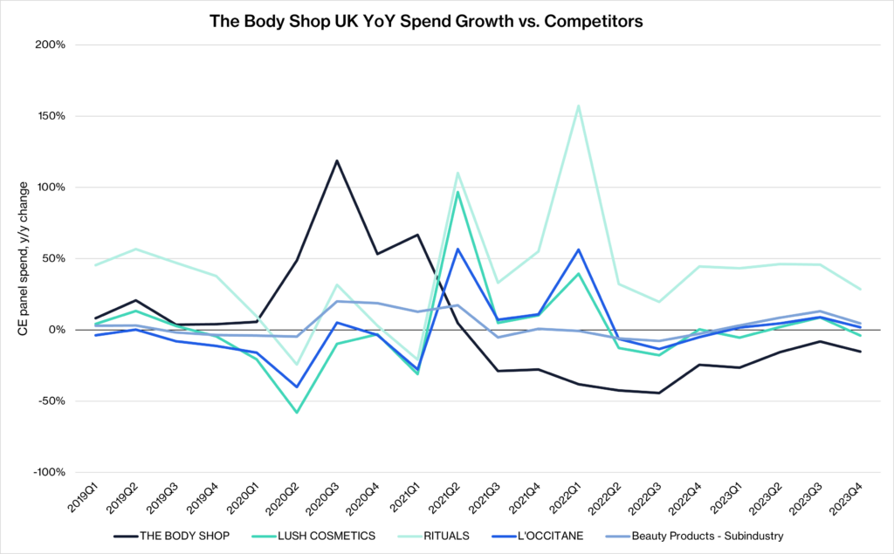
Table 1: The Body Shop UK YoY Spend Growth vs. Competitors
Source: (Rehan, Thorpe and Heravi, 2024)

2.2 Segmentation Analysis
This process of segmentation will help The Body Shop to realise certain groups of consumers with unique wellness requirements, and the Harmony Steam Diffuser could be positioned in the context of mindful and eco-conscious lifestyles. The brand is able to offer personalised value propositions and communicate more efficiently by making use of demographic, psychographic, behavioural, and lifestyle variables to enhance customer relevance and aid in premium positioning (Blichfeldt and Faullant, 2021). Segmentation also ensures that marketing waste is minimised as the resources are directed to high-potential consumers who are already in the aromatherapy consumer category. Segmentation is, however, limited. Psychographic and lifestyle segments cannot be easily measured and can be very volatile as the trends of wellness change. Excessive market segmentation may limit market size and complicate and raise the cost of marketing.

2.3 Targeting Strategy
This marketing strategy will use a differentiated targeting approach where two distinct consumer segments that are closely related are targeted. The main audience is Mindfulness Tech Consumers between 22-40 who buy aromatherapy products regularly and are willing to use smart solutions to wellness to deal with stress, sleep, and mood regulation. This segment is very active on the body influencers and ethical brands, which makes The Body Shop a legitimate option (Chen, Li and Chen, 2021). The second target group will include environmentally friendly youth professionals who appreciate clean perfumes, simplistic design, and sustainability. Targeting differentiation also enables The Body Shop to customise both messaging and value propositions to segment and capitalise on the similarities in the ethical and wellness values. The benefits are better market resonance, increased early adaptation and a premium margin potential. Nevertheless, the approach adds complexity to marketing and costs of communication with the target audience in comparison to undifferentiated targeting.

2.4 Differentiation Strategy
The Harmony Steam Diffuser stands out among a range of unique features. To begin with, it has intelligent aromatherapy algorithms that automatically modify the intensity of the mist and humidity depending on the mood program chosen by the user, like Sleep, Focus or Calm. Second, it supports the ethical principles of The Body Shop in terms of the sustainability of used materials and the ability to use only ethical oils that are cruelty-free (Kaur, Gangwar and Dash, 2022). Third, its high aesthetic quality through minimalist design and recycling packaging can be delivered at a higher level compared to the market’s mass-market diffusers. Lastly, the device establishes a unified ecosystem where it can be easily connected to the existing fragrance oils at The Body Shop, promoting repeat purchases. This stratified differentiation has provided as well as operational eminence as well as brand-congruent emotional worth.

2.5 Positioning Strategy
Positioning Statement: To wellness-conscious people who want to have natural balance with the help of technology, Harmony is an intelligent, ethically designed steam diffuser personalising the scent to the vibe of the consumer, unlike generic diffusers that have little control over and limited wellbeing (Cooper, 2019).
The product has functional value of programmable smell cycles, silent ultrasonic diffusion and high-quality construction. Emotionally, it will deliver an edited experience of calm, enabling users to experience a steady wellness at home (Cooper, 2019). Harmony occupies a higher value curve than its cheaper competitors because it has superior sustainability, mood-modulation functionality, and brand loyalty. This stance is a combination of emotional appeal and unambiguous functional advantage, which supports an elite, but affordable identity.

3. Element 2 – Marketing Mix (4ps)
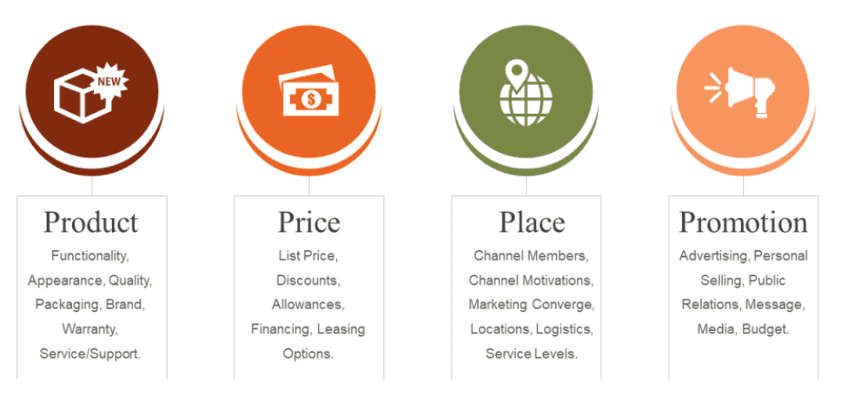
Figure 2: Marketing Mix (4ps)
Source: (Kaur, Gangwar and Dash, 2022)

3.1 Product Strategy
It is the Harmony Steam Diffuser with the main advantage of offering emotional rest and thus helping people to experience personalised wellbeing moments that facilitate better sleep, concentration, and mood control at home. Its real product combines ultrasonic diffusion, programmable scent cycles, adjustable mist intensity, and silent functionality to provide a more sophisticated sensual experience than the traditional diffusers. These attributes react to the increasing consumer need for tech-enhanced self-care practices (Kaur, Gangwar and Dash, 2022). Enhanced components also reinforce the proposal. A year of warranty makes them more trustworthy, and optional updates to the app add new programs to change the mood in accordance with the seasonal fragrance releases. The option of using refill bundles with the diffuser and the essential oils will promote repeat buying and build a sense of loyalty (Pozzi, Rossi and Secchi, 2023). The intention to be sustainable will be the primary focus, as the device is made of recyclable materials, is not compatible with cruelty-free oil, and consumes less energy- this is to make sure that it aligns with the long-standing ethical principles of The Body Shop.
All in all, product strategy is the perfect mix of functionality and emotional appeal, which makes Harmony a high-end, but affordable wellness-technology device. This plan raises the portfolio of The Body Shop and still retains ethical integrity (Pozzi, Rossi and Secchi, 2023).

3.2 Price Strategy
Harmony uses a premium-value pricing model that is imbued with its design quality, sustainable materials, and high levels of scent-modulation. This will help to match its competitors like Neom and Vitruvi, who sell their smart diffusers at price between PS90 and PS150, and Muji, with their simple diffusers occupying a lower price range (Cooper, 2019). The positioning of Harmony at PS119-PS139 will enable it to be competitive as well as indicate greater emotional and functional value. Cost structure factors such as proprietary software development, energy-efficient components and ethically sourced material are also reflected in the price. These will justify a higher but reasonable price to correspond with the reputation of The Body Shop concerning quality. Combination pricing, e.g. "Harmony + Two Oils" and "Sleep Cycle Set", generates a sense of added value and stimulates cross-category buying behaviour (Rauschnabel et al., 2022). This facilitates first-mover adoption as well as retention over time in terms of refill oils and a similar situation as observed in wellness markets, where razor-blade pricing is applied. This pricing rationale supports the positioning of Harmony as a premium player and the potential of a sustainable ecosystem in the long term.

3.3 Place Strategy
The harmony will be distributed by a well-planned omnichannel approach that will comprise the combination of physical shops, e-commerce, and optional connectivity through apps. The retail network of the Body Shop gives the company direct national exposure, while the online store guarantees convenience and worldwide access. The in-store experience areas will enable customers to test the level of mist, the scent mode, and design functions - influencing the trial and conversion that is essential with sensory products (Florén et al., 2018). In logistic terms, the small size that the diffuser is packed in lowers storage and delivery expenses. The current warehouse systems can integrate hardware and stock with little operational interference. The online distribution helps to scale quickly, whereas the app integration provides a more long-term perspective of digital add-ons, like the downloadable scent programs or personalised recommendations.
It is also possible to grow internationally. The European and Asian markets remain very strong in terms of demand for self-care and home-wellness products. The good brand equity of The Body Shop in these areas provides a favourable platform for the global rollout. This combination distribution plan delivers the widest reach possible and strengthens experiential discovery and online interaction.

3.4 Promotion Strategy
The promotional message of harmony aims at ethical narrative stories and emotional well-being stories, which are consistent with the brand identity of The Body Shop. The marketing will be focused on how aroma practices can alleviate stress, promote sleep, and help establish conscious areas. The hashtag of launch, e.g. #HarmonyAtHome, will promote the user-made content of rituals. This is in line with wellness marketing trends in which authenticity is the source of engagement (Cooper, 2019).
A major role will be played by social media. TikTok and Instagram advertising will involve brief, relaxing videos that will show mood programs, diffuser looks, and eco-friendly packaging. Ethical lifestyle creator and mindfulness coach influencer collaborations will establish trust and increase reach. All these partnerships should be based on the values of The Body Shop to ensure brand authenticity (Rehan, Thorpe and Heravi, 2024). Sensorial experience in a store will give the customers the opportunity to test the diffuser in the store, which will relate to emotional experience and intention to buy. Purchasing promotions (Winter Calm or Focus Reset) would make it more relevant and emphasise the versatility of the diffuser.
On the whole, the campaign approach incorporates online power, a narrative of honesty, and a test to trial to make the launch emotionally powerful. This combination will increase brand loyalty and early adoption in the emerging wellness-technology market.

4. Element 3 – Marketing Strategy Pitch
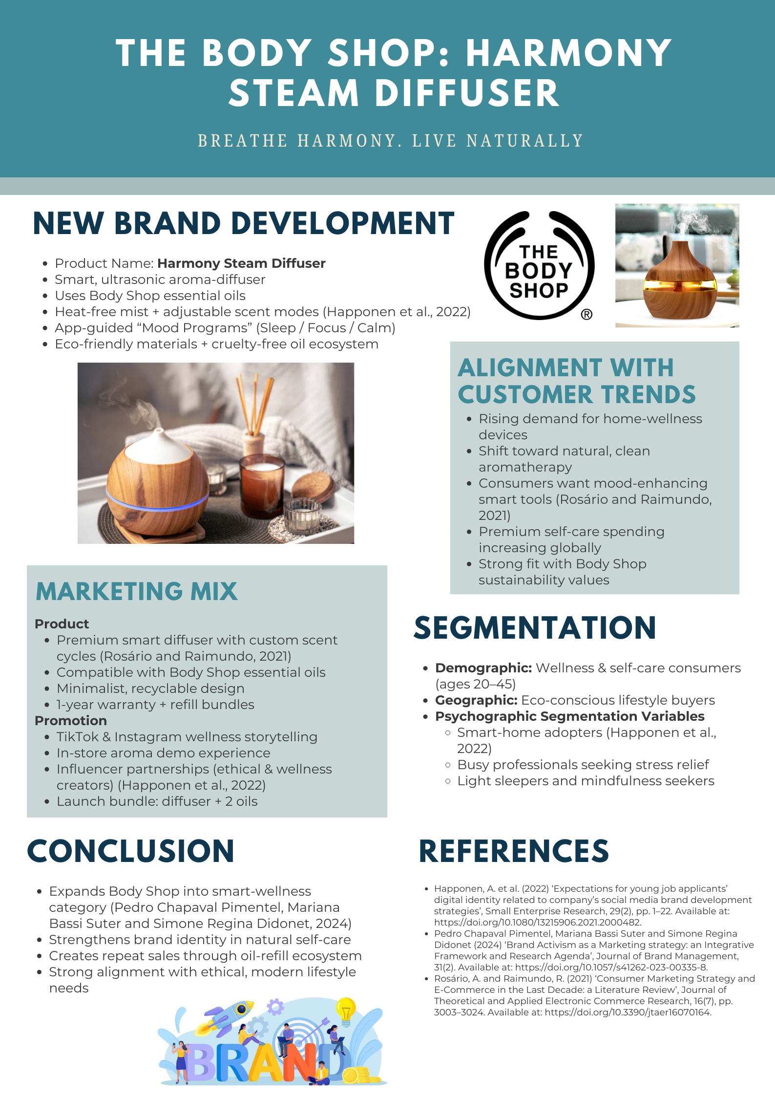

5. Element 4 – Reflection
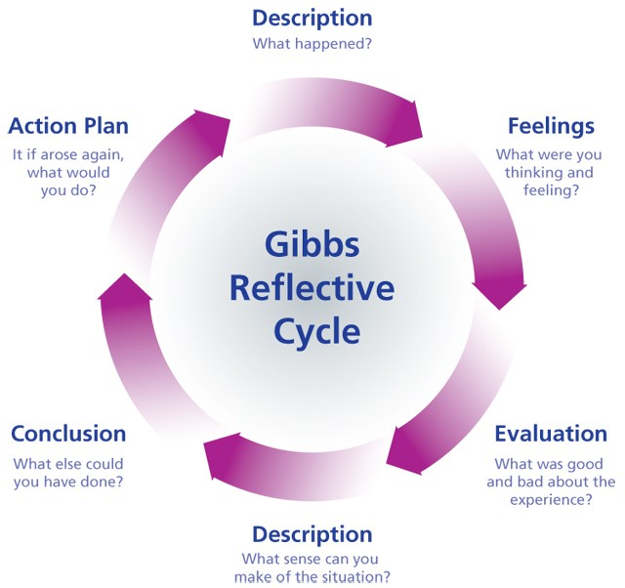
Figure 3: Gibbs’ Reflection
Source: (Florén et al., 2018)

5.1 Description
This assignment consisted of developing a new brand idea in The Body Shop and coming up with a comprehensive marketing plan for the Harmony Steam Diffuser. I did a STDP analysis, a 4Ps framework, a promotional pitch, and a poster that would be used in a brief in-class presentation (Florén et al., 2018). These elements combined were used to make a wellness-tech concept into a brand proposal that is structured and market-ready.

5.2 Feelings
My initial expectations were that I would have no issues learning about the ethical background of The Body Shop, since I was less confident about implementing the principles of wellness-tech, as this field implied the use of equipment and intelligent functions outside the usual beauty marketing (Kaur, Gangwar and Dash, 2022). More confidence was acquired as the work went on. I liked creative thinking and liked the way the wellness market enabled the emotional story to be told; however, I was also pressured to make the technology easier to understand so that it would still make sense and be realistic to The Body Shop.

5.3 Evaluation
The research that I did on the trends of wellness and their pricing on competitors was one of the strengths. This assisted me in explaining why the brand extension had some reason. I also discovered creativity value addition to the idea and particularly to developing mood-based scent programs (Pozzi, Rossi and Secchi, 2023). Nonetheless, I had overcomplicated the idea, and simplifying the product into a simple smart diffuser has helped in being clear. The urgency to meet deadlines during the pitch preparation meant that I had to give more importance to the key information instead of explaining much about the technical aspects.

5.4 Analysis
The STDP model was used to identify the segments like mindfulness users and eco-conscious consumers, which helped me to realise the role of the emotional needs in the purchasing behaviour. The 4Ps analysis allowed me to reflect on such practical aspects as pricing, distribution, and promotional storytelling. The analysis of the market reports on the trends of home-wellness revealed the way the premium diffusers place themselves based on design, scent quality, and brand values (Cooper, 2019). It made me understand that wellness branding is based on emotional reassurance and a feeling of relaxation instead of purely functional statements. In general, I was able to understand that an effective premium branding has to combine narrative, aesthetics, and perceived self-care.

5.5 Conclusion
In case I repeated this project, I would also get more primary sources, like brief surveys regarding the use of diffusers or the preference regarding mood settings (Blichfeldt and Faullant, 2021). There are also several names of products that would be tested out before I settle on one, since naming affects emotional attachment.

5.6 Action Plan
Goal | Specific Action | Measurable | Achievable | Relevant | Time-Bound
Improve research depth | Use 3 additional academic + industry sources in future projects (Kaur, Gangwar and Dash, 2022) | Minimum 3 new sources | Yes | Strengthens analytical quality | Next assignment cycle
Strengthen prototyping skills | Create simple product sketches or wireframes | 1–2 sketches per concept | Yes | Improves idea clarity (Rauschnabel et al., 2022) | Within first week of project
Validate ideas early | Collect quick user feedback via 5–10 survey responses | At least 5 responses | Yes | Ensures realistic market fit | Within first 10 days of project
Enhance visual communication | Practise 1 new poster or slide design template per project | 1 template applied | Yes | Improves pitch effectiveness | Before final presentation
Refine brand naming | Generate 5 name options + shortlist 1 through peer feedback (Rauschnabel et al., 2022) | 5 options created | Yes | Strengthens emotional branding | During concept development phase

6. Conclusion
This portfolio indicated how the Harmony Steam Diffuser gives a brand extension that is strategically coherent to The Body Shop. The analysis of the STDP showed that the presence of mindfulness-oriented, environmentally friendly consumers who want to find smart ways to take care of themselves is a great opportunity. The 4Ps supported this fit through creating a high-end, environmentally friendly, and emotionally appealing product, which was backed by good pricing, omnichannel distribution, and an ethical promotion narrative (Blichfeldt and Faullant, 2021). Collectively, these factors make Harmony a plausible wellness-technology solution that enhances the identity of The Body Shop, besides diversifying its product platform. As the demand for these devices that guarantee home well-being increases, the diffuser has great scope in the long term to receive repeat purchases, expand globally, and rebrand.

7. References
Blichfeldt, H. and Faullant, R. (2021) ‘Performance effects of digital technology adoption and product & service innovation – A process-industry perspective’, Technovation, 105, pp. 102–275. Available at: https://doi.org/10.1016/j.technovation.2021.102275.
Chen, H., Li, L. and Chen, Y. (2021) ‘Explore success factors that impact artificial intelligence adoption on telecom industry in China’, Journal of Management Analytics, 8(1), pp. 1–33. Available at: https://doi.org/10.1080/23270012.2020.1852895.
Cooper, R.G. (2019) ‘The drivers of success in new-product development’, Industrial Marketing Management, 76, pp. 36–47. Available at: https://doi.org/10.1016/j.indmarman.2018.07.005.
Florén, H. et al. (2018) ‘Critical Success Factors in Early New Product development: a Review and a Conceptual Model’, International Entrepreneurship and Management Journal, 14(2), pp. 411–427. Available at: https://doi.org/10.1007/s11365-017-0458-3.
Homburg, C. and Wielgos, D.M. (2022) ‘The value relevance of digital marketing capabilities to firm performance’, Journal of the Academy of Marketing Science, 50(4). Available at: https://doi.org/10.1007/s11747-022-00858-7.
Kaur, B., Gangwar, V.P. and Dash, G. (2022) ‘Green Marketing Strategies, Environmental Attitude, and Green Buying Intention: A Multi-Group Analysis in an Emerging Economy Context’, Sustainability, 14(10), p. 6107. Available at: https://doi.org/10.3390/su14106107.
Kumar, H., Gupta, P. and Chauhan, S. (2023) ‘Meta-analysis of augmented reality marketing’, Marketing Intelligence & Planning, 41(1). Available at: https://doi.org/10.1108/mip-06-2022-0221.
Pozzi, R., Rossi, T. and Secchi, R. (2023) ‘Industry 4.0 technologies: critical success factors for implementation and improvements in manufacturing companies’, Production Planning & Control, 34(2), pp. 1–21. Available at: https://doi.org/10.1080/09537287.2021.1891481.
Rauschnabel, P.A. et al. (2022) ‘What is augmented reality marketing? Its definition, complexity, and future’, Journal of Business Research, 142, pp. 1140–1150. Available at: https://doi.org/10.1016/j.jbusres.2021.12.084.
Rehan, A., Thorpe, D. and Heravi, A. (2024) ‘Project success factors for leadership practices and communication: challenges in the construction sector’, International Journal of Managing Projects in Business, 17(3), pp. 562–590. Available at: https://doi.org/10.1108/ijmpb-12 -2023-0279.

