Morgan Lloyd Davies (1910276)
UWTSD | SA1
Bim execution plan (BEp)
5010- Ysgol bae Abertawe

Table of Contents
Project information 2
Management 4
Planning and documentation 5
standards, methods and procedures 6
IT solutions 8

Project information

- Project Owner: Morgan Davies
- Project Name: Ysgol Bae Abertawe
- Project Location and Address: Maritime quarter, slipway road, SA1 1UB
- Brief Project Description: 1 form entry for 90 infants
- Additional Project Information: design will be completed on revit.
- Project Numbers: 5010

here are the leading riles throughout the project

role | Authority
Project lead manager | Enforce the BIM standard and ensure delivery of the information requirement in the EIR.
Lead designer | Enforce spatial coordination.
Interface manager | Negotiate space allocation.
Task team information manager | Reject mon-compliant models, drawings and documents.
CAD coordinator | Enforce CAD related project BIM standards.
BIM manager | In charge of the BIM procedures.

Here’s the table that shows the role code for each discipline working on the project.

Project  discipline | Role code
Client | K
Client representative | J
Facilities manager | F
Main contractor | W
Architect | A
Structural engineer | S
Civil engineer | C
Mechanical engineer | M
Electrical engineer | E
Public health engineer | P
Landscape | L

Management

- Client- the client will be kept informed throughout the BIM process and if anything is needed to be changed, that will be executed.

- Client representative- the client’s representative will be authorising the conclusive decisions between the client and the representative.

- Facilities manager- the client has the option to appoint a facilities manager or choose someone with a similar capacity to provide feedback for soft landings.

Primary responsibilities
Architect | Develop a 3D drawing and make changes into the model before the project has been completed if necessary. Turn up to all meetings when necessary, when potential changes need to be done to the model. BIM element turnover, have responsibility of as-built models to ensure BIM scope for each team.
Contractor | Design-build team with model requirements, if something is needed to be changed then it can be done, update records of the models at the end of the project.
Subcontractor | Any design-intent changes within the model at the end of the project. Make sure the final project is accurate to the model, ensure the process is in place to begin the work on site.

BIM manager:
The civil engineer will be the BIM manager for this project, they will oversee all BIM procedures throughout the project. This person will oversee the handover of the different stages throughout of the designing process. They will have a small group working for the BIM manger to ensure that the project runs smoothly throughout the project with no issues. They will be working closely with the BIM coordinators who are managing the BIM process.

Project manager: The responsibilities for the project manager are to ensure that the project is successful throughout the designing and construction of the whole project. Making communication between parties easier. They will be monitoring every aspect, including the planning, execution, control and closure. Making sure that the targets are met within time and within budget.

Main contractor
The main contractor will oversee the delivery methods and communication on site

BIM use | User | software | Version
Design | Architectural | Revit | 2021
Design | Interior | Revit | 2021
Design | Structural | Revit | 2021
Design | Mechanical | Revit | 2021
Design | Electrical | Revit | 2021
Design | Plumbing | Revit | 2021

Planning and documentation

Supple chain assessments and production of the documents have been completed; this should then be used to scope some information. Management delivery should be carried out at the earliest time possible.

All stakeholders will be assessed for the capability to meet the requirements of the project before starting the work on site. The delivery manager will oversee the overall responsibility of the supplier’s information e.g., when deliveries are due etc.

- Subcontractors will be sent in BIM capability assessments to return before work on site begins.
- The consultant will also be sent a BIM capability assessment, which will also need to be completed prior to the works starting.

Client strategic purposes
It is intended that the information provided in the models can be utilised for the following the purposes:
- Space planning
- Operations
- Maintenance
- Business case
- Regulations and compliance
Level name | Description | Elevation
Parking | Ground floor | 0mm
School | Ground floor | 0mm
Playground | Ground floor | 0mm
Hall | Ground floor | 0mm
Main hall | Ground floor (double roof) | 0mm
Roof | Roof

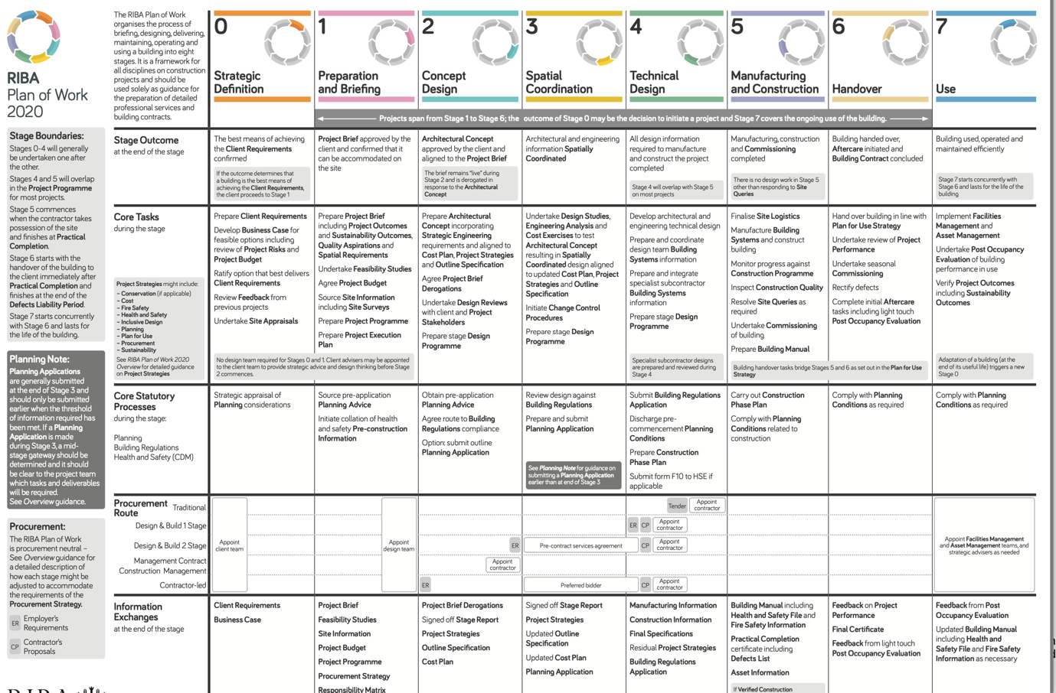
with this being the plan of work from 2020 produced by RIBA

standards, methods and procedures

here are the standards which will be used throughout the project.

•BS 1192:2007+A2:2016 - Collaborative production of architectural, engineering and construction information. Code of practice
•PAS 1192-2:2013 - Specification for information management for the capital/delivery phase of construction projects using building information modelling
•PAS 1192-3:2014 - Specification for information management for the operational phase of assets using building information modelling
•BS 1192-4:2014 - Collaborative production of information. Fulfilling employer’s information exchange requirements using COBie-Code of practice
•PAS 1192-5:2015 - Specification for security-minded building information modelling, digital built environments and smart asset management
•BS 8541-1,3 & 4 :2012 - Library objects for architecture, engineering and construction
•BS 5606:1990 - Guide to accuracy in building
•CDM 2015 - The Construction (Design and Management) Regulations 2015•CIC/BIM Pro:2013 - Building Information Model (BIM) Protocol, 1st Edition 2013
•CIC/INF/MAN/S:2013 - Outline Scope of Services for the role of Information Management, 1st Edition 2013
•BS ISO 12006-2:2015 - Building construction – Organisation of information about construction works - Part 2 Framework for classification
•BS ISO 120006-3:2007 - Building construction – organisation of information about construction works - Part 3 Framework for object-oriented information
•BS ISO 55000:2014 - Asset management – Overview, principles and terminology•BS 8536-1:2015 - Briefing for design and construction. Code of practice for facilities management (Building’s infrastructure)
•BG 61/2015 - Soft Landings & Government Soft Landings
•BG 6/2014 - A Design Framework for Building Services, 4th Edition
•NBS Uniclass 2015 - a dynamic classification for the construction industry

Units and measurements

The models will be drawn to a scale of 1:100 and all measurements will be drawn to the closest mm. Angular measurements will be measured to the closest degree. All units for an area will measured at m².
A site plan will be displayed at a scale of 1:1250 to display the proposed site plan.

Volume strategy
The volume strategy will identify the core area of the asset which acquires coordination consideration prior to the model being detailed to a specific level to avoid any clash.
- Volumes are responsible for the task teams.
- There’s a chance volume may overlap but this would not happen in 3D sheets.
- The selection of volumes and their allocations to the task team members should be carefully considered.

Room numbering and naming
Within the different views and sheets, there will be named rooms throughout the entire model. This will help the client understand the building. All rooms will also be numbered.

Drawing sheets
Drawing sheets will be created within a modelling environment. The drawings will be produced in 2D and 3D sheets. When printing the sheets, 2D sheets will be printed in PDF and 3D sheets will be printed in DWFx.

IT solutions

Discipline | 2D/3D | Version | Native file type | Information exchange format
Main contractor (W) | 3D | 2021 | .rvt | .rvt.ifc
Architect (A) | 3D | 2021 | .rvt | .rvt.ifc
Structural engineer (S) | 3D | 2021 | .rvt | .rvt.ifc
Civil engineer (C) | 3D | 2021 | .rvt | .rvt.ifc
Mechanical engineer (M) | 3D | 2021 | .rvt | .rvt.ifc
Electrical engineer (E) | 3D | 2021 | .rvt | .rvt.ifc

There will be no software upgrades throughout the course of the project, unless stated by the project information manager.

