
Name: ANITA JOHNSON
Student’s ID number: 2422551
Module Code: BMHP5030
Module name: physiology
Lecturer: Shaila Hussain

Submission date 13 April 2026
Table of content

Introduction 3
Scenario 3
What is asthma? 4
Understanding Asthma and its risk factors 4
Structure of the respiratory system and its mechanical process 4
Gas exchange: oxygen uptake and carbon dioxide removal 6
Irritants, inflammation and airway swelling 6
The importance of monitoring and recording respiratory data 7
Lifestyle modification and evidence-based recommendation 8
Patient education and engagement 9
Conclusion 10

Case study: supporting adolescents with asthma within the local GP surgery

Introduction
Asthma is a prevalent chronic inflammatory disease of the Airways that affects individuals of all ages. The World Health Organization (WHO) indicates that in 2019, around 262 million people globally were suffering from asthma, resulting in nearly 461,000 deaths that year. Asthma remains at the top of the most frequently encountered chronic diseases worldwide, particularly in children, and it is a major contributor to morbidity and healthcare burden across countries of all income levels (World Health Organization 2024).

There are several different types of asthma. For example, common types include allergic asthma, triggered by allergens such as pollen, dust mites, or animal dander. This type is widely recognised as the most common phenotype and often begins in childhood. Another type of asthma, non-allergic asthma, is not linked to allergic sensitisation. It usually develops later in life and can be triggered by irritants such as smoking, vaping, air pollution, viral infections, or cold air (ref).

Scenario
As a practice nurse at the local GP surgery, a developing pattern has become increasingly apparent: teenagers with a history of childhood asthma are presenting with more frequent and at times severe exacerbations. In response to this trend, we have established a weekly asthma clinic led by the practice nurse and a general practitioner. The initiative aims not only to optimize pharmacological treatment but also, crucially, to improve occupational asthma caused by exposure to specific sensitising agents in the workplace, such as chemicals or dusts. Exercise-induced asthma: these symptoms can be triggered exclusively by physical activity (Asthma UK 2025). According to the global burden of disease due to asthma, the overall prevalence of current asthma symptoms in GAN phase 1, 11.0% of adolescents have the highest diagnostic asthma condition.
Discussion among the multidisciplinary team has highlighted that lifestyle changes typical of adolescence, including smoking, vaping, increased social interaction in crowded environments, and lower adherence to inhaled treatments, are significantly contributing to worsening respiratory control furthermore many young individuals exhibit a limited understanding of how their respiratory system operates, how asthma effects this system and how their lifestyle chosen may exhibit airways inflammation. Therefore, enhancing patients’ education has become a fundamental aspect of our clinical approach and empowering adolescents to engage effectively with self-management strategies and to monitor their health safety

.

What is asthma?
Asthma is a chronic lung condition that inflames and narrows the airways, making breathing difficult. Exposure to triggers such as dust, cold air, exercise, or allergens causes the airway muscles to tighten, the lining to swell, and mucus to build up, leading to coughing, wheezing, chest tightness, and shortness of breath. Symptoms can range from mild to life-threatening. The exact cause is unknown, but asthma is linked to both genetic and environmental factors, including a family history of allergies or asthma (World Health Organization, 2024).

Understanding Asthma and Its Risk Factors
Risk factors are influenced by multiple factors. genetic factors, exposure to environmental allergens, air pollution, tobacco smoking, and an early childhood Respiratory infection. All contribute to increased susceptibility (Dharmage et al.,2019). In teenagers, additional behavioral factors arise, particularly cigarette smoking and vaping, which are independently correlated with diminished asthma control and an increased risk of exacerbation (Polosa et al.,2019). Moreover, social exposure to crowded indoor environments may further increase contact with respiratory pathogens, thereby compounding the risk. In clinical practice, it has become clear that adolescents often underestimate the cumulative effect of their exposures. Consequently, part of the clinic's role is to help patients understand asthma not merely as an episode of inconvenience but as a chronic inflammatory condition that necessitates continuous attention.

(Asthma UK, 2023)

Structure of the respiratory system and its mechanical process
To enhance understanding, it is vital to first outline the anatomical structure of the respiratory system. This system is broadly classified into a conducting zone and the respiratory zone (West 2021). The conducting airways begin at the nasal cavity, where the air we inhale is filtered, warmed, and humidified. The air then flows through the pharynx and larynx into the trachea, which branches into the right and left main bronchi. These bronchi further divide into smaller bronchi, creating a complex bronchial tree. The respiratory zone begins at the terminal bronchioles and ends in alveolar sacs, which contain millions of alveoli. These fragile, thin-walled structures, closely associated with pulmonary capillaries, form the alveolar capillary membrane, the site of gas exchange (Hall, 2020). The lungs are housed within the thoracic cavity and are surrounded by pleural Membranes that reduce friction during breathing movement. This complex arrangement maximizes surface area for effective oxygen absorption and carbon dioxide elimination.
Mechanical inspiration is the physical act of ventilation, involving the movement of air into and out of the lungs. During the inhalation phase, the diaphragm contracts and moves downwards while the external intercostal muscle raises the ribs. This synchronises with the thoracic cavity, leading to a decrease in intrathoracic pressure below atmospheric pressure (Hall 2020).
In quiet breathing, exploration is primarily a passive process; the diaphragm relaxes, and the elastic recoil of lung tissue decreases thoracic volume, raising pressure and expelling air.
However, in asthma, the narrowing of the Airways increases airflow resistance, especially during expiration. As a result, adolescents frequently report difficulty exhaling, leading to air trapping and a feeling of chest tightness (Gina 2024). Explaining the mechanical aspects helps patients understand why bronchodilators, which relax the smooth muscle in the airways, are crucial for alleviating acute symptoms.
This diagram shows the structural respiratory system and its mechanical processes.
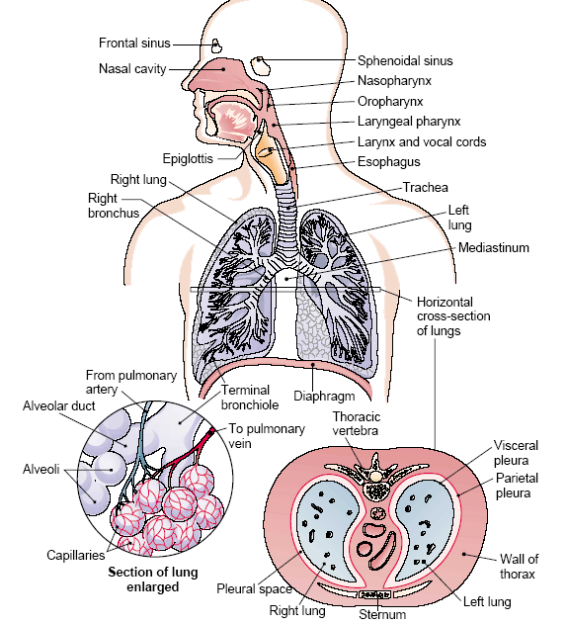

(Respiratory medicine, 2019)

Gas exchange: oxygen uptake and carbon dioxide removal
That exchange occurs in the alveoli by diffusion, which is influenced by the partial pressure difference. The concentration of oxygen is greater in the air of the alveoli compared to the deoxygenated blood in the pulmonary capillaries. Oxygen diffuses through the thin membranes between the alveoli and the capillaries into the

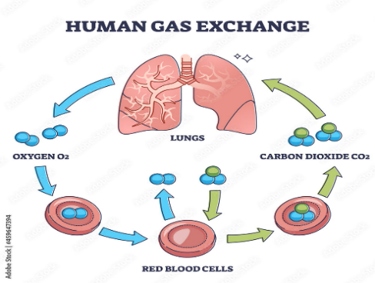
bloodstream. (West 2021) Once in the bloodstream, oxygen binds to haemoglobin in red blood cells and is delivered to systemic tissues for cellular respiration. Conversely, carbon dioxide, which is a byproduct of metabolism, is present in high concentration in venous blood. It diffuses into the alveoli, and it's then exhaled.
This change is vital for cellular energy production. Oxygen supports oxidative phosphorylation in mitochondria, producing adenosine triphosphate (ATP), the body's primary energy currency (Hall, 2020). When airway inflammation disrupts ventilation, the delivery of oxygen may be hindered, and the removal of carbon dioxide can become less effective. adolescents often respond favourably when they grasp the physiological connection between breathing energy level and symptom control.

Irritants, inflammation, and airway swelling
Irritants such as tobacco smoke, e-cigarette vapor, airborne pollutants, and respiratory viruses activate the inflammatory pathway in airway epithelium (Barnes 2017). The mediators of inflammation increase blood vessel permeability, causing mucosal Edema and the infiltration of immune cells, while concurrently causing smooth muscle contraction, narrowing the bronchial lumen. This interplay of bronchoconstriction, excessive mucus production, and tissue swelling greatly elevates airway resistance (Kuman, Abbas, and Aster,2020). In adolescents, these symptoms include wheezing, shortness of breath, and reduced exercise tolerance.
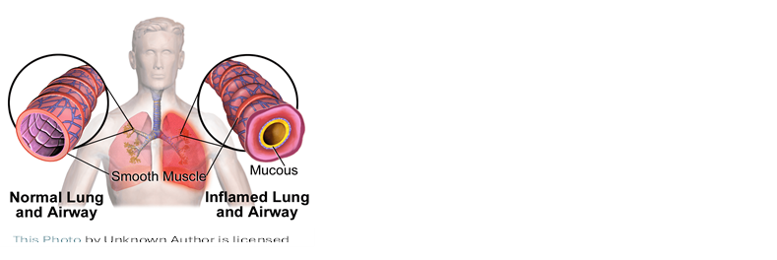
(Asthma UK,2023). This picture shows normal lungs and airways and an inflamed lung and airways.
Smoking and vaping present serious concerns. Smoking from combustible tobacco is rich in various oxidants and particulates that contribute to persistent airway inflammation. ( Addissouky, T.A.et al., 2024). Despite being often regarded as less harmful, vaping aerosols have been found to cause airway irritation and inflammation responses as well (Gotts et al., 2019). Furthermore, less severe respiratory infections, which are frequently encountered in social settings like clubs and bars, can lead to acute exacerbation by worsening Airway inflammation (Jackson et al., al 2014). Assisting adolescents in understanding the biological chain of events often boosts their motivation for behavioural change.

The importance of monitoring and recording respiratory data
As practicing nurses, we encourage teenagers to Self-Monitor, as this is essential for effective asthma management. The measurement of peak expiratory flow (PEF) serves as an objective indicator of airway caliber and airway restriction (National Institute for Health and Care Excellence [NICE], 2023). By regularly tracking peak flow readings, patients can identify early signs of deterioration before symptoms escalate to a severe level.
In the clinic, adolescents are encouraged to maintain a peak flow diary, ideally recording readings in the mornings and evenings, and to establish a personal best, which allows for comparison over time. A study suggests that a decline below 80% of this personal best may indicate increased inflammation and the need for intervention (GINA,2024).
Evidence shows that waiting for an asthma action plan that includes peak flow monitoring can lead to fewer hospital admissions and improved symptom control (Gibson et al., 2003). Furthermore, digital applications now support real-time tracking, which increases engagement among young people who are comfortable with technology. (Chan et al.,2017).
Crucially, monitoring promotes self-efficacy, and adolescents start to identify patterns, for example, lower readings after smoking or during viral infections, thus reinforcing the real consequences of their lifestyle choices

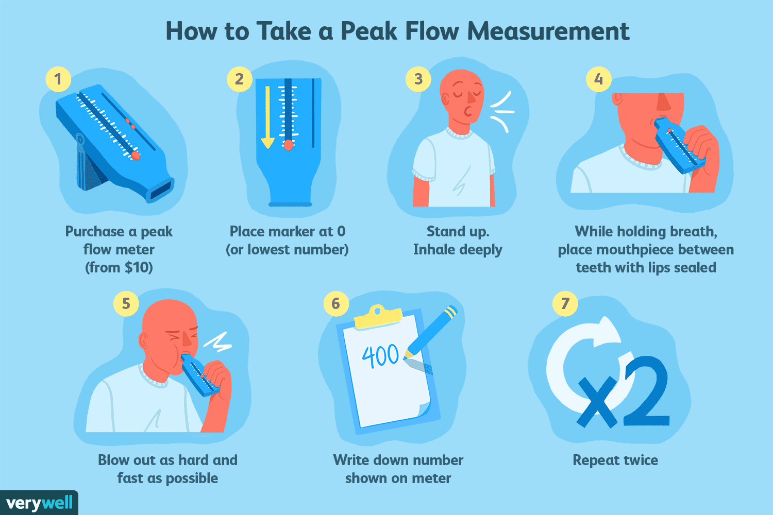
Verywell Health, n.d.)

Lifestyle modification and evidence-based recommendations
To improve asthma outcomes in adolescence, a comprehensive intervention is essential. Smoking cessation is critical, as even light smoking can hinder the lungs’ function and reduce their responsiveness to corticosteroids (Thompson al.,2016). et Consequently, referrals to structured cessation programs and behavioural support are commonly provided; similarly, it is important to discourage vaping, given the emerging evidence linking E-cigarette use to airways inflammation. (Gotts et al., 2019). Vaccination against influenza and COVID-19 reduces symptom severity (NICE, 2023).
Regular physical exercise is encouraged, as controlled exercise can improve lung capacity and overall health when pre-exercise bronchodilator use is optimized (Carson et al., 2023). Moreover, adherence to preventer inhalers, which are usually inhaled corticosteroids, is emphasized, as these medications can reduce airway inflammation and the frequency of exacerbations when used consistently (Reddel et al., 2019). Inhaler techniques are assessed at each appointment us improper use is a frequent reason for inadequate control. Environmental awareness is also significant; it is advised to avoid known allergens, limit exposure to air pollution whenever possible, and maintain a smoke-free living space (Dharmage et al., 2019).

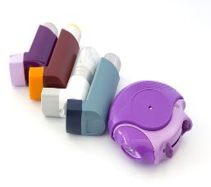

(Respiratory medicine (2018). The different types of inhalers)

Patient education and engagement
A recurring theme in the adolescent clinic is the significant influence of knowledge. When young individuals understand the psychological mechanisms underlying their symptoms, especially airway inflammation, reduced ventilation, and disrupted gas exchange, they often take a strong sense of responsibility for their own care.
Motivational interviewing methods are applied to investigate ambivalence regarding smoking or social behaviour. Instead of imposing rules, the clinical dialogue emphasizes collaborative goal setting.
Adolescents are encouraged to voice their personal goals, whether related to sports, academics, or social engagement, and to see how improved respiratory health can support their aspirations. Consequently, education is not just about providing information; it becomes a catalyst for behavioural change (British Thoracic Society, 2019).

Conclusion
The establishment of a specialised clinic for adolescents’ asthma within primary care indicates a significant unmet demand as adolescents begin to assert that their lifestyle choices may unintentionally affect their respiratory health. Asthma is fundamentally a chronic inflammatory disorder of the Airways disrupt mechanical ventilation and gas exchange, thereby hindering the delivery of oxygen and the removal of carbon dioxide
Exposure to irritants such as tobacco smoking, vaping, aerosols, and respiratory infection exhibits airway inflammation, increasing resistance to airflow, and leading to asthma excavation however, with structured education, consistent peak flow monitoring, adherence to medication, and evidence-based lifestyle changes, adolescents can regain control over their asthma.
ultimately empowering young patients with knowledge about their respiratory health encourages informed decision-making and ongoing practise participation, thus the clinic not only alleviates symptoms but also fosters long-term respiratory resilience.

References
Addissouky, T.A., El Sayed, I.E.T., Ali, M.M., Wang, Y., El Baz, A., Elara Bany, N., and Khalil, A.A., 2024. Oxidative stress and inflammation: elucidating mechanisms of smoking-attributable pathology for therapeutic targeting. Bulletin of the National Research Centre, 48(1), p.16.
Almomani, B.A., Mokhemer, E., Al-Sawalha, N.A., and Momany, S.M., 2018. A novel approach of using educational pharmaceutical pictograms for improving inhaler techniques in patients with asthma. Respiratory Medicine, 143, pp.103–108.
Barnes, P.J., 2017. Asthma and COPD: Basic Mechanisms and Clinical Management. 2nd ed. London: Academic Press.
British Thoracic Society (BTS), 2019. British guideline on the management of asthma. London: BTS.
Carson, K.V. et al., 2013. Physical training for asthma. Cochrane Database of Systematic Reviews, (9).
Chan, A.H.Y. et al., 2017. Digital interventions to improve adherence in asthma. Journal of Allergy and Clinical Immunology: In Practice, 5(3), pp.610–619.
Dharmage, S.C., Perret, J.L. and Custovic, A., 2019. Epidemiology of asthma. Nature Reviews Disease Primers, 5(1), pp.1–23.
Gibson, P.G. et al., 2003. Self-management education and regular practitioner review for adults with asthma. Cochrane Database of Systematic Reviews, (1).
GINA, 2024. Global Strategy for Asthma Management and Prevention. Global Initiative for Asthma.
Gotts, J.E. et al., 2019. What are the respiratory effects of e-cigarettes? BMJ, 366, l5275.
Hall, J.E., 2020. Guyton and Hall Textbook of Medical Physiology. 14th ed. Philadelphia: Elsevier.
Jackson, D.J. et al., 2014. Role of respiratory infections in asthma exacerbations. Lancet, 384(9943), pp.169–180.
Kumar, V., Abbas, A.K., and Aster, J.C., 2020. Robbins and Cotran Pathologic Basis of Disease. 10th ed. Philadelphia: Elsevier.
London Children’s Chest Clinic, 2025. How to Use a Peak Flow Meter • London Asthma Clinic. [online] Available at: https://londonasthmaclinic.com/childhood-asthma/how-to-use-a-peak-flow-meter [Accessed 22 March 2026].
National Institute for Health and Care Excellence (NICE), 2023. Asthma: diagnosis, monitoring, and chronic asthma management. London: NICE.
NHS, 2023. Asthma. [online] Available at: https://www.nhs.uk/conditions/asthma/ [Accessed 22 March 2026].
Papi, A. et al., 2018. Asthma. Lancet, 391(10122), pp.783–800.
Polosa, R. et al., 2019. Electronic cigarette uses and asthma outcomes. Expert Review of Respiratory Medicine, 13(10), pp.967–976.
Public Health England (PHE), 2021. Health effects of vaping in adolescents. London: PHE.
Reddel, H.K. et al., 2019. Global Initiative for Asthma strategy update. European Respiratory Journal, 53(6).
Thomson, N.C., 2016. Addressing corticosteroid insensitivity in adults with asthma. Expert Review of Respiratory Medicine, 10(2), pp.137-156.
Verywell Health (n.d.) How to take a peak flow measurement. Available at: [insert URL if you have it] (Accessed: 13 April 2026).
West, J.B., 2021. West’s Respiratory Physiology: The Essentials. 11th ed. Philadelphia: Wolters Kluwer.
World Health Organization (WHO), 2024. Asthma. [online] Available at: https://www.who.int/ [Accessed 22 March 2026].
World Health Organization (WHO), 2023. Asthma Fact Sheet. Geneva: WHO.

