
Module Assignment Submission
Student Name: | Jemma Rees
Student Number: | 2008032
Module Code: | BMSK 6003
Module Title: | Leading and Implementing Workplace Change

Statement of Confirmation of Authenticity
By the act of making this submission, the student declares that this is the work of the student named above. The work has not, in whole or in part, been knowingly presented elsewhere for assessment, or where assessment has been built on a previous assessment, this has been identified. Where materials have been used from other sources it has been properly acknowledged. If this statement is untrue, the student acknowledges that an assessment offence has been committed.
Attention is drawn to the plagiarism and unfair practice policies of the University.

Table of Contents
1.0 Introduction 2
2.0 Critically Analyse The Current Forces For Change In The Organisation's Micro And Macro Environment That Can Impact Workplace Culture And Capability 3
2.1 Definition 3
2.2 What Is Organisational Change 3
2.3 Change Theories 5
2.3.1 Kurt Lewin 5
2.3.2 Elisabeth Kübler-Ross 5
2.3.3 Prosci's ADKAR Model 5
2.3.4 John Kotter 6
2.4 Current Forces For Change In Office For National Statistics Micro-environment That Can Impact Workplace Culture And Capability 6
2.4.1 Analysis 6
2.5 Current Forces For Change In The Civil Service's Macro Environment That Can Impact Workplace Culture And Capability 7
2.5.1 PESTLE Analysis 7
2.5.2 Political Factors 7
2.5.3 Economic Factors 7
2.5.4 Social Factors 7
2.5.5 Technological Factors 8
2.5.6 Legal Factors 8
2.5.7 Environmental Factors 8
2.6 Culture 8
2.7 Conclusion 9
3.0 Evaluate How Organisational Stakeholders Can Be Efficiently Led Through Complex Workplace Change 9
3.1 Introduction 9
3.2 The Change 9
3.3 What Are Stakeholders 10
3.3.1 Stakeholder Analysis 10
3.3.2 Stakeholder Risk Analysis 11
3.3.3 Summary 11
3.4 Communication Plan 11
3.4.1 Summary 12
3.5 Resistance To Change 12
3.5.1 Summary 14
3.6 Kübler-Ross 14
3.6.1 Stage 1 – Shock and Denial 14
3.6.2 Stage 2 – Anger and Fear 14
3.6.3 Stage 3 – Acceptance 15
3.6.4 Stage 4 – Commitment 15
4.0 Conclusion 15
5.0 References 17
6.0 Bibliography 21
7.0 Appendices 23
Appendix 1 – Catalysts For Change 23
Appendix 2 - Kurt Lewin's Change Model 24
Appendix 3 - Kübler -Ross Change Curve 25
Appendix 4 - Prosci's ADKAR Model 26
Appendix 5 - Kotter's 8 Step Model 27
Appendix 6 - SWOT Analysis 28
Appendix 7 – PESTLE Analysis 29
Appendix 8 – Lewin's Force Field Analysis 30
Appendix 9 – Our Force Field Analysis 31
Appendix 10 - Stakeholder Analysis Matrix 32
Appendix 11 - Stakeholder Map 33
Appendix 12 - Stakeholder Risk Analysis Matrix 34
Appendix 13- Stakeholder Communication Plan 35
Appendix 14 - Belbin's Team Roles 36
Appendix 15 - Ishikawa (Fishbone) Diagram 37
Appendix 16 - Gantt Chart 38

Introduction

Firstly, this assignment will define change management and its links with organisational change types, then provide brief examples of change theories.
Next, it closely examines the current forces for change in an organisation's micro and macro environment and how these can impact workplace culture and capability. To aid in understanding, we will analyse our current workplace, the Office For National Statistics (ONS); where relevant, we will draw upon case studies of external organisations to compare and contrast.
Using stakeholder analysis methods, we will evaluate how to efficiently lead organisational stakeholders through complex workplace changes and emphasise the importance of effective communication concerning change theories.
Finally, we will comprehensively conclude our findings and appropriate recommendations.

2.0 Critically Analyse The Current Forces For Change In The Organisation's Micro And Macro Environment That Can Impact Workplace Culture And Capability

2.1 Definition

During our research into a substantive, robust definition of change management, we have come across various interpretations of the concept. One example is suggested by Moran and Brightman (2001; as cited in Todnem, 2005), who propose change management as 'the process of continually renewing an organisation's direction, structure, and capabilities to serve the ever-changing needs of external and internal customers.
Additionally, according to Burnes (2004; as cited in Todnem, 2005), change is a constant in organisational life, both operationally and strategically. Thus, any organisation must determine where it needs to go in the future and how to manage the necessary changes.
Furthermore, APM (2022) states that organisations rely on change management to facilitate a smooth transition from the current state to the desired future state. This involves a concentrated effort to work with stakeholders to ensure the desired changes are successfully implemented. By managing change effectively, organisations can minimise disruptions and achieve their strategic objectives promptly and efficiently.

2.2 What Is Organisational Change
Organisational change is thought to enhance performance, productivity, and growth in a competitive business environment; it is often necessary to implement various organisational changes. These changes may pertain to the organisation's structure, procedures, culture, technology, or strategy. Proper evaluation and implementation of such changes can lead to positive outcomes and help the organisation stay ahead in the market (Kumarasinghe & Dilan, 2021, pp. 49–69)
Organisational change is a ubiquitous and indispensable business phenomenon influenced by internal (micro) and external (macro) factors. However, implementing organisational change can profoundly impact the entire organisation and is comparable to a journey from the past to the present (Percipio, 2023).
Management objectives, innovative ideas, new legislation, customer feedback, overhauling its corporate social responsibility policy or broadening its product base can act as catalysts for change (Indeed Editorial Team, 2022) (Appendix 1)
According to Bourda (2023), creative thinking and innovation often drive internal changes, which can take various forms, such as structural changes to the organisation, like reorganising management hierarchy, team restructuring, new team or department creation, or redefining roles as organisational charts are redrawn.
Another type of organisational change could include strategic transformation. These transformations are meticulously planned and executed efforts to redefine an organisation's mission, objectives, or values Bourda (2023). For instance, a company may pivot in a new direction by adopting advanced technology.
Another could be influenced by policy modifications, such as adjustments to parental leave, remote work options, or changes to job roles, which potentially impact personnel and necessitate the application of tactful communication directly Cao et al. (2000).
However, Bourda (2023) argues that not all change comes from within the organisation. External factors, such as newly implemented legislation, customer complaints, negative publicity, and competitive business challenges, can induce remedial or reactive modifications within an organisation.
Whether change entails minor adjustments or more substantial strategic transformations, organisational change generally occurs in three phases: evaluating and reassessing current processes, exploring alternative ideas, and implementing the most effective solutions as the new norm.
The specifics vary based on the driving force for change. However, embracing change is crucial for organisations to remain flexible and adaptable in ever-evolving markets. Percipio (2023)
Fortunately, numerous change models and sources of information assist with managing organisational change, which we will explore further by utilising a SWOT and PESTLE analysis.

2.3 Change Theories

2.3.1 Kurt Lewin
According to Rieley and Clarkson (2001; as cited in Todnem, 2005), early change theories were believed to harm organisational improvement and efficiency, arguing that routine is the key to success. However, Luecke (2003; as cited in Todnem, 2005) challenges this and suggests that continuous change has the potential to become a habit in itself.
Furthermore, Weick and Quinn's (1999) research into organisational change by Kahn (1970) concluded that organisational change theories are often repeated without new data or development of the theory. As a result, advice is offered without evidence of success; Macy & Izumi (1993), Woodman (1989) and Golembiewski & Boss (1992; as cited in Weick and Quinn (1999) express similar views.
The scholar Lewin (1947) is widely recognised (Schein, 1996); (Cummings et al., 2016); (Cameron & Green, 2009); (Gill, 2003) as a pioneering figure in his field and his contributions remain significant to this day.
Kurt Lewin's organisational change model is considered one of the most influential (Bourda, 2023); Lewin's (1947) change model presents a straightforward framework to manage change, consisting of three distinct stages. He used the analogy of a block of ice to explain organisational change in that it thaws, transforms, and reforms (Appendix 2)
Before making any further changes, the organisation needs to establish stability. This approach will guarantee a smooth transition and ensure the company's continued success (Lewin, 1947).
Schein (1996) recognises Kurt Lewin's significant influence on his understanding of change in his work. Schein changed his perspective from "planned change" to managed learning, reflecting Lewin's impact on him.

2.3.2 Elisabeth Kübler-Ross
Kübler-Ross's (1969) classic work on the stages of grief gave rise to numerous change models that describe how people deal with death (Appendix 3); the Kübler Ross Model deals with individual resistance to change in organisations. Recovery models acknowledge this resistance and minimise barriers to change. They also help HR managers prepare for emotional consequences and resistance.

2.3.3 Prosci's ADKAR Model
Hiatt and Creasey (2003) suggest Prosci's ADKAR Model (Appendix 4)focuses on identifying stakeholders, motivating them to support the change, and giving them the skills to succeed when the change is implemented. It offers guidance for sustaining a change and provides value throughout the life of a change initiative.

2.3.4 John Kotter
Kotter's (1996) Leading Change Model (Appendix 5) focuses on guiding leaders through implementing a pre-designed change rather than assessing the need for change. This model, along with other leadership models, can serve as a helpful guide for managers in developing leadership skills for successful change management.

2.4 Current Forces For Change In Office For National Statistics Micro-environment That Can Impact Workplace Culture And Capability

The Office for National Statistics (ONS) (Office for National Statistics, 2021) has been continuously accredited by Investors in People (2023) since 2011. Their recent review awarded the ONS a 'silver' award, demonstrating that the ONS has a forward-thinking and progressive approach to improving the business through diversity and social responsibility.
Furthermore, the organisation conducts an annual employee survey (ONS, 2017) to gather feedback and share the results with all employees to initiate appropriate actions and changes within the micro-environment.
From the information available, we have conducted a SWOT analysis to aid in identifying the organisations' strengths, weaknesses, opportunities, and threats, thus identifying the current forces for change in the microenvironment (Appendix 6).

2.4.1 Analysis
Here are the results of our analysis:
The ONS (2021) requires improvements in its senior leadership behaviours and principles; it would also benefit from improved collaboration and resource utilisation, which could be achieved by personal development plans, workforce planning, and suitable learning opportunities, including on-the-job training, to prevent stagnation and complacency.
Retaining talent is difficult due to low morale caused by rudeness, favouritism, lack of innovation, and low pay. Organisations offering higher pay may threaten the ONS, recruiting talented employees with the offer of better pay. To prevent this, it is essential to recognise and utilise talents, create a positive work culture, and value employees' contributions.
However, the analysis indicates that employees are generally content with the wide range of benefits offered and working flexibility but are still concerned about low pay and strong competition for skilled workers in the digital field.
Our analysis shows that employees desire improvement in listening skills, modesty, leadership, management, culture, collaboration, and knowledge sharing. This view is also supported by the Civil Service Reform (2014).
It is recommended that the organisation continuously improves while addressing employee concerns such as lack of innovation, unhelpful performance reviews, and limited career advancement opportunities, which can negatively impact morale and teamwork. Effective communication, consistent leadership, and leveraging support from change champions can help address pockets of resistance and challenges.
In summary, the organisation is actively seeking feedback across the organisation via its annual people survey ONS (2017) and an independent report conducted by Investors in People to gather feedback and identify areas for improvement, which has revealed a need for enhancements in senior leadership, collaboration, and resource utilisation.
There are also concerns about low morale, rudeness, and lack of innovation; however, employees are generally satisfied with their benefits and flexible working. Recommendations include addressing employee concerns, improving leadership and management, and engaging change champions to overcome resistance.

2.5 Current Forces For Change In The Civil Service's Macro Environment That Can Impact Workplace Culture And Capability

2.5.1 PESTLE Analysis
We conducted a PESTLE analysis of the ONS (Appendix 7); our findings are as follows:

2.5.2 Political Factors
The ONS operates independently but receives funding from the UK government. The government has a certain degree of influence over the organisation and could impact its ability to collect data. Additionally, the government's policies on funding may also affect the organisation's ability to function effectively.

2.5.3 Economic Factors
The UK economy faces several challenges, including inflation, rising interest rates and a cost-of-living crisis. These challenges could impact their ability to collect and publish statistics. The UK is also facing a skills shortage in data science and analytics, which could make it challenging to recruit and retain the staff it needs.

2.5.4 Social Factors
The population of the UK is getting older, which may impact the process of gathering data on the population. Additionally, as the UK diversifies, it could become more challenging to collect data that accurately represents the population. While the emergence of social media and other digital platforms provides new avenues for data collection, it also presents new challenges, such as ensuring data privacy and security.

2.5.5 Technological Factors
New technologies like artificial intelligence and machine learning can transform data collection and analysis. However, they also bring challenges, such as using data ethically and responsibly.

2.5.6 Legal Factors
In the UK, some laws and regulations govern the collection and use of data. These laws may affect the ability to collect and publish statistics. Additionally, the UK is reviewing and potentially changing its data protection laws, which could significantly impact their work.

2.5.7 Environmental factors
Climate change poses a significant challenge for the UK. The UK is responsible for collecting data on climate change, but it could be adversely affected by the impacts of climate change, such as extreme weather events. Moreover, the UK faces several environmental challenges, including air and water pollution. These challenges could hinder their ability to collect accurate environmental data.

2.6 Culture
According to Ting-Toomey (2005; as cited in Rees, 2022), Culture encompasses various aspects such as ethnicity, nationality, faith, and language. It is defined by our psychological attachment, integration, and acceptance of those around us.
Moreover, an organisation's culture stems from its employees' collective efforts and interactions rather than being imposed from a position of authority. Managers must understand their staff's cognitive readiness towards change and the existing organisational practices, as personal values and interpretations play a significant role in opinions on organisational change authority (Hodges,1997; as cited in Austin and Ciaassen, 2008).
Furthermore, according to Schein's (2010; as cited in Rees (2022) 'Organisational culture triangle', an organisation's culture has three layers: Artefacts, Espoused values, and Underlying beliefs. Embracing employee diversity leads to increased efficiency, creativity, and innovation. Examining and assessing its three layers is vital to improving a company's culture, transforming the deepest layer of basic assumptions and addressing values and beliefs.
We can determine from Foster-Fishman's (1995; as cited in Austin and Ciaassen, 2008) research that culture is crucial in managing change, and intentionally altering it poses challenges. Inspirational leadership, management support, and value-based training have been identified as factors for positive cultural change.
Still, their approach has been criticised for overlooking diverse views and only focusing on surface-level cultural artefacts. However, carefully considering the change and the process adopted to facilitate it, empowering and valuing employees while considering their diverse nature, increases the likelihood of success. With this approach, change will naturally be embedded into the existing culture Konstantinos Tasoulis et al. (2023)

2.7 Conclusion
As a result of the UK government's funding, the organisation may be subject to government policies that could impact its operations. The organisation may face economic obstacles such as inflation and a skills shortage that could impede data collection efforts.
Additionally, demographic shifts, including an ageing population and diverse communities, present challenges for accurate data collection; while artificial intelligence and machine learning technologies offer progress possibilities, they pose ethical challenges.
Laws and regulations governing data collection could affect the organisation's work, and changes to data protection laws could have significant consequences. Furthermore, environmental concerns such as climate change and pollution may also hinder data collection accuracy.

3.0 Evaluate How Organisational Stakeholders Can Be Efficiently Led Through Complex Workplace Change

3.1 Introduction
For this report, we have identified a necessary change within the organisation, and the report will address the need to update the system employees use to record hours worked. The initial step is determining if the change is feasible (Warrilow, 2023).
One method to perform this evaluation is Lewin and Cartwright's (1951) Force Field Analysis (Appendix 8); the tool encourages discussions and contemplation regarding the necessity of change, potential obstacles, and the feasibility of implementation, as its findings will likely be incorporated into a business proposal for senior approval.
The following section will define a stakeholder and evaluate the importance of stakeholders and methods of stakeholder engagement, then evaluate resistance to change and its impact.

3.2 The Change
Due to the ONS's sensitive nature, we cannot address changes identified in our SWOT and PESTLE analysis; however, we have identified a generic, although complex and valid, need for an organisational change in the technology used to record employees' hours worked.
According to Jalagat (2016), it is crucial to communicate the desired outcome to all stakeholders and align efforts with the company's objectives to drive successful change within an organisation. This can be achieved by creating a shared vision with key stakeholders.
Pendlebury et al.'s. (1998) research suggests addressing three key areas: why the change is necessary, the desired outcome, and how the change will be implemented. Engaging with stakeholders in this process is essential to minimise resistance to the change and empower them to take ownership of it.
Furthermore, Jalagat (2016) recommends first considering the current state, the transition and the desired state to help think about maximising resources and minimising costs, ensuring the change remains beneficial to the organisation.
Our force field analysis (Appendix 9) identifies the forces for and against the change; applying a scoring matrix to the analysis indicates that the need for change is more significant than potential resistance. This analysis will also assist in understanding the urgency of the change.
Before implementing the change, we must understand our stakeholders, their interest and power, which we will evaluate in the next section.

3.3 What Are Stakeholders
According to Freeman (1984, p. 46), a stakeholder is 'any group or individual who can affect or is affected by the achievement of the organisation's objectives'; the definition remains valid today and is a view shared by many, such as Ansoff (1965); Argenti (1989); Sternberg (1994; as cited in Slinger, 1999).
Similarly, Matuleviciene and Stravinskiene (2015) state that stakeholders are crucial for the success of an organisation. However, their level of interest may fluctuate and evolve depending on the nature of the organisational change.
Furthermore, Brugha and Varvasovszky (2000) claim that stakeholder analysis has gained popularity in recent years, noting it is more intuitive than scientific, as it involves identifying stakeholders and analysing their interests and power; the analysis results can then inform a communication plan.

3.3.1 Stakeholder Analysis
Buchanan and Badham (1999/2020) propose that when considering a change, it is essential to consider all the individuals involved, including stakeholders. Stakeholder analysis is a highly recommended practice in these scenarios. It involves identifying the primary stakeholders, understanding their requirements and interests, and devising strategies to gain support, address their concerns, or limit their objections.

The stakeholder analysis matrix (Appendix 10) and stakeholder map (Appendix 11) provide a coherent method of recording the stakeholder's details, their impact and influence, and specific details on how they can positively or negatively impact the change. Thus providing a clear overview of the most influential stakeholders and a plan of engagement; however, this exercise must not be carried out in isolation to prevent bias (Slinger, 1999).
Furthermore, understanding the stakeholders involved can offer valuable insights into potential resistance. Newcombe (2003; cited in Makwambeni et al., 2023) suggests that a dissatisfied stakeholder may transition from having low impact and low interest to having high impact and high interest. Recognising this early on can help prevent unexpected resistance and adverse effects on the proposed changes.
An example of this can be seen in a case study by Carter et al. (2012); Honeywell implemented a significant change to their project methodology whilst forgetting to ensure stakeholder agreement and acceptance, leading to a misalignment in their change initiative, resulting in a cultural barrier causing leadership to reject the change and become unsupportive. The study concludes that change is not just about change but about power; when people perceive a lack of power or control, they become resistant.
As previously identified, it is essential to manage even those who may not express their opinions, as they can be swayed by opponents and become opposition (Buchanan and Badham, 1999/2020).

3.3.2 Stakeholder Risk Analysis
Conducting a Stakeholder Risk Analysis can also prove beneficial (Appendix 12) as it provides a clear visual of who may be at greater risk or influential in affecting the change's success.
According to Ndlela's (2018) research, effective risk management of stakeholders requires a thorough understanding of their needs and concerns. To achieve this, communicators must identify, assess, and segment their audience, tailoring messages to specific groups.
Furthermore, risk analysis effectively creates two-way communication between the organisation and the stakeholders, a view supported by Gutteling and Wiegman (1996; as cited in Ndlela, 2018).
Makwambeni et al. (2023) suggest involving stakeholders in decision-making for an organisation's success. Honest dialogue with diverse stakeholders is crucial (Usadolo & Caldwel, 2016; Freeman et al., 2017; Barnes et al., 2022); additionally, these interactions offer a chance to exchange values, practices, strategies, and information (Silva & de Campos, 2020).

3.3.3 Summary
Based on the stakeholder analyses conducted, it is apparent that the stakeholders pose a potential risk to the success of the change. However, identifying this early in the process allows us to prioritise the stakeholders and focus on their needs. Conducting additional risk analyses to discern how the stakeholders' impact may evolve as the change progresses would be advantageous.

3.4 Communication Plan
After identifying our stakeholders and analysing their interests, power, impact, and risk in the change, we can create a stakeholder communication plan (Appendix 13). This plan will engage stakeholders effectively by using their preferred method of communication or the most impactful means. However, it is important to remember that if further stakeholder analysis is conducted, the communication plan should also be reviewed to ensure alignment.
Butt et al. (2016) warn that there is a lack of research on organisational change management processes and the level of necessary change interactions required; however, to achieve stakeholder communication, it is recommended by PMI (2013; as cited in Butt et al., 2016) to utilise three modes of communication: push, pull, and interactive communication.
Push communication sends information through letters and emails, while pull communication requires stakeholders to extract necessary information from organisational repositories or an intranet. Interactive communication involves a multidirectional exchange of information between the organisation and stakeholders.
Based on a study by PMI (2013; cited in Butt et al., 2016), interactive communication is the most effective way to achieve stakeholder common understanding (PMI, 2013). Essentially, combining these three communication modes in a specific manner establishes efficient communication routines. Effective communication involves providing accurate information to the appropriate stakeholders at the right time (Kerzner, 2009; cited in Butt et al., 2016), and it aims to reinforce stakeholders' understanding of any changes continually.
However, according to Kerzner (2009; as cited in Butt et al., 2016), there may be a risk of conflicting interpretations among stakeholders despite a thorough exchange of information. This can decrease trust between stakeholders, leading to a decline in their commitment towards the success of the change.

3.4.1 Summary
The evidence demonstrates the significance of stakeholder identification, analysis, and communication. However, it also underscores insufficient research and techniques for establishing and maintaining strong stakeholder relationships. Additional research in this field would be particularly advantageous in facilitating successful organisational change.

3.5 Resistance To Change
"People do not resist change. They resist being changed!" – Peter Senge (Senge et al., 2011)
According to Kotter (1995), a lack of motivation to change could render the change a failure before it has even started; stakeholders require suitable motivation to begin the change process, and this could be achieved by utilising Belbins team roles (1981) after conducting a stakeholder analysis it is possible to identify change champions (those who are already motivated to change).
Moreover, Belbin (2023) suggests that identifying team roles (Appendix 14) can complement the change process of Kübler-Ross (1969); for instance, Resource Investigators and Shapers tend to thrive on change, finding it exhilarating and welcoming the chance for new possibilities and tangible advancement.
Conservative and process-oriented implementers may have difficulty adapting to changes that could disrupt their efficient work methods, particularly in the short term. At the same time, Monitor Evaluators are unlikely to have strong emotional reactions; they may be sceptical if they have not been convinced of the advantages of the change.
Dempsey et al. (2021) suggest using the Ishikawa or Fishbone diagram (Appendix 15) to identify the root cause of resistance to change and guide stakeholders towards resolution. Additionally, it is important to plan change systematically, involve employees from the start, and create a realistic implementation schedule to ensure a smooth transition. If resistance to change is already present, it is vital to address it directly and not suppress it with disciplinary measures. Instead, developing good human resource practices and addressing any issues head-on can help reduce uncertainty and create readiness for change.
Similarly, George 2016 It is important to acknowledge that resistance to change is not always a result of a lack of foresight; some people may experience tangible losses due to the change. If not appropriately addressed, resistance can lead to social or organisational issues. Stakeholder analysis is helpful as it identifies who needs the most engagement at this stage, which is set in motion with the communication plan.
Furthermore, it is natural for people to resist change, but we should not view it as good or bad (Lines, 2005; as cited in Erwin and Garman, 2010). Instead, we should see it as an opportunity to strengthen relationships and bring about positive cultural changes.
According to Erwin and Garman (2010), engaging with stakeholders meaningfully can make change easier. Although change can be difficult, it is worthwhile if the reward justifies it. This confirms the need for change and benefits the organisation and stakeholders.
Additionally, Erwin and Garman's (2010) research highlights varying viewpoints regarding the causes of resistance to change. While Giangreco and Peccei (2005, as cited in Erwin and Garman, 2010) found that resistant behaviour can manifest in both passive and overt ways, Bovey and Hede (2001, as cited in Erwin and Garman, 2010) argue that resistance is a complex phenomenon that encompasses an array of behaviours, including those that are supportive/resistant, active/passive, and covert/overt.
It can be concluded that people can have a range of emotional reactions to change, such as feeling happy or scared. Some people may experience adverse reactions like stress, anxiety, or anger, while others may respond positively by embracing the change. To handle change constructively, it is important to identify and address these different reactions (Erwin & Garman, 2010).

3.5.1 Summary
Change is a complex challenge faced by all organisations, which requires careful consideration and engagement with stakeholders; organisations must work with their stakeholders to successfully implement change. Encouraging readiness for change can help reduce employee resistance to change.

3.6 Kübler-Ross
Based on our SWOT and PESTLE analysis, we have identified significant emotional instability within the organisation. As a result, we have determined that the most appropriate approach to guide our stakeholders through this change is to follow the Kübler-Ross method (1969). While we considered other models described in section 2.3, we believe the Kübler-Ross model is the best fit because it focuses specifically on managing change-related emotions.
Furthermore, George (2016) proposes that organisational change primarily concerns people, not just replacing systems, processes, or structures. People experience personal transition periods during changes, which may result in losses, decreased power or reputation, or reduced resources and income; the faster the benefits of the change are apparent to the people involved, the more readily it will be accepted and applied.
Moreover, the Kübler-Ross model was initially used to help individuals adapt to traumatic life situations, and it outlines the four stages (shock/denial, anger/fear, acceptance, and commitment) that individuals go through as they try to adjust to changes. This model can be used to explain the emotional impact and reactions individuals experience during a change. It is especially beneficial for changes that are viewed as unfavourable; if the change is perceived as neutral or positive, the steps outlined in the model may be reduced.

3.6.1 Stage 1 – Shock and Denial
It is common for individuals to experience shock and denial when facing unexpected or unwanted changes. As they begin to accept the reality of the situation, they may enter a stage of fear or anger, often stemming from a concern about negative outcomes (George, 2016). Creating and maintaining a Gantt chart, as shown in Appendix 16, can help track the stages of the required change and the Kübler-Ross change curve (Jehan & Nishantha, 2023); effective communication is crucial during this stage, and implementing a communication plan can be highly beneficial.

3.6.2 Stage 2 – Anger and Fear
The second stage of change can bring stress and discomfort, and success may be difficult to achieve until one moves beyond this stage. This is especially true for those who feel vulnerable or at risk (Burtonshaw, 2008; as cited in Aninkan, 2018). Stage two is considered the riskiest stage, and failure rates are high if stakeholders are not managed correctly, and could result in a prolonged crisis and ultimately lead to failure of the planned change.
Unfortunately, predicting the exact emotional response is impossible since it varies greatly depending on the organisational culture. However, to reduce the risk, paying close attention to stakeholders and demonstrating emotional intelligence through active listening and empathy (Goleman, 1996).

3.6.3 Stage 3 – Acceptance
Transitioning from stage two to stage three of the change process can be incredibly advantageous for individuals. Individuals begin to shift towards a more optimistic and accepting mindset. Rather than dwelling on what has been lost, they explore new opportunities and learn how to adapt to their new circumstances.
Although the change process is almost complete, it is essential to aid in the acceptance of the change to continue regular engagement with stakeholders, provide additional training as required and allow plenty of time for people to explore their new state; this will help embed the change (Weick & Quinn, 1999).

3.6.4 Stage 4 – Commitment
The stakeholders have wholeheartedly embraced the change and are fully invested in its progress. They are actively working to reestablish connections with others and are beginning to see the fruits of their labour. To ensure that the change is fully integrated into the organisational culture, it is essential to recognise achievements, address any obstacles, and concentrate on their capacity to surmount them. (Kotter,1995; as cited in Gill, 2003). This affirms their dedication and establishes a pattern for future transformations. Only when these steps are taken can individuals genuinely enjoy the advantages of change.

4.0 Conclusion
The purpose of this report was to examine the current factors influencing change in the micro and macro environment of the ONS. Our analysis reveals that the organisation is affected by significant factors in the macroenvironment, many of which are beyond their control as they are legislative policies established by the government. However, our research suggests that improvements can be made in the microenvironment to boost employee morale. These types of changes are more feasible, but due to the nature of the ONS, they may be difficult to implement.
After conducting an extensive evaluation on how to guide stakeholders through a complex workplace change, we discovered that there are multiple resources available that offer suitable models and methods for leading an organisation through change. However, we found that the effectiveness of these approaches is heavily influenced by the specific type of change being implemented.
Our report has identified that there is a lack of research on understanding organisational culture in the field of organisational change management. We suggest that future studies should concentrate on the effects of organisational culture, its potential impact on organisational change, and most importantly, how to manage and shape organisational culture.
Despite the limited word count of this report, we have gained valuable insights and strived to provide a brief overview of relevant theories and methods pertaining to organisational change. If given the chance, we would like to delve deeper into this field in the future.

5.0 References
Akhtar, R. (2023, May 26). Organisational Change Nature Causes and Change Process. GeeksforGeeks; GeeksforGeeks. https://www.geeksforgeeks.org/organizational-change-nature-causes-and-change-process/
Aninkan, D. (2018). Organizational Change, Change Management, and Resistance to Change -An Exploratory Study. European Journal of Business and Management, 10(26). https://core.ac.uk/download/pdf/234628564.pdf
APM. (2022). What is change management and organisational change? Apm.org.uk. https://www.apm.org.uk/resources/what-is-project-management/what-is-change-management/
Austin, J. (2015). Leading Effective Change: A Primer for the HR Professional. ResearchGate; ResearchGate. https://www.researchgate.net/publication/345819452_Leading_Effective_Change_A_Primer_for_the_HR_Professional
Austin, M. J., & Ciaassen, J. (2008). Impact of Organizational Change on Organizational Culture. Journal of Evidence-Based Social Work, 5(1-2), 321–359. https://doi.org/10.1300/j394v05n01_12
Belbin. (2023). Belbin. Belbin.com. https://www.belbin.com/resources/articles-directory/the-change-curve
BigPicture Team. (2023, September). Change management with BigPicture software. BigPicture. https://bigpicture.one/blog/change-management-software/
Bourda, F. H. (2023). Percipio - Immersive Learning Platform. Skillsoft. https://percipio.com
Brugha, R., & Varvasovszky, Z. (2000). Stakeholder analysis: a review. Health Policy and Planning, 15(3), 239–246. https://doi.org/10.1093/heapol/15.3.239
Buchanan, D., & Badham, R. (2020). Power, Politics, and Organizational Change. SAGE. (Original work published 1999)
Butt, A., Naaranoja, M., & Savolainen, J. (2016). Project change stakeholder communication. International Journal of Project Management, 34(8), 1579–1595. Researchgate. https://doi.org/10.1016/j.ijproman.2016.08.010
Cameron, E., & Green, M. (2009). Making sense of change management : a complete guide to the models, tools & techniques of organizational change (2nd ed.). Kogan Page. https://scholar.google.co.uk/scholar_url?url=https://www.booksfree.org/wp-content/uploads/2022/03/Making-Sense-Of-Change-Management.pdf&hl=en&sa=X&ei=wcnoZI_YA9Kvy9YP2bKM4Ag&scisig=AFWwaeY-P-HOYR5VWGR3IDCY_r7P&oi=scholarr
Cao, G., Clarke, S., & Lehaney, B. (2000). A systemic view of organisational change and TQM. The TQM Magazine, 12(3), 186–193. https://doi.org/10.1108/09544780010320241
Carter, L., Ulrich, D., & Goldsmith, M. (2012). Best Practices in Leadership Development and Organization Change : How the Best Companies Ensure Meaningful Change and Sustainable Leadership. Wiley. https://www.perlego.com/book/1009743/best-practices-in-leadership-development-and-organization-change-how-the-best-companies-ensure-meaningful-change-and-sustainable-leadership-pdf
Civil Service Reform. (2014, July 22). Leading and managing change: People Impact Assessment. GOV.UK. https://www.gov.uk/government/publications/leading-and-managing-change-people-impact-assessment
Cummings, S., Bridgman, T., & Brown, K. G. (2016). Unfreezing Change as Three steps: Rethinking Kurt Lewin's Legacy for Change Management. Human Relations, 69(1), 33–60. Sagepub.
Dempsey, M., Geitner, L., Brennan, A., & Mcavoy, J. (2021). A Review of the Success and Failure Factors for Change Management. IEEE Engineering Management Review, 50(1), 1–1. Researchgate. https://doi.org/10.1109/emr.2021.3130989
Erwin, D. G., & Garman, A. N. (2010). Resistance to organizational change: linking research and practice. Leadership & Organization Development Journal, 31(1), 39–56. https://doi.org/10.1108/01437731011010371
Fathy, Y. (2018, July 28). Belbin Team Roles. Wordpress. https://yasminfathy.wordpress.com/2018/07/28/belbin-team-roles/
Freeman, R. E. (1984). Strategic Management : A Stakeholder Approach (p. 46). Cambridge University Press.
George, B. (2016). ORGANIZATIONAL CHANGE MANAGEMENT: PART OF THE MANAGEMENT STRATEGY. http://economice.ulbsibiu.ro/revista.economica/archive/68513bucata.pdf
Gill, R. (2003). Change management—or change leadership? Journal of Change Management, 3(4), 307–318. Henry Stewart Publications. https://scholar.google.co.uk/scholar_url?url=http://spartan.ac.brocku.ca/~bwright/4P93/Reading%25202_Gill_change%2520leadership.pdf&hl=en&sa=X&ei=wcnoZI_YA9Kvy9YP2bKM4Ag&scisig=AFWwaeZfOYWGe1qd2RS57Xi_CFVE&oi=scholarr
Goleman, D. (1996). Emotional Intelligence: Why It Can Matter More than IQ. Bloomsburg.
Hiatt, J., & Creasey, T. J. (2003). Change Management: The People Side of Change. Prosci Learning Center Publications.
Indeed Editorial Team. (2022). 7 Types of Change in an Organization (With Benefits). Indeed.com. https://www.indeed.com/career-advice/career-development/types-of-change
Investors in people. (2023, August 11). Home. Investors in People. https://www.investorsinpeople.com/
Ishikawa, K. (1985). What is Total Quality Control? The Japanese Way. Prentice Hall.
Jalagat, R. (2016, November 25). The Impact of Change and Change Management in Achieving Corporate Goals and Objectives: Organizational... ResearchGate; www.researchgate.net. https://www.researchgate.net/publication/310828676_The_Impact_of_Change_and_Change_Management_in_Achieving_Corporate_Goals_and_Objectives_Organizational_Perspective
Jehan, S. N., & Nishantha, G. G. D. (2023, September 12). Change Management in Electronic Re-governance: Re-Engineering the Pensions Department in Sri Lanka. ResearchGate. https://www.researchgate.net/publication/265011064_Change_Management_in_Electronic_Re-governance_Re-Engineering_the_Pensions_Department_in_Sri_Lanka
Konstantinos Tasoulis, Pappas, I. O., Vlachos, P. A., & Emeka Smart Oruh. (2023). Employee reactions to planned organizational culture change: A configurational perspective. Human Relations. ResearchGate. https://doi.org/10.1177/00187267231183305
Kotter, J. (1995). Leading change: why transformation efforts fail. IEEE Engineering Management Review, 37(3), 42–48. https://doi.org/10.1109/emr.2009.5235501
Kotter, J. P. (1996). Leading Change. Harvard Business School Press.
Kübler-Ross, E. (1969). On Death and Dying. Routledge. https://doi.org/10.4324/9780203010495
Kumarasinghe, H. P. N., & Dilan, H. K. T. (2021). Organizational Change and Change Management (pp. 49–69). Global Learners Academy of Development Korattur. https://www.researchgate.net/publication/358356402_Organizational_Change_and_Change_Management
Lewin, K. (1947). Frontiers in Group Dynamics: Concept, Method and Reality in Social Science; Social Equilibria and Social Change. Human Relations, 1(1), 5–41. https://doi.org/10.1177/001872674700100103
Lewin, K., & Cartwright, D. (1951). Field theory in social science. Harper & Bros.
Makwambeni, P., Makwambeni, B., & Usadolo, S. (2023). An Analysis of Stakeholder Engagement in the E-Learning Policy-Making Process at a Higher Education Institution in South Africa. African Journal of Inter/Multidisciplinary Studies, 5(1), 1–13. https://doi.org/10.51415/ajims.v5i1.1167
Matuleviciene, M., & Stravinskiene, J. (2015). The Importance of Stakeholders for Corporate Reputation. Engineering Economics, 26(1). Researchgate. https://doi.org/10.5755/j01.ee.26.1.6921
Ndlela, M. N. (2018). A Stakeholder Approach to Risk Management. Crisis Communication, 53–75. springer. https://doi.org/10.1007/978-3-319-97256-5_4
Office for National Statistics. (2021). Ons.gov.uk. https://www.ons.gov.uk/
ONS. (2017). People Matters - Office for National Statistics. Ons.gov.uk. https://www.ons.gov.uk/aboutus/whatwedo/peoplematters
Pendlebury, A. J., Grouard, B., & Meston, F. (1998). The Ten Keys to Successful Change Management. John Wiley & Sons.
Percipio. (2023). Percipio. Percipio.com. https://ons.percipio.com/videos/ec637965-13b7-4986-9ffa-6a24e5827377?tab=transcript
Prosci Inc. (2023). The Prosci ADKAR® Model | Prosci. Prosci.com. https://www.prosci.com/methodology/adkar
Rees, J. (2022). Developing Workplace Critical Thinking.
Rees, J. (2023a, September 3). Force Field Analysis — SmartDraw. Smartdraw.com. https://cloud.smartdraw.com/editor.aspx?templateId=4550b437-6b3c-4a8c-a37e-1a63c70db755&noro=1&nsu=1#depoId=49146018&credID=-52918237
Rees, J. (2023b). PESTLE Analysis.
Rees, J. (2023c). Stakeholder Analysis Matrix.
Rees, J. (2023d). Stakeholder Communication Plan.
Rees, J. (2023e). Stakeholder Map.
Rees, J. (2023f). Stakeholder Risk Analysis Matrix.
Rees, J. (2023g). SWOT Analysis.
Schein, E. H. (1996). Kurt Lewin's change theory in the field and in the classroom: Notes toward a model of managed learning. Systems Practice, 9(1), 27–47. https://doi.org/10.1007/bf02173417
Senge, P., Kleiner, A., Roberts, C., Ross, R., Roth, G., & Smith, B. (2011). The Dance of Change : the Challenges of Sustaining Momentum in a Learning Organization. Nicholas Brealey Pub.
Slinger, G. (1999). Spanning the Gap – the theoretical principles that connect stakeholder policies to business performance. Corporate Governance: An International Review, 7(2), 136–151. https://doi.org/10.1111/1467-8683.00142
Todnem, R. (2005). Organisational change management: A critical review. Journal of Change Management, 5(4), 369–380. https://doi.org/10.1080/14697010500359250
Warrilow, S. (2023). Force Field Analysis - A Practical Tool For Assessing The Case For Change. Strategies-For-Managing-Change.com. https://www.strategies-for-managing-change.com/force-field-analysis.html
Weick, K., & Quinn, R. (1999). Oraganizational change and development. AR Journals, 50, 361–386. Sanford University - Green Library. https://scholar.google.co.uk/scholar_url?url=http://web.mit.edu/curhan/www/docs/Articles/15341_Readings/Organizational_Learning_and_Change/Weick_%26_Quinn_1999_Organizational_change_and_devlopment.pdf&hl=en&sa=X&ei=kdDoZNnYB8L2mgH5oq6ABQ&scisig=AFWwaeZfmznnRiCqFCfCmBbpy_yH&oi=scholarr

6.0 Bibliography
Belbin, R M. Management Teams: Why They Succeed or Fail. London, Heinemann, 1981.
Bush, Thomas. "What Is Macro Environment? 2 New Examples You Can't Miss." PESTLE Analysis, 13 Sept. 2020, pestleanalysis.com/macro-environment/. Accessed 30 July 2023.
Cao, Guohong, et al. "Towards Systemic Management of Diversity in Organizational Change." Strategic Change, 1 June 1999, onlinelibrary.wiley.com/doi/abs/10.1002/(SICI)1099-1697(199906/07)8:4%3C205::AID-JSC417%3E3.0.CO;2-R?casa_token=HtfsVX9fOWYAAAAA:LigFjmDPjUW0i-0BbdegbETz9MK496KHLnoOz3PaR8xnZ-KtiR-WEZTOED6DKik58x0cQfCMNs46jviB, https://doi.org/10.1002/(sici)1099-1697(199906/07)8:4%3C205::aid-jsc417%3E3.0.co;2-r. Accessed 26 Aug. 2023.
CIPD. "CIPD | Change Management." CIPD, 2013, www.cipd.org/uk/knowledge/factsheets/change-management-factsheet/. Accessed 1 Aug. 2023.
Dunleavy , Patrick . "Audit 2017: How Representative and Effective Are the UK Civil Service and the Wider Public Services Management System?" Democratic Audit, 31 July 2017, www.democraticaudit.com/2017/07/31/how-representative-and-effective-are-the-uk-civil-service-and-the-wider-public-services-management-system/. Accessed 26 Aug. 2023.
Karácsony, Peter, et al. “EMPLOYEE ATTITUDE to ORGANISATIONAL CHANGE in SMALL and MEDIUM-SIZED ENTERPRISES.” E+M Ekonomie a Management, vol. 26, no. 1, Mar. 2023, pp. 94–110, www.researchgate.net/publication/368945566_EMPLOYEE_ATTITUDE_TO_ORGANISATIONAL_CHANGE_IN_SMALL_AND_MEDIUM-SIZED_ENTERPRISES, https://doi.org/10.15240/tul/001/2023-1-006. Accessed 1 Aug. 2023.
Kotter, John, et al. CHANGE : How Organizations Achieve Hard-To-Imagine Results in Uncertain and Volatile Times. S.L., John Wiley, 2021.
Maslow, A H. Motivation and Personality : (under the Editorship of Gardner Murphy). New York, Evanston, And London, Harper & Row, 1954.
Mind Tools. "MindTools | Home." Mindtools.com, 2023, www.mindtools.com/ajm9l1e/lewins-change-management-model. Accessed 8 Aug. 2023.
Ndlela, Martin N. "A Stakeholder Approach to Risk Management." Crisis Communication, 2018, pp. 53–75. springer, link.springer.com/chapter/10.1007/978-3-319-97256-5_4, https://doi.org/10.1007/978-3-319-97256-5_4. Accessed 11 Sept. 2023.
Pendlebury, John. Conservation in the Age of Consensus. Routledge, 17 Sept. 2008.
Rabaiotti, Gemma. "Business Insights and Impact on the UK Economy." Ons.gov.uk, Office for National Statistics, 21 Sept. 2022, www.ons.gov.uk/businessindustryandtrade/business/businessservices/bulletins/businessinsightsandimpactontheukeconomy/22september2022#cite-this-statistical-bulletin. Accessed 28 Aug. 2023.
Watson, Matt. "Top 5 Epic Fails in Change Management." Linkedin.com, 2021, www.linkedin.com/pulse/top-5-epic-fails-change-management-matt-d-m-watson-ph-d-pmp. Accessed 12 Sept. 2023.

7.0 Appendices

Appendix 1 – Catalysts For Change

Structural Change | Organisational changes may be needed to improve performance and efficiency, such as adjusting departments, reporting hierarchies, or job responsibilities. These changes support goals and foster growth in a competitive market.
Procedural Change | By changing workflows and processes, productivity can be improved, costs can be cut, and resources can be optimised through streamlining and re-engineering.
Cultural Change | Transforming an organisation's culture requires aligning individuals' thoughts, actions, and interactions with new goals and strategies.
Technological Change | Technological systems can greatly affect an organisation's performance. Changes may require new skills and work methods for the best results.

Adapted from Percipio (2023)

Appendix 2 - Kurt Lewin's Change Model

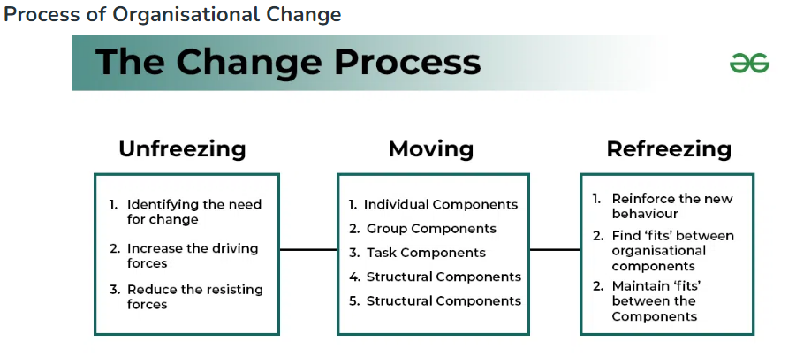
Akhtar (2023)

Appendix 3 - Kübler -Ross Change Curve

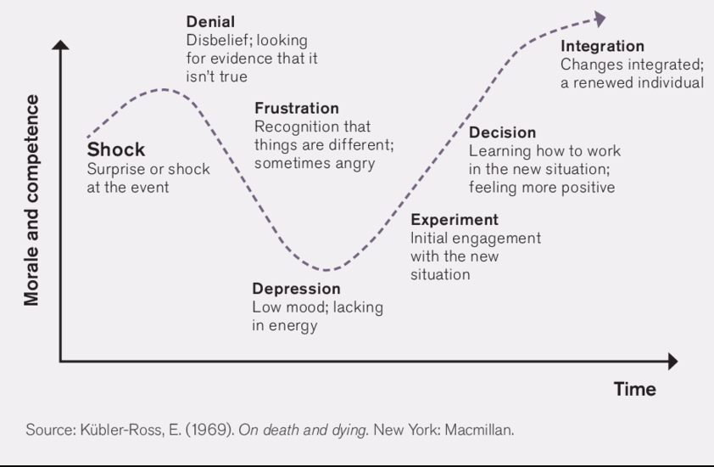
Austin (2015)

Appendix 4 - Prosci's ADKAR Model
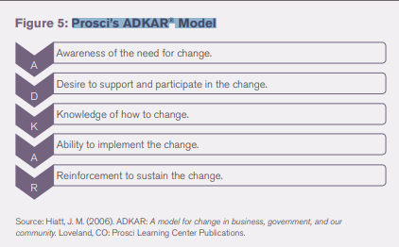
Austin (2015)

Appendix 5 - Kotter's 8 Step Model
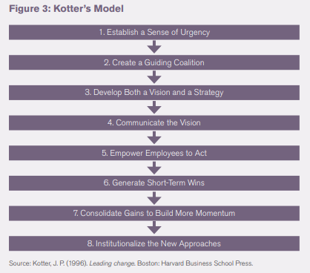
Austin (2015)

Appendix 6 - SWOT Analysis
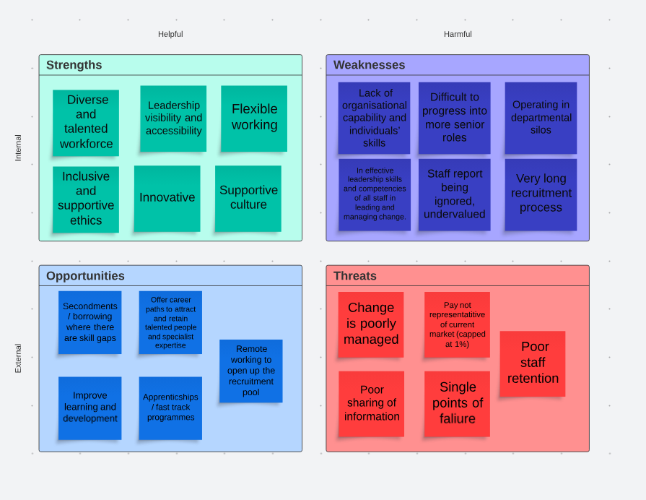
Rees (2023g)

Appendix 7 – PESTLE Analysis

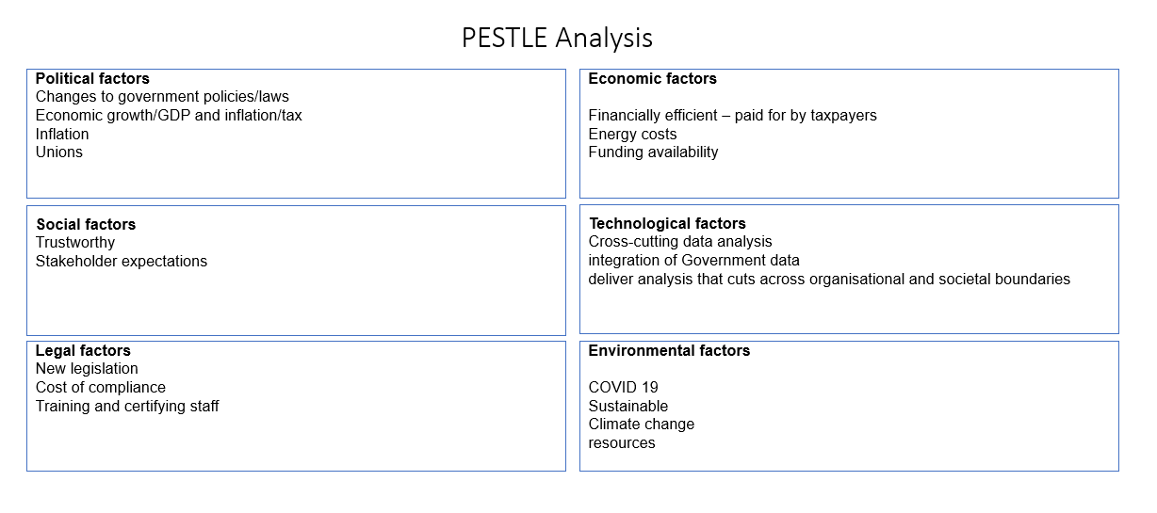
Rees (2023b)

Appendix 8 – Lewin's Force Field Analysis
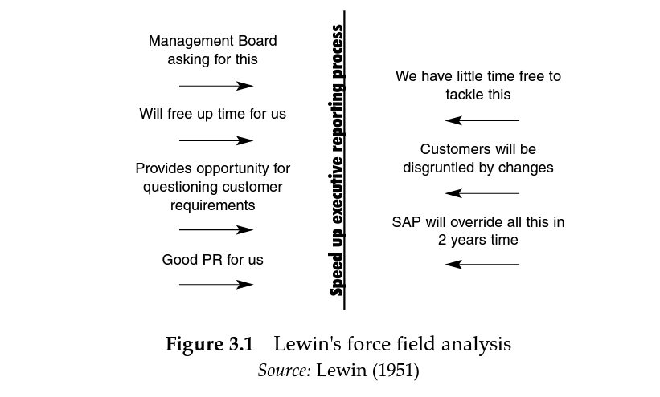
Lewin 1951; as cited in Cameron and Green, 2009)

Appendix 9 – Our Force Field Analysis
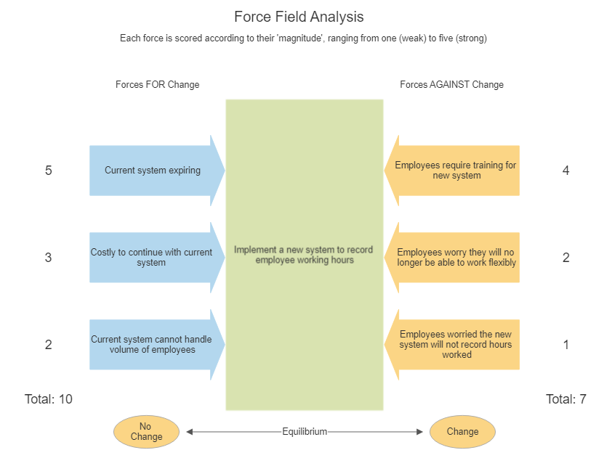
Rees (2023a)

Appendix 10 - Stakeholder Analysis Matrix
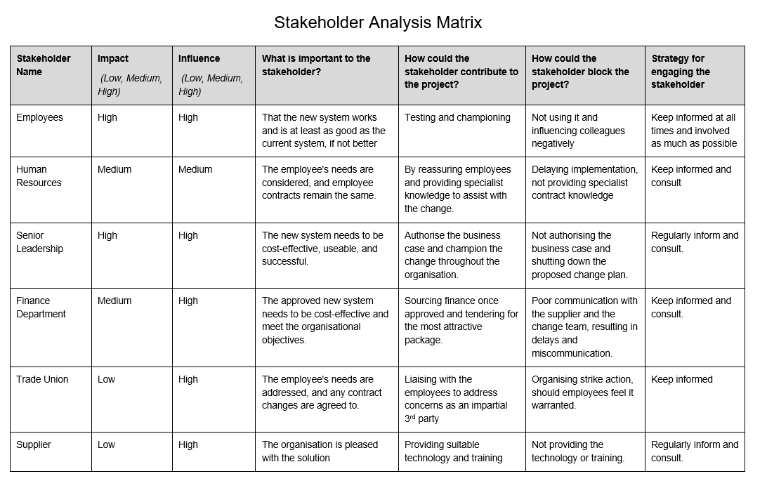
Rees (2023c)

Appendix 11 - Stakeholder Map
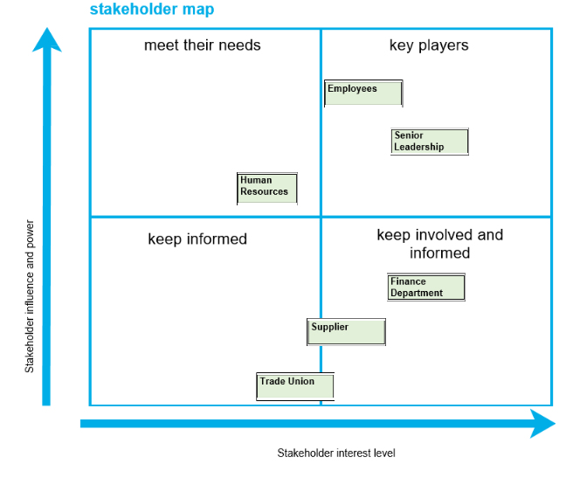
Rees (2023e)

Appendix 12 - Stakeholder Risk Analysis Matrix
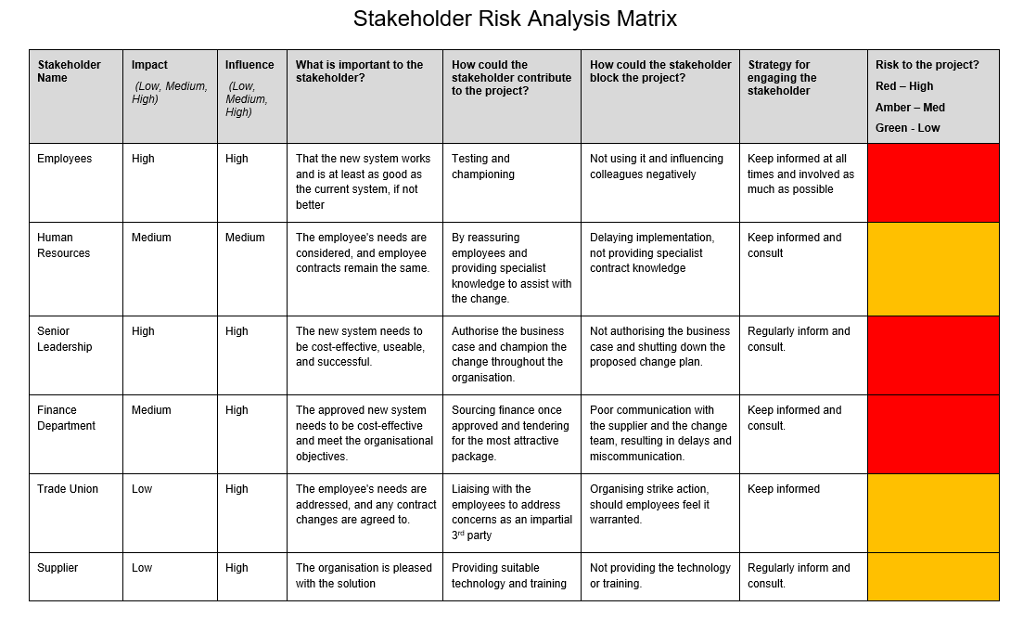
Rees (2023f)

Appendix 13- Stakeholder Communication Plan
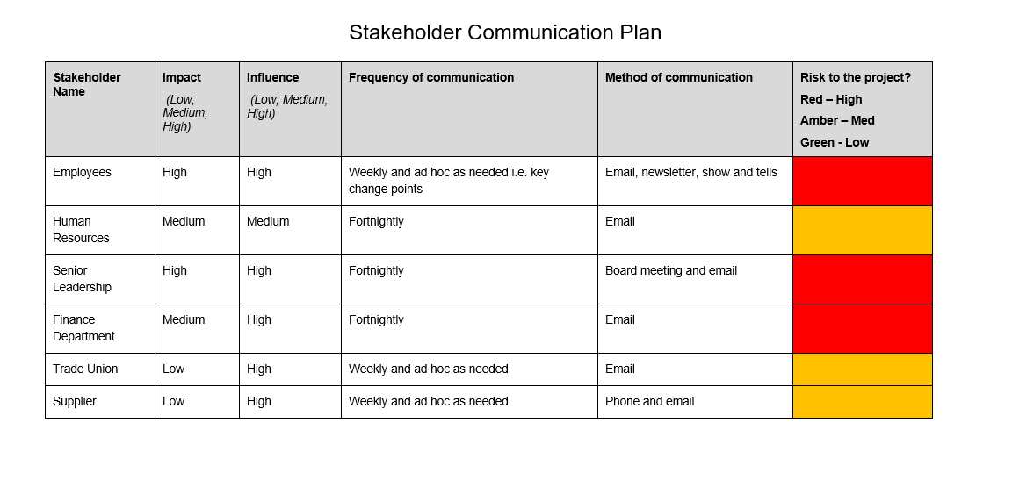
Rees (2023d)

Appendix 14 - Belbin's Team Roles
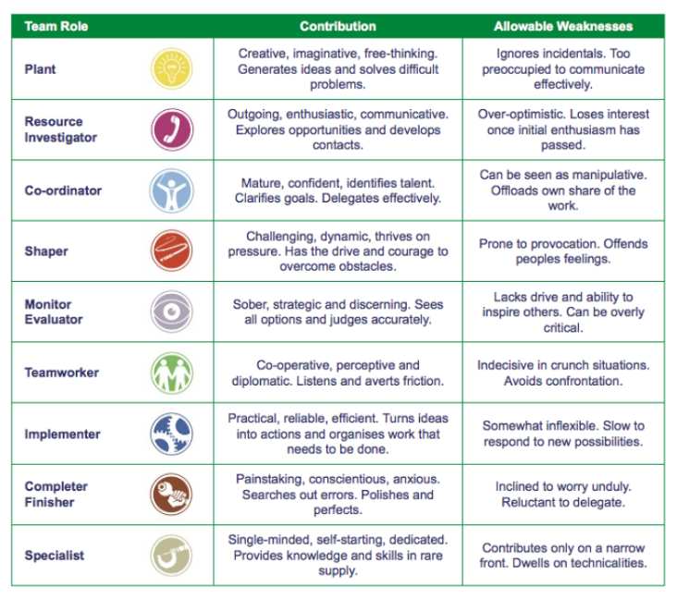
Fathy (2018)

Appendix 15 - Ishikawa (Fishbone) Diagram
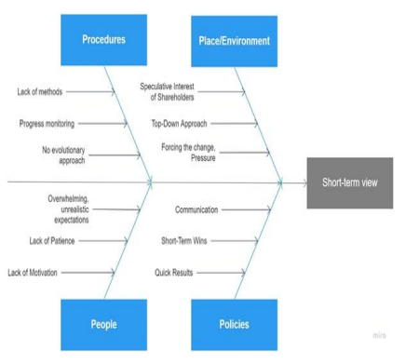
Dempsey et al. (2021)

Appendix 16 - Gantt Chart
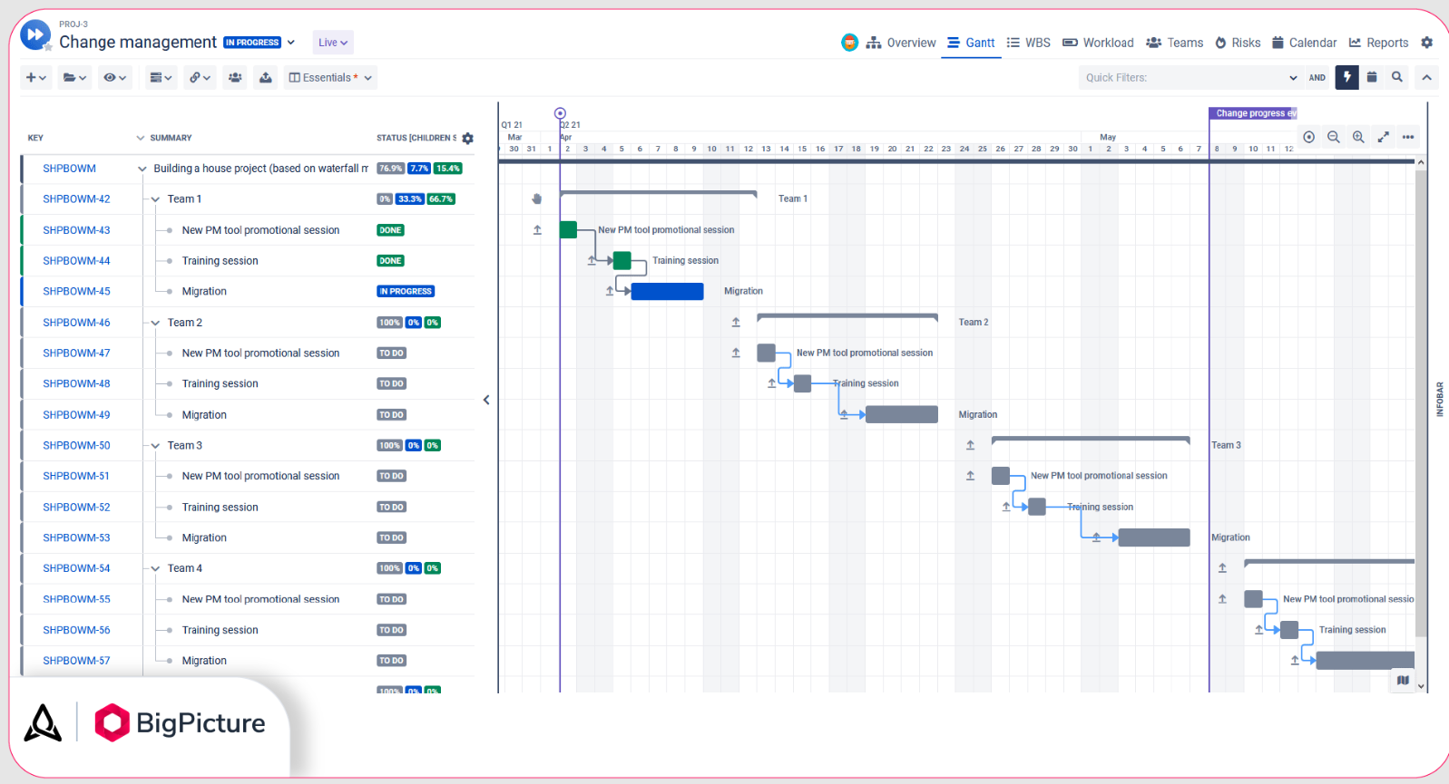
BigPicture Team (2023)

