Self- Reflection on conducting research on the impact of AI on employee performance at Amazon

This reflection is written to share the learning experience obtained during research and analysis of data. To share my experience, I have used the Gibbs reflective cycle. It has different steps which helped in structural learning.

- Description
The research was conducted on the role of AI in employee productivity at Amazon. In this regard, the primary research was conducted where consent was taken from a range of participants to get their perception of the use of technology in the workplace. There were 60 participants for this research. There were varied responses to some queries and for that statistical analysis was needed. It was a challenging task for me.
For this, I attended online tutorials and received help from a friend to use the statistical tool. Descriptive statistics, with Pearson correlation, Cronbach's alpha, regression, and one-way ANOVA, were utilized. The results were subsequently related to the Job Demands-Resources hypothesis and the Technology Acceptance Model. As part of the process, I had to go beyond just providing figures and explain the implications of the findings for managers, employees, and HR practice.
- Feelings
Artificial intelligence (AI) is becoming more obvious in modern organizations, which gave me confidence about the topic at first. Choosing and understanding statistical tests, though, was an area in which I felt less assured. It was anticipated that there would be a direct correlation between use of AI and increased output. The regression results were a reason for concern because I thought the results were weak. However, after doing the analysis, I have realized that these are actual findings and unexpected outcomes should not be regarded as failed results. The relationship may turn out to be more complex than first thought.

- Evaluation
The research approach was successful in several respects. Avoiding a simplistic view of technology, the survey discussed both the advantages and disadvantages of AI. More complexity in findings could also be expected because there was consistency in the productivity and adoption. More understanding was developed with better analysis and learning of data. I am thankful to this activity that I got learning of the statistical tools and knowledge of reading ANOVA tables and regression analysis.
There were fewer robust parts. Scales measuring training and overall benefits had poor Cronbach's alpha. This proved that not all components were compatible with one another. Employees from a variety of professions were included in the relatively small sample. Organizational performance records were also disregarded in favour of individual assessments of output.
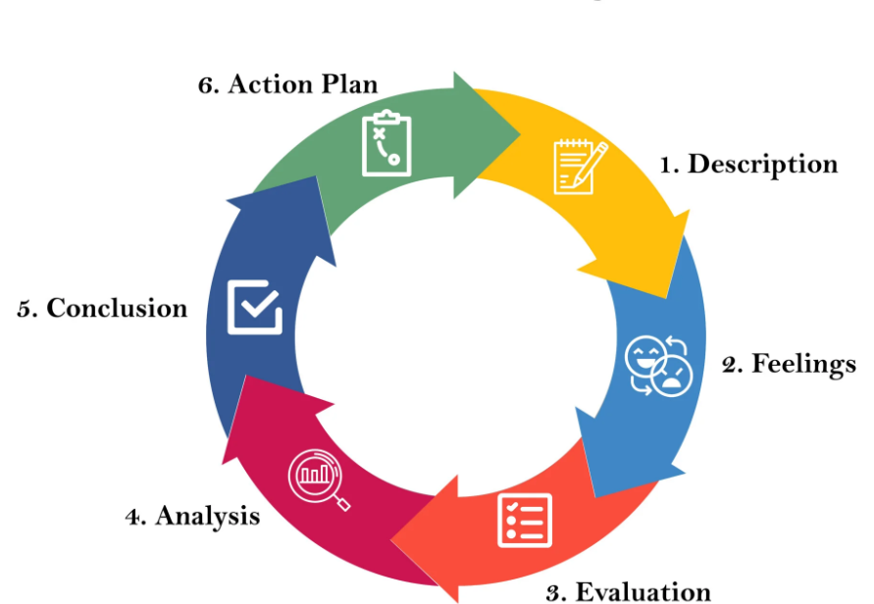

Figure showing the different stages of Gibbs reflective cycle (McLeod, 2025)

- Analysis
I have learned that obtaining high or average scores does not mean that results are strong. Even if respondents had a positive impression of AI and productivity separately, their combined scores would still be in the positive range. Training, management, job design, and the appropriateness of AI for certain activities can all impact productivity.
Similarly, while a significant ANOVA does show a difference overall, it takes post hoc testing to determine which groups actually differ.

- Conclusion
Thanks to this opportunity, I now have a better grasp of survey methodology, SPSS analysis, and critical thinking. I realized that it's better to be transparent about research limitations than to try to hide things like low reliability, insignificant results, and small samples. I have realized that things have changed about the AI. Instead of being afraid of technology, we need to adopt it to use it for the development of unique skills.

- Action Plan
In future, I would like to design the questionnaire more carefully to avoid unclear questions. I will recruit a more balanced sample but with necessary ethical approval process. I will learn more about the use of SPSS statistical tool and Excel formulas for the calculations and better interpretation of data. I have the intention to apply the SMART action plan to arrange the priority tasks to complete in scheduled time.

Reference
Gibbs, G. (1988) Learning by doing: A guide to teaching and learning methods. Oxford: Further Education Unit, Oxford Polytechnic.
McLeod, S. (2025). Gibbs reflective cycle. Simply Psychology. Available at: https://www.simplypsychology.org/gibbs-reflective-cycle.html

