Component 1- Coursework: Portfolio

Programme: CertHE Computing Skills for Workplace
Module: Software Solutions for Business
Module code: ACCA4026
Student name: Hifza Nasir
Student ID number: 2524550

Table of Contents
Task 1: e-Commerce Website Builders 3
1.1 Shopify 3
1.1.1 Overview 3
1.1.2 Key Features 3
1.1.3 Benefits in Business Context 3
1.1.4 Limitations 4
1.2 Wix e-Commerce 4
1.2.1 Overview 4
1.2.2 Key Features 4
1.2.3 Benefits in Business Context 5
1.2.4 Limitations 6
Task 2: Mind-map of contemporary software applications 6
2.1 Description and Benefits of Mind Mapping 6
2.2 Mind Map of Contemporary Business Software Applications 6
Task 3: 7
a. Office Applications for Creating, Storing, Presenting and Analysing Data 7
3.1 Microsoft Word 7
3.2 Microsoft PowerPoint 9
3.3 Microsoft Excel 10
3.4 Microsoft Access 11
b. Practical Testing of Selected Features 13
Feature 1: Mail Merge in Microsoft Word 13
Step 1: Preparing the Data Source 13
Step 2: Creating the Main Document in Word 14
Step 3: Linking Excel Data to Word 14
Feature 2: Pivot Table in Microsoft Excel 16
Step 1: Preparing Sales Data 16
Step 2: Creating the Pivot Table 17
Conclusion of Practical Testing 19
Task 4: Communication and Collaboration Applications 19
4.1 Communication Application: Microsoft Teams 19
4.2 Online Collaboration Application: Google Workspace 20
4.3 Practical Testing of Communication and Collaboration Features 22
References 25

Introduction:
This assignment is about different software used in business. These software helps organisations to work better, save time, and improve communication.
In this report, I will explain e-commerce platforms like Shopify and Wix and mind mapping and its benefits. I will also describe office applications such as Microsoft Word, PowerPoint, Excel, and Access.
In addition, I will discuss communication and collaboration tools like Microsoft Teams and Google Workspace. Some practical examples are also included to show how these tools are used in real situations. Overall, this assignment shows how software is important in modern business.

Task 1: e-Commerce Website Builders

1.1 Shopify

1.1.1 Overview

Shopify is an E-Commerce service offered on the cloud, which allows businesses to develop, operate and grow online stores without prior knowledge of expert technical expertise. It is a Software-as-a-Service (SaaS)-based solution offering a one-of-a-kind hosting, security and maintenance solutions [1].
Figure 1 Shopify Ecommerce Platform

1.1.2 Key Features
Shopify also has a drag-and-drop store builder with customizable themes with which businesses can create professional sites. It has various payment gateways, including Shopify Payments and PayPal, which make transactions easy. The system has an inventory and order management system to facilitate efficient operations. Moreover, the built-in search engine optimisation and marketing tools, including discount codes and email alerts, are useful in increasing the visibility and contact with customers. Its mobile-friendly interface and analytics dashboard also promote real-time monitoring and decision-making [2].
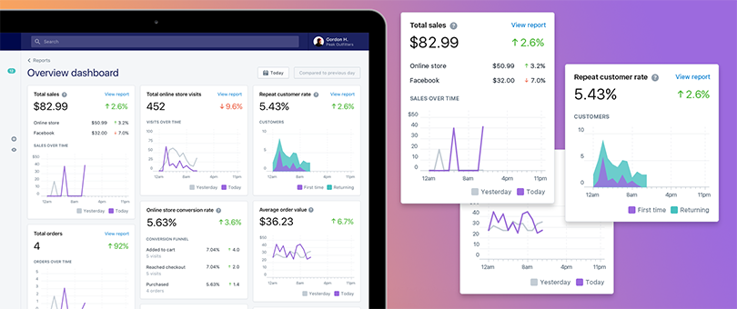
Figure 2 New Merchant Overview Dashboard [2]

1.1.3 Benefits in Business Context
Shopify improves the level of efficiency of the business in that it can quickly deploy the store and shorten time-to-market. It is scalable, offering businesses the opportunity to grow without changing the platforms. The integrated ecosystem minimises the usage of other applications, hence streamlining the processes. In addition, good security functions, such as an SSL certification, can handle safe transactions and convince customers [3].

1.1.4 Limitations
Shopify has certain weaknesses, despite having strengths. An increase in subscription costs may be based on the need for more advanced features in businesses. Compared to open-source platforms, there are not that many options for customisation. Moreover, transaction costs are imposed except for the use of Shopify Payments [4].
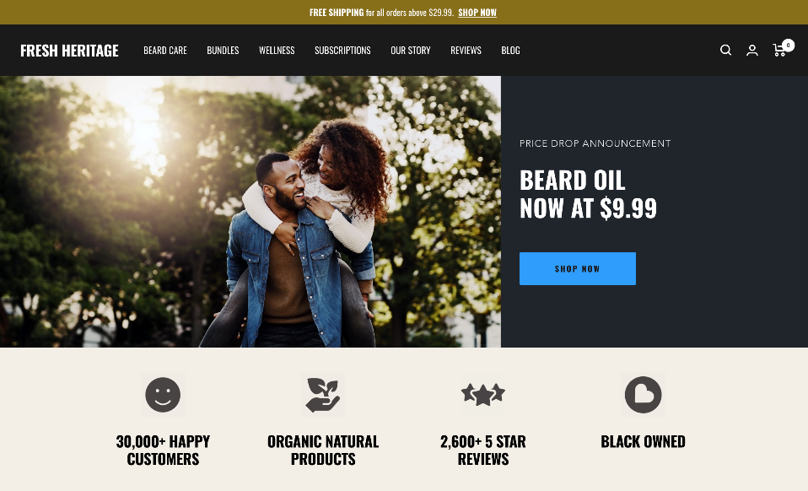
Figure 3 Shopify Stores as Inspiration [4]

1.2 Wix E-Commerce


1.2.1 Overview
Wix is a convenient site development platform and offers online payment services. It is aimed at individuals and small companies with low technical skills and has a drag-and-drop interface, which allows users to build websites fast [5].
Figure 4 Wix: Ecommerce Web Platform

1.2.2 Key Features
Wix offers customisation features as well as a design assistant based on artificial intelligence (Wix ADI), which makes it easier to build a site. It facilitates safe payment transactions, product handling and tracking orders. There are in-built marketing applications, such as search engine optimisation and email services, which positively affect online awareness [6].
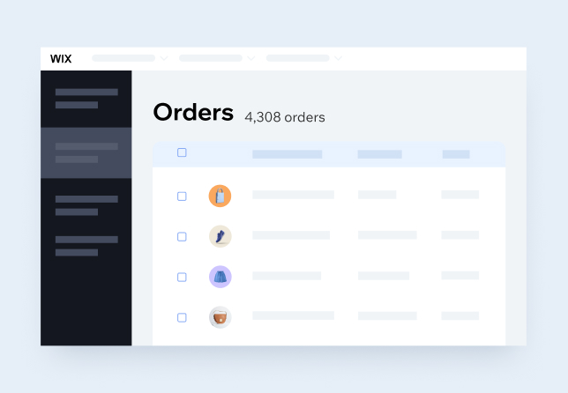
Figure 5 Building an e-commerce Website [6]
It further offers an app marketplace where they can add functionality depending on their business requirements.

1.2.3 Benefits in Business Context
Wix is very affordable and user-friendly, so it is perfect for small businesses and start-ups. It has the advantage of being used in the development of online stores quickly, and it has great flexibility in terms of design, where the business can make a harmonious website with great visual appeal. This helps to build up the brand and enhance customer interaction [7].
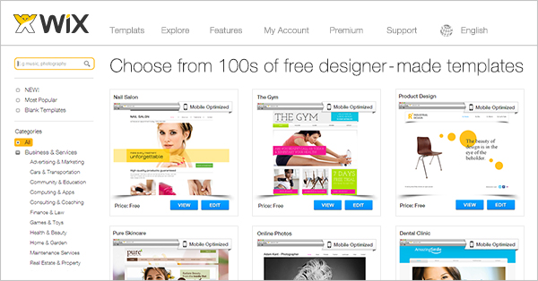
Figure 6 E-commerce Website Templates [7]

1.2.4 Limitations
Nevertheless, Wix cannot be used in large-scale operations as it cannot scale so much. Complex websites or heavy traffic may cause a fall in performance. It also has additional, lesser features of inventory control and back management than Shopify.

Task 2: Mind-map of contemporary software applications

2.1 Description and Benefits of Mind Mapping

Mind mapping represents a visual tool which is applied to systematise information in a connected and structured way. It starts with a core idea, around which other ideas, connected hierarchically, radiate out and create a web of ideas. This technique is based on the natural way of processing information by the human brain, as it is an effective way of analysing complicated concepts and enhancing comprehension. Mind mapping has been extensively utilised in business settings in planning, problem-solving and knowledge management processes. Among the advantages of mind mapping, there is the fact that it improves the generation of ideas. It promotes mind brainstorming and creative thinking because a person can expand the thoughts visually around a central theme and allows the same to be considered by different individuals and groups. Moreover, mind mapping is beneficial to facilitate better decision-making through the presentation of information in a clean and structured format that allows managers to assess alternatives and to determine relationships between variables more efficiently. The other significant benefit is better information retention. The visual layouts, keywords, and structured layouts make it easier to recollect information than in traditional linear notes. Mind mapping also provides efficient planning of projects as the large and complex tasks are subdivided into small, manageable elements, which aids in establishing priorities and following up on achievements [8].

2.2 Mind Map of Contemporary Business Software Applications
The business software applications form the central node of the mind map, and these are the digital tools which assist in the daily organisational activity. Based on this core idea, several major branches develop, each of which exemplifies a type of software applied in contemporary businesses [9].
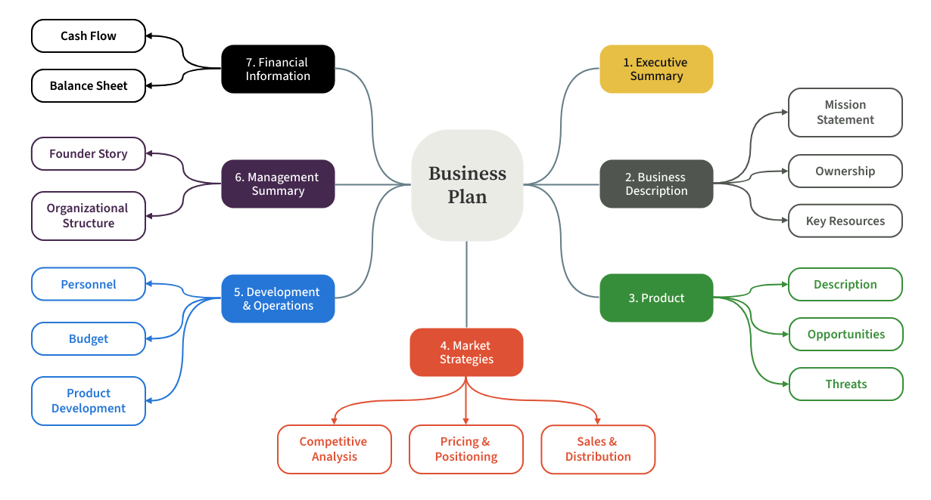
Figure 7 Business Plan Mind Map [9]
The first branch is Communication Tools, which contains applications, like WhatsApp and Microsoft Teams. These are tools that allow instant messaging, voice and video calls, and allow real-time communication among the employees and the customers. The second category is the Collaboration Tools, where such platforms such as Google Workspace and Slack can be found. All these applications facilitate teamwork in the form of shared documents, storage on the cloud, and integrated work procedures that can be utilised to allow two or more people to work on the same task at the same time. The third branch is Data Analysis Tools, which will be Microsoft Excel and Tableau. Project Management Tools is also a significant branch, and it comprises Trello and Asana. The functions assist organisations to plan, allocate and keep track of activities that suit time delivery of projects. The e-Commerce Platforms department is represented by services like Shopify and Wix, which allow companies to design and operate an online store. The given mind map shows the connection of various types of software applications and the overall contribution it makes to the process of business efficiency, communication, and decision-making [10].

Task 3:

a. Office Applications for Creating, Storing, Presenting and Analysing Data

3.1 Microsoft Word

Microsoft Word is an official word-processing program created by Microsoft and is commonly used in business organisations to create, edit, format and share documents. It is included in the Microsoft 365 Office and is regarded as the necessary tool to support administrative, managerial, and operational work. Some of the formal documents prepared using Microsoft Word by businesses include reports, contracts, proposals, policy documents, meeting minutes, business letters and internal communications [11]. The software also has an easy-to-use interface coupled with advanced formatting and editing features that enable it to be used in both simple and complicated documentation.

Figure 8 Microsoft Word [11]
Formatting and layout capabilities in Microsoft Word form one of the most important strengths. The users can use styles, themes, headings, page designs and templates to make structured and professional documents. The built-in spelling and grammar checker enhances the accuracy and professionalism of the documents. Besides, SmartArt, tables, charts, and image insertion features enable the user to make documents appealing. The Track Changes and the Comments features, which are provided in team-based environments, allow several users to read and make changes in documents without losing the old ones. The other feature that is of great importance in the course of business is the Mail Merge, which enables organisations to create personalised letters, invoices, or emails to large numbers of recipients using one template and a source of data [12].
Table 1 Summary of Microsoft Word [12]
Feature Category | Business Benefit | Limitation
Document Formatting | Professional and consistent documents | Formatting issues across versions
Review Tools | Easy collaboration | Can become complex with many editors
Mail Merge | Saves time in bulk communication | Requires a structured data source
Integration | Improves workflow efficiency | Limited data analysis capability

Microsoft Word offers several business advantages. It enhances productivity through standardisation of documentation procedures and the use of templates to support repetitive processes. It improves the flow of communication by a well-defined structure and professionalism. Moreover, it is also integrated with other Microsoft applications like Excel and Outlook, which enhances efficiency in workflow [12].
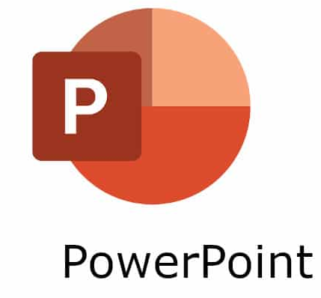

3.2 Microsoft PowerPoint
Microsoft PowerPoint is a presentation software application designed by Microsoft and highly utilised in contemporary business settings in visual communication. It allows one to make a presentation in the form of a slide and use text, images, graphs, charts, multimedia and animations. PowerPoint is normally applied in business meetings, strategic planning, sales presentations, staff training, marketing presentations and financial reports. This has an impact on its visual structure, which simplifies the complex information and makes it more tolerant to diverse audiences [13].
Figure 9 Microsoft PowerPoint
PowerPoint has all the features capable of supporting the designs of the presentation professionally. The software has inbuilt templates and themes that assist in ensuring the visual consistency. The Slide Master feature also enables users to make formatting standards on all slides, and this is more effective in keeping corporate branding. Also, animations and transitions create more interest once they are used in the right way. The use of charts and graphs can be directly inserted or imported into Excel, which makes it easy to represent the business-related data correctly. Another feature of significant importance is Presenter View, where the presenter can see notes on the slide and the next one, even though the audience can only see the presentation [14].
Table 2 Summary of Microsoft PowerPoint [14]
Feature Category | Business Benefit | Limitation
Pre-designed slide layouts | Professional visual consistency | Limited uniqueness without customization
Data visualisation tools | Simplifies complex data | Requires accurate data input
Controls overall formatting | Maintains brand identity | Needs technical understanding
Video, audio, images | Enhances engagement | Large files may slow performance

The main advantage of Microsoft PowerPoint in business activity is the enhanced communication. It helps managers and employees to provide information in a well-developed and visually attractive way. Charts and infographics can be used to simplify complex financial information, performance reports, and project updates. Moreover, PowerPoint can be integrated with multimedia which means that organisations can use videos or audio recordings during training. Despite these strengths, PowerPoint has its own flaws. Excessive use of animations and text has the potential to lower the effectiveness of presentations [15]. Besides, it cannot be used in the analysis of detailed data or in long-form documentation. PowerPoint greatly relies on the presentation capacity of the presenter.

3.3 Microsoft Excel

Microsoft Excel is a spreadsheet program created by Microsoft and is among the most effective tools applied in the world of business to manage and analyse data. It enables organisations to manage numerical data, thereby recording, computing, analysing and visualising it effectively. The applications of Excel are in accounting, finance, marketing, human resources, operations and supply chain management. It offers business a chance to do calculations in the form of formulas and functions, prepare financial projections, budgeting, sales performance analysis and inventory management [16].
Excel has extensive inbuilt functions, including IF, VLOOKUP, SUM, AVERAGE, COUNT and logical operators. Such purposes automate the calculations and minimise human error. One of the most powerful features in Excel is Pivot Tables, which enables the consumer to summarise and analyse large data sets in very little time. The charts and graphs are used to visualise trends and patterns, and data interpretation is easy for the decision-makers. The other feature that is worth mentioning is Goal Seek, which can be used to predict and perform scenario analysis by using the necessary input value to obtain this or that output. Conditional formatting improves the interpretation of the data since the program highlights the values according to the established requirements [17].
Figure 10 Microsoft Excel
Excel enhances decision-making in business operations. It allows financial planning and analysis of revenue and performance. Excel is used by managers to make comparisons between historical data and trends. It also facilitates automation with the use of macros, which minimise repetitive processes and enhance productivity. Excel is not without limitations, though. Incorrect formulas may lead to wrong conclusions unless checked keenly. It might not operate effectively with huge volumes of data as compared to sophisticated database systems. It is also not applicable to multi-user management of databases as compared to other systems, such as Microsoft Access [18].

3.4 Microsoft Access

Microsoft Access is a database management system (DBMS) created by Microsoft and is part of the Microsoft Office suite (selected editions) made available. As compared to Word, PowerPoint and Excel, which are mainly aimed at document creation and data analysis, Microsoft Access is specifically intended to be used in storing, organising and retrieving structured data. It also allows businesses to develop relational databases to store information in large quantities in an organised manner [19]. Microsoft Access is widely applied in small and medium-sized organisations in handling customer records, employees, inventory, supplier databases and sales records.
Figure 11 Microsoft Access
The creation of tables is one of the key characteristics of Microsoft Access, and the data in these tables is arranged in rows and columns like the table in Excel, albeit with more robust data integrity controls. A primary key may be provided on each table, but it makes sure that all the records are unique. There is also access whereby the user can define relationships among various tables, defining a relational database structure. This prevents data duplication and enhances consistency. The other valuable feature is Queries, which allow users to search, filter, calculate, and extract certain data in a single or multiple tables. Queries are effective, particularly in the production of business reports or the detection of trends amongst data stored [19].
Limitation
Limited scalability
Requires database design knowledge
Can be complex for beginners
Requires initial setup
Limited compared to enterprise BI tools
Not ideal for very large organizations
Microsoft Access has also Forms, which have the advantage of user-friendly interface in adding and updating data without altering the tables directly. Forms are advantageous in organisations with several employees’ feeding data since they minimise errors and create consistency in reporting data. Moreover, Reports feature enables business to create organized and professional reports of data stored, e.g., monthly sales reports or attendance summaries of employees. Such reports could be printed or exported so that they could be presented and analysed [2].

Enhanced data organisation and integrity are the main advantages of Microsoft Access in business operations. Through relational databases, organisations can work with a large amount of data with minimal redundancy. It facilitates effective decision-making as it provides defined queries and report creation [7]. There is also the integration of access with other Microsoft applications like Excel and Word, whereby one can export their data to further analysis or reports. Nevertheless, Microsoft Access has some limitations. Typically, it can be used on small to medium-sized databases but might not be efficient when used in large-enterprise contexts where the records are in the millions. In bigger organisations, more powerful database systems like SQL Server can be used. Furthermore, Microsoft Access also needs a working knowledge of the concepts of database design, like relationships, primary keys, and queries, which some users might need training on [6]. It can be accessed by multiple users, although the performance may decrease when many users access the database at the same time. Microsoft Access is significant in the management of business information because it offers an organised and solid system to store and retrieve information. Although it might not be as efficient as enterprise-level database systems, it is a worthy and viable solution to many small and medium-sized organisations.

b. Practical Testing of Selected Features

Feature 1: Mail Merge in Microsoft Word
This practical exercise aimed at testing the Mail Merge tool in Microsoft Word to create personalised letters to several recipients with the use of a single template and an Excel data source. Mail Merge is generally useful in business to send out bulk emails, invoices, appointment letters and marketing messages [9].

Step 1: Preparing the Data Source
First, an Excel spreadsheet was created containing customer details. The spreadsheet included the following fields:
Table 3 Data Source Excel File
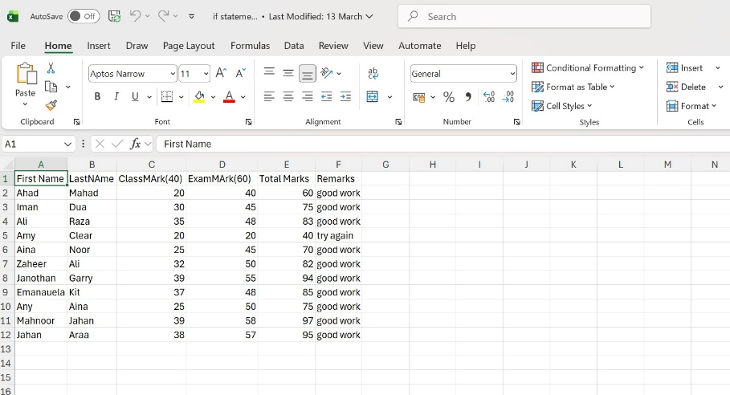
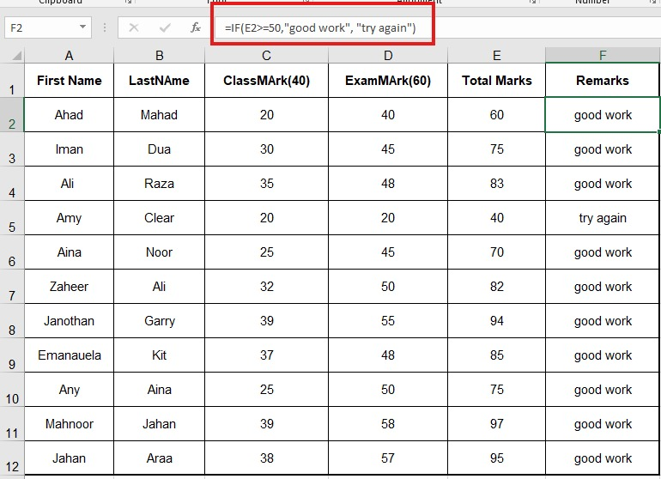
Table 4 If Function Applied
An IF function checks a condition and returns one value if the condition is true, and another if it is false.

Step 2: Creating the Main Document in Word
The letter template of a formal business letter was developed using Microsoft word. The letter had blank where the information about customers would be displayed.
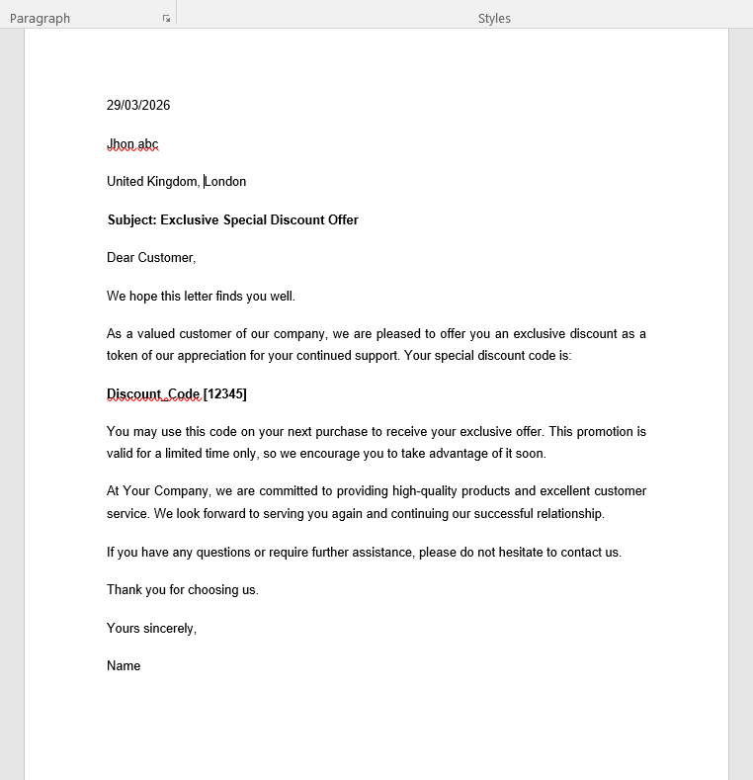
Figure 12 Letter in MS Word

Step 3: Linking Excel Data to Word
The following steps:
- Clicked on Mailings tab
- Selected Start Mail Merge Letters
- Clicked Select Recipients Use Existing List
- Selected the prepared Excel file and inserted merge fields into the document
- Preview Results
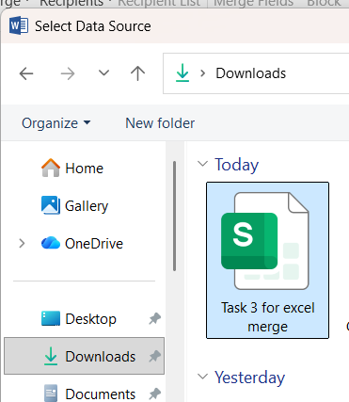
Figure 13 Selecting Data Source
Now selecting the sheet to merge in MS word;
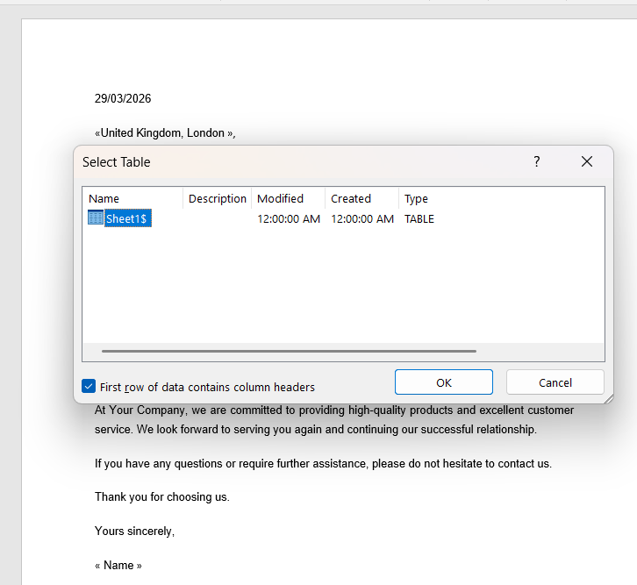
Figure 14 Merging Sheet into Word data
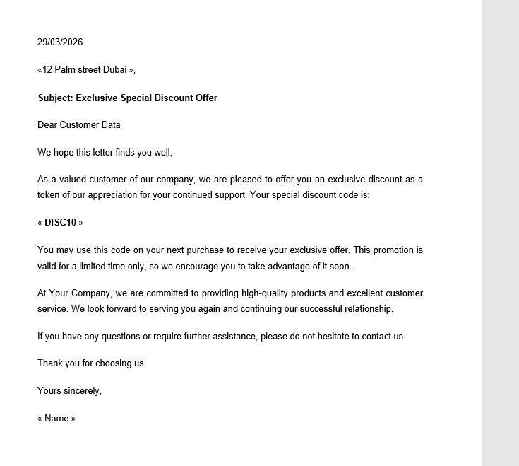
Figure 15 Preview Results
The Mail Merge option was effective in that it was able to create personalised letters of all the customers with the same template. This shows that through businesses, it is possible to send bulk marketing letters and create letters of appointment to employees. Also design invoices on a personal basis and enhance the efficiency of communication [14]. Mail Merge saves time, saves manual work and does not result in errors in communicating to the customers.

Feature 2: Pivot Table in Microsoft Excel
The purpose of this activity was to test the Pivot Table feature in Microsoft Excel to summaries and analyze sales data by region. Pivot Tables are widely used in business for reporting and decision-making.

Step 1: Preparing Sales Data
A dataset was created in Excel containing:
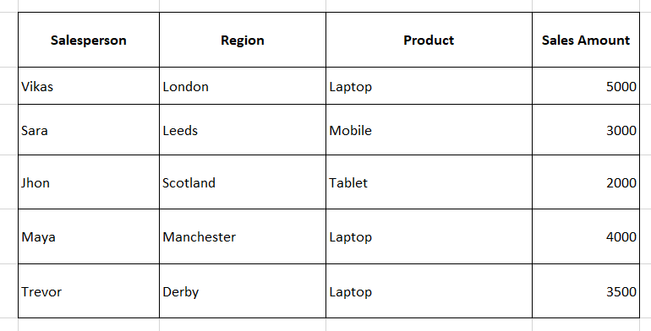
Figure 16 Raw Sales Dataset in Excel

Step 2: Creating the Pivot Table
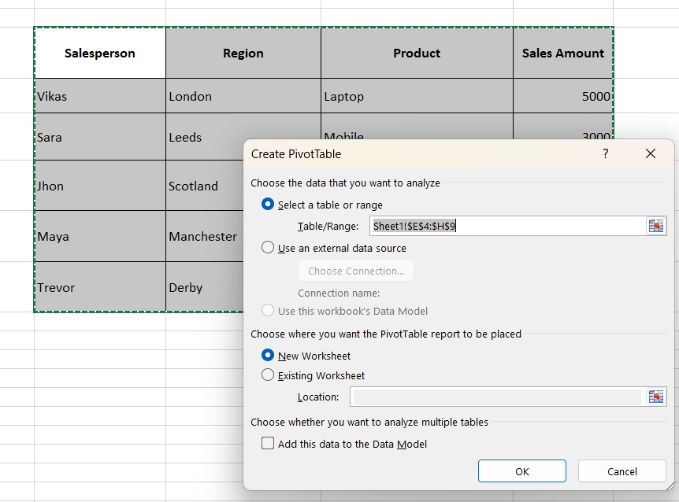
Figure 17 Insert Pivot Table and Select Range

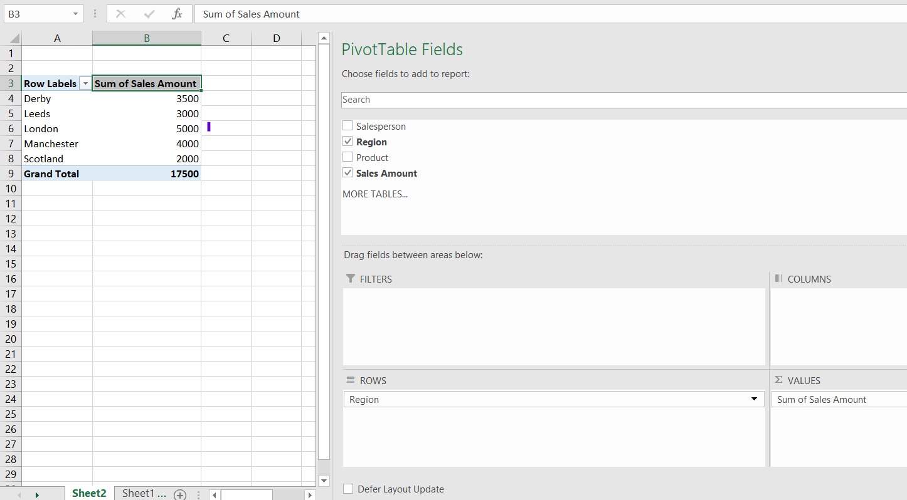
Figure 18 The excel calculated total sales by region
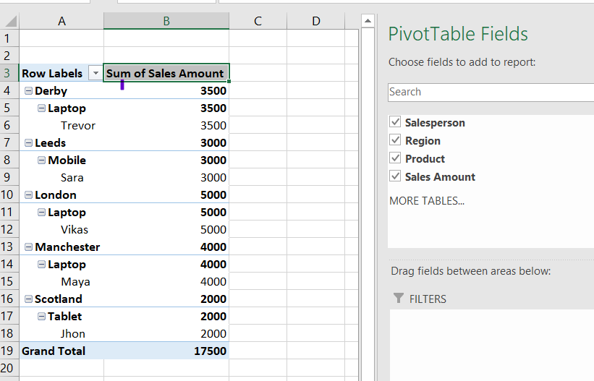
Figure 19 Final Pivot Table
The Pivot Table successfully summarized total sales by region without manually calculating totals. Pivot Tables improve efficiency by quickly transforming raw data into meaningful reports.

Conclusion of Practical Testing
The practical testing of Mail Merge and Pivot Table demonstrates how Microsoft Office applications support real business operations. Mail Merge improves communication efficiency by automating personalised document generation, while Pivot Tables enhance data analysis and reporting capabilities. Both features reduce manual work, minimize errors, and increase productivity in organisational environments [4].

Task 4: Communication and Collaboration Applications

4.1 Communication Application: Microsoft Teams
Microsoft Teams is a communication platform that was created by Microsoft in the cloud. Modern organisations have been extensively using it to facilitate both internal and external communication. Microsoft Teams is software for messaging, video conferencing, file sharing, and integrating applications into a single platform. Since the development of the remote working and hybrid work models, Microsoft Teams is among the most used business communication tools across the globe.
Microsoft Teams enables employees to interact in real-time via chat messages, voice calls, and video meetings. It also includes one-to-one communication as well as group dialogues arranged under Teams and Channels that facilitate a way to structure communication by department or project. It has one of the most powerful aspects, which is integration with Microsoft 365 applications which include Word, Excel, PowerPoint, and SharePoint, where users can work on their documents directly within the communication tool. Also, Teams is integrated with the recording of meetings, screen sharing, live captions, and calendar scheduling, which makes the meetings more efficient and documented [3].
Microsoft Teams enhances productivity in the business environment whereby communication is centralized within a single system rather than using many tools. It minimizes the amount of email since it promotes instant messaging and formal discussions. It also improves teamwork at a distance because employees will be able to participate in meetings even at various geographical areas. Also, it has inbuilt security and compliance features, which can guarantee safe communication and data protection, which is critical in organisations with sensitive data. There are limitations to Microsoft Teams though. It needs internet connection that is stable in order to perform well. Too many notifications can decrease the concentration of employees, unless handled appropriately. Advanced features can be complicated to the smaller business without the necessary training [5].
The major characteristics and business advantages of Microsoft Teams will be summarized as follows:
Feature | Business Benefit
Instant Messaging | Faster communication than email
Video Conferencing | Supports remote work
File Sharing | Improves collaboration
Integration with Microsoft 365 | Increases productivity
Meeting Recording | Documentation and training support
On the whole, Microsoft Teams is a very important tool in facilitating organisational communication and ensuring the efficiency of operations in contemporary companies.

4.2. Online Collaboration Application: Google Workspace
Google Workspace is a cloud-based solution from Google that provides collaborative services. It also incorporates Google Docs, Google Sheets, Google Slides and Google Drive. Businesses have a strong preference to Google Workspace due to its ability to provide real-time collaboration and cloud storage without needing any intricate installation. Google Workspace provides the possibility of working on a document by several people at the same time. Automatic saving of changes in real-time will minimize the chances of loss of data. The updates made by each user are visible immediately, and it has a version history, which enables organizations to trace the changes and restore the old version in case a need arises. This aspect greatly increases collaboration in project management and openness [20]. 
Figure 20 Joining Meeting Video On
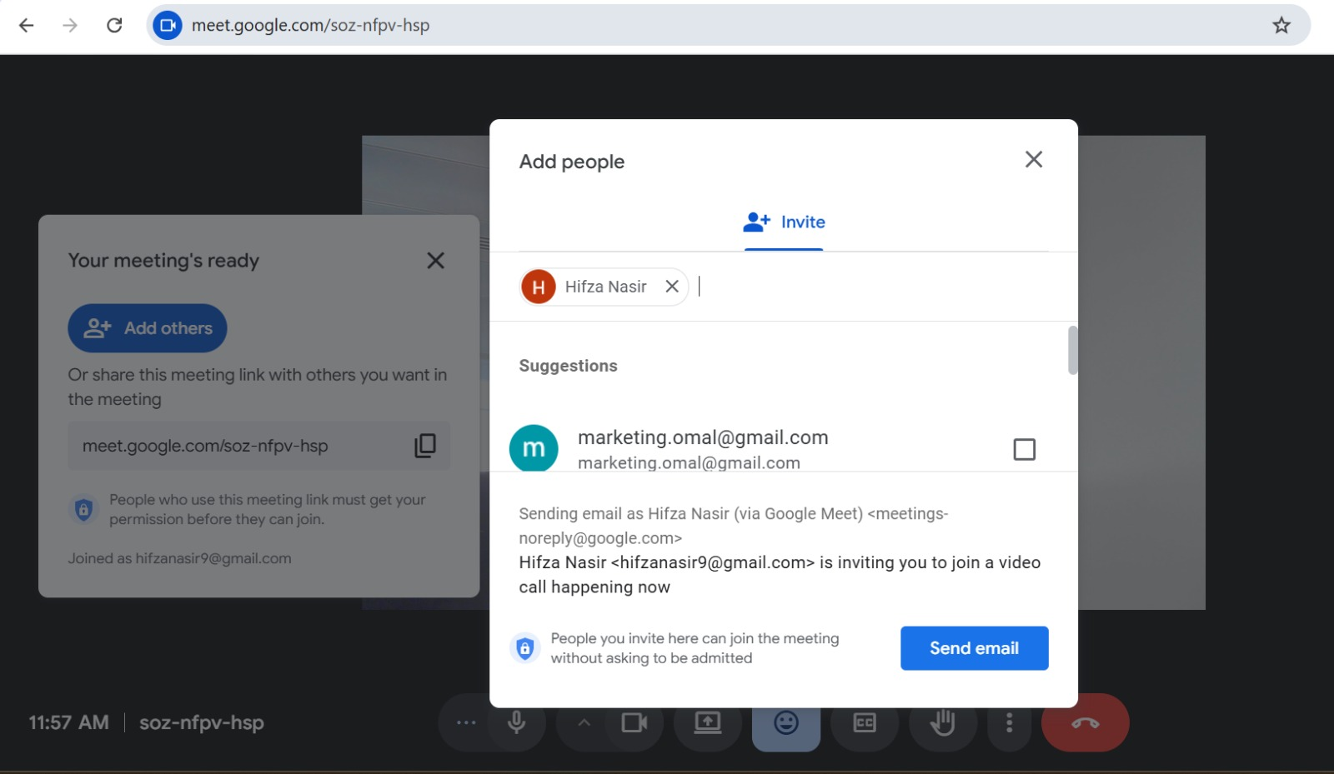
Figure 21 Adding People in the Meeting

Figure 22 Person Joined the Meeting
Google Workspace helps in remote working and cooperation in business activities. It is possible to prepare reports in Google Docs, analyze the financial data in Google Sheets, and prepare the presentations in Google Slides. Google Drive has secure cloud storage, which allows employees to access files any time and regardless of the device provided that the device has internet connection. The permissions (view, comment, edit) are shared that improves control and security of the documents. Google Workspace has limitations though they are limited in number [16]. It is highly reliant on the internet to be fully functional. Certain high-end format and analysis functions are not as strong as desktop Microsoft Office applications. Also, companies that deal with very sensitive information might need more security settings. The key characteristics and strengths in business are as follows:
Feature | Business Benefit
Real-Time Editing | Enhances teamwork
Cloud Storage (Google Drive) | Access from anywhere
Auto-Save | Reduces data loss risk
Version History | Improves accountability
Sharing Controls | Enhances security
To sum up, Google Workspace is a useful online collaborative tool, which fosters efficiency, flexibility, and teamwork within contemporary organizations.

4.3 Practical Testing of Communication and Collaboration Features
To illustrate the knowledge of practical use, one of the features of Microsoft Teams (a communication tool) and one of the features of Google Workspace (a collaboration tool) were tested. The video meeting feature of Microsoft Teams was the first one to be tested. An appointment was made using the calendar option on the application. The participants were contacted via their emails [12].
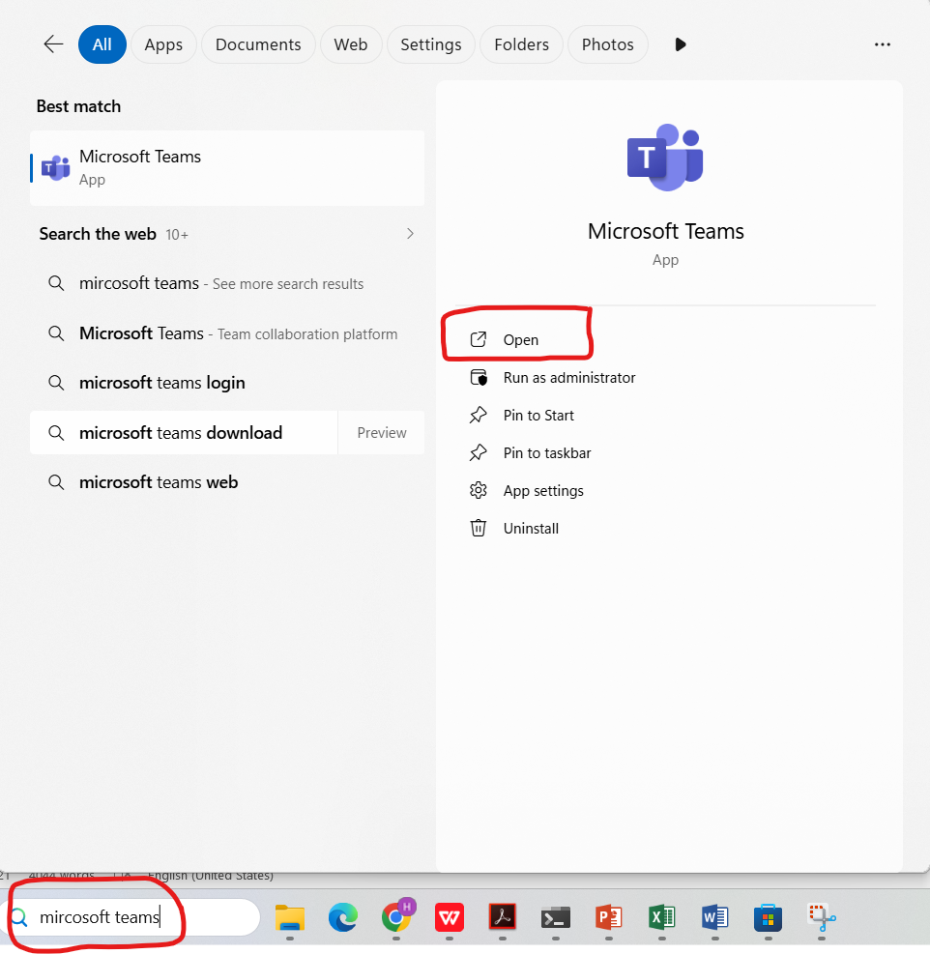
Figure 23 Open Microsoft Teams
Video conferencing and screen sharing facilities were turned on during the meeting. The system can facilitate real time communication among the participants and the recording meeting option was applied to save the session. This aspect shows how companies can hold virtual meetings effectively, especially where people are working remotely. The reports and data can be presented using screen sharing, whereas documentation and review can use recording [13].
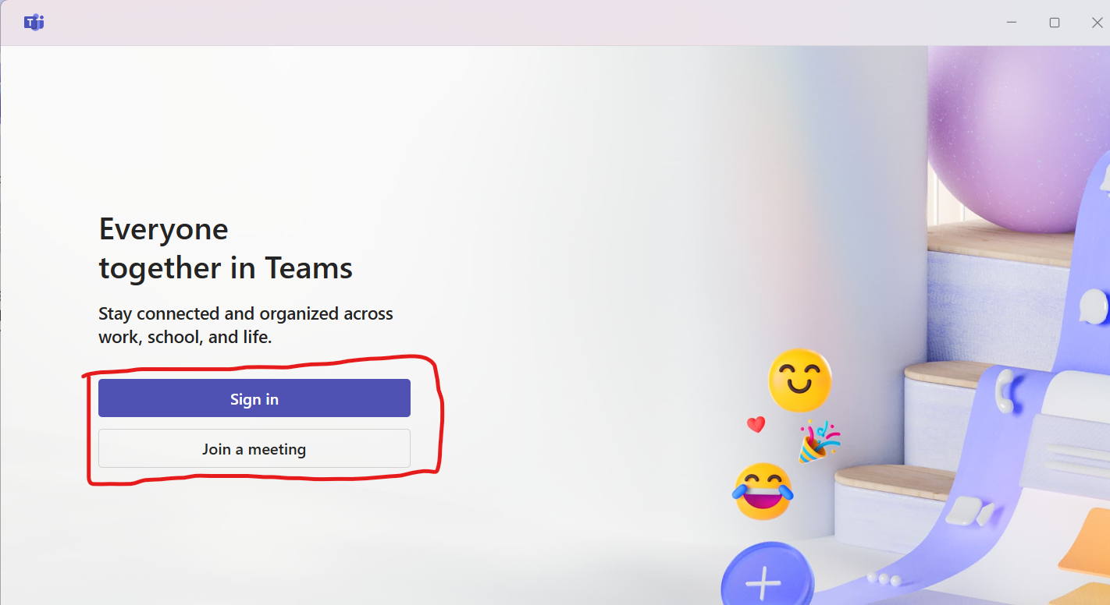
Figure 24 Log in using Microsoft account
Navigation to the Calendar in this case is performed after the teams are logged into.
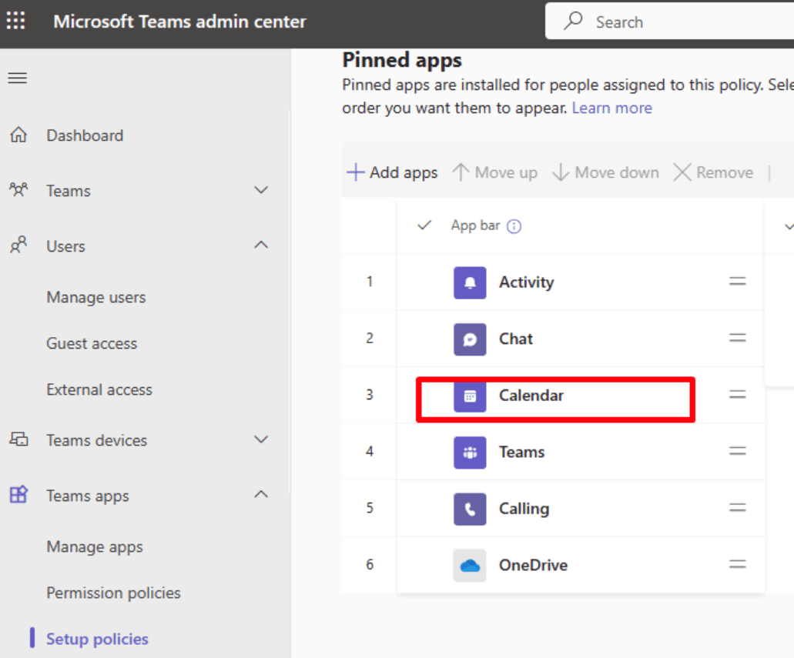
Figure 25 Navigate to the Calendar
The second feature that was tested was the real-time collaboration of documents in Google Docs (Google Workspace). A document was opened and shared with another user by use of the Share button. Permission was allowed to be edited. The two users worked on the document in real time and any changes would be reflected on the screen immediately. The version history functionality was checked to ensure that all changes were monitored. This aspect is a good indication of how teamwork efficiency can be increased through collaboration tools as there is no need to email a number of versions of documents. Such practical activities confirm that communication and collaboration technologies are very important in improving organisational performance [15]. They minimise time wastage, enhance coordination and facilitate flexible working models.

References
[1] M. Amini and N. Jahanbakhsh Javid, ‘A Multi-Perspective Framework Established on Diffusion of Innovation (DOI) Theory and Technology, Organization and Environment (TOE) Framework Toward Supply Chain Management System Based on Cloud Computing Technology for Small and Medium Enterprises’, Jan. 01, 2023, Social Science Research Network, Rochester, NY: 4340207. Accessed: Apr. 02, 2026. [Online]. Available: https://papers.ssrn.com/abstract=4340207
[2] L. Babashahi et al., ‘AI in the Workplace: A Systematic Review of Skill Transformation in the Industry’, Administrative Sciences, vol. 14, no. 6, p. 127, Jun. 2024, doi: 10.3390/admsci14060127.
[3] X. Yu, S. Xu, and M. Ashton, ‘Antecedents and outcomes of artificial intelligence adoption and application in the workplace: the socio-technical system theory perspective’, Information Technology & People, vol. 36, no. 1, pp. 454–474, Feb. 2022, doi: 10.1108/ITP-04-2021-0254.
[4] V. G. Goulart, L. B. Liboni, and L. O. Cezarino, ‘Balancing skills in the digital transformation era: The future of jobs and the role of higher education’, Industry and Higher Education, vol. 36, no. 2, pp. 118–127, Apr. 2022, doi: 10.1177/09504222211029796.
[5] A. Binsztok, B. Butryn, K. Hołowińska, M. L. Owoc, and M. Sobińska, ‘Business computer simulation supporting competencies. Potential areas of application and barriers.’, Procedia Computer Science, vol. 207, pp. 3875–3883, Jan. 2022, doi: 10.1016/j.procs.2022.09.449.
[6] M.-L. How and S.-M. Cheah, ‘Business Renaissance: Opportunities and Challenges at the Dawn of the Quantum Computing Era’, Businesses, vol. 3, no. 4, pp. 585–605, Dec. 2023, doi: 10.3390/businesses3040036.
[7] A. Alam, ‘Cloud-Based E-learning: Scaffolding the Environment for Adaptive E-learning Ecosystem Based on Cloud Computing Infrastructure’, in Computer Communication, Networking and IoT, S. C. Satapathy, J. C.-W. Lin, L. K. Wee, V. Bhateja, and T. M. Rajesh, Eds, Singapore: Springer Nature, 2023, pp. 1–9. doi: 10.1007/978-981-19-1976-3_1.
[8] M. A. Al-Sharafi, M. Iranmanesh, M. Al-Emran, A. I. Alzahrani, F. Herzallah, and N. Jamil, ‘Determinants of cloud computing integration and its impact on sustainable performance in SMEs: An empirical investigation using the SEM-ANN approach’, Heliyon, vol. 9, no. 5, May 2023, doi: 10.1016/j.heliyon.2023.e16299.
[9] M. A. Hazrat, N. M. S. Hassan, A. A. Chowdhury, M. G. Rasul, and B. A. Taylor, ‘Developing a Skilled Workforce for Future Industry Demand: The Potential of Digital Twin-Based Teaching and Learning Practices in Engineering Education’, Sustainability, vol. 15, no. 23, p. 16433, Jan. 2023, doi: 10.3390/su152316433.
[10] T. Rasool, N. F. Warraich, and M. Sajid, ‘Examining the Impact of Technology Overload at the Workplace: A Systematic Review’, Sage Open, vol. 12, no. 3, p. 21582440221114320, Jul. 2022, doi: 10.1177/21582440221114320.
[11] D. Cetindamar, K. Kitto, M. Wu, Y. Zhang, B. Abedin, and S. Knight, ‘Explicating AI Literacy of Employees at Digital Workplaces’, IEEE Transactions on Engineering Management, vol. 71, pp. 810–823, 2024, doi: 10.1109/TEM.2021.3138503.
[12] A. Khang, B. Jadhav, and S. Birajdar, ‘Industry Revolution 4.0: Workforce Competency Models and Designs’, in Designing Workforce Management Systems for Industry 4.0, CRC Press, 2023.
[13] S. Janakiraman, M. Sabin, M. Exter, and S. Duan, ‘Preliminary Results from a Systematic Literature Review on Computing Competencies Valued in the Workplace’, ACM Trans. Comput. Educ., vol. 26, no. 2, p. 22:1-22:50, Feb. 2026, doi: 10.1145/3785359.
[14] L. Li, ‘Reskilling and Upskilling the Future-ready Workforce for Industry 4.0 and Beyond’, Inf Syst Front, vol. 26, no. 5, pp. 1697–1712, Oct. 2024, doi: 10.1007/s10796-022-10308-y.
[15] D. Schlegel and P. Kraus, ‘Skills and competencies for digital transformation – a critical analysis in the context of robotic process automation’, International Journal of Organizational Analysis, vol. 31, no. 3, pp. 804–822, Aug. 2021, doi: 10.1108/IJOA-04-2021-2707.
[16] J. Muzam, ‘The Challenges of Modern Economy on the Competencies of Knowledge Workers’, J Knowl Econ, vol. 14, no. 2, pp. 1635–1671, Jun. 2023, doi: 10.1007/s13132-022-00979-y.
[17] M. J. A. Gonçalves, A. C. F. da Silva, and C. G. Ferreira, ‘The Future of Accounting: How Will Digital Transformation Impact the Sector?’, Informatics, vol. 9, no. 1, p. 19, Mar. 2022, doi: 10.3390/informatics9010019.
[18] S. Morandini, F. Fraboni, M. De Angelis, G. Puzzo, D. Giusino, and L. Pietrantoni, ‘The Impact of Artificial Intelligence on Workers’ Skills: Upskilling and Reskilling in Organisations’, 2023, doi: 10.28945/5078.
[19] P. Diawati, S. S. Gadzali, M. K. N. A. Aziz, A. M. A. Ausat, and S. Suherlan, ‘The Role of Information Technology in Improving the Efficiency and Productivity of Human Resources in the Workplace’, Jurnal Teknologi Dan Sistem Informasi Bisnis, vol. 5, no. 3, pp. 296–302, Jul. 2023, doi: 10.47233/jteksis.v5i3.872.
[20] N. Leesakul, A.-M. Oostveen, I. Eimontaite, M. L. Wilson, and R. Hyde, ‘Workplace 4.0: Exploring the Implications of Technology Adoption in Digital Manufacturing on a Sustainable Workforce’, Sustainability, vol. 14, no. 6, p. 3311, Jan. 2022, doi: 10.3390/su14063311.

