Module Title: Strategic Management and Sustainability
Module Code: LCBB6015
Student Name: Amadu Barrie
Student ID: 2323784

Executive summary
The strategy analysis has discussed some internal and external environment audits, and the external environment audit has evaluated the external factors using the PESTEL analysis and Porter’s five forces model. The internal factors of Aston Martin have been analysed through the resource-based view and the value chain framework. Further, the SWOT analyses of the company have been presented to highlight the key threats and opportunities for the luxury automobile. The strategy formulation has suggested some strategic alternatives to Aston Martin to enhance their market position while ensuring sustainable growth in the global market. The automobile industry is now facing new challenges and is under transformation which will shape the future of automobile industry, and in particularly the British automative industry is under high pressure due to their competitors.

Table of Contents
Introduction 4
Strategy analysis 5
Strategy Formulation 14
Conclusion and Recommendation 16
References 17

Introduction
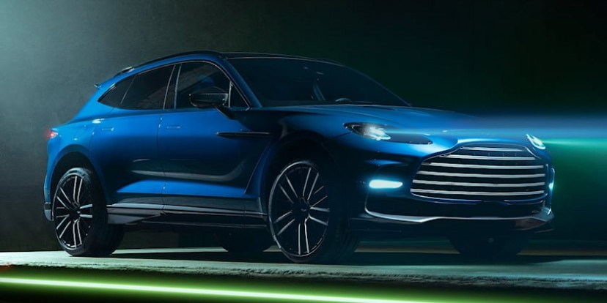
Figure: Aston Martin
Source: (astonmartin, 2026)
Strategic management is the process of setting goals, analysing the business environment and executing plans to ensure long-term success (Connaughton, 2021). The automobile industry is currently moving towards a sustainable future, where the main goal of the industry is to meet today’s needs without harming the economy. Aston Martin is a British manufacturer of luxury sports cars, famously recognised for its long association with the James Bond film franchise (astonmartin, 2026). The luxury car manufacturer’s vision is to be the world’s most desirable, ultra-luxury brand. The mission of the company is to celebrate a century of British engineering mastery and iconic design through luxury sport utility vehicles. And the static objectives are the transformation from internal combustion engines to hybrid and fully battery electric vehicles to reduce the environmental burden.

Strategy analysis
External Environment Audit
Pestel analysis
Political
Aston Martin is a British manufacturer, and the global supply chain of this company is impacted by the UK-EU and UK-US trade policies. For instance, in 2025, Aston Martin ended up with a loss of around $150 million due to the disrupted sales in the key markets and the uncertainties of tariffs (Winton, 2025). The government policies are also evolving rapidly, and they are shifting towards green initiatives. This directly dictates the funding and grants available for the company’s long-term electrification research and development.
Economic
One of the most significant economic factors are the global monetary policies heavily affect the borrowing costs which are required for the massive capital expenditure. Economic factors have pushed this company to cut a fifth of its workforce, which generally means that around 600 people will lose their jobs, which will hinder operational efficiency (Price, 2026).
Social

Figure: Q by Aston Martin
Source: (astonmartin, 2026)
The consumers' preferences are shifting towards ultra-personalised and custom-made products, and Aston Martin addresses the issue through their Q by Aston Martin division (astonmartin, 2026). The initial social drivers are prestige and brand heritage; therefore, the buyers purchase Aston Martin wholly to enhance their status and for the exclusivity of this brand.
Technological

Figure: Aston Martin is investing in hybrids and pure EVs
Source: (Hood, 2024)
In recent times, Aston Martin is putting a huge investment into integrating hybrid powertrains, pure EVs, and advanced driver-assistance systems (Hood, 2024). They have also innovated carbon fibre and advanced aerodynamics, which are crucial for optimising performance, speed, and more.
Environmental
There are several strict environmental regulations, such as Euro 7 for the automotive industry, which require Aston Martin to drastically reduce its carbon footprint (europa, 2026). Some pressures are there from environmental groups and socially conscious investors which needs this company to shift towards sustainable manufacturing processes. They are also exploring eco-friendly, carbon-neutral materials in their car interiors to manage sustainability and ESG pressures.
Legal
The regulatory frameworks worldwide dictate strict safety testing, pedestrian protection standards, crash compliance, and more. This company also needs to protect patents regarding engine design, vehicle, and other styling elements. Therefore, protecting the proprietary designs and the company's trademark helps protect them from infringement. These IP laws govern licensing agreements and merchandising for Aston Martin worldwide while helping them to protect their exclusivity (astonmartin, 2026).
Porter’s five forces
Competitive rivalry
The competitive rivalry for Aston Martin is high as this global automobile company operates in a vicious luxury, high-performance segment amongst brands like Ferrari, Lamborghini, Bentley, and more. Dynamics have also changed as the competition has shifted towards heritage motor force visibility and high-performance electrification.
Bargaining power of buyers
The customers of Aston Martin are generally elite ones, and they are less price sensitive and highly attracted by exclusivity and status; therefore, the bargaining power of buyers is moderate. However, the consumers have gained some power due to the ease of comparing specifications online. Aston Martin mitigates these challenges by replacing high-volume push sales with designated allocations and highly personalised options, which makes direct price comparison difficult.
Bargaining power of suppliers
The bargaining power of suppliers is high as this brand heavily relies on a limited number of high-quality suppliers. For instance, Mercedes-Benz supplies engine and electronic architectures to Aston Martin (astonmartin, 2023). During times of global supply chain disruptions, this brand is often forced to maintain or pass on premium costs, which can sometimes impact the gross margin of this company.
Threat of substitutes
The threat of substitutes is low, as owning a luxury sports car or high-end SUV, there are only a few direct substitutes outside of competing luxury markets. Also, there are some indirect alternatives, as some ultra-rich buyers might choose alternative forms of premium transportation, such as private jets or yachts. Therefore, the threat of substitutes is low, which can give Aston Martin a competitive advantage in the global market.
Threat of new entrants
The ultra-luxury automobile industry needs immense investment in capital for research and development, specialised tooling, and legal compliance with strict global safety standards. This makes it difficult for newcomers to establish a high-end luxury brand like Aston Martin and compete with other luxury brands in the global market. New entrants can also face extreme difficulty while replacing the century old-brand heritage, prestige, and loyal communities which Aston Martin possesses.

Internal Environment Audit
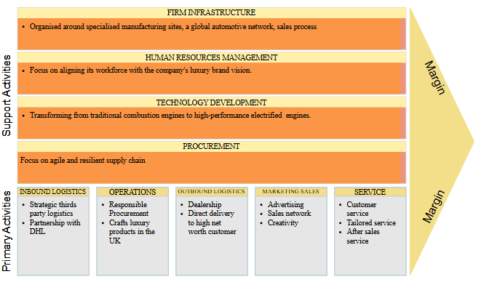
Figure: Value Chain Analysis
Source: Author
Value Chain Analysis
The value chain is a business strategy tool used to examine internal capabilities and was invented by Michael Porter, a Harvard Business School professor, in 1985.
Primary Activities
Aston Martin relies on a strategic third-party logistics model to manage its complex inbound supply chain of over 200 global suppliers. Partnership with DHL helps them to manage the inventory, warehousing and in-plant logistics (automotivelogistics, 2025). The brand primarily crafts its luxury products in the UK, at Gaydon, England, while the DBX707 luxury SUVs are manufactured in ST Athan, Wales. The company enforces a responsible procurement policy and assesses major suppliers on social and environmental standards (astonmartin, 2026). The brand distributes vehicles to a global dealer network across fifty countries as they optimise their transport to ensure vehicles arrive securely. The brand heavily relies on bespoke, tailored customer experiences to meet the demand and also the recent utilisation of the Aston Martin Aramco F1 team as a global marketing platform, helping them to meet the demands of high-net-worth buyers (astonmartin, 2026). The brand fosters personalised customer relationship management where after-sales service, maintenance, and bespoke modification programmes leverage deep brand loyalty.
Support Activities
The business firm's infrastructure is organised, and a global network of around fifty countries is helping the brand to gain its business objectives. Further, the human resource management is focusing on providing equal opportunities for the staff who can share their valuable input. The brand is transforming from a traditional combustion engine to a hybrid model, which will ensure fuel efficiency. Moreover, for procurement, the brand is highly reliant on supply chain management (astonmartin, 2026).
Resource-Based View
This is a strategic framework in business that focuses on analysing a company’s internal resources to identify a competitive advantage. This framework emphasises the importance of both tangible and intangible resources, where tangible resources include physical assets (Mazzei, 2024). Intangible resources include elements like brand reputation and intellectual property, which are less easily replicated by competitors.
Tangible resources
Aston Martin builds its competitive advantage in the luxury sports car market by fostering a unique blend of heritage, engineering expertise and Formula One technology. The UK-based manufacturing facilities give them a luxury construction site, and a partnership with Mercedes-Benz stabilises operations and helps them with finance. Under the Racing Green framework, the brand avails specialised components and technology towards sustainability goals (astonmartin, 2026).
Intangible resources
Over 100 years of glory with British styles and cinematic fame, like featuring in the James Bond franchise, help them to create global visibility (astonmartin, 2026). The Aston Martin Aramco F1 team helps the brand in global marketing. Further, after-sales service and providing maintenance costs to the customer, the brand has enhanced customer loyalty.
SWOT Analysis
A SWOT analysis is a strategic planning framework used to evaluate an organisation's position in the global environment. Aston Martin is an iconic British manufacturer known for producing ultra-luxury, high-performance sports cars. Its core strength is a rich heritage and bespoke design (astonmartin, 2026). However, weaknesses are associated with this organisation as the world is now transforming towards EVs, and the brand has limited mass market penetration in terms of EV cars.
Strengths  Elite Brand Recognition  Decades of rich heritage and deep luxury connection help the brand to maintain its prestige.  Racing Pedigree  A strong partnership with the Formula One groups enhances the brand's high-performance image, and the global marketing through this helps them to meet the demands of the high-net-worth buyers.  Bespoke Design  The brand's bespoke customisation service, called Q by Aston Martin, which allows the consumer to work with the design teams to create a personalised sports car according to their needs (astonmartin, 2026). These personalised services enhance customer satisfaction. | Weakness  Delayed Electrification  The brand has been struggling to launch the EV products in the market, where rival competitors are already scaling up the EV cars in the UK market (astonmartin, 2026).  Limited Portfolio  A smaller product range compared to the rival companies, like BMW, makes the brand shift towards providing a hybrid engine.  Lower market reach  Companies like Tesla and BMW are expanding their global reach frequently, whereas Aston Martin has minimal presence in several high-growth emerging economies.
Opportunities  Expanding EV line-ups  As the world is moving towards electric vehicles, the brand has a good opportunity to provide sports utility vehicles with battery engines, as the customer can experience sustainability with speed (Gustafsson and Holster Krantz 2022).  Expanding to the emerging market  The brand must expand its reach towards emerging economies like the Asia Pacific by providing a base model to capture the market. | Threat  Fierce Competition  Established luxury and supercar makers like Bentley and Tesla fight heavily for market share, and with a short product range, the brand faces a severe threat from these brands.  Economic Volatility  Fluctuating fuel costs due to instability in the Middle East are disrupting the supply chain, impacting the business heavily.

Strategy Formulation
Aston Martin needs to ensure sustainable growth and enhanced market position, and for ensuring this they need to shift towards high-performance Battery Electric Vehicles. They also need to strengthen their strategic tech collaboration and expand their ultra-luxury lifestyle ecosystem, as this will help them reduce dependency on traditional automotive cycles.
Accelerate electrification
Aston Martin needs to accelerate their electrification through strategic partnerships rather than investing heavily in proprietary EV platform development. This global organisation can also leverage existing supply chain agreements, such as utilising high-performance battery and electric drive systems, and more. This will allow them to introduce compelling BEVs which match their Formula 1 heritage, without disrupting the profit margins (astonmartinf1, 2026).
Expand the Racing Green initiative and sustainability initiatives
Aston Martin needs to transition their portfolio to electrified sports cars and SUVs while integrating some sustainable materials. As around 59% of UK consumers are shifting their preference towards EVs, they are becoming more eco-conscious regarding their purchases (electroverse, 2025). This brand can also capitalise on King Charles III’’s royal warrant and ESG investor appeals; this will help them in attracting environmentally conscious and ultra-luxury consumers (Murray, 2022). They are already incorporating vegan leather-free interior options, and they need to increase the number as the number of vegan and eco-conscious customers is increasing rapidly.
Exclusive Portfolio Management
This global brand can enhance their ultra luxury market position by leveraging exclusive portfolio management. This will help them shift their focus from the mass market volume to high-margin custom-made models. They can also limit wholesale unit volumes, which will help them boost demand while protecting their exclusivity and pricing power. Aston Martin can limit the supply of core models as it will build a sustained order book while reducing the dealership discount. Aston Martin already leverages custom-made services, and they need to expand this service, as this will help them capture outsized margins.

Conclusion and Recommendation
The report has analysed Aston Martin’s internal and external factors, where brand visibility and market presence help them meet the demand. On the other hand, the low product range and limited EV products create hurdles for the brand to meet the sustainability standards.
Recommendation
The brand must start its EV production to meet the sustainability standards and must capture the emerging economies to gain a competitive edge (Gustafsson and Holster Krantz 2022). Furthermore, the global supply chain is disrupted due to the Middle East tension, so the brand must find an alternative supply chain to mitigate the operational disruption.

References
astonmartin, (2023). Aston Martin to create industry leading ultra-luxury high performance electric vehicles. [Online] Available at: https://www.astonmartin.com/en/our-world/news/2023/6/26/aston-martin-to-create-industry-leading-ultra-luxury-high-performance-electric-vehicles[Accessed 06 June 2026].
astonmartin, (2026). About Us. [Online] Available at: https://www.astonmartin.com/en/corporate/about-us [Accessed 06 June 2026].
astonmartin, (2026). ASTONMARTIN.COM - GENERAL TERMS & CONDITIONS. [Online]Available at: https://www.astonmartin.com/en/legal[Accessed 06 June 2026].
astonmartin, (2026). Embedding sustainability principles. [Online] Available at: https://www.astonmartin.com/en/corporate/sustainability/responsible-business/embedding-sustainability-principles [Accessed 07 June 2026].
astonmartin, (2026). Q by Aston Martin. [Online] Available at: https://www.astonmartin.com/en/q-by-aston-martin [Accessed 07 June 2026].
astonmartin, (2026). Strategy. [Online] Available at: https://www.astonmartin.com/en/corporate/about-us/strategy [Accessed 07 June 2026].
astonmartinf1, (2026). Our Racing Heritage. [Online] Available at: https://www.astonmartinf1.com/en-GB/heritage[Accessed 07 June 2026].
automotivelogistics, (2025). The story of 2025 livestream: Data-driven planning anchors Aston Martin amid turbulence. [Online] Available at: https://www.automotivelogistics.media/supply-chain/the-story-of-2025-livestream-datadriven-planning-anchors-aston-martin-amid-turbulence/2578236 [Accessed 07 June 2026].
Connaughton, S. A., (2021). Strategic Management in a Sustainable Society. [Online] Available at: https://www.ebsco.com/research-starters/environmental-sciences/strategic-management-sustainable-society [Accessed 06 June 2026].
electroverse, (2025). Why are more UK consumers choosing electric cars?. [Online] Available at: https://electroverse.com/community/news-and-competitions/why-are-more-uk-consumers-choosing-electric-cars-[Accessed 07 June 2026].
europa, (2026). Vehicle emissions and battery durability (Euro 7): technical requirements and certification rules. [Online] Available at: https://eur-lex.europa.eu/EN/legal-content/summary/vehicle-emissions-and-battery-durability-euro-7-technical-requirements-and-certification-rules.html[Accessed 06 June 2026].
Gustafsson, L. and Holster Krantz, L., (2022). Brand Strategy in the Era of Electric Vehicles: Researching the brand strategies of some of the largest vehicle manufacturers in the shift towards EVs.
Hood, B., (2024). Aston Martin Is Investing in Hybrids as EV Demand Wavers. [Online]Available at: https://robbreport.com/motors/cars/aston-martin-combustion-engine-shift-focus-ev-hybrids-1235580040/[Accessed 06 June 2026].
Mazzei, M., (2024). Resource-Based View (RBV). [Online] Available at: https://www.ebsco.com/research-starters/business-and-management/resource-based-view-rbv [Accessed 07 June 2026].
Murray, M., (2022). King Charles III: Welsh businesses await Royal Warrant decision. [Online] Available at: https://www.bbc.com/news/uk-wales-62889003[Accessed 07 June 2026].
Price, R., (2026). How Aston Martin must adapt to meet changing needs. [Online] Available at: https://www.bbc.com/news/articles/c2k8nl2evxyo[Accessed 06 June 2026].
Winton, N., (2025). Aston Martin Stumbles Again As Investors Patience Is Tested. [Online]Available at: https://www.forbes.com/sites/neilwinton/2025/10/07/aston-martin-stumbles-again-as-investors-patience-is-tested/[Accessed 06 June 2026].

