Appendix A

Emotion Regulation Questionnaire (ERQ)
Gross & John
9/03
The Emotion Regulation Questionnaire is designed to assess individual differences in the habitual use of two
emotion regulation strategies: cognitive reappraisal and expressive suppression.
Citation
Gross, J.J., & John, O.P. (2003). Individual differences in two emotion regulation processes: Implications for
affect, relationships, and well-being. Journal of Personality and Social Psychology, 85, 348-362.
Instructions and Items
We would like to ask you some questions about your emotional life, in particular, how you control (that is, regulate
and manage) your emotions. The questions below involve two distinct aspects of your emotional life. One is your
emotional experience, or what you feel like inside. The other is your emotional expression, or how you show your
emotions in the way you talk, gesture, or behave. Although some of the following questions may seem similar to one
another, they differ in important ways. For each item, please answer using the following scale:
1-----------------2------------------3------------------4------------------5------------------6------------------7
strongly neutral strongly
disagree agree
1. ____ When I want to feel more positive emotion (such as joy or amusement), I change what I’m thinking about.
2. ____ I keep my emotions to myself.
3. ____ When I want to feel less negative emotion (such as sadness or anger), I change what I’m thinking about.
4. ____ When I am feeling positive emotions, I am careful not to express them.
5. ____ When I’m faced with a stressful situation, I make myself think about it in a way that helps me stay calm.
6. ____ I control my emotions by not expressing them.
7. ____ When I want to feel more positive emotion, I change the way I’m thinking about the situation.
8. ____ I control my emotions by changing the way I think about the situation I’m in.
9. ____ When I am feeling negative emotions, I make sure not to express them.
10. ____ When I want to feel less negative emotion, I change the way I’m thinking about the situation.
Note
Do not change item order, as items 1 and 3 at the beginning of the questionnaire define the terms “positive emotion”
and “negative emotion”.
Scoring (no reversals)
Reappraisal Items: 1, 3, 5, 7, 8, 10; Suppression Items: 2, 4, 6, 9.

APPENDIX B
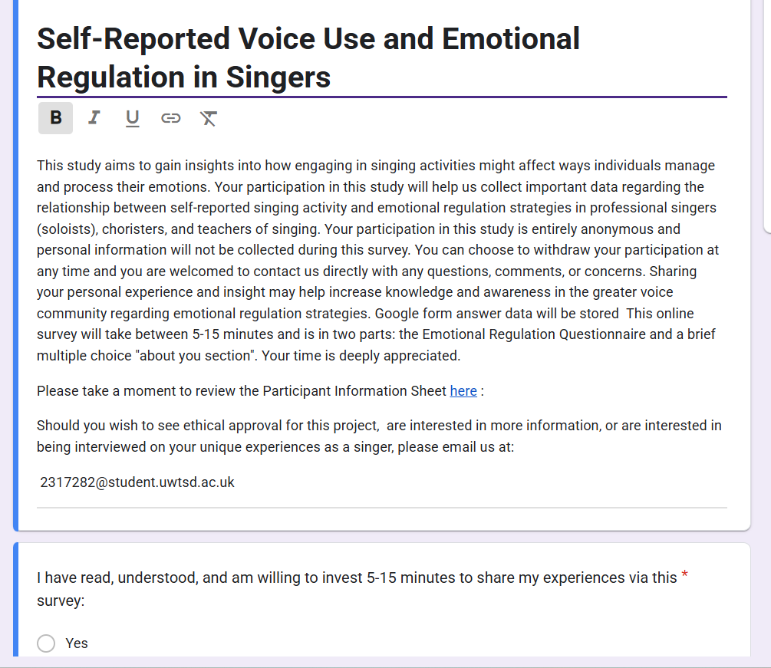
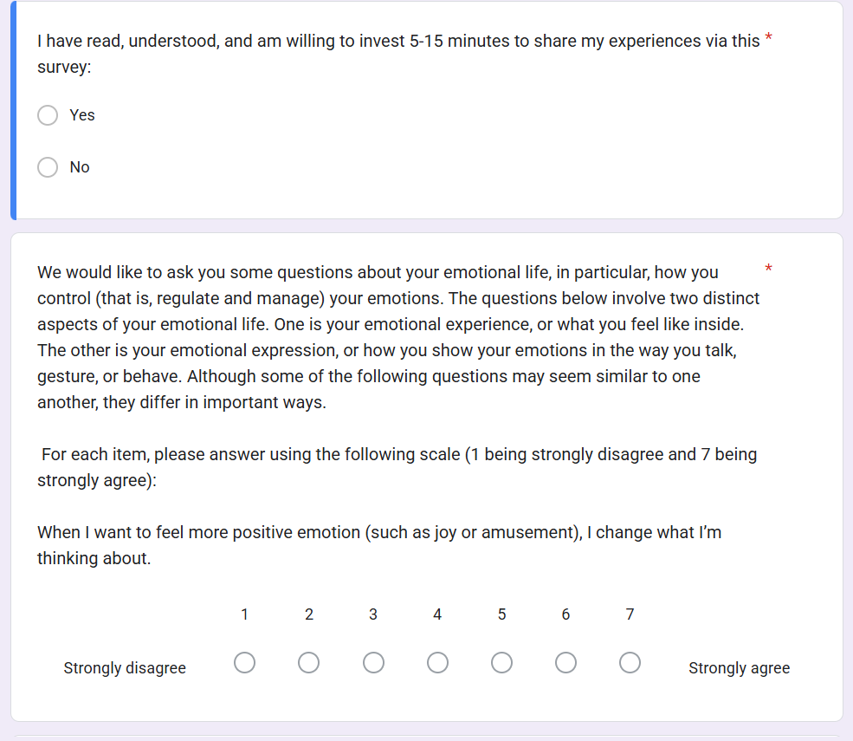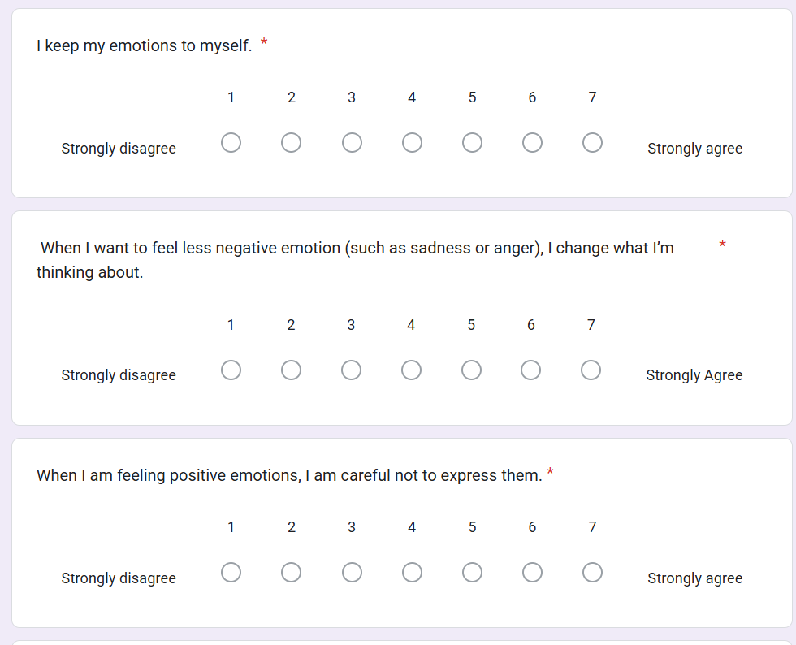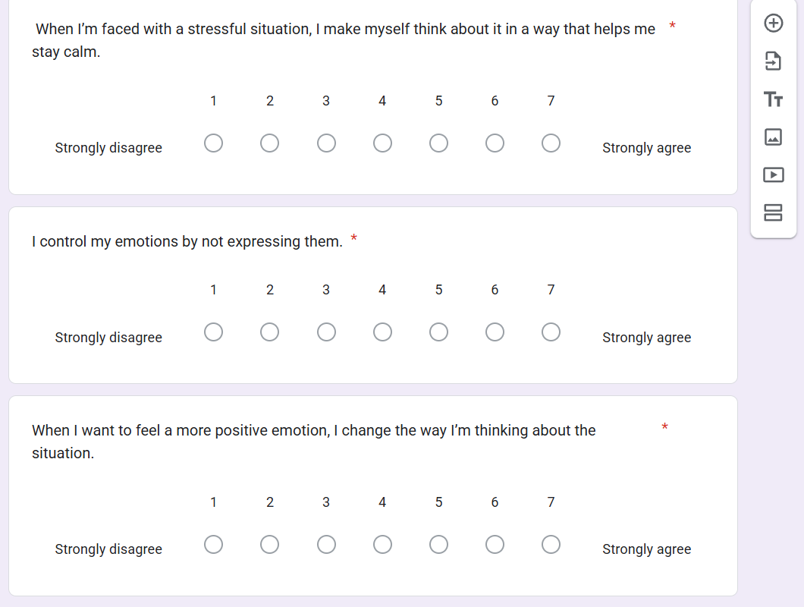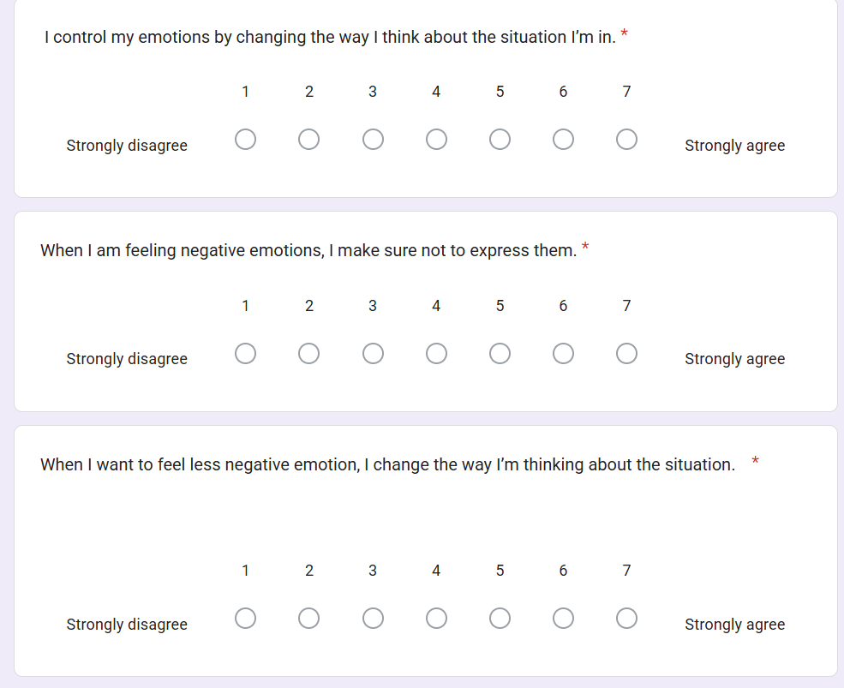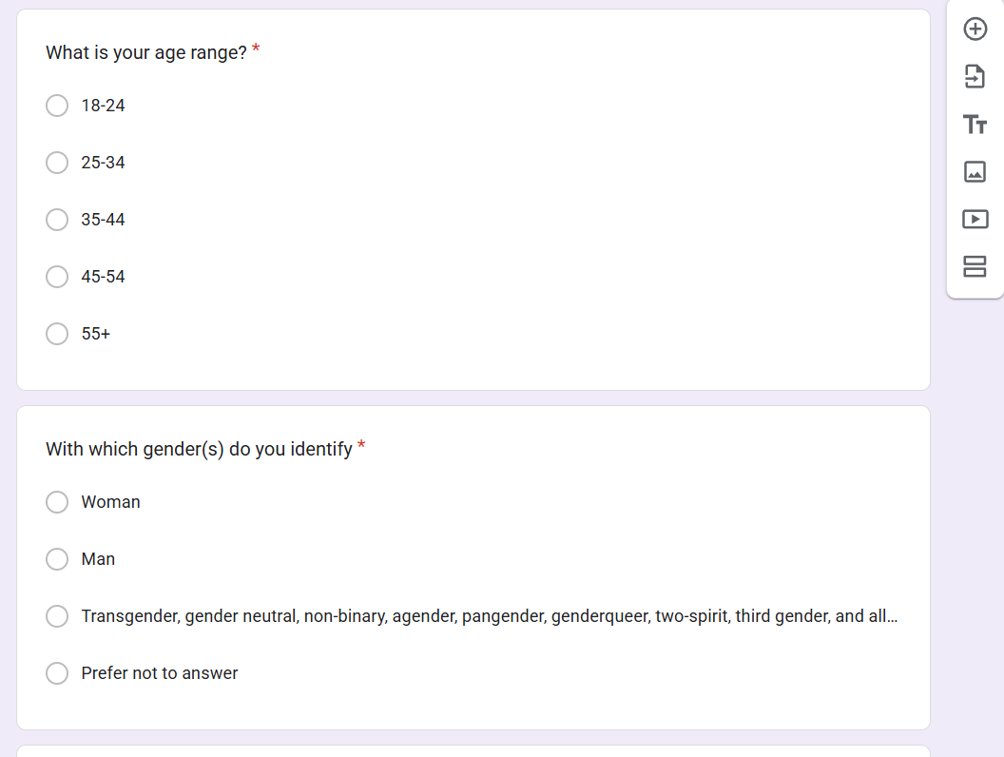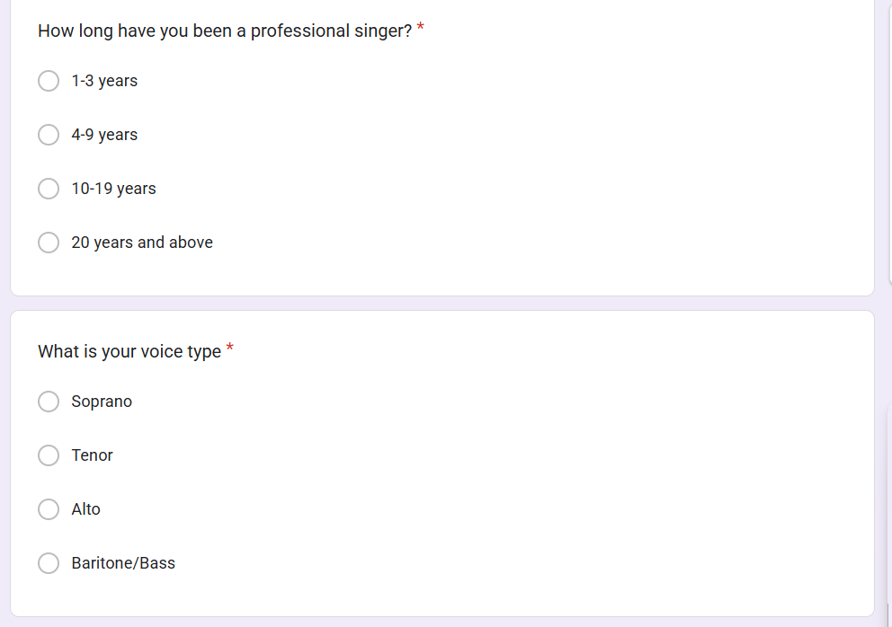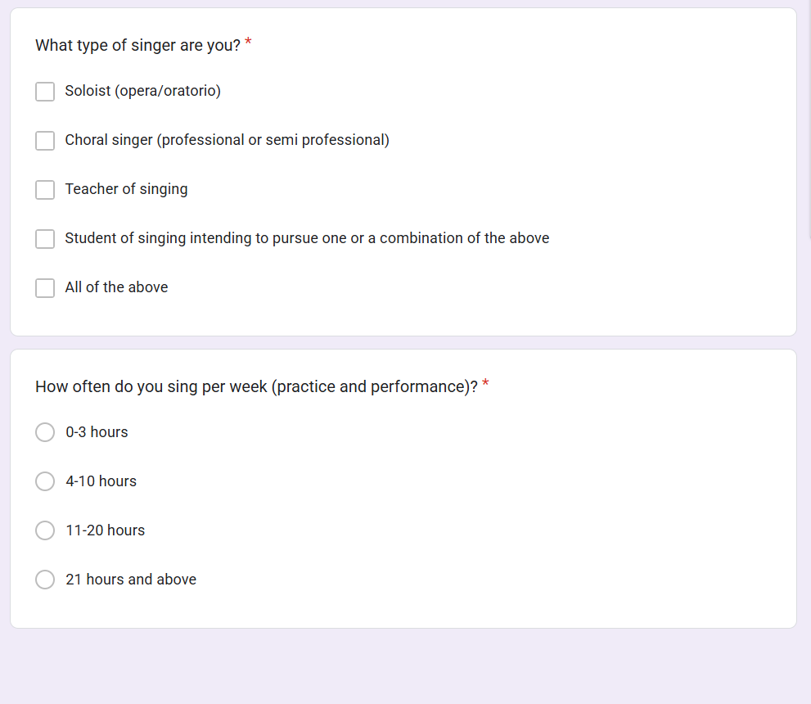

APPENDIX C- Raw Data

Demographics
ERQ Scores

APPENDIX D

INFORMED CONSENT FORM

Full title of Project: What is the relationship between self-reported singing activities and emotional regulation strategies in professional singers (soloists), choristers, and teachers of singing?
 | Please initial box
I confirm that I have read and understand the Participant Information Sheet for the above study and have had the opportunity to ask questions.

I understand that taking part in the project will involve taking part in an anonymous questionnaire and individual interview, where I will be asked about my thoughts, experiences and opinions regarding how singers experience emotional regulation.
I understand that my participation is voluntary and that I am free to withdraw at any time up until the point the data are analysed without giving reason.

I agree to take part in the above study.
I agree that my data gathered in this study may be stored (after it has been anonymised) in a specialist data centre and may be used for future research; and that any researcher who has access to these data may only do so if they agree to preserve the confidentiality of these data.
 | Please tick box
 | Yes | No
I agree to the interview being audio-recorded.
I agree to the use of anonymised quotes in the qualitative research report.

Name of Participant Date Signature

Name of Researcher Date Signature
One copy to be kept by the participant, one to be kept by the researcher

PARTICIPANT INFORMATION SHEET

Study title
What is the relationship between self-reported singing activities and emotional regulation strategies in professional singers (soloists), choristers, and teachers of singing?

Invitation paragraph
You are being invited to take part in a research project. Before you decide whether you want to take part it is important for you to understand why the research is being done and what it will involve. Please take the time to read the following information carefully.

Who is conducting the research?
This project is being conducted by Amanda Baggett as part of their project coursework at The Voice Study Centre.

What is the purpose of the study?
The purpose of this study was to look at how singers experience emotional regulation as it pertains to reported singing activity.

Why have I been invited to participate?
You have been invited to take part as you have identified yourself as a professional singer, chorister or teacher of singing.

Do I have to take part?
No. It is up to you to decide whether to take part as participation is entirely voluntary. If you do decide to take part you will be asked to read and sign an Informed Consent Form. You are still free to withdraw at any time, before the data are analysed and without giving a reason.

What will happen to me if I take part?
The study involves taking part in a short questionnaire comprised of and Emotional Regulation Questionnaire and a short demographics section. Voluntary additional individual interviews are available, where you will be asked about how you experience emotional regulation. This interview will be audio-recorded, and should take around 10 minutes.

Are there any lifestyle restrictions?
There are no lifestyle restrictions relevant to this study.

What are the possible disadvantages and risks of taking part?
No risks are anticipated in taking part in this study.

What are the possible benefits of taking part?
Benefits of taking part in this study include aiding research into the understanding of how singers experience emotional regulation as it pertains to reported singing activity. The main beneficiary of the study is the researcher, who will use the data for a postgraduate quantitative research report.

What if something goes wrong?
If you are harmed by taking part in this research project, there are no special compensation arrangements. However, if you wish to complain about your experience of the study, please contact the thesis advisor.

Will what I say or do in this study be kept confidential?
Questionnaire data is collected anonymously. Only your first name will be used in the interview, and your name and the names of any people that you talk about will be replaced by pseudonyms during transcription to ensure anonymity. Only the researcher and the grader will have access to the data, which will be stored by the researcher in accordance with the Voice Study Centre and the University of Wales policy on data security. The anonymised data will be used for a qualitative research report. The interview recording will be destroyed once the report has been marked.

Will I be recorded, and how will the recording be used?
The one-to-one interview will be audio-recorded. Only your first name will be used in the interview, however your name and the names of any people that you talk about will be replaced by pseudonyms during transcription to ensure anonymity.

Who has reviewed the study?
This study requires ethics approval by the Research Ethics Committee at the Voice Study Centre, University of Wales Trinity St David.

If you have any additional questions regarding this study, please contact either:
Researcher: Amanda Baggett
Email: 2317282@student.uwtsd.ac.uk

Module Lead:
Email:
Voice Study Centre

Thank you for taking time to read this information.

DEBRIEF STATEMENT

What is the relationship between self-reported singing activities and emotional regulation strategies in professional singers (soloists), choristers, and teachers of singing?
Thank you very much for taking the time to participate in this study. The purpose of this study was to look at how singers experience emotional regulation as it pertains to reported singing activity. It is hoped that the findings may contribute to the existing body of knowledge on the topic.

In the unlikely event that you feel affected by any aspect of this study or wish to talk to someone about any related issues, please contact the following:

Student Support and Welfare Team:

https://www.uwtsd.ac.uk/experience-facilities/student-support-wellbeing/reporting-university

Opening Hours: Monday to Thursday 09.00-16.30
Friday 10.00-16.30

Telephone: +44 (0) 1895 267045

Phone lines operate: Monday-Thursday 09.00-16.30
Friday 10.00-16.30

Email: student.support@uwtsd.ac.uk

If you have any additional questions regarding this study, please contact either:
Researcher: Amanda Baggett
Email: 2317282@student.uwtsd.ac.uk

Module Lead:
Email:
Voice Study Centre

APPENDIX E
QUALITATIVE INTERVIEW QUESTIONS

Interview 1
- Int: Can you identify, on a scale of 1-7, how often you think you reframe or adjust your thinking in a stressful situation?

Part: Um (pause) I think I would rate this as a four. I say that because I really try to remind myself that the most challenging arias are an opportunity for growth and growth in this business means you have a job. The mindset shift is also a bonus, um, because I just feel more excited rather than anxious, if that makes sense

Int: it makes complete sense. Thank you.

- Int: If comfortable, would you please describe what happens internally for you when you adjust or shift your viewpoints in the aforementioned stressful situation?

Part: So I really think I can feel my heartbeat slow and I feel like I regain control. The “I can’t do this” becomes “I have practiced to the best of my ability and I am in fact prepared”, ya know. I really feel like it gives my performance a little boost.

- Int: On a scale of 1-7, how strongly do you feel your emotions influence your voice during performances?

Part: Probably a 4, ummm I think my other answer was also a 4 so that’s fun. Uuuuuhhhhh if I’m overly anxious or nervous my breath support tanks. I think when I’m not nervous or anxious I am far better engaged, project better, phrase more musically and with negative…

Int: Hold that thought because I think you’ll answer this next question

- When you experience a negative emotion, like frustration, during a performance how do you think you handle it on a scale of 1-7?
Part: Ha. Ok uh, I’d say a 5. Truthfully, in opera you can’t let the frustration linger because you’re meant to be in character and the show is relying on you to deliver, your colleagues are relying on you. So I focus on a deep low breath or think of how happy my cat makes me to dispel some of that frustration and avoid derailing my own singing.
- Int: After a performance do you find yourself being able to engage in any reflection when you have left over tension or stress?

Part: That also a 5. I think. After the show I always journal or debrief with my colleagues or call my mom. I always tell my voice coach at the next coaching for sure. It helps me to parse out what went well and what needs improvement for the next time. You have to release those anxieties.
- Int: Do you believe that shifting your perspective or pushing your emotions aside aides in your success on and off stage?

Part: If I suppress my feelings I won’t likely be as engaged with the role, my colleagues or whats going on on stage, oof or even my own breathwork. I think I am a reappraisal chicken.

- Int: How important do you think emotional authenticity is for you and your connection with an audience on a scale of 1-7?

Part: These are such intense questions! Ok, uh, full on 7. My whole job is storytelling and if I’m not dialed in and connection to the emotions the audience really suffers. Like, they can tell when you’re off. But I want to be clear in that I mean channeled or dialed in when we talk about “genuine”

Int: Gotcha. Thank you.
- What is your formula for balancing the portrayal of intense emotions on stage while maintaining good technique?

Part: Holy man, um uh, yea. So It’s a constant dance. I have to let myself feel the emotions while reminding myself of my technical anchors. It’s a steady flow of seeing the emotion as a tool for expressing what needs to be expressed and not an obstacle that has to be hurdled.

- Int: Do you ever feel like who you portray on stage clashes with the essence how you feel on a day to day basis off stage?

Part: I’d say maybe a 1 or 2, honestly. Conflict is part of character development so you just separate it

- Int: How might you describe what it feels like after taking on a very demanding post-performance?

Part: Like, physically tired, and emotionally lighter. There isn’t anything quite like being on stage doing what you love. It could be so much worse and I feel so much more accomplished than some of my friends who work in tech or health care and just hate what they do in order to survive.
Interview 2
- Can you identify, on a scale of 1-7, how often you think you reframe or adjust your thinking in a stressful situation?
PART: A TWO. UH, YES A TWO DEFINITELY. I WON’T TRY TO CHANGE HOW A SITUATION IS OR HOW I VIEW IT I JUST PUSH THROUGH IT AND HOPE FOR THE BEST.
- If comfortable, would you please describe what happens internally for you when you adjust or shift your viewpoints in the aforementioned stressful situation?

PART: OH GOD YES. DEFINITELY. I AM A VERY PRIVATE GUY AND AND I AM NOT THE BEST MUSICIAN OR SINGER IN THE GROUP. ITS SOMETHING I TAKE RESPONSIBILITY FOR AND REALLY WANT TO KEEP ANIXIETY AND STRESS PRIVATE.

- On a scale of 1-7, how strongly do you feel your emotions influence your voice during performances?
PART: I WOULD SAY A 4 BECAUSE EVEN THOUGH I CAN’T SHOW IT I NOTICE THAT MY VOICE TIGHTENS UP, LIKE WHEN YOU’VE HAD A GOOD CRY, YEA? AND THEN I JUST DECOMPRESS AT HOME BY MYSELF. Me AND MY CAT, CHEDDAR.

- When you experience a negative emotion, like frustration, during a performance how do you think you handle it on a scale of 1-7?
PART: 7. I DON’T THINK ANYONE NOTICES ME AT ALL. THEY ARE FOCUSED ON THEMSELVES AND THE DIRECTOR.
- After a performance do you find yourself being able to engage in any reflection when you have left over tension or stress?

PART: I TEND TO MOVE ON QUICKLY SO A TWO. THERE MIGHT BE A FLEETING THOUGHT LIKE “THAT WAS STRESSFUL” BUT NOTHING OF NOTE

- Do you believe that shifting your perspective or pushing your emotions aside aides in your success on and off stage?

PART: I DON’T SHARE HOW I FEEL. THAT ISN’T ANYONES BUSINESS BUT MINES

- How important do you think emotional authenticity is for you and your connection with an audience on a scale of 1-7?

PART: SURE IT MIGHT BE NEGATIVE IN THE LONG RUN, BUT ITS OK IN THE SHORT RUN BECAUSE I DON’T HAVE TO BURDEN ANYONE. I REALLY AM NOT COMFORTABLE SHARING WITH A LARGE GROUP IN THAT WAY.

- What is your formula for balancing the portrayal of intense emotions on stage while maintaining good technique?

PART: I’D GIVER A 3. SOME FOLKS ARE VERY OPEN BUT I NOTICE ABOUT HALF OF US KEEP A PROFESSIONAL DEMEANOR AND DON’T ENGAGE IN CONVERSATIONS ABOUT PERSOANL THINGS.

- Do you ever feel like who you portray on stage clashes with the essence how you feel on a day to day basis off stage?
PART: RELIEVED HONESTLY! I AM SO GRATEFUL WHEN WE COME OFF STAGE BECAUSE ITS DRAINING HOLDING ALL IN ALL THE TIME. I DO FEEL PROUD THOUGH THAT I MANAGED.

- How might you describe what it feels like after taking on a very demanding post-performance?
PART: I JUST FEEL STRESSED AND DEFEATED. ITS DIFFICULT KEEP EVERYTHING SO CLOSE TO THE CUFF TO REMAIN A PROFESSIONAL AND NOT LET ON THAT I’M STRUGGLING. I AM JUST MORE COMFORTABLE DEALING WITH IT ON MY OWN.

