
University of Wales Trinity Saint David
Skills for Workplace
Research and analysing data
EMPL-4012

Skills for the Workplace
Module Assignment Submission
By
Name: Rajnikant Parmar
Student ID: 1605427
Date of submission: 10Th Jan 2018
Tutor: Diola Bijlhut

Statement of Confirmation of Authenticity
By the act of making this submission, the student declares that this is the work of the student named above. The work has not, in whole or in part, been knowingly presented elsewhere for assessment, or where assessment has been built on a previous assessment, this has been identified. Where materials have been used from other sources it has been properly acknowledged. If this statement is untrue, the student acknowledges that an assessment offence has been committed.
Attention is drawn to the plagiarism and unfair practice policies of both the University and of ILM.

Table of Contents
Working from Home 3
2. Assessment 3
3. The burning Question 3
Benefits of working from home: 3
Limitations of working from home: 4
Which jobs are best for working at home? 5
10 best jobs working from home 5
4. Research Methodology 6
4.1 Primary Research 6
4.2 Summary of Primary Research 9
5. Secondary Research 10
5.1 Findings from Secondary Research 10
6. Limitations of Research 10
7. Conclusion 11
8 Bibliography 12
9. Appendices 13

Working from Home
Working from home is a process in which an employee doesn’t have to come to office in the working hours for a specific timeframe or amid the business hour. This sort of works is for the most part done autonomously by employee from outside the workplace. It is more similar to that; a worker can remain far from the workplace yet at the same time he can function as a perpetual employee since up close and personal contract for this activity may not be essential. (Doyle, 2017)

Working at home means someone working directly from home with his/her own PC. It provides him a flexible work hour as well as ease of work. Many employers nowadays are offering this opportunity to their employees.

2. Assessment
Some findings from articles
3 articles mentioned in the assignment section more or less provided a pessimistic view of working from home. 1 article solely tells about Yahoo CEO prohibiting their employees to work from home. In other 2 articles even, the reference of Yahoo CEO has been given. Only 1 article by Heath Mc Gregor who runs an Executive Search Business believes that working from home is the future. Working from home provides flexibility, comfort, might prevent inflated office rent etc. On The other hand, teamwork hampers collective creativity, speed and quality etc. The working from home concept has not flourished as much as expected.

3. The burning Question
Is working from home really worth it? It may be because
Employees enjoy a greater flexibility and can work with much more comforted
Employers can prevent sky high rents for office and utility bills.

Benefits of working from home:
Friendly Environment
There is a saying that no place like home. So, if an employee can work from home it is expected that he/she will perform even better taking advantage of the environment. (Doyle, 2017)
Flexibility
An employee can work according to his/her own time table doesn’t need to get up and be at office on time. Telecommuting enables employee to get an extremely adaptable work routine. They can work at whatever point they need. No constraints of time. No stress about either its day or night. So, individuals are cheerful. Telecommuting enables a man to telecommute amid the most gainful time. (Gregory, 2016)

Balancing personal and family life
An employee working from home can easily balance personal and professional life and give more time to family. (Gregory, 2016)
Less rent and more savings for Company
The absence which are unscheduled costs employee 1800 USD per employer ever. The absenteeism can be reduced to 63% every year by telecommuting If some employees are telecommuted part time than 11,000$ per employee can be saved, 700 billion per year can be saved per year. Besides less space for employees means less office space which in turn saves money. (Gregory, 2016)
Social benefit
More people working from home means less traffic and less people going out on street. 2 billion gallons of gas can be saved per year. As a result, it will save more fuel, less traffic jam and less air pollution. (Doyle, 2017)

Limitations of working from home:

So far, we have only discussed about the positive factors about working from home. But like every other thing it also has its downside or demerits. So, let us point out some of the demerits of working from home
Distraction
(www.regus.co.uk, 2017) found that from 24,000 workers over 95 countries found out that 45% found difficulty in concentrating due to distractions like noise here are there, children crying, doorbells of postman etc.
Access to Documents
25% reported in survey of (www.regus.co.uk, 2017) responded that they didn’t have any access to the sensitive documents of the Company.
Loneliness and lack of help
People suffer from loneliness and at times don’t get their desired help. (Doyle, 2017)
Difficulty in isolating home life and work life
When you are working from home you will end up performing household chores too along with your work. As a result, a lot of time will also be wasted which might result in loss of energy. (Doyle, 2017)
Lack of discipline
Since working from home has a lot of flexibility it is seen that some employees have a tendency of being carried away. Since there is no one to give you order employees seem to take it easy and often they are unable to complete the work. (Gregory, 2016)

Danger of not being promoted
There is a popular saying that out of sight out of mind. So, when an employee is not visible though he is contributing for the Company employers have a tendency of valuing employees more who are working in office. Their progress or determination is obviously more visible. When it comes to promotion they are bound to get more priority.
Not possible in Companies where physical presence and team effort is must
There are many Organizations in which there is no scope for employees to work from home. Organizations which require a lot of planning, where it needs a creative team to find solution to a problem. Though through Skype and others ways video conferencing can be done but it’s simply not effective.

Which jobs are best for working at home?
The mobile technology has made it easier for people to work from their respective home or specific area.
As per Katie Berdaro, an analyst of Pay Scale.com 2 types of professional workers are best suited most while working at home (Luckwaldt, n.d.)
i. IT professionals who don’t need much interaction with others can do their job successfully.
ii. Those employees who maximum tasks can be done via phone and email for example employment recruiters, statisticians and analysts etc.

10 best jobs working from home
According to (EZARIK, 2016) the following jobs are best for working from home.
Virtual Assistant
Medical Transcriptionist
Translator
Web Designer/Developer
Call Representative
Tech Support specialist
Travel Agent
Teacher
Writer/editor
Franchise owner

Highest paying jobs from home
Jobs | Median Annual telecommuter salary
Actuary | 96,000 USD
Business Intelligence Test | 79,200 USD
Software Developer | 75,500 USD
Compensation analyst | 75,0000 USD
Market Research Manager | 71,900 USD
Public Relations Manager | 63,200 USD
Source: https://www.monster.com/career-advice/article/best-paying-work-from-home-jobs

4. Research Methodology

4.1 Primary Research
In Bringing Work Home by (Hamilton, n.d.), Boston College a survey was done and found out about types of telecommuting from 2.2 million Americans.

So here we can see that telecommuting arrangements are mostly from Home

So here we see most time is utilized by Telecommuters using Computer and doing Research

Here another survey was done in HOME IS WHERE THE WORK IS: A new study of homeworking in Aces a survey was done by employees who managed home workers

So here we can see that most employees confessed that managing work from home was more difficult than managing office stuffs.

Very few people believe that homeworking staff can be managed more easily even if their office presence were stronger

Most of the employees who manage home workers are not comfortable in managing their worker hours

From this we can clearly say that people who manage homeworkers can easily monitor the quality of home workers under them

The amount of work done by home workers can be easily monitored

4.2 Summary of Primary Research
Most common types of Telecommuting preferred by Americans are Home and Road.
Telecommuters utilize most of their time using Computer and by Reading and Research.
Majority of employees managing homeworkers find it more difficult to manage home workers rather than office workers even if they have a bit of presence in office.
Most of the employees managing employees working at home find it easy to monitor the quality and amount of work done by the employees under them. (Green, 2013)

5. Secondary Research
Growth of working from home
(U.S. Bureau of Labor Statistics, 2016) in their research found out that 24% of people who were employed did some work or the whole work from home. Noticeably 38% of people in management and 35% in professional and other professional and related occupations did some part of their work or even their full work from home in last 10 years,
As per survey of (Green, 2013) 60% of the employers identified telecommuting as a cost saving option like reduced cost savings like less space for the office, technology costs.

5.1 Findings from Secondary Research
About quarter of employees did whole or some portion of work from home. Among them most were in management and other professional related occupations.
Working from home has several benefits like flexibility, friendly environment. It can help a lot to employees who balance work and personal life. Besides Companies can be benefited by employees working from home like they can save rent, prevent absenteeism etc. (Doyle, 2017)
Working from home has also a lot of disadvantages like lack of discipline, distraction, access to documents, danger of not being promoted etc.
People like IT professionals who are focused more on creativity and only need a PC or Laptop can easily work from home. On the other hand, employees who need to rely more on teamwork it’s tough for them to work from home. (Luckwaldt, n.d.)
Some of the highest paying jobs working from home are Actuary, Software Developer, Competition analyst, Market Research Manager, PR Manager etc.

6. Limitations of Research
In primary Research which is collecting information directly from a person it is seen that there is tendency of biasedness even after giving guarantee that their personal information will be kept private.
In this assignment there was a word limit so some articles of other authors were not included.

7. Conclusion
So, is working from home really worth it?
i. If employees job role matches the type of jobs suited for working from home like IT professional, travel agent, public relations manager etc.
ii. It is to be ensured that employees are proving their worth working from home by evaluating their performance.
In an organization an employee can’t work all the time from home but if even if some work is done it will help the Company as well as the society. However, it is completely subjective to type of Company and role. But either way it is to be ensured that he is providing value to the organization.

8 Bibliography
Cottrell, S., 2015. Skills For Soccess. 3rd ed. London: Palgrave macmillan.
Doyle, A., 2017. What Is Telecommuting? - Definition, Pros and Cons. [Online]
Available at: https://www.thebalance.com/what-is-telecommuting-2062113
[Accessed 5 January 2018].
EZARIK, M., 2016. The 10 best (and real) work-at-home jobs. [Online]
Available at: https://www.bankrate.com/finance/personal-finance/10-best-and-real-work-at-home-jobs-1.aspx
[Accessed 22 January 2018].
Green, L., 2013. What are the cost savings of telecommuting?. [Online]
Available at: https://www.pgi.com/blog/2013/03/what-are-the-cost-savings-of-telecommuting/
[Accessed 28 december 2017].
Gregory, (., 2016. The Pros and Cons of Working from Home. [Online]
Available at: https://www.thebalance.com/the-pros-and-cons-of-working-from-home-2951766
[Accessed 22 December 2017].
Hamilton, E., n.d. Brining Work Home, Boston: Center for Work & Family. Boston College.
Luckwaldt, J. H., n.d. Best-Paying Work-from-Home Jobs. [Online]
Available at: https://www.monster.com/career-advice/article/best-paying-work-from-home-jobs
[Accessed 07 january 2108].
U.S. Bureau of Labor Statistics, 2016. 24 percent of employed people did some or all of their work at home in 201. [Online]
Available at: https://www.bls.gov/opub/ted/2016/24-percent-of-employed-people-did-some-or-all-of-their-work-at-home-in-2015.htm
[Accessed 08 January 2018].
www.regus.co.uk, 2017. The workplace Revolution. [Online]
Available at: https://www.regus.co.uk/work-uk/wp-content/uploads/sites/131/2017/04/Report3.pdf
[Accessed 26 December 2017].

9. Appendices

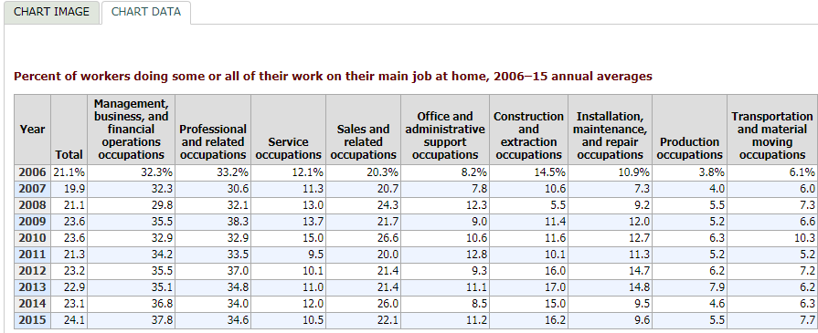
Source: https://www.bls.gov/opub/ted/2016/24-percent-of-employed-people-did-some-or-all-of-their-work-at-home-in-2015.htm
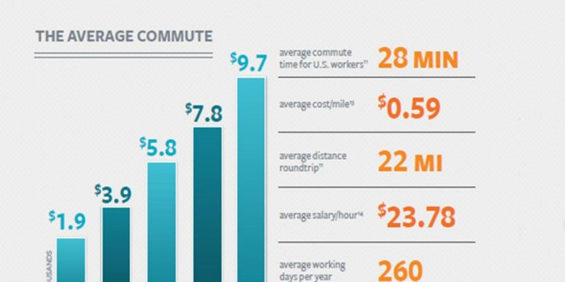
Source: https://www.pgi.com/blog/2013/03/what-are-the-cost-savings-of-telecommuting/

Primary Research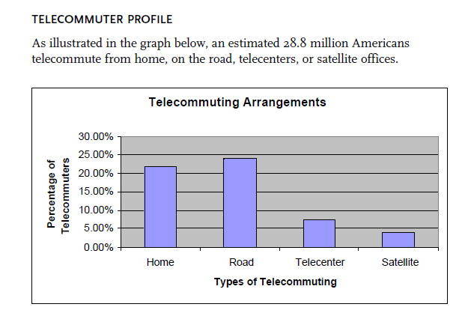
Source: Bringing Work Home. By Elizabeth Hamilton pg. 7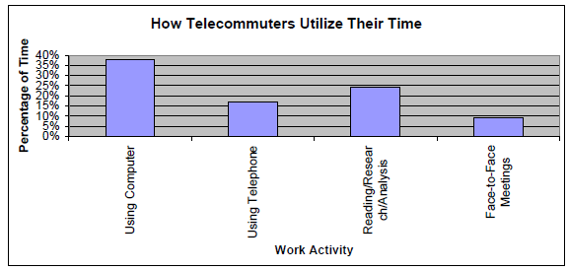
Source: Bringing Work Home. By Elizabeth Hamilton pg. 8

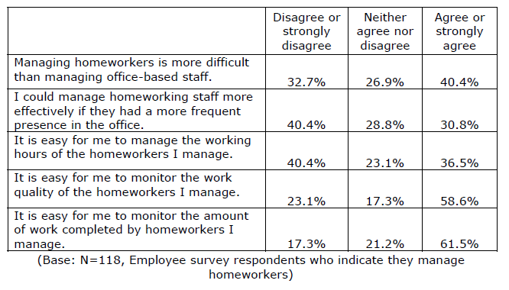

Source: Home is where work is-
Alexandra Beauregard, Kelly Basile and Esther Canonico pg 44

