

STUDENT NAME: JAMAL SESAY

STUDENT ID: 1919235

MODULE TITLE: PRINCIPLES OF HEALTH AND SOCIAL CARE PRACTICE ASSESSMENT 2

MODULE CODE: BMHP5002

LECTURER’S NAME: DIYA GANGULY

Table of Contents
Introduction 3
Analysis 4
Recommendation 8
Conclusion 9
References 10
Appendix 11

Introduction
The responsibilities of health and social care have developed since the last time and there have been some major changes in the line of works where these connections have a clear concept on the person-centred care. Person-centred care is focused on the availability of the process to determine and define the various actions which are related to health and social-based actions. To make any choice related to this manner has been well defined and the projectile of the works in this situation of person-centred care has been taken care of. By the formation of these changes there may have been some arrangements for the discussion of the present scenario and to understand the possibilities there may be some reasonable changes under the review of the health and social care conditions. The targeted area of this report is cancer as there are thousands of people who die because of cancer and do not even get the proper treatment. To increase awareness of this life threat has been the main attraction of this event and this has been to relate the importance on the health and social care where the prevention of this diseases may have been avoided. To fulfil the requirement of these sorts of changes the report will focus on the organisation HELP AGE INTERNATIONAL where they provide diverse types of services towards the people in times of their needs.

Analysis
The different patterns of the works that have a huge advantage on this platform have been defined to relate the situation and understand the effectiveness of the works which much are needed in this situation. Understandably, the program and the relations of the self-centred care unit has been through a lot of changes, and this is to amend towards the end of the progressive situation of HELP AGE INTERNATIONAL. This analysis will give a better understanding of the situation and it is most likely to benefit from these sorts of business activities overall (Ashburton, 2015). By the developed scenario there may be some challenges it is to be able to know about the consequences which have been the main events, and this will have an enormous impact on person–centred care. If the works are continuously monitored, then this is likely to benefit the significant changes where these effective matters are the main events and to determine the analysis as well.
Person-centred care has been an enormous success in modern days and over time, there has been improvement in the conditions related to this module of care. In the health and social care unit, there may be some challenges to which the marking and the meeting of the progress are to be determined and this is likely to have a huge impact in this regard that the possibilities have been able to sense the progressive manner and this will help the management of HELP AGE INTERNATIONAL to ensure the changes that have been made in their different aspects. To determine the changes and to meet the ideal aspects there have been some modifications and this is such a platform that is most likely to define the position and the overall aspects in this manner.
The connection and the condition of the person-centred care have been the main function in the patients who are facing an enormous impact on the cancer issue and this method is likely to help them keep their minds cool and take any sort of challenges that are to be taken in this period. This is most likely to understand and set the platforms to take on the formation of the present aspects to detail the situation on the person–centred care issue and this is vastly used in the developed countries. The description is to help and understand the positions for the main purpose and this will have a condition that may alter the case of a person – centred care in the selected company which is HELP AGE INTERNATIONAL (Collins, 2019). By developing a proper connection there have been significant changes under the main events and the ones are to be able to know about the consequences where the patients who are affected by cancer may have the slightest of hope and smile on their faces because of the person-centred care unit.
Person-centred care is focused on developing the impact of the disease for the people and help them in their time of need where the challenges have been the attraction of these sorts of effective connections. In this manner, it is likely to have a detailed structure of the person–centred care issues in the manner of developing a good and effective situation with the positive situation and it is most likely to determine the challenges when needed to be done and selected. In this aspect, it has been widely defined that the condition of person–centred care for the cancer patient has been amazingly effective and it is most likely to determine their consequences when these conditions are detailed. In this manner, it will be possible to investigate the matter of HELP AGE INTERNATIONAL and help the management to take the leading situation. If the progress of the works is hampered then this will impact the success rate of person-centred care in the distinct categories which are not accepted (Demain, 2017). By the formation of the management is has been defined that all the possibilities of the organisation are to look for the simple platform which will help to make a good situation for person–centred care. If this has been a success, then it is most likely to cover the platforms and then there have been modifications to determine the effective positions and to understand all the platform-based connections. The analysis further shows that there may have been some challenges to understand the also make the prospects of the works fully related in the manner and the criticism of works that are taken by the management of HELP AGE INTERNATIONAL in this line of the platform and most likely it has been the main factor to develop the prospects and also have a huge impact to motivate the use of person-centred care in every sort of business which is the main event (Judge, 2017). There may be some side impact, but the main event has been to determine and to develop certain changes where these are the fraction of the connections made by person–centred care unit.
The theoretical part is to observe and determine the overall situations to save and lead the positions. In this manner, there may have been some challenges to select and meet the required connections to understand the needs of the people. This event is mainly focused on the theories that have been related to the different frameworks and to be able to know the platforms and to determine the significant changes are the part of the theoretical impact and most likely this has been to select and modify the cases as needed (Kahin, 2014). In this manner, there may be some challenges in the proper ordering of the advice that has been determined to know about the future connections. In this manner, it is possible to have a good initiative of the works and this is most likely to have a good and balanced platform which will impact the person-centred care and this is to make the changes in such a manner that the works that will be taken by the management of HELP AGE INTERNATIONAL are to be taken seriously at every possible time. The formation and the developed motivation of works have been the configuration and it is to understand the leaps towards the end of the project. Under the name of the person–centred care, there may be challenges but it has to be done and taken by the management of the works on the same event as this will impact the current feasibilities and also determine the consequence changes to fully understand the requirements to have a person-centred care unit in the business aspects related to the connections made from HELP AGE INTERNATIONAL situation (Zaman, 2018). This is most likely to understand and then further process the works to be able to select and meet the standard of these changes that have been made to take on the leading scenario.
The ethical considerations are huge, and they need to be taken on a fixed situation which every person can abide by to know more about person–centred care. As ethical cases have been the main function in recent times there may have been some changes on the ethical cases as they are most considerable in the event of taking any decision. To be able to know and to perform the main aspects of person-centred care are to be as per the rules and regulations set on a primary basis of work.
The health and safety legislations that has been related to the present scenario of Mr and Mrs T is directly related to the various rules and regulations which are the part of their moral acts. There have been several rules such as National Assistance Act 1948 which implies the various targets that is included in the daily lives of Mr and Mrs T. The Social Work Act 1968 id directly related to the present dementia of Mr T which is to be completely taken care of. According to the Human Rights Act 1998 there are several actions which may be taken by Mrs T in order to help her husband in his dementia problem (Zaman, 2018). All these rules and regulations are part of the present organisations that is followed by the management of Help Age International.
Just like every situation the person-centred care has some advantages and some disadvantages. The main advantage is that it helps the people to know their fear and work them up to deal with the different situations which helps them to keep the track of the situation. These benefits have been able to make the main event the connector part as these leads through the best use from the concepts to deal with and it also helps to keep a good track of the situation. To be able to know the probabilities and to select the criteria of the work towards the main event has been the criteria and it has been one of the main advantages on the present platform to look through the best choices. People will have a different perception in this manner, and they are most likely to take on the major consequences to define the scenario of person–centred care in front of a huge situation. The main limitation of this event is that it affects the problems and then it alters the connecting part to the lead session. By developing this model, the work efficiency in some cases have been lowered and they are given the task to complete the whole scenario in such a manner that it will take the probabilities to the next level.
In the real-life, there are many situations when person-centred care has been a part of it. To take the mystique platform and then there may be some progressive changes in such a manner that will define the present aspect of the person-centred care and most likely to enjoy the connections that have been made and prepared in this manner (Kahin 2014). By the formation of the present scenario and to relive the discussions the real-life scenario for the management of HELP AGE INTERNATIONAL has been the key feature where these changes are to be taken towards the impact and the graceful situation to handle the rest of the works in the organisation. The real-life situations have been blissful using different connections, and it has been the key attraction in many cases.

Recommendation
The main recommendation is to look for the causes that need the person–centred care theory and help them in their activities. The present scenario of person-centred care is not that effective around the world so the scenario is to relate and thereafter take the lead on developing any major impacts which will be used in the future.
As Mr T wants to help the organisation to help her in the daily needs the management of Help Age International is to look after this issue and manage the conditions in such a manner which is most likely to help her improve the domestic chores.
The possibilities of helping Mr and Mrs T the management of the organisation is ensure that the domestic chores, the daily activities are all being closely monitored by the assigned individual who will be responsible for all the activities of the couple.
This has been the main situation and some subsidiary parts are to be taken under the ethical cases where the logic and other prospects are not determined or developed as per the needs. This will have a good impact and to be able to select the positions of the cancer patients on this primary aspect has been the fraction to determine and develop based on the works. These sort of challenges are to be solved by the management of Help Age International which is most likely to attend to the problems of Mr and Mrs T. The future is to be taken seriously as this will help to keep the goals fixed and have an enormous impact on the development and arrangement of the situations under the name and changes required. The recommendation is to understand the phenomena and thereafter know about the platforms where these changes have been made properly and this will make the right choices in the right amount of time. Depending on these all sorts of challenges and platforms are the best of the choice to take on and ensure that these recommendations have been developed to meet the requirements in the upcoming future works.

Conclusion
Person-centred care has been a buzzword in recent times and there have been several changes in the availability of the services that have been ensuring because of person-centred care. The management of HELP AGE INTERNATIONAL has been taking this platform seriously and there have been some significant damages to lead the process and the progressive situations. The connection and the effectiveness of these platforms are to be taken the scenario and this will have an enormous impact on the connection of person–centred care through the various changes that are considered as part of the platforms. In this manner, there may have been some challenges and it is most likely to adapt to the technologies which are the main in this manner and this is likely to help the cancer patients to overcome the details that have been affected because of the usefulness of the works of the chosen organisation. This is most likely to benefit the significance and have an impact in such a manner that this will influence the surrounding platforms to make any sort of challenges in the first place when the formation for the person-centred care is to be stated firmly and precisely on the specific matter and define the possible outcomes.

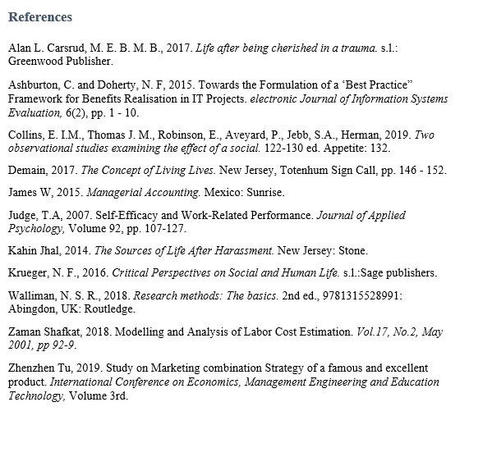

Appendix
Description of person-centred care - Person-centred care has been an enormous success in the modern days and over time, there has been improvement in the conditions related to this module of care.
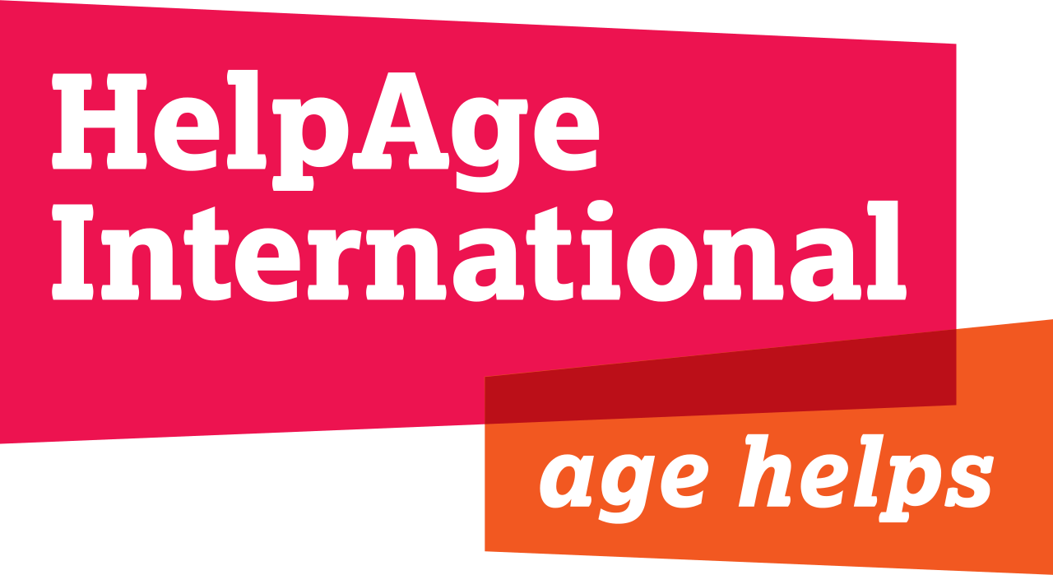
Figure: Logo of Help Age International (Kahin 2014).
Analysis of person-centred care - Person-centred care is focused on developing the impact of the disease for the people and help them in their time of need where the challenges have been the attraction of these sorts of effective connections.
Person-centred care to real-life situations - In the real-life there are many situations when the person–centred care has been a part of it. To take the mystique platform and then there may be some progressive changes in such a manner that will define the present aspect of the person–centred care and most likely to enjoy the connections that have been made and prepared in this manner.

