The soft drinks Industry – Sugar Tax
The market failure and solutions implemented.

Introduction

During this essay there will be research into a specific industry, in this essay the focus will be on the Food and Beverage industry and mainly focusing on the Soft Drink industry. Then researching into how the market is failing before the now solutions we’re put in place. There will be use of hypothetical diagrams during this essay, but all the facts and figures will be focusing on the Soft Drink Industry.
The Soft Drink Industry consists of establishments primarily engaged in manufacturing non-alcoholic, carbonated beverages, mineral waters and concentrates and syrups for the manufacture of carbonated beverages. (Encyclopedia, 2022) In 1875 Robert Barr started producing and selling aerated waters, as soft drinks were then called. Robert Barr was doing this in a small factory in Falkirk which has now grown into one of the UK’s best loved soft drinks companies. (Barr, 2022)

An analysis of the Soft Drinks industry and their failure which is associated with the consumption of sugar which is in soft drinks and the over consumption due to the presence of both negative externalities and imperfect information. (Stoughton, 2016)

Soft Drinks Industry: market failure

Soft drinks are not good for a person’s health this this because they tend to contain lots of sugar. If a person was to consume to many soft and sugary drinks then they may lead to, weight gain, diabetes, and cardiovascular conditions, (Dredson, 2021) if you were to drink one to two original Coca Cola 12oz cans a day this would be roughly 39 grams of sugar per can. (Coca-Cola, 2022) and this would also increase your risk of having type 2 diabetes by more than 20%. (Brennan, 2020) in 2016 carbonated drinks this includes colas, lemonade and flavoured fizzy drinks were at an all-time high of sales value in the U.K with this being valued at 1.3 billion British pounds. This was then very closely followed by the juice and juice drink market which was valued at 1.29 billion British pounds (Ridder, 2022)

When the consumer, consumes sugar sweetened beverages which would include carbonated soft drinks this may mean that they be a key contributor to the epidemic of overweight and obesity. (Vasanti S Malik, 2011) In 2015 nearly two thirds of adults 63% in England were classed as being overweight or obese. In 2015 19.8% of children were class as obese and a further 14.3% were classed as overweight. (GOV, Health Matters: Obesity and the food enviorment , 2017) IN 2014/2015 the National Health Service spent £6.1 billon on treating obesity-related ill health conditions. (Holmes, 2021)
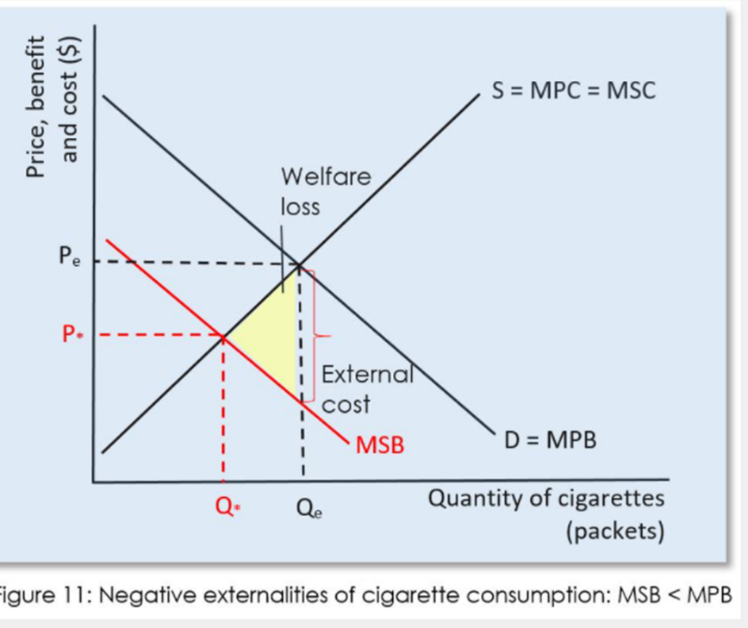

The Figure 11 diagram above shows that there are no external positive effects from the Soft Drinks carbonated industry on third parties this will only causes harm over a long period of consumption. Each bottle of soft carbonated drink which is sold and is consumed by the consumer causes a contribution to the strain on services such as the National Health Service and can also make a rise on ill-health such as obesity and being over-weight. The vertical difference between both MSB and MPB demonstrates the negative externality which in the case of the strain which obesity and being overweight causes on the National Health Service. Q* means that the optimal level of consumption and the marginal social benefit meats the marginal social cost which is recognised as the equilibrium.

Methods to improve market failure: Solution One
It is so important to improve the market failure within the Soft Drinks industry. With soft carbonated drinks mainly having so much sugar in them and making a strain on the National Health service it is important to come up with a solution to be able to solve this, or at least lessen the amount of sugar which the consumers are consuming. The main solution to this was the introducing of sugar tax or another phrase for this would be, The Sugar Drinks Industry Levy. The ‘Sugar Tax’ law was brought in, in the United Kingdom to try and tackle childhood obesity as it will mean that with Sugar Tax it is going to then reduce the amount of sugar which is consumed. In 2018 millions of children across the United Kingdom will benefit from the Government’s scheme. Sugar Tax is when the Government have put a tax on all soft carbonated drinks which contain sugar. The ‘Sugar Tax’ was only introduced in 2018 and since then this has already resulted in over 50% of manufacturers reducing the amount of sugar content of drinks since it was announced. This is of the equivalent of 45 million kg of sugar every year. The soft drinks manufacturing who don’t reformulate will pay the levy, which is expected to raise £240 million each year. The money which is saved is to go towards doubling Primary Sports Premium, the creation of a Healthy Pupils Capital Fund to help schools upgrade their sports facilities and give children access to top quality PE equipment. This levy will also give a funding boost for healthy school breakfast clubs.

The aim of the Soft Drinks industry Levy is to encourage companies to reformulate their soft drinks. Since the levy has been announced two years the expected amount of revenue has gone down from £520m in year 1 to £240m even before coming into effect. The rates which companies will need to pay are:
- 24p per litre of drink if it contains 8 grams of sugar per 100 millilitres.
- 18p per litre of drink if it contains between 5-8 grams of sugar per 100 millilitres. (Treasury, 2018)

Sugar tax is one of the best way forwards in the Soft Drinks industry because in the long run it is making consumers and also manufacturers potentially pay for the National Health Service, services in the long run for obesity and overweight assistance.

The famous chef Jamie Oliver was the inventor of Sugar Tax. The Jamies Italian restaurant chain introduced the sugary drinks tax for the reason of he wanted the Government to act. In June 2015 Jamie Oliver announced that every drinking in his restaurant chains which contained sugar would now cost 10p extra. The reason which Jamie did this was so that all of the extra 10p’s would then dd up and help pay for food education and water foundations in schools. Jamie Oliver believes that this is a step in the right direction as he says ‘“This levy is one of the most important and symbolic moments so far in the fight to protect our kids against diet-related disease. This is a progressive levy, for good, which – let’s remember – polled at 69% popularity, and will bring much-needed new money into the education system. My hope is that some of this money will be funnelled into food education to teach our kids how to cook from scratch, setting them up for life. But the real beauty of this levy is that it’s pushed the industry to accelerate reformulation of high-sugar fizzy drinks, which is profoundly powerful for child health. These drinks are the single largest source of sugar and empty calories in our children’s diets – action is essential!’ (Oliver, 2018)

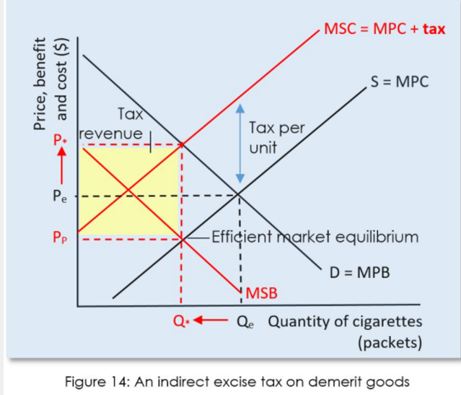
Figure 14 diagram hypothetically represents the indirect tax on the carbonated Soft Drinks industry. By looking at the diagram and looking at the red MSC = MPC + Tax line this would mean that because of the sugar tax it would mean that if any soft drink which contained sugar that the consumer would have to pay more for this beverage rather than if they chose a no sugar/diet version of the beverage this is shown in P*. As shown on Figure 14, PP means that the consumers would be able to pay a lower price if they didn’t opt for the sugary drink.

Command and Control – Solution 2 -
Advertising ban to remove negative externality

A government can regulate to correct a negative externality of consumption. In the UK are going to ban junk food advertising online and before 9pm on television from 2023. The United Kingdom Government is to be going to ban adverts which include the following food and beverage items:
- Chocolate
- Burgers
- Soft Drinks
- Cakes
- Sweets
- Ice Cream
- Biscuits
- Sweetened juice
- Crisps
- Chips
- Pizza
There will be also new rules on online promotion, but firms selling junk food will still be able to run websites. The TV restrictions come after Boris Johnson made tackling obesity which affects a large amount of the U.K. (Parkinson, 2021)
The reason which Boris Johnson is urging for there to be a water shed put in place for TV after 9pm is because half of the food and drinks TV ads seen by children are for unhealthy products such as junk food, sugary drinks and outlets such as McDonald’s. (Campbell, 2018) This advertising ban has been brought in after the advertising of such foods during children’s programmes has been banned since 2007. But research by the broadcasting regular Ofcom has shown that children spend 64% of their TV viewing time watching shows which are not specifically aimed at them. (Campbell, 2018)

The Government have also got an aim for promotions of unhealthy foods restricted form April 2022. (GOV, Promotions of unhealthy foods restricted from April 2022, 2020) these offers for unhealthy foods such the ‘buy one get one free’ and promotions in prominent locations in stress and online to be restricted by April 2022. To help fight the want and need for sugary drinks being able to have a free refill of sugary soft drinks in the eating out sector. All of these restrictions which have been put in place are going to apply to medium and larger stores. (GOV, Promotions of unhealthy foods restricted from April 2022, 2020)

In 2007 the average amount of children who would watch TV in their room was 69% but in 2016 this was only 48% this was the ages between five and fifteen. The number of children fell from 69% in 2007 and feel to 48% 2016. (Statista, 2018)

There are so many more popular platforms and online activities for the younger generations. Youtube remains a firm favourite among children aged 5-15 years old. They would choose Youtube over an on-demand service such as BBC iPlayer. Children are now starting to use more social media use is diversifying the social media platforms which children are joining are, Facebook, Snapchat, Instagram. The main two newer platforms which the younger generation are beginning to use are TikTok and Twitch. (OfCom, 2020). The reason why the previous data is important because it shows that even though there isn’t a ban on TV adverts and general advertising of food and beverages which contain a high volume of sugar, salts and fats yet it does mean that the Government will need to ensure that they are branching out further a field to be able to get this message across to the younger generation as not all of them are watching the television it tends to be a Youtube video, but the Government can ban adverts but they will need to also come up with a content creator legislation where they cannot influence their viewers to eat foods such as McDonalds. When the McDonalds adverts stop it could be one of the ways which they can market is through the promotion of their company through famous influencers.

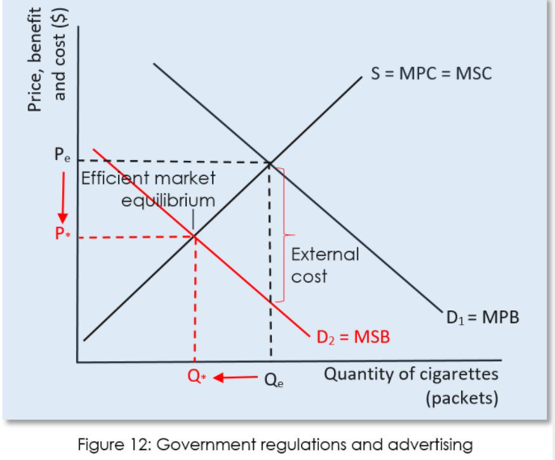
Whilst exploring the Figure 12 diagram it is found that the Government are trying to ban fast food TV adverts and adverts in general and also trying to ban promotions such as buy one get one free on food and beverages which contain high sugars salts and fats to be able to stop the demand curve (D1) this would be until it overlaps with (D2) this would be achieved in 2023 when this bans have been put in place and the externality has been eliminated. As the demand for food and beverages with high sugar, salts and fats in become less in demand Qe would slowly start to become Q*. In 2023 it is hypotactically predicted that the food and beverage businesses which contain high sugars, salts and fats are going lower their pricing from PE to P* to be able to reduce the surplus.

Soft drinks industry post market failure:

In the United Kingdom it is led to believe that with the gradual reduction in the sugar content in sweetened beverages which is estimated as 40% reduction in sugars over a five year reduce the number of obese adults by half a million and new cases of type two diabetes by 300,000. (Thornton, 2018) By the Government introducing sugar tax on sugary beverages and increasing the prices of these beverages this will be able to lead to a reduction in consumption of around 20% potentially being able to prevent a strain on the National Health Service and also obesity and type two diabetes. The UK’s Sugar Levy has turned out to be successful from a public health point of view has it is to be believed that the new legislation has been responsible for nearly 6,500 calories from just soft drinks in the UK per person. (Arthur, 2021)

Conclusion

To conclude the main problem of this essay was to be able to answer what the market failure was for the Soft Drinks industry and how sugar tax was a solution for this. The main market failure was that all of the high amounts of sugar which are in the beverages were causing strain on the National Health Service due to them needing assistance with obesity, being overweight and diabetes. The first solution to be able to over come this was to be introduce sugar tax. The Sugar Drinks Industry Levy. The ‘Sugar Tax’ law was brought in, in the United Kingdom to try and tackle childhood obesity as it will mean that with Sugar Tax it is going to then reduce the amount of sugar which is consumed. One of the main ways which the Government is helping with this is by putting a monetary tax on sugary drinks. The second solution of this market failure was to look further into the issue and actually look into the command and control of advertising, especially for food and beverages which contain a high number of salts, sugar and fats. By 2023 the UK Government want to be able to ban adverts and TV adverts to be able to make sure that these are not seen anywhere and the impression of this is not seen everywhere there will be a 9pm watershed on these adverts. Post market changes have meant that they amount of sugar which members of the UK’s society thanks to the Sugar Tax means that they are going to be consuming nearly 6,500 calories less a year just from not drinking sugary drinks.
During this research it taught us that the National Health Service was under a massive strain not just from general health issues but massively from obesity, being overweight and type two diabetes. But thankfully due to the sugar tax coming into place is meant that some of this strain came in and meant that people were able to manage and think about their health. Also, this would mean that when the legislation of food and beverages containing high salts, sugars and fats would mean that they would have to be put on after a watershed time period this will also help with the strain on the National Health Service as people will not be seeing these types of food and beverages.

References
Arthur, R. (2021, August 05). Reformulation sucess: The UK sugar levy has arguably been very successful from a public health point of view. Retrieved from Beverage daily: https://www.beveragedaily.com/Article/2021/08/05/Sugar-tax-success-UK-Soft-Drinks-Industry-Levy-drove-reformulation-says-study
Barr, A. (2022). AG Barr - Our history . Retrieved from AG Barr: https://www.agbarr.co.uk/about-us/who-we-are/our-history/
Brennan, D. (2020, October 22). Drinking Cola: Is it good for you? Retrieved from NOURISH: https://www.webmd.com/diet/drinking-cola-good-for-you
Campbell, D. (2018, May 31). Half of food and drink TV ads seen by children are for unhealthy products - study. Retrieved from The Guardian: https://www.theguardian.com/society/2018/may/31/half-of-tv-ads-seen-by-children-are-for-junk-food-and-drink-report#:~:text=Half%20of%20food%20and%20drink%20advertisements%20children%20see%20on%20television,to%20limit%20exposure%20to%20them.
Coca-Cola. (2022). How much sugar is in a Coca-Cola. Retrieved from The Coca-Cola Company : https://www.coca-colacompany.com/faqs/how-much-sugar-is-in-coca-cola#:~:text=in%2Dcoca%2Dcola-,There%20are%2039%20grams%20of%20sugar,12%20oz%20Coca%2DCola%20can.
Dredson, D. (2021, February 18). Is soda bad for your health, and what are the options? Retrieved from Medical News Today: https://www.medicalnewstoday.com/articles/is-soda-bad-for-you#:~:text=Soda%20is%20not%20good%20for,can%20lead%20to%20health%20problems.
Encyclopedia. (2022). Soft Drink Industry. Retrieved from Encyclopedia : https://www.encyclopedia.com/history/dictionaries-thesauruses-pictures-and-press-releases/soft-drink-industry
GOV. (2017, March 31). Health Matters: Obesity and the food enviorment . Retrieved from GOV: https://www.ncbi.nlm.nih.gov/pmc/articles/PMC3210834/#:~:text=Consumption%20of%20sugar%2Dsweetened%20beverages,incomplete%20compensation%20for%20total%20energy.
GOV. (2020, December 28). Promotions of unhealthy foods restricted from April 2022. Retrieved from GOV UK: https://www.gov.uk/government/news/promotions-of-unhealthy-foods-restricted-from-april-2022
Holmes, J. (2021). Tackling obesity: The role of the NHS in whole-system approach. TheKingsFund.
OfCom. (2020). Childern and parents: Media use and attitudes report 2019. Making Sense of Media.
Oliver, J. (2018, April 6). What is the Soft Drinks Industry Levy (sugar tax)? Retrieved from Jamie Oliver: https://www.jamieoliver.com/features/soft-drinks-industry-levy/#:~:text=Soft%20drink%20companies%20who%20make,to%20avoid%20paying%20the%20levy.
Parkinson, J. (2021, June 24). Anti-obesity drive: Junk food TV adverts to be banned before 9pm. Retrieved from BBC NEWS : https://www.bbc.co.uk/news/uk-politics-57593599
Ridder, M. (2022, January 13). Soft drink sales value in the United Kingdom (UK) 2017. Retrieved from Statista: https://www.statista.com/statistics/706850/soft-drink-sales-value-united-kingdom-uk/
Statista. (2018). Share of children with TVs in their bedrooms in the United Kingdom (UK) 2007-2016. Retrieved from Statista: https://www.statista.com/statistics/398238/children-with-tvs-in-their-bedrooms-uk/
Stoughton, H. a. (2016). The UK sugar tax: will it reduce obesity? . Dynamic Learning.
Thornton, J. (2018, June). The UK has introduced a sugar tax, how does it work? Retrieved from London School of Hygine and Tropical Medicine : https://www.lshtm.ac.uk/research/research-action/features/uk-sugar-tax-will-it-work#:~:text=Higher%20prices%2C%20better%20health&text=A%20UK%20modelling%20study%20advocating,2%20diabetes%20by%20around%20300%2C000.
Treasury, H. (2018, April 5). Soft Drinks Industry Levy comes into effect. Retrieved from GOV.UK: https://www.gov.uk/government/news/soft-drinks-industry-levy-comes-into-effect
Vasanti S Malik, M. B. (2011, November 8). Intake of sugar-sweetened beverages and weight gain: a systematic review. Retrieved from PubMed Central: https://www.ncbi.nlm.nih.gov/pmc/articles/PMC3210834/#:~:text=Consumption%20of%20sugar%2Dsweetened%20beverages,incomplete%20compensation%20for%20total%20energy.

