Sanwar Ali Ahmed
Student 1920465
Assessment 2
BMSK4003 Digital Skills and Research Methods

Website login details
Email address: 1920465@gnail.com
Password: Macbook15

At Weebly.com

Introduction

Formulation of questionnaire needed to be conducted first hand to accurately identify the awareness of crypto currency and understanding, this initial questionnaire was created by a Google docs and released to my student colleagues and peers, we needed to identify if there was demand for such digital item and current understand of blockchain in the traditional financial industry, we did identify a lack of understanding and implication already being implemented in the financial system so it's important to create our website to bring relevant easy to understand information with video tutorials mainly implemented via our website.

If you invested $100, in 2010 your bitcoin would be worth $48 million in 2021 CNBC

www.bitblock.co.uk

Questionnaire design & analysis

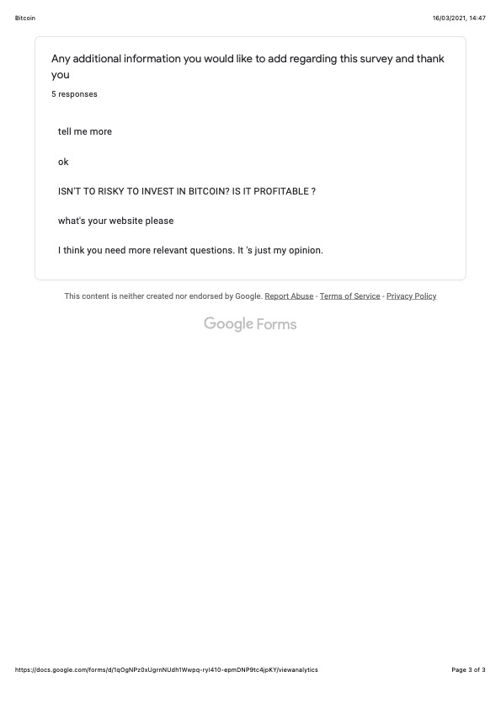
My market research identified a misconception and a lack of understanding of Bitcoin and the importance of the underlying behind technology which underlies it which is blockchain, it seems people associate Bitcoin with financial trading and underlying price.
So it's very evident people are not aware of blockchain technology and its implications in the financial sector as it's mainly reported as an financial instruments on the mainstream media.
This reinforces our research that people need to be educated in all thing’s cryptocurrency and the underlying technology which is blockchain peer to peer transactions without any third party involved being irreversible.

From our research we have identified 75% have heard of Bitcoin however only 62% aware that it's over 30,000 uk Sterling at present of April 2021, also only 32% are aware you could convert your Bitcoin into Sterling currency.

Website design (600 words)

The market research indicated that simplistic basic introduction into crypto currency is needed to help people slowly maneuver the vast information required to fully understand but yet the simple the underlying core technology beneath bitcoin, which is blockchain technology,
And explain that bitcoin is merely information which is conducted and transferred to one data point to another, like a train on its train tracks this information cannot be reversed or manipulated once data or information is conducted this trail could be accessed at any time by everyone.

Therefore, we design our website in a very simplistic manner with basic information yet able to type further into this particular matter without getting overwhelmed,
We gave our website a financial simplistic format with basic financial colours with basic fonts without getting complicated.

We will be adding video tutorials on basic matters in categories from beginners to advanced so people are able to absorb information at their own capacity.
We will look at the option for our audience to subscribe in our weekly newsletter to constantly receives Newsbytes whilst maintaining engagement and interest.

As this is a complicated subject, we endeavour to bring bitesize news from around the world in a short and fun manner to keep the audience to engage in the latest trends from the blockchain world.
This is very important specially from the financial world even Technology minded persons because they may be using that application of technology unknowingly blockchain technology incorporated.

We use very basic blockchain pictures not to overwhelm the audience
If this website was live video tutorials would be inserted linked to YouTube.

Keywords inserted into SEO are as follows:

Bitcoin block chain easy to understand financial freedom

Metadata:

Bitcoin blockchain for beginner’s financial freedom

We have inserted easy to use contact details and email for correspondence,
Would you like to hear from you, We at Bitblock.co.uk will endeavour to reply to your enquiry within 24 hours or 48 hours over the weekend thank you, including address and map

Also, most importantly we must highlight a note that anything we present on use it’s not endorsing or giving financial advice so therefore we inserted a disclaimer stating the following:

Disclaimer:
We are Bitblock.co.uk do not give any financial advice or recommend any material presented regarding crypto currency, all material presented is our opinion. Please do your own research before investing and consult your local regulated financial advisor.
Crypto currency is very volatile, and you may lose more than you invest.

According to resourcetechniques 2019 there are 5 Basic Elements of Web Design
1 Content 2 Usability 3 Aesthetics 4 Visibility 5 Interaction.

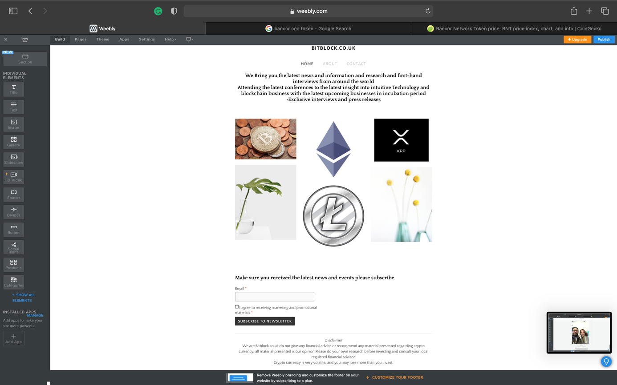

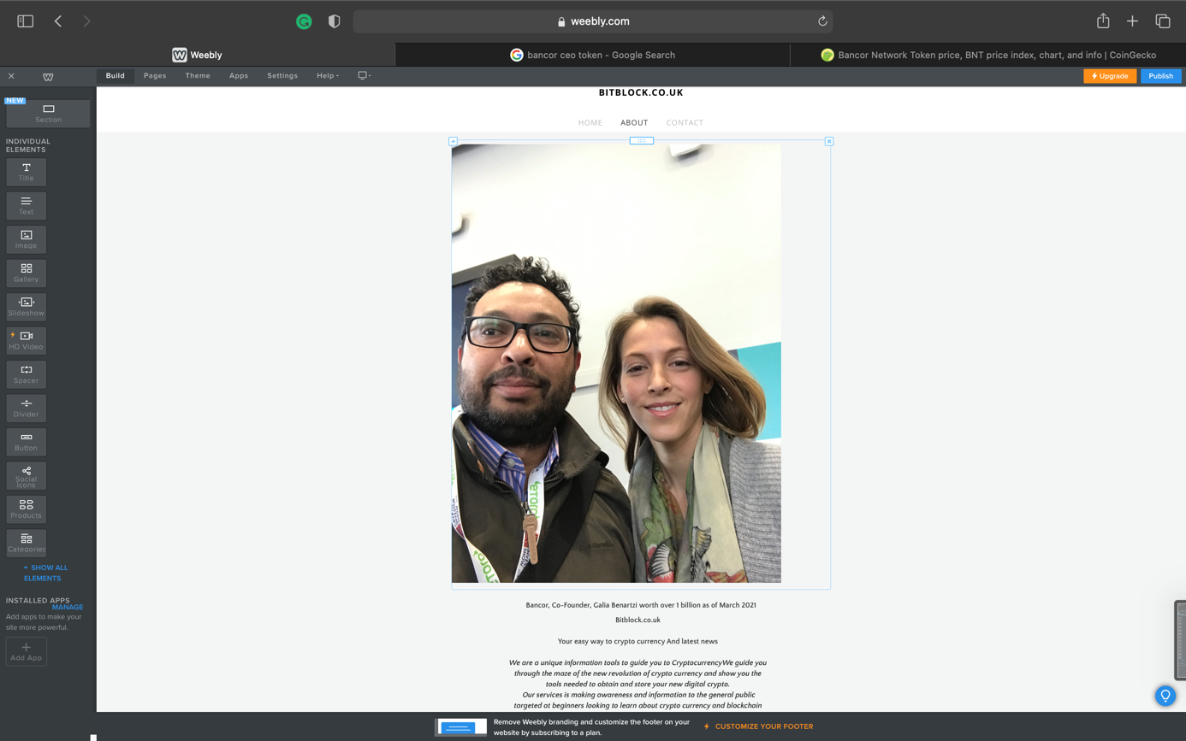

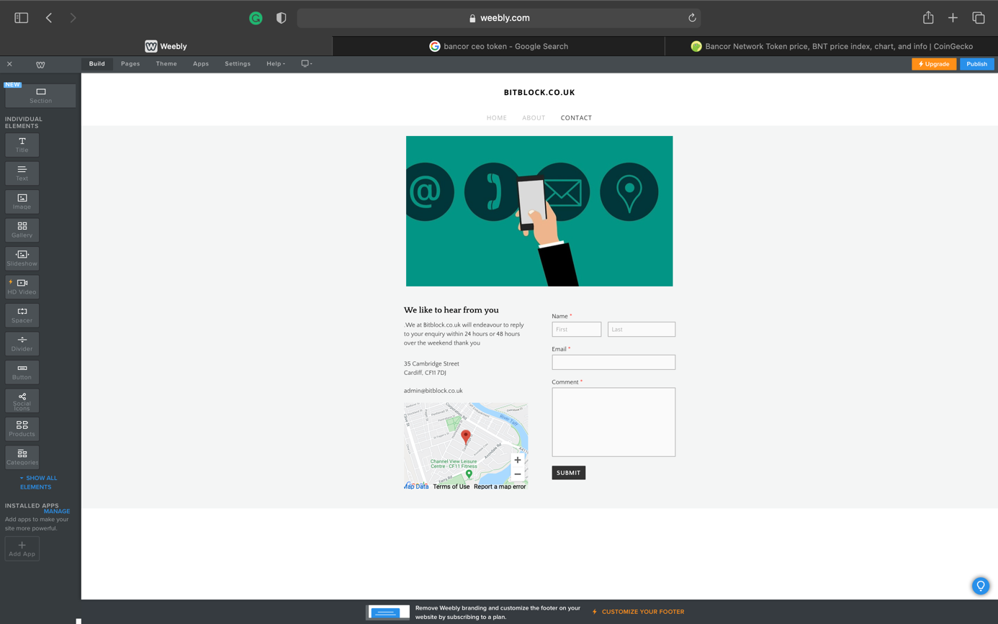

Conclusion

Overall our market research identified generally the vast population Heard the name BITCOIN
However majority of people don’t understand its fundamental technology and its place in the current financial system, unconsciously they assume is some sort of complicated financial instrument similar to stocks in the traditional stock market, so we understood we need to start up very basic fundamentals of crypto currency and its implication and future in corporation with me to every technology Application without the end user realising its interaction with blockchain,

So we will be implementing basic tutorials on different subcategories videos with weekly Newsbytes in a simplistic and condensed manner, this will keep the audience engaged and interested without getting too complicated,
We also identified that colour coordination and pleasing pictures likely to attract the attention of the public who are eager to learn but yet being hesitant because find it difficult to comprehend all assuming financial knowledge is needed to understand bitcoin.

“Tesla cars can be bought in Bitcoin” BBC 2021

References

carmen-reinicke. (02021). Bitcoin hits another record. Here’s how much you’d have if you invested $100 in 2009. Available: https://www.cnbc.com/2021/02/12/how-much-youd-have-today-if-you-invested-100-in-bitcoin-in-2009.html. Last accessed 10/03/2021

Resourcetechniques. (2019). 5 Basic Elements of Web Design. Available: https://www.resourcetechniques.co.uk/news/web-design/5-basic-elements-of-web-design-100152. Last accessed March 2021.

BBC. (02021). Tesla cars can be bought in Bitcoin. Available: https://www.bbc.co.uk/news/technology-56508568. Last accessed March 2021.

Include at least 5 references

