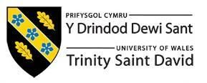
Programme Master of Business Administration
Module: MARKETING MANAGEMENT
Module code: LCMB7024
Assessment Component 2
Title: Marketing Portfolio New Balance
Word Count:
Lecturer: Dian Mayasari

Student Name: Vaishnavi Vasantrao Patil
Student ID: 2504969
Submission Date- 19th November 2025

Contents
Element 1: STDP Analysis (NB Revive) – 3
Introduction- 3
1.1 New Brand Concept: NB Revive 3
1.2 Market relevance & consumer trends 3
1.2.1 Segmentation- 3
Demographics 3
1.2.2 Targeting- 4
1.2.3 Differentiation- 4
1.2.4 Positioning- 4
Element 2: Marketing Mix (7Ps)- 5
• Product- 5
• Price- 6
• Place- 6
• Promotion- 6
• People- 6
• Process- 7
• Physical Evidence- 7
2.1 Strategic Alignment & KPI’s- 7
Element 3: Marketing strategy pitch 8
Element 4: Reflections 9
4.1 Learning Experience- 9
4.2 Skill Gained- 9
Collaboration and communication: 9
Digital literacy: 9
4.3 Challenges faced- 10
4.4 Lessons for the Future- 10
5 References 10

Element 1: STDP Analysis (NB Revive) –

Introduction-
The international sports footwear and clothing company New Balance is renowned for its comfort, fit, and craftsmanship. It is also placing a growing strategic emphasis on innovation and sustainability. New Balance, known for its performance-driven designs and "Made in USA/UK" lines, has recently made a formal commitment to climate change and materials. The company has also released sustainability and impact reports that set goals for supply-chain collaboration with suppliers, energy, and materials. This brand heritage lends credibility to the introduction of a sustainable subline that emphasizes environmental impact while maintaining performance criteria.

1.1 New Brand Concept: NB Revive
New Balance's gender-neutral footwear line, NB Revive, is a product sub-brand that blends noticeable eco-materials and end-of-life considerations with the brand's iconic comfort technology (cushion, fit, and durability). Key characteristics of the product include the use of plant-based dyes, limited recyclable packaging, biodegradable or bio-based midsole chemicals when feasible, and uppers composed of certified recycled textiles and ocean-recovered plastics. The line will also undertake a take-back/refurbishment pilot to extend life and reduce its landfill contribution. NB ReVive's message is sustainability without compromising comfort or daily performance. There is a market for these products, as evidenced by the growing demand for eco-friendly footwear.

1.2 Market relevance & consumer trends
Sustainability has moved from a niche to the mainstream in the clothing and shoe industries. The global market for sustainable footwear is expected to be worth billions of dollars, with mid-single-digit compound annual growth rates (CAGRs) anticipated over the next ten years. This suggests that there is increasing commercial potential for eco-positioned footwear brands. Consumer research shows that younger generations (Gen Z and Millennials) are disproportionately likely to Favor and pay more for sustainable brands; multiple industry surveys show that a significant portion of Gen Z is willing to pay more for products that reflect their values and to purchase sustainably. However, research also shows a "attitude–behaviour gap"—consumers express sustainability preferences, but price, convenience, and style still influence final purchase decisions. For this reason, NB ReVive needed to combine authentic environmental credentials with attractive design and easily accessible purchase options.

1.2.1 Segmentation-
The following behavioural, psychographic, regional, and demographic criteria will be used to segment NB ReVive:
Demographics: both sexes, ages 18 to 40, mid- to upper-income (disposable income to pay a modest premium)
Psychographic: Value-driven, environmentally conscious, health and fitness-focused, and design-conscious customers who support businesses that align with their beliefs.
Geographic: Urban and suburban consumers in the UK, Western Europe, North America, and some APAC regions who are concerned about sustainability.
Behavioural: Customers seeking durable everyday shoes, early adopters of eco-friendly product lines, and brand-loyal customers prepared to pay more for perceived quality or environmental impact. According to market research, younger consumers in developed metropolitan economies spend more on sustainable products, which is supported by these divisions.

1.2.2 Targeting-
The primary target market consists of young urban professionals and students (18–35) who are internet-savvy, socially conscious, and willing to pay a little more for ethically produced goods. Connecting with this group can be accomplished through social media, university ambassador programs, and pop-ups, or in-city shopping events. Secondary goals include runners who care about the environment and lifestyle consumers (ages 35 to 45) who value comfort and longevity but want to have less of an environmental impact. By concentrating on this two-tier approach, a variety of attraction and purchase opportunities are preserved along with premium positioning. The messaging will emphasize lifetime benefits (like the take-back/refurbish program), comfort features, and verified materials.

1.2.3 Differentiation-
The following are the ways that the NB ReVive will differentiate itself:
(1) comfort + verified sustainability—measurable performance metrics paired with traceable recycled/biobased inputs;
(2) manufacturing transparency—supplier audits and life-cycle claims backed by sustainability reports;
(3) longevity and circularity features (refurbish/take-back), not just "greenwashed" messaging;
(4) authentic storytelling grounded in New Balance's manufacturing heritage rather than celebrity hype. That combination reduces the attitude-behaviour gap by offering both value and values.

1.2.4 Positioning-
The positioning statement reads "NB ReVive — Sustainable Comfort for Every Step."
presented as a high-end, reasonably priced athletic lifestyle footwear line that offers measurable environmental benefits (recycled content, reduced lifecycle impact, repair/return possibilities) while preserving New Balance's renowned comfort and fit. The target market for this service is consumers who want to maintain daily performance and flair while making wise choices.

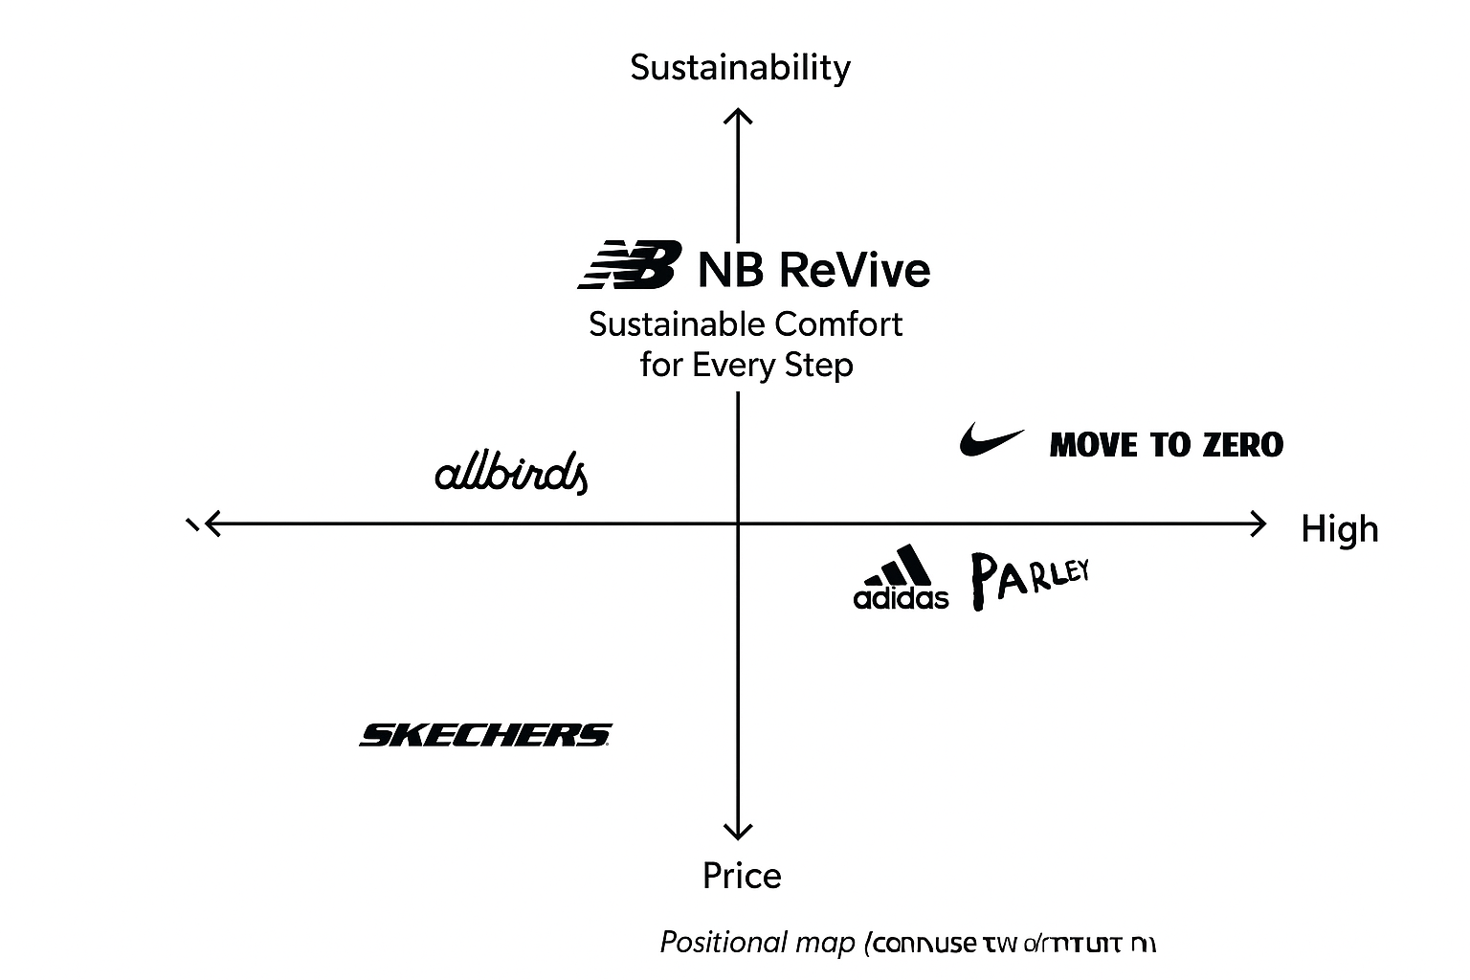

Element 2: Marketing Mix (7Ps)-
NB ReVive is a hybrid product-service offering that combines a circularity service (take-back, repair/refurbish, lifetime information) with luxury everyday footwear made of recycled or biobased materials. Utilizing the 7Ps ensures that the actual product and service components (people, process, and tangible evidence) support the brand's promise of "Sustainable Comfort for Every Step." The following applies and links each P to evidence and market data.

Product-
In order to facilitate material separation and repair at the end of their useful lives, NB ReVive shoes use plant-based dyes, verified recycled textiles and ocean-recovered plastics for the uppers, bio-based or lower-carbon midsole blends whenever feasible, and modular design. In addition to New Balance comfort technology (responsive cushioning, arch support), each pair will have a QR digital ID that shows LCA statistics, material provenance, and repair instructions. Zero-plastic mailers are used for limited editions, and the packaging is straightforward, recyclable, and printed with soy-based inks. Life-cycle assessments (LCA) are used in product development to quantify footprint improvements and notify customers of validated claims. Design-for-disassembly and recycled content can greatly reduce lifecycle impacts and establish a trustworthy brand claim. Significant differences in materials and manufacturing options are shown by LCAs of footwear.

Price-
The NB ReVive is more costly than standard mass-market shoes but less expensive than high-end performance models because it employs an accessible-premium pricing strategy. This accounts for the higher input and circularity costs while maintaining reach for the target 18–35 cohort. According to market research, consumers are willing to pay more for sustainability: Consumers will pay about 9.7% more for sustainable products, according to PwC's 2024 Voice of the Consumer. Pricing tiers will include limited eco-innovation drops (higher premium), core everyday models (little premium), and subscription/loyalty discounts for customers who participate in take-back/refurbish programs in an effort to promote circular behaviour and increase lifetime value. Messages must use transparency (materials, LCA) to support price in order to bridge the attitude-behaviour gap.

Place-
The distribution strategy includes direct-to-consumer (New Balance e-commerce with enhanced product pages that display QR-driven LCA information), pop-up experiences in sustainability-focused cities (London, Amsterdam, Portland), flagship stores, and a few third-party eco-retail partners. The company will also test repair/refurbishment hubs in flagship locations and collaborate with logistics firms for reverse logistics and take-back collection. Pop-ups are used as educational and sampling platforms to increase conversion for sustainable products; this omnichannel approach is consistent with data showing that urban, digitally native consumers shop both online and in-store.

Promotion-
Real narrative and supporting evidence, such as client endorsements, brief documentaries that show refurbishing workshops, and video case studies of material sourcing, are heavily emphasized in the promotional strategy. While social media campaigns (#StepIntoChange) focus on micro-influencers with genuine environmental commitment rather than celebrity endorsements, campus ambassador programs will target students. Earned media campaigns highlight LCA results and the take-back pilot, while paid digital ads target lookalike groups characterized by sustainable purchasing behaviour. Because sustainability claims can be greenwashed, all promotional messages will include verifiable links to the product's traceability pages and third-party audit declarations. Research indicates that in order to keep consumers' trust, brands need to deliver on their promises; therefore, advertising needs to be transparent and validated by third parties.

People-
People are essential. Store staff and maintenance technicians will receive training in circular services, material literacy, and the basics of carbon and lifespan to help them communicate trade-offs to customers. Questions concerning provenance and repairs will be answered by sustainability consultants via chat. The hiring process gives preference to candidates with storytelling and sustainable product handling skills. Studies on services marketing have shown that people and service delivery have a big impact on customer satisfaction and word-of-mouth, which is important for a high-end, values-driven brand where customer trust is important. Training programs will be measured and standardized through mystery-shop audits and NPS.

Process-
The process lays out the consumer journey from discovery to return/refurbish. Key procedures include simple online product pages with QR-linked lifecycle information, trained staff to assist with foot scanning and fitting in-store, streamlined take-back logistics (prepaid return labels, pop-up collection points), clear refurbish timelines, and the issuance of subscription or trade-in credit upon return. The process places a strong emphasis on convenience, which is crucial for closing the gap between attitude and behaviour. Circular economy research recommends low-friction returns and clear financial incentives to encourage participation in take-back programs; NB ReVive's processes will follow these best practices. Operational KPIs include refurbishment turnaround time, return uptake rate, and reuse/recycling recovery percentage.

Physical Evidence-
Digital IDs and LCA snapshot labels on product tags, simple lifecycle charts on packaging, and recovered materials used in retail interiors, as well as visible repair benches and instructional signs, are examples of concrete evidence of the brand's authenticity. Concrete proof of claims is provided by online interactive LCA dashboards and repair-status trackers. Research on circular fashion emphasizes how apparent physical cues (material samples, repair stations) and digital evidence (proof of audit/LCA) enhance perceived value and reduce scepticism. Consistent digital and physical cues across touchpoints are necessary to boost brand trust.

2.1 Strategic Alignment & KPI’s-
The brand's positioning aligns with two 7Ps: comfort and sustainability. Social sentiment ratings, average order value (AOV) boost relative to core ranges, take-back participation rate, and sales conversion in test cities are examples of short-term KPIs. Mid-term KPIs include the percentage of recycled content in supply, the refurbishing throughput, and the estimated carbon reduction per pair (using LCA). The long-term success indicators will be an increase in customer lifetime value, a reduction in the total lifecycle footprint per sold pair, and the implementation of circular processes throughout all New Balance lines. As a result, the 7Ps strategy addresses both business and environmental goals while operationalizing the brand promise.

Element 3: Marketing strategy pitch
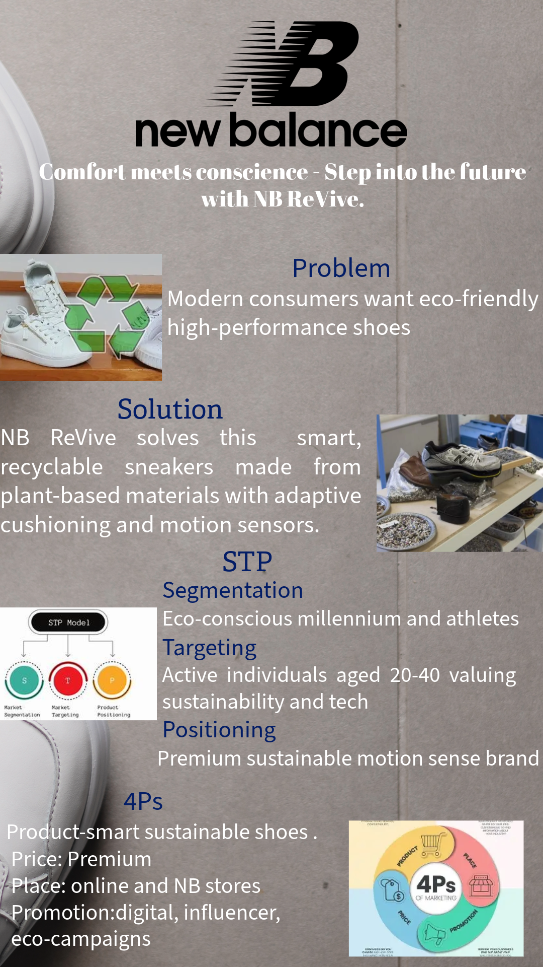

Element 4: Reflections

4.1 Learning Experience-
The development of the NB ReVive brand concept offered a useful understanding of how sustainability ideas can be incorporated into marketing strategy. Research on emerging consumer trends in sustainable footwear indicates that ethical and environmental responsibility are becoming more and more important when making decisions about what to buy (Schiaroli, 2024). Segmentation, targeting, and positioning (STP) frameworks were used to transform theoretical ideas from lectures into practical analysis that demonstrated how demographic and psychographic data affect real marketing strategies. Furthermore, it became clear that consumers prefer transparent and verifiable claims over token gestures, which is why evidence-based sustainable marketing is essential. Working through the 7Ps framework reinforced the need for consistency in product design, pricing, distribution, and promotion. This holistic perspective has expanded my understanding of marketing as an analytical and creative process that links brand purpose, consumer knowledge, and quantifiable impact (Kotler & Keller, 2022).

4.2 Skill Gained-
Several academic and professional skills were enhanced by this project.
4.2.1 Research and analytical abilities: Evaluating sustainability reports and market statistics improved my ability to identify trustworthy sources and conduct unbiased trend analysis (Saunders et al., 2019).
4.2.2 Collaboration and communication: Group discussions and peer review sessions promoted the growth of clear, compelling communication and teamwork abilities, which are critical for introducing ideas to a range of audiences.
4.2.3 Digital literacy: Using Canva to prepare the pitch presentation and make the marketing poster helped me hone my design and digital storytelling abilities. I learned how to transform complex research into clear visuals and compelling statements that engage audiences on an intellectual and emotional level (Tuten & Solomon, 2021).
4.2.4 Strategic thinking: Adding sustainability to the marketing mix encouraged systems thinking, which simultaneously considers social, economic, and environmental impacts when choosing products and services.

4.3 Challenges faced-
Finding a balance between creativity and practicality was one of the biggest obstacles. The ambition to develop an ideal eco-product had to be curbed by practical constraints and realistic cost structures. Finding reliable life-cycle data for materials was another difficulty; much secondary data in sustainability marketing is still fragmented or controlled by brands, which restricts full transparency (White et al., 2019). Time management was also difficult when combining the research, writing, and design phases. Initially, I was unaware of how long it would take to align theoretical models (like STP and the 7Ps) with actual brand growth. To overcome these obstacles, prioritization, iterative improvement, and feedback from tutors and peers were required. My ability to recover and approach marketing assignments with a problem-solving mindset was enhanced by these experiences.

4.4 Lessons for the Future-
In the future, I want to improve in three main areas.
Future projects will combine information from multiple sources, such as industry databases, academic journals, and customer interviews, to offer deeper insights and reduce bias.
Time management: Establishing objectives early on will help you feel less stressed at the last minute and produce edits of higher quality.
Persuasive storytelling: While I've become more comfortable giving presentations, I've realized that I need to better integrate logical and emotional reasoning when pitching to clients or investors. It is possible to effectively communicate the social and commercial advantages of sustainable brands by fusing design, narrative, and evidence.
Overall, this portfolio improved my understanding of marketing as an integrative discipline that combines creativity, ethics, and data. The experience has improved my ability to develop ethical and profitable marketing strategies, which is a critical skill for future employment in global corporations and sustainable brand management.

5 References
- Kotler, P. and Keller, K.L. (2022) Marketing Management. 16th edn. Harlow: Pearson.
- PwC (2024) Voice of the Consumer Survey 2024. PricewaterhouseCoopers. Available at: https://www.pwc.com..
- Saunders, M., Lewis, P. and Thornhill, A. (2019) Research Methods for Business Students. 8th edn. Harlow: Pearson.
- Schiaroli, L. (2024) ‘Sustainable footwear market trends: Consumer attitudes and demand’, Journal of Sustainable Fashion, 12(2), pp. 55–70.
- Tuten, T.L. and Solomon, M.R. (2021) Social Media Marketing. 4th edn. London: Sage.
- White, K., Habib, R. and Hardisty, D.J. (2019) ‘How to SHIFT consumer behaviours to be more sustainable: A literature review and guiding framework’, Journal of Marketing, 83(3), pp. 22–49.
- New Balance (2024) Sustainability and Impact Report 2024. New Balance Athletics Inc. Available at: https://www.newbalance.com.
- Global Sustainable Footwear Market Report (2024) Global Sustainable Footwear Industry Analysis 2024–2032. MarketWatch. Available at: https://www.marketwatch.com.
- Aitken, R., Watkins, L. and Williams, J. (2020) ‘Sustainable consumption and the attitude–behaviour gap’, Journal of Consumer Marketing, 37(2), pp. 139–149.
- Bocken, N., de Pauw, I., Bakker, C. and van der Grinten, B. (2016) ‘Product design and business model strategies for a circular economy’, Journal of Industrial and Production Engineering, 33(5), pp. 308–320.
- Ellen MacArthur Foundation (2021) Circular Economy in Fashion & Footwear. Ellen MacArthur Foundation. Available at: https://ellenmacarthurfoundation.org.
- Gazzola, P., Pavione, E., Pezzetti, R. and Grechi, D. (2020) ‘Trends in the fashion industry: The perception of sustainability and circular economy’, Sustainability, 12(7), pp. 2809–2824.
- Global Data (2023) Sustainable Footwear Market Forecast 2023–2030. Global Data Market Analysis. Available at: https://www.globaldata.com.
- Grubor, A. and Milovanov, O. (2017) ‘Brand strategies in the era of sustainability’, Interdisciplinary Management Research, 13, pp. 51–59.
- Kotler, P. and Armstrong, G. (2021) Principles of Marketing. 18th edn. Harlow: Pearson.
- Niinimäki, K. and Hassi, L. (2011) ‘Emerging design strategies in sustainable production and consumption’, Journal of Cleaner Production, 19(16), pp. 1873–1880.
- Niinimäki, K. (2020) ‘Sustainable fashion and circular design’, Sustainability, 12(7), pp. 2438–2455.
- Peattie, K. and Crane, A. (2005) ‘Green marketing: Legend, myth, farce or prophesy?’, Qualitative Market Research, 8(4), pp. 357–370.
- Statista (2024) Revenue of the Athletic Footwear Market Worldwide from 2019 to 2028. Statista Research Department. Available at: https://www.statista.com.
- Sustainable Apparel Coalition (2022) Higg Materials Sustainability Index (MSI) Methodology. Sustainable Apparel Coalition. Available at: https://apparelcoalition.org.
- UN Environment Programme (2023) Sustainable Fashion: A New Textiles Economy. UNEP. Available at: https://www.unep.org.

