

Programme : Master of Business Administration
Module : Marketing Management
Module code : LCMB7024
Title : Marketing Environment Analysis
Lecturer : Dian Mayasari (Birmingham)
Student Name : Md Khaled Iqbal Sumel
Student ID : 2507096
Submission Date- 24th October 2025
Word count : 2730

Table of Contents
1.0 Introduction………………………….………………………………. 3
2.0 Organisational Profiles: Monzo and Lloyds Banking Group….. 3-5
3.0 Critical Macro-Environmental Analysis………………………….. 5-10
4.0 Strategic Response Mechanisms………………………………….. 10-13
5.0 Conclusion……………………………………………………………. 13-14
References………………………………………………………………….. 14-16

1.0 Introduction
The 9.5tn pounds UK banking industry is experiencing disruption, regulation and technology are taking away old barriers (Bank of England 2023), presso, oligopoly, five banks and 85% of PCAs (Entrants&CMA) segmented by pro-competition demands772, the natural laboratory to contrast pioneers with adoptive incumbents. Our case is Monzo (mobile-only, 2015) vs Lloyds (259-year former; 25% current accounts) (Lloyds Banking Group, 2023a). Relevant Findings Informed by the theory on disruptive innovations, dynamic capabilities and RBV (Christensen, 1997; Teece, 2009; Barney, 2014), we struggle with how regulation/technology (dis)enables pioneer verses follower options and how marketing optimises positioning vis-a-vis asymmetric capabilities. Findings challenge the advocates of pioneer-advantage announcements, give information on inefficiencies of incumbents other than the technology gap, and hold up the extent to which sustainable advantage is on the correspondence among legacy, circumstance, and the dynamic capacity, not when a company joins (Suarez and Lanzolla, 2007).
2.0 Organisational Profiles: Monzo and Lloyds Banking Group
Monzo Bank Limited (The Pioneer) Founded in 2015 Monzo is a mobile-first current account with no physical infrastructure, which proves to be a pioneer in the United Kingdom of the challenger banking industry (Monzo, 2023).

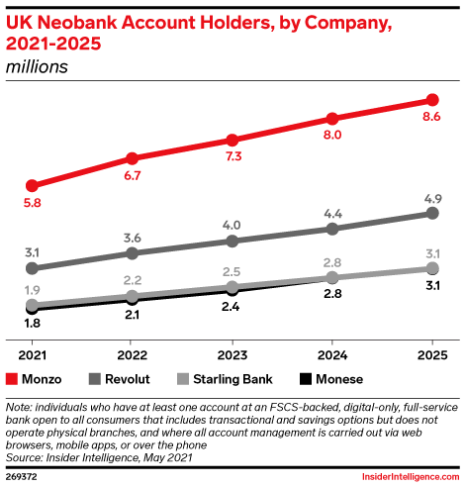

It was the iconic hot coral debit card that heralded a new generation, and instant spending notifications, budgeting features and free international payments addressed the issues incumbents neglected (Mention, 2019). Monzo was granted a full banking licence in the United Kingdom in 2017 and can now be involved in the Current Account Switch Service and also has a regulatory credibility (Competition and Markets Authority, 2019). Monzo uses a freemium strategy: Free: This is the scale driver (8+ million customers by 2023); premium: Monzo Plus (PS5/month) and Monzo Premium (PS15/month): Every engagement is monetised; Marketplace: Adding referral fees and net interest margin to this business model (Monzo, 2023). It only became profitable in FY2022/23 after losing over PS500 million, which casts the issue of sustainability (Financial Times, 2023).
Lloyds Banking Group PLC (The Follower) The incumbency of United Kingdom banking, founded in 1765, includes Halifax, Bank of Scotland, and Scottish Widows as well as its brand leader (Lloyds Banking Group, 2023a). Lloyds has a 24 percent share of current accounts, a 740+ number of branches and PS441 billion deposit base, which works to its advantage (Lloyds Banking Group, 2023b). Following the 2008 bailout and restructuring, a digital transformation under the leadership of CEO Antonio Horta-Osorio (2011-2021) was based on efficiency, adoption, and response to challengers (Skinner, 2018). The More Digitised, Simpler, Lower Risk programme diverted PS3 billion (2018-2021) to modernize its technology, add digital and mobile capabilities, and streamline its branch network (around 25% fewer branches) and achieved 18 million active digital users, a core of 75% customer-centric posture (Lloyds Banking Group, 2021). Lloyds pursues a hybrid approach: it retains face-to-face service as a service valued where possible and develops digital technology that is equal to challengers like Atom Bank (Laukkanen, 2016).

3.0 Macro-environmental Analysis Analysis Critical.
3.1 Regulatory Transformation - challenges and opportunities.
Redesign of regulations because the global financial crisis has both facilitated competition and increased prudential expectations. Open Banking necessitates sharing data safely with the consent of the customer so that third parties have access to payments and account information.

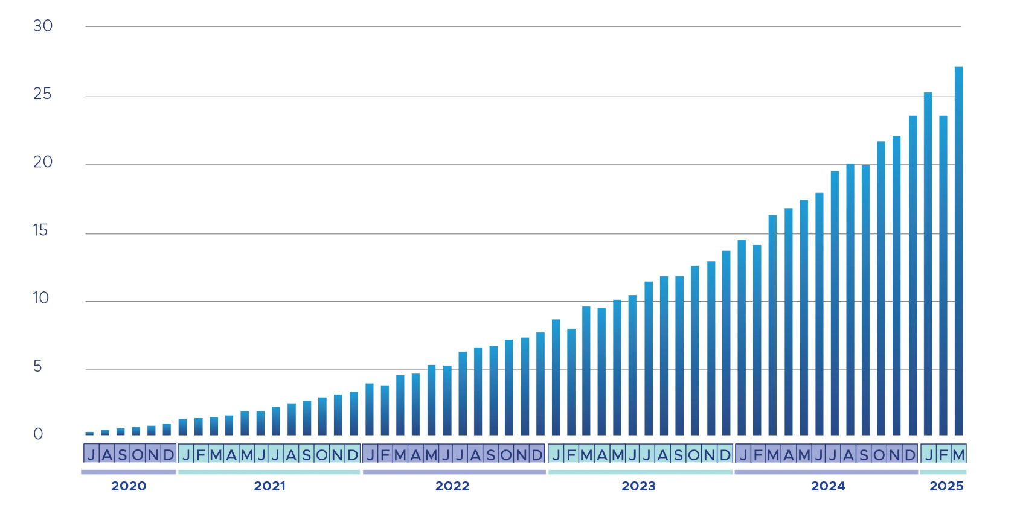
Source: Open Banking Limited

Simultaneously, the Current Account Switch Service helps to minimize the frictions that used to secure the positions of incumbents by the seven working days switch and redirection of payments. The combination of these interventions puts customer power in equilibrium, reduces acquisition costs of digital entrants, and compels incumbents to support relationships in terms of value, proposition, and service and not through inertia (CMA, 2019; FCA, 2021).
Market leader (Lloyds) -- Opportunities: Become an ecosystem leader: integrate third party products in owned channels and cross sell core lending and wealth, with richer multi product datasets to create artificial intelligence personalisation (Leo et al., 2019; Jacobides et al., 2021).
Reposition the Current Account Switch Service as a win back lever through targeted incentives, free fee holidays and across brand bundling that increases switching benefits and customer lifetime value (CMA, 2019; UK Finance, 2023). Implement shape favourably by consultation and industry fora; established relations with the Financial Conduct Authority and Bank of England enhance the book of influence on the standards to be followed, the schedules, and the expectations of the supervisors (Boot, 2017).
Market dominance (Lloyds) Threats:
Disintermediation risk, whereby open bank interfaces in the form of fintech interfaces take center stage and transactional data are harmed at the point of need, undermine the primacy of first order banks (Zachariadis and Ozcan, 2017).
The elevated compliance drag rate and the cost of legacy core adaptation depreciates returns as compared with asset light adherents, which displaces budgets aimed at change the bank to run the bank operations (FCA, 2021). Structural frictions are reduced by the Current Account Switch Service; any minor dissatisfaction is able to focus outflows within the profitable cohorts, making churn sensitive (CMA, 2019; Klemperer, 1995).
Followers (Monzo)--Opportunities: The senate members (Monzo) are the followers. It gets people into the game through mobilisation as a licensee (lower barriers of entry), and an aggregator model via the Open Banking (own the interface and experience without owning all the balance sheet products) (BoE, 2021; Monzo, 2023; Jacobides et al., 2021).
The Current Account Switch Service favours high Net Promoter Score, digital first brands; inflows are boosted by simplified applications and transparent prices at comparatively inexpensive marginal cost (UK Finance, 2023).
Followers (Monzo) -- Threats: Policy risk: tougher capital, anti money laundering and data protection regulations, new designs of Open Banking scope and funding may undermine the economics of aggregation and referral (Ozili, 2018; FCA, 2021).
The dependence on regulatory arbitrage-based income where balance sheets are lightweight can be frail when the supervisors seal the loopholes and align standardisation among the entities (Vives, 2019).
Getting to the point Critical synthesis: regulation generates forces that are asymmetrical but equalised. Incumbents pay higher fees and have more demanding responsibilities but still have a hand in framing and magnifying, where followers scale more quickly by riding on openness, but get more frequently subjected to sudden rule adjustments and re-calibration by the supervisor.
3.2 Technology Disruption - threats and opportunities.
The data quality, the architectural coherence, the cloud operating leverage and the automation determine the value of migration in banking. With features of the user interface becoming similar, sustainable differentiation starts to move beyond look and feel to low cost in order to serve, durability, and the ability to recombine data and partners fast into new propositions (Davenport and Harris, 2017).

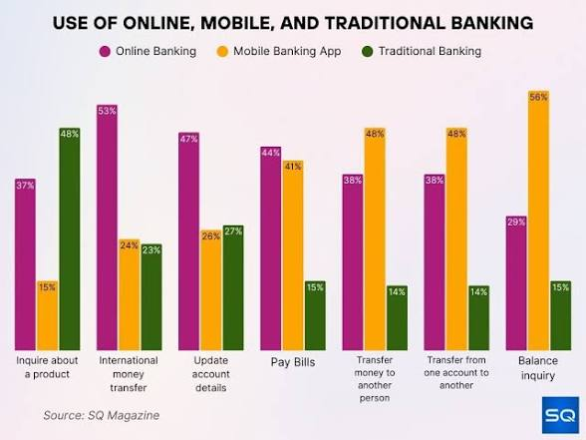
Market leader (Lloyds) -- Opportunities:
Card, mortgage, and saving scale data are also useful in better personalisation of machine learning and preventing frauds, as long as the governance and data pipeline quality are enhanced (Leo et al., 2019; Davenport and Harris, 2017).
The hybrid deployment models will be able to raise resilience and availability in a market that is sensitive towards trust, combining the private cloud, public cloud and on premise to provide continuity (Skinner, 2018).
Firm capital and brand allow build-buy-partner games: modernise cores, recruit rare engineering skills, and buy or form joint ventures with fintechs to lift the capabilities faster (Warner & Wager, 2019).
Market leader (Lloyds) - Threats: Path dependence and technical debt limit innovation velocity and cost to serve; incomplete ecosystem participation through incomplete application programming interface enablement (Teece, 2007; Warner & Wager, 2019).
User experience can be easily paralleled; front end benefits are degraded by batch processes, data silos and manual exceptions (Mbama & Ezepue, 2018).
Follwers (Monzo)--Opportunities: The first architecture of cloud native and application programming interface is associated with low unit costs (typically less than PS5 per account), continuous integration and delivery, and clean permissioned data to achieve rapid iteration and partner integration (Lee & Shin, 2018; Vives, 2017; Davenport and Harris, 2017).
The creation of habits and advocacy via mobile first design, real-time notification, and budgeting solutions drives the efficient acquisition and increased engagement (UK Finance, 2023; Mbama and Ezepue, 2018).
Followers (Monzo) -- Threats:
Cloud and vendor dependency risk concentration and resilience; outage has an immediate response in trust shock and social media criticism (Vives, 2017).
Effects of scale in artificial intelligence: smaller datasets will have decreasing returns as applications extend past payments into credit and wealth where incumbent history will give modelling benefits (Brynjolfsson and McAfee, 2017). When controls reduce with scale, the unit economics may be compressed at an accelerating pace than the revenue growth due to fraud and financial crime.
The takeaway: with the commoditization of artificial intelligence and user experience features, sustainable advantage shifts over to deep architecture (resilient, low cost cores) and orchestration capability-incumbents through scale and resilience; followers through speed and interface ownership (Eisenhardt and Martin, 2000). The victors will make compliance, data, and design an operating system that is cohesive to recombine continuously.

4.0 Strategic Response Mechanisms
4.1 Monzo's disruptive model
Monzo aims at targeted differentiation of digital natives with technologically superior, user centric banking with zero margin current accounts to win users; trust feeding subscriptions and market place monetisation; advocacy fuelling viral growth (Porter, 2008; Monzo, 2023). The strategic rationale is to attract daily engagement, turn a portion of the daily engagement into paid levels and partner referrals, and grow exponentially due to community effects.
Product: Free current accounts with real time notifications, spending analytics, foreign use free fees solve pain points that incumbents have not tackled. Premium levels-- Plus at PS5 and Premium at PS15 includes an insurance option and more advanced interest options and advanced controls whereas the in app marketplace reveals third party savings and investments and utilities (Mention, 2019). Close feedback loops and product cadence—smaller, more frequent releases—support perceived momentum and dependability.Pricing: Scale is supported by a freemium model; between 9 and 10 percent of customers become subscribers. Revenue incorporates subscriptions, card interchange and partner referrals and diversification away from interest margins. The cost of acquiring customers is approximately PS30 as opposed to PS150+ among the incumbents as a sign of organic attraction, mobile onboarding and easy switching (Monzo, 2023). The pricing model is set to ensure that the core remains free, convenience and benefits are monetised and the price transparency is preserved to uphold trust.
Location (Place): No branch estate mobile only allows the product speed and platform tenacity to be free of fixed costs. This footprint minimizes unit costs, enhances operating leverage and autonomously accesses national coverage without physical limitations (Lee and Shin, 2018). An open and partner friendly orientation enables Monzo to integrate new offers in the app without expansion in the balance sheet.
Advertisement: Little advertising expenditure; expansion will be driven by word of mouth, referral, a 50,000 or more community message board and the unique coral card as a social cue (Rogers, 2003). Community involvement becomes both product research and brand promotion and reduces the acquisition cost and the time to adopt new features.
People: Teams are technology driven, agile, customer centric and lean towards rapid experimentation and iteration (Tripsas and Gavetti, 2000). Hiring portrait and rewards are based on product ownership and customer results rather than hierarchical management.
Process: Opening accounts on demand with clear charges and chat in app with response times around two minutes make the process less frictional and anxiety-inducing (Parasuraman et al., 1985). Constant integration/deployment allows the regular, secure updates; the recovery of services is transparent, quick and responsive.
Physical evidence: The physical and digital evidence of simplicity and modernity is shown through the coral card and smooth user experience of the app (Kotler and Keller, 2016). Key questions: Product-market fit and regulatory leverage/technology have not fully translated to resilient economic footing. Revenue mix remains focused (circa 71% net interest margin) that further exposes profit to the cycle; and both income streams are heavily skewed demographically(18-35) lifecycle retention in mortgages and wealth(including pension choices), leading profitability to just break even in FY 2022/23, under a tightened capital and compliance framework(Monzo, 2023; Financial Times, 2023).
The execution priorities are expansion of higher margin fee lines, expansion of multi product adoption, enhancement of fraud/financial crime controls and maintenance of low acquisition costs as mainstream adoption increases.
4.2 Lloyds' adaptive strategy
Lloyds also integrates the notions of differentiation and cost discipline by leveraging scale and adopting challenger characteristics; More Digitised balances digital construction, branch streamlining and multi brand orchestration (Porter, 2008; Lloyds Banking Group, 2021). The objective is to protect and increase relationship depth and reduce cost of serving and modernising the core. Product: Relationship breadth anchors on a full suite proposition of current accounts, United Kingdom mortgages, cards, business banking, insurance and wealth. Product aggregation and product stickiness are stimulated by incentives (e.g. fee waivers, benefits) in the Club Lloyds (Lloyds Banking Group, 2023a). Partnerships that are selective are a complement to owned manufacture in which speed or economics favour collaboration.
Pricing: Competitive standard rates, relationship pricing and fee free current accounts (under the terms and conditions) will promote the mass appeal and support the value exchange by means of bundling. Flexibility in pricing among brands gives the opportunity to make targeted offers without damaging flagship positioning.
Context (Place): The needs of heterogeneous customers, such as reassurance seeking and complicated advice segments, are met, with the help of an omnichannel model, which has about 740 branches, 18 million digital users and phones help (Verhoef et al., 2015). Branch rationalisation is concerned with high value catchments: digital journeys consume routine service.
Promotion: Multi brand targeting: The propositions are aligned to the segment expectations across the platform of By Your Side life stages: Lloyds (reliability), Halifax (value), Bank of Scotland (heritage) to support the relevance and trust (Keller, 2001). Apps are becoming the part and parcel of campaigns in the pursuit of digital activation. People: It has around 64,000 positions and trains them on the need to be digital minded and keeps its banking experience (Lloyds Banking Group, 2023b). The change management programmes focus on customer journey ownership and cross functional teamwork.
Process: Continuous digital to branch experiences (e.g. start a mortgage online and finalize it in person) combine convenience and human touch; complicated situations will prompt professional attention (Laukkanen, 2016). Investments are aimed at straight through processing, improved data lineage and reduced exception rates.
Evidence is evident: In high-stakes categories, the existence of a visible branch and brand heritage is a sign of safety and survival, preserving trust (Ennew et al., 2011).
Critical: PS3 billion technology investment, 18 million digital users and almost parity applications disapprove of simplistic displacement of incumbents claims (Teece, 2009). However, there are still tensions between the costs of the branch and the challenger level pricing, cultural inertia that stifles innovation, multi brand orchestration complexity and the proverbial risk of straddling the cost leadership and differentiation without structural or strategic distinction (Warner & Wager, 2019; Porter, 1996). Modernisation of core architecture to turn front end parity into cost and speed benefit, refinement of brand roles to lessen cannibalisation and redirection of capital run the bank to change the bank activities at pace are all strategic imperatives. Overall, the strengths of Monzo are speed, consistency and community, and the strengths of Lloyds are trust, depth and stability. Both have to continue building dynamic capabilities to maintain an advantage.
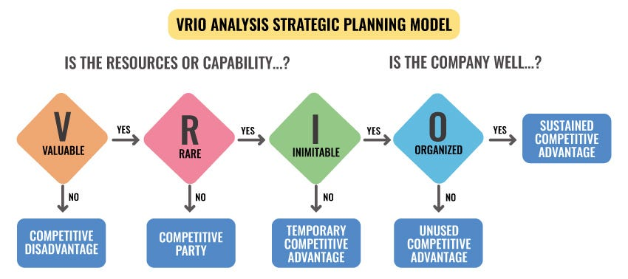
5.0 Conclusion
Source: Derived from Jay B. Barney (2014) Gaining and Sustaining Competitive Advantage

In disrupted markets, sustainable competitive advantage relies on macro-environmental condition, organisational competencies, and resource foundation- not leader position or heritage position (Teece, 2009; Porter, 1996). Permissive regulation and technology played to the advantage of Monzo, but the scale requires the company to face traditional banking problems: the need to expand demographics, the need to have a long-term revenue base, and the need to develop trust. In contrast, the resource commitment and dynamic capabilities of Lloyds do not fit the deterministic disruption accounts, showing that the omnichannel can withstand the Schumpeterian forces (Barney, 2014).
Each of them does not have absolute premises. Monzo is exposed to pressures of profitability, population constraints and threats of competitors. Lloyds is faced with cultural resistance, infrastructure, and cost-effectiveness versus service-differentiation dilemmas. Competitive results in the future are not much dependent on pioneer-follower trends but the quality of execution, strategy, and ongoing development of capabilities in keeping up with changes in the environment. This proves the main postulates of strategic management- competitive advantage is to be renewed, but not in place (Teece, 2007; Porter, 2008). Success needs the quality to coordinate faster than competitors and strategic coherence during disruption.
References
Bank of England (2023) Financial Stability Report. Available at: https://www.bankofengland.co.uk/financial-stability-report (Accessed: 20 October 2025).
Barney, J.B. (2014) Gaining and Sustaining Competitive Advantage. 4th edn. Harlow: Pearson.
Christensen, C.M. (1997) The Innovator's Dilemma: When New Technologies Cause Great Firms to Fail. Boston, MA: Harvard Business School Press.
Competition and Markets Authority (2019) Retail Banking Market Investigation: Final Report. Available at: https://www.gov.uk/cma-cases/review-of-banking-for-small-and-medium-sized-businesses (Accessed: 20 October 2025).
Financial Conduct Authority (2021) Open Banking: Competition Review. Available at: https://www.fca.org.uk/publication/corporate/open-banking-report.pdf (Accessed: 20 October 2025).
Financial Times (2023) 'Monzo achieves first annual profit as customer base grows', 12 July. Available at: https://www.ft.com/content/monzo-profit-2023 (Accessed: 20 October 2025).
Lee, I. and Shin, Y.J. (2018) 'Fintech: Ecosystem, business models, investment decisions, and challenges', Business Horizons, 61(1), pp. 35-46.
Lloyds Banking Group (2021) Strategic Review 2021. Available at: https://www.lloydsbankinggroup.com/investors/strategic-report.html (Accessed: 20 October 2025).
Lloyds Banking Group (2023a) Annual Report and Accounts 2022. Available at: https://www.lloydsbankinggroup.com/investors/annual-report.html (Accessed: 20 October 2025).
Monzo (2023) Annual Report and Accounts 2023. Available at: https://monzo.com/annual-report/ (Accessed: 20 October 2025).
Porter, M.E. (2008) On Competition. Updated and expanded edn. Boston, MA: Harvard Business Press.
Suarez, F.F. and Lanzolla, G. (2007) 'The role of environmental dynamics in building a first mover advantage theory', Academy of Management Review, 32(2), pp. 377-392.
Teece, D.J. (2009) Dynamic Capabilities and Strategic Management. Oxford: Oxford University Press.
UK Finance (2023) Banking Statistics 2023. Available at: https://www.ukfinance.org.uk/data-and-research/statistics (Accessed: 20 October 2025).
Vives, X. (2019) 'Digital Disruption in Banking', Annual Review of Financial Economics, 11, pp. 243-272.
Zachariadis, M. and Ozcan, P. (2017) 'The API economy and digital transformation in financial services', SWIFT Institute Working Paper, 2016-001.
eMarketer (n.d.) Monzo's high customer service ranking is much-needed good news. Available at: https://www.emarketer.com/content/monzo-high-customer-service-ranking-much-needed-good-news (Accessed: 19 October 2025).
Ghobadi, A. (2024) 'Cracking the code: Strategy demystified through the resource-based view', Medium. Available at: https://medium.com/@amirghobadi/cracking-the-code-strategy-demystified-through-the-resource-based-view-cac8b33a9014 (Accessed: 19 October 2025).
Open Banking Limited (2025) The OBL impact report 7: Adoption analysis. Available at: https://openbanking.foleon.com/live-publications/the-obl-impactreport-7/adoption-analysis (Accessed: 19 October 2025).
SQ Magazine (2025) Mobile banking statistics. Available at: https://sqmagazine.co.uk/mobile-banking-statistics/ (Accessed: 19 October 2025).

