
Campaign Proposal
Jiaying He

14 May 2024
UWTSD
Marketing in Practice

Contents
Executive Summary 2
1. Introduction 3
1.1 Background 3
1.2 Aims and Audiences 3
1.3 Key Factors 3
2. Overview 3
3. Campaign messages 5
4. Channels and Campaign Ideas 5
4.1 Advertising 5
4.2 Online Marketing 5
4.3 Sales Promotion 6
4.4 Public Relations and Publicity 6
4.5 Direct Marketing 7
4.6 Personal Selling 7
4.7 Channels Not Chosen 7
5. Budget Split 8
6. Metrics 9
6.1 Conversion rate 9
6.2 Market Penetration 10
6.3 Return on Investment (ROI) and Cost Per Acquisition (CPA) 11
7. Conclusion 11
Reference 12
Appendix 15

Executive Summary
This report outlines a strategic marketing campaign for the launch of a vegan cooking box service aimed at increasing brand awareness and acquiring new users in the UK market, targeting vegans and non-vegans who age 20-50 and are interested in vegan diets, delivering the messages of health benefits and convenient nature of the products.
With a growing demand for sustainable food options, vegan food box has a stronger market space in providing a healthy and convenient diet. Thus, the campaign adopts a multifaceted strategy focusing on precise targeting, compelling content creation, and rational resource allocation across various marketing channels. To be specific, it encompasses a blend of traditional and digital marketing strategies, including advertising (TV, radio, outdoor, and print), online marketing (social media, SEO, paid ads, influencers), sales promotions (early bird offers, free shipping, coupons, samples, referral discounts), public relations (vegan expert partnerships, CSR activities), direct marketing (email campaigns), and personal selling (retail partnerships). These initiatives are underpinned by meticulous planning and execution, guided by comprehensive market research and insights synthesized from industry trends.
Key metrics for success include conversion rate, aiming to reach 1.5 million people for a 2% conversion rate to acquire 30,000 new members, and market penetration, targeting a significant market share to gain the remaining 20,000 members. Return on investment (ROI) and cost per acquisition (CPA) will be continuously measured and adjusted monthly to optimize campaign effectiveness. By leveraging these strategies and metrics, the campaign aims to onboard 50,000 new members within six months, contributing to the promotion of vegan diets and a sustainable future.

- Introduction
  - Background
With the global shift towards more sustainable and ethical food choices, the demand for vegan alternatives has never been greater (Silva Souza, Atkinson and Montague, 2020). Through extensive market research and customer feedback, we have identified a growing desire for high-quality, plant-based meal options, that require the support of vegan ingredients. According to (Minassian, 2022) , overall vegan food delivery orders in 2021 increased by 17% compared to trends in 2020. To follow this momentum, we decided to capture a share of the market and occupy a place in the vegan food subscription box industry.
  - Aims and Audiences
By launching the vegan cooking box service, we aim to increase brand awareness and acquire users. Specifically, we plan to expand our reach and visibility exclusively within the UK market, leveraging local insights and positioning ourselves as the go-to solution for delicious vegan meals. However, our target group is not just vegans, but also non-vegans as potential users. According to Martinelli and De Canio (2022), non-vegans may also buy vegan products because of conformity or ethical motives. Thus, we are committed to getting more people to try vegan diets and expanding the impact of healthy diets through our campaign. Given the craze for vegan food for all age groups, our target audience is positioned in the 20–50-year-old group with major purchasing power. Besides that, the rapid change of The Times may lead to the shortening of the purchase cycle of users, and we hope to maintain the consumer lifetime value for 3-5 years. With a budget of £500,000 and a goal to onboard 50,000 new members within six months, comprehensive research and strategic deployment will be conducted to ensure a significant expansion of our offerings. Multifaceted promotion strategies encompassing a blend of traditional and digital marketing channels will be effectively planned according to financial input and schedule (McDougal, 2024).
  - Key Factors
Key factors contributing to the success of our campaign include precise targeting, compelling content creation, rational resource allocation, and robust performance-tracking mechanisms (Yoroflow, 2024). Additionally, Call-to-Action and promotional offers are also important to be involved in different channels. By prioritizing these critical elements, we aim to maximize ROI and drive sustainable growth for our Vegan Cooking Box service.
- Overview
Chart 1 The Gantt Chart
- Campaign Messages
Overall, all the above activities are to promote the benefits of vegetarian food and the convenience of our food box. Around this information, different messages will be delivered to vegans and non-vegans in a more targeted manner, where non-vegans may need stronger motivation, such as health awareness and animal bioethics (Kopplin and Rausch, 2022). Our USP includes providing the whole process service for vegan diets and creating a comfortable cooking and dining experience for the audience with the most nutritious and convenient Food box. Exquisite advertising design and strong Call-to-Action will be used to better express campaign ideas, which develop a promotional message that effectively communicates our brand's value proposition and drives desired consumer behaviors.
- Channels and Campaign Ideas
  - Advertising
Advertising is one of the most popular and traditional forms of marketing communications. Among different channels, TV and radio ads with mass audiences can be effective for small businesses and drive brand awareness (Smith, 2023). However, broadcast TV viewing continued its long-term decline among all ages in recent years, but the high cost of TV ad slots remains, contributing to the limitation of broadcast influence (Ofcom, 2023). Thus, we scheduled TV ads in the early stage of our campaign to drive awareness, but will not keep it for so long to save cost and optimize allocations. The TV ads should be well-designed with a clear focus. Yli-Kauhaluoma (2021) suggested that an international vegan label in vegan product advertising is beneficial to attract non-vegan individuals, which will be considered in our design.
Radio ads are similar to TV, but are much cheaper, so they are scheduled after TV to fill the blank of broadcast promotion. For example, BBC Radio 4 - The Food Programme is our best choice for radio promotion (BBC, 2024), which is not only highly related to our product but also owns a large target audience. Broadcasting during commuting hours allows people to learn about our brand and products regularly and unintentionally.
Outdoor ads are durable to stay in people’s view and can reach a massive audience. Wei et al. (2021) recommended that an indication for “more information” is useful to incent people to scan the code in outdoor ads, which will be adopted in our proposal.
Despite the decline of print publications under the proliferation of digital media, publications like magazines often have a built-in, well-defined audience (Squier, 2023). We allocated it in the later stage with less budget, not aiming to accumulate lots of accounts but loyal ones.
  - Online Marketing
According to Kemp (2024), the UK internet penetration stood at 97.8 percent in 2024, which has an extensive effect on people’s lives, and social media is also a big contributor in response to consumer decisions to adopt a vegan diet (Davies, 2018). Strategies including SEO and paid online ads will be applied in several mainstream online platforms according to our scheduling, for maximining the brand coverage in the early stage. Additionally, we will identify and partner with influencers whose audience aligns with our target demographic for high-quality vegan-sponsored content. Except for paid marketing, owned posts will be combined to provide lasting and low-cost product information, with an extra aim to strive for third-party earned reporting of our brand (Kelley et al., 2022).
Walsh (2024) reports that Facebook, YouTube and Instagram ranked at the top on the Monthly Active Users List in 2024, which are seen as the best choices to adopt online marketing. Therefore, our above activities will be conducted simultaneously on those platforms to reach the maximum coverage and deepen people’s impressions of our vegan campaign.
  - Sales promotion
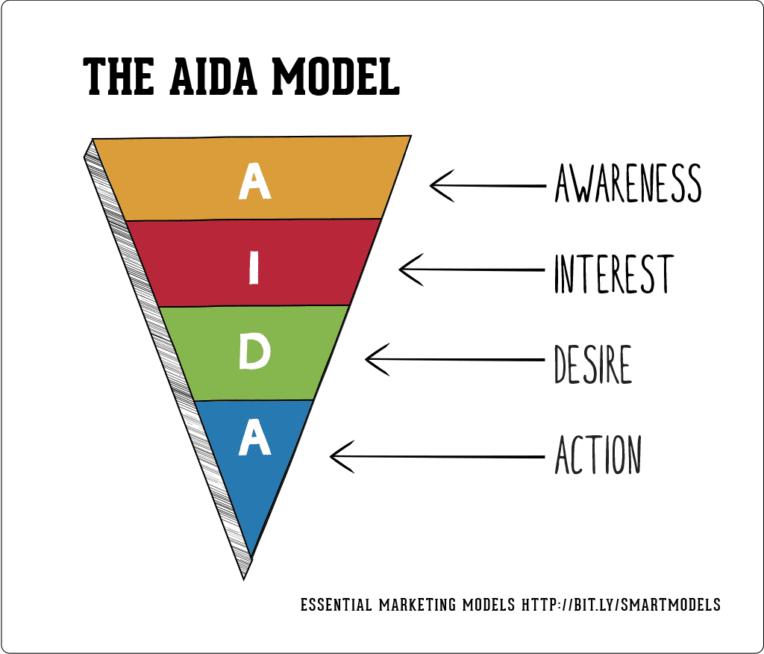
Picture 1 The ALDA Model
In the AIDA model, if advertising and online marketing are to focus on the Awareness and Interest step, then sale promotion particularly emphasizes the Desire phase (Yaakub, Nor and Jusoh, 2021). In our campaign, various kinds of sales promotion are applied in the follow-up stage to encourage the purchase decision, pushing Desire to Action. Among them, an early bird offer will be scheduled first to interplay with other activities for a coordinated marketing mix. Additionally, as the most common sales strategies, free shipping and coupons will also be deployed as extra incentives. Referring to Suryani and Syafarudin (2021), to lead customers to be willing to subscribe, they must first be able to try the product for assurance, which inspires us for free samples. By trying a vegan meal made by our food box, vegan individuals may be attracted by its convenience while non-vegans can be potentially converted into our customers. Furthermore, referral discounts are set for promoting word-of-mouth marketing, which aims to approach our goal of onboarding more new members. (Jung et al., 2020) have proved that the word-of-mouth method is effective but the necessary precondition is that the call-to-action includes prosocial elements, which reminds us to elaborately design the diction of posting the referral discounts.
  - Public Relations and Publicity
Managing public relations is a significant link in any marketing campaign, which also overlaps a lot with online marketing (Quesenberry, 2020). Just as shown in the Gantt Chart, the partnership is a good way to network with professional experts in vegan areas. Alike influencer marketing, their authority and influence can bring advantages to the brand's image, thus attracting more users to trust and subscribe. Additionally, Corporate Social Responsibility (CSR) is also scheduled to build a positive brand image in the first stage. Following Gürhan-Canli and Fries' (2023) suggestion, CSR activities need to be specifically emphasized to earn consumers’ affinity. Publicity is scheduled in the later part of the campaign based on pre-existing consumers. Both community and prize contests are set to promote engagement and expand the influence of our vegan campaign, which will cooperate with other social media marketing.
  - Direct marketing
Based on the pull policy by directly communicating with customers, we implemented email marketing, which can serve multiple valuable purposes for our business including branding, engagement, sales and conversion (Shwake, 2024). Various types of emails like welcome emails, promotional offers, and newsletters will be regularly sent to possible target audiences. Through big data research, we hope to accurately differentiate between vegan and non-vegan groups, pushing more specialized Food boxes to the vegan crowd and emphasizing the advantages of convenience, while pushing vegan food that is easier to try and more emphasis on health characteristics to the non-vegan crowd. By obtaining the age information of the crowd, E-mails can be sent according to the active time of different ages, for example, office workers may check emails in the morning, but all these need to be established under the information access channels allowed by GDPR (Intersoft, 2024).
  - Personal selling
In contrast to the pull policy, personal selling aims to promote the product flow following the communication flow step by step based on the push policy. B2B is the most commonly used channel and is proven to be an effective way to reach and accumulate a user base (Prihatini and Gumilang, 2021). Therefore, our main plan is to forge partnerships with major retailers such as Tesco, Sainsbury, and Lidl to stock our vegan cooking box in their stores, leveraging their existing customer base and distribution network. This channel will be based on supply to retailers for distribution, but sales personnel will be deployed to perform additional promotional launches in densely populated cities.
  - Channels Not Chosen
The campaign plan is dedicated to leveraging the interaction of the promotion mix to maximize user engagement. However, due to the budget and resource limits, some channels cannot be involved. For example, we have no plans for a press conference or press release because of fewer media attention as a start-up. In addition, although cinema ads are seen as a beneficial way to increase brand awareness, there is too high for small businesses and they have not fully regained their influence in recent years as a result of the COVID-19 pandemic (Statista, 2024). In short, we considered the overall deployment of the campaign and finally presented the envisioned plan.

- Budget Split
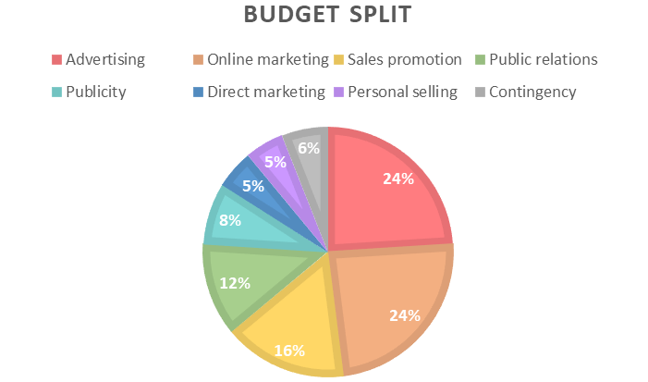
Chart 2 The Budget Split
According to Friedman (2024), there's no one-size-fits-all approach in marketing budget allocation, but the guidance for average split indicates that a significant chunk, around 40-50% of the budget, is allocated to digital marketing efforts. As it is shown in the overall budget split chart, the online marketing, publicity and direct marketing all related to this section, exactly contributing to 49% of the budget. Moreover, traditional marketing still holds its ground, typically accounting for 20-30% of the budget, which also coincides with our advertising allocation, and 10%-15% is to be allocated to sponsorship and events, where PR and personal selling will take up that part of the budget.
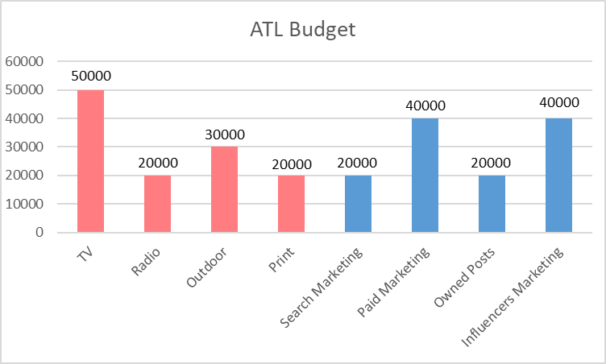
Chart 3 The ATL Budget Split
For ATL marketing, we include many different channels, and their allocation of budget is based on related data and experience. Statistics show a good return on investment with TV advertising in the UK, with £1.73 returned for every £1 invested in the short term and up to £4.20 long term, but the costs for a 30-second ad at a time can vary from £70 to £34,000 (Lill, 2022). Thus, although we scheduled TV ads for only 2 months, they can still cost £50,000 ranking at the top of expenses. Other ad channels are much cheaper than TV, and each of them will cost £20,000-£30,000 based on different release periods.
In addition, search marketing like SEO is allocated £20,000 for three months and paid marketing may cost double because multiple platforms need to post. Owned posts can be the most economical activity to conduct where only content-making and operation costs (AppsFlyer, 2024), so despite the whole-process scheduling, it is only allocated for £20,000. In contrast, influencer advertising is more costly, especially for well-known ones, so £40,000 is assigned to invest in more influential celebrities.
Beyond that, 6% of the budget is split for the contingency to cover potential events that are not specifically accounted for. The purpose is to compensate for the uncertainty in budget estimates and unpredictable risk (Wigmore, 2019).
- Metrics
Because our final goal is to onboard 50,000 new members, the number of customers acquired is seen as the most important indicator, which can be measured from two levels.
  - Conversion rate
The first KPI is the conversion rate.
The visitor data will be caught from website page views, Email click-through rate, follower growth rate, QR code-scan rate, etc., which is overall data for all online marketing activities (Marketing Revolution, 2021). Besides that, registration amount is also integrated data including referral rates and customers acquired from publicity events. According to Bailyn (2024), the digital marketing conversion rate is 2% on average for each channel (Chart 4). Thus, to gain 60% new members (30,000) on this level, our goal is to reach more than 1,500,000 (30,000/2%) audiences during the campaign.
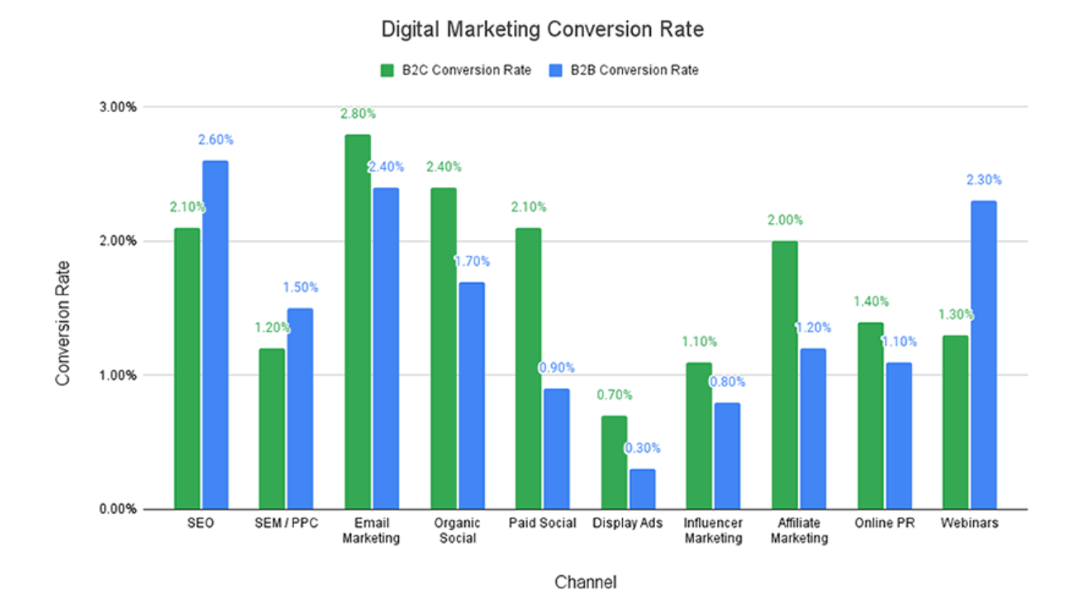
Chart 4 Average Digital Marketing Conversion Rate
  - Market penetration
Another indicator is related to sales, which is a more direct way to calculate the customer acquired. Market penetration is for measuring the total customer base compared with the total market potential. This KPI will be mainly applied in sales promotion and personal selling sectors.
Data can be obtained from the number of people buying from retailers and online stores, as well as the population size of vegans and potential vegans. The higher the market penetration rate, the greater the opportunity for growth and revenue. The average B2B market penetration is 10%- 40% (Capital, 2023), so to reach our goal of gaining the rest 20,000 members, a larger market should be reached. This metric provides valuable insights into the market potential and helps develop market share (Frost, 2023).
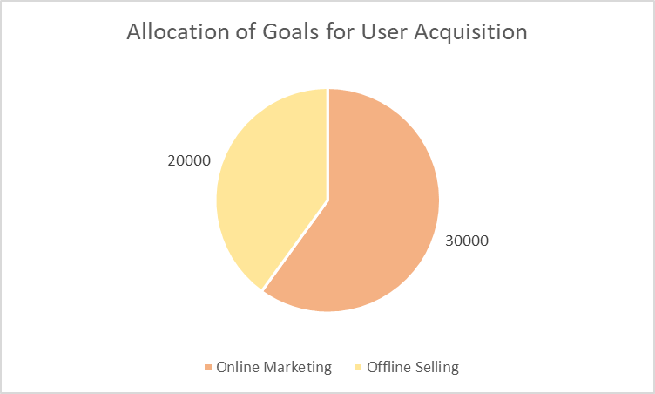
Chart 5 Allocation of Goals for User Acquisition
  - Return on Investment (ROI) and Cost Per Acquisition (CPA)
All of the metrics will be conducted monthly for continuous measurement and adjustment. At the end of the campaign, we will measure the ROI and CPA as a whole, aiming to learn lessons from investment and campaign effectiveness for future marketing campaigns (Rayco, 2020).
- Conclusion
As a new initiative, this vegan food box campaign will be a great opportunity for us to expand brand awareness and promote products. This marketing campaign plan is not definite and perfect, we will continue to adjust and optimize activities focus and budget split during the campaign, striving to maximize the effectiveness of different marketing mixes.
As we embark on this journey, we sincerely hope that more users will join us, regardless of whether they are vegan or not, for redefining the landscape of a healthy diet and contributing to a more sustainable future for all (Oke, 2023).

Reference
AppsFlyer (2024) ‘Owned media: AppsFlyer mobile glossary’, AppsFlyer. Available at: https://www.appsflyer.com/glossary/owned-media/ (Accessed: 7 May 2024).
Bailyn, E. (2024) ‘Digital Marketing Conversion Rates: 2024 Report’, First Page Sage, 28 February. Available at: https://firstpagesage.com/reports/digital-marketing-conversion-rate/ (Accessed: 7 May 2024).
BBC (2024) BBC Radio 4 - The Food Programme, BBC. Available at: https://www.bbc.co.uk/programmes/b006qnx3 (Accessed: 14 May 2024).
Capital, L. (2023) What Is Market Penetration? Definitions, Strategies & Examples, Lighter Capital. Available at: https://www.lightercapital.com/blog/what-is-market-penetration-strategy-definition-examples (Accessed: 7 May 2024).
Davies C. (2018) ‘Do Influencers on Social Media Influence People to Adopt a Vegan Diet and How Does This Affect Consumer Decision Making?’ Available at: https://radar.brookes.ac.uk/radar/items/297813ba-c352-42b9-8a40-295dcae066da/1/ (Accessed: 3 May 2024).
Friedman, H. (2024) Precision in Planning: Strategies For Marketing Budget Allocation. Available at: https://improvado.io/blog/marketing-budget-allocation (Accessed: 6 May 2024).
Frost, A. (2023) Sales Metrics 101: The Ultimate Guide to Understand What to Track, How to Track, & Why. Available at: https://blog.hubspot.com/sales/sales-metrics (Accessed: 7 May 2024).
Gürhan-Canli, Z. and Fries, A. (2023) ‘Branding and corporate social responsibility (CSR)’, Brands and Brand Management, pp. 91–110.
Intersoft (2024) General Data Protection Regulation (GDPR) – Legal Text, General Data Protection Regulation (GDPR). Available at: https://gdpr-info.eu/ (Accessed: 14 May 2024).
Jung, J. et al. (2020) ‘Words Matter! Toward a Prosocial Call-to-Action for Online Referral: Evidence from Two Field Experiments’, Information Systems Research, 31(1), pp. 16–36. Available at: https://doi.org/10.1287/isre.2019.0873.
Kelley, L.D. et al. (2022) Advertising media planning: a brand management approach. Routledge. Available at: https://www.taylorfrancis.com/books/mono/10.4324/9781003258162/advertising-media-planning-larry-kelley-kim-bartel-sheehan-lisa-dobias-david-koranda-donald-jugenheimer (Accessed: 19 April 2024).
Kemp, S. (2024) Digital 2024: The United Kingdom — DataReportal – Global Digital Insights. Available at: https://datareportal.com/reports/digital-2024-united-kingdom (Accessed: 3 May 2024).
Kopplin, C.S. and Rausch, T.M. (2022) ‘Above and beyond meat: the role of consumers’ dietary behavior for the purchase of plant-based food substitutes’, Review of Managerial Science, 16(5), pp. 1335–1364. Available at: https://doi.org/10.1007/s11846-021-00480-x.
Lill, D. (2022) How much does traditional advertising cost in the UK, Talk Retail. Available at: https://talk-retail.co.uk/how-much-does-traditional-advertising-cost-in-the-uk/ (Accessed: 7 May 2024).
Marketing Revolution (2021) 35 Marketing Metrics to Measure Campaign Success | Marketing Evolution. Available at: https://www.marketingevolution.com/knowledge-center/marketing-metrics-kpis-campaign-success (Accessed: 7 May 2024).
Martinelli, E. and De Canio, F. (2022) ‘Non-vegan consumers buying vegan food: the moderating role of conformity’, British Food Journal, 124(1), pp. 14–30.
McDougal, M. (2024) How a Mix of Traditional and Digital Marketing Might Be the Key to Success. Available at: https://www.tkg.com/insights/learn/traditional-and-digital-marketing-mix (Accessed: 19 April 2024).
Minassian, L. (2022) ‘Why the Global Rise in Vegan and Plant-Based Eating is No Fad (30x Increase in US Vegans + Other Astounding Vegan Stats)’, Food Revolution Network, 6 April. Available at: https://foodrevolution.org/blog/vegan-statistics-global/ (Accessed: 19 April 2024).
Ofcom (2023) Media Nations 2023, Ofcom. Available at: https://www.ofcom.org.uk/research-and-data/tv-radio-and-on-demand/media-nations-reports/media-nations-2023 (Accessed: 3 May 2024).
Oke, O. (2023) ‘Campaign Performance: Key Metrics for Success Analysis’, NewswireJet, 14 July. Available at: https://newswirejet.com/campaign-performance-key-metrics-for-success/ (Accessed: 19 April 2024).
Prihatini, W. and Gumilang, D.A. (2021) ‘The Effect of Price Perception, Brand Image and Personal Selling on the Repurchase Intention of Consumers B to B of Indonesian General Fishery Companies with Customer Satisfaction as Intervening Variables’, European Journal of Business and Management Research, 6(2), pp. 91–95.
Quesenberry, K.A. (2020) Social media strategy: Marketing, advertising, and public relations in the consumer revolution. Rowman & Littlefield Publishers. Available at: https://books.google.com/books?hl=zh-CN&lr=&id=QWTyDwAAQBAJ&oi=fnd&pg=PR3&dq=Managing+public+relations+can+be+a+significant+link+in+any+marketing+campaign.&ots=BunjMjJHxN&sig=_d855tKpbbHSVMV8eBcXpCLvFEg (Accessed: 6 May 2024).
Rayco (2020) ‘CPA (Cost Per Acquisition): The Key Metric to Boost Your ROI’, 21 September. Available at: https://pathmonk.com/cpa-the-key-metric-to-boost-your-roi/ (Accessed: 7 May 2024).
Shwake, E. (2024) The 29 Best Email Marketing Campaign Examples To Inspire You, Wix Blog. Available at: https://www.wix.com/blog/email-marketing-examples (Accessed: 6 May 2024).
Silva Souza, L.G., Atkinson, A. and Montague, B. (2020) ‘Perceptions about veganism’. Available at: http://eprints.kingston.ac.uk/id/eprint/45271/ (Accessed: 19 April 2024).
Smith, C. (2023) Have you considered local radio or TV advertising? Available at: https://www.simplybusiness.co.uk/knowledge/articles/radio-advertising-costs-and-tv-advertising-costs/ (Accessed: 3 May 2024).
Squier, M. (2023) Council Post: Why Magazine Ads Still Belong In Your Media Plan, Forbes. Available at: https://www.forbes.com/sites/forbesagencycouncil/2023/04/21/why-magazine-ads-still-belong-in-your-media-plan/ (Accessed: 3 May 2024).
Statista (2024) Cinema ad spend in the UK 2023, Statista. Available at: https://www.statista.com/statistics/262726/cinema-advertising-revenue-in-the-uk/ (Accessed: 6 May 2024).
Suryani, I. and Syafarudin, A. (2021) ‘The effect of sales promotion on purchasing decisions’, Ilomata International Journal of Tax and Accounting, 2(2), pp. 122–133.
Walsh, S. (2024) The Top 10 Social Media Sites & Platforms, Search Engine Journal. Available at: https://www.searchenginejournal.com/social-media/social-media-platforms/ (Accessed: 3 May 2024).
Wei, Z. et al. (2021) ‘Influence of incentive frames on offline-to-online interaction of outdoor advertising’, Journal of Retailing and Consumer Services, 58, p. 102282.
Wigmore, I. (2019) What is contingency budget (cost contingency)? | Definition from TechTarget, WhatIs. Available at: https://www.techtarget.com/whatis/definition/contingency (Accessed: 7 May 2024).
Yaakub, N.A., Nor, K.M. and Jusoh, A. (2021) ‘THE EFFECT OF PRICE DISCOUNT AND FREE GIFT ON ONLINE ENTREPRENEURS’BUSINESS PERFORMANCE IN SOCIAL COMMERCE’, International Journal of Business and Economy, 3(3), pp. 29–42.
Yoroflow (2024) (16) Optimizing Creative Campaign Management For Maximum Impact | LinkedIn. Available at: https://www.linkedin.com/pulse/optimizing-creative-campaign-management-maximum-impact-yoroflow-42jlc/ (Accessed: 19 April 2024).

Appendix
Chart 1 The Gantt Chart 4
Picture 1 The ALDA Model 6
Chart 2 The Budget Split 8
Chart 3 The ATL Budget Split 8
Chart 4 Average Digital Marketing Conversion Rate 10
Chart 5 Allocation of Goals for User Acquisition 10

