EXPANDING HSBC'S OPERATIONS IN THE EU: ANALYSIS OF POLAND AND FRANCE

INTERNATIONAL BUSINESS COMUNICATION

Student Name: Eugenia Adriana Manda- 2113738
Lecturer: Dr. Zainab Atta
Date: 22 Dec 2023

Tabel of content
Introduction…………………………………………………………………………………3
Country Evaluation
- Poland Cultural Differences and Labor Outlook…………………………………….4
- France Cultural Differences and Labour Outlook……………………………………8
Conclusion…………………………………………………………………………………..13
Reference List……………………………………………………………………………….14

Introduction to HSBC
HSBC, as one of the world's leading banking and financial services organizations, operates on a global scale. HSBC was started in 1865 and it has been in operation since then (Xu, 2020). The corporation originated from the need to establish a bank that would facilitate trade between India, China, and Europe. Throughout its operation, HSBC successfully expanded its operations becoming a significant international financial partner in international trade. During the 20th century, HSBC expanded to different countries including Singapore, the Philippines, and Japan while strengthening its presence in Europe and North America. Towards the end of the 20th century and throughout the 21st century, HSBC continues to expand its operations and global footprints (Xu, 2020). In 1992, HSBC was involved in one of the best financial moves by acquiring Midland Bank in the UK, reinforcing its present position in Europe. In 2023, HSBC will be one of the largest banking corporations with branches in over 64 countries across the world offering retail banking, wealth management schemes, corporate banking, and investment options (Xu, 2020). Known for its diverse portfolio of services, HSBC's expansion strategy requires meticulous consideration of cultural and business nuances in potential host countries.
HSBC has been instrumental in the development of global finance, especially in trade and investments. Additionally, the bank has been effective in supporting emerging markets by providing financial resources and technical advice to foster economic development. HSBC is a socially and environmentally responsible entity because it supports sustainability initiatives and adheres to the UN principles of responsible banking (Xu, 2020). The corporation is well positioned for expansion and growth to new markets due to its authoritative financial status and commitment to innovation.

Country Evaluation
Poland Cultural Differences and Labor Outlook
Poland, with its exceptional social contexts and language, poses both openings and challenges for HSBC. Poland is geographically close to the UK but has several cultural differences that can impact the business expansion of HSBC into the Polish market. Understanding the cultural landscape is vital to navigating successfully. The communication style in Poland is mainly direct, less expressive, and highly formal (Walaszczyk and Mazur, 2019). The preferred communication differs from the British approach, which is indirect with a focus on elements such as humor and understatement. For instance, when giving employees feedback, Polish culture prefers direct communication of the areas that need improvement rather than just stating that the individual should put more effort into the workplace. In British culture, a manager may only state that the overall performance is, but more improvement is required. However, such communication can be frustrating and confusing for Polish employees because they are probably used to direct communication of failure while trying to be polite. Poland leans towards a collective culture that values group goals, social establishments, and identifying with a certain group. This can be illustrated in the collaboration encouraged in business decisions leading to extensive consultation with various individuals within a group before drawing the main conclusion. Poland scores high on power distance suggesting that hierarchy is highly respected in businesses and contact should be initiated from the top management. A solid relationship with corporations is mainly established through effective collaboration with the leaders to establish permanent contact (Holostenco, 2022). However, there is a change in the way the top executives are willing to receive and respond to feedback. The feedback from subordinates is encouraged to be more indirect and respectful when addressing the management as a way according to respect to the authorities.
Compare countries – Trompenaars cultural dimensions.
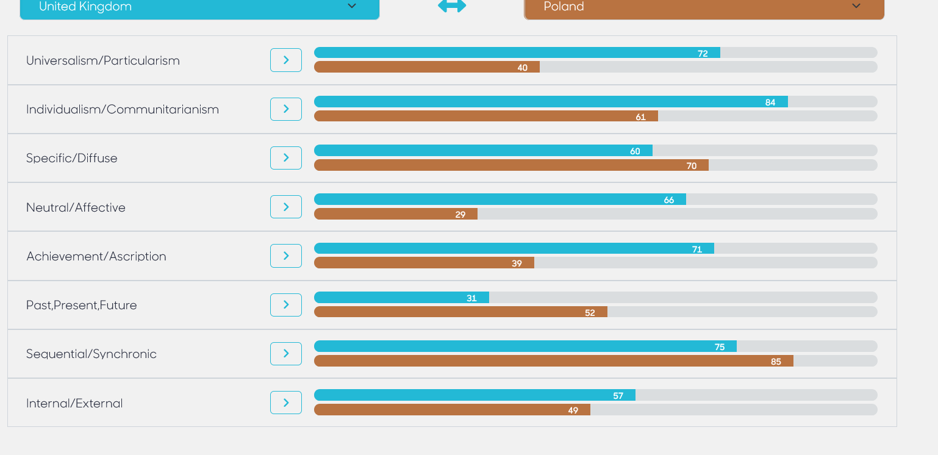
Trompenaars Cultural Dimensions
The UK and Poland
(thtconsulting,2023)

In Poland, uncertainty avoidance is high, indicating that many individuals and cultural establishments lean towards established rules and procedures. Polish business culture prioritizes predictability as suggested by the preference for a direct, clear explanation and well-structured agenda. This is different from UK culture which prefers open-ended questions as well as an informal and flexible approach to business dealings (Barber, 2021) On masculinity versus femininity, Poland has a moderately masculine culture, which indicates the value of work-life balance. While the UK culture is mainly focused on assertiveness, accomplishment, and material wealth, in Poland, achievements should be coupled with quality of life.

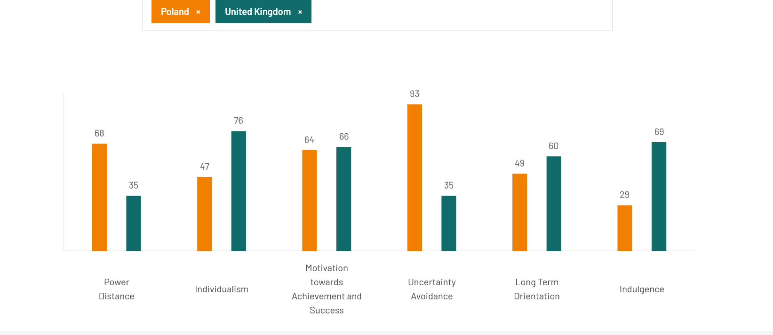
Hofstede’s Cultural Dimensions
The UK and Poland
(hofstede-insights,2023)

HSBC can navigate challenges by establishing various strategies such as cultural training, relationship building, and cultural sensitivity awareness. Cultural training can inspire individuals working for HSBC to learn and adopt distinct and diverse communication methods and requirements for interacting with local customers (Holostenco, 2022). Building positive relations with Polish colleagues and stakeholders can establish trust and assist HSBC in overcoming cultural barriers while fostering cooperation. Lastly, the cultural sensitivity communication approach can help HSBC personnel refrain from making assumptions based on information that is not credible. While many people are comfortable with humor and sarcasm, it is not recommendable to assume everyone will like communication that is structured in a similar criterion. In comparison UK, labor costs are relatively low in Poland providing an advantage for HSBC, especially where labor-intensive operations are involved. The Polish workforce is recognized for its high productivity and strong respect for work ethics. In terms of governmental support, Poland offers tax breaks and incentives in a bid to encourage foreign investments. The government ensures the business environment is supported for investments by foreign and multinational corporations.
While the labor market presents several advantages for the establishment of HSBC operations in Poland, the corporations must address challenges. The probable challenges in the labor market could include skills mismatch, high labor turnover, and demographics of an aging workforce. Additional training and development programs may be needed to ensure employees are coached to match the specific needs of the company. HSBC may face a situation characterized by an aging population and future shrinking of the workforce, indicating there is a need for establishing for retaining talent for long-term success.
Communication Barriers
Identifying potential communication challenges in the Polish business landscape is crucial for HSBC to establish effective communication channels. While British culture prefers the use of humor and sarcasm, ineffective consideration of the language used and its meaning in Polish culture could lead to misunderstanding. To avoid such situations, HSBC should collaborate with Polish communication experts and ensure they understand the cultural impact that every communication they make. The mode of communication in Poland is mainly consensus-based involving consultations of multiple individuals. HSBC may need to establish a different approach to decision-making to ensure it corresponds to the slower collaborative process encouraged in Poland. However, this can be challenging considering HSBC is accustomed to the first approach of making and communicating decisions using the top-down strategy. Considering the formal communicating approach exhibited in the Polish culture, HSBC employees may need to learn to be more patient, less assertive, and highly attentive to nonverbal cues. To ensure the management understands the communication barriers and other related issues, the company should establish a communication channel that allows employees to voice their concerns and provide feedback freely without fear of retaliation.
France Cultural Differences and Labor Outlook
France, with its rich social contexts and language intricacies, presents a unique business environment. Assessing potential risks is vital for HSBC's successful integration into the French market. France has a culture that is distinctly different from the cultural establishment of Britain. The communication style in France is direct, assertive, and less evasive with a disregard for the importance of avoiding open confrontation (Holostenco, 2022). France's culture does not prefer understatements or any communication methods that make communication less direct. Meetings and negotiations in France tend to be highly formal and structured with well-defined agendas as opposed to the collaborative and informal nature observed in the UK. In France, negotiations are confrontational, and the result is usually a concession while the UK focuses on mutual agreement.
The business culture in France is mainly focused on hierarchy and reverence for authority. Businesses tend to utilize a top-down decision-making approach where a central authority is expected to champion the strategic positions of a company (Coeli, n.d.)). There is always clear command structure and individuals are often ranked based on their qualifications and experience. For instance, French companies usually have a top manager who is highly respected and provides guidelines and instructions to the subordinates who are expected to execute daily tasks. On the contrary, the British follow an egalitarian business culture that is based on teamwork and consensus building in making decisions. Skills and experiences are valued, however, collective involvement of all parties in decision-making is preferred in the UK (Coeli, n.d.). Due to differences in business culture, HSBC needs to train its employees to adopt the culture of the company and ensure they are not fixated on hierarchical leadership or a central authority form of decision-making. In this case, the manager is likely to encourage inclusivity and contribution by team members to ensure diverse ideas are communicated to the management and the decision-making process is achieved through collaborative approaches.
For the successful establishment of HSBC’s operation in France, the corporation should modify its business practices to avoid culture clash with the locals. HSBC should recognize the hierarchical nature of France's business world, focus on direct communication, and ensure skills and experience are prioritized. While changing its culture within a short time may not be possible, the company should adopt major practices and understand the locals while trying to initiate changes to its operations. Clear messaging, avoiding assumptions about French culture, and acknowledgment of the importance of work-life balance should be part of HBSC's plan to manage cultural diversity. Adhering to France business norms and etiquette can build trust among the locals and foster positive relationships with French partners and clients.

Compare countries – Trompenaars cultural dimensions.
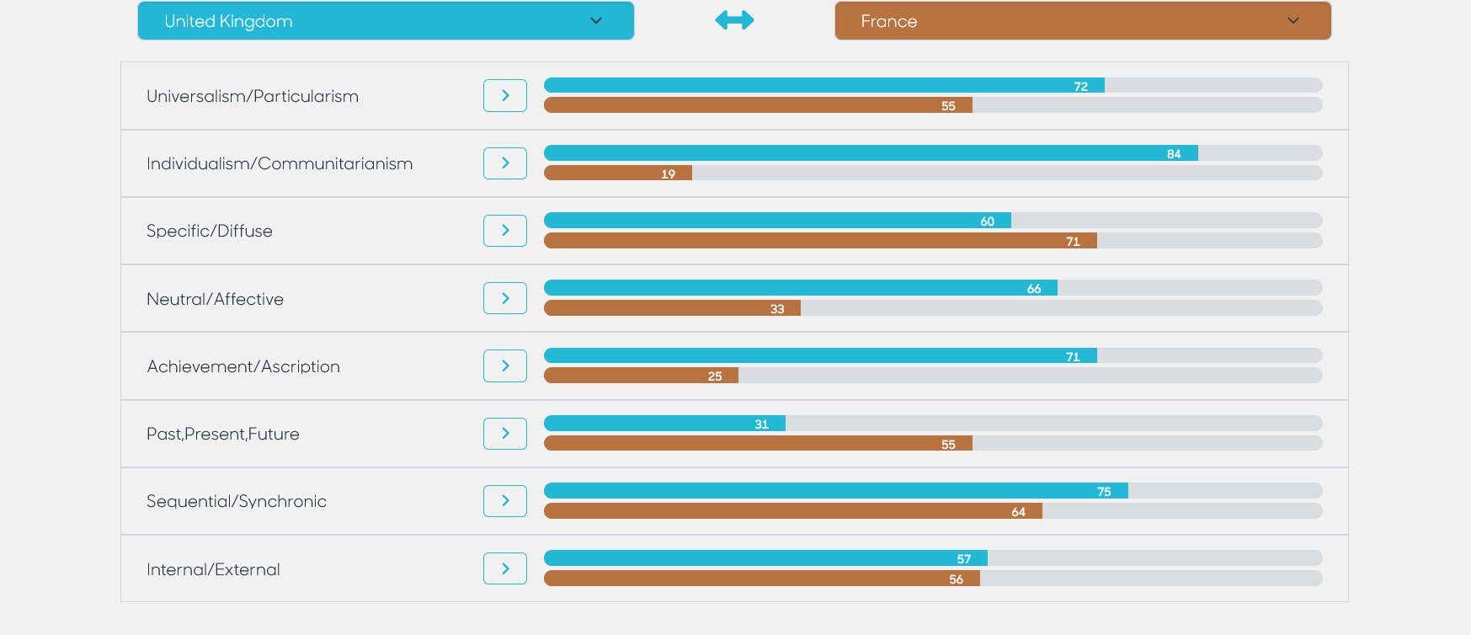
Trompenaars Cultural Dimensions
The UK and France
(thtconsulting,2023)

Analyzing the diversity within the French workforce and considering cultural dimensions, including those highlighted by Hofstede, provides insights into the local labor landscape. France hosts individuals with diverse backgrounds including different ethnicities and nationalities. Diversity in the French labor market brings a significant wealth of ideas, experience, and skills that can contribute to creativity, innovation, and economic growth (Coeli, n.d.). Conversely, it is a challenging task to ensure equal opportunities are presented to the diverse populations in the French labor market.
As per the Geert Hofstede cultural dimensions, the diversity of the labor market is characterized by five key dimensions, including power distance, individualism versus, collectivism, masculinity versus femininity, uncertainty avoidance, and long-term orientation. Regarding the cultural profile of France, Hofstede’s dimensions can be rated with different scores (Czerny and Kowalczyk, 2023). Power distance can be rated as moderate due to the existence of a hybrid of hierarchical and egalitarian business practices that have changed the traditional system of centralized leadership. Many corporations have started to embrace a culture of inclusivity in decision-making while emphasizing the significance of respecting authority. France leans towards collectivism as opposed to individualism by emphasizing the vitality of group and team goals. Teamwork and collaboration are highly valued workplaces. On masculinity versus femininity, France is estimated to score a rating of moderate masculinity due to a strong balance between insistence and teamwork. Regarding uncertainty avoidance, France is considered to be highly predictable, structured, and firm in adherence to set rules. There is a high-value attachment to formal education, experiences, job security, and skills as crucial elements in the labor market. France's culture emphasizes focus on long-term goals, which can be evidenced by the strong focus on the social security system, education, and career advancement.
The diversity of the labor has a significant impact on the business establishment of HSBC in France. The employer is expected to embrace diversity while ensuring all populations are afforded equal opportunity. Additionally, the corporation should promote activities that foster inclusivity in the workplace and establish appropriate procedures to protect any groups that may be considered marginalized. Employee engagement ensures everyone feels respects and involved in the overall running of the company (Alshaabani, Hamza and Rudnák, 2021). HSBC should invest in training and development programs that ensure employees are engaged and ready to compete in the versatile labor market in line with the French culture of the tendency to focus on long-term goals.

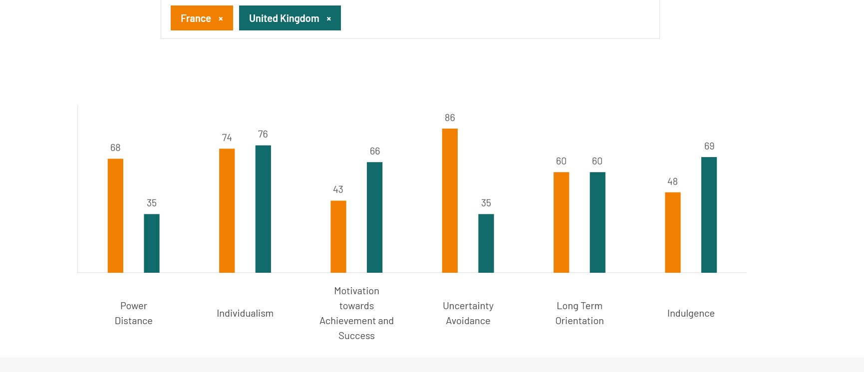
Hofstede’s Cultural Dimensions
The UK and France
(hofstede-insights,2023)

Communication Barriers
Evaluating potential communication challenges in France is critical for HSBC to tailor its communication strategies to the local business culture. The new cultural and linguistic environment can be challenging for the company to manage, especially in maintaining effective communication with stakeholders (Xu, 2020). French is the main language in France and HSBC must ensure that translations are performed effectively to provide adequate clarity. This could involve hiring native French speakers and ensuring they are tasked with direct communication with the locals because most France citizens prefer communicating through their language.
In many instances, French business communication may seem informal and focused on context reference and orientation to relationship. Such communication may be difficult to understand for individuals from countries that prefer purpose-oriented and more direct approaches to business communication (Jonsen et al., 2021). Context reference indicates that communicators may make jokes or use irony to mention events that are related to the topic of discussion without striving to understand whether the other party understands the historical background of the information. Relationship-oriented communication may also prove difficult to master because French business talks prefer beginning with an orientation about the process, small talks, and offering personal greetings to everyone. Some individuals from different culture may find informal personnel boring or even strange as they may expect straightforward handling of the business process and negotiations. To generate trust in the French business environment HSBC should ensure its interactions with customers and business partners are friendly and culture-sensitive to avoid misunderstandings.

Hofstede cultural dimension France Poland and UK
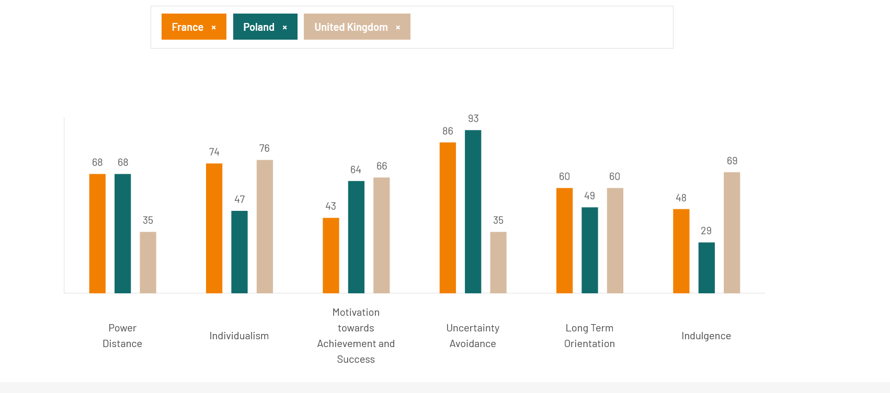
Hofstede’s Cultural Dimensions
The UK, Poland, and France
(hofstede-insights,2023)

Conclusion
Evaluation of a country’s fitness for business expansion is an essential undertaking for any corporation that intends to establish its operation in a foreign land. For HSBC to successfully expand its operation into Poland or France, several actions must be taken to ensure the business meets the expectations of the locals in the targeted locations. The analysis focuses on cultural divergencies, labor outlook, and communication barriers, crucial circumstances for launching a favorable atmosphere for new management operations. HSBC should initiate appropriate measures such as training of workforce, adjusting communication approaches, and establishing of appropriate organizational culture that suits the targeted location.
Reference List
Alshaabani, A., Hamza, K.A. and Rudnák, I., (2021) ‘Impact of diversity management on employees’ engagement: the role of organizational trust and job insecurity’, Sustainability, 14(1), p.420. https://doi.org/10.3390/su14010420
Barber, A., (2021) UK Banks and the Lessons of the Great Financial Crisis (pp. 237-278). Springer International Publishing.
Coeli, R. (n.d.) 'French business culture', Blog French Business Culture. Available at: https://www.reginacoeli.com/blog/french-business-culture.html (Accessed: 15 December 2023).
Czerny, M. and Kowalczyk, M. (2023) ‘How cultural factors influence sustainable development reporting in Poland’, Theoretical Journal of Accounting, 47 (3), pp.203-220. http://dx.doi.org/10.5604/01.3001.0053.7702
Holostenco, M. (2022) 'French business etiquette', Planetary Blog, 30 January, Available at: https://www.planarty.com/blog/french-business-etiquette (Accessed: 15 December 2023).
Jonsen, K., Point, S., Kelan, E.K. and Greeble, A. (2021) ‘Diversity and inclusion branding: a five-country comparison of corporate websites’, The International Journal of Human Resource Management, 32(3), pp.616-649. https://doi.org/10.1080/09585192.2018.1496125
Polat, G. (2021) ‘Advancing the multidimensional approach to family business professionalization’, Journal of Family Business Management, 11(4), pp.555-571. https://doi.org/10.1108/JFBM-03-2020-0020
Storry, M. and Childs, P. eds., (2022). British cultural identities. Taylor & Francis.
Walaszczyk, L. and Mazur, R. (2019) ‘Risk insights vs. competences in managing multicultural teams in Poland’, International Entrepreneurship Review, 5(3), p.145. https://doi.org/10.15678/IER.2019.0503.10
Warburton, K. (2023). French business communication styles. Available at: https://www.worldbusinessculture.com/country-profiles/france/business-communication-styles/(Accessed: 7 December 2023)
Xu, J., 2020. The growth and internationalisation of global and Chinese banks: The cases of HSBC and ICBC (Doctoral dissertation, University of Cambridge).

