AS1 – Reading and Notes Assignment
Name: Eliza Pandelica
Student ID: 2542281

Task 1 – Reading Task Template
Upload your photo of your A3 in-class notes here:
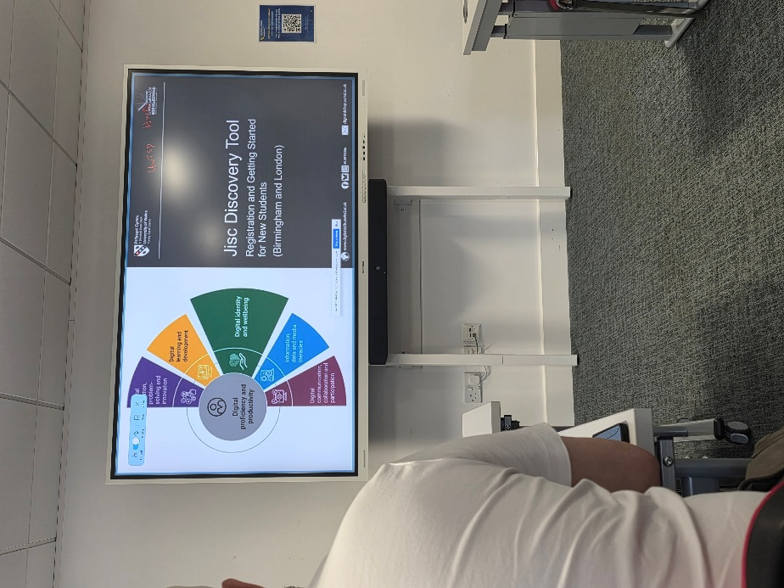
a. What is the main idea of the text?
The main idea is that a small sandwich shop became extremely popular after customer-made TikTok videos went viral, attracting people from far away and creating long queues.
b. What are two key points?
One key point is that the shop’s rise in popularity was driven mainly by customers posting videos, not by the shop’s own marketing.
Another key point is that the sudden attention increased business so much that people queued for hours and travelled long distances.
c. What part of the text did you find most important? Why?
The most important part is the explanation of how customer-made social media content increased the shop’s visibility, because it demonstrates the real impact of organic online sharing on small businesses.
d. Was anything unclear or difficult to understand?
I was not sure about why people were willing to travel three hours for a sandwich, because the article did not fully explain what made the food so unique.
e. How did your group help you understand the text better?
My group helped me by discussing similar viral cases, explaining how trends spread online, and helping me select the most relevant details for the summary.

3. One-sentence reflection
The hardest part was choosing the single most important detail because the article included many interesting examples and facts.

Task 2 – Vocabulary
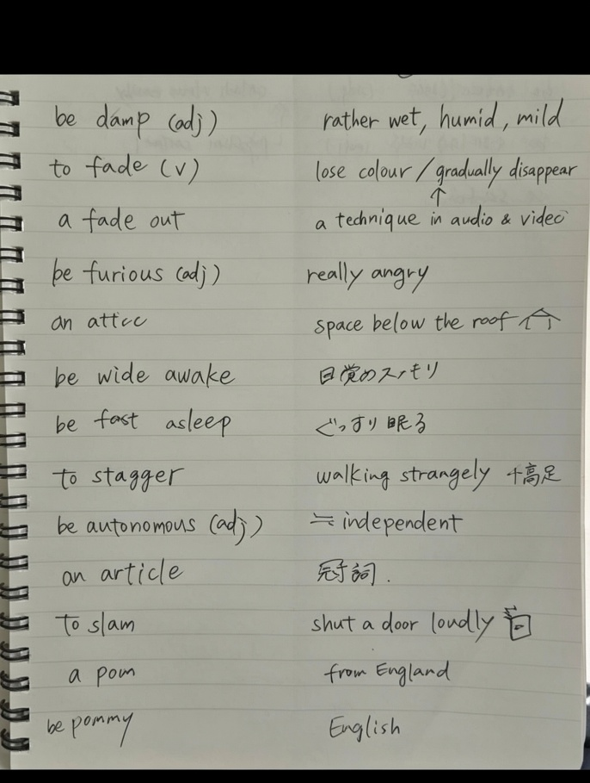
- damp – slightly wet or humid.
Example: My clothes felt damp after hanging outside overnight.
- fade – to become less bright or less clear gradually.
Example: The writing on my T-shirt started to fade after many washes.
- fade out – to become gradually quieter or darker until it disappears.
Example: The song ended with a slow fade-out.
- furious – extremely angry.
Example: She was furious when she missed her train.
- attic – the space under the roof.
Example: We stored old boxes in the attic.
- wide awake – fully alert.
Example: After drinking coffee, I was wide awake.
- fast asleep – sleeping deeply.
Example: The baby was fast asleep in the cot.
- stagger – to walk unsteadily.
Example: He staggered after standing up too quickly.
- autonomous – independent.
Example: The robot can work autonomously without help.
- article – a piece of writing published in a newspaper, magazine, or online source.
Example: I read an article about climate change.
- slam – to shut something loudly.
Example: He slammed the door when he left.
- pom / pommy – slang for someone from England.
Example: Australians sometimes call English people “pommies.”

Task 3 – Summary and Reflection
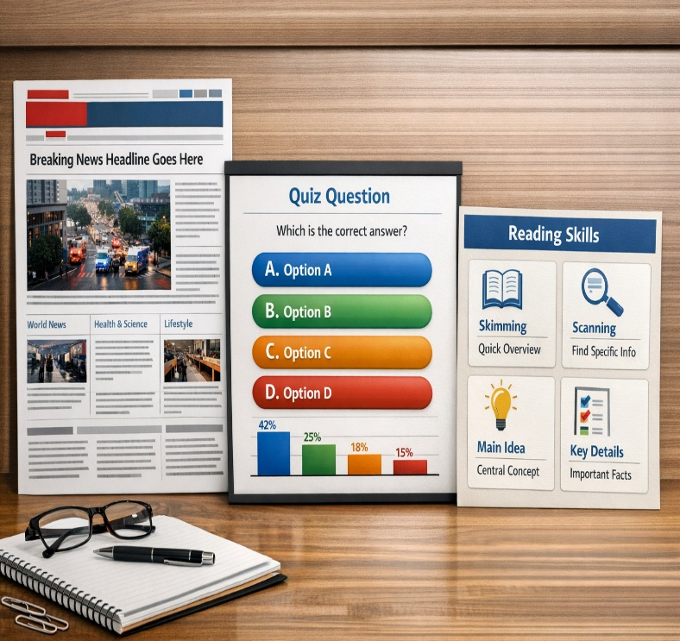
Summary
The article describes how a small sandwich shop became famous after customers posted TikTok videos of its chicken burger. The shop, normally visited by locals, began attracting people from far away and developed long queues. The owner explained that the attention came mainly from customer-made content rather than the shop’s own marketing, illustrating how quickly social media can change a business’s fortunes.
Reflection
I learned how powerful organic social media content can be for small businesses and how scanning and skimming can help me find key information quickly. Discussing the article with my group helped me consider different perspectives and select the most important points. Going forward, I want to practise editing short videos and improve my awareness of privacy so that I can share content responsibly.

Conclusion
In conclusion, this assessment has contributed to the development of my reading, note-taking, vocabulary, and reflective skills. It has also highlighted the importance of identifying main ideas, selecting relevant supporting details, and engaging in collaborative discussion to achieve a clearer understanding of a text. Overall, this task has strengthened my confidence in reading critically and producing effective summaries.

