AN INVESTIGATION AND COMPARISON BETWEEN INDUSTRY 4.0 PRACTISES AND TRADITIONAL METHODS, RELATING TO THE INTEGRATION OF AN INDUSTRIAL ROBOT/ COBOT IN A MANUFACTURING ENVIRONMENT.

SUBMITTED BY

ADAM WILLS. 2240443

ASSIGNMENT 1: WRITTEN REPORT

Submitted in partial fulfilment of the requirements for
Programme: MSc International Innovation Management.
MSc Industry 4.0 Advanced Manufacturing.
Module: Introduction to Industry 4.0. ACPA7004

Lecturer: Mahesh Kannath

Date: 01/04/2023
Contents

- Introduction
- Aims and objectives
- Background information
- Asses driving factors behind automation project.
  - Currently technological trends.
  - Financial implications.
  - Health and Safety.
  - Cell performance. KPI’s.
- Discuss methodology used to implement project relating to Industry 4.0 Standards.
  - Design. Additive manufacturing.
  - Proof of concept/ Installation.
  - Training
- Conclusion
- Recommendations
- References

1. Introduction
The purpose of this document is to investigate and evaluate the benefits and restrictions of practises relating to industry 4.0 methodology, with reference to the installation of an industrial style collaborative robot, in a machine tending application within an industrial manufacturing environment of the automotive sector.

2. Aims and Objectives
The document looks to critically assess and compare the project to traditional methods by investigating data relating to business finances, health and safety, design and manufacturing practices, employee engagement, and machine performance and efficiency.

3. Background Information
ZF Automotive Pontypool, manufacture and assemble brakes for passenger vehicles. As part of a world-wide drive for manufacturing improvement, ZF Pontypool, created an automation team to review its current processes with the aim to reduce cost and improved productivity by introducing new technologies on-site. This resulted in several projects that looked to replace machine tending operators with industrial robots or collaborative robots, ‘cobots’. For this report, we will assess one of the many installations completed under this objective.

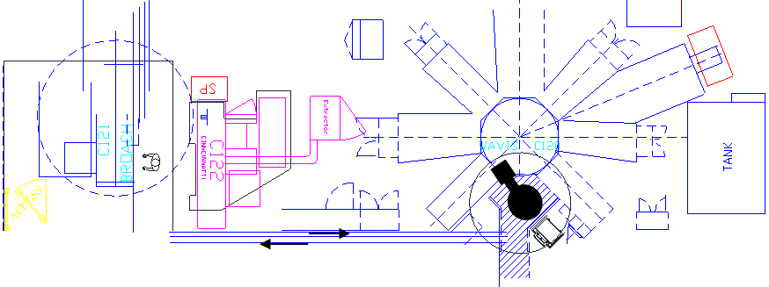
Fig1. Cell C layout.
A collaborative robot was installed on a multi station, rotary index machine tool known as C120. C120 is situated in Machining Cell C and is part of a 3-machine system that performs machining operations on a cast iron, hydraulic vehicle brake, bracket component.
Prior to the automation project, the Cell C would be operated by two employees who would collect, load, and transfer un-machined components to each of the machining operations independently and sequentially.

4. Driving Factors Behind Automation
4.1. Current trends / reasons to automate
Manufacturing facilities are currently facing an unprecedented challenge. This is especially true for automotive manufacturing businesses within the UK. Due to political developments and the increased strain on logistical departments, Covid-19, the 2021 semi-conductor shortage, supply pressures and additionally, energy security concerns, (Cosgrove and Borland, 2023) ZF Automotive looked for ways its processes could adapt to ensure the business remained competitive in such a fluctuating environment.

4.2. Financial Implications
A significant factor effecting a business’ potential competitiveness is the cost to produce a part (Vlachvei, et al, 2017, p 5). With labour cost ever increasing, and the amount of labour needed changing depending upon production requirements, the necessity for business to be able the negate the need to raise or lower their labour levels to suit is a key factor in decision-making regarding automation projects.
In this case, the salary of a production employee to tend the machine (Per annum) is £30460. Compared to the cost of an appropriately specified ‘Universal Robot’ at £28350, it is clear that the initial cost saving requirement could be fulfilled in a short space of time. When considering more detailed costs for the integration, the actual pay-back period for this specific project was 1.5 years.

Tab 1. Finance table
4.3. Health and Safety
An additional factor to take into consideration when integrating a cobot in machine tending applications is the benefit to Health and Safety. Consider the weight of a component at 1190.38g’s and a 20 second cycle time, an operator will move approximately 1499.88 Kg’s of material per shift. The repetitive nature of this movement lends itself towards causing significant strain or injury to an operator. 18% of non-fatal workplace injuries reported under RIDDOR in 2021/22 were the result of, handling, lifting or carrying. This equates to an approximate cost to business of £1.4 billion. (HSE statistics, 2022)
For HSE managers, this statistic re-enforces the acceptance of introducing the new technology to the shop floor. The reduced likelihood of operator injury coupled with upskilling and improved employee engagement is a key benefit to the business.

4.4. Cell Performance
Manufacturing performance and efficiency can be measured using numerous key performance indicators, (KPI’s). An example could be, Output per hour, Asset availability, Cycle time, OEE and Quality.
A key benefit to automatic machine tending solutions is the ability for the application to run without the need for intervention from production employees. A cobot, does not require convenience breaks and can run continuously provided components to tend are available.
For ZF who run 3, 8Hr shifts over a 24Hr period, this additional running equated to a saving of £4800 per year and an improved productivity of 8% over manual loading. (Table 1.0)
For production managers, this increased output gives measurable indications of the success of the project and helps to assist decision making when discussing further opportunities

5. Implementation with Regards to Industry 4.0
5.1. Design. Additive Manufacturing
An influential technology that many industries are now adopting is the use of additive manufacturing machines. These machines are no longer, large, costly, high spec assets that require a high level of knowledge and understanding to control and use. ‘3D printers’ that primarily use plastic filament material are now readily available to the public at an affordable cost. Also, the software, used to generate 3D models can be accessible for free, online. This accessibility, coupled with the significantly low time to produce components, allows design engineers to design, manufacture, test, and remanufacture parts to suit the project at a significantly reduced lead time and cost when compared to traditional methods.
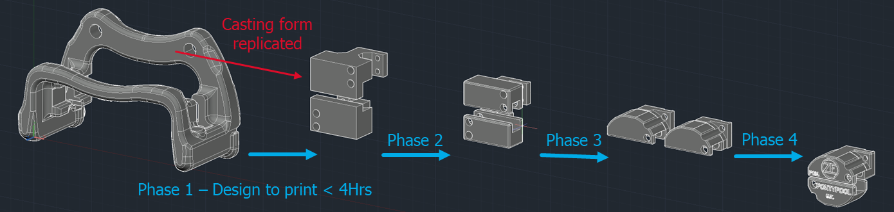

In this instance, the robot and component interaction point, the end effector assembly, consists of a small electric servo motor that drive two mechanical grippers. The two grippers clamp the component with a set force allowing the robot to move the component from one point to another.
Fig 2. Additive manufacturing phases
The additive manufacturing technology allowed engineers to produce a ‘ready for production’ part, in less than one week from initial design at a material cost of £3.04. Using traditional methods, the design and manufacture would have taken approximately 8-10 weeks at a cost of over £2000.
Furthermore, during testing, it was possible to send the 3D model electronically to an external company who specialise in additive manufacturing of metal-based components. The company produced the components in both an aluminium and titanium composite material to ensure the robustness and strength of the part was suitable for production requirements. No further traditional machining was required.

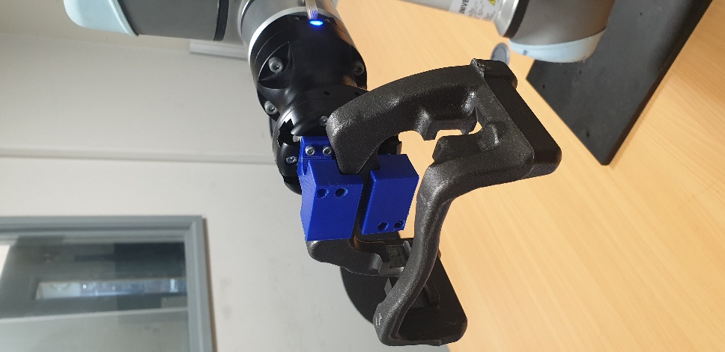
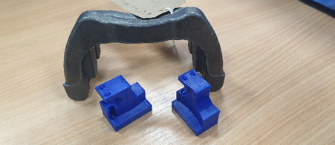

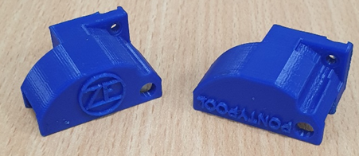

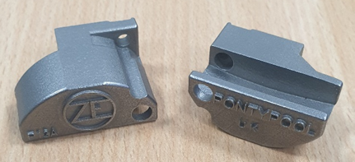
Fig 3,4,5,6. Examples of 3D printed parts produced.

5.2. Proof of Concept / Installation
There are usually a large variety of processes at any type of manufacturing plant. Historically, to automate these processes business would have to dedicate a vast amount of resource to each individual project. Due to the differences in things such as, components to be loaded, process tooling and the physical environment, integrators would specify different robot manufactures depending on their specific suitability. Businesses could end up with numerous types of robots, end effectors and componentry, all of which would require specific knowledge, spares, and training for them to operate efficiently.
When designing the system to automate C120, the team decided to use a ‘Universal robot – UR10e’ this is a type of collaborative robot, known for its ease of use, ease of redeployment and vast array of OEM type ‘add-on’ accessories.
ZF Pontypool had already installed this type of robot on another process on site. Testing and proof of concept for the C120 project was simple, the original cobot was moved from its location, (less than 20Kg’s in weight), installed in a test location, fitted with the new end effectors, and a new program was loaded into its CPU. No other reconfiguration was needed allowing the team to quickly highlight any areas of concern with program and installation.

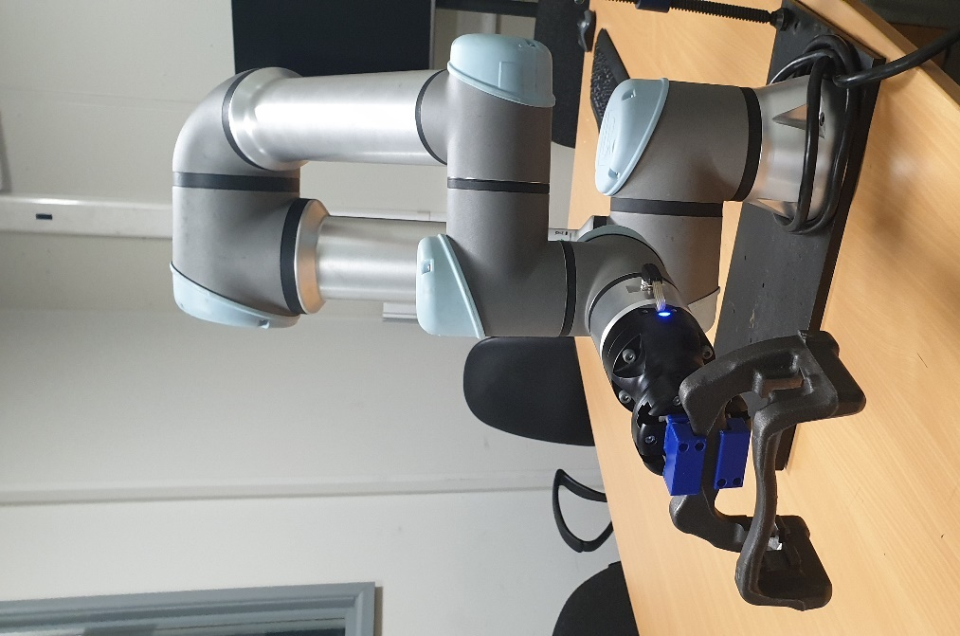
Fig 7. Flexible redeployment
This flexibility of configuration and deployment is a key factor relating to industry 4.0. The ‘ready for industry 4.0’ movement requires systems to be able to carry out a variety of tasks simply, be easily reconfigurable and scalable to other processes (Ciszak, 2018, p. 8). By then introducing further connectivity to the production network, logistical and production departments can use production data to predict, organise and plan for single cobots to be moved between processes to suit production requirements.

5.3. Training. Employee Engagement
Industry 4.0 can be described as, being ‘built on the basis of cyberphysical production systems, merging of real and virtual worlds.’ (Gallagher, 2017, p. 6). Whilst designing components for this project we have seen virtual designs become a physical reality, this merging of realities is evident through the accredited training supplied via the ‘Universal Robot Academy’


Fig 8. UR Academy home page. https://www.universal-robots.com/academy/
The digitalization of education and training packages available for robotics now means business can ensure engagement of employees prior to the physical attribution of the product. The training courses exist in the digital world where student’s login into a classroom via the internet. The student is shown scenarios and must interact with the simulation to progress through the course.
‘Industry 4.0 emphasizes the importance of keeping employees engaged and at the centre of industrial processes’ (Soldatos, 2018, p.8)
This level of engagement ensures that employees are ready to begin operation and setup as and when required, guaranteeing that the flexible, fast, efficient, and quality focused interaction between real and virtual world associated with industry 4.0 can be adhered to.

6. Conclusion
On the surface, introducing cobots and robots to the production floor to automate processes can seem like a hugely beneficial activity for manufacturing businesses. Advertised as a simple and fashionable method to help reduce the effect of political and environmental factors, automation can, and does, reduce the cost of production, and increase performance, within a short space of time.
Health and safety measures can be improved in some instances due to reduced manual labour and by improving the general well being of employees by upskilling and moving them to more rewarding roles.
There are, however, restrictions and disapprovals associated with the addition of automation. The current low level of technical ability and understanding of new technologies such as collaborative robots, and cyber security, adds to the likelihood the projects budgets will be exceeded due to additional tasks completed to ensure installations adhere to policies and procedures regarding these topics.
Additionally, historically the consensus with regards to robotics and automation is one of fear and worry. ‘Negative attitudes towards robots can hinder their adoption, and organizations should take steps to address these attitudes’ (Çiğdem, Meidute-Kavaliauskiene and Yıldız, 2023). It takes significant coaching and time to help employees understand the requirement for automation to change their belief from one of rejection and worry, to full acceptance and engagement.

7. Recommendations
Automation and connectivity of machine tending applications in a manufacturing environment is the future. The driving force behind the current trend in industry 4.0, is wholly and significantly justified with the outlook being very exciting for engineers in this field. To enable automotive businesses to succeed and be competitive they should be looking to accept and introduce these new technologies whilst investing efficiently in academic studies and training relating to Industry 4.0, automation, and robotics.

8. References
- Cosgrove, N. (2023) 2022 – A year of continued challenges for UK Automotive. Available at: https://www.ey.com/en_uk/news/2023/01/2022-a-year-of-continued-challenges-for-uk-automotive. Accessed 20/03/2023
- Vlachvei, A. et al. (2017) Factors affecting firm competitiveness and performance in the modern business world. IGI Global: Business Science Reference.
- Health and Safety Executive. (2022) Health and safety at work. Summary statistics for Great Britain 2022.
Available at: https://www.hse.gov.uk/statistics/overall/hssh2122.pdf Accessed 20/03/2023
- Ciszak, O. (2018) Industrial 4.0 – Industrial robots.
Available at: https://eudl.eu/pdf/10.4108/eai.6-11-2018.2279577 Accessed 15/04/2023
- Gallagher, S. (2017) Industry 4.0 Testlabs in Australia preparing for the future. Australia. Swinbourne Research.
- Soldatos, J. (2018) Introduction to industry 4.0 and the digital shop floor vision. Greece. River Publishers.
- Çiğdem, Ş. Meidute-Kavaliauskiene, I. Yıldız, B. (2023) Industry 4.0 and Industrial Robots: A Study from the Perspective of Manufacturing Company Employees. Available at: https://doi.org/10.3390/logistics7010017. Accessed 16/04/2023.

