
MBA Marketing Management Module BMMB7012 Assignment
By Sarah Puntan-Galea (student no. 2218593)
Lecturer: Gwyneth Jones

The evaluation of Tesco Clubcard’s contribution to the competitive positioning of the supermarket’s brand

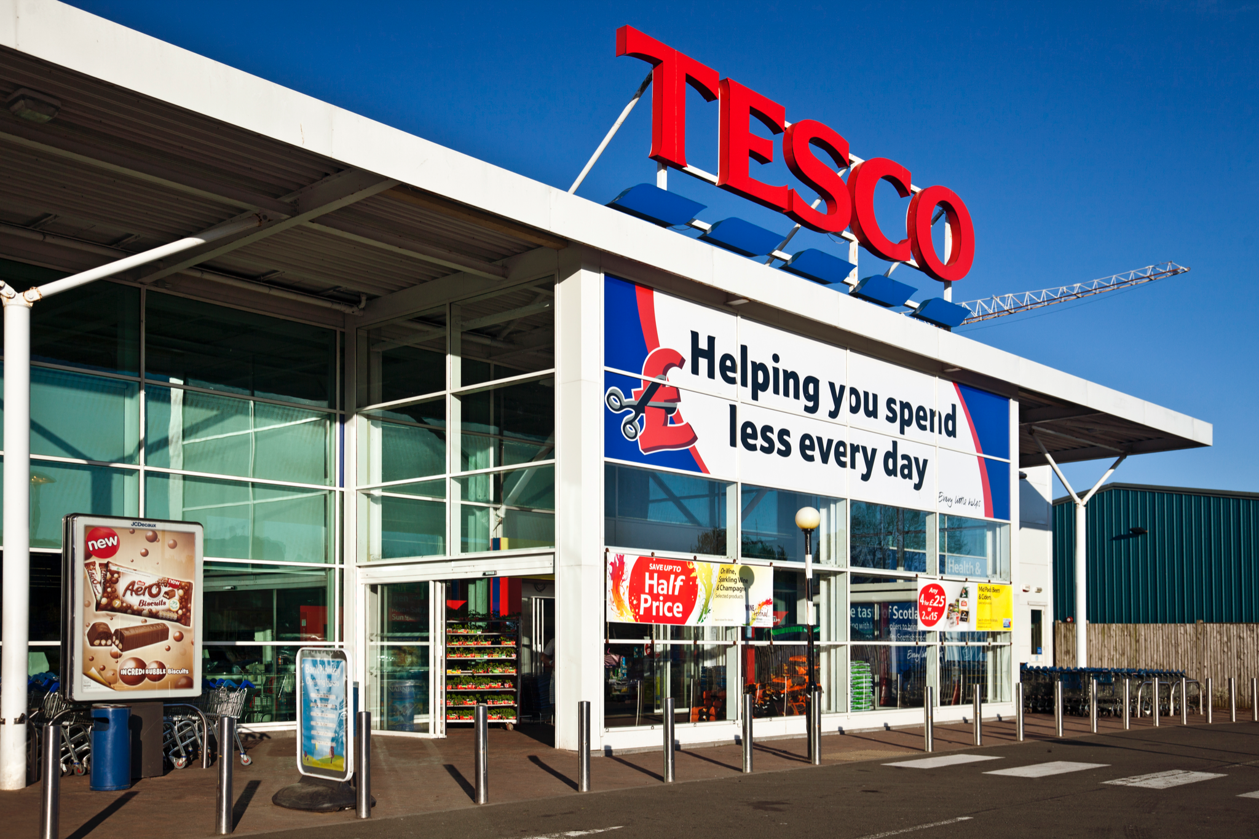 | 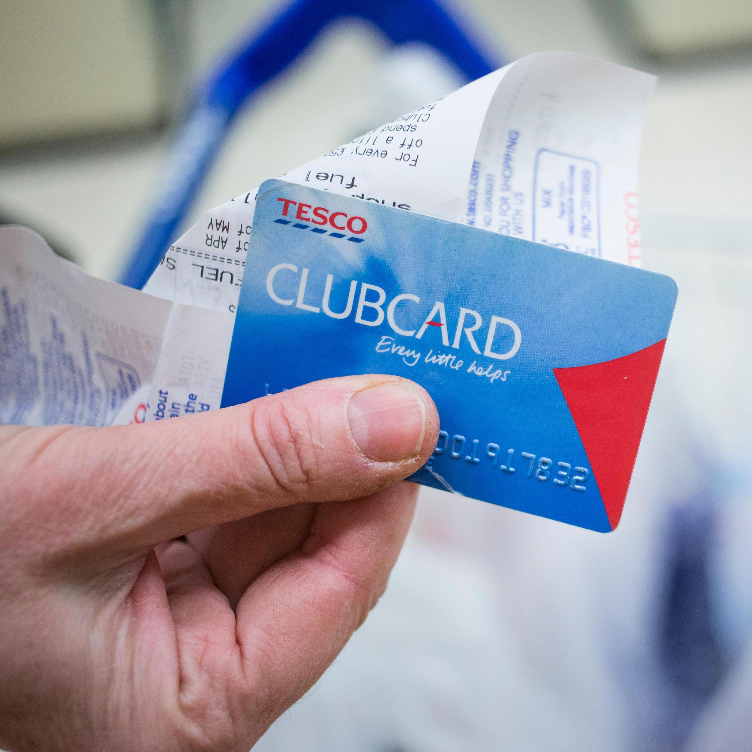
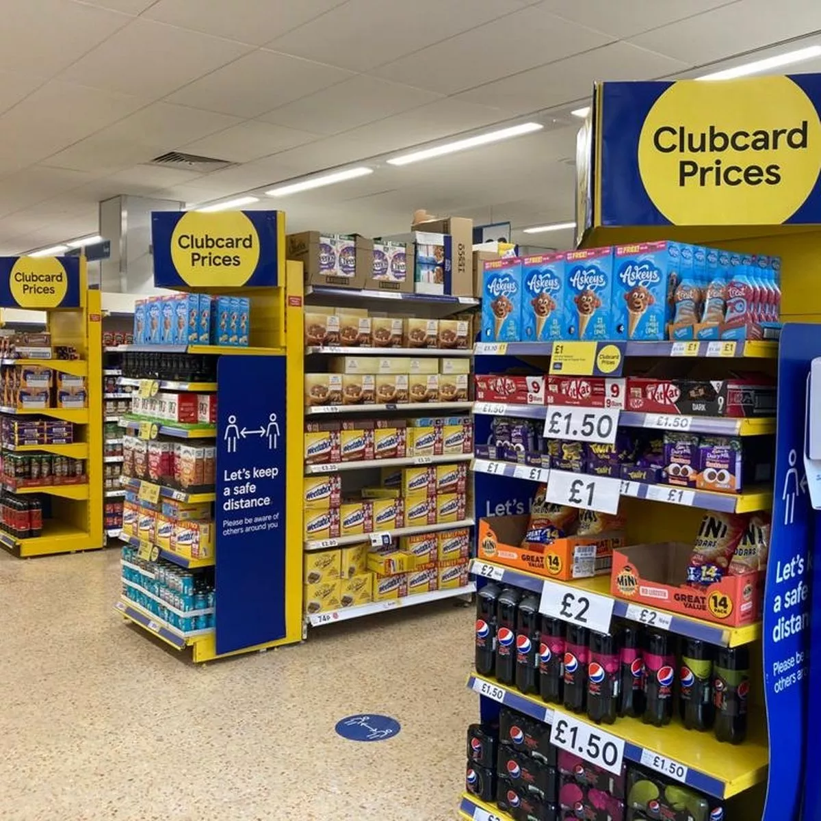 | 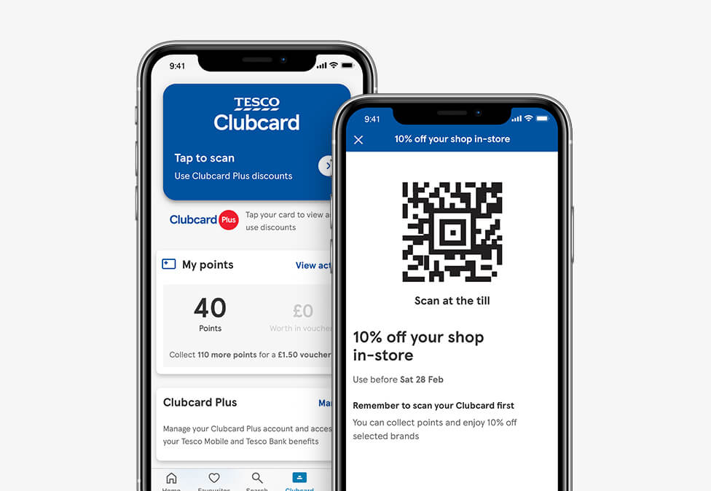
1.0) EXECUTIVE SUMMARY

This assignment looks at how the loyalty scheme of UK supermarket Tesco, Clubcard, is used as a major marketing tool to help the competitive positioning of the brand - and whether it is successful. To do this, building on the group presentation, a marketing audit was carried out, using analytical tools to critically evaluate the role and activities of Tesco’s marketing department.

Commencing by understanding the concept of marketing [Kotler, 2012], before looking at the background of Tesco, Clubcard, how the loyalty scheme has recently changed (which has been negatively received by customers), and the supermarket’s marketing strategy [Tesco, 2023].

Tools are then used to critically evaluate Tesco’s marketing activities, including a PESTLE [Jobber, 2010] to complete a thorough macro environment analysis - a strategic tool used for understanding market growth or decline, business position, potential and direction for operation. Porter’s 5 Forces to analyse the micro environment [Porter, 1979], which focuses on the threat of new entrants to the market, customer bargaining power, supplier bargaining power, competitors and threat of substitutes. A SWOT to analyse the internal environment of Tesco and its competitive position “to develop its strategic planning and ensure its marketing strategy is based upon situation, resources and goals” [Jobber & Ellis-Chadwick, 2020]. A STP analysis to analyse how different approaches are needed for different customers [Hanlon, 2022]. A Value Creation analysis, to deduct if Tesco Clubcard’s value offer exceeds that of its competitors. Then finally, the 7 P’s Marketing Mix [Farrall & Lindsley, 2005] is used to evaluate Clubcard’s positioning to ensure it meets the customers' needs, to conduct competitor analysis, and appraise their marketing strategy - this also allows for decisions not to be made in isolation, and helps to build the brand.

This analysis found Tesco Clubcard still offers value for customers, even after recent changes which have lowered the value offering, and is a well established scheme that will continue to operate and support loyalty to the supermarket. For Tesco, the data Clubcard acquires makes its marketing communications more focused, relevant, and personalised for their customers, so it needs to be retained at all costs - and all negative issues that deter customers are addressed. With the increased cost of living being experienced by all UK customers, Tesco will need to do more than the current, changed loyalty scheme to retain customers.

However, till the recent changes, Tesco have been offering the best value of any loyalty scheme alongside loyalty points [Houlton, 2022]. But this may change, with other supermarkets wanting the market share and upping their loyalty rewards, like Nectar [Sainsbury, 2023], or reducing their prices - as seen by Tesco’s price competitors, Aldi and Lidl. If there is a better offer, customers who shop at Tesco because of their value promise will change stores.

The assignment draws on these main findings to conclude with a list of shortcomings Tesco’s marketing department needs to address. From digitalisation and ethical issues due to customers having to handover personal data to access discounts, to the negatively received recent Clubcard changes, and price discrimination for non-Clubcard members, including those without a fixed address who arguably need lower priced goods (especially groceries) more.

It then finishes with short and long term (realistic) recommendations the marketing department could implement to address shortcomings. From media ideas to address the current negative press about recent Clubcard changes, to better unit pricing on Clubcard promoted goods in-store, and using segmentation data to launch new ranges (a cost of living value 'basics' range, for example). With long term recommendations including using KPIs to monitor Clubcard’s success, and further developing the loyalty scheme.

2.0) CONTENTS

Title page ………. 1
1.0 Executive summary ………. 2
2.0 Contents ………. 5
3.0 Introduction ………. 6
3.1 What is marketing? ………. 6
3.2 Background to Tesco, its loyalty scheme, and recent Clubcard changes ………. 7
4.0 Task 1 - Main findings ………. 10
4.1 Tesco and its Clubcard’s marketing strategy ………. 10
4.2 PESTLE analysis ………. 11
4.3 Porter’s 5 Forces analysis ………. 14
4.4 SWOT analysis ………. 16
4.5 Value creation analysis ………. 19
4.6 7 P’s marketing mix ………. 21
5.0 Task 2 - Conclusion ………. 24
6.0 Task 3 - Recommendations ………. 26
7.0 References ………. 29
7.1 Figures ………. 37

3) INTRODUCTION

3.1) What is marketing?

According to Kotler [2012], marketing is “the science and art of exploring, creating and delivering value to satisfy the needs of a target market at a profit. Marketing identifies unfulfilled needs and desires. It defines, measures and quantifies the size of the identified market and the profit potential. It pinpoints which segments the company is capable of serving best and it designs and promotes the appropriate products and services.”

In 2017, the American Marketing Association defined it as “the activity, set of institutions, and processes for creating, communicating, delivering, and exchanging offerings that have value for customers, clients, partners, and society at large”.

Basically, it is the form of communication between a business and its customers, with the goal of selling its products or services to them - the management process through which goods and services move from concept to the customer, and has less to do with getting customers to pay for a product as it does with developing a demand for that product and fulfilling the customer’s needs.

For this assignment, I am looking at the supermarket Tesco, and how its loyalty scheme - and the recent changes to it - have contributed to the success of the brand by analysing its marketing strategy: The plan to attract and retain customers through its Clubcard.

3.2) Background to Tesco, its loyalty scheme, and recent Clubcard changes
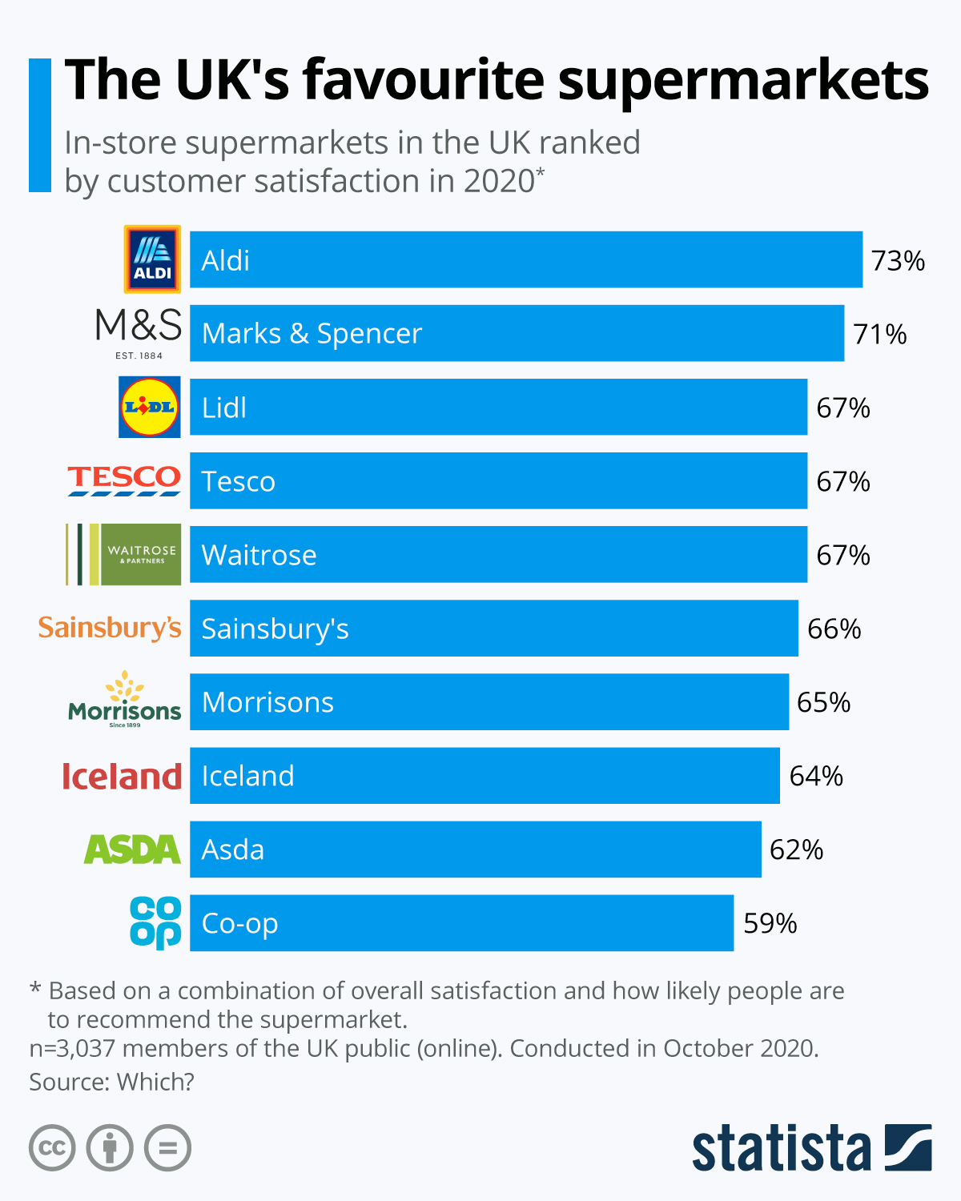

Figure 1: Statista

Tesco plc was established in 1919 by Jack Cohen. Originally a grocery stall in London (the brand first appeared in 1924), Cohen then opened the first Tesco shop in 1931, and supermarket in 1956. His business motto “pile it high, sell it cheap”, is still at the core of its ‘Every little bit helps’ motto and value for money commitment, which is at the heart of its current marketing campaign [Tesco.com, 2023] [O’Grady, 2001].

Tesco is now a British multinational groceries and general merchandise retailer still headquartered in England, that sells more than food, having diversified into areas from clothing to petrol, furniture to financial services. It currently employs 337,000 staff across 5000 stores in the UK and 12 countries globally, with group sales of £57,656 million (excluding petrol) [Statista, 2023], [Tesco.com, 2023], [Bedford, 2023].

However, Tesco revealed its pre-tax profits have dropped by 50% to £1 billion as “customers continue to cut costs and focus on value” due to the cost of living crisis [Grocery Gazette, 2023]. Led by CEO Ken Murphy since 2020, Tesco still holds the largest market share of the UK supermarket industry (27.3%), is the fourth ‘UK favourite supermarket’ [Statista, 2021 - see figure 1], third largest retailer in the world (gross revenues), and was floated on the London Stock Exchange in 1947 [Marketing Week, 2023], [Tesco.com, 2023] and is a constituent of the FTSE 100 Index.

Tesco introduced its loyalty card, Clubcard, in 1995 and an internet shopping service in 1997 - Tesco Direct [Tesco, 2023]. According to the Grocery Gazette [April 2023], Clubcard has 21 million members in the UK, rewarding customers with points for every pound spent - points can be converted into vouchers to spend in-store or on partnership rewards.

In 2022, Tesco was deemed to be the supermarket that offered the best loyalty programme [Houlton, 2022]. But just a year later, Clubcard has changed its structure, with significant changes within the app. (including scrapping the original one), and a reduction of value to partner rewards mostly to compensate for the pre-tax profit dip mentioned earlier [Sayce, 2023], [Atkin, 2023].

It is those recent changes, and the wider issues of the supermarket’s loyalty scheme, that this assignment will look at, and how they affect the competitive positioning of the brand - focusing on Tesco’s UK stores, the British Clubcard scheme, and the UK marketing strategy.

Including the ethics involved: whether it is fair to charge customers different prices for the same product, almost forcing them to join the scheme, and using Clubcard to collect and use members’ (the customers) data for future targeted marketing. Plus, using the findings to show the shortfalls in Tesco’s marketing strategy, and recommendations for its future direction.

4.0) TASK 1 - MAIN FINDINGS

4.1) Tesco and its Clubcard’s marketing strategy

Tesco has used marketing to acquire and keep loyal customers and gain stakeholders’ trust [Sarkar, 2021]. Although known for its value commitment due to its ‘Every little bit helps’ motto [Tesco, 2023], the supermarket aims to reach and attract customers from all financial backgrounds - this is evident in its sub-brands: Tesco Finest, for affluent customers, and Tesco Everyday Value for the more budget conscious shopper [Tesco, 2023].

The Clubcard has played a key part of Tesco’s marketing strategy since it was launched in 1995 to maintain customer loyalty through a point-based system with discounts on products, and other subsidiaries like double data on Tesco Mobile. With five million subscribers in its first year, Tesco finally overtook its competitor, Sainsbury’s, to become the number one loyalty scheme in the UK with shoppers choosing to shop at Tesco because of its loyalty scheme [Dubrin, 2008].

The Clubcard marketing strategy, with Tesco’s marketing strategy running alongside, has been used to obtain customer data and observe buying habits [Sarkar, 2021]. This data is analysed, so the right products are on the right shelves, in the right stores. This is invaluable insight, making the Tesco Clubcard a promotional tool in itself, and it has its own adverts and strategy that runs alongside the supermarket’s [Morris, 2004]. (WATCH Tesco Clubcard advert LINK: Tesco Clubcard. The Power to Lower Prices.)

This data allows the supermarket to hyper-target specific customers and to earn their trust - STP (Segmentation, Targeting, Positioning) marketing, with Clubcard data allowing segmentation and targeted marketing. With customisation becoming another key part of its latest marketing strategy: sending out discounts on birthdays via email, and campaigning door-to-door, for example [Sarkar, 2021]. Plus successful initiatives like the Big Clubcard Voucher Exchange promotion, which saw over three million customers participate, offering new ways to get more value via category-specific deals [Seth & Randall, 2011].

Tesco has also made a partial shift to digital marketing recently, which costs much less and has a wider outreach. From its website, to YouTube and across most social media platforms. On Twitter alone, it has more than 15 accounts, a separate one for each of its business units. and the online customer care account is active 24-7.

Other successful marketing tools which have helped Tesco differentiate itself as a unique brand, include step-by-step recipes from famous chef Jamie Oliver prepared using ingredients available at any Tesco store, and the monthly Tesco Magazine as a food and lifestyle magazine available in-store with 4.65 million readers worldwide [Cedar, 2023].

To critically evaluate Tesco and its Clubcard’s marketing activities, we need to look into the capability of the global brand to build and maintain good relationships with its customers by analysing the effects of micro and macro environmental forces challenging its effectiveness. Starting with a PESTLE Analysis.

4.2) PESTLE ANALYSIS

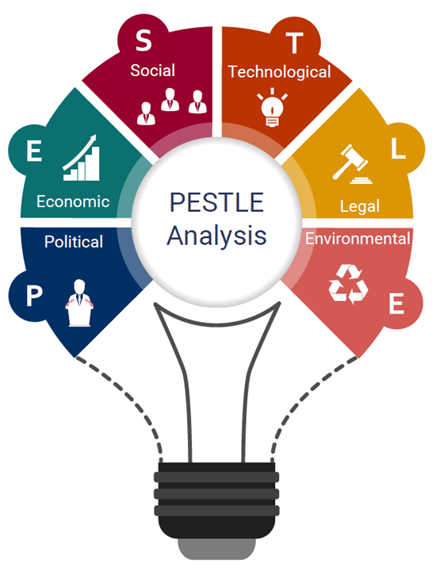

Figure 2: ibisworld.com

PESTLE stands for Political, Economic, Social, Technological, Legal and Environmental. Used as a tool of analysis, it is particularly important in marketing strategy planning, because the nature of marketing is to interact with the world external to your business - the macro environment. It is a strategic tool for understanding market growth or decline, business position, potential and direction for operations [Jobber and Ellis-Chadwick, 2019].

As defined by Jobber in 2010, a macro environment is "A number of broad forces that affect not only the company, but also the other actors within the ‘micro’ environment. In the main, companies have no influence over the elements within the ‘macro’ environment".

To complete a thorough macro environment analysis of Tesco, its Clubcard loyalty scheme, and the recent changes to it for this assign, we must also complete a PESTLE analysis, as first developed by Agilar in 1967 to "assist management in its task of charting the company's future course of action" (NB: text in below box is the author’s own work).

POLITICAL
Does Tesco’s Clubcard pricing system go against government policy [Shaw, 2023]? Will people lobby against this ‘priceism’, leading to bad publicity and negative social media? Will customers boycott, or even go elsewhere?
ECONOMIC
Will the cost of living stresses keep non-Clubcard customers away due to high prices? Recent articles suggest so [Wright, 2023]. Would the promise of Aldi (considered a cheaper competitor) price matches be possible, confusing the strategy?
SOCIAL (CULTURAL)
Penalises those without a Clubcard, from tourists to people without a fixed address, which has led to negative media [McGleenon, 2023]. How do you honour lower prices to members who forget their card - refunds with a receipt? This will be time-consuming. How do you honour lower prices to members who forget their Clubcard? This will be very time-consuming, and time is money!
TECHNOLOGICAL
IT systems need to differentiate prices for the same goods charged to customers (between Clubcard members and those without a Clubcard), especially tricky with online ordering and in-store self-service tills and shopping trolley scanners.
LEGAL
We need to look at and consider consumer rights: Is it legal to charge customers different prices [Sri-Pathma, 2023]? Which? claims the decision not to display unit pricing on some offers could be a “misleading practice” under the Consumer Protection From Unfair Trading Regulations 2008. Unit prices can be used by shoppers in stores and online to compare the value of products they are purchasing. Is it the same scenario in Tesco stores overseas, or is there inconsistent pricing globally? Are Clubcard keeping data in a GDPR-compliant and lawful way [Kleinman, 2020]?
ENVIRONMENTAL
Is it ethical to market the same goods at different prices to different customers [Taylor, 2021]? Will lower prices be able to include environmentally-friendly goods (meat-free, non-plastic packaging, etc)? The quoted This is Money article shows how a shop can cost 45% more [Taylor, 2021].

Figure 3: PESTLE analysis

4.3) PORTER’S 5 FORCES ANALYSIS

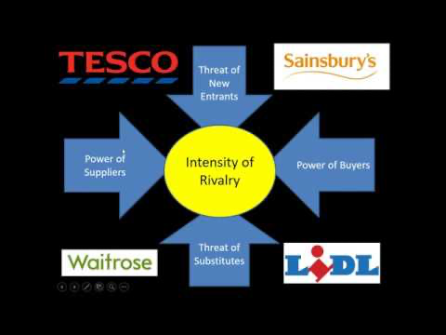
Figure 4: YouTube.com

To analyse the micro environment of Tesco’s loyalty scheme and recent Clubcard changes in the context of the supermarket’s marketing strategy, you can use Porter’s 5 Forces. This was developed by Porter [1979], as a simple framework for assessing and evaluating the competitive strength and position of a business organisation. It provides a good platform for conducting a strategic and marketing analysis even when profit criteria is not considered [Johnson et al, 2009].

When looking at the threat of new entrants:
Other supermarket loyalty schemes already exist, including Sainsbury’s Nectar card [Sainsbury, 2023]. The Clubcard scheme could be seen as a barrier to new customers, who are unable to access the special offers unless they give their personal data to Tesco. If customers access a store ad-hoc and have to pay full price as they don't have a Clubcard, they may feel aggrieved and less likely to join moving forward.

Customer Bargaining power:
If customers are satisfied with the rewards and offers they receive through a particular supermarket, they could feel less likely to change store. The rewards are based on customers' shopping habits, offering bespoke offers to each one [Tesco, 2023].

Supplier bargaining power:
Promotional offers may prove lucrative. Suppliers may be lured by the supermarket to offer exclusive discounts to Clubcard members, allowing the supermarket to negotiate a better buying rate whilst enhancing its bargaining power, whilst Increasing sales for both supermarket and supplier.

Competitors:
How does this differ to other supermarkets’ loyalty schemes? The competition between supermarkets has always existed, almost every supermarket today has a loyalty scheme, with each one offering different discounts based on the customers shopping habits at that particular store [Goldfingle, 2023]. The cost of living crisis is seeing people shop at multiple supermarkets to obtain offers to simply save money.

Threat of substitutes:
Needs to remain unrivalled from its competitors. Tesco must ensure it offers unrivalled discounts and rewards for customers, they have a scheme to access discounted products, whilst collecting points from groceries and fuel. These can be converted into vouchers to be spent in store or utilise them at partner rewards, where they can double the value at attraction venues [Tesco, 2023].

4.4) SWOT ANALYSIS

A SWOT is used to analyse the internal environment of a company, and its unique factors [Fahy & Jobber, 2019]. It dos this by being a framework that looks at Strengths, Weaknesses, Opportunities, Threats, and is crucial when evaluating the company’s - in this assignment’s case, Tesco - competitive position, to develop its strategic planning and ensure its marketing strategy is based upon situation, resources and goals [Jobber & Ellis-Chadwick, 2020].

Looking specifically at Tesco’s loyalty scheme, Clubcard, and its recent changes, a SWOT was carried out that showed six Strengths, Weaknesses, Opportunities, Threats (NB: text in below box is the author’s own work):

Strengths  - Boosting customer loyalty and engagement.  - Provides Tesco with a greater understanding of customer preferences through collected data.  - Customers feel they are being rewarded for their loyalty with low prices, essential in the current ‘cost of living crisis’ climate.  - Supermarkets as an industry operate on the tightest margins, with intense competition, therefore it is essential that they keep customers returning - the Clubcard loyalty pricing structure is an effective way of doing this.  - Offers discounted prices on the most popular items to further engage customers.  - An already established loyalty scheme with a strong customer base.  - The one-stop shop - a Tesco customer can go to the supermarket for a weekly grocery shop, and buy everything else they need (from petrol to clothes) under one roof, and get Clubcard points and discounts across the board, making the customer want to keep buying goods over-and-above their grocery shop. | Weaknesses:  - The cost and financial impact of offering lower prices.  - Already on a tight margin with the rise of food because of Brexit, Ukraine, etc, Tesco are offering reduced prices, and they will have to continually analyse the cost of the lower prices are being compensated by increased sales.  - Consumers may see the pricing as an unfair structure, and no longer shop in Tesco, especially those reluctant or unwilling to share personal data, which may lead to them avoiding Tesco completely.  - Recent changes have led to negative press.  - People without a fixed address - homeless, refugees - cannot partake in the scheme, which could be seen as unfair.  - If members forget their Clubcard when purchasing a product, if they cannot avail of the discount they may go elsewhere - and being able to refund, takes up resources. And accessing discounts with online purchases is open to card sharing.  - If the cost of living crisis worsens, customer demand will fall for all Tesco goods, without any fault of the company.
Opportunities:  - The larger the customer loyalty base, the better the data will be in determining buying trends.  - Allows Tesco to compete with the low cost supermarkets, whilst gathering customer data.  - Tesco had to do something to compete with the low cost supermarkets, and they could not keep reducing prices while overheads are increasing - this structure allows the lower prices to be scattered across the product range.  - This pricing structure will allow Tesco to manipulate what customers buy, charging lower prices for items they want to sell more of.  - Allowing better negotiation of prices with producers and manufacturers.  - Encouraging repeat customers of a certain product when the price returns to the higher cost.  - Allowing Tesco to expand its base by partnering with other organisations over and above groceries and diversified goods, like holiday companies for example, which help increase the sale of other goods - travel insurance and travel goods, from suntan lotion to suitcases and swimwear. This will expand the Tesco portfolio, increasing new customers who do not shop at Tesco’s supermarkets. | Threats:  - Competition of rival supermarkets offering similar pricing structures - Tesco may have to keep changing their offering in order to compete.  - Even though their new pricing structure offers lowest prices to Clubcard members, it is only on certain items, so many consumers will find that their overall shop will be cheaper in the low cost supermarkets such as ALDI or Lidl.  - Maintaining IT security to prevent a data breach concerning personal data of Clubcard customers.  - The removal of any benefits (seen with recent changes) may disappoint customers who will be tempted away by other loyalty scheme offerings.  - Partner organisations going out of business, or not honouring deals advertised by Clubcard to lower trust in the scheme.  - Brexit, Ukraine, and other external factors that raise costs of items usually involved in the scheme, may lead to disappointment when those items disappear from the scheme, and could result in a loss of customers.  - Another pandemic - are all the strategies and emergency plans in place, including staffing to switch to online delivery again, meeting demand.

Figure 5: SWOT analysis

With more word length, I would at this point include a more detailed STP (Segmentation, Targeting, Positioning) analysis - although I briefly touched upon this when mentioning different brands within the brand - Tesco Finest food range, for example, higher priced due to higher quality, for the affluent customer who is still getting value with a luxury product at high street prices.

The STP marketing model “focuses on commercial effectiveness, selecting the most valuable segments for a business and then developing a marketing mix and product positioning strategy for each segment” [Hanlon, 2022]. A marketing model that, in this assignment, redefines who Tesco markets its products to, and how, by segmenting its audience, and targeting the best-fit audience segments for their products, positioning the products to capture the target segment effectively. Basically: brand strategy, positioning, relationship.

4.5) VALUE CREATION ANALYSIS

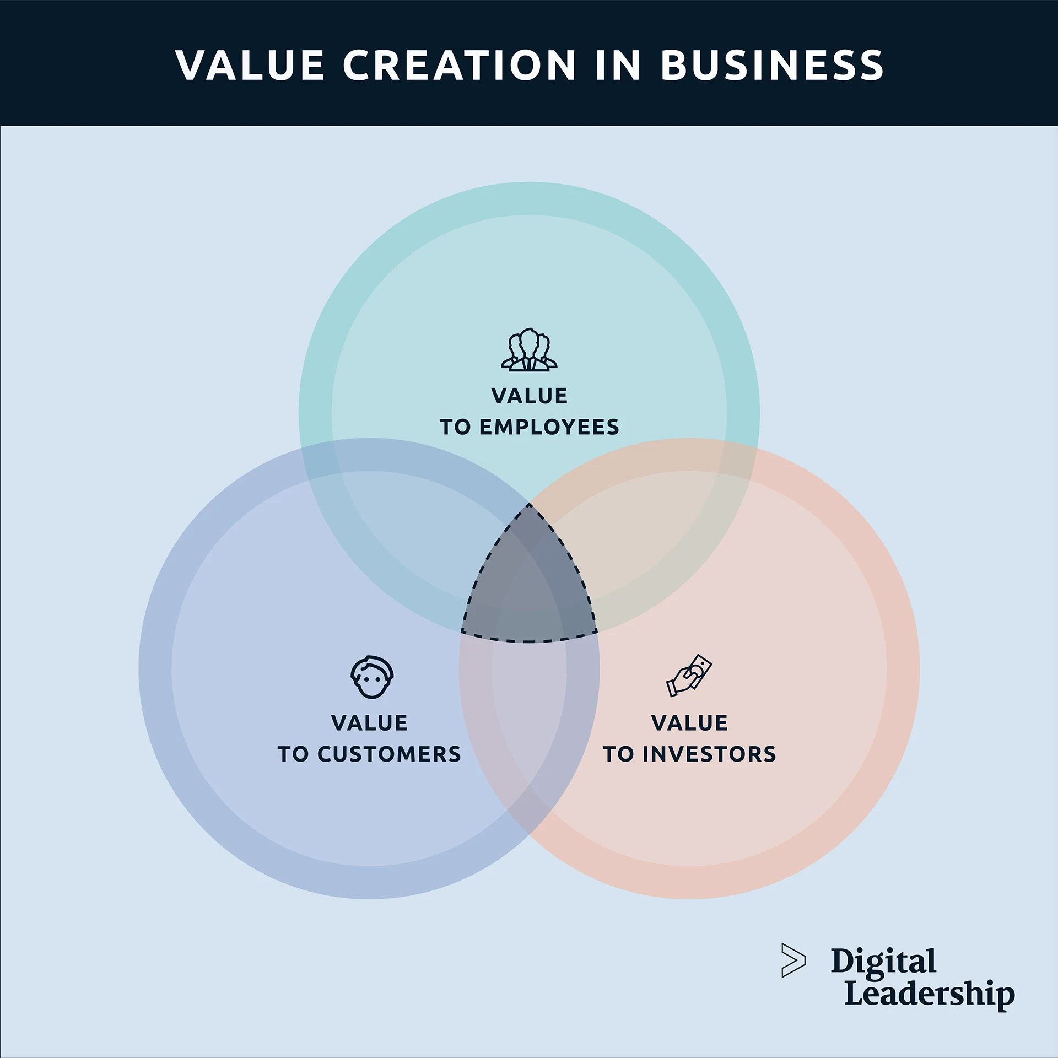

Figure 6: digitalleadership.com

It is also important to look at value creation in this assignment’s analysis, which occurs when companies enter into exchanges with their customers [Jobber & Ellis-Chadwick, 2019]. Tesco’s Clubcard’s value offer should exceed that of the competitors - especially due to the brand’s mission being value based.

Value creation leads to, increased customer spending:
Clubcard rewards can lead to people spending more in-store, online, via phone purchases, or at petrol stations.

Retaining customers:
If people feel rewarded, they are less likely to switch brands as long as the reward scheme is of significant benefit to them financially - it was deemed the best reward scheme [Houlton, 2022].

Customer personalisation:
Through the capture of customer data, the supermarket can offer personalised offers based on the customer’s shopping habits. This assists the store in stocking products based on the needs of the community [Bayford, 2023].

Competitive advantage:
The Clubcard scheme provides a range of benefits and offers over other supermarket loyalty schemes. Third parties allow customers to multiply the value of vouchers to spend at your chosen location [Chernev, 2014].

4.6) 7 Ps MARKETING MIX

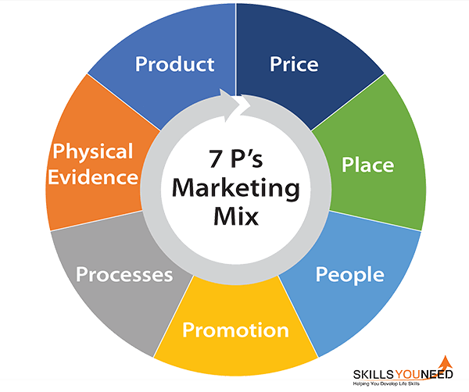

Figure 7: skillsyouneed.com

Once the Tesco Marketing Department has looked at:
- the micro (internal) and macro (external) environments within which it operates,
- ways of identifying and analysing buying behaviour in order to develop the STP approach,
- developed value for customers which, looking at the company’s mission, is a key part of ensuring long-term success,
- and the target market has been identified, then the details of the marketing mix can be planned, using the 7 P’s Marketing Mix [Farrall & Lindsley, 2005].

This is a framework designed to help businesses build a complete marketing strategy, from start to finish, and is an evolution upon the 4 Ps model created by E. Jerome McCarthy in 1960, which was based on the original concept of a 'marketing mix' from a 1964 article by Professor Neil Borden.

But this was created during a time when the majority of businesses sold physical products, and was updated in 1981 by Booms & Bitner to the 7 Ps as more service-oriented businesses started to emerge. Which is more suitable when looking at Tesco's Clubcard for this assignment.

The supermarket's marketing department can use it together with the other analytical tools mentioned in this assignment to evaluate the supermarket loyalty scheme's positioning to ensure it meets the customers' needs, to conduct competitor analysis, and appraise their marketing strategy. It also allows for decisions not to be made in isolation, and helps to build the brand.

Including (NB: text in the box below is this author's work):

Product
A loyalty scheme which offers members lower prices and reward schemes to members (customers).
Price
A free product, offering members (customers) customised rewards and offers based on shopping habits.
Place
Can be used in-store in supermarkets nationwide or for online purchases. Also used for other Tesco products from petrol to insurance, and when using the Tesco credit card elsewhere.
Promotion
Promoted through in-store and online product discounts, which are only applicable to Clubcard members (customers).
Physical environment
All data is collated by Tesco, which shows every member’s (customers) buying habits and preferences, which can be used for targeted marketing and promotions.
Process
The loyalty scheme is used as a physical card or through the Clubcard app., which is designed to be a ‘one destination’ to do online shopping or manage your membership.
People
Available to anyone willing to sign up, who allow Tesco to access their personal data.

Figure 8: 7 P’s Marketing Mix analysis

5.0 TASK 2 - CONCLUSION

When Clubcard started, it rewarded customer’s loyalty with points. Now, although Tesco still rewards its loyal customers with points, those have been reduced by recent changes to the scheme and it penalises those without a Clubcard (customers who haven’t handed over their details, or those who can’t because they have no fixed address) with inflated prices.

However, Tesco Clubcard still offers value for customers, and is a well established scheme that will continue to operate and support loyalty to the supermarket. For the supermarket, the data Clubcard acquires makes Teco’s marketing communications more focused, relevant, and personalised for their customers, so it needs to be retained at all costs - and all negative issues that deter customers address. With the increased cost of living, Tesco will need to do more than the current, changed loyalty scheme to retain customers.

Till now, they have been offering the best value alongside loyalty points [Houlton, 2022]. But this may change, with other supermarkets wanting the market share and upping their loyalty rewards, like Nectar [Sainsbury, 2023], or reducing their prices - like Tesco’s price competitors, ALDI and Lidl. If there is a better offer, customers who shop at Tesco because of their value promise will change stores.

In conclusion, drawing on the main findings in this assignment, here are the main shortcomings identified with Tesco’s Clubcard strategy that the marketing department need to address (recommendations on how to address these follow in the next section):

Ethical reasons: The need for customers to give their personal data to the supermarket in order to access their discounts may breach laws and deter customers who will need to be issued with a new card due to a potential security breach [Kleinman, 2020].

Cutting discounts: The reduction in points customers are able to collect after recent changes [Clarke, 2023] on the amount spent will lead to less points being collected, lowering customers reward value (especially on fuel changes) and potentially leading to customers going elsewhere.

Reduced spending: Non-clubcard members or customers who forget their Clubcard may lead to people not buying a good or product because they would not receive the discounted rate. This could also lead existing customers to feel dissatisfied and potentially switch supermarkets.

Price discrimination: Tourists and non-members, including customers from other supermarkets, are discriminated against for not being Clubcard holders [Taylor, 2021].

Digitisation: Tesco have recently switched to a digital format via the app. for vouchers, and will no longer send them via post, which means all Clubcard holders will need a smart device to access the personalised offers which could alienate certain customers, especially older customers who are more digitally challenged, or rural customers living in areas with bad internet coverage [McHardy, 2023].

6.0) TASK 3 - RECOMMENDATIONS

Moving forward, bearing in mind the public’s “disappointed” reaction to the recent Clubcard changes [Clarke, 2023], there are several short term recommendations for the Tesco marketing department which would be easy to implement with the current staffing and budget. These include:

1) Address the current negative press about the Clubcard changes, especially in the face of the cost of living crisis. The best way to tackle this is for the marketing team to work internally with their media team to ‘speak’ straight to the customer through social media messaging, as well as getting the wider media to report Tesco's rationale for its decision by offering the CEO for interviews - use excerpts of this interview for a CEO statement in a press release to be published on the website (and posted on social media), using CEO to increase its reach.
2) Unit pricing being clearly shown on Clubcard promoted goods in-store, allowing customers to establish if the loyalty scheme pricing is the best value for them.

3) Tesco should retain the current - or introduce a more efficient - system for members who forget their Clubcard to still access discounts by showing their ID and membership number at the store tills (the current situation allows for discount money to be refunded at the customer service desk to customers who paid the full price when producing the receipt and their Clubcard [Tesco, 2023]). For online customers, their membership number could match the delivery address to unlock discounts.

4) To ensure the continuation of multi-generational - across product ranges - customer loyalty, it is important Tesco realises 'one size (or in this case customer loyalty scheme) doesn't fit all', and segmentation data is used to launch different Clubcards. For example, a student, kids, and OAP version could be launched with different ranges tailored to each group - a cost of living value 'basics' range, for example.

5) To attract good press, and look like a true value (and caring) brand during the cost of living crisis, staple goods (milk, bread, apples, etc) could be made available at Clubcard prices to all shoppers. This would counteract the issue that those without a fixed address who are unable to get a Clubcard - like those seeking asylum and the homeless - are penalised. Creating a way for them to unlock discounts too. This should be included in the Tesco Corporate Social Responsibility strategy, as well as gifting all final ‘best before’ date produce to foodbanks.

In the long term:
6) Tesco should continue to monitor its Clubcard scheme (measuring its marketing success through KPIs) to ensure the price reductions are cost effective. As well as offering Clubcard prices throughout the store to not lose business to competitors like Aldi or Lidl value supermarkets, especially on the most popular, important (vegan, plant-based items), and staple items.

7) The marketing department could also develop the scheme further to include more collaborations - customers using their Clubcard for deals outside the store, in other stores, or for other activities, basically reintroducing a more cost effective version of the recently cut offers which led to negative media as quoted previously. This would enhance the value creation process, and lock-in wider brand loyalty.

7.0) REFERENCES

Aguilar, F J. (1967). Scanning the business environment (Studies of the modern corporation). Macmillan. Johannesburg, 1967.

American Marketing Association (2017). About AMA. Available at: https://www.ama.org/the-definition-of-marketing-what-is-marketing/ (Accessed 6 July 2023).

Atkin, E. (2023). All the changes coming to Tesco in April and the rest of 2023, Metro. Available at: https://metro.co.uk/2023/04/18/all-the-changes-coming-to-tesco-in-april-and-the-rest-of-2023-18627140/#:~:text=From%20today%2C%20April%2018%2C%202023,the%20Tesco%20Grocery%20%26%20Clubcard%20app. (Accessed: 07 July 2023).

Bayford, K. (2022). C-stores remain strong despite fall in grocery spending, Grocery Gazette - Latest Grocery Industry News. Available at: https://www.grocerygazette.co.uk/2023/04/28/supermarket-loyalty-tesco/c (Accessed: 7 June 2023).

Bedford, E. (2023). Topic: Tesco plc, Statista. Available at: https://www.statista.com/topics/3807/tesco-plc/#topicOverview (Accessed: 21 June 2023).

Borden, N. H. (1964). The Concept of the Marketing Mix. Journal of Advertising Research. Cambridge, UK: Cambridge University Press. Available at: https://motamem.org/wp-content/uploads/2019/07/Borden-1984_The-concept-of-marketing-mix.pdf (Accessed 30 August 2021).

Booms, B. and Bitner, M. J. Marketing Strategies and Organizational Structures for Service Firms in James H. Donnelly and William R. George, (eds), Marketing of Services, Chicago: American Marketing Association, 47-51. (1981).

Cedar (2023). Our work, Available at: https://www.cedarcom.co.uk/work/ (Accessed: 8 July 2023).

Chernev. A. (2014). Strategic Marketing Management. 8th Edn. USA: Cerebellum Press.

Clarke, J. (2023). Tesco customers ‘disappointed’ at changes to Clubcard Rewards Scheme (2023) The Independent. Available at: https://www.independent.co.uk/business/tesco-customers-disappointed-at-changes-to-clubcard-rewards-scheme-b2305052.html (Accessed: 07 July 2023).

Dubrin, A. (2008). Essentials of Management, 8th edn, Nelson Education, Ltd, Montreal. Dr. Philip Kotler answers your questions on marketing, Kotler Marketing Group, Inc. Available at: https://www.kotlermarketing.com/phil_questions.shtml#:~:text=Marketing%20is%20the%20science%20and,identifies%20unfulfilled%20needs%20and%20desires (Accessed: 07 July 2023).

Farrall, C and Lindsley, M. (2005). The Marketing Mix, Cambridge University Press, Cambridge.

Fahy, J. and Jobber, D. (2019). Foundations of marketing. Sixth edition. London: McGraw-Hill Education.

Fleming, M. (2019). ‘We had to make sure it didn’t fall on its arse’: How Tesco revolutionised loyalty with Clubcard. Marketing Week (online). Available at: https://www.marketingweek.com/tesco-clubcard-loyalty/ (Accessed 5 July 2023).

Goldfingle, G. (2023). Sainsbury’s promises new entry price push as it expands nectar prices, Retail Gazette. Available at: https://www.retailgazette.co.uk/blog/2023/04/sainsburys-entry-prices-nectar/ (Accessed: 6 June 2023).

Grocery Gazette (2023). Latest Grocery Industry News: Tesco CEO paid £4.4m in 2022 as cost-of-living crisis continues. Available at: https://www.grocerygazette.co.uk/2023/05/12/tesco-ceo-paid-4-4m/#:~:text=Tesco%20CEO%20Ken%20Murphy%20was,m%20in%20performance%2Dbased%20remuneration. (Accessed: 07 July 2023).

Hanlon, A. (2022). How to use Segmentation, Targeting, and Positioning (STP) to develop marketing strategies. Available at: https://www.smartinsights.com/digital-marketing-strategy/customer-segmentation-targeting/segmentation-targeting-and-positioning/ Accessed: 10 July 2023).

Holmes, H. and Foster-Collins, L., (2023). Why supermarket loyalty schemes are moving past points: As Sainsbury’s and Co-op ape Tesco’s Clubcard Prices model, supermarkets are able to make more on consumer data. But are there risks? Grocer, p12.

Houlton, C. (2022). Tesco Clubcard named Best Supermarket Rewards Scheme, Grocery Gazette - Latest Grocery Industry News. Available at: https://www.grocerygazette.co.uk/2022/11/10/tesco-clubcard-rewards-scheme/
(Accessed: 11 June 2023).

Ibisworld (2020). How to conduct a pestle analysis - industry insider, IBISWorld. Available at: https://ibisworld.com/blog/3-step-pestle-analysis/99/1127/ (Accessed: 03 June 2023).

ISSUU (2021). Tesco magazine, Available at: https://issuu.com/tesco_magazine/docs/tesco_magazine_may_2021/10 (Accessed 8 July 2023).

Ivy, J. (2008). A new higher education marketing mix: the 7Ps for MBA marketing. International Journal of Educational Management. 22 (4): 288–299. doi:10.1108/09513540810875635. ISSN 0951-354X.

Jobber, D and Ellis-Chadwick, F. (2019). Principles and practice of marketing. Ninth edition. Maidenhead: McGraw-Hill Higher Education.

Jobber, D. (2010) Principles and Practice of Marketing. 3rd Edition. McGraw-Hill Education, London.

Johnson, G., Scholes, K. and Whittington, R. (2008). Exploring corporate strategy. Pearson Education UK. P.55.

Kleinman, Z. (2020). Tesco sends security warning to 600,000 clubcard holders, BBC News. Available at: https://www.bbc.co.uk/news/technology-51710687 (Accessed: 11 June 2023).

Kotler, P., Keller, K. L., Brady, M., Goodman, M. and Hansen, T. (2019). Marketing Management, 4th European edition. Harlow, UK: Pearson Education.

Kotler, P (2012). What is marketing?, kotlermarketing.com. Available at: www.kotlermarketing.com/phil_questions.shtml#answer3 (Accessed June 2023).

Marketing Week (2023). Grocery market share, top UK ads, agency diversity: 5 interesting stats, Marketing Week. Available at: https://www.marketingweek.com/grocery-market-share-top-uk-ads-agency-diversity-5-interesting-stats/# (Accessed: 21 June 2023).

MBA Management Models (2021). The marketing mix: The 7 PS, MBA Management Models. Available at: https://www.mbamanagementmodels.com/the-marketing-mix-the-7-ps/#further-reading (Accessed: 21 June 2023).

McGleenon, B. (2023). Urgent price warning to Tesco customers without a Clubcard, Yahoo! News. Available at: https://uk.news.yahoo.com/tesco-clubcard-prices-phone-contracts (Accessed: 21 June 2023).

McHardy, M. (2023). Tesco issues fresh warning to anyone with a Clubcard, The Independent. Available at: https://www.independent.co.uk/news/uk/home-news/tesco-clubcard-points-deadline-app-b2302171.html (Accessed: 03 June 2023).

McCarthy, E. J. (1964). Basic Marketing: A managerial approach. Homewood, IL: Irwin.
Morris, T (2004). Tesco: A Case Study in Supermarket Excellence, Coriolis Research, Auckland. Available at: https://static1.squarespace.com/static/62b234e5b82e3f577d752b01/t/631ecc93f27caa32e41a430b/1662962854660/coriolis_tesco_study_in_excellence.pdf (Accessed: 9 July 2023).

Porter, M. E. (1979). How Competitive Forces Shape Strategy Available at: https://www.hbs.edu/faculty/Pages/item.aspx?num=10692 Harvard Business Review 57, no. 2, p137–145. (Accessed: 6 July 2023).

Porter, M. E. (2008). The Five Competitive Forces That Shape Strategy Available at: https://hbr.org/2008/01/the-five-competitive-forces-that-shape-strategy
Special Issue on HBS Centennial. Harvard Business Review 86, no. 1, p78–93. (Accessed: 3 July 2023).

Sarkar, M. (2021). Tesco - British retailer that redefined grocery shopping. Available at: https://thestrategystory.com/2021/06/10/tesco-business-model/ Accessed: 8 July 2023).

Sayce, R. (2023). Major changes to Tesco Clubcard from today - all you need to know, Metro. Available at: https://metro.co.uk/2023/06/12/two-major-changes-coming-to-tesco-clubcard-this-week-what-you-need-to-know-18934494/ (Accessed: 21 June 2023).

Seth, A & Randall, G (2011). The Grocers: The Rise and Rice of The Supermarkets Chains, 3rd edn, Kogan Page Publishers, London.

Shaw, N. (2023). Tesco clubcard prices could be unlawful, as watchdog asked to investigate, Wales Online. Available at: https://www.walesonline.co.uk/news/uk-news/tesco-clubcard-prices-could-unlawful-27085830 (Accessed: 21 June 2023).

Sri-Pathma, V. (2023). Tesco could be breaking law on Clubcard Pricing, says Which?, BBC News. Available at: https://www.bbc.co.uk/news/business-65854124 (Accessed: 15 June 2023).

Statista (2021). Tesco - British retailer that redefined grocery shopping. Available at: https://thestrategystory.com/2021/06/10/tesco-business-model/ (Accessed: 8 July 2023).

Taylor, R. (2021). Why this shopping basket costs 45% more at Tesco without a Clubcard, This is Money. Available at: https://www.thisismoney.co.uk/money/bills/article-10308957/Why-shopping-basket-costs-45-Tesco-without-Clubcard.html (Accessed: 1 June 2023).

Tesco (2011). Annual Report and Financial Statements 2011, Available at: https://www.tescoplc.com/media/4ixd0444/tesco_annual_report_2011.pdf (Accessed 7 July 2023).

Tesco (2013). Our History Available at: https://www.tescoplc.com/about/our-history/ (Accessed 1 July 2023).

Tesco (2023). Preliminary results 2022/23, Home. Available at: https://www.tescoplc.com/preliminary-results-202223/#:~:text=We%20expect%20to%20be%20able,%C2%A3130m%20and%20%C2%A3160m (Accessed: 21 June 2023).

Tesco (2023). About Clubcard, Tesco.com. Available at: https://secure.tesco.com/clubcard/about (Accessed: 7 June 2023).

Tesco - Real Food (2023). Jamie Oliver, Tesco.com. Available at: https://realfood.tesco.com/jamie-oliver.html (Accessed: 7 July 2023).

Wright, G. (2023). 4 ways Tesco is winning shoppers during the cost-of-living crisis, Retail Gazette. Available at: https://www.retailgazette.co.uk/blog/2023/04/tesco-maintaining-customers/ (Accessed: 21 June 2023).

YouTube (2023).Tesco Clubcard: The Power to Lower Prices, available at: https://www.youtube.com/watch?v=nom9bzrjOpQ (Accessed 7 July 2023).

7.1) FIGURES
[Title page images from tesco.com]

Figure 1 (p7): Statista (2021) Tesco - British retailer that redefined grocery shopping. Available at: https://thestrategystory.com/2021/06/10/tesco-business-model/ Accessed: 8 July 2023).

Figure 2 (p12) - PESTLE diagram: ibisworld.com (2020), How to conduct a PESTLE analysis. Available at: https://www.ibisworld.com/blog/3-step-pestle-analysis/99/1127/ (Accessed 7 July 2023).

Figure 3 (p13): PESTLE analysis by assignment author.

Figure 4 (p14) - Porter’s 5 Forces diagram: Business E. (2018), Analysing a Strategic Position of a Business, The Competitive Environment, Porter’s Five Forces. Available at: https://www.youtube.com/watch?v=yXueg_k35fQ (Accessed 8 July 2023).

Figure 5 (p16): SWOT analysis by assignment author.

Figure 6 (p20) - Value creation: Dieffenbacher, S.F. (2022), Value Creation Definition, Model, Principles, Importance & Steps. Available at: https://digitalleadership.com/blog/value-creation/ (Accessed 8 July 2023).

Figure 7 (p21): 7 P’s marketing Mix diagram: skillsyouneed.com (2023). The 7 Ps of Marketing Mix. Available at https://www.skillsyouneed.com/lead/7-marketing-ps.html#:~:text=The%20Seven%20Ps%20started%20as,%2C%20processes%2C%20and%20physical%20evidence. (Accessed 9 July 2023).

Figure 8 (p22): 7 P’s marketing Mix analysis by assignment author.

ENDS

