

Executive summary
The report sheds light on the significant implication of knowledge management that facilitated the operation of the e-commerce giant Amazon. The integration of knowledge management helps the e-commerce giant Amazon to ensure better customer relationship management while creating knowledge assets in an efficient manner. The report evaluates the theoretical intervention of the knowledge management model that directly applies to the E-Commerce giant Amazon to identify the underline challenges in knowledge management. The report further provides better recommendations to help address the knowledge management challenges for better customer relationship management in the leading retail company Amazon.

Contents
Introduction 4
Task 1 4
Background of the company 4
Underpinned knowledge management theory 5
Knowledge management development practices 7
The necessity of an information system in Amazon 9
Implemented information system by Amazon 10
Evaluation of the identified scenario 11
Potential knowledge management challenges of Amazon 13
Recommendations to strengthen knowledge management practices 14
Task 2 15
Conclusion 15
References 16

Introduction
The unprecedented outbreak of global pandemic like Coronavirus affects the completely global business economy to a considerable extent. The advent of the coronavirus pandemic devastated business operations due to the government-imposed restrictions and locked down measures in order to contain the spread of Coronavirus. This impacted the whole business infrastructure across the group while bringing the organisational entities to complete stand steel and increased mass layoffs and unemployment worldwide. Economic terminal and white spread unemployment that has been navigated due to the Coronavirus pandemic and its unprecedented outbreak in the Global world led the Global Business to identify different Strategies and recommendations in order to combat the ill effects of the global pandemic. The significant strategies that have been applied by The E-Commerce giant Amazon have been discussed in the report while enlightening on the fact of knowledge management practices implemented by the E-Commerce multinational retailer Amazon. The report further offers a widespread and comprehensive inside into the elevated customer experience managed by The E-Commerce giant Amazon with the help of knowledge management practices. The report discusses the role of the knowledge management principle that offers significant value for providing a personalized customer experience.

Task 1

Background of the company
The American multinational e-commerce and retail company Amazon has expensive its operation all across the globe. Amazon has spread its wings in different segments late digital streaming artificial intelligence cloud computing and e-commerce practices. The company has pioneered separation in manufacturing electronics offering Web Services online retailing and other technology-driven cloud computing practices (Amazon.com, 2022). The company has been recognised as one of the largest online e-commerce and retail companies while being a prominent Cloud Service Provider. Jeff Bezos founded the company on 5 July 1994. The company is headquartered in Seattle Washington that generates revenue of 46,980 crores USD as per the reports of 2021. The company subsidiaries are Whole Foods Market, Zappos and Audible. The company has driven its operation by the customer-centric commitments that enable the business to offer employment to the 1,608,000 employees all across the globe.

Figure 1: Featuring the Company
(Source: Amazon.com, 2022)

Underpinned knowledge management theory
The reports shed light on the key integration of the theoretical intervention of knowledge management principles and practices. The significant intervention of knowledge management theory majorly emphasizes the organisational infrastructure while enlightening on the fact of organisational cultural design and hierarchical practices in order to manage knowledge processes (Purwanto, 2020). The multidisciplinary process of knowledge management involves the methodical approach of developing sharing utilising and managing the organisation's knowledge that helps in enhancing productivity efficiency while retaining the critical integrity of the organisational data. The report has underpinned significant knowledge management theories with the use of the WIIG knowledge management model and ZACK Knowledge Management Model.
WIIG knowledge management model
Karl Wiig that offers a four-stage knowledge management cycle to demonstrate how information has been built and utilised by organisational individuals has proposed the WIIG knowledge management model in 1993. This ensures facilitates the development and accumulation of information deployment and utilisation of quality knowledge practices (Bilginoğlu, 2019). This model offers a four-stage knowledge management cycle. The key purpose of this knowledge management modelling is to capture knowledge with a certain perspective that would meet the future requirements of an organisational entity. This facilitates user relevancy while ensuring offering better competency in the business with a competitive advantage.
Building knowledge
This stage helps in demonstrating internal and external sources of knowledge that cover explicit knowledge development.
Holding knowledge
This stage shows the data in a retrievable and specific physical format for offering better training to the Employees.
Pooling knowledge
This stage in the knowledge management model utilizes the appropriate knowledge management system (Nisar et al., 2019). It ensures to offer cross-sectional connection interaction between the groups of experts.
Applying knowledge
This page in the knowledge management model uses the data in order to alter or improvise the word process. This stage ensures a demonstration of completeness, connectedness and congruency.
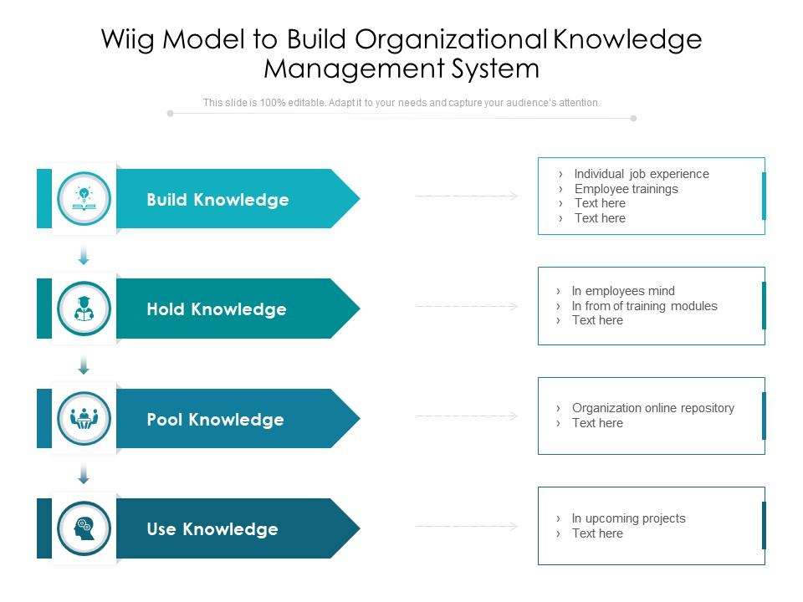
Figure 2: WIIG knowledge management model
(Source: Nisar et al., 2019)
ZACK Knowledge Management Model
Mayer and Zack that targets to define the various stages of the significant knowledge management cycle have proposed the Zack knowledge management model. The significant stages that are refined in the Zack knowledge management model offer information collection and then conversion of the data into usable knowledge. This undergoes enumeration, acquisition, storage, retrieval refinement and data distribution (Dwivedi et al., 2020). The knowledge management model has been recognised and considered as one of the leading models that offer better knowledge management scope to cover the entire organisational requirements of managing data with a robust knowledge management model.
Acquisition of information
The knowledge management stages offer a significant position of data that offers accurate and quality data efficiency. This ensures improvise the scope of credibility, relevance, exclusivity and accuracy in the operation.
Refinement of data
Data refinement is the other approach of the Zack knowledge management model, which ensures to convert data into knowledge packets. This ensures store and retrieves operational practices (Gregg, 2018). This involves a physical, logical data restructuring process that undergoes cleaning and standardisation of the data in order to make it reusable for the customers.
Storage and retrieval
The information repository offers customised software that helps in storing data in an efficient manner this would be used in a downstream method that ensures to keep attract of the data as written information files holders and other printed documents.
Distribution
In Zack's knowledge management, model distribution reflects through the data sharing process that offers a significant implication of data to the customers. This offers better frequency timing to ensure the operation practices are managed efficiently.
Presentation
This is the final stage of the knowledge management cycle. This stage is dependent highly on the organisational complexities that need to be considered (Ferraris et al., 2018). This ensures the data undergoes tailoring and customisation to enhance productivity and eliminate redundancy for information capturing.

Knowledge management development practices
Knowledge management in an organisation offers a methodical step, which enables an organisation to manage its key resources in a proper manner. The knowledge management model enables the application of explicit information in organisation usage while ensuring to offer better problem-solving and decision-making capabilities to add core organisational value.
Importance of understanding the prerequisite of the KM Model
The significance of the knowledge management model offers reliable management practices of data that accumulate and efficiently share the same data with the organisational body. This enables an individual to develop an organisational culture that can facilitate employee satisfaction and model to a significant extent (Antunes and Pinheiro, 2020). The prerequisite of the knowledge management model is the development of data storage, effective data application and integration that facilitates the business information while making it accessible to the authorised individuals. This helps in improving the performance while determining the strategic decision-making to a huge extent. This speeds up innovation in organisation culture while sure to practice effective voting in a faster manner. The stages that ensure the integration of knowledge management practices in the knowledge management cycle involve capturing and creating data storage data sharing applications and data integration.
Knowledge creation
This is a significant step that ensures to development and built knowledge map. The knowledge map creation involves decision-making practices and workforce documentation full stop this helps in identifying the key knowledge practices in the organisational body while disseminating the knowledge for better usage in an efficient manner (Manesh et al., 2020). This stage of the knowledge management cycle initiates with organising and capturing data within the knowledge management system that targets to address certain business operational projects and tasks.
Storing
This stage of the knowledge management cycle help in storing the data in a significant manner for future application. Knowledge has been stored typically in the form of a knowledge repository that involves data basis reports and documents. Specialised software applications are widely used in knowledge management to store data and organise the materials in a usable manner (Li, 2021). This electronic database is responsible for storing external and internal communication that helps in offering critical visualisation and analytical capability to support making better decisions.
Sharing
This stage of the knowledge management cycle shows how to share the accumulated and capture data to share with other organisational individuals. This helps in benefiting the other Employees with whom the knowledge has been shared. This stage demonstrates broken-down knowledge management siloes wherein the data is initially organised, captured and created in order to make the data accessible to the other employees. This helps in offering skills, experiences and knowledge that are acquired to the other employees.
Data application
Data application in the KM model ensures to help cater to the diversifying data needs and requirements for better interpretation by the employees (Latilla et al., 2018). This is the semantic search approach in the KM model to ensure the acquired and stored data are applied in operational practices.
Data integration
This approach has been followed by the data integration of the knowledge management model. The data integration in the KM model ensures to help to better the operational practices by combining data from various sources in the management. This manipulates the completely operational practice by offering a unified structure of the data combination in the long run. These are the key approaches wherein the operational management is highly dependent to deliver better work practices.

The necessity of an information system in Amazon
The application of information systems in the operational practice of The E-Commerce giant helps in decision-making (Archer-Brown and Kietzmann, 2018). This helps in offering the delivery of data at a strategic time.
Facilitating competitive advantage
The need for an information system in Amazon helps in training competitive advantage. This develops mode competitiveness while staying ahead of the market competitors.
Organizing personal data
This helps in managing the data while collecting the designer's strategic manner. The personal data of the customers are analytically evaluated with the use of an information system.
Improved decision-making
This helps in improving decision-making capabilities in the business. This encourages is the whole operation to manage and operate in a strategic way to deliver better instances in business operation practices (Gaviria-Marin et al., 2018). This helps in managing and delivering better instances towards the delivery of better management architecture to the E-Commerce giant Amazon.

Figure 3: The necessity of an information system in Amazon
(Source: Gaviria-Marin et al., 2018)

Implemented information system by Amazon
The E-Commerce giant Amazon has invested its operation in integrating information systems to a huge extent. This offers better and streamlined approaches to placing orders and processing transactions ordered delivery while managing customer relations. The successful integration of different information system components in Amazon involves the customer relationship management system and its data basis in order to improve process analysis (Al Ahbabi et al., 2018). The decentralization and enhanced information transparency through the intelligence analytics in Amazon helps in understanding the market environment and improves strategic formulation in operation.
Integration of various information systems
Integration of various information systems that are widely adopted by the e-commerce pioneer sheds light on the use of networking, groupware, web services, middleware and other strategic interventions. This ensures to help deliver the management information system while generating more revenues towards bettering and streamlining the operational practices in Amazon. The enterprise system has also been integrated into the retail company Amazon in order to deliver better accounting human resources and logistics practices (Din et al., 2018). The interface system and technology have driven Amazon's infrastructure that helps in offering an interconnected database management architecture that is independent in security and offers better approaches towards management practices.
Input, processing, and output of such a system
Input in information system
In information systems, input is a strategic component that is embedded in the system for better user approaches. The various input devices that are widely used by Amazon are respective of the integrated information systems that are used are scanner mouse microphone keyboard and so on.
Processing
The information system and its components enlighten on the fact of delivering better information processing that is provided to the input devices. The processing phase in the information system architecture of the E-Commerce retailer Amazon has been used after the input phase (Abubakar et al., 2019). It takes place within the internal part of the information system. The fundamental purpose that has been solved by the processing phase is taking in footed information while converting it to a usable format. The users while making sure that the program and the usable output are processed and managed in an efficient manner without any interruption use this.
Output of information system
The second and third phases of the information system component in the output approach. This output architecture offers usable outcomes to the users that are displayed on the computer screen post-feeding inputs to the computer system. The output approach alliance with the system architecture that helps in processing the data while offering the output in different forms like audio from the speaker monitor and printer for displaying the visual work.
Feedback
The information system components that involve input processing and output also integrate the feedback that helps in saving the information temporarily (Ganguly et al., 2019). This helps in preventing data loss while making sure to save the data on a CD, USB or any hard disc.

Evaluation of the identified scenario
The pandemic-fuelled management growth of the e-commerce giant Amazon has been evaluated in the report that demonstrates the underpinned knowledge management theories. It helps in understanding the significant creation, sharing, integration and application of knowledge in the delivery of better organisational culture in the business.
Effectiveness of knowledge and information management culture
The integration of the KM model in the management practices offers better intervention on how the integration of this would help in leveraging better operational practices and business value.
Unique portal and interface
The significant value of the business has been facilitated by the integration of knowledge management practices and principles. The E-Commerce retail giant offers the one-stop shopping experience (Gregg, 2018). This enables the users to explore the E-Commerce site Amazon conveniently with the help of technology integration and knowledge management in Amazon.
Distributed upstream content
The distributed creation of upstream content in Amazon helps in controlling everything that has been shown to the users. This ensures earlier the design standards policies content creation and writing style to offer relevance and accuracy in the operation.
Consistent transactions
A single portal and interface have been offered to the Employees with an easy getaway. This ensures the accessibility of e-Learning Course work videos and job management tools in a single platform.
Consistent presentation
Workers in Amazon are ensured to integrate knowledge management to deliver a consistent display of information related to every product that is being sold on the website (Nisar et al., 2019). This helps the users to archive and track every data and information based on content management. The knowledge management intervention helps in composing the data while publishing the same to the uses. The integration of knowledge management helps in beating the consistency in data presentation.
Creating knowledge asset
The creation of knowledge assets in the knowledge management practices that are adapted by Amazon ensures conducting a series of activities.
- This phase starts with compiling and gathering the knowledge assets while creating a centralised location for all the assets to store. This helps in ensuring the inclusion of information in the planning and promoting knowledge management (Ferraris et al., 2018). The integration of the WIIG knowledge management model in Amazon helps in building, holding, pooling and applying the key knowledge in the same phase.
- This is followed by establishing the requirement in the existing inventory. After this step, the type value security would be considered in order to create acid categories. The categorisation of assets in Amazon will help in aligning with the business plan customer profiles purchase history documents supplier list and source code.
- The assets should be with a significant value in order to classify them in a significant manner. The security approach includes confidential data general data partner data and local data to categorise in an efficient manner (Singh et al., 2021). ZACK Knowledge Management Model in Amazon helps in data acquisition, refinement, data retrieval, data distribution and data protection.
- The implementation of a data security policy involves a comprehensive explicit and circulated data architecture in order to drive success in the operation.
- The knowledge creation process has also been encouraged and driven by the allowed collaboration designated space feedback first aid trust mentorship opportunities in the knowledge management system.
- Encryption staff training and security measures manage protection of valuable business resources. This ensures a selection of a certain technology that allows users in order to access the data in an efficient manner while using intuitive data in the additional process (Castaneda et al., 2018). This also ensures saving cut data while satisfying the security practices and standards in the industry.
Maintaining effective customer relationship management
The effective customer relationship management that is practised in the E-Commerce giant Amazon ensures to deliver better success and customer relationship management. Knowledge management ensures tracking the customer behaviour and their queries in order to understand how to meet their changing needs.
- The knowledge management system that has been adopted by the E-Commerce giant Amazon helps in tracking customer behaviour and preferences in order to deliver and meet the customer demands that are changing rapidly.
- Integration of the knowledge management system and information system that is widely used by Amazon helps in interacting with the customers while providing them with opportunities to avail e-retail shopping experiences (Szczepaniuk et al., 2020). ZACK Knowledge Management Model helps in offering better customer satisfaction as the data would undergo data acquisition, refinement, stored data and distribution.
- This ensures to enhance customer satisfaction while offering them self-service capabilities to drive better customer relationship management in the operations of Amazon. WIIG KM model pools the knowledge for better CRM practices In Amazon.
- The CRM platform and highly facilitated by the adoption of a knowledge management tool in Amazon that helps in driving call deflection within the workforce with the ZACK Knowledge Management Model. This helps in addressing the dwelling management issues in order to offer better customer satisfaction to a huge extent (Abualoush et al., 2018). The integration of the KM model acquires and refines data that helps in generating authentic customer experiences.

Potential knowledge management challenges of Amazon
The significant role of knowledge management in Amazon ensures better customer returns and customer experience to a huge extent. However, there are several challenges in the knowledge management system that leads Amazon to suffer from inefficient work practices and disrupted operational excellence.
- The rapidly changing technological adoption is the biggest challenge that the E-Commerce company Amazon has been dealing with in recent times. The lack of technical expertise among the employees aligned with the ever-changing technology infrastructure in the business-led the operation to suffer from the operation.
- The lack of employee motivation is another challenge that is faced by the e-commerce Pioneer Amazon (Liebowitz and Beckman, 2020). The disrupted leadership and HR practices in Amazon fail to offer employee motivation in order to align with the technological changes the company has been going through.
- The lack of employee participation and the use of unnecessarily complicated software tools in driving knowledge management is the critical challenge faced by the E-Commerce giant Amazon.
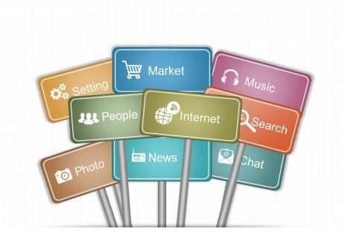
Figure 4: Potential knowledge management challenges
(Source: Liebowitz and Beckman, 2020)

Recommendations to strengthen knowledge management practices
The key recommendations need to be designed to help deliver better instances towards bettering the operational practices.
- The involvement of advisors in Amazon needs to be leveraged for better content creation. This helps in creating a knowledge culture for improving learning and development practices.
- Centralisation of knowledge content needs to be driven by the E-Commerce giant for bettering customer retention and creation of knowledge assets in an efficient manager (Martins et al., 2019). Two matrices need to be tracked in order to gauge success order to facilitate the return of investment for efficient budget management.
- The application of natural language processing should be improvised in the E-Commerce giant Amazon helps in improving the search functions in an efficient manner.
- The simplification of knowledge management in the business practices would help in generating more advisors while making sure that the operational practices would manage CRM practices and the development of knowledge assets.

Task 2 - Poster
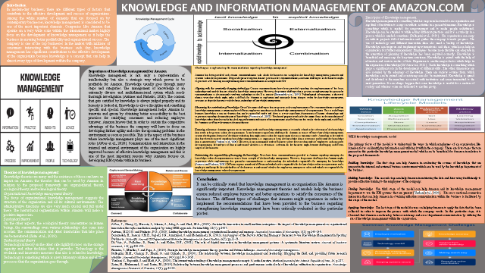

Conclusion
The report sheds light on the significant implication of knowledge management practices that are adopted by the E-Commerce giant Amazon. The evaluation of knowledge management principles that have been highly practised by Amazon helps in streamlining customer relationship management while creating knowledge assets to a huge extent. The report further delivers better insight into the theoretical interventions of knowledge management that generate and leverage better recommendations to cater to the operational requirement of the global retail giant Amazon. Amazon has adopted the knowledge management practices that helped the operation to survive during the unprecedented outbreak of the coronavirus pandemic. The WIIG knowledge management model and ZACK Knowledge Management Model has been applied to the e-commerce giant Amazon. The KM model that has been integrated into the operation would help in making sure that the leading retail giant Amazon has been successful to leverage better success. The components of information system infrastructure have been discussed widely while making better efforts to deliver customer satisfaction.

References
Abualoush, S., Bataineh, K. and Alrowwad, A.A., (2018). The role of knowledge management process and intellectual capital as intermediary variables between knowledge management infrastructure and organization performance. Interdisciplinary Journal of Information, Knowledge, and Management, 13, p.279.
Abubakar, A.M., Elrehail, H., Alatailat, M.A. and Elçi, A., (2019). Knowledge management, decision-making style and organizational performance. Journal of Innovation & Knowledge, 4(2), pp.104-114.
Al Ahbabi, S.A., Singh, S.K., Balasubramanian, S. and Gaur, S.S., (2018). Employee perception of impact of knowledge management processes on public sector performance. Journal of knowledge management.
Amazon.com. 2022. [online] Available at: <https://www.amazon.com/> [Accessed 8 July 2022].
Antunes, H.D.J.G. and Pinheiro, P.G., (2020). Linking knowledge management, organizational learning and memory. Journal of Innovation & Knowledge, 5(2), pp.140-149.
Archer-Brown, C. and Kietzmann, J., (2018). Strategic knowledge management and enterprise social media. Journal of knowledge management.
Bilginoğlu, E., (2019). Knowledge hoarding: A literature review. Management Science Letters, 9(1), pp.61-72.
Castaneda, D.I., Manrique, L.F. and Cuellar, S., (2018). Is organizational learning being absorbed by knowledge management? A systematic review. Journal of Knowledge Management.
Din, I.U., Guizani, M., Kim, B.S., Hassan, S. and Khan, M.K., (2018). Trust management techniques for the Internet of Things: A survey. IEEE Access, 7, pp.29763-29787.
Dwivedi, Y.K., Hughes, D.L., Coombs, C., Constantiou, I., Duan, Y., Edwards, J.S., Gupta, B., Lal, B., Misra, S., Prashant, P. and Raman, R., (2020). Impact of COVID-19 pandemic on information management research and practice: Transforming education, work and life. International journal of information management, 55, p.102211.
Ferraris, A., Mazzoleni, A., Devalle, A. and Couturier, J., (2018). Big data analytics capabilities and knowledge management: impact on firm performance. Management Decision.
Ganguly, A., Talukdar, A. and Chatterjee, D., (2019). Evaluating the role of social capital, tacit knowledge sharing, knowledge quality and reciprocity in determining innovation capability of an organization. Journal of knowledge management.
Gaviria-Marin, M., Merigo, J.M. and Popa, S., (2018). Twenty years of the Journal of Knowledge Management: A bibliometric analysis. Journal of Knowledge Management.
Gregg, M., (2018). Counterproductive: Time management in the knowledge economy. Duke University Press.
Latilla, V.M., Frattini, F., Petruzzelli, A.M. and Berner, M., (2018). Knowledge management, knowledge transfer and organizational performance in the arts and crafts industry: a literature review. Journal of Knowledge Management.
Li, S., (2021). Application of computer technology in administrative management. In Journal of Physics: Conference Series (Vol. 1769, No. 1, p. 012074). IOP Publishing.
Liebowitz, J. and Beckman, T., (2020). Knowledge organizations: What every manager should know. CRC press.
Manesh, M.F., Pellegrini, M.M., Marzi, G. and Dabic, M., (2020). Knowledge management in the fourth industrial revolution: Mapping the literature and scoping future avenues. IEEE Transactions on Engineering Management, 68(1), pp.289-300.
Martins, V.W.B., Rampasso, I.S., Anholon, R., Quelhas, O.L.G. and Leal Filho, W., (2019). Knowledge management in the context of sustainability: Literature review and opportunities for future research. Journal of cleaner production, 229, pp.489-500.
Nisar, T.M., Prabhakar, G. and Strakova, L., (2019). Social media information benefits, knowledge management and smart organizations. Journal of Business Research, 94, pp.264-272.
Purwanto, A., (2020). Effect of Hard Skills, Soft Skills, Organizational Learning and Innovation Capability on Islamic University Lecturers’ Performance. Systematic Reviews in Pharmacy.
Singh, S.K., Gupta, S., Busso, D. and Kamboj, S., (2021). Top management knowledge value, knowledge sharing practices, open innovation and organizational performance. Journal of Business Research, 128, pp.788-798.
Szczepaniuk, E.K., Szczepaniuk, H., Rokicki, T. and Klepacki, B., (2020). Information security assessment in public administration. Computers & Security, 90, p.101709.

