The History of Jazz and How it Has Influenced Modern Music
Brandon Macleod-Pritchard
P146635

Contents:
Introduction : 3
Chapter 1 : 3
Chapter 2 : 7
Chapter 3 : 9
Bibliography : 12

Introduction
Jazz has been said to have been one of the most influential genres of music in western culture Spawning a multitude of subgenres each of these branching off to influence other areas of music. With this said I decided to research into three areas; The history of Jazz and how It formed into a genre, influential Jazz artists and their influences on modern artists, and finally to look at examples of how jazz has influenced modern music .
Chapter 1 History of Jazz
Early Beginnings - New Orleans Jazz
'During the second decade of our century, while the world was engaged in its first "global" war, and European music was being thoroughly revitalised' (Schuller, 1968: 3).. This opening sentence really does set the theme for post war Europe where radicalism is taking place on every scale. For centuries Europe has followed the same recipe for the creation of music following rules that have been established for hundreds of years without any outside influence. In the midst of this European crisis the American government established a period of isolationism. It is within the isolated country that Schuller describes as a 'great ethnic melting pot' (Schuller, 1968: 3) that Jazz was formed. Early Jazz is in its simplest description is a fusion genre of 'African rhythmic, formal, sonoric, and expressive elements and European rhythmic and harmonic practices'(Schuller, 1968: 3) using these elements jazz was able adopt a unique sound style that was unheard of in the world. There is much speculation to when jazz was first formed as Schuller states "It is impossible to establish the exact beginnings of jazz as a distinct self-contained music. Some historians use the year 1895 as a working date; others prefer 1917" (Schuller, 1968: 63) I believe the speculation is due to the situation of many African Americans during this period as heavy segregation and racism ruled at this time so potentially this caused early jazz to be a more underground movement. The early history of jazz appears more and more tragic to me the further I read into Schullers book. According to Schuller most recording of early jazz "were made by society orchestras, novelty bands, or jazz groups who were forced by the companies recording them to play novelty or polite dance music" (Schuller, 1968: 3) this quote says to me that the jazz the bands were forced to record is not even considered true jazz. Another point to make off that quote goes to show have jazz wasn't appreciated at this time by the recording companies .
The basic musical ideas in jazz can be seen when you analyse some sheet music and compare them to the western standard at the time.
Figure 1 (Richardson, 1917: 3)
Figure 1 shows a section taken from Don Richardson's New Orleans Jazz shows the melody from bars 37 to 43. Looking at this melody you can see that there is not much emphasis on dynamics throughout this section, however there is a fair amount of emphasis on the rhythms that drive the piece and accents on the off beats.
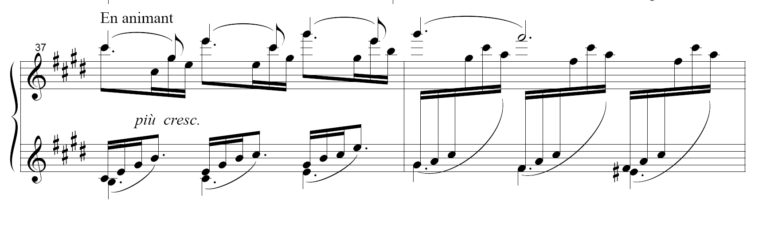Figure 2 (Debussy, 1905: 3)
When you compare Figure 1 to Figure 2 which is traditional western music at the same time period you can see the main difference being in the phrasing of the piece it has more of a flowing melody rather than a heavy percussive driving rhythms. You can see in Figure 1 that the main accent of the piece is on the offbeat of the bar creating syncopated rhythms, these rhythms driving on the weak beat of the bar is one of the main distinguishing factors between Jazz and western music at the time. Another point to notice is that in the Robinson piece it is very chord and triad based whereas the Debussy piece is more arpeggio based.
To understand the difference in the pieces we must look at the composition of early jazz where the genre was comprised of two elements: The Rhythms of Africa, and the pitches and harmonies that were formed in Europe. In the western world the rhythms of pieces were very straight forward and tended to flow with each also the strong beats of bars were very different to that of jazz. for example a standard bar of 4/4 would have strong accents on beats one and three of each bar, where as in jazz the weak beats tend to get accented to create and new different rhythm by replacing the strong beats of one and three with two and four. Obviously being one of the bigger influences on jazz music African music is described by Schuller as being "additive rather than divisive" ( Schuller, 1968: 11) this is clearly seen ethnic African music with more layers being added of the base layer. From another source however which credits Buddy Bolden although not being the inventor of the genre he is consider to be one of the first New Orleans Jazz composer to master the recipe for which Jazz was comprised of "the rhythms of ragtime, the bent notes and chord patterns of blues, and an instrumentation drawn from New Orleans brass bands and string ensembles." (Gioia, 2011: 34) This point also gives us the idea that jazz is a fusion genre of everything that was happening in new Orleans culture at the time and it seems to have worked in bringing all of the cultures in the area together on a musical level. It would also appear that Boldens combination of blues and ragtime was quite a strange choice of coupling as this happened before blues really gained much popularity in the world of music it tended to be used within Afro-American culture as a form of folk music commonly used for church ceremonies. Whereas ragtime was gaining quite a bit of popularity in America in the early 20th century because of the ragged syncopation it was easy to dance to ( as one of the precursors to ragtime was cakewalk music which was commonly used as a dancing competition for African American people post slavery era where the prize being a cake). 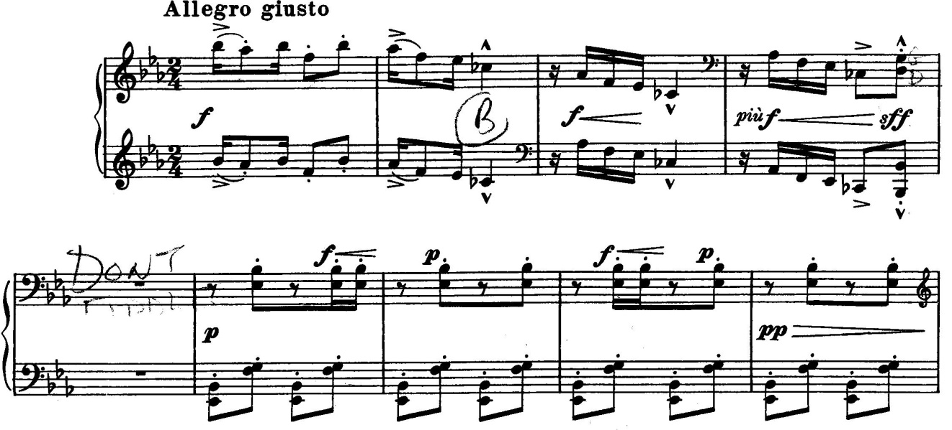
Figure 3 (Debussey 1908: 26)
Figure 3 is an excerpt from Debussy's Golliwoggs cakewalk and if we compare that to Figure 1 we can find many similarities between the two styles of music for example the time signature is the same measure two crotchet beats in a bar. Also from bar six in Figure looking at the bass line we can see similarities between that and Figure 1 as the clear use of syncopation by providing a strong 'weak' beat.
The blues elements that were incorporated into jazz were the structure off a blues song which is commonly in AAB this mostly likely allowed the freedom for improvisation which is very common in jazz, due to a structure like this it allows the freedom for the big band to go off and created an new melody but whilst keeping to the root notes of the structure thus allow everything to still remain in key. The other element of blues music that was commonly incorporated into jazz was the use of 'Blues notes' which is in a basic explanation an accidental of sort but also a bent note depending on the instrument that is it is played on and its capability of playing either semitones or quartertones. It gives the audio effect of being minor and 'sad' thus the name blue note.
The Swing Era
The next important step for the evolution of jazz was the beginning of swing music which is just the next sub genre of jazz to take the mantle of popularity. The important aspect of swing music is it's development of the jazz and ragtime syncopation with the developments of the swing rhythm which would be backed by the basic swing drum beat pictured below in Figure 4 obviously there are many different variations of this particular beat but the basic show a growth in the emphasis on the basics of furthering the syncopation found before that was mainly accented 'weak' beats of two and four by starting to institute more of a accent on the half beats by the inclusion of triplets it creates even more of a delayed feel to the music giving it what can only be described as a swing.

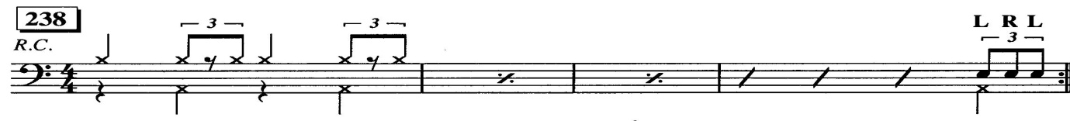Figure 4 (Lauritsen 2003: 67)
Swing music is really the major turning point for jazz as it is begin to gain a cross cultural following across the United States this is backed up by the emergence of many white band leaders in this time period such as: Benny Goodman "the King of Swing" (Gioia 2011: 131), Charlie Barnet, Les Brown, Jimmy Dorsey and his brother Tommy Dorsey. The bandleader I would like to focus on is Benny Goodman as a title such as the 'King of Swing' designates that he must have a had the biggest influence on the formation of the genre. The swing era of music emerged from the great depression when the entertain industry as a whole was taking a massive hit as seen by the record sales over a five year period "Record sales in the United States had surpassed one hundred million in 1927, but by 1932 only six million were sold" (Gioia 2011: 127) that is an at least ninety four percent decrease in record sales. Also during this period there silent films were slowly being phased out in favour of films with sound this led to mass unemployment in the music sector due to large number of cinemas no longer needing band to provide live shows with the film screening. One of the final negative changes in the period for jazz musicians was the rising popularity of the radio due to the fact that " a single band could now entertain countless listener" (Gioia 2011: 127) due to this one band can take on the role of many however despite being career killer for most jazz musicians a few noticed the opportunity that this creates, as one band can now reach countless listeners that they would have never previously had access to due to the new technology creating a new age of Jazz celebrities. We can see from figures provided by Gioia the sales of radio equipment skyrocketed in the United States as in 1921 sales for radio equipment was at "$11 million" but by the end of the decade sales had reached " over $850 million" (Gioia 2011: 128) this massive increase in availability for radio equipment also increases the viability of this new medium of entertainment. With all of these things in place Benny Goodman utilised them to send himself into stardom along with it starting a new era of music the Swing Era. Obviously doing these things Goodman received a lot of criticisms mainly being the fact that jazz music is mainly for Afro-American origin and Goodman being white he was accused of exploiting their culture for his own benefit, but I would have to say that this isn't the case due to the racial situation in the United States at the time. According to Gioia, Goodmans "performance at the Palomar Ballroom in Los Angeles on August 21, 1935, a date now conventionally cited as the birth of the Swing Era" (Gioia 2011: 131) this date being only eighty years after the abolishment of slavery in the United States so racism was a commonplace all around and many African American performers and band leaders found difficulty in this period to gain a more commercial following where as Goodman was more readily accepted into particular situations and opportunities to allow the genre to flourish. Also another point to make about whether it would appear that Goodman had exploited Afro-American culture for his gain or not can be seen with Goodman's use of African American members in his band such as: Fletcher Henderson, Jimmy Mundy, Horace Henderson and some others. Fletcher Henderson is cited as "a major turning point for the band's sound" Gioia goes even further by stating that Henderson was "perhaps even decisive - in the bands success" (Gioia 2011: 132). By considering that Goodman had created a racially integrated band could easily disprove the accusations that he was exploiting another's culture as per that he was more accepting of the others culture and wanted to create his own mark upon it. The final point to consider that probably led to the success of swing music was Goodman's focus on creating a strong rhythm section as we have previously seen rhythm being the driving force behind the whole jazz movement, as a solid rhythm can allow greater freedom of improvised solos from many different instruments because everything will fall back in to place with aid of the rhythm section. By creating this backbone to his band allowing the swinging rhythm to be fully integrated into the songs this creates an opportunity to be easier for widespread audiences to listen with ease as more traditional jazz could be harder for average untrained ear to listen to or even understand. This obviously goes to show that the main aspect of swing music was to get people up and dancing to get more of a crowd participation in the music thus people will then find it more enjoyable and a strong rhythm section allows this to happen.
Chapter 2: Rock and Roll
Early Rock and Roll
"Rock and roll is a form of popular music that emerged in the United States in the late Forties and early Fifties" and its roots can in ""race" music, or rhythm and blues, and "hillbilly" music" (Rock Hall, 2013). Rhythm and Blues had its origins in the African American community at some point in the early 1940's and was probably the latest incarnation of jazz music in that time period as it appearing towards the end of the Swing Era. The main characteristics of Rhythm and Blues is in most of its aspects very similar to that of Swing Big Bands in terms of heavy focus on the rhythm section of the piece and as the name states it is essentially a marrying of the rhythm of Swing and the Blues scales and play style. As seen in Figure 5 which is a basic representation of the twelve bar blues walking bass. The root notes are coloured in red and if follows a basis of blues chord patterns which use the Tonic ( I ), the Sub-Dominant ( IV ) and the Dominant ( V ). The pattern below follows the chord progression of I IV I V IV I in Rhythm and Blues the rhythm section would follow this base but with more of a swing feel instead of smooth quaver notes.
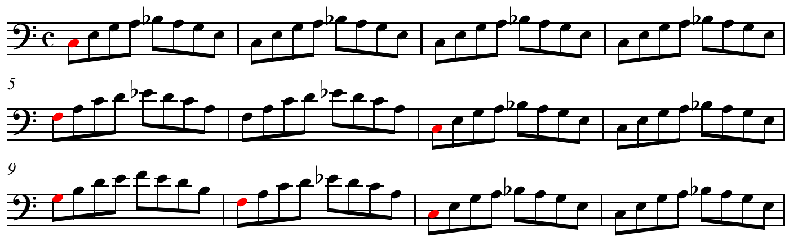Figure 5
Rock and Roll would take the basics from Rhythm and Blues and it would be melded together with country music to create the recognisable genre we know as Rock and Roll. The origin of rock and roll can be attributed to the widespread migration of African Americans from the more rural south to the more urbanised and industrial north. "The Great Migration" (Staff, 2010) as it is called by history.com was happening all throughout the start of the 20th century but it had 2slowed considerably in the 1930s when the country sank into the Great Depression, but picked up again with the coming of World War II" (Staff, 2010) due to this migration of African Americans to the north and with them they were bringing their culture and their Rhythm and Blues music. The packing of all these people together in urban centres led to a major culture collision between blacks and whites where as previously to the Great Migration "nine out of every ten black Americans lived in the South, and three out of every four lived on farms. Obviously being in these new conditions allowed the members of each culture to be exposed to the opposite ends to the music spectrum and obviously from that would come a lot of inspiration and experimentation in music. Another forming point for Rock and Roll came from the expense that during the war Swing and Jazz Big Bands were losing their members to drafts and volunteer service so this made the operation of a Big Band highly unfeasible. Also due to the nature of the war and much of industry being switched over for the production of munitions and weapons there could arguably be said that there could have been a shortage of high quality instruments. Out of this would come a line up that many would recognise as it is still a common place today of Guitar, Bass, Drums and Vocals. This setup was allowed to flourish during this period due to the increased availability of electric guitars and with the aid of the first mass produced electric bass guitar by Fender in the 1950s, with the aid of the electric instrument you are able to replace the necessity for multiple band members to create a rhythm section as volume was no longer an issue. Another point to consider is that as technology advances so does the number of new and improved effects for the electric guitars giving them even more versatility than before. A main effect to note that is gaining prominence with the emerging Rock and Roll genre is the use of distortion on the electric guitar this can be heard on countless tracks.
Rockabilly
Rockabilly is considered one of the earliest forms of the Rock and Roll genre and is what most will recognise as classic Rock and Roll with many big names and its belt such as: Elvis Presely, Little Richard, Buddy Holly, Chuck Berry, Billy Hayley, and this list could go on due to the high number of influential artists from this era of sound. As stated earlier the marrying of Rhythm and Blues with Country becomes evident with Rockabilly With heavy focus on the twelve bar blues becoming a common place in most songs but this is often coupled up with the use of the swing drum beat this allowed the music to become a hit with the younger generations due to the ease that it is to move along with and dance to. These aspects can be heard on most tracks for example if you listen to Rock Around the Clock by Bill Hayley and his Comets ( link to the song www.youtube.com/watch?v=ZgdufzXvjqw). You can clearly hear the 12 bar walking blues bass line being played on the acoustic bass, this is layered with a syncopated rhythm guitar riff following the same chord pattern as the root note of the bass line. On top of that the swinging drum beat is prevalent throughout and the music video places a massive amount of emphasis on how people can dance easily to this music. One thing to be noted that is different about this piece compared to many earlier forms of jazz is that there is a guitar solo obviously prior to Rock and Roll electric guitars were not a commonplace and they allow the development of these single note solos and they can be audible due to amplification. Another thing to note with regards to guitar solos they are basically at the time of recording a new form of improvisation that was very commonplace in all forms of jazz it just goes to show the instruments can evolve but the principles will stay the same. Another aspect of Rock and Roll that comes through fairly often is its use of call and response and example of this that I have found is in the song Yakety Yak by the coasters (Can be heard here www.youtube.com/watch?v=-WfDYssJMqs) where the use of multiple vocalists for a call and response section in the chorus that can be used to increase crowd participation in songs thus in a way increasing the ease of enjoyment the music. The concept of call and response can be seen throughout musical history but it also has origins in African folk music given the terms of where jazz has come from as Schuller breaks down how a basic African folk drum song is created "The basic African ensemble consists of a solo cantor answered by a chorus" (Schuller 1968: 11) this can be considered a basic form of call and response and in a way such form can be applied to rock and roll where the verse is the call and the chorus is the response on a grander scale in a musical sense.
The biggest reason I have found to why Rock and Roll because such an influential genre of music is most likely due to how it because of how it managed to invade British charts. So where this genre originated from a culture clash it has also managed to tear down the musical barriers between countries. Where before American jazz has never really taken off in the United Kingdom let alone Europe as names like Benny Goodman never really left their mark, where as Rock and Roll invaded with a passion maybe this was due to the fact that record labels saw this genre of music as a good money maker for them as the charts were initially "Dominated by American acts, or re-creations of American forms of music" (Wikizero) record labels would commonly re-record American hits using session musicians as it would have been the easiest way to create a successful venture. But due to this invasion as a sort of American Rock and Roll it fuelled the British popular music industry to new heights that had never been reached before so now all of these different ideas are coming together and influencing each other and it led to the creation of what is today known as Rock music and Pop music.
Chapter 3 : Modern Music and how it could has been influenced by Jazz
Popular Music
Modern Popular music as a genre emerged as a term from the Rock and Roll era because as a definition it covers whatever music has the forefront in the charts. In the beginning both Pop and Rock music were completely synonymous with each other and as a genre of music it was considered as an alternative for the high energy Rock and Roll and it was mainly focusing on the idea of song writing over high energy performance. However as time goes on there is a greater divergence between Rock music and Pop music each becoming their own respected path and with their own respective influences and focuses.
The main characteristics of Pop music is the focus on the production of the song where a lot more is put in to producing the record and there is more emphasis on the recording stage as compared to live performances also there appears to be less focus on the more virtuoso aspects of music. The lyrical content of popular music tends to focus more on the current trends of society as its priority. As for the rhythm section of the song most modern pop songs focus on a basic 4/4 backing and in terms of Swing and Rock and Roll the rhythms and the beat have a heavy focus on being easy to dance to.
Some examples of Pop songs where you can clearly hear the jazz influences resonating throughout are My Same By Adele (www.youtube.com/watch?v=MyQ0odvDHnw) as you listen to the track the first thing that stands out to me is that predominant swing drum beat in the background and the syncopated rhythm guitar. The screeching tone on the guitar can be traced back to the blaring horns of the swing era and the use of blues not takes it back to a very early form of jazz as inspiration for this piece. But if you listen to another song Youngblood by 5 Seconds of Summer (www.youtube.com/watch?v=Jqs5EaAaueA) it gives a very different vibe as the only aspect that could be considered 'Jazzy' is the use of syncopation however most other parts of the song a focused on the straight four beats in the bar there is not emphasis on beats two or four to make it recognisable as jazz syncopation per say there is only syncopation on all of the and beats it does however create a sort of shuffle feeling in the song but without being true shuffle due to the lack of the shuffle drum beat. The final example of Modern Pop music I have listened to look for jazz influences is Jackie Chan by Tiesto & Dzeko (www.youtube.com/watch?v=6DaL-Z4dwzl) this piece has the basic 4/4 beat that is found in most pop songs however the rhythm line delivered by the synthesizers is very full of a syncopated riff of sorts and is quite similar in drive to the guitar riff in the Adele track with the only major difference being in the timbre of the sounds used.
Rock Music
The roots of Rock music are closely tied to that of Rock and Roll but as a whole Rock music draws a lot of inspiration from many different genres such as Electric Blues, Folk, many influences come directly from Jazz itself and a number of influences come from Classical music. The characteristics of rock music is based around the setup of electric guitars with electric bass and drums with one or more vocalists which is as a whole very similar to the setup of a Rock and Roll group. As stated earlier Rock and Pop were very similar up until when Rock music started to focus on become harder and heavier where Pop music focused on being easy to listen to. The main focus of Rock music is the opposite to Pop where as there is more of a focus on the artistic ability in the song writing and the emphasis is more heavily placed on the live performances more than studio production and recording.
Looking at some examples of Rock music to listen for Jazz like influences for example Falling Down by Atreyu (www.youtube.com/watch?v=_flr7CEr824) the main aspect of this song appears to have been heavily inspired by Rock and Roll tracks from the drum beats being in the swinging style and the rhythm used by the guitars and bass in the verses. The use of call and response vocals in the chorus is also something that is commonly seen in Rock and Roll music. The biggest sign of how this song is inspired by Rock and Roll is the use of the guitar solo which is a common place in most rock tracks of the modern day. The second example of music I listened to was Stranger Things by Periphery (www.youtube.com/watch?v=9LNU8IL4QHY) the start of the song is seemingly smooth and melodic but about 1:30 it picks up with palm muted syncopated rhythms which really throws the emphasis around the beats. The use of an almost drum solo is evident from about 2:50 onwards this can be seen in many jazz pieces especially from band leaders like Buddy Rich.
Conclusion
In my findings I have found that there are many factors point to how modern music has been influenced by jazz. But also in my research I have found that certain elements of jazz have been kept on throughout the years for example the whole idea of syncopation has be kept for the most part and it has been developed and evolved as sound is constantly changing. I feel like the whole idea of Jazz is a genre of music that is constantly evolving into new forms of music, new arrangements and new sounds for example it has transitioned through the years from New Orleans all the way to Rock and Roll then from Rock and Roll a whole new playing field was created due to the sudden fact that music had become globalized where the first step was Rock and Roll coming to the United Kingdom and then from there more and more influences were piled upon each other. All of these different styles come together the create the music of the modern world but I do believe that Jazz and the story of Jazz has played a major part in this as our transition away from the classical era of composers to the idea of a band composers.

Bibliography
Books
Schuller, G. (1968). Early Jazz. Oxford: Oxford University press, Inc.
Gioia, T. (2011). The History of Jazz Second Edition. Oxford: Oxford University Press, Inc.
Websites
Rock Hall. (2013, October 18). The Roots and Definition of Rock and Roll. Retrieved July 23, 2018, from www.rockhall.com: www.rockhall.com/roots-and-definition-rock-and-roll
Staff, H. (2010). Great Migration. Retrieved July 24, 2018, from History.com: www.history.com/topics/black-history/great-migration
Wikizero. (n.d.). British Popular Music. Retrieved July 25, 2018, from www.Wikizero.com: www.wikizero.com/en/British_Popular_Music
Images
Figure 1 Richardson, D. (1917). New Orelans Jazz. New York: Leo Feist, Inc.
Figure 2 Debussy, C. (1905). Clair de Lune. Non Basic Stock Line.
Figure 3 Debussy, C. (1908). Children's Corner. Milan: Carisch.
Figure 4 Lauritsen, C. (2003). Drum Method: L.T.P. Publishing Pty, Ltd.
Figure 5 Hyancinth. (2010, December 9). Twelve Bar Boogie Woogie Blues in C. Retrieved July 22, 2018, From wikipedia.com: en.wikipedia.org/wiki/Twelve-bar_blues#/media/File:Tweleve_bar_boogie_woogie_blues_in_C.png

