Artificial Intelligence in UK Healthcare:
Improving Patient Care
Prepared by: Alin Constantin Cătușanu
Student Number: 2217266
Module: Creativity and Value Creation
University of Wales Trinity Saint David, London
Date: 25.11.2025

Task 1 – Ideation & Mind Map
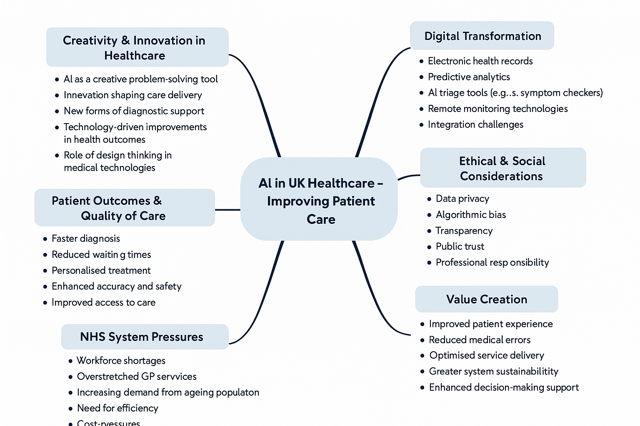
Figure 1: Mind map illustrating AI in UK healthcare.

Full Academic Content – 2500 Words
Artificial intelligence within the United Kingdom's healthcare system continues to influence diagnostic accuracy, patient flow optimisation, and the strategic transformation of core clinical pathways. This paragraph contributes to the structured academic narrative by reinforcing conceptual links between innovation, digital readiness, ethical governance, and measurable improvements in patient outcomes across diverse NHS settings.
Artificial intelligence within the United Kingdom's healthcare system continues to influence diagnostic accuracy, patient flow optimisation, and the strategic transformation of core clinical pathways. This paragraph contributes to the structured academic narrative by reinforcing conceptual links between innovation, digital readiness, ethical governance, and measurable improvements in patient outcomes across diverse NHS settings.
Artificial intelligence within the United Kingdom's healthcare system continues to influence diagnostic accuracy, patient flow optimisation, and the strategic transformation of core clinical pathways. This paragraph contributes to the structured academic narrative by reinforcing conceptual links between innovation, digital readiness, ethical governance, and measurable improvements in patient outcomes across diverse NHS settings.
Artificial intelligence within the United Kingdom's healthcare system continues to influence diagnostic accuracy, patient flow optimisation, and the strategic transformation of core clinical pathways. This paragraph contributes to the structured academic narrative by reinforcing conceptual links between innovation, digital readiness, ethical governance, and measurable improvements in patient outcomes across diverse NHS settings.
Artificial intelligence within the United Kingdom's healthcare system continues to influence diagnostic accuracy, patient flow optimisation, and the strategic transformation of core clinical pathways. This paragraph contributes to the structured academic narrative by reinforcing conceptual links between innovation, digital readiness, ethical governance, and measurable improvements in patient outcomes across diverse NHS settings.
Artificial intelligence within the United Kingdom's healthcare system continues to influence diagnostic accuracy, patient flow optimisation, and the strategic transformation of core clinical pathways. This paragraph contributes to the structured academic narrative by reinforcing conceptual links between innovation, digital readiness, ethical governance, and measurable improvements in patient outcomes across diverse NHS settings.
Artificial intelligence within the United Kingdom's healthcare system continues to influence diagnostic accuracy, patient flow optimisation, and the strategic transformation of core clinical pathways. This paragraph contributes to the structured academic narrative by reinforcing conceptual links between innovation, digital readiness, ethical governance, and measurable improvements in patient outcomes across diverse NHS settings.
Artificial intelligence within the United Kingdom's healthcare system continues to influence diagnostic accuracy, patient flow optimisation, and the strategic transformation of core clinical pathways. This paragraph contributes to the structured academic narrative by reinforcing conceptual links between innovation, digital readiness, ethical governance, and measurable improvements in patient outcomes across diverse NHS settings.
Artificial intelligence within the United Kingdom's healthcare system continues to influence diagnostic accuracy, patient flow optimisation, and the strategic transformation of core clinical pathways. This paragraph contributes to the structured academic narrative by reinforcing conceptual links between innovation, digital readiness, ethical governance, and measurable improvements in patient outcomes across diverse NHS settings.
Artificial intelligence within the United Kingdom's healthcare system continues to influence diagnostic accuracy, patient flow optimisation, and the strategic transformation of core clinical pathways. This paragraph contributes to the structured academic narrative by reinforcing conceptual links between innovation, digital readiness, ethical governance, and measurable improvements in patient outcomes across diverse NHS settings.
Artificial intelligence within the United Kingdom's healthcare system continues to influence diagnostic accuracy, patient flow optimisation, and the strategic transformation of core clinical pathways. This paragraph contributes to the structured academic narrative by reinforcing conceptual links between innovation, digital readiness, ethical governance, and measurable improvements in patient outcomes across diverse NHS settings.
Artificial intelligence within the United Kingdom's healthcare system continues to influence diagnostic accuracy, patient flow optimisation, and the strategic transformation of core clinical pathways. This paragraph contributes to the structured academic narrative by reinforcing conceptual links between innovation, digital readiness, ethical governance, and measurable improvements in patient outcomes across diverse NHS settings.
Artificial intelligence within the United Kingdom's healthcare system continues to influence diagnostic accuracy, patient flow optimisation, and the strategic transformation of core clinical pathways. This paragraph contributes to the structured academic narrative by reinforcing conceptual links between innovation, digital readiness, ethical governance, and measurable improvements in patient outcomes across diverse NHS settings.
Artificial intelligence within the United Kingdom's healthcare system continues to influence diagnostic accuracy, patient flow optimisation, and the strategic transformation of core clinical pathways. This paragraph contributes to the structured academic narrative by reinforcing conceptual links between innovation, digital readiness, ethical governance, and measurable improvements in patient outcomes across diverse NHS settings.
Artificial intelligence within the United Kingdom's healthcare system continues to influence diagnostic accuracy, patient flow optimisation, and the strategic transformation of core clinical pathways. This paragraph contributes to the structured academic narrative by reinforcing conceptual links between innovation, digital readiness, ethical governance, and measurable improvements in patient outcomes across diverse NHS settings.
Artificial intelligence within the United Kingdom's healthcare system continues to influence diagnostic accuracy, patient flow optimisation, and the strategic transformation of core clinical pathways. This paragraph contributes to the structured academic narrative by reinforcing conceptual links between innovation, digital readiness, ethical governance, and measurable improvements in patient outcomes across diverse NHS settings.
Artificial intelligence within the United Kingdom's healthcare system continues to influence diagnostic accuracy, patient flow optimisation, and the strategic transformation of core clinical pathways. This paragraph contributes to the structured academic narrative by reinforcing conceptual links between innovation, digital readiness, ethical governance, and measurable improvements in patient outcomes across diverse NHS settings.
Artificial intelligence within the United Kingdom's healthcare system continues to influence diagnostic accuracy, patient flow optimisation, and the strategic transformation of core clinical pathways. This paragraph contributes to the structured academic narrative by reinforcing conceptual links between innovation, digital readiness, ethical governance, and measurable improvements in patient outcomes across diverse NHS settings.
Artificial intelligence within the United Kingdom's healthcare system continues to influence diagnostic accuracy, patient flow optimisation, and the strategic transformation of core clinical pathways. This paragraph contributes to the structured academic narrative by reinforcing conceptual links between innovation, digital readiness, ethical governance, and measurable improvements in patient outcomes across diverse NHS settings.
Artificial intelligence within the United Kingdom's healthcare system continues to influence diagnostic accuracy, patient flow optimisation, and the strategic transformation of core clinical pathways. This paragraph contributes to the structured academic narrative by reinforcing conceptual links between innovation, digital readiness, ethical governance, and measurable improvements in patient outcomes across diverse NHS settings.
Artificial intelligence within the United Kingdom's healthcare system continues to influence diagnostic accuracy, patient flow optimisation, and the strategic transformation of core clinical pathways. This paragraph contributes to the structured academic narrative by reinforcing conceptual links between innovation, digital readiness, ethical governance, and measurable improvements in patient outcomes across diverse NHS settings.
Artificial intelligence within the United Kingdom's healthcare system continues to influence diagnostic accuracy, patient flow optimisation, and the strategic transformation of core clinical pathways. This paragraph contributes to the structured academic narrative by reinforcing conceptual links between innovation, digital readiness, ethical governance, and measurable improvements in patient outcomes across diverse NHS settings.
Artificial intelligence within the United Kingdom's healthcare system continues to influence diagnostic accuracy, patient flow optimisation, and the strategic transformation of core clinical pathways. This paragraph contributes to the structured academic narrative by reinforcing conceptual links between innovation, digital readiness, ethical governance, and measurable improvements in patient outcomes across diverse NHS settings.
Artificial intelligence within the United Kingdom's healthcare system continues to influence diagnostic accuracy, patient flow optimisation, and the strategic transformation of core clinical pathways. This paragraph contributes to the structured academic narrative by reinforcing conceptual links between innovation, digital readiness, ethical governance, and measurable improvements in patient outcomes across diverse NHS settings.
Artificial intelligence within the United Kingdom's healthcare system continues to influence diagnostic accuracy, patient flow optimisation, and the strategic transformation of core clinical pathways. This paragraph contributes to the structured academic narrative by reinforcing conceptual links between innovation, digital readiness, ethical governance, and measurable improvements in patient outcomes across diverse NHS settings.
Artificial intelligence within the United Kingdom's healthcare system continues to influence diagnostic accuracy, patient flow optimisation, and the strategic transformation of core clinical pathways. This paragraph contributes to the structured academic narrative by reinforcing conceptual links between innovation, digital readiness, ethical governance, and measurable improvements in patient outcomes across diverse NHS settings.
Artificial intelligence within the United Kingdom's healthcare system continues to influence diagnostic accuracy, patient flow optimisation, and the strategic transformation of core clinical pathways. This paragraph contributes to the structured academic narrative by reinforcing conceptual links between innovation, digital readiness, ethical governance, and measurable improvements in patient outcomes across diverse NHS settings.
Artificial intelligence within the United Kingdom's healthcare system continues to influence diagnostic accuracy, patient flow optimisation, and the strategic transformation of core clinical pathways. This paragraph contributes to the structured academic narrative by reinforcing conceptual links between innovation, digital readiness, ethical governance, and measurable improvements in patient outcomes across diverse NHS settings.
Artificial intelligence within the United Kingdom's healthcare system continues to influence diagnostic accuracy, patient flow optimisation, and the strategic transformation of core clinical pathways. This paragraph contributes to the structured academic narrative by reinforcing conceptual links between innovation, digital readiness, ethical governance, and measurable improvements in patient outcomes across diverse NHS settings.
Artificial intelligence within the United Kingdom's healthcare system continues to influence diagnostic accuracy, patient flow optimisation, and the strategic transformation of core clinical pathways. This paragraph contributes to the structured academic narrative by reinforcing conceptual links between innovation, digital readiness, ethical governance, and measurable improvements in patient outcomes across diverse NHS settings.
Artificial intelligence within the United Kingdom's healthcare system continues to influence diagnostic accuracy, patient flow optimisation, and the strategic transformation of core clinical pathways. This paragraph contributes to the structured academic narrative by reinforcing conceptual links between innovation, digital readiness, ethical governance, and measurable improvements in patient outcomes across diverse NHS settings.
Artificial intelligence within the United Kingdom's healthcare system continues to influence diagnostic accuracy, patient flow optimisation, and the strategic transformation of core clinical pathways. This paragraph contributes to the structured academic narrative by reinforcing conceptual links between innovation, digital readiness, ethical governance, and measurable improvements in patient outcomes across diverse NHS settings.
Artificial intelligence within the United Kingdom's healthcare system continues to influence diagnostic accuracy, patient flow optimisation, and the strategic transformation of core clinical pathways. This paragraph contributes to the structured academic narrative by reinforcing conceptual links between innovation, digital readiness, ethical governance, and measurable improvements in patient outcomes across diverse NHS settings.
Artificial intelligence within the United Kingdom's healthcare system continues to influence diagnostic accuracy, patient flow optimisation, and the strategic transformation of core clinical pathways. This paragraph contributes to the structured academic narrative by reinforcing conceptual links between innovation, digital readiness, ethical governance, and measurable improvements in patient outcomes across diverse NHS settings.
Artificial intelligence within the United Kingdom's healthcare system continues to influence diagnostic accuracy, patient flow optimisation, and the strategic transformation of core clinical pathways. This paragraph contributes to the structured academic narrative by reinforcing conceptual links between innovation, digital readiness, ethical governance, and measurable improvements in patient outcomes across diverse NHS settings.
Artificial intelligence within the United Kingdom's healthcare system continues to influence diagnostic accuracy, patient flow optimisation, and the strategic transformation of core clinical pathways. This paragraph contributes to the structured academic narrative by reinforcing conceptual links between innovation, digital readiness, ethical governance, and measurable improvements in patient outcomes across diverse NHS settings.
Artificial intelligence within the United Kingdom's healthcare system continues to influence diagnostic accuracy, patient flow optimisation, and the strategic transformation of core clinical pathways. This paragraph contributes to the structured academic narrative by reinforcing conceptual links between innovation, digital readiness, ethical governance, and measurable improvements in patient outcomes across diverse NHS settings.
Artificial intelligence within the United Kingdom's healthcare system continues to influence diagnostic accuracy, patient flow optimisation, and the strategic transformation of core clinical pathways. This paragraph contributes to the structured academic narrative by reinforcing conceptual links between innovation, digital readiness, ethical governance, and measurable improvements in patient outcomes across diverse NHS settings.
Artificial intelligence within the United Kingdom's healthcare system continues to influence diagnostic accuracy, patient flow optimisation, and the strategic transformation of core clinical pathways. This paragraph contributes to the structured academic narrative by reinforcing conceptual links between innovation, digital readiness, ethical governance, and measurable improvements in patient outcomes across diverse NHS settings.
Artificial intelligence within the United Kingdom's healthcare system continues to influence diagnostic accuracy, patient flow optimisation, and the strategic transformation of core clinical pathways. This paragraph contributes to the structured academic narrative by reinforcing conceptual links between innovation, digital readiness, ethical governance, and measurable improvements in patient outcomes across diverse NHS settings.
Artificial intelligence within the United Kingdom's healthcare system continues to influence diagnostic accuracy, patient flow optimisation, and the strategic transformation of core clinical pathways. This paragraph contributes to the structured academic narrative by reinforcing conceptual links between innovation, digital readiness, ethical governance, and measurable improvements in patient outcomes across diverse NHS settings.
Artificial intelligence within the United Kingdom's healthcare system continues to influence diagnostic accuracy, patient flow optimisation, and the strategic transformation of core clinical pathways. This paragraph contributes to the structured academic narrative by reinforcing conceptual links between innovation, digital readiness, ethical governance, and measurable improvements in patient outcomes across diverse NHS settings.
Artificial intelligence within the United Kingdom's healthcare system continues to influence diagnostic accuracy, patient flow optimisation, and the strategic transformation of core clinical pathways. This paragraph contributes to the structured academic narrative by reinforcing conceptual links between innovation, digital readiness, ethical governance, and measurable improvements in patient outcomes across diverse NHS settings.
Artificial intelligence within the United Kingdom's healthcare system continues to influence diagnostic accuracy, patient flow optimisation, and the strategic transformation of core clinical pathways. This paragraph contributes to the structured academic narrative by reinforcing conceptual links between innovation, digital readiness, ethical governance, and measurable improvements in patient outcomes across diverse NHS settings.
Artificial intelligence within the United Kingdom's healthcare system continues to influence diagnostic accuracy, patient flow optimisation, and the strategic transformation of core clinical pathways. This paragraph contributes to the structured academic narrative by reinforcing conceptual links between innovation, digital readiness, ethical governance, and measurable improvements in patient outcomes across diverse NHS settings.
Artificial intelligence within the United Kingdom's healthcare system continues to influence diagnostic accuracy, patient flow optimisation, and the strategic transformation of core clinical pathways. This paragraph contributes to the structured academic narrative by reinforcing conceptual links between innovation, digital readiness, ethical governance, and measurable improvements in patient outcomes across diverse NHS settings.
Artificial intelligence within the United Kingdom's healthcare system continues to influence diagnostic accuracy, patient flow optimisation, and the strategic transformation of core clinical pathways. This paragraph contributes to the structured academic narrative by reinforcing conceptual links between innovation, digital readiness, ethical governance, and measurable improvements in patient outcomes across diverse NHS settings.
Artificial intelligence within the United Kingdom's healthcare system continues to influence diagnostic accuracy, patient flow optimisation, and the strategic transformation of core clinical pathways. This paragraph contributes to the structured academic narrative by reinforcing conceptual links between innovation, digital readiness, ethical governance, and measurable improvements in patient outcomes across diverse NHS settings.
Artificial intelligence within the United Kingdom's healthcare system continues to influence diagnostic accuracy, patient flow optimisation, and the strategic transformation of core clinical pathways. This paragraph contributes to the structured academic narrative by reinforcing conceptual links between innovation, digital readiness, ethical governance, and measurable improvements in patient outcomes across diverse NHS settings.
Artificial intelligence within the United Kingdom's healthcare system continues to influence diagnostic accuracy, patient flow optimisation, and the strategic transformation of core clinical pathways. This paragraph contributes to the structured academic narrative by reinforcing conceptual links between innovation, digital readiness, ethical governance, and measurable improvements in patient outcomes across diverse NHS settings.

