Cloud-Based Web Services
Assignment 2

Table of Contents
What is cloud computing 3
Types of service models 3
Scaling 3
Horizontal Scaling 3
Vertical Scaling 4
Availability 4
Investment 4
Security 5
Where on-site hosting can be cheaper 5
Drawbacks to cloud computing 5
Hardware failures 5
Fair play 5
Virtualization 7
Development process of NodeJS + Docker 8
Creating a NodeJS project 8
Typescript 8
Typeorm 8
Dockerization 9
Development Conclusion 9
References 10
Figures 11
Presentation 13

What is cloud computing
The Cloud is a network of computer resources that can be accessed on demand, such as hardware, storage, databases, networks, and software applications. While it may not involve new technologies, it is a new way of managing IT that can provide benefits such as scalability and cost savings.

Types of service models
There are several service deliveries models that one can offer. Three of the most common delivery models would be IaaS, PaaS, SaaS. These three models are [1]:
Infrastructure as a service (IaaS). This provides processing, storage, networks, and other computing resources to the consumer. Example of this would be processing / memory intensive applications using a service like AWS IaaS.
Platform as a Service (PaaS). Unlike IaaS where the user can manage an entire/multiple machines over the network. PaaS only allows the consumer to deploy code to the hosting service and the service provider manages the resources themselves. An example of this would be the Google Cloud Platform which allows consumers to deploy applications which they build.
Software as a Service (SaaS). Compared to the previous two. The consumer purchases the right to use the online service of a provider. An example of this would be Google Drive / Google Photos which allows the user to save files / photos and edit them online.
There are other specialised variations of delivery models. Some of these are:
- Database as a service (DaaS)
- Communication as a Service (CaaS)
- Integration Platform as a Service (IPaaS)
- Testing as a Service (TaaS)

Scaling
When implementing an application into the cloud, scaling needs to be though upon. From a resource perspective, this represents the ability to handle the increase and decrease in demand. The two types of scaling are [2]:
- Horizontal Scaling
- Vertical Scaling.

Horizontal Scaling
The practice of horizontal scaling refers to increasing the number of servers of other resources to increase the capacity. This can also be referred to as “scale-out” because its involvement in adding more units to the capacity in a distribution.
Horizontal scaling is often implemented as a scaling technique to increase the capacity and improve the overall reliability of a cloud service. It allows a cloud service to handle more traffic by distributing the workload over several machines instead of relying on a single machine. This can be more cost-effective and easier to implement and manage than improving a single system [2].
For example, if a cloud-based service is experiencing high traffic and starts to slow down. A system which monitors the resources and stability of the service can automatically add more servers to the system to distribute the workload and improve the overall performance.

Vertical Scaling
The practice of vertical scaling refers to increasing the capacity of a single server by adding more resources. This can be improving the CPU, increasing RAM / disk space. This is also known as “scale-up” due to it involving the act of increasing the capacity of a single unit of a system.
This type of scaling can be useful approach for increasing the capacity for the short term. But there are limitations. As the capacity of a single server increases, it may reach the point where it can no longer become cost-effective to scale up. In these cases, Horizontal scaling is a better solution.
Mixing both techniques could result in the most cost-effective solution but can be less reliable compared to an entire horizontal system. Using a mix system will lead to a system were depending on the load, could result in either up-scaling or out-scaling depending on the traffic’s requirements [2].

Availability
From horizontal scaling comes redundancy. This can improve the overall availability off a cloud service. An example of this would be the availability level of your subscribed service from Microsoft Azure can be shown in the following formula found within the reference [3]:

The formula shows us that when a new addition is added to a service, the overall availability of the system increases. Meaning the reliability also increases. Also, that the more additional servers added to a service. The availability increases gradually decrease. An example of this would be that if a service consisted of 2 machines that gave an availability of 90%. And then an additional server is added to the system would increase the overall availability to 99.9%. Another addition would result in 99.99% and so on.
From this, having a cloud service can be far more reliable than an on-site service. This is many due to the many problems that could cause the on-site solution to go down. While a solution in the cloud could be scaled so that it can be accessed from multiple different hosts so no matter how many hosts go down. There will always be a backup solution.

Investment
Unlike an on-site infrastructure, cloud computing is cheaper to invest into compared to create an on-site system. This is due to many factors that are involved when hosting a service. Cloud computing can be more cost-effective than on-site hosting, especially for small businesses that do not have the resources to maintaining their own servers / infrastructure. With cloud computing, you only pay for resources that the consumer uses, rather than having to invest in and maintaining the hardware and infrastructure.
Also involved in the cost side of things. Cloud computing is easier to scale compared to an on-site system. This is due to the ease of increasing and decreasing the resources that the service requires. Compared to an on-site system, where you need to purchase everything needed for the peak load. Which will result in a higher cost compared to on-demand scaling with cloud computing [4].
With cloud computing providers comes redundant infrastructure. This improves the reliability of the services. This also leads to less cost since a backup infrastructure needs to be implemented and maintained for a scenario where the main services go down.

Security
For security, depending on the consumer’s needs. Cloud computing is either advantageous or a drawback. If the consumer needs to keep their data needs to be secured so no one can access their data, then an on-site system would have the benefit because you aren’t relying on a third party to host that data. And you can implement your own security policies to protect your data. On the other hand, in-house security measures may not be as robust as a cloud computing provider. Meaning that going cloud could be a better solution [5].

Where on-site hosting can be cheaper
One exception to on-site hosting having the biggest benefit. Is that GPUs for higher over a cloud service can cost more than purchasing the equipment and running / maintaining the infrastructure. This is due to the high rental costs that come with GPU processing times.

Drawbacks to cloud computing
Unfortunately, cloud computing does come with some drawbacks. And all the drawbacks depend on the service provider and the service that a consumer picks.

Hardware failures
At some point there will be hardware failures. And all providers must deal with them. Once this happens, and it affects your service. The service provider moves your workload to another healthy server while they fix the issue. Unfortunately, this will lead to the workloads being rebooted or moved in a planned move. There will be sufficient warnings ahead of the event. But this can cause downtime depending on the scaling of the company. Also, if the consumers applications keep a lot of in-memory state, this can lead to a lot of data being lost due to the event [6].

Fair play
Depending on the service that a consumer purchases. They could be sharing a shared pool of resources. This means that each consumer is provided with a set list of resources and then a shared resources which is distributed and increased on demand. An example of this could be linked to networking and having a base rate of 100Mbit per second. And allowing the consumer to burst up to 1Gbit. But the problem that relates to this can be “noisy neighbours”. Noisy neighbours are resource hogs that take up a large amount of the shared portion of the resources [7]. This means that the consumer can face serious competition to resources if a noisy neighbour is present. An example of this would be a public virtual private network. If there are a bunch of neighbours that are using bandwidth heavy tasks on the same network, you are using. Then this can affect your overall experience when using the same VPN. It could either affect the ping rate or even overall bandwidth speed.
Not only noisy neighbours can affect your service. But throttling can be applied to your application if it violates the terms and services of the fair play resources. This is put into place to protect the service provider, as well as the other consumers on the same resource pool. If you are affected by this, you can expect a limit in the performance of the service that is provided to you.

To eliminate this issue, the usage of dedicated resources can be used and is effective. But one drawback to this is the increase in price due to the dedicated resources being bought from a provider.

Virtualization
This refers to the creation of a virtual version of something. This can be a virtual machine or a virtual private network. This allows a single server to run multiple different isolated virtualised programs. Each can support their own operating systems and applications. With this implemented, different applications can run on the same device without interfering with each other and makes deploying and managing applications in the cloud easier.
Containers are a form of lightweight version virtualisation. This also allows multiple applications to run on a single device, but instead of each application running inside their own isolated operating system. Each application runs in its own “container”. This can lead to a more efficient use of the systems resources and make it easier to deploy and manage the system in the cloud.
A software that uses containerization is Docker. This platform allows developers to package their applications and as well as the dependencies into a container. Once done, they can easily deploy and run the container on any platform that supports Docker. This makes the process of build, test, and deployment easier for developers when developing an application. With this container can be used with Kubernetes to manage multiple docker instances across multiple different networks. This means that the scaling of a Docker and Kubernetes system can go either Horizontal or Vertical giving it a very versatile scaling option to cope with on demand loads.
The main driving forces behind the adoption of Docker is the: flexibility, portability, and ease of use. Docker allows developers to focus on the development of an application rather than spending time focusing on the underlying infrastructure [8].
Docker does not only benefit developers, but also operation teams. This allows them to easily manage and scale the applications as the containers can be easily moved between environments and ran on different types of platforms that support Docker.

Development process of NodeJS + Docker
NodeJS is a JavaScript runtime which is build on Chromes JS engine. It allows a developer to run JavaScript on a server, allowing backend services made from JavaScript a reality.
When learning NodeJS for the development of the eCommerce Application. Many aspects of NodeJS were discovered and proved its versatility. From the start to the end, the entire development process was easy to learn and straight forward.

Creating a NodeJS project
When creating a NodeJS project. The first thing that was done was to download the latest version of NodeJS from their website. One done, to create a NodeJS project a simple command of “npm init” was used to create a barebone project with NodeJS. With this the projects name, version, description, and other features could be specified in the package.json file which was automatically generated.
Not everyone wants to create their entire project from scratch. Luckily, NodeJS has a package manager called NPM which allows the installation of “Packages” which can be used within the project. A very well-known backend framework called “Express” was downloaded via the npm tool (E.g. npm install express). And a basic file was created to test out if the package was downloaded [F1]. With this, to start the server the command “node app.js” was used to allow users to access the express server by entering its IP into the browser. And they would be greeted by “Hello World”.
After the base introduction into NodeJS, further research was conducted to find an Express server template with basic development standards. Luckily, express comes with a tool called “express-generator”. This allowed the generation of a Express server with a simple command (npx express-generator). From this a template was created which allowed the development of the express application to become easier.

Typescript
Another issue that was come across was that due to JavaScript being a typeless scripting language. The need for typed objects for easy organisation, and faster development was needed. After some research, TypeScript was found. From a video found online from the Universities resources, an instructional video was found which showed the process of installing and implementing typescript into a project.
After this was done. The usage of typescript, the codebase of the NodeJS project become much more reliable and easier to read. This is due to the typing that can be added to object/json structures which prevented mismatches with types and other issues. TypeScript caught many errors before running the Express server for any bugs.

Typeorm
Due to the project being delated to eCommerce. A database needed to be added and attached to the express service. This means research needed to be conducted to see what the best option is. For the database, a simple MySQL server was picked due to its simplicity to setup and run. To communicate to the server from the express service, a package needed to be found which would allow Typing to be put into place, as well as ease of implementation into express.
It was found that Typeorm was the best option. This is due to it being a object-relational mapper that allows Typescript to be used and works with MySQL. From its documentation it was found that a simple command of “npx typeorm init” could be used in the existing project to add the Typeorm functionality. From the figure supplied. It was an easy implementation where a block of coded which allowed the initialisation of Typeorm to be taken place. Which allows express to connect to the database for real-time interactions.

Dockerization
After creating the NodeJS application and database. The application needed to be added to a Docker container to be ran from. To do this a docker fill needed to be created which allowed the docker container to interact with the NodeJS application. Once implemented and working, a database needed to be added to the container to allow the application to function. To do this a “Docker compose” file was created which included instructions relating to the database, environment variables, and the NodeJS application. Once created, the command of “docker-compose up” was ran so that docker could install all the data it needed to create the database and the nodejs application. After the installation, a container with the database and application was created and running. From this, the express server was running fine with the database attached.

Development Conclusion
Overall, the development of the NodeJS application was straightforward and stress free. Due to NodeJS having NPM which allows the installation of different packages which can contain different frameworks, this reduced the development time of the application by quite a bit. Also, with the addition of TypeScript. The codebase of the project became readable and more reliable due to the bugs being caught while in its development process.
Containerising the project was easy due to how straightforward docker was, and how adding the NodeJS application and the MySQL database was easily done by creating only two different files.

References
[1] Manvi, & Shyam, G. K. (2021). Cloud computing : concepts and technologies (First edition.). CRC Press.
[2] Erl, Thomas. (2013). Cloud computing: concepts, technology & architecture. Pearson Prentice Hall
[3] Bai, Haishi. (2019). Zen of Cloud – Learning Cloud Computing. Second Edition. CRC Press.
[4] Randee Adams, Eric Bauer. (2012). Reliability and Availability of Cloud Computing. IEEE Press.
[5] Carstensen, Golden, B., & Morgenthal, J. (2012). Cloud computing : assessing the risks (1st edition). IT Governance Publishing.
[6] Apostu, A., Puican, F., Ularu, G., Suciu, G. and Todoran, G., 2013. Study on advantages and disadvantages of Cloud Computing–the advantages of Telemetry Applications in the Cloud. Recent advances in applied computer science and digital services, 2103.
[7] Ericson, J., Mohammadian, M. and Santana, F., 2017, August. Analysis of performance variability in public cloud computing. In 2017 IEEE International Conference on Information Reuse and Integration (IRI) (pp. 308-314). IEEE.
[8] Rad, B.B., Bhatti, H.J. and Ahmadi, M., 2017. An introduction to docker and analysis of its performance. International Journal of Computer Science and Network Security (IJCSNS), 17(3), p.228.
[9] Martin Heller. (2020). What is NodeJS.
https://courses.cs.duke.edu/compsci290/current/readings/What_is_Node.js_InfoWorld.pdf

Figures
[F1]
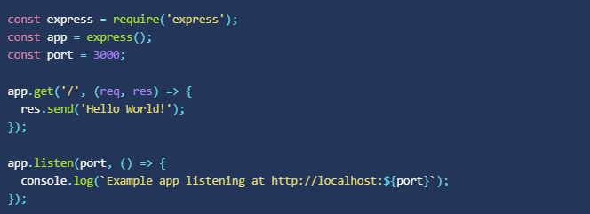
[F2]
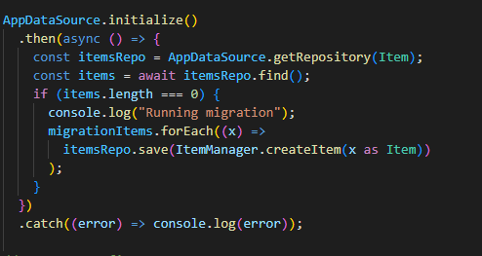
[F3]
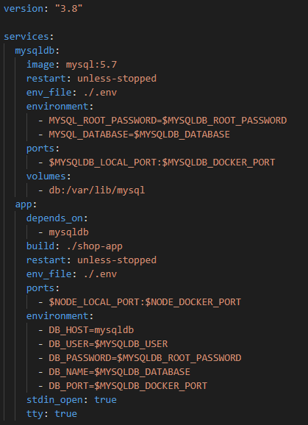
[F4]
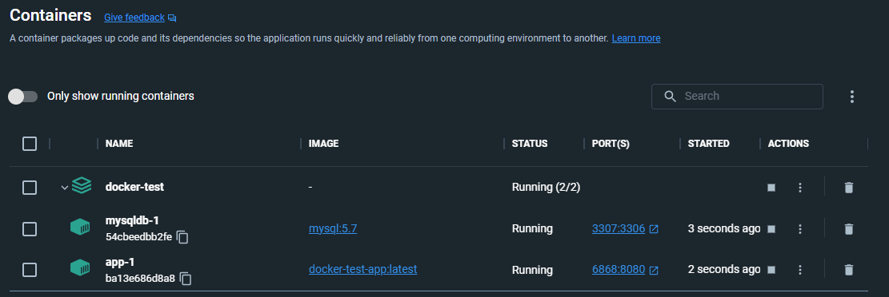

Presentation
https://youtu.be/zeDGQ2TmT4Q

