Certificate of Higher Education in Skills for The Workplace

Student Name: Ioana Andreea Dumitru

Student ID: 2025727

Module Code: BMSW4003

Lecturer Name: Md. Nazmul Hasan

DIGITAL SKILLS AND RESEARCH METHODS
Component 2

Table of Contents
Introduction 3
Mean median mode calculator from primary and secondary data set 3
GRIT calculations, and assumptions as per Angela Duckworth 5
The CRAAP test after doing a GRIT survey 7
DIKW model explanation 8
Relation of DIKW framework with primary and secondary research 9
Main findings 9
Conclusion 10
References 11

Introduction
The contemporary or the digital technologies that are used in workplaces are very much essential in order to collect important data, and it also plays other vital roles in the workplace. Smartphone or mobiles were luxury items for many people a decade ago. Nowadays digital technologies have become more advanced at an exponential rate. The mobiles have become the necessary gadgets for each and every person. Some organizations provide Smartphone or tablets to their employees in order to enhance their usage of digital technologies in their businesses. Evolving several new technologies in the workplaces is equivalent to finding various extensive applications in many aspects of the worldwide digital workplaces. Different new technologies play vital roles in the workplaces, such as artificial intelligence, the internet, virtual reality, and many more. These innovative technologies are helping in the world’s advancement and also deal with the modernization of the world rapidly.
Today’s workplaces are very much accustomed to the practices of buying several important digital tools for each and every business problem. This may seem like a progressive option for the company’s businesses, but if multiple digital tools are used in the business then a serious issue may arise if the functions of those tools overlap each other. For example, in a digital workplace the team that deals with the finances of the company, for invoicing processes using a specialized tool. In this tool, all the important expenses are kept organized and updated. Then after a few months, the sales team requires a proper system in order to track all the expenses that are incurred in order to acquire the customer. In that case, a new innovative tool can solve every problem of the sales team.

Mean median mode calculator from primary and secondary data set
The DIKW is an important model to understand technologies and also to improve workplace efficiency and employability. This model represents a process by a graphical representation of how the advancement and modernization of digital technologies are useful in the workplace. This specific model gives a detailed explanation of the procedure of how the data has been processed. The model also helps to identify the digital skills and to improve those skills in the workplace for the betterment of the company’s businesses. The GRIT score is the other very important feature in order to understand the level of improvement made by digital technologies in the workplace to increase the business processes of a company. A specific scientific technique is mainly used to calculate this GRIT score. The following table shows the GRIT score of primary data.
Mean | 3.8321428571429
Median | 3.9
Mode | 4,3.4
Table 1: GRIT score of primary data files
(Source: self-created)

Mean | 3.5413450292398
Median | 3.6
Mode | 3.8
(Source: self-created)
These 2 GRIT tables contain some data of the GRIT score that are very much important for understanding the level of improvement made by digital technologies in the workplace to increase the business processes of a company (Mantzou et al. 2018 p. 52). The GRIT score table contains 3 different scores that are self-created. Those 3 scores are, mean score, median score, and mode score. Here in the tables, all the calculated data are collected from a primary set of data and a secondary set of data.

Mean | 3.5714285714286
Median | 3
Mode | 4
Table 3: Highest academic levels of primary data files
(Source: self-created)
Mean | 3.2982456140351
Median | 3
Mode | 3
Table 4: Highest academic levels of secondary data files
(Source: self-created)
Both the GRIT tables contain many vital pieces of information regarding the new digital technologies improvement levels of primary and secondary data sets. After observing both the tables it can be stated that the primary set of data is better than the secondary data set. From these two GRIT tables above it has been found that the secondary data set of the improvement levels of the new technologies is less than the primary data set’s score.

GRIT calculations, and assumptions as per Angela Duckworth
The famous researcher and psychologist Angela Duckworth first provided the concept of the GRIT calculation in the year 2020. The main aim of proposing this GRIT concept is to help a person so that he or she can stick to their goals or to the subject for which the person has a passion. When one remains stuck towards their goals or passion it does not mean that person has an emotional attachment to that particular thing. It actually means that person is highly committed to that. Those commitments help the person to decide the direction that is correct or better in order to achieve the goal easily. Here the main attention is given to one’s directions, commitments, and goals as the GRIT theory or concept. This concept states that one should often stock their ambitions and goals in order to fulfill them even if one faces hurdles and suffers a lot in their way towards the goals or ambitions. For example, a person wants to fulfill his or her goal of achieving success in the creation of a new innovative digital technology that will serve the purpose of online business (Knox et al. 2020 p. 6). Then that person should remain stick to that goal and should apply several intelligent ideas to become successful in his or her life by achieving that goal. The person should also be very much talented in order to become successful in his or her plans. The GRIT theory of Angela Duckworth forces an individual in order to gain willpower and also to have the courage of fulfilling all the ambitions or goals. There is a belief that without a GRIT theory the values of one’s potential talents will remain incomplete.
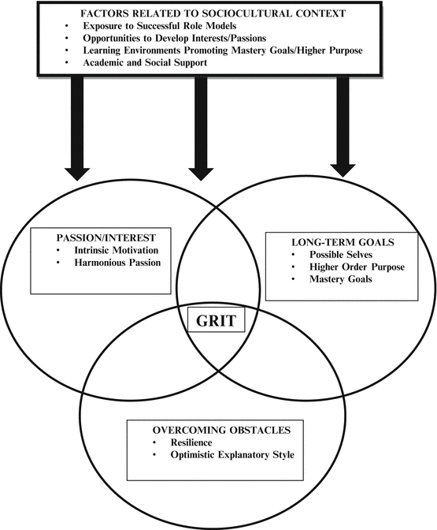
Figure 1: The GRIT assumptions
(Source: Fielding, 2019)
Several assumptions that are formed are based on this GRIT theory. This theory states that one should never rely on money too much in order to get success in life or in the workplace. According to this theory, money is not the obstacle in the pathway of one’s goals. Some people stop working hard and indulge themselves in a race with other competitors in their work fields for which they struggle a lot in their path of success. While considering life a race people often forget to improve the quality of their performances and hence their success rates fall. In order to develop skills and to achieve several goals one often forgets to give priority to their efforts, talents and also loses their self-beliefs and their self-confidence. The self-beliefs and the self-confidence of people are very much important to improve their work in their workplace. By calculating the average of perseverance and also the consistency average the GRIT score tables are created.

The CRAAP test after doing a GRIT survey
One of the famous evaluation methods is the CRAAP test. The acronym of the CRAAP test stands for “Currency, Relevance, Authority, Accuracy, and Purpose” (researchguides.ben.edu, 2021). The test actually provides one with a question list based on their project in order to evaluate all the data or information that has been extracted at the time of research. In order to check the legitimacy of the survey of GRIT, it is quite important to include this CRAAP test here (researchguides.njit.edu, 2021). Here the currency refers to the factors times and also to the daily updates of the data.
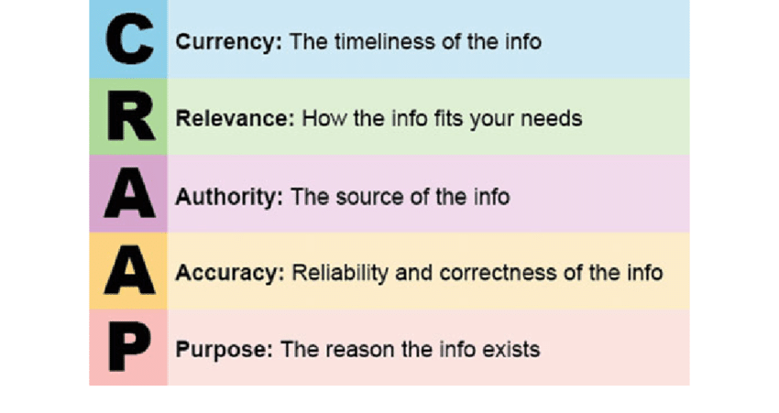
Figure 2: The CRAAP test
(Source: researchguides.njit.edu, 2021)
This GRIT survey never leaks any kind of vital information that is based on the daily updates of the data that are collected from the primary and the secondary data sets. The GRIT survey is done only on the target audiences in order to collect authentic data and information (Panicker et al. 2020 p. 1). Thai surveys are generally authentic in nature, as the information that is collected here is correct, relevant, trustworthy, and authentic. In order to analyze any findings based on the research, this survey is very much important for the members of the project.

DIKW model explanation
In the development of digital skills in order to create new contemporary or digital technologies this DIKW model is used by each and every professional (Teruel et al. 2021 p. 1).
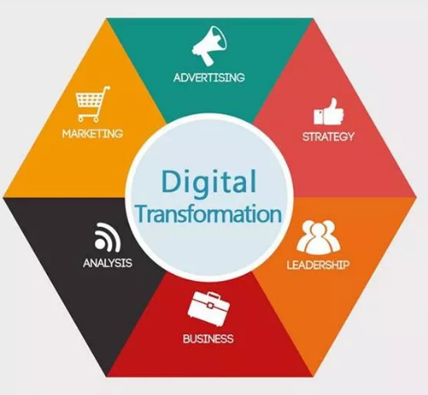
Figure 3: The wisdom of digital transformation.
(Source: Teruel et al. 2021 p. 1)
The knowledge, data, and information that are obtained from this DIKW model are valued by all hierarchies (Ardolino et al. 2018 p. 1). This model mainly stands for-
- Data: Here data has been identified in the form of several important and relevant images, words, number sets, tables, charts, and lists of personal or other official data;
- Information: The knowledge that is gained by communication with other employees in the workplace, studying the technical matter, making detailed research on the project, and providing important instructions regarding the project.
- Knowledge: Having proper knowledge about all the electronic tools, devices, resources, and systems that help to process and generate vital information.
- Wisdom: Digital technologies make people clever and also wiser. That is why the requirement of wisdom in digital technology is quite urgent and also very important. Wisdom always helps people to properly behave in this digital world.

As in this digital world, nothing is secret and everything remains open and accessible to each and everyone on the digital platform.

Relation of DIKW framework with primary and secondary research
The concept of the DIKW model has been analyzed in this research paper. This DIKW model actually consists of data, wisdom, knowledge, and information. The model actually helps in the management of several bits of knowledge in order to explain the ways by which the data can be aligned with different active components, wisdom, pieces of knowledge, and information. The project work of this paper is mainly based on this DIKW model. This model is basically a hierarchical model which depicts the connections among data, information, and knowledge. If the quantity of the collected data increases, the quantity of the knowledge and the information will also increase within a short period of time. The DIKW model or pyramid is mainly used to extract the data, ideas, and information from the roots of knowledge management. It explains why an individual has moved from data (“D”) to the information (“I”), then knowledge (“K”), and then to wisdom (“W‘) with the components of decisions and also the actions.

Main findings
In this research paper, the data on digital skills and the understanding of the new contemporary or digital technologies that are used to improve workplace efficiency and employability are collected from the primary and secondary datasets. The concept of the DIKW model has been analyzed in this research paper. This model represents a process by a graphical representation of how the advancement and modernization of digital technologies are useful in the workplace (Tungkasthan et al. 2019 p. 1). The model also helps to identify the digital skills and to improve those skills in the workplace for the betterment of the company’s businesses. The GRIT score is the other very important feature in order to understand the level of improvement made by digital technologies in the workplace to increase the business processes of a company. The GRIT score table contains 3 different scores that are self-created. Those 3 scores are, mean score, median score, and mode score. From the primary data set, we found: Mean- 3.8321428571429, Median- 3.9, and Mode- 4, 3.4. From the secondary data set, we found: Mean-3.5413450292398, Median- 3.6, and Mode-3.8. Then the CRAAP test has been done with respect to the GRIT survey in order to check the legitimacy of the work done in the business project of the company (guides.emich.edu, 2021). This GRIT survey contains all vital information that is based on the daily updates of the data that are collected from the primary and the secondary data sets.

Conclusion
To conclude it can be stated that the DIKW model helps to represent a process by a graphical representation of how the advancement and modernization of digital technologies are useful in the workplace. The model also helps to identify the digital skills and to improve those skills in the workplace for the betterment of the company’s businesses. It actually helps in the management of several bits of knowledge in order to explain the ways by which the data can be aligned with different active components, wisdom, pieces of knowledge, and information. The GRIT score is the other very important feature in order to understand the level of improvement made by digital technologies in the workplace to increase the business processes of a company. A specific scientific technique is mainly used to calculate this GRIT score.

References
Ardolino, M., Rapaccini, M., Saccani, N., Gaiardelli, P., Crespi, G. and Ruggeri, C., 2018. The role of digital technologies for the service transformation of industrial companies. International Journal of Production Research, 56(6), pp.2116-2132.
Barber, W., van Oostveen, R. and Childs, E., 2019, November. Situating Resilience, Grit and Growth Mindset as Constructs of Social Presence in the Fully Online Learning Community Model (FOLC). In ECEL 2019 18th European Conference on e-Learning (p. 65). Academic Conferences and publishing limited.
guides.emich.edu,2021. “CRAAP Test for Evaluation”. Available at: https://guides.emich.edu/craap/accuracy [Accessed on November 10, 2021]
Haiyang, Z., Lei, Y. and Yucong, D., 2021, September. Service Recommendation based on Smart Contract and DIKW. In 2021 IEEE World Congress on Services (SERVICES) (pp. 54-59). IEEE.
Knox, J., Williamson, B., and Bayne, S., 2020. Machine behaviorism: future visions of ‘learnification’and ‘datafication’across humans and digital technologies. Learning, Media and Technology, 45(1), pp.31-45.
Mantzou, P. and Bitsikas, X., 2018. GRIT PALIMPSEST. In CIRA@ EuroMed (pp. 51-59).
Panicker, P., 2020. Embedding Culture and Grit in the Technology Acceptance Model (TAM) for Higher Education. arXiv preprint arXiv:2005.11973.
researchguides.ben.edu,2021. “Evaluating Sources: The CRAAP Test”. Available at: https://researchguides.ben.edu/source-evaluation [Accessed on November 11, 2021]
researchguides.njit.edu, 2021. “How to Evaluate Information Sources: CRAAP Test”. Available at: https://researchguides.njit.edu/evaluate/CRAAP [Accessed on November 10, 2021]
Teruel, M., Coad, A., Domnick, C., Flachenecker, F., Harasztosi, P., Janiri, M.L. and Pal, R., 2021. The birth of new HGEs: internationalization through new digital technologies. The Journal of Technology Transfer, pp.1-42.
Tungkasthan, A., Poompuang, P. and Intarasema, S., 2019, November. Government data-sharing framework based on DIKW hierarchy model. In 2019 17th International Conference on ICT and Knowledge Engineering (ICT&KE) (pp. 1-4). IEEE.

