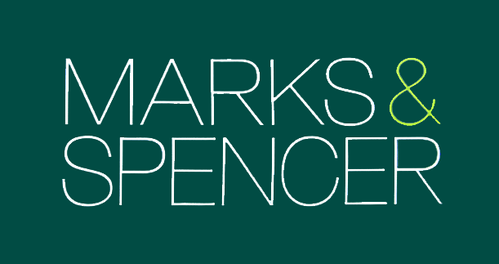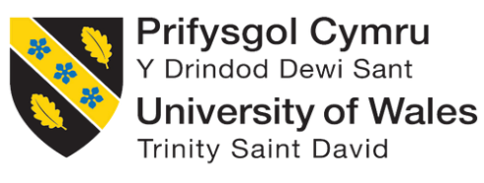

Plan A at Marks and Spencer- Does it deliver on CRM?
Understanding and engaging in the customer experience.
BMSW5103

Report was compiled by
student: Zilvinas Miksys (1815997) Date:17/03/21
Table of Contents
1.0 Introduction: 2
2.0 Findings: 2
2.2. CRM- Benefits and disadvantages of a CRM system: 4
Advantages: 5
Disadvantages: 6
2.2.1 The process used by Marks and Spencer for CRM 7
Touchpoints: 8
Investigating the customer relationship experience of Marks and Spencer and Tesco based on Ethical Policy: 11
2.4 Sustainability: 13
Identifying the policy used by M&S and Tesco in their organization: 15
Ethical and sustainable good behavior by M&S many impacts on the CRM of M&S 16
Variety of quality and models, and theories that uses improving its CRM 18
Comparison 21
2.6 Segmentation: 21
Marketing mix: 23
Loyalty ladder to maintain CRM: 25
3.0 Conclusion: 26
4.0 Recommendations: 27
References: 28

Introduction:

As the marketing research department, the CEO of the M&S company requested for undertaking the overall research and presented a report about the whole. Customer relationship management (CRM) helps the business or organizations gain insight into each customer's behavior and modify the business's operations to serve better to the consumers. This assignment's chosen organization is Marks and Spencer, who are fuses for CRM and successfully massage it by offering the customer their own-label foods and own-brand services. In this assignment, the discussion is on the CRM's advantages and disadvantages and the concept of quality, ethics, and stability in Tesco. It is one of the biggest retail companies based in the UK market, known for its sustainability and ethics. The discussion is on quality models, and by using this, M&S gets which advantages (Toms and Zhang, 2016, pp.3-30). For this, some secondary research was done to gain the variables of knowledge about the concepts and their uses in the Tesco and M&S company.

Findings:
2.1 Introduction to organization
M&S is the multinational retailer company of British that is headquartered in London in England. The company specializes in selling home products, clothing, and food products marked by its label. The organization was founded in 1884, and the founders of this company are Thomas Spencer and Michael Marks. The critical people of this organization are Archie Norman, the company's chairman, and Steve Rowe is the company's Chief Executive. The total revenue of this company is €10,181.9 million in the year 2020. The company has a massive number of employees that is about 80,000. The company's primary stakeholders are suppliers, customers, owners, and the employees of the company. The company's name is listed on London's stock exchange, and there are 650 stores. It is spread around 29 countries (Scandelius and Cohen, 2016, pp.3487-3499). The company maintains its high-profile campaign of the media for marketing and to maintain customer relationship management. The company’s market share is about 3.1% in the UK market and in the other international markets with a net income of €27.4 million in the year 2020 that stated that with their market share, they are running with the profit margin.
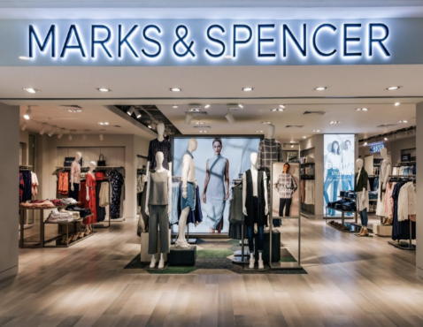
Figure: Marks & Spencer Company
(Source: Scandelius and Cohen, 2016, pp.3487-3499)

2.2. CRM- Benefits and disadvantages of a CRM system:

‘Customer Relationship Management (CRM) is an IT-enhanced value process, which identifies, mature, combines, and focuses the various capabilities of the organization to the customer’s opinion to deliver long term exceptional customer value, at a profit, to well-known existing and future customer segments.’, according to Starky, Woodcock in the year 2000.
Customer Relationship Management is the procedures for which the organization or the business mainly focuses on customer interaction. This is based primarily on the analysis of data and also the extensive information about them. These CRM channels include the company's telephone, website, live chat, email, and marketing materials. Most of the companies in recent times use social media platforms. This system helps the company learn about the organization's target audiences and cater to valuable e customers' requirements. This system is effective in driving sales and retaining customers for the growth of the business.
This customer relationship management system is used with the present, past, and potential customers (Jin et al., 2018, pp.15-23). The types of this system are divided into some parts. They are strategic, operational, analytical, collaborative, and the customer data platform for assembling various data about the organizations’ associated customers and targeting new audiences.
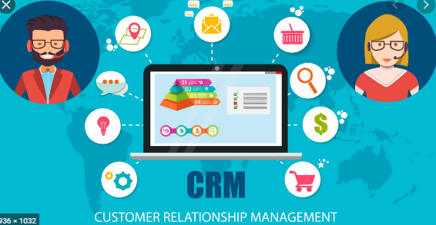
Figure: CRM System
(Source: Jin et al., 2018, pp.15-23)

Advantages:
This CRM system is mainly integrated within the software system, facilitating organization, collection, and customer management. This system is also very beneficial for large and small-scale businesses for Marks & Spencer if implemented in the company appropriately. They are such as-
- It gives the organization enhanced and better services for customers and adds a personal touch for the existing relationships among the customers and business.
- It is also helpful to facilitate the overall discovery of the target and new customers that enhance business growth and adds some prospects to the company.
- It is also relevant for increasing the customers' revenues and promotes the business and organizations products and services (Talay et al., 2019, pp.81-98).
- This system helps simplify the marketing and sales procedure of this company. Moreover, for making the existing customers of the organization more effective and efficient towards the organization.
- It helps enhance the customer experience by the allowance of the improved resolution of queries and personalization.
- Customers get better satisfaction doing business with the company.
- The consumers get better help in good communication, and the relationship makes loyalty between the company and the consumers.

Disadvantages:
There are variables of disadvantages present of this customer relationship management besides its advantages. They are:
- Most of the time, the customer's experiences might disprove because of the staff or the employee's over-reliance upon this system.
- The data and security protection issues are regarding this customer relationship management system by the centralized data (Di Bona et al., 2020, p.4949).
- The initial and time productivity for the implementation cost of this system.
- The system requires a procedure organization for driving the sales, but in the meanwhile, this is not possible all the time to keep this system.
- This system has crucial disadvantages. This system of CRM is not suited to all kinds of business.
- The experiences of the customer might be improved for the staffs’ system on the over-reliance.
- Sometimes the personal consumer data is at risk as CRM is now maintained through software and AIS.
- Sometimes consumers don't need assistance, but the continuous service makes them cautious and restricted in a few areas.

2.2.1 The process used by Marks and Spencer for CRM
M&S is mainly conducting for the implementation of the post by the various software involved with this customer relationship management. For their overall growth and other concern for marketing and target audiences, the company uses this customer relationship management system's variables. It helps the company M&S for customer retention; it allows the company to maintain the cloud-based data. The techniques which the company uses for the process of CRM are:
- The predictive analytics of this CRM is for the customer's behaviours on their purchasing (Büyüközkan et al., 2017, pp.194-206).
- They use CRM as the company's marketing or social well-informed technique or tool. This technique is aware of the market based on the peoples that help this company's overall growth.
- They focus on the five stages of this system within the company M&S such as customer acquisition, the potential consumer, conversion, customer loyalty, and customer retention.
- They are working for evaluating the company or brand's awareness among the domestic or international customers of theirs.

Touchpoints:
The Touchpoints are defined by the customer's way of interaction with the overall business. The process can be started by person-to-person interaction, through any app or website, and other forms. The Touchpoints help give the business or the company opportunity for comparison with the different valuable perceptions of the business or the organization (Prisacariu and Shah, 2016, pp.152-166). This system or the process of Touchpoints allows the consumers to have the best experiences every time they are engaging in touching the parts of any service, product, organization, or Touchpoints of the brand.
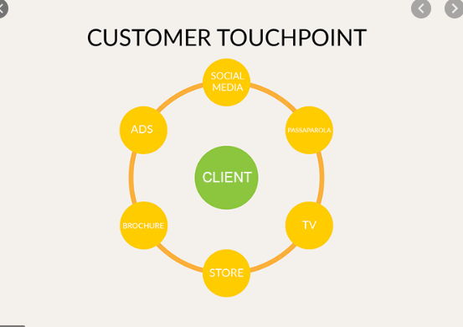
Figure: Touchpoints
(Source: Prisacariu and Shah, 2016, pp.152-166)

Trust/Satisfaction/Loyalty
The protection Touchpoints are very useful for any organization, such as Marks & Spencer, for building up the customer's trust, satisfaction, and loyalty level towards the company. The Touchpoints are mostly the understanding of the customer's overall journey from purchasing any products or services to the user of the thing. It helps this company to understand the expectations and requirements of the customers properly. Moreover, by getting all the sufficient information about the customers, they can provide the products and services that are the primary expectation of Marks & Spencer. It helps enhance the customer's level of trust, satisfaction, and loyalty and maintain customer relationship management (Dumford and Miller, 2018, pp.452-465). The touchpoints for the company M&S uses for increasing the level of customer satisfaction by analyzing their overall journey from purchasing the thing and to use them. The Best touchpoints of this company are associated with online platforms, and by fulfilling the customers' requirements and expectations, the company can quickly increase the customer’s satisfaction level.

2.3 Ethics:

Ethics is the backbone of society. Ethics play a significant role in society because it arises from the conscience or a sense to determine right and wrong, according to Pettifor & Jean in 1996. The ethics or the concept of moral philosophy is the philosophy brand that involves systemizing, recommending, and defending ideas of wrong and right behaviour (Prisacariu and Shah, 2016, pp.152-166). The ethics field includes concern and the matter for the value, aesthetics, and the effectiveness of evil and good, wrong and right, vice and virtue, crime and justice, etc.
Critically described: According to the author Prisacariu and Shah, the concept of ethics within the business context is fasting to implement reasonable business practices and policies supporting business morals. The organizational statements, individuals, and legal systems originate these business ethics and the values, norms, unethical practices, and ethical practices for successfully guiding the overall business (Nygaard et al., 2017, pp.133-139). On the contrary, the author Nygaard the business's practical ethics suggests or refers to the contemporary standards of organization, principles, norms, and values governing its business's behaviour and actions. In the organization or the business context, the manager's role is to maintain the overall ethical status for the business growth and maintain the CRM. But most of the time, this is not practical or ideal for small-scale businesses. These ethics in the organization or the business context help provide significant competitive advantages for its valuable customers.
- It is also helpful for improving the customers' overall happiness to purchase its services and products and their satisfaction.
- If a company keeps its effects on the overall business, this will help attract more crucial investors.
- Maintaining a higher standard of ethics within the organization can enhance the customer's satisfaction level towards the company.
- It is also better for sustainability and environmentally friendly, suitable for society (Hasnin et al., 2017, pp.23-43).
- The disadvantages of business ethics areas this works for limited its capability to maximize the overall profit margin.
- It is also very time-consuming for its application or implementation for business practices.
- Not ideal or practical for small-scale businesses.
- It is dangerous for the customers as the companies are sometimes building up their ethics many false expectations for the consumers.
- The other factor of this business ethics concept is its instability (Moore et al., 2017, pp.1-8).

Investigating the customer relationship experience of Marks and Spencer and Tesco based on Ethical Policy:
Tesco:
The company Tesco is concerned about being ethical in the business perspective to maintain customer relationship management; they face many issues. For being ethical in every part of their work, they maintain a very enhanced supply chain with their suppliers and the customers and the involvement in sustainability and works better for society. They mainly focus on the ethical policies in their company context for serving better for their customers and the community. The company has the pillars of respect, responsibility, trustworthiness, fairness, and caring for each of the products and services regarding the distribution network. This company's ethical policies reflect Tesco company's controls, values, and the procedures of their fetch on underbelly with the employees and externally with the customers. It gives the company an advantage for maintaining customer relationship management (Bhattacharya and Polman, 2017, p.71).
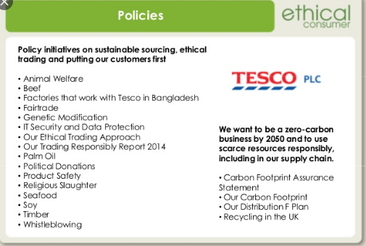
Figure: Ethical policies in Tesco
(Source: Bhattacharya and Polman, 2017, p.71)
Marks & Spencer:
The company Marks & Spencer uses various features for being ethical in every part. This Plan A uses and fulfils its commitments to address social and environmental issues around the world. For this planet's concern, they also use materials or eco-friendly products. They maintain the relationship with their customers by applying various ethical policies upon the marketing strategies regarding the social media platform through apps and other websites to provide the best services and products and maintain a good relationship with them. For their labor treatment, the company maintains a good relationship with the employees and provides them with the required salary to support their ethical virtues (Martelli et al., 2016, pp.1485-1500).

Both companies' ethics gives long-term running and offers competitive advantages for gaining more productivity. For the ethical approach, the company Tesco focuses on the ethical policies in their company context for serving better for its customers and society. On the other hand, M&S company maintains the relationship with their customers by applying various ethical policies upon the marketing strategies regarding the social media platform through apps and other websites to provide the best of the services and products and maintain a good relationship with them. For the overall discussion, these two companies are giving similar ethical policies to be sustainable.

2.4 Sustainability:

Sustainable development meets the needs of the present without compromising the ability of future generations to meet their own needs. Economists generally accepted and supported Brundtland’s definition of sustainable development., according to Brundtland, in 1987. The concept of sustainability means or describes that to meet the requirements but not compromise with future generations' capability to meet their future needs. It is the composition of the three crucial pillars. They are social, environmental, and economical for informally as a planet, profits, and people. Sustainability in the business context is known for maintaining corporate sustainability to coordinate and manage the financial, social, and environmental concerns and demands for making a sure ethical, responsible and ongoing success of the business. The concept of sustainability is a concern not only for the environmentalist. It is in the company's context for maintaining the business strategies regarding environmental degradation (Righolt et al., 2020, pp.102-106).

Benefits:
- The significant impact of the sustainability factor in the business context helps improve its image and get many competitive advantages.
- It helps increase the organization’s overall productivity and reduce the company's operational management.
- This is also relevant for increasing the business's ability to complete the laws and regulations of business.
- Crucial for reducing the overall waste and reworking for using the new procedures for uses of the fewer materials in the feature of production and less waste to make goods (Aksnes et al., 2019, p.2158244019829575).
- Sustainability is also effective for making the shareholders and stakeholders of the company happy.
- This is the biggest concern for society and the whole planet, so adapting this term can give customers satisfaction for purchasing things.
Disadvantage:
- Water, air pollution, spreading of the various diseases between the people mainly by the suitability by the discharges of the multiple kinds of waste.
- The process of sustainability is challenging to manage and take the persons' efforts associated with it.
- This procedure of instability is, most of the time, costly to maintain.
- The sustainability factor is very high cost with its upfront. It also needs a very high element of motivation to stay within this.
- AS the sustainability process is costly, so the companies set the price of the products and services high to adjust with the cost of their sustainability, which is a disadvantage for the customer to buy them.
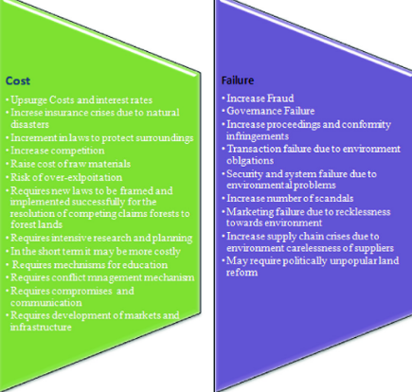
Figure: Sustainability Advantages and Disadvantages
(Source: Aksnes et al., 2019, p.2158244019829575)

Identifying the policy used by M&S and Tesco in their organization:
Tesco: The company Tesco for its environmental sustainability, uses the variables of policies and strategies such as- they are focused on reducing their footprint of carbon from direct use (Behmel et al., 2016, pp.1312-1329). They are also working with the partners and supply chains for reducing the emissions of carbon. They are too focused on leading towards the revolution for the consumption of green. They are using wind turbines, heat pumps associated with the ground source, low carbon energy, photovoltaic cells to power the tills, collection of the rainwater for various uses, and the recycled materials for making the changing of the products. Marks and Spencer: The Marks & Spencer company makes Plan A for building up the concern of sustainability for the need of the future being and the business to fetch positive impact on the customers' overall well-being. They also maintain the matter of fashion via the instability process. They are again finding innovative and new ways of reducing plastic and making plans for using alternate things. Plan A of this company for trading ethically, reducing the waste and other harmful substances to the environment (Dibb, 2017, pp. 41-59).

Ethical and sustainable good behavior by M&S many impacts on the CRM of M&S
To maintain good customer relationship management, the company uses various ethical and sustainable features in every part. The company's ethics and sustainability behaviour effectively attract customers towards the company and maintains a good relationship among society. This is also relevant for associating with customer relationship management's main factors. The customers want the company's best approaches and by some sustainable criteria required by the company to focus on. The ethics and sustainability from the aspect of business are most demanding on the point of view of the customer to purchase the things again and again from that particular company that gives them trust, satisfaction, and loyalty towards the company M&S. These two factors are giving the company some competitive advancement from comparing with the competitors for gaining the best relationship with the customer for a long-term basis (Force and Richelle, 2016, pp.87-93).
The company is concerned for its maintenance of the concern of fashion via the instability process. These processes of ethics and sustainability are also helpful for this company to attract new customers. They are again finding innovative and new ways of reducing plastic use and making a plan for using alternate things. It helps the company maintain customer relationship management and take the business's growth very high.
2.5 Quality:
Quality means “consistent conformance to customers’ expectations”, according to Afferson and Beach in 2009.
In the context of business, the concept of quality has a very pragmatic kind of interpretation as superiority and non-superiority of something (Scott and Walker, 2017, pp.179-201). The quality is the conditional, perceptual, and the thing with the subjective kind of attributes for understanding the different things by the various or other people. It is the business's primary idea, which helps business professors with the items or the services by involving the procedures, processes, personnel, equipment, and investments. This is a more complicated kind of term, which is the primary thing for receiving the jinxed services and responses from the customers relevant to its growth and giving them the required practitioner based on its quality. The customers of the organizations or companies are looking for enhanced quality for purchasing the things. It is also not any kind of action but a kind of "Habit".

Quality Control:
It is the procedure by which the overall business is seeking to ensure that the quality of the product is improved and maintained. This quality control process involves trusting determining and units if all the final products have the specifications.

Quality Assurance:
It is the way that works for preventing defects and mistakes in avoiding problems and manufactured products when delivering services and products to the consumers. Quality assurance mainly comprises procedural and administrative activities for implementing them within the quality system.

Variety of quality and models, and theories that uses improving its CRM
QMS models: This is the set of the business procedures that are mainly implemented for helping the company to deliver the services or products for achieving the level of customer satisfaction (Umbara and Ariyanti, 2016, pp. 118-125). The nine core components of a Quality Management System are Quality objectives, Quality manual, Organization responsibilities and structures, Data management, Processes, Customer level of satisfaction by the quality of the product, continuous improvement, quality instruments, and document control.
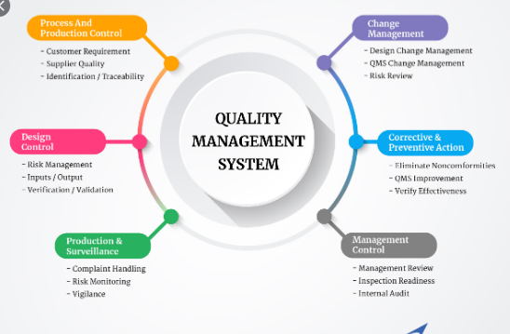
Figure: Quality Management System
(Source: Umbara and Ariyanti,, 2016, pp. 118-125)

PDCA Model:
This is the continuous and effective loop of doing, planning, acting, and checking. It helps to provide effective and straightforward approaches to resolving problems and also to manage overall changes. This is also relevant for updating working practices and procedures.
TQM:
It is probably based on the philosophy of management and business, which help maintain CRM. This model's target is the employees' commitment to giving them total quality (Toms and Zhang, 2016, pp.3-30).
BSC:
This is the model known as the Balanced Scorecard model. This model is mainly based on the target setting and measures the overall achievement in four main areas. They are such as-
- Profitability-financial
- Long term relationship-customer perspective
- Productivity-internal view
- Creative teams-innovation.
This is reluctant for achieving the quality and is to maintain the company CRM system
Quality monitoring:
The term quality monitoring is the procedure by which the business's cells make sure that the product's quality is improved or maintained. It monitors the status of the process, system, and activity. It is the process of testing finished services or products. The issues regarding the quality such as inspection and lower costs, long-term relationship, prevention of failure and variation all the subjects are most required proper monitoring or observation for improving the operation process and maintaining CRM
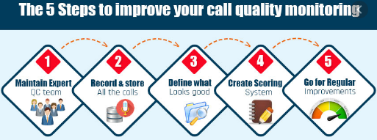
Figure: Quality Monitoring
(Source: Toms and Zhang, 2016, pp.3-30)

Comparison
All the above-discussed models of the quality are relevant for the business's growth, for increasing market share and brand awareness. They also help maintain customer relationship management (Scandelius and Cohen, 2016; pp., 3487-3499). All the models are different from each other by their services and the results that differ most of the time. The company M&S is using a variety of models and are getting success in their customer relationship management. However, they have to focus on implementing more models over the above section to demonstrate the overall knowledge about quality management and measure the variety of links associated with the customer relationship management of this company's growth. The models are different from various perspectives. They have various characteristics for ensuring quality and maintaining the various aspects of the costumes (Jin et al., 2018, pp.15-23).
The company Marks and Spencer undertakes the quality monitoring for the support purpose of the CRM, gives them the power to observe the characteristics of monitoring, and get some competitive advantages for maintaining customer relationship management. It makes the norm's quality characteristics and gives this organization some enchanted and effective ideas for evaluation in the customer experience format. The quality of products from M & M & M&S the customer can improve their satisfaction level and increase the loyalty factor.

2.6 Segmentation:
Market segmentation:
Marks and Spencer use mostly Segmentation based on demographics for selecting the company's target markets for the company variables of products. The company's focus for the customers is different age groups, social class, income, and occupation (Talay et al., 2019, pp.81-98). The company focuses on the mainly middle-class people-oriented market to deliver its products and services with these types of needs for its market share. This process helps them meet the customer's requirements by this demographic Segmentation, and they make their products as per the requirement. It helps this company understand the consumers and the areas for improvement by concentrating on its satisfaction factor.
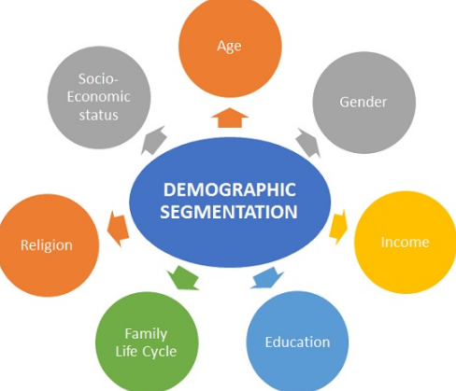
Figure: Demographic Segmentation
(Source: Talay et al., 2019, pp.81-98)
Targeting Audiences:
The target audiences of this company M&S selected by its demographic Segmentation, and the age group for this company to target their audiences are 30+ people. They are the people with executive occupation and high income by their business's ethical structure and running successfully (Di Bona et al., 2020, p.4949). However, the company has to be focused on the target audiences that can resize the company's threats and enhance opportunities for building up the CRM and growth of its business.

Marketing mix:

Product:
The company's products for selling are apparel for kids, women, and men. They also have accessories, footwear, lingerie, formal wear, school uniform for kids, skincare products, hair care, toiletries, and make-up products. The company sells home products and furniture, wine, food, flowers, and others.
Price:
The company posted that its net income and revenue in the year 2017 is about 115.7milion and 10,622.0 million. They give 100 % value for the money. They use the policy of dynamic pricing.
Place:
The company M&S spread it all over the market in the global market: Egypt, Finland, Ireland, Germany, Kabul, Canada, Belgium, Austria, China (Büyüközkan et al., 2017, pp.194-206). They have their overseas offices in India, Bangladesh, Sri Lanka, Thailand, Turkey, and other places.
Promotion:
They use a variety of channels for promotional activities. They use print, visual, and digital mediums. The ads of the products are placed in newspapers, magazines, television, and radio. The various social media platforms use top offer and discount strategies and events for attracting customers towards their brand.
Physician Evidence: The physical evidence of the company M&S is both in the stores and online to connect with the domestic and international market people.
People: The people are mainly from the UK market, and other than that, the people from Egypt, Finland, Kabul, Canada, Belgium, Austria, China, Turkey, Germany, Bangladesh, Sri Lanka, India, Turkey, and others.
Process: The process of the marketing mixes in both the stores and online marketing the customers choose their required products then purchase from the stores. Moreover, for online marketing, they place the order, and the company's executive or employees deliver the things in the scheduled time (Prisacariu and Shah, 2016, pp.152-166).
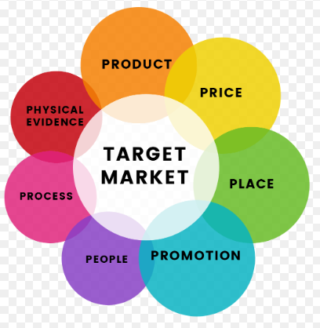
Figure: Marketing Mix 7Ps
(Source: Prisacariu and Shah, 2016, pp.152-166)

The use of the effective marketing mix of 7Ps for the company M&S can be relevant for establishing the long-term relationship of the customers and also to take them up in the steps of the loyalty ladder. The five stages of this loyalty ladder can be easily fulfilled by the marketing mix that is the prospect, customers, clients, supporters and the advocate.

Loyalty ladder to maintain CRM:
The loyalty ladder is the marketing relationship concept that sees the consumers gradually moving up by relationship levels. Its four effective matrices define this loyalty ladder: prospect, customer, client, and advocate. It is related to customer relationship management, which helps maintain and enhance this system to increase its market share, business growth, and other perspectives. To build up the loyal base for the consumers, the company's organizations use the seven effective and crucial categories. They are such as-
- Suspect
- Prospects
- Customers
- Clients
- Members
- Advocate
- Evangelist
These seven categories of this loyalty ladder help the company M&S for identifying their most potential consumers who are influential for remaining with the business for a very long-time period and become loyal to the organization (Dumford and Miller, 2018, pp.452-465). This is undertaken under the brand management and relationship marketing for the company to deal with the customers and build up the long-term relationship with them by making the various approaches and handling them profitable for business and maintaining and enhancing the customer relationship management system M&S company.
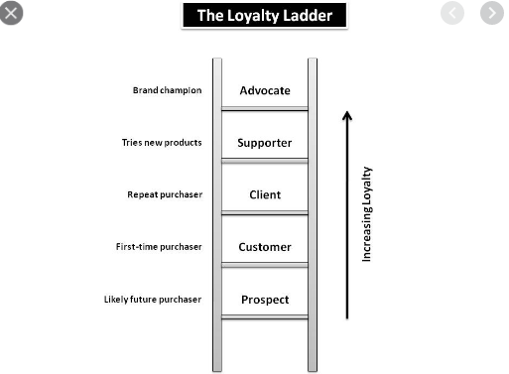
Figure: Loyalty Ladder
(Source: Dumford and Miller, 2018, pp.452-465)

3.0 Conclusion:
The overall research on the various aspects regarding customer relationship management is forced in this assignment. The organization chooses for this discussion, Marks and Spencer evaluates all the other forms like ethics, sustainability, quality, and Segmentation relevant to maintaining the organization’s CRM system. The CRM in this company can support the various models associated with quality. The quality monitoring purpose gave them competitive advantages for business growth and increased customer loyalty and satisfaction. The company works for the different things that support the CRM, such as proper market segmentation, focus on the target audiences and their marketing mix for the promotional activity, and effectively focus on the Touchpoints for ensuring and understanding the journey of consumers and can quickly identify the areas for improvement. The company M&S, in most of their things, lacked the proper CRM system and are not using the touchpoints properly to secure the customers' satisfaction level. The sustainability concept and business ethics for the better management of customer relationships.

4.0 Recommendations:
The company Marks and Spencer can utilize and enhance the CRM system by using the below discussion recommendation. They are such as-
- Making the CRM software in the company Marks and Spencer easy for use by the internal employees and customers. The company can follow the customers on the social media platform by giving various offers and keeping in touch with the customers' Touchpoints.
- Providing all the employees acquired with M&S proper training about this CRM system can give some more competitive advantages for their business growth.
- Also, adapting the various models skewed with quality models and quality monitoring can give the company some characteristics to enhance its quality and maintain the ethics and sustainability for ensuring CRM.
- Maintaining the proper Segmentation of the market, the target market, and the marketing mix by adding some new product lines and mainly focusing on the promotional activity can give M&S some advantages for the enhancement of the CRM system.

References:
Aksnes, D.W., Langfeldt, L. and Wouters, P., 2019. Citations, citation indicators, and research quality: An overview of basic concepts and theories. Sage Open, 9(1), p.2158244019829575.
Behmel, S., Damour, M., Ludwig, R. and Rodriguez, M.J., 2016. Water quality monitoring strategies—A review and future perspectives. Science of the Total Environment, 571, pp.1312-1329.
Bhattacharya, C.B. and Polman, P., 2017. Sustainability lessons from the front lines. MIT Sloan Management Review, 58(2), p.71.
Büyüközkan, G., Güleryüz, S. and Karpak, B., 2017. A new combined IF-DEMATEL and IF-ANP approach for CRM partner evaluation. International Journal of Production Economics, 191, pp.194-206.
Di Bona, G., Forcina, A., Falcone, D. and Silvestri, L., 2020. Critical risks method (CRM): A new safety allocation approach for critical infrastructure. Sustainability, 12(12), p.4949.
Dibb, S., 2017. Changing times for social marketing segmentation. In Segmentation in social marketing (pp. 41-59). Springer, Singapore.
Dumford, A.D. and Miller, A.L., 2018. Online learning in higher education: exploring advantages and disadvantages for engagement. Journal of Computing in Higher Education, 30(3), pp.452-465.
Force, C.E.T. and Richelle, I., 2016. Opinion Statement ECJ-TF 2/2015 on the Decision of the European Court of Justice in European Commission v. United Kingdom ("Final Losses”) (Case C-172/13), Concerning the "Marks & Spencer Exception". European Taxation, (2016/2-3), pp.87-93.
Hasnin, N.E., Tanim, T.R. and Alam, K.M.S., 2017. A Study on Selected Firms of the Apparel Industry to Find Out the Motive Behind Firms to Exercise Corporate Social Responsibility–‘To Buy Goodwill'or 'Out of Good Intention. Australian Academy of Accounting and Finance Review, 2(1), pp.23-43.
Jin, H., Miao, Y. and Park, S.T., 2018. A Case Study of Marks and Spencer lost China. Journal of Industrial Convergence, 16(2), pp.15-23.
Martelli, N., Serrano, C., van den Brink, H., Pineau, J., Prognon, P., Borget, I. and El Batti, S., 2016. Advantages and disadvantages of 3-dimensional printing in surgery: a systematic review. Surgery, 159(6), pp.1485-1500.
Moore, J.E., Mascarenhas, A., Bain, J. and Straus, S.E., 2017. Developing a comprehensive definition of sustainability. Implementation Science, 12(1), pp.1-8.
Nygaard, A., Biong, H., Silkoset, R. and Kidwell, R.E., 2017. Leading by example: Values-based strategy to install ethical conduct. Journal of Business Ethics, 145(1), pp.133-139.
Prisacariu, A. and Shah, M., 2016. Defining the quality of higher education around ethics and moral values. Quality in Higher education, 22(2), pp.152-166.
Righolt, A.J., Walji, M.F., Feine, J.S., Williams, D.M., Kalenderian, E. and Listl, S., 2020. An International Working definition for quality of oral healthcare. JDR Clinical & Translational Research, 5(2), pp.102-106.
Scandelius, C. and Cohen, G., 2016. Achieving collaboration with diverse stakeholders—The role of strategic ambiguity in CSR communication. Journal of Business Research, 69(9), pp.3487-3499.
Scott, P. and Walker, J.T., 2017. Barriers to 'industrialization for interwar British retailing? The case of Marks & Spencer Ltd. Business History, 59(2), pp.179-201.
Talay, M.B., Akdeniz, M.B., Obal, M. and Townsend, J.D., 2019. Stock Market Reactions to New Product Launches in International Markets: The Moderating Role of Culture. Journal of International Marketing, 27(4), pp.81-98.
Toms, S. and Zhang, Q., 2016. Marks & Spencer and the Decline of the British Textile Industry, 1950-2000. Business history review, 90(1), pp.3-30.
Umbara, T. and Ariyanti, M., 2016, March. The Effect Of Customer Relationship Management To Speedy/Indihome Customer Loyalty And Strategic Implementation In Telkom E-Service. In 3rd International Seminar and Conference on Learning Organization (pp. 118-125). Atlantis Press.

