APPENDIX GA36b
LEVEL 5 ASSESSMENT

Student Name: JENNATH FLORES |  |  |  | Student ID number: 2324516
Programme: | BA (Hons) Leadership and Management Skills for the Workplace
Module: |  |  |  |  | Organisational Culture
Module code: |  |  | LCLM 5006
Assignment Title: |  | Developing Emotional Intelligence Skills in Leadership
Module Leader: |  | Nishi Ramsurrun |  |  |  | Internal Verifier: | MD Kalam
 |  |  |  |  |  | Internal Verifier: | Samuel Ofori
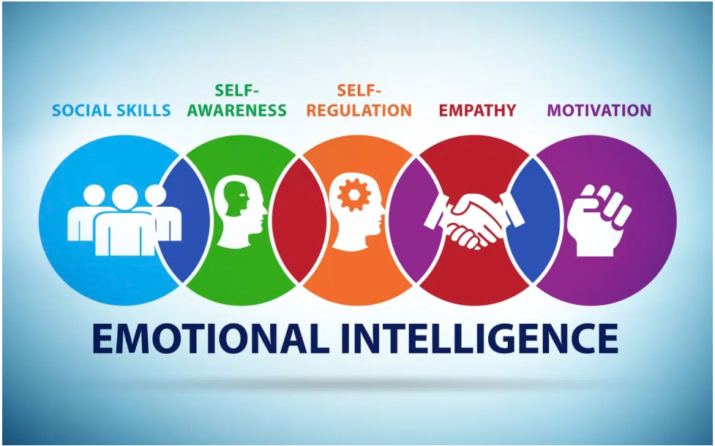

Executive Summary

This report examines the importance of Emotional Intelligence (EI) in leadership and caregiving within sheltered housing and other types of housing, particularly for caregivers managing multiple housing scheme environments. The capacity to understand and manage emotions, both one’s own and those of others, is a critical determinant of effective leadership, compassionate care, and team cohesion. Drawing upon theoretical frameworks by Goleman (1998) and Salovey & Mayer (1990), this report applies these models to real-world caregiving scenarios.

The report begins by defining Emotional Intelligence and examining leading theoretical models before analysing its relevance to leadership across different homes. It discusses practical approaches to developing EI in the workplace and provides a self-reflective analysis of personal EI competencies. Finally, an action plan is proposed to strengthen emotional awareness, empathy, and leadership across diverse care environments.

Developing EI among carers enhances residents’ wellbeing, supports cohesive teamwork, and nurtures a culture of respect, empathy, and professionalism. These skills are essential not only for managing daily challenges but also for maintaining high standards of resident care and safeguarding in an emotionally demanding sector.

Table of Contents
- Executive Summary……………………………………01
- Introduction……………………………………………..02
- Defining Emotional Intelligence………………………..04
- Theoretical Models of Emotional Intelligence…………06
- Emotional Intelligence and Leadership Across Different Sheltered Homes……………………………………………………..07
- Developing Emotional Intelligence in the Workplace….08
- Self-Reflection on Emotional Intelligence……………….09
- Action Plan for EI Development…………………………10
- Conclusion…………………………………………………11
- References………………………………………………….11

- Introduction

The role of carers in sheltered housing extends far beyond providing practical assistance. It involves emotional labour, leadership, and constant adaptability to residents’ needs, often in high-pressure and emotionally charged situations. Emotional Intelligence (EI) has become a cornerstone of effective leadership and caregiving, enabling carers to navigate interpersonal challenges with empathy, composure, and professionalism (Goleman, 1998).

Working across multiple sheltered housing schemes compounds these demands. Each home has its own culture, staff dynamics, and resident profiles, requiring carers to adjust their communication style and emotional responses accordingly. In one home, residents may need more medical or dementia-related support, while in another, social inclusion and mental well-being may be the main priorities. Leaders must therefore exercise high emotional awareness to adapt seamlessly between environments while ensuring consistency in care standards.

EI not only influences individual performance but also shapes organisational culture. Leaders with high EI create psychologically safe spaces where staff feel valued and residents feel respected. Conversely, a lack of EI can lead to miscommunication, staff burnout, and lower resident satisfaction. This report explores how EI can be harnessed and developed by carers in leadership positions across sheltered housing services, linking theoretical frameworks to real-world practice and reflective learning.

2. Defining Emotional Intelligence
Emotional Intelligence is broadly defined as the capacity to identify, understand, manage, and use emotions effectively (Salovey & Mayer, 1990.
(Goleman, 1998). Unlike cognitive intelligence (IQ), which measures analytical abilities, EI reflects how individuals manage emotions to influence thinking and behaviour.
For carers, EI is integral to maintaining professionalism and empathy in emotionally complex environments. The five core components of EI, as identified by Goleman (1998), are particularly relevant to caregiving and leadership:
- Self-Awareness – Recognising one’s emotions and their impact on behaviour and decision-making. For instance, a carer aware of their stress levels can take proactive steps to prevent emotional spill-over during resident interactions.
- Self-Regulation – Managing emotional impulses and maintaining composure under pressure. This helps carers respond calmly when residents become distressed or confrontational.
- Motivation – Maintaining a sense of purpose and commitment to quality care, even amid challenges such as staff shortages or emotionally draining situations.
- Empathy – Understanding and responding to the emotions of residents and colleagues. Empathy allows carers to perceive unspoken needs, such as loneliness or anxiety, particularly in vulnerable residents.
- Social Skills – Building and maintaining positive relationships with residents, families, and multidisciplinary teams. Strong social skills enable effective collaboration and resolution of conflicts.
These competencies form the emotional foundation for carers to deliver compassionate, person-centred care. When applied consistently, they enhance both resident satisfaction and staff morale.

3. Theoretical Models of Emotional Intelligence
The concept of EI has evolved through several key theoretical models that inform modern leadership and caregiving practices.
3.1 Salovey and Mayer’s Ability Model (1990)
Salovey and Mayer (1990) define EI as the ability to perceive, understand, and regulate emotions in oneself and others. Their four-branch model emphasises:
- Perceiving emotions – Recognising emotional cues through facial expressions and tone of voice.
- Using emotions – Applying emotions to facilitate cognitive processes such as decision-making.
- Understanding emotions – Interpreting emotional language and complex emotional transitions.
- Managing emotions – Regulating emotions in oneself and others to promote well-being.
In a sheltered housing context, this model aligns with carers’ daily interactions. For example, accurately perceiving subtle changes in a resident’s mood can help prevent escalation of distress, while managing one’s emotional response ensures calm and reassurance.
3.2 Goleman’s Mixed Model (1998)
Goleman expanded EI to include personal and social competencies. His framework is widely applied in organisational leadership, connecting emotional management to workplace success. In sheltered housing, this model emphasises:
- Personal competence – Self-awareness, self-regulation, and motivation that govern how carers manage themselves.
- Social competence – Empathy and social skills that determine how carers manage relationships. Goleman’s model links directly to leadership behaviours such as empathy-driven communication, conflict mediation, and team motivation, all essential within multi-disciplinary care settings.

3.3 Bar-On’s Emotional-Social Intelligence Model (1997)
Bar-On (1997) conceptualised EI as an interconnected set of emotional and social competencies influencing one’s ability to cope with environmental pressures. His Emotional Quotient Inventory (EQ-i) measures traits such as stress tolerance, interpersonal relationships, and impulse control, all crucial for carers working in emotionally taxing environments.
Together, these models highlight that EI is both learnable and measurable. Carers can enhance their EI through training, reflection, and feedback, translating theory into everyday professional practice.

4. Emotional Intelligence and Leadership Across Different Sheltered & Homes
Carers working across multiple housing schemes encounter diverse emotional landscapes and leadership demands. EI allows them to remain flexible and responsive while maintaining high care standards.
4.1 Adapting to Organisational Culture
Each sheltered home operates with its own routines, management structures, and resident demographics. A carer with strong EI can quickly assess and adapt to these differences without compromising consistency. For example, in one scheme, teamwork may be collaborative and informal, while in another, communication may follow stricter hierarchies. Emotionally intelligent leaders read these dynamics and adjust their style to maintain cohesion.
4.2 Understanding Resident Diversity
Residents’ needs vary widely, from those with physical disabilities to those experiencing cognitive decline or mental health challenges. Carers with high empathy tailor their communication and support accordingly. For instance, some residents may respond best to calm reassurance, while others value direct, confidence-inspiring communication. Recognising these emotional preferences is a hallmark of emotionally intelligent leadership.
4.3 Team Dynamics and Motivation
Carers frequently lead or support small teams of colleagues, some of whom may be temporary or newly trained. EI enables leaders to understand individual strengths and anxieties, fostering motivation and teamwork. When conflicts arise, such as disagreements over workload distribution, leaders with strong self-regulation and empathy can mediate fairly and constructively.
4.4 Managing Emotional Labour and Crises
Sheltered housing often involves managing emotionally intense situations, such as resident deaths, health emergencies, or family disputes. Leaders with developed EI manage their emotional labour effectively, offering support to others while maintaining their own well-being. For example, during an emergency, an emotionally intelligent carer remains composed, reassures staff, and communicates clearly with emergency services and families.
4.5 Applied Example
A carer working in Home A encounters a resident with dementia who becomes distressed when routines change. The caregiver uses gentle communication, maintains eye contact, and modulates tone to calm the resident. In Home B, another resident may exhibit frustration over mobility loss. The same carer uses empathetic listening and goal setting to empower them. Despite differing circumstances, EI allows consistency in compassion and professionalism.

5. Developing Emotional Intelligence in the Workplace
Developing EI is an ongoing process involving self-reflection, training, and environmental support. Organisations that invest in emotional competence development benefit from improved morale, reduced turnover, and enhanced resident satisfaction.
5.1 Reflective Practice
Reflective practice is a cornerstone of EI development. By analysing emotional responses after each shift or interaction, carers can identify triggers, strengths, and growth areas. Reflective journals or supervision sessions help translate experiences into learning. For example, after a tense exchange with a colleague, a carer might reflect on whether frustration stemmed from external stress rather than the colleague’s behaviour.

5.2 Training and Professional Development
Structured EI training, covering communication, conflict management, and stress regulation, can build emotional awareness and empathy. Training sessions can include role-play scenarios or mindfulness exercises to simulate emotionally charged environments.

5.3 Peer Mentoring and Coaching
Pairing experienced carers with newer staff fosters mutual learning. Mentorship encourages emotional openness, resilience, and reflective dialogue. Senior carers can model empathy and composure, demonstrating EI in action.
5.4 Feedback Mechanisms
Receiving feedback from colleagues, supervisors, and residents provides insight into how one’s emotions and actions affect others. Regular 360-degree feedback can highlight blind spots in emotional awareness and promote behavioural adjustment.
5.5 Mindfulness and Self-Care
Mindfulness and stress management techniques, such as breathing exercises or brief reflective pauses, help carers regulate emotions during high-pressure moments. Practising emotional detachment, when appropriate, protects carers from compassion fatigue while maintaining empathy.
5.6 Organisational Support
Leaders play a vital role in creating emotionally intelligent cultures. Open communication, recognition of staff achievements, and emotional supervision meetings help sustain high morale and EI growth across teams.

6. Self-Reflection on Emotional Intelligence
Self-reflection allows carers to assess their current EI competencies and identify development needs. Using tools such as the Emotional Quotient Inventory (Bar-On, 1997) or Goleman’s five-domain framework, carers can evaluate how emotions influence their leadership and interactions.
6.1 Recognising Emotional Triggers
Working across multiple homes exposes carers to varying stressors. Recognising triggers, such as last-minute schedule changes, resident aggression, or communication breakdowns, helps in developing coping strategies. For instance, acknowledging frustration rather than suppressing it allows healthier emotional regulation.

6.2 Strengths and Growth Areas
A reflective self-assessment might reveal strong empathy and communication with residents, but a need to improve patience with less experienced staff. Identifying such patterns guides targeted development efforts.

6.3 Learning from Emotional Mistakes
Emotional intelligence grows through experience. A carer who once reacted defensively to criticism might learn to view feedback as constructive input, improving self-regulation and openness.

6.4 Reflection Example
A carer reflects on an incident where a resident’s family expressed dissatisfaction over communication delays. Initially defensive, the carer later recognised the family’s anxiety and adjusted their communication to provide regular updates. This experience strengthened empathy, transparency, and relationship management skills.

7. Action Plan for EI Development
A structured action plan ensures sustained EI growth through clear, measurable goals.
Goal: | Actions | Timeframe | Success Indicators
Enhance self-awareness | Keep a reflective journal documenting emotional triggers and responses after each shift. | 0–3 months | Improved emotional clarity and calmer responses to stress.
Improve self-regulation | Attend stress management and mindfulness training. Practise deep breathing during high-pressure moments. | 0–6 months | Reduced emotional reactivity and improved focus.
Strengthen empathy | Participate in resident feedback sessions; shadow colleagues to observe different communication styles. | 3–9 months | Positive feedback from residents and colleagues.
Develop conflict resolution skills | Undertake mediation or communication skills training; role-play difficult conversations. | 6–12 months | More collaborative and solution-focused team interactions.
Promote emotional intelligence in teams | Lead monthly emotional well-being discussions; mentor junior staff in EI principles. | 12–24 months | Enhanced team morale and emotional culture across homes.
Regular supervision and annual appraisals should review progress, reinforcing accountability and continuous learning.

8. Conclusion
Emotional Intelligence is not merely an abstract concept; it is a practical leadership tool that transforms caregiving into a compassionate, adaptive practice. For carers working across multiple sheltered housing services, EI enables seamless adaptation to varied emotional climates, ensuring that every resident and colleague feels respected, understood, and supported.
Developing EI fosters better decision-making, reduces stress, and enhances teamwork. Organisations that prioritise EI create environments where emotional well-being complements operational excellence. Through reflective practice, structured training, and mentorship, carers can continually evolve as emotionally intelligent leaders who embody empathy, resilience, and professionalism.
Ultimately, EI development contributes not only to individual growth but also to the collective strength of sheltered housing services, ensuring that every interaction, policy, and act of care reflects dignity, understanding, and humanity.

References
Bar-On, R. (1997). Bar-On Emotional Quotient Inventory (EQ-i): Technical Manual. Toronto: Multi-Health Systems.
Cherniss, C. (2010) ‘Emotional intelligence: Toward clarification of a concept’, Industrial and Organisational Psychology, 3(2), pp.110–126.
Cooper, R.K. and Sawaf, A. (1997) Executive EQ: Emotional Intelligence in Leadership and Organisations. New York: Grosset/Putnam.
Goleman, D. (1998). Working with Emotional Intelligence. New York: Bantam Books.
Mayer, J.D., Salovey, P. and Caruso, D.R. (2004) ‘Emotional Intelligence: Theory, Findings, and Implications’, Psychological Inquiry, 15(3), pp.197–215.
Salovey, P. and Mayer, J.D. (1990) ‘Emotional Intelligence’, Imagination, Cognition and Personality, 9(3), pp.185–211.

Word Count: 3,115 words

