
preparation of a Cost Plan
Principles of measurement and estimating
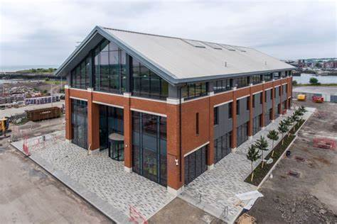

(Figure 1 Y Fforwm, UWTSD,2022.)
Student Name: Lynsey Davies
Student ID: 1911295
Lecturer: Dr Deborah Hughes
Module Code: ACBA5003

Table of Contents.
Front Page
- Professional Letter to the client…………………………………………………………………..Page 2-4
- References………………………………………………………………………………………………..Page 5

Table of figures
Figure 1 ………………………………………………………………………………………………………….Cover Page

1.0


Elemental Cost Breakdown for Y Fforwm Building, University of Wales Trinity Saint David.
Dear Miss Hughes,
Please see attached Elemental Cost Plan as requested. The final figure quoted is an estimated cost, based on the information supplied from the Architects drawings only and no specification was obtained. In the absence of a specification and estimated budget cost I have used inflated unit costs and provisional sums which will provide you with an over estimated final figure and hopefully be within your set budget.
From the drawings I was able to extract measurements and a true cost provided, where we could not identify precise details, assumptions were made, and indicative cost/provisional sum was quoted.
The cost plan is largely based on assumptions, below is a detailed breakdown of the elements:

FACILITATING WORKS.
- Carried out by the client.
SUBSTRUCTURE.
- Main elements of the substructure were identified at current prices and will provide a true cost to date.
- Piles and caps were overestimated due to not being able to identify exact measures according to engineer’s drawings, awaiting quotations from local suppliers.
- A provisional sum was used for the areas to the revolving doors, lift pit and deep pit areas as I could not identify a cost, awaiting quotations from local suppliers.
SUPERSTRUCTURE.
- Prices for Concrete framing and columns are based on overestimated sizes and quantities, awaiting quotations from local suppliers.
- Provisional sum entered for Solar panels due to limited design information. To be updated pending a detailed specification.
- Windows were based on an inflated cost due to various sizes and design uncertainty, awaiting final design for quotations to be sent to local suppliers.
- No design requirements specified for Partition walls, costs identified and used based on a two-story school block, awaiting final design.
- Internal door cost was based on a FD60 rating door to ensure this cost was over estimated due to the amount required. Awaiting final design and door ironmongery details to obtain an exact price. the internal doors have been provided by the nearest approximate measurement offered.
INTERNAL FINISHES
- Provisional sum applied due to no design information. These elements have large quantities and will need a detailed specification to request quotations.
FITTINGS AND FURNISHINGS
- Provisional sum applied due to no design information. These elements have large quantities and will need a detailed specification to request quotations.
SERVICES
All service drawings to be fully designed by Design Engineers, once the final drawings have been received, I will put these out to tender.
EXTERNAL WORKS- TBC
MAIN CONTRACTOR'S PRELIMINARIES- TBC
I the estimate is within your estimated budget, please if you have any other questions, please do not hesitate to contact me- 07572434543
Yours Sincerely
Lynsey Davies

References:
2020. Spons Architects and Builders price Book 2020. Oxon: Aecom.
Coursehero.com. 2022. NRM 1.pdf - RICS new rules of measurement The RICS new rules of measurement (NRM) is a suite of documents issued by the RICS Quantity Surveying and | Course Hero. [online] Available at: <https://www.coursehero.com/file/27008002/NRM-1pdf/> [Accessed 5 May 2022].

