Andrei Lebedinschii 1917123
Introducing the Modern Workplace – assessment 1
Lecturer – Jean-Paul Okeke

Unilever – Structure and Culture

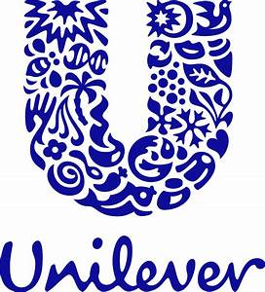

Table of Contents:
Introduction 4
Organizational Culture 5
Organizational Structure and Design 9
Conclusion 12
Reference List 13

Introduction
The essay explains the organizational culture and structure of Unilever. The organizational culture of company defines certain values, assumptions and beliefs through which individuals interact with each other. Organizational culture relatively shows the expectations, philosophy and experiences of firms for guiding the individual behavior. The essay also describes the financial position of company in the market. Unilever has product type divisional organizational structure. The company has segmented their home care and personal care products based on their organizational structure. It further demonstrates several factors affecting the organizational culture of Unilever. The essay shows that life cycle, strategy, technology and environment are the major factors that affect Unilever’s culture. The essay also explains Hofstede’s model application on the business. The Hofstede’s model is primarily based on the individual differences in terms of beliefs and values regarding their work goals. At least, it explains several theories based on organizational structure of the company.

Organizational Culture

Company Background
Unilever is regarded as the best consumer goods company across the world. The company also offers a different range of products and services such as food, beverages, personal care product, and many more. In 1894, Unilever Plc is incorporated as fast-moving consumer goods (Dunlop and Strath, 2020). The company mainly operates its services in 70 countries.
Unilever
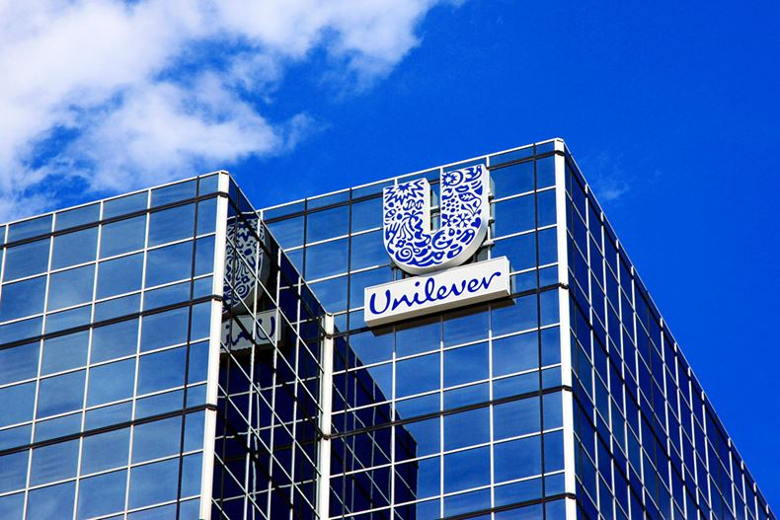
Citywire reporters, (2020)
Importance of Organizational Culture
The success of Unilever Plc is connected to its organizational culture and the types of operation and policy leaders have to implement above time. There is a close relationship between workforce and organizational culture (Buschgens et al., 2013). The Company becomes successful due to the effectiveness of its leaders that provide support to improve the organizational culture. Unilever mainly explores new areas and pays much attention to HR department for improving employees’ performance. Unilever's Culture also provides support for the high performance of the employees. (Ostroff, 2012)

The effect of the corporate culture also reflects on the stable performance of the customer products. Organizational Culture refers to norms and beliefs set by firms to achieve their long term objectives. Strong corporate culture may enable businesses to maintain strong relationship with stakeholders (Buschgens et al., 2013). The Unilever business culture of performance that focuses on the importance of the worker results. The corporate culture may also point to the essential measures use to identify the result and accuracy of the outcome. Unilever's culture of performance has some important points to explain below: spotlight on performance: both individual and managerial performance, focus on excellence: quality of outcome in all areas and effectiveness: efficient work by using advanced technology and other tools.
The culture of Unilever mainly focuses on the performance and quality of the business. The corporate culture mainly observes in the long history of the firm. Success is important based on the capability of the Unilever business culture to increase the high recital and quality of workforces to increase their outcome. It's culture is the civilization of the performance of the business. Unilever also collaborates with other successful companies to enhance their brand image and boosts profit margins (Hasan, 2020).

Theories related to Organizational Culture
Unilever requires adopting various theories to develop a fruitful condition for workers and enhance customer potential. The theories help the company to enhance the operational activities and focus on satisfying customer needs and demand. There are various theories related to organizational culture are explained as under:

Hofstede Model of Organizational Culture
Geert Hofstede has proposed the Hofstede model in the year 1980. This model explains that a regional and national factor contributes to the culture of company for influencing the employee’s behavior. Technological advancement has forced the people of different cultural background to work together. Hofstede defined culture as shared and learned way of acting and thinking while performing particular tasks in the group. The culture of business organizations is becoming interconnected that makes the business to expand globally. The model shows that each individual involved in business organization should be capable of dealing with large variety of people from other nations and cultural backgrounds. The Hofstede model can help Unilever by providing crucial information about certain cultural differences between different countries. The model analyzes national and organizational cultures that are the major factors affecting employee’s motivation and conflicts in the business. This model is typically based on six dimensions that are as followed:
Power Distance: It mainly refers to differences in the employment culture as per the power delegate to the workers of the company. There is little business that believes in appointing team leaders or team managers who are accountable for their team and have the problem of extract the best out of the member. The team’s have a focus on the leaders and work as their advice and order. However, Unilever's worker is answerable for his performance.
Masculinity vs Femininity: It mainly refers to the outcome of analyzing the difference among the male and female principles on the organizational culture of Unilever. A male employee has been following different plans or policies as compared with females in the decision making procedure of the business. The roles and responsibilities also vary as per sex of human resources (Büschgens, 2013).
Individualism: Unilever mainly focuses on team members to accomplish the business goals and to provide high-quality service to their customer. Employees work with each other to fulfill the task within a particular time. Unilever Plc has motivated their workers to share a new idea with their juniors. It also used advanced technology to increase the business performance moreover, Unilever refers to individual work and assign a particular task to each employee.
Uncertainty Avoidance Index: Unfamiliar conditions and uncertainty are considered in this factor. The avoidance index has helped to identify employee patience in the difficult situation of the firm. Unilever also provides training and advice to their existing employee to easily handle the uncertain situation and to identify the problem.
Long Term Orientation: Unilever Company focuses on developing a sound relationship with their work to accomplish the business goals. This relationship helps to improve employee trust and confidence in the company and also easily communicate with each other. Unilever may also include employees in the decision making and they receive the opinion of the employee to make the right decision that helps to become successful (Knein, 2020).
French and Raven Basis of Power
This theory is established by a social psychologist named John French and Bertran Raven to recognize the impact on leaders. Unilever Company uses this theory to offer effective leaders to its existing employee. Several kinds of power are explained as under:

Legitimate Power: The Chairman and top authority of Unilever has owned this power to manage the operation. The top authority holds this power to impact on the perception of employees. The chairman plays crucial role in motivating employees for accomplishing corporate objectives. Unilever has experienced leaders that try to create healthy atmosphere for staff members. This may develop sense of accomplishment and job satisfaction among employees.
Reward Power: Unilever uses this power to provide recognition, incentive, new project, and another opportunity to its employee. The reward power mainly helps to motivate workers to accomplish their projects or task within the estimated time.
Coercive Power: Under this power, the employees are dissatisfied and frustrated due to the heavy workload. Unilever must also give penalties or punishment to employees if they cannot achieve standard result (Mansaray, 2020).
Informational Power: This power is also used by Unilever to maintain control above the monetary condition of the business and prevent the secret information of the company from competitors

Organizational Structure and Design

Unilever's organizational structure is responsible for making sure accurate support for product innovation in the success of the business. Organizational structure refers to the arrangement and system that use to develop and interconnected with several business elements like office and team members. Unilever's structure easily adopts the changes in the customer product and global marketplace (Rakova, 2020).

Methodical Unilever Organizational Chart 2019
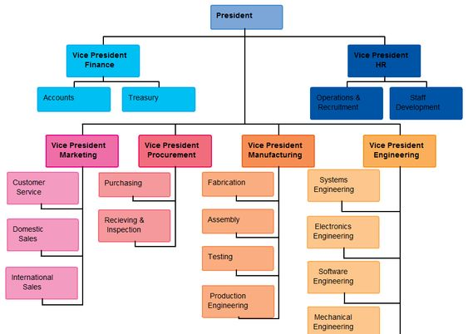
Source: pinterest.com, (2019)

Currently, Unilever has mainly adopted divisional structure to fulfill their business objectives and pays much attention towards product category (Buschgens et al., 2013). Unilever's business structure provides support to diversify the global activities of the company. Unilever is the biggest firm with a wide range of customer products that manage by divergence in the business having a vertical axis that mainly represents the level of the harmonious combination of the national difference and impact of strategic and operational reconciliation.
Unilever's organizational structure mainly provides support to the growth of product and innovation in business. Each product is subdivided into semi-autonomous capabilities of the growth of products that directly focus on the customer product market segment. Unilever's structure is more flexible than the traditional structure such as a functional organizational structure. The top authority of Unilever has taken right decisions for the success of the business (Joseph, 2020).
The manager of Unilever estimates the full control of the organizational activities in a country. Independently, Unilever takes decisions, innovation and products are made by the host country. The matrix structure of Unilever is also designed to allow movement of individuals without interference with entire productivity and performance. Unilever's focuses on matrix structure will also continue to include in the future. Team members of Unilever have been capable to reduce the cost of products and services.

Theories related to Organizational Structure

Unilever uses different theories of organizational structure help to maintain a strong business structure. The theories also help Unilever to accomplish workers' trust and confidence. Some organizational structure theories are explained as under:
Scientific Management: This theory is introduced by Fredrick Taylor that mainly started some scientific methods to improve business activities. The scientific management main aims to attain product standard, operation quality, and specialization. Management theory helps to build a strong relationship among the employee and business. Unilever also focuses on their manufacturing processes to develop eco-friendly products for customers. On the other side, open systems may provide appropriate solution to Unilever related to information security and network. Efficient IT systems may also help Unilever to establish well defined structure and gain customer insights. Taylors also provide information about effective training plans to enhance the performance of workers or subordinates. This theory also helps employees to build new skills and properly communicate with their junior to take any kind of decision-related to Unilever Plc.
The organizational structure of Unilever focuses on high quality, better performance, and greater efficiency through technology and other tools. Unilever has product type divisional organizational structure. The company divides components based on its product ranges. Unilever divided the structure into geographic division, corporate executive teams and product type division. Under product type division, company segmented refreshment, home care, foods and personal care products. Through product type division, company manages the development, manufacturing, sale and distribution of consumer goods. Managers in Unilever often use this structure for matching the consumer needs with appropriate products. Unilever has corporate executive teams that include marketing, communication, HR, chief executives and supply chain. The company also has geographic division that helps in supporting the regional strategies. This segment shows that marketing strategies of company in Europe are totally different from Asian markets. The organizational culture of Unilever relatively supports the innovation and product development. For instance, each product division has capabilities of developing product for meeting the needs of consumers in the market. Through this product type divisional structure, Unilever differentiates its products despite operating in global market.
Demographic changes force the business organizations to change their structures. Changing social trends also influences the structure of business. Technology and economic recession led the business to change their organization structure. Due to recession, consumers spending is reduced that has a major impact on the business performance. For surviving in the market, Unilever has to change their organizational structure. The new leadership, conflict, new mission, low performance and satisfaction are also the major factors that can affect the Unilever’s organizational structure.
The company can encourage effective communication reducing gossips and rumors in the business. Unilever can also provide training to their workers for enhancing their knowledge and skills. The company can also increase the team members and individual accountability for improving the profitability and consumer satisfaction.

Theories
Scientific management theory: The scientific management theory helps businesses to motivate their employees by using advanced technology to enhance business activities. It provides scientific management theory stated that to increase the performance and productivity of the employees of Unilever. This theory satisfies its employees by providing guidance and advice. It is helpful to control the operation and maintain good environmental conditions for employees. This theory also helps to increase the standard of living and decrease their high turnover of employees. Unilever uses the scientific management theory and follows all the rules, regulations, competition technology, etc. that help to manage their business activities efficiently. Unilever must adopt this theory to decrease the wastage of product and provide specialized training to their employees (Narula, 2020).
Bureaucratic Theory: This theory is introduced by Max Weber, it is considered as high structured and maintaining the impersonal business relationships. Unilever must adopt a hierarchical business structure by following their roles and responsibilities. Some principle is followed by Unilever that are explained as under:
Formal Hierarchical Structure: Unilever Plc must control the lower management in effective ways. Unilever must follow a formal hierarchy structure that has included a central decision making procedure by using planning.
Rules-Based Management: Businesses must also create specific rules and regulations to monitor daily operations. Unilever's Low management also tries to execute the decision taken by the top authority.
Functional Specialty: Unilever Company must divide workers into various functional levels based on the skills and information.
Up focused Mission: Unilever's main aim is to satisfy the need for the stakeholder related focus mission and vision. Furthermore, Unilever Company must focus on enhancing the profitability. Then identify the company needs.
Impersonal: Bureaucratic theory follows Unilever's true and fair condition that may follow to every member of staff. Unilever Company cannot differentiate among the worker in terms of the caste, religion, education, and culture difference.
The Bureaucratic method is helpful for Unilever to maintain a strong relationship with employees. Moreover, this theory may follow some problems that may harm firm goodwill. This theory helps to increase the performance and productivity of the firms. Unilever's formal rules and regulations may follow an effective decision making process (Macias, 2020).

Conclusion
The essay can be concluded after discussing Unilever's impact on the company's organizational structure and culture. The essay analyzed that Unilever must adopt a matrix organizational structure for the provision of employee-related information and must comply with certain rules and regulations. Unilever must follow theories of organizational structure and culture. The company must comply with administrative regulations to improve effectively the productivity.

Reference List:

Büschgens, T., Bausch, A. and Balkin, D.B., 2013. Organizational culture and innovation: A meta‐analytic review. Journal of product innovation management, 30(4), pp.763-781.

Hasan, H. and Nikmah, F., 2020, March. The Effect of Organizational Culture, Organizational Learning and Creativity on Employee’s Performance. In 2nd Social and Humaniora Research Symposium (SoRes 2019) (pp. 456-460). Atlantis Press.

Joseph, J. and Gaba, V., 2020. Organizational structure, information processing, and decision-making: A retrospective and road map for research. Academy of Management Annals, 14(1), pp.267-302.

Knein, E., Greven, A., Bendig, D. and Brettel, M., 2020. Culture and cross-functional coopetition: The interplay of organizational and national culture. Journal of International Management, 26(2), p.100731.

Macias, J., 2020. Enhancing Knowledge Worker Creativity in Bureaucratic Organizations: A Grounded Theory Study (Doctoral dissertation, Southeastern University).

Mansaray, H.E. and Jnr, H.E.M., 2020. The Connection between National Culture and Organizational Culture: A Literature Review. Britain International of Humanities and Social Sciences (BIoHS) Journal, 2(1), pp.179-189.

Narula, V., 2020. Unit-2 Scientific management approach. Indira Gandhi National Open University, New Delhi.

Ostroff, C., Kinicki, A.J. and Muhammad, R.S., 2012. Organizational culture and climate. Handbook of Psychology, Second Edition, 12.

Rakova, B., Chowdhury, R. and Yang, J., 2020, January. Assessing the intersection of organizational structure and FAT* efforts within industry: implications tutorial. In Proceedings of the 2020 Conference on Fairness, Accountability, and Transparency (pp. 697-697).

Dunlop, H. and Strath, J., 2020. Shanks v Unilever: the sweet smell of success. Journal of Intellectual Property Law & Practice.

Online:

Image by Citywire reporters, (2020), Unilever, Citywire Funds Isider, https://citywire.co.uk/funds-insider/news/the-expert-view-unilever-taylor-wimpey-and-compass/a1349846#i=2 , (copied on 7/23/2020)

(2019), Methodical Unilever Organizational Chart 2019, https://in.pinterest.com/pin/855191416725214635/ , (copied on 7/23/2020)

