Cert HE Business Skills for the Workplace

Employability and Career Development
(LCLM4005)

Student:
Cesar Martin Perea
(2511411)

The document has been prepared as part of the application process for the Assistant Manager position at “The Blues Kitchen Shoreditch” in London. It begins with the original job advertisement, followed by a CV tailored to the role and a cover letter outlining why the applicant believes they would be a strong fit for the position. Together, these documents highlight the applicant's skills, experience, and suitability for the role.

- Job Advertisement
The job advertisement included in this document was found on the Indeed website by searching for Assistant Manager roles in London. The selected vacancy was chosen as it reflects the applicant's professional interests and career goals.
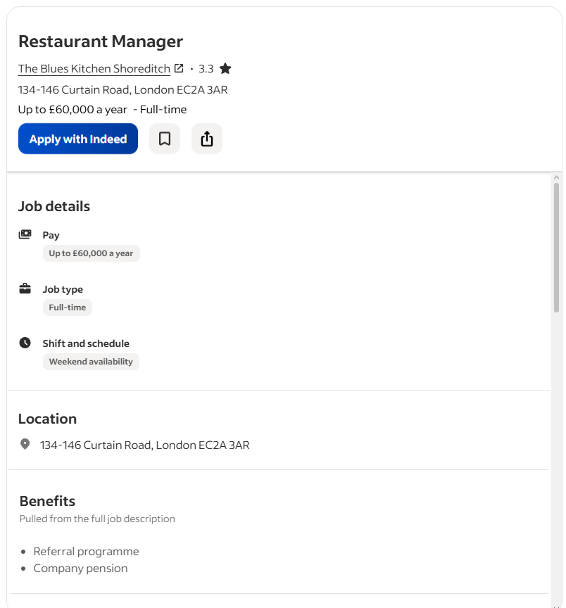
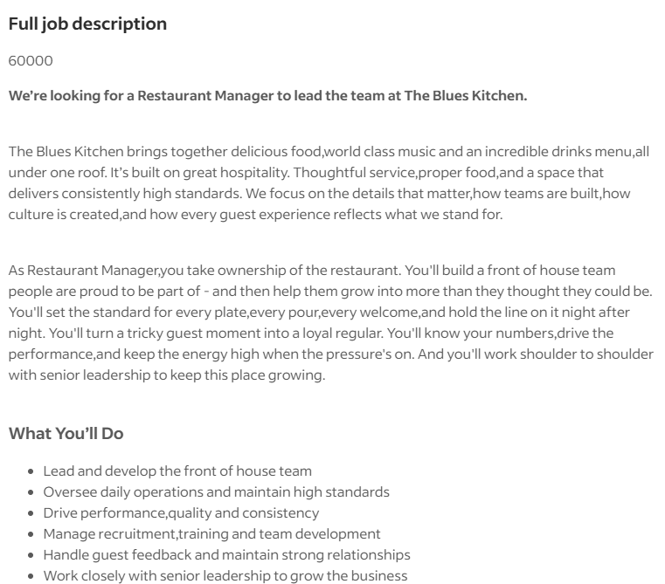
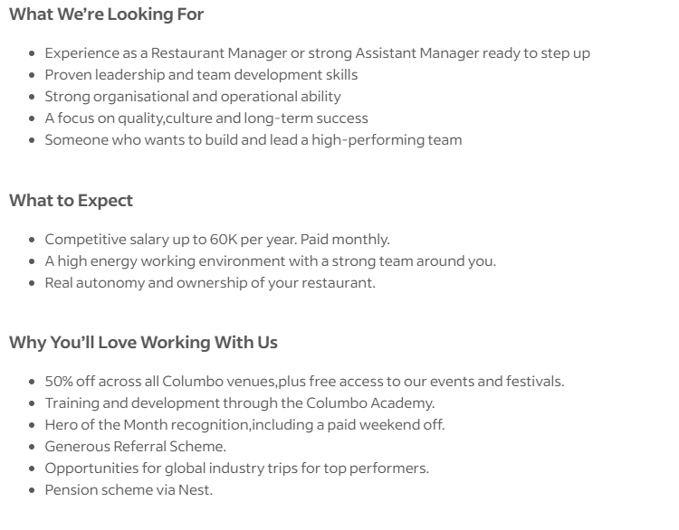

- Curriculum Vitae (CV)

Cesar Martin Perea
Phone: Email: 2511411@student.uwtsd.ac.uk Location: London, UK.
Professional Summary
Hospitality professional with extensive experience in bar and restaurant supervision, customer service, team leadership, and operational management across Colombia, Ecuador, Spain, and the UK. Skilled in staff training, cash handling, rota coordination, conflict resolution, and maintaining high hygiene and safety standards. Background in architecture adds strong organisational, planning, and project-coordination abilities. Currently pursuing Cert HE Business Skills for the Workplace to strengthen managerial competencies. Seeking an Assistant Manager position to contribute leadership, operational efficiency, and exceptional guest experience.
Key Skills
- Team leadership and supervision
- Staff training and coaching
- Customer service excellence
- Cash handling and POS operations
- Rota and shift management
- Conflict resolution
- Multicultural communication
- Bar and restaurant operations
- Health and safety compliance
- Workflow optimisation
- Guest satisfaction improvement
- Inventory and stock control
Professional Experience
Bar Supervisor – Archduke Restaurant, London, UK
2022 – Present
Supervise daily bar operations in a high-demand environment. Deliver excellent customer service and resolve guest concerns. Manage cash handling, card payments, and end-of-day financial reports. Ensure hygiene standards and maintain organised work areas. Coordinate with kitchen and floor staff to ensure smooth service flow. Train new staff in service procedures, safety protocols, and customer interaction.
Supervisor – Sansibar (Vikins Group), Palma de Mallorca, Spain
2022 (7-month season)
Led a team of 4 employees in a busy bar setting. Managed customer service, table service, and bar support. Oversaw cleanliness, stock control, and opening/closing procedures. Assisted in conflict resolution and maintained service quality. Ensured compliance with food safety and hygiene regulations.
Supervisor & Cashier – El Panal del Marisco, Guayaquil, Ecuador
2015 – 2020
Supervised waitstaff and coordinated daily restaurant operations. Managed customer service, table assignments, and guest satisfaction. Handled cash, card payments, and closing reports. Ensured cleanliness and organisation of dining and service areas. Supported staff training and workflow improvements.
Order & Dispatch Assistant – Surtinohemi Hardware Store, Tumaco, Colombia
2011 – 2014
Managed incoming and outgoing orders for the family hardware business. Coordinated product dispatches and delivery schedules. Took and organised factory orders for broom production. Maintained inventory records and customer communication. Ensured accurate order preparation and timely deliveries.
Architectural Assistant / Site Resident – Freelance & University Projects, Ecuador
2021 – 2022
Assisted in architectural drawing, planning, and project documentation. Supported on-site supervision, ensuring compliance with project specifications. Coordinated with contractors and suppliers to maintain workflow. Developed strong organisational and project-management skills.

Education
Cert HE – Business Skills for the Workplace
2025 – Present
Bachelor of Architecture – University of Guayaquil, Ecuador
Graduated 2021
Certifications
- Food Safety
- First Aid
- Fire Safety
- Leadership and Group Management
- Customer Service Training
Languages
- Spanish – Native
- English – Advanced
- Portuguese – Basic
- French – Basic
Additional Information
- Right to work in the UK
- Experience in multicultural teams
- Strong adaptability and communication skills

- Cover letter.

Assistant Manager (Hospitality)
Cesar Martin Perea London, UK
Hiring Manager at The Blues Kitchen Shoreditch [134-146 Curtain Road, London EC2A 3AR]
Wednesday, 8th July 2026
Dear Mr/Mrs/Miss/Ms at The blues Kitchen Shoreditch,
I wish to apply for the role of Assistant Manager, currently being advertised on INDEED. Please find enclosed my CV for your consideration.
As you can see from my attached CV, I have over ten years of experience in the hospitality industry, and I believe that my background in team supervision, customer service, bar operations, staff training, and fast-paced service environments makes me a strong candidate for the role.
In my current role as a Bar Supervisor at Archduke Restaurant in London, I have been responsible for overseeing daily bar operations, supporting staff training, managing payments, coordinating with floor and kitchen teams, and ensuring excellent customer service in a high-volume environment.
During this experience, I have strengthened my ability to lead teams effectively, maintain high service standards under pressure, solve operational problems quickly, and support a positive and efficient working environment. My previous roles in Spain and Ecuador further developed my adaptability, teamwork, and leadership skills, while my background in architecture has given me strong organisational and planning abilities.
All of this, coupled with my enthusiasm and dedication, as well as my skills in leadership, communication, organisation, and customer service, has helped me consistently contribute to smooth operations and high guest satisfaction.
I am confident that I can bring this level of success with me to The Blues Kitchen Shoreditch and help the team build upon their reputation as one of London’s most vibrant venues for live music, cocktails, and Southern-inspired hospitality. With my previous experience and expertise, I believe my contribution will have a positive impact on your operations and guest experience.
Thank you for considering my application. I look forward to the opportunity to discuss how my experience aligns with your needs and to contribute to the continued success of The Blues Kitchen Shoreditch.
Yours sincerely, Cesar Martin Perea

