Presentation week 9
6th of December

ACE: Academic and employability skills
Lecturer: Sylvia Hoffman

Student: Valentina Garzon Gomez
ID: 2111132

Slide 1:
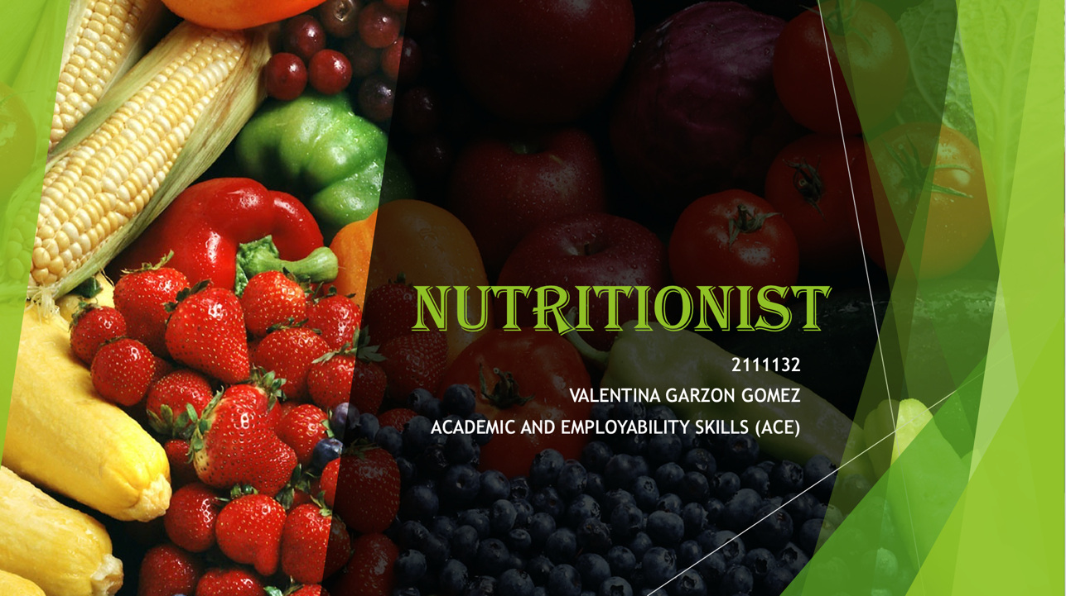

Slide 2:


Slide 3:
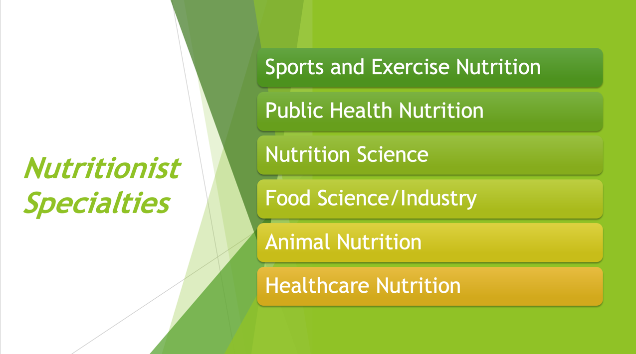

Slide 4:
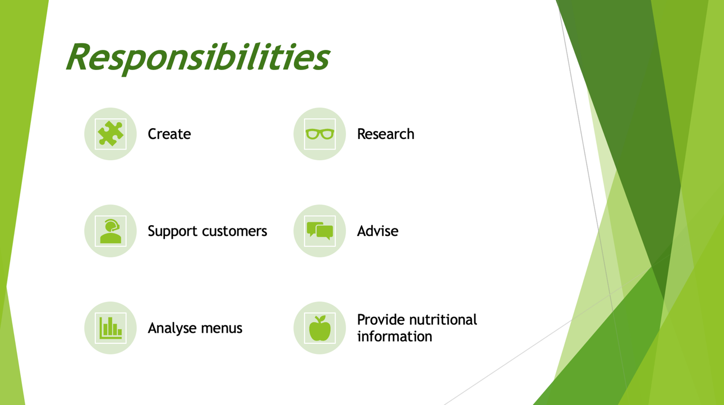

Slide 5:
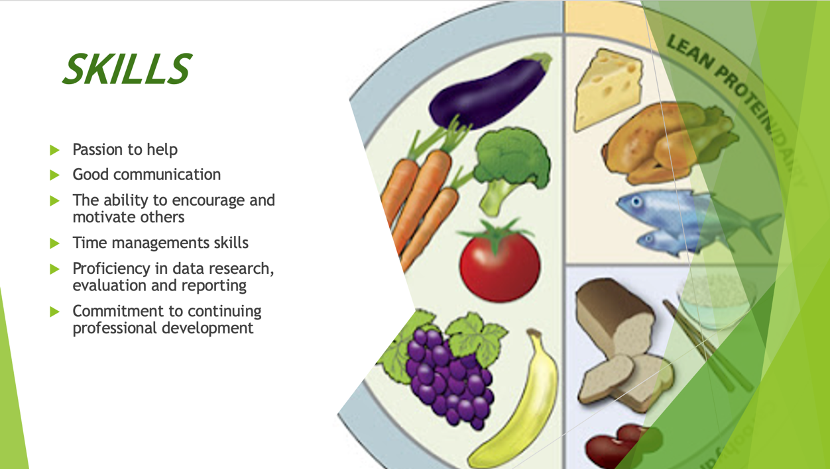

Slide 6:


Slide 7:


